Fire Detection and Alarm Mini Project

When a fire breaks out, time is of the essence. Prompt measures need to be taken to evacuate the trapped people and contain the fire before it spreads out of hand. However, to accomplish this we need a system that can detect fires before it is too late.

This fully automated Fire Detection and Alarm System is equipped with a temperature sensor and a 555 timer IC. This fire detection can sense changes in temperature and sound an alarm in case of fires.

Block Diagram:

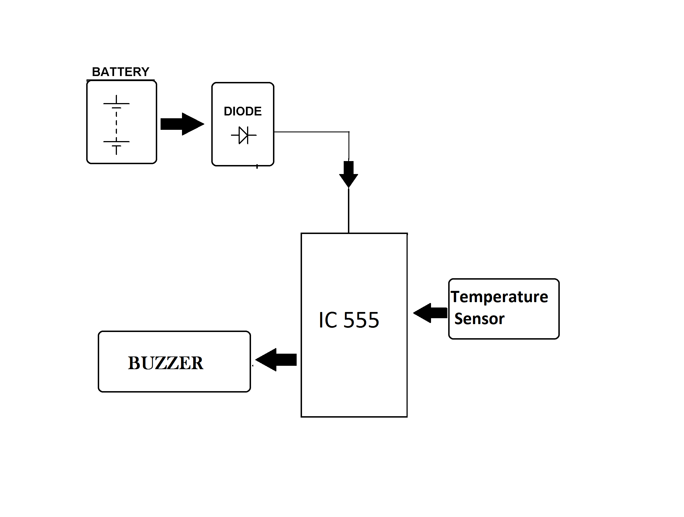

Hardware Specifications

- Temperature Sensor
- Resistors
- Capacitors
- Transistors
- Cables and Connectors
- Diodes
- PCB and Breadboards
- LED
- Transformer/Adapter
- Push Buttons
- Switch
- IC

