**AWS Task 01**

Launch a t2.micro instance in Mumbai region where ssh can be done only from your IP address with docker and docker-compose installed in it.

**Launch a t2.micro instance in Mumbai region**

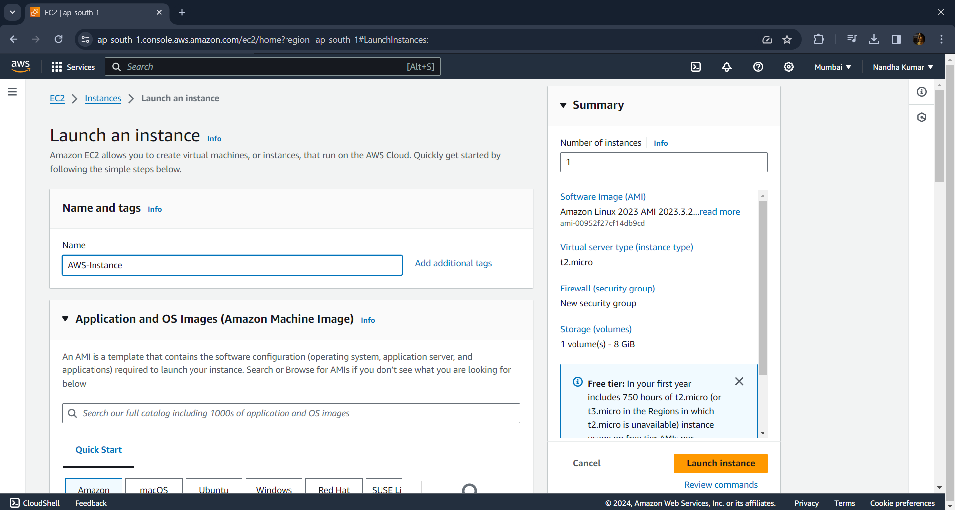

**Pem file created:**

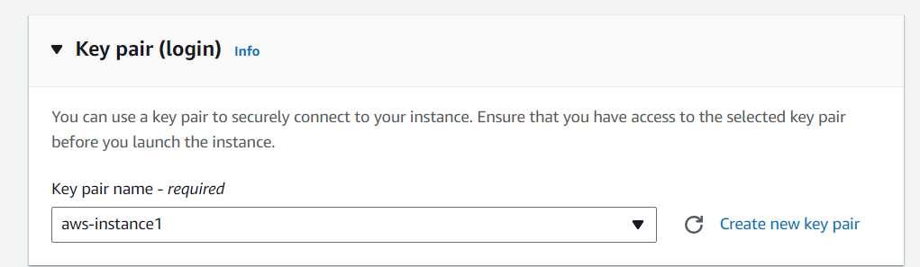

**Launched EC2 instance Successfully:**

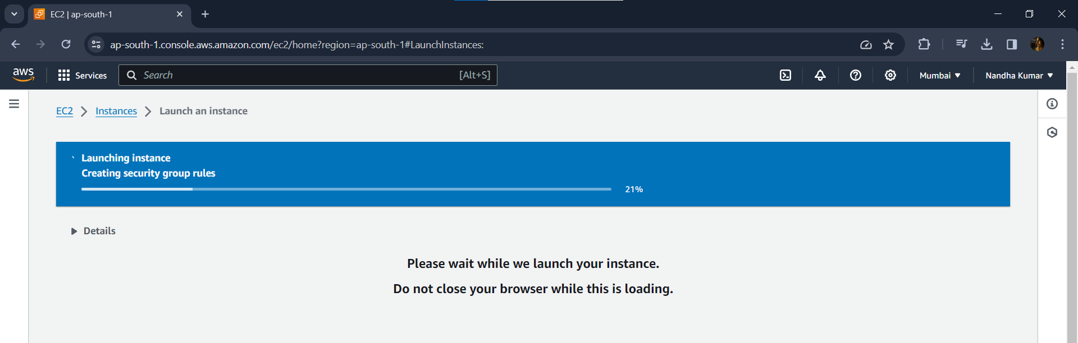

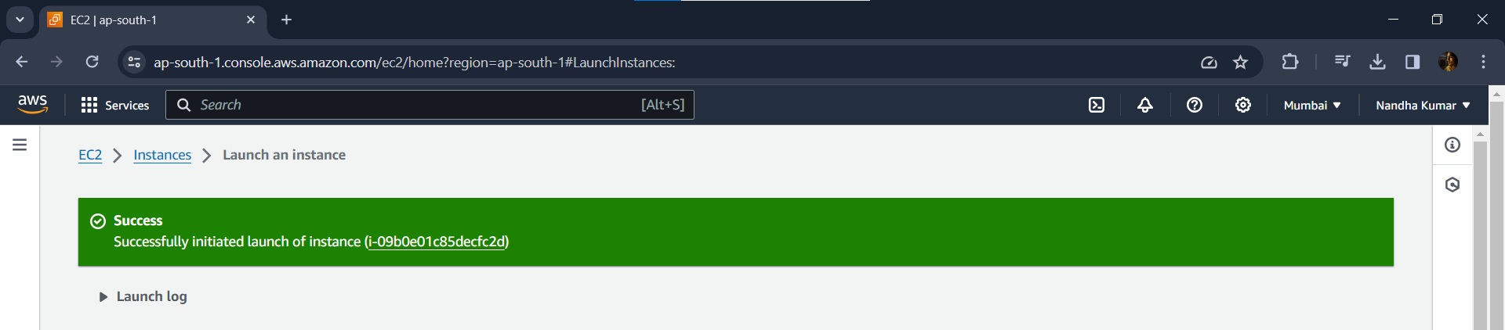

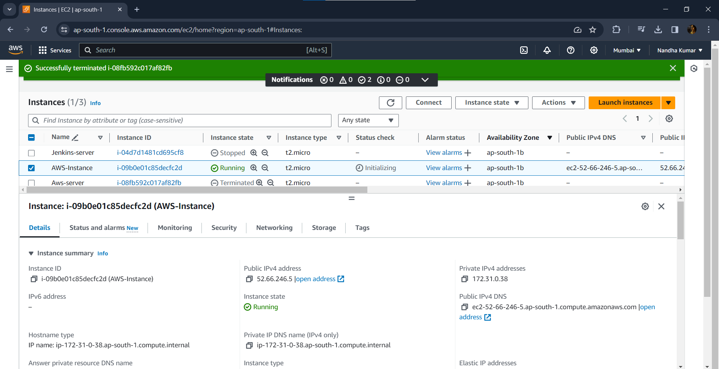

**Connecting through SSH in local machine**

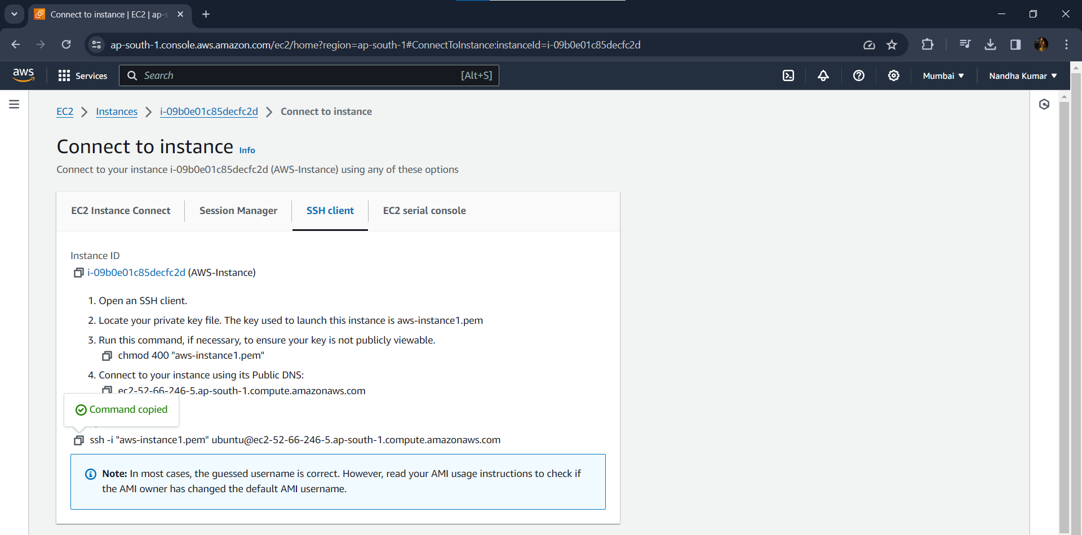

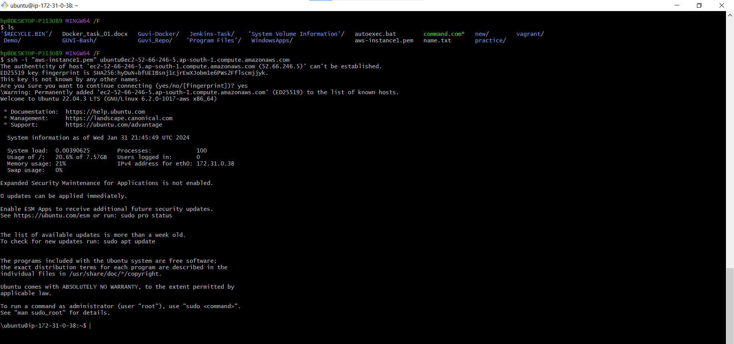

**docker and docker-compose installed:**

