**Docker Task 02**

**Create a custom docker image for nginx and deploy it using docker-compose, where the volume mount should be at /var/opt/nginx location. Push the created custom docker image to your docker hub.**

**Creating a custom docker image:**

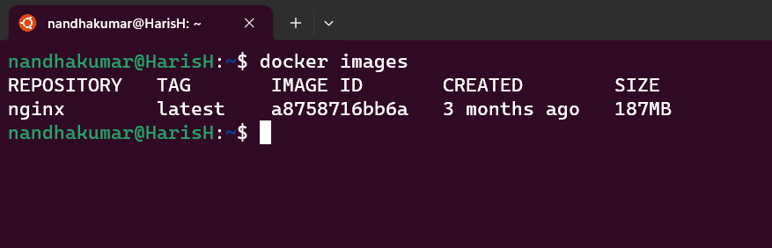

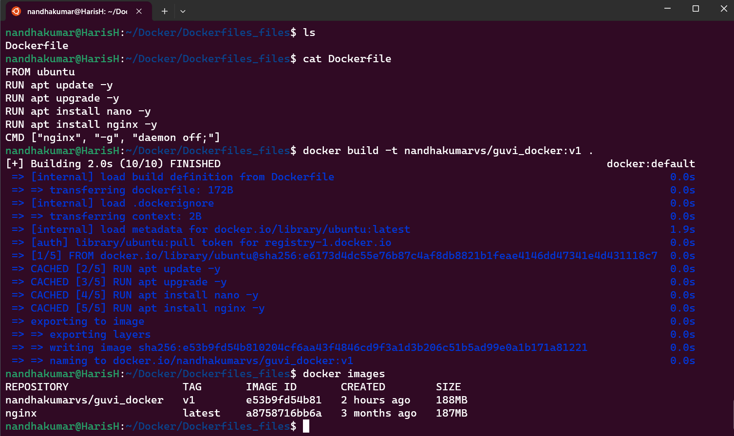

**Deploy it using docker-compose**

**Before Mounting:**

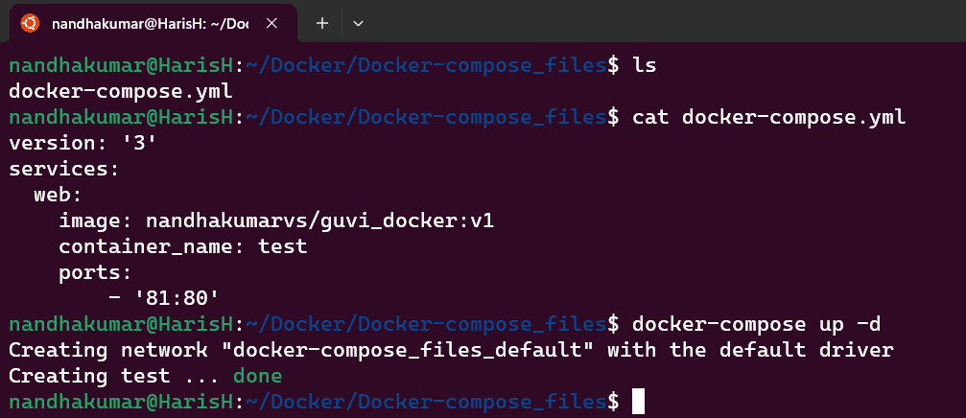

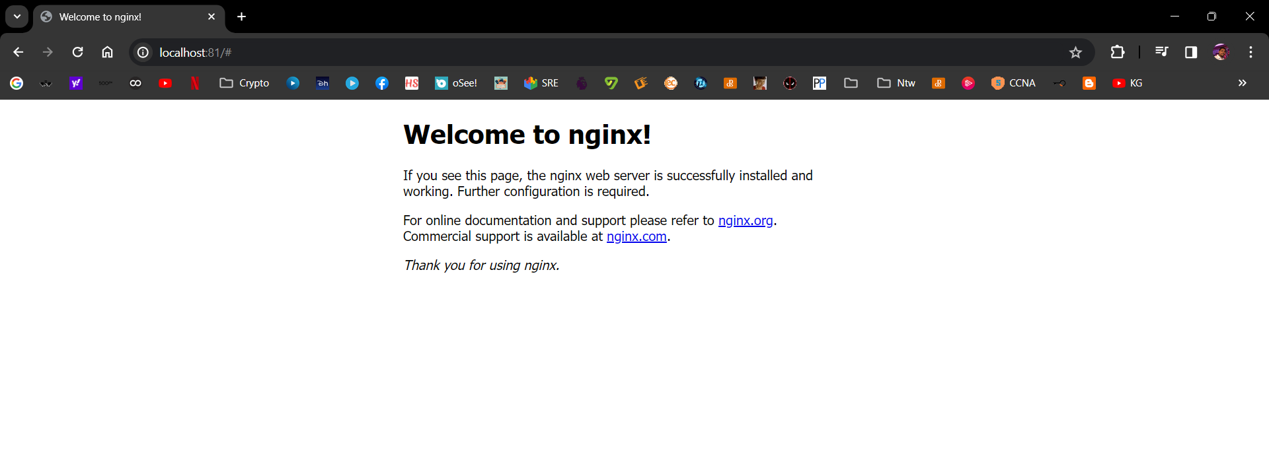

**After docker-compose up - docker container writes html file while running:**

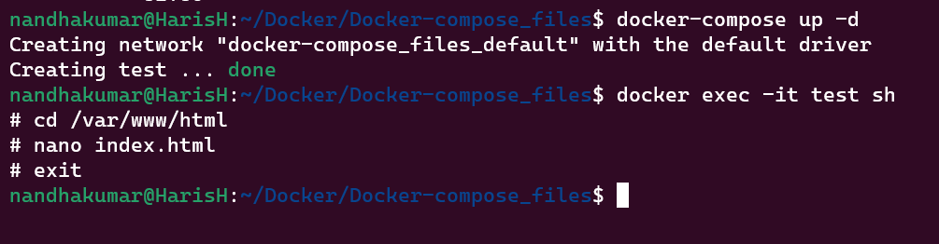

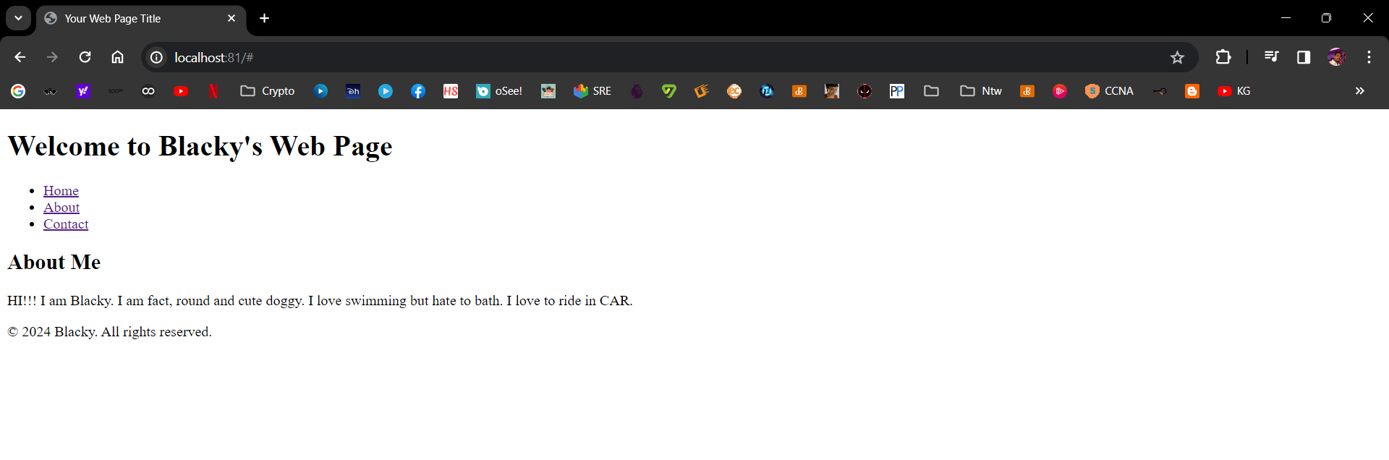

**Doing docker-compose down**



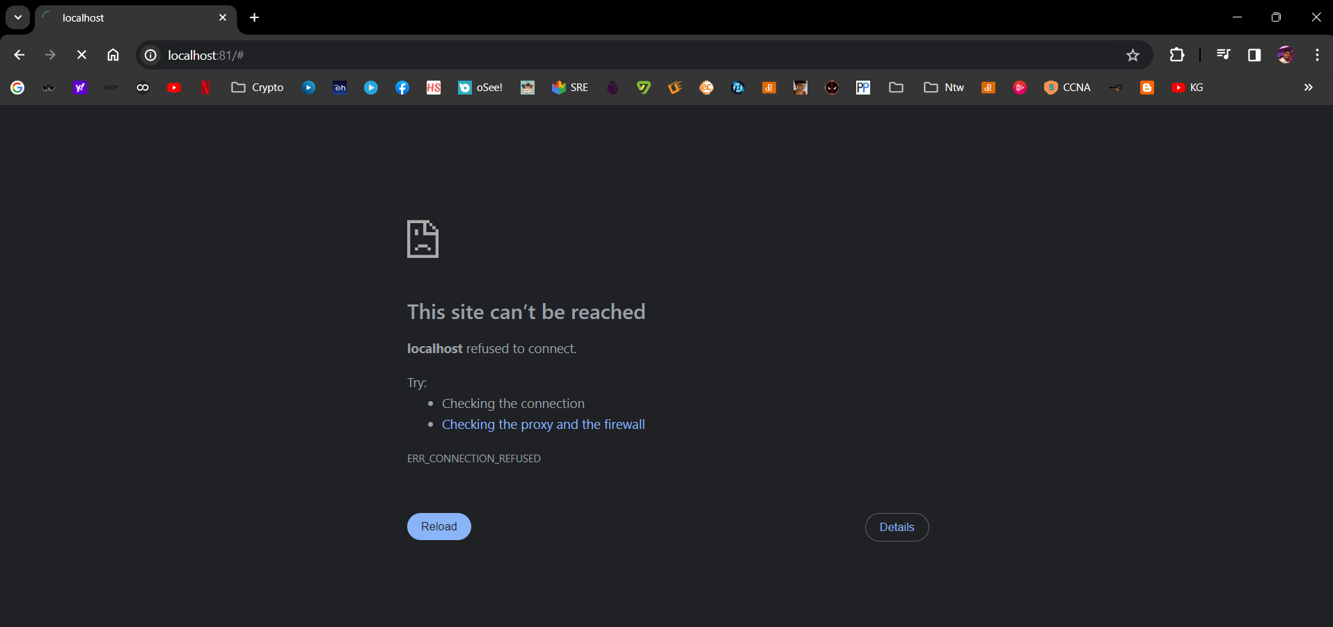

**Doing docker-compose up again:**

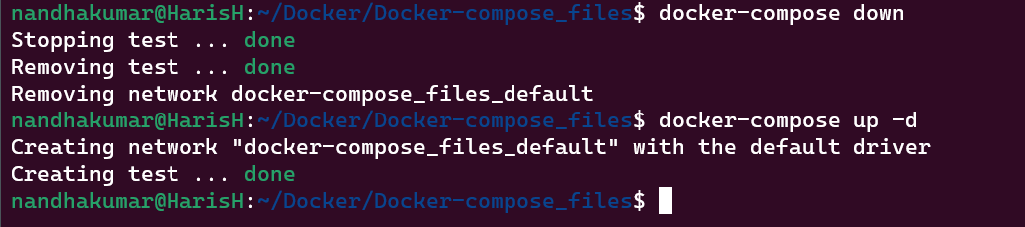

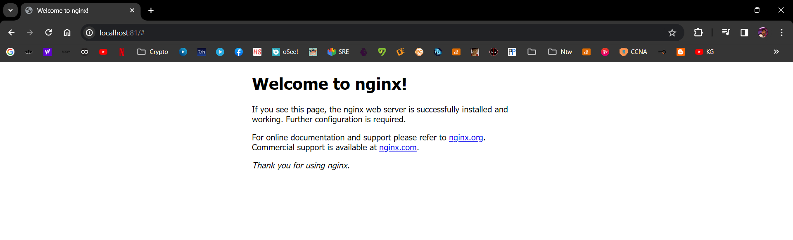

**After Mounting:**

**Creating local mount**

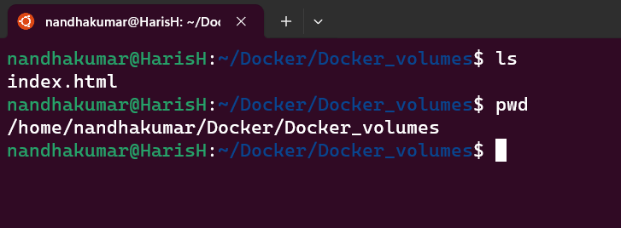

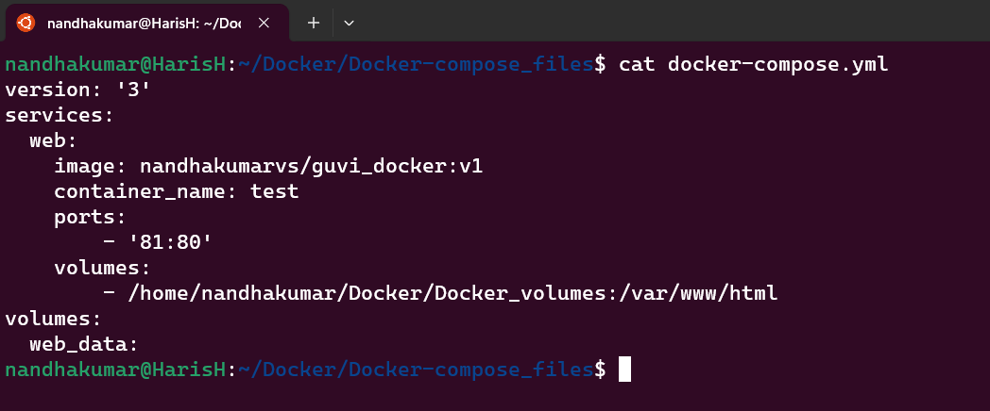

**Running docker-compose up -d**

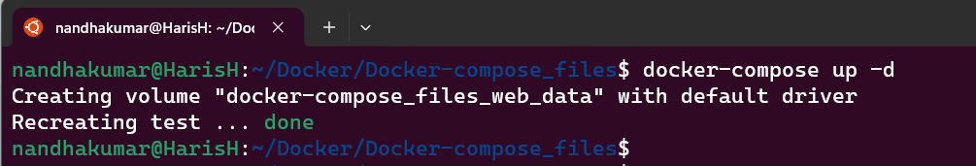

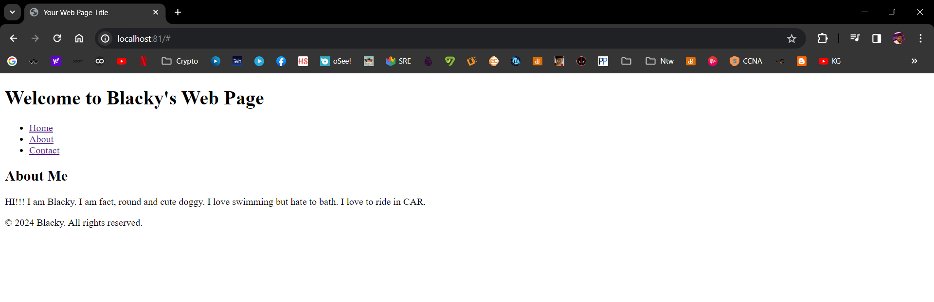

**Now, writing html files with few lines:**

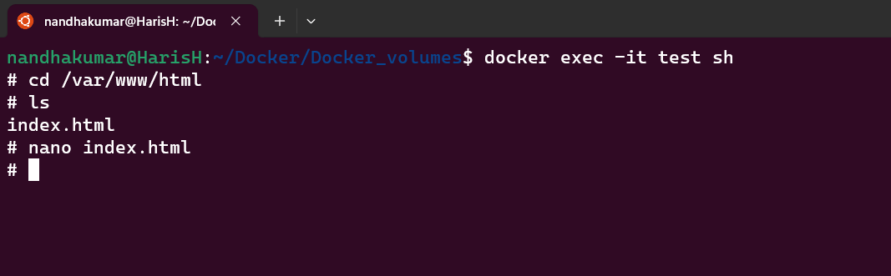

**After writing html file:**

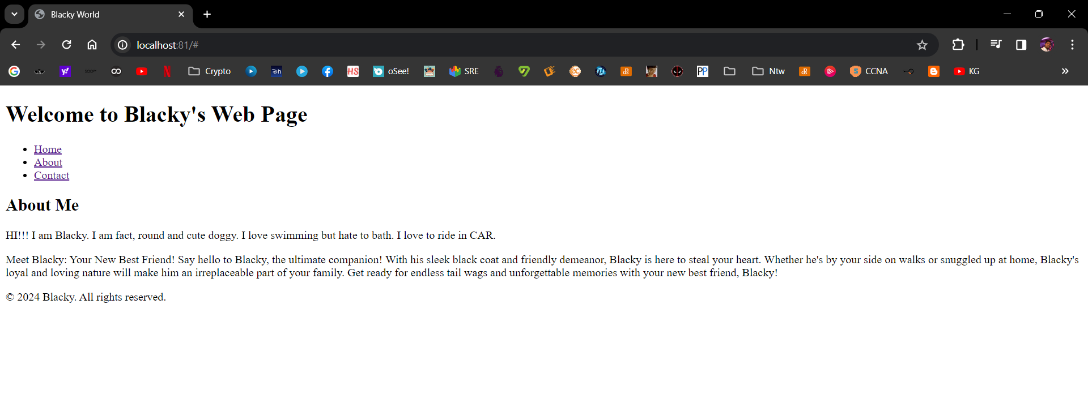

**Now, running docker-compose down**

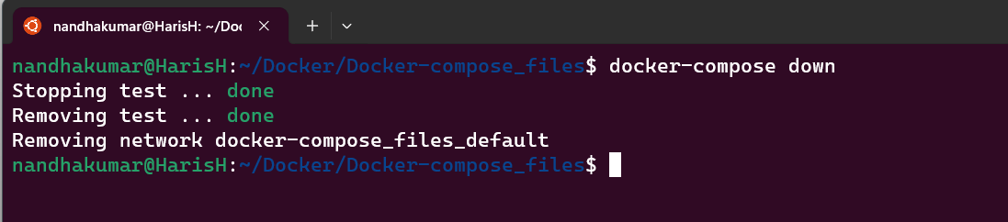

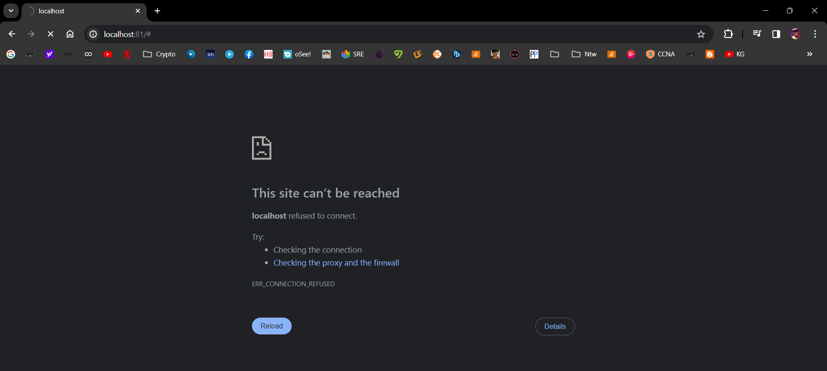

**Again, running docker-compose up -d:**



**Newly added html code exist, volumes are mounted to repository:**

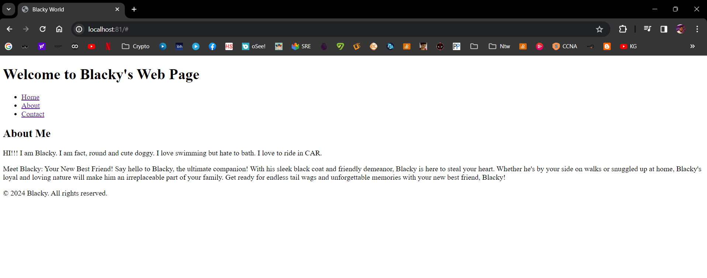

**Docker volume details:**

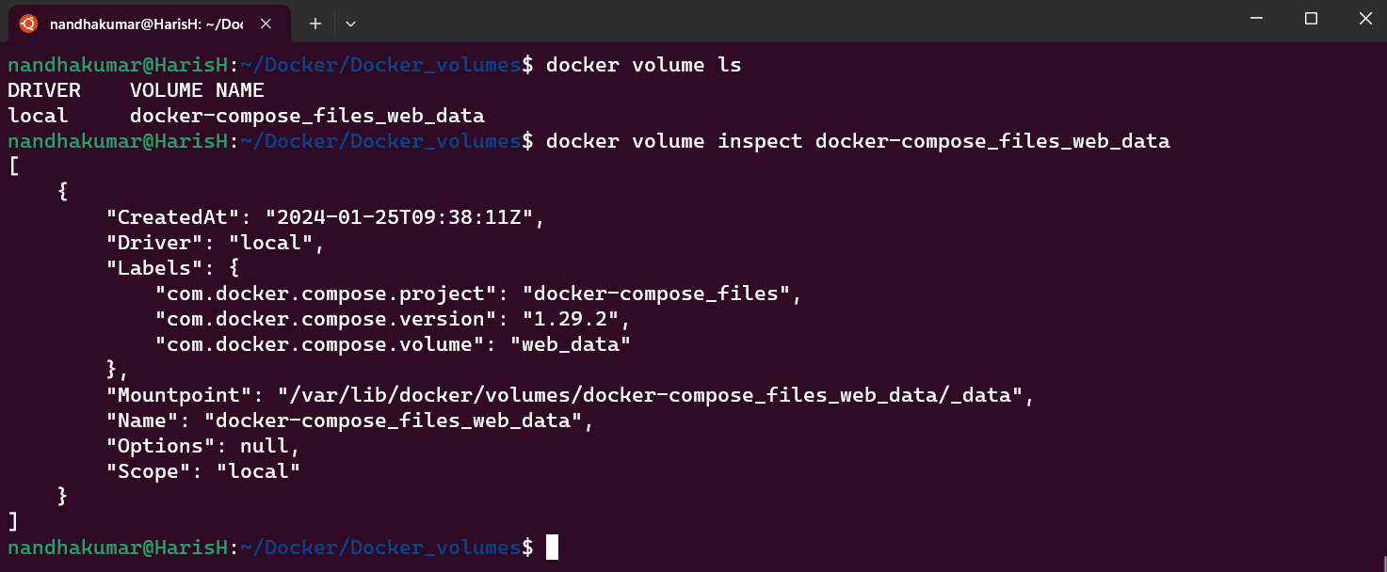

**Pushing docker image to docker hub:**

