**Jenkins Task01**

**Create a simple script file, with some data present it and push it to repo. Now Create a project in Jenkins connected to your GitHub repository. When a commit is made to your repo, automatically build must get triggered from Jenkins and the output must be shared to me via email.**

**Cloning a Git repository in local Server:**

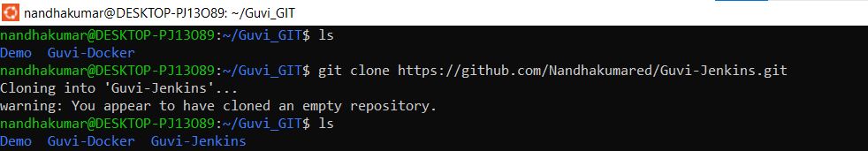

**Creating a file and pushing it to Git Hub:**

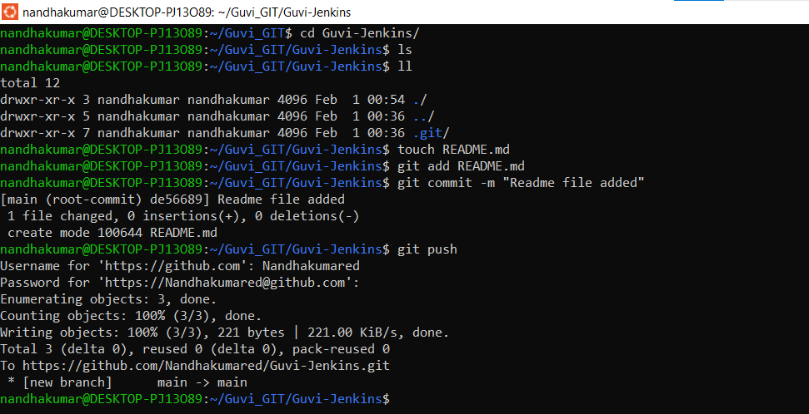

**Create a simple script file, with some data present it and push it to repo.**

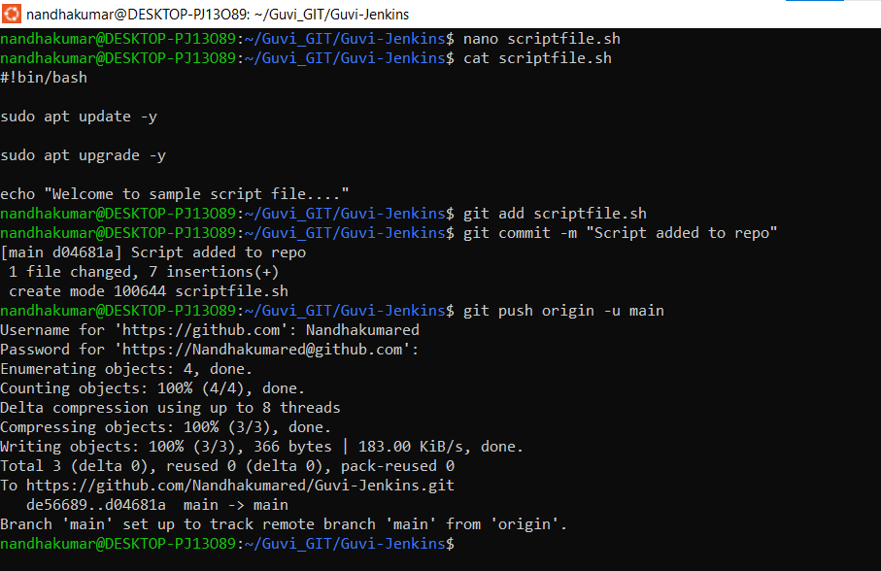

**Create a project in Jenkins connected to your GitHub repository:**

**Jenkins Configuration:**

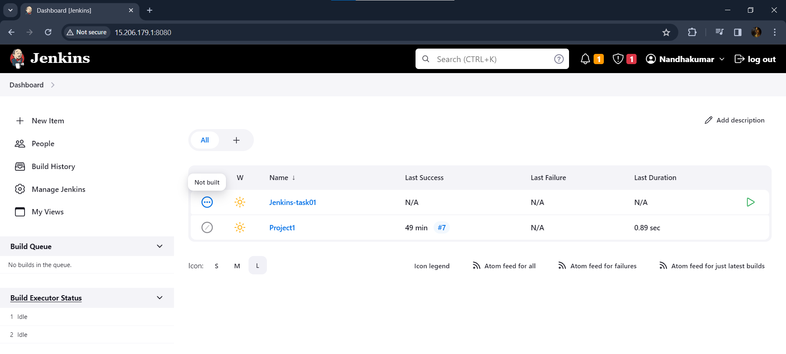

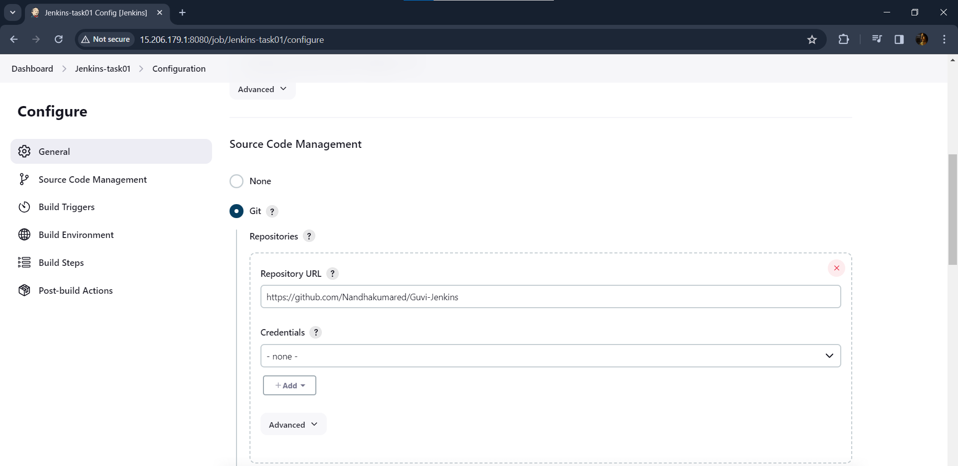

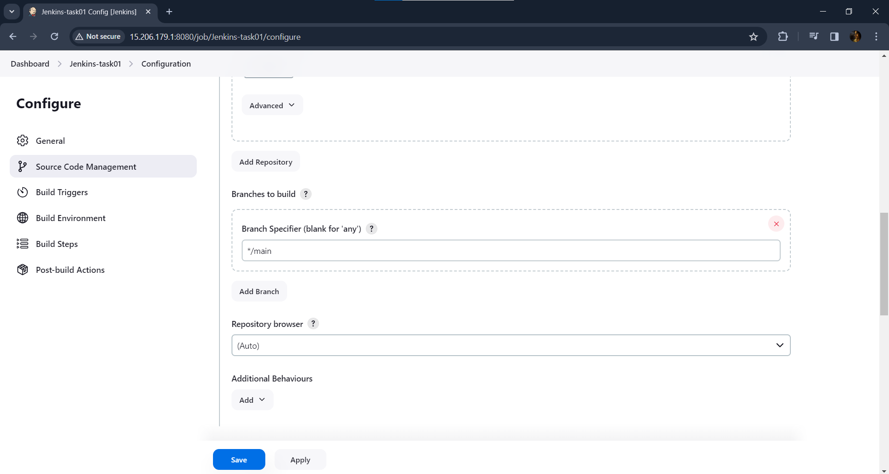

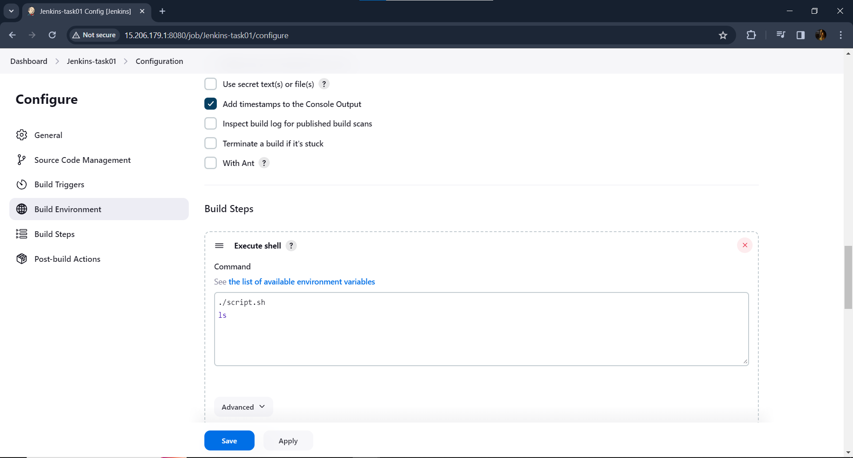

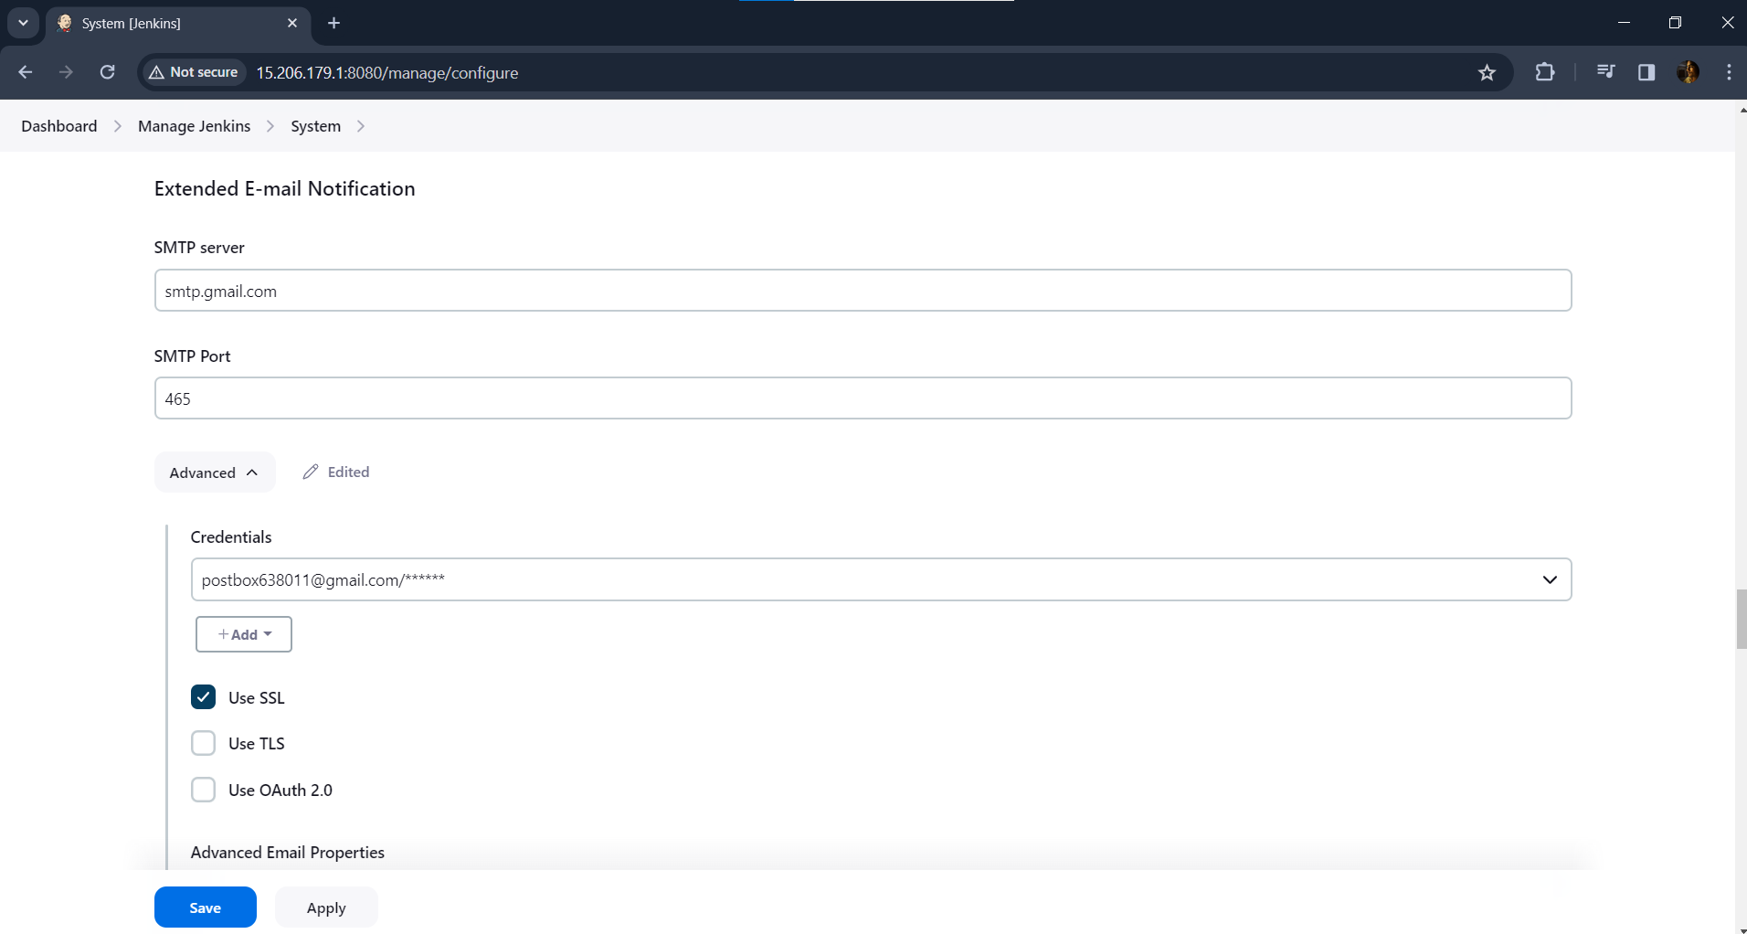

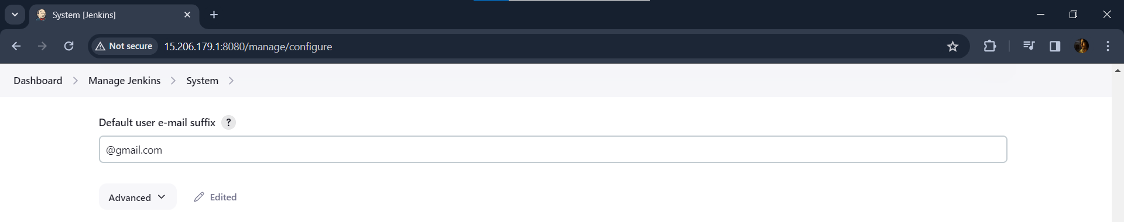

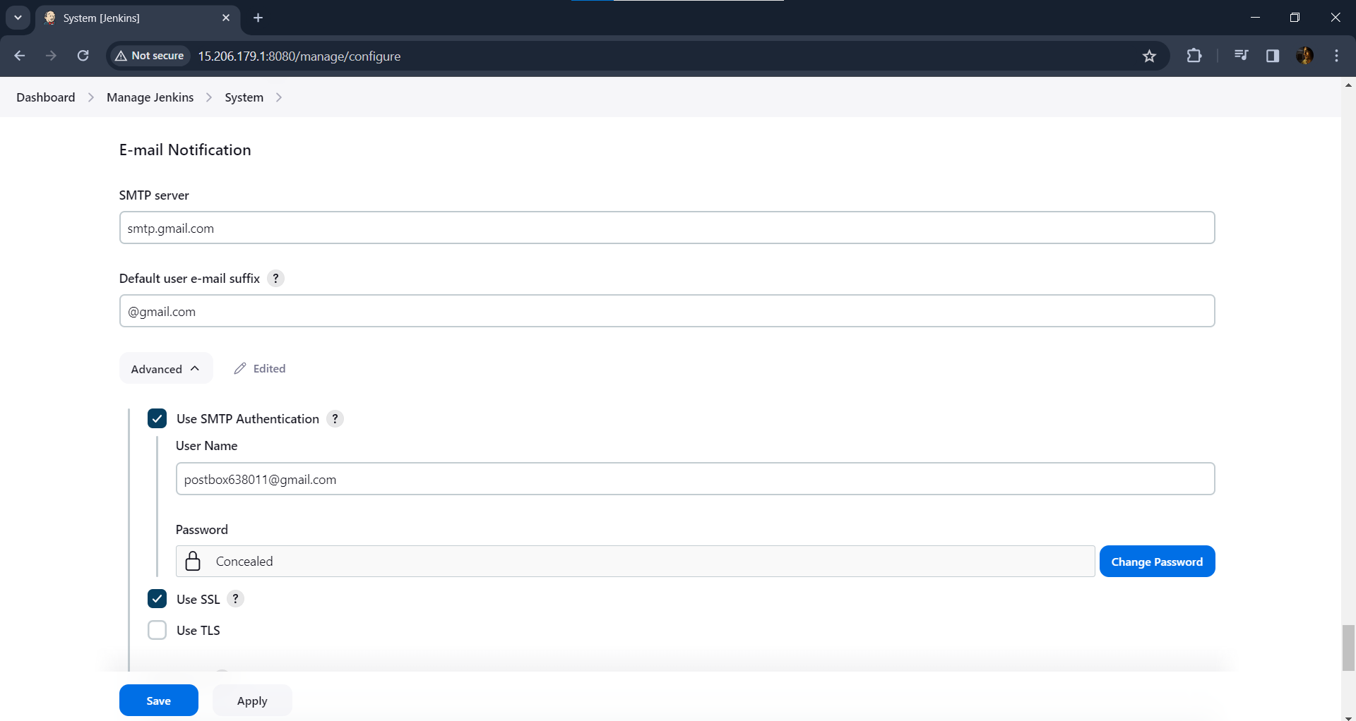

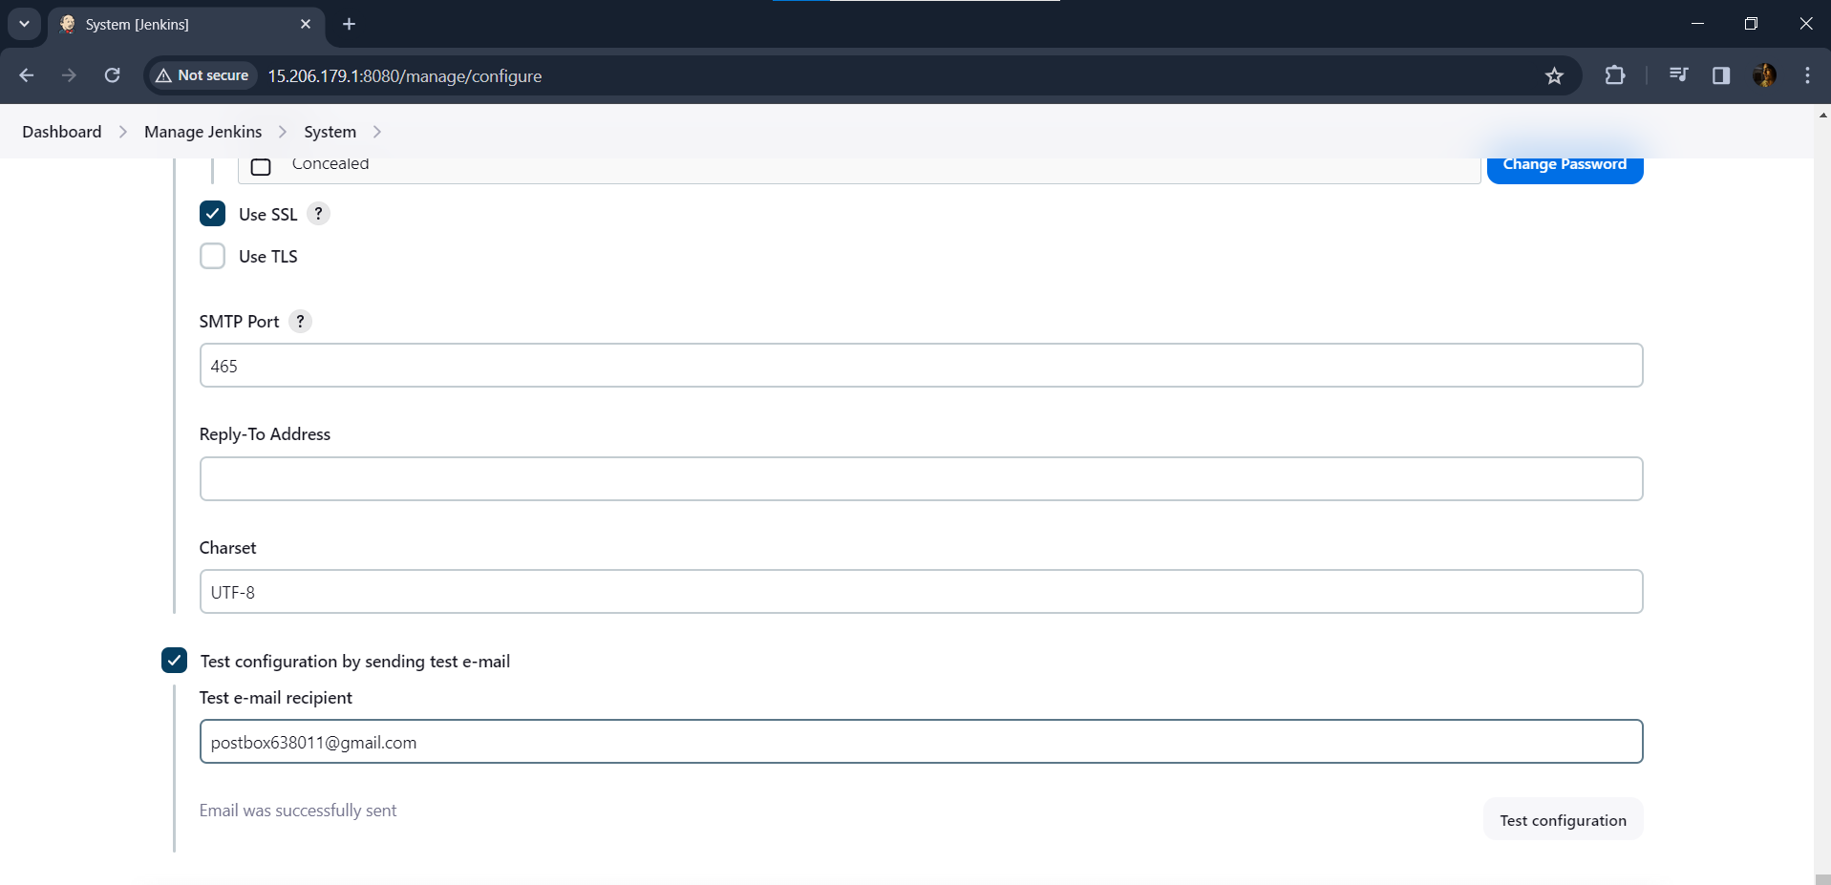

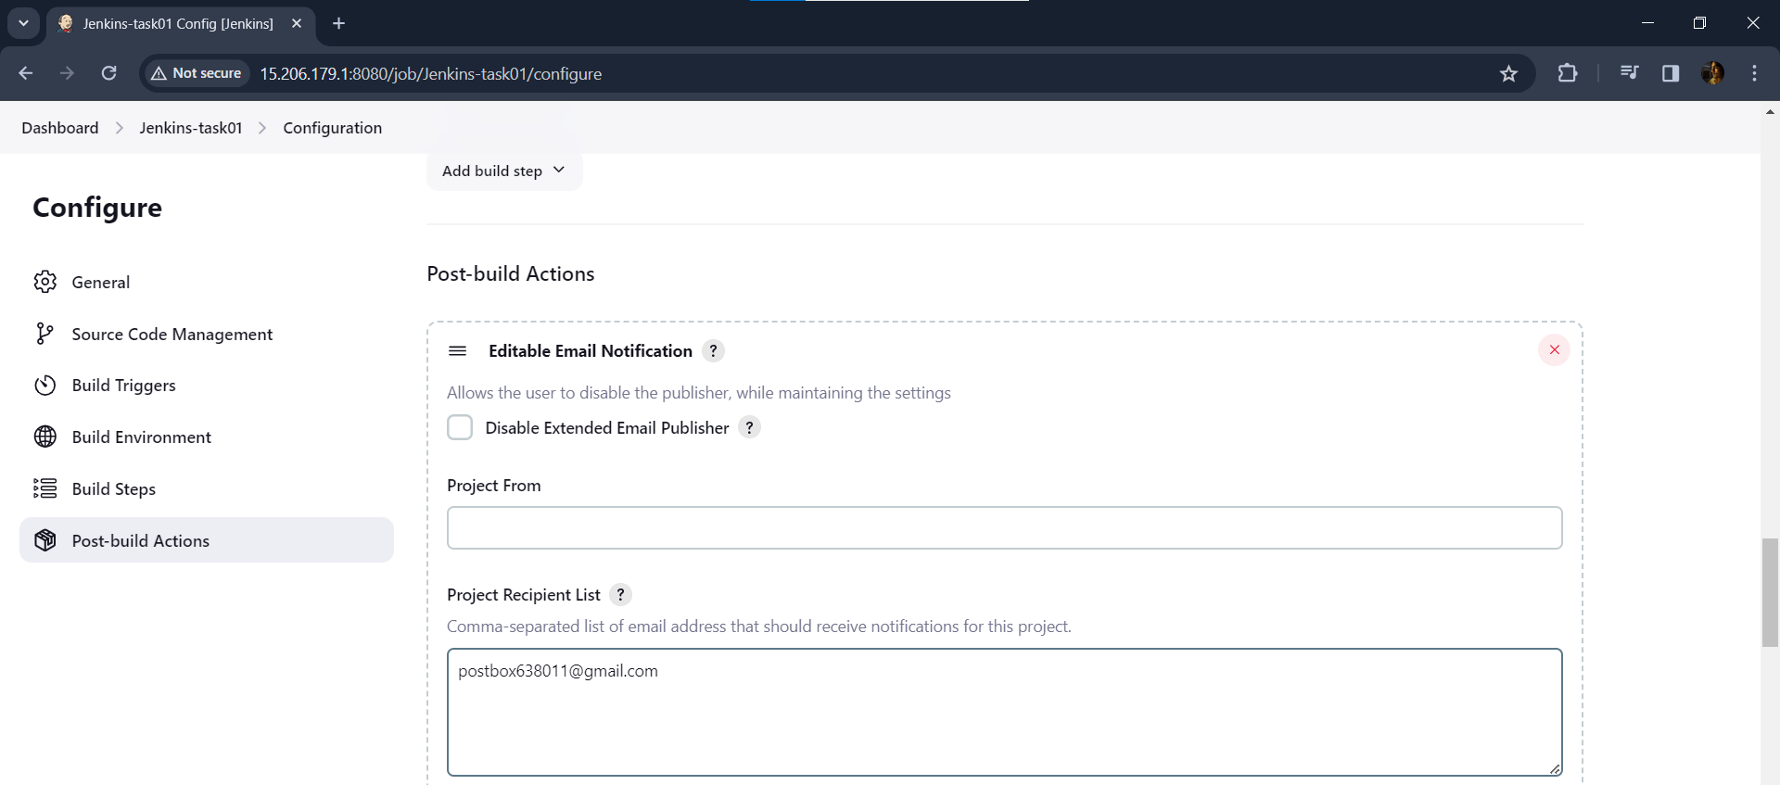

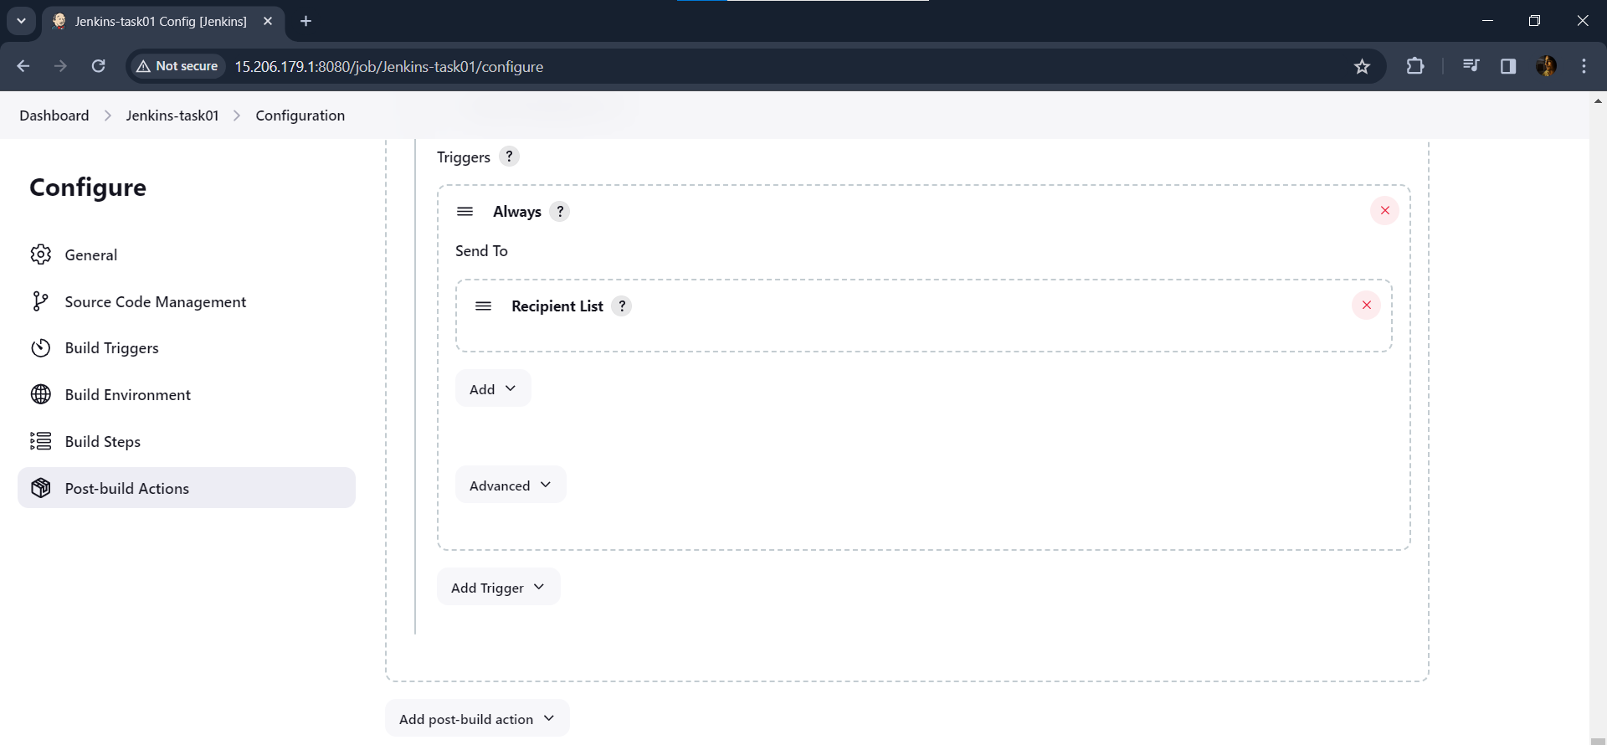

**When a commit is made to your repo, automatically build must get triggered from Jenkins**

**Git repo before commit:**

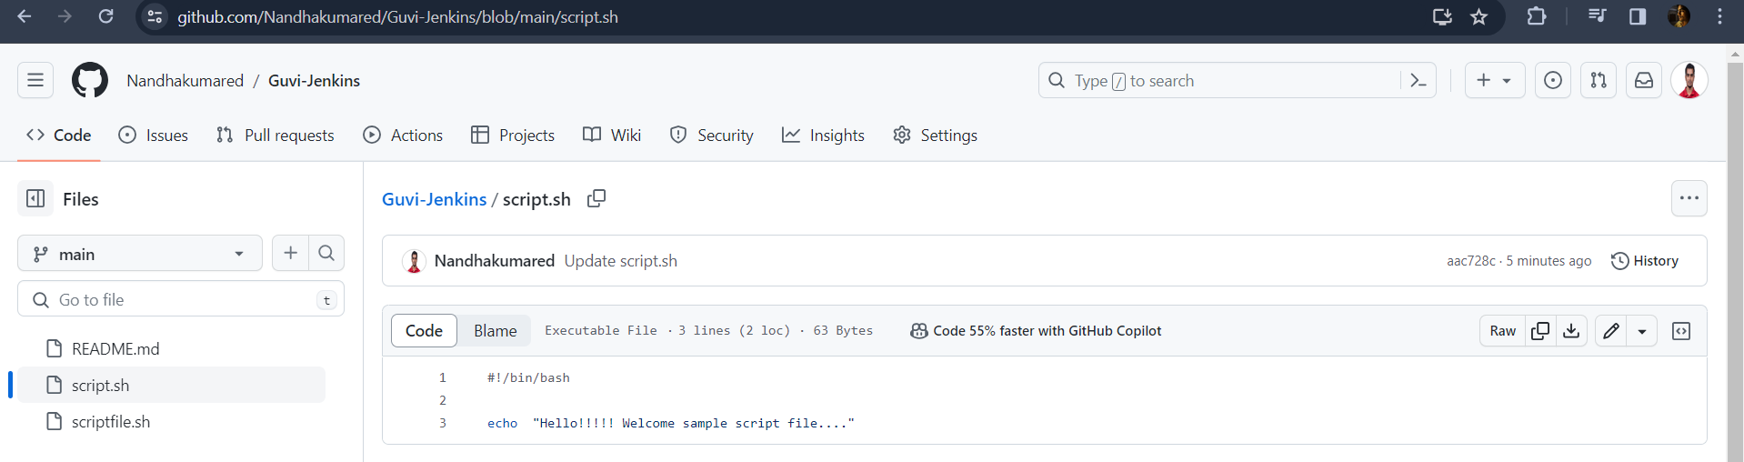

**Adding commit:**

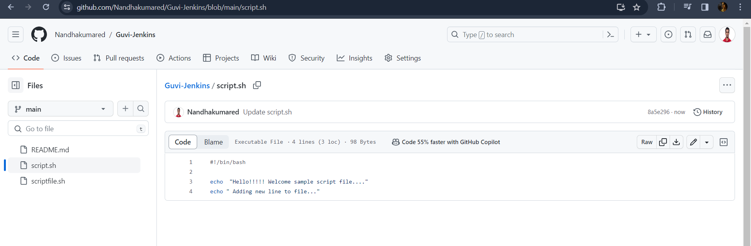

**Automatically build get triggered from Jenkins by webhook**

Webhook for auto trigger:

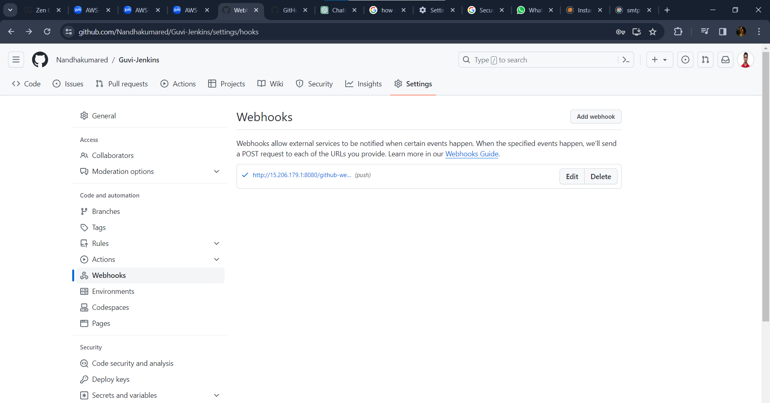

**The output shared via email**

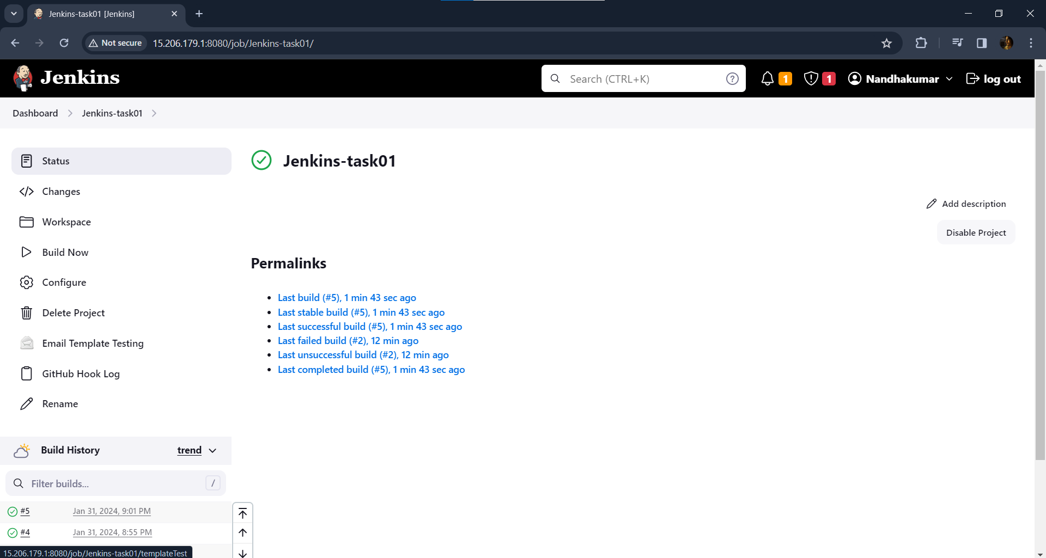

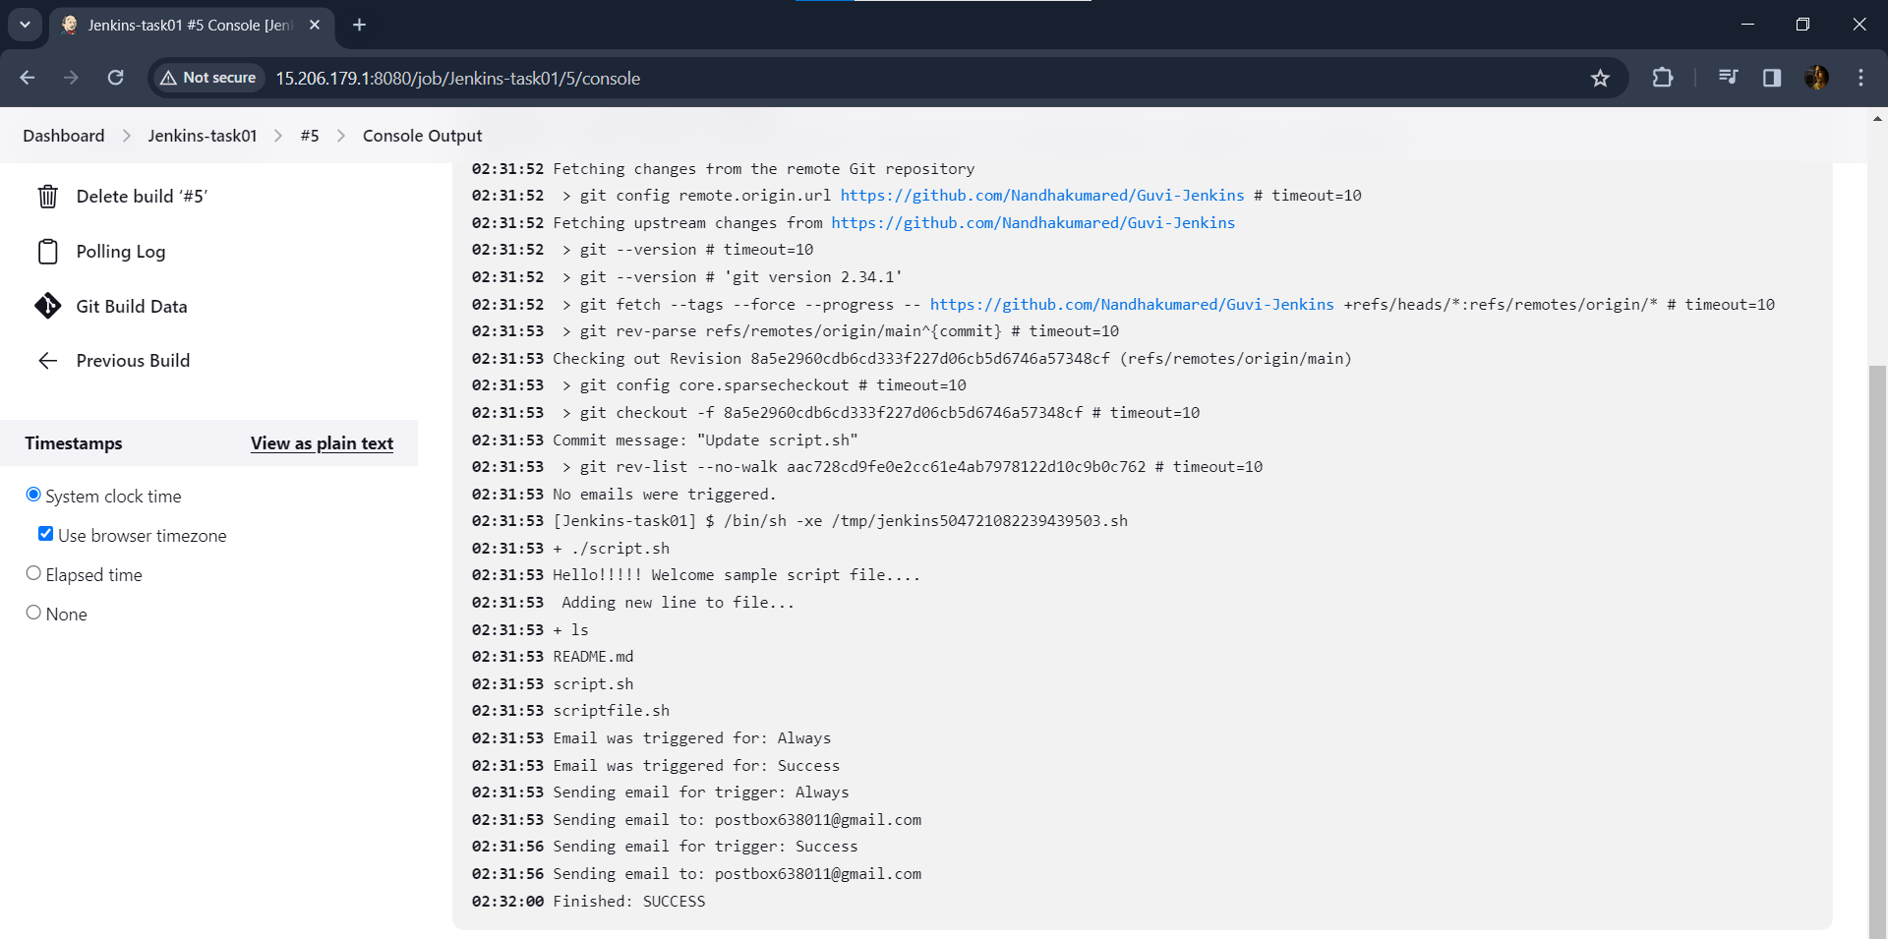

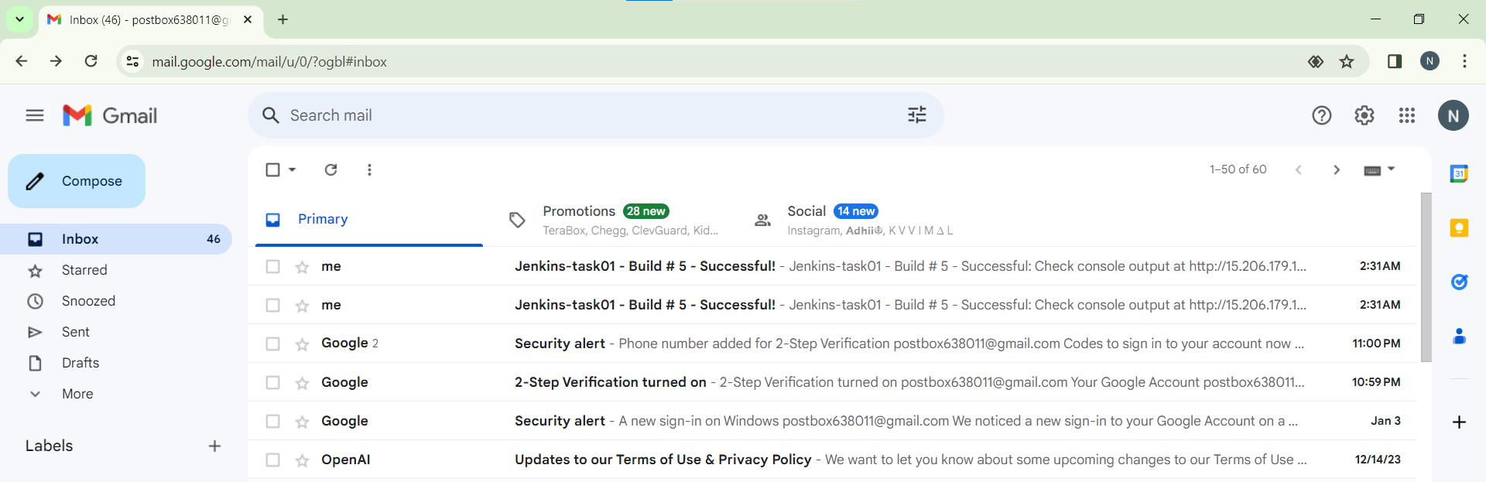

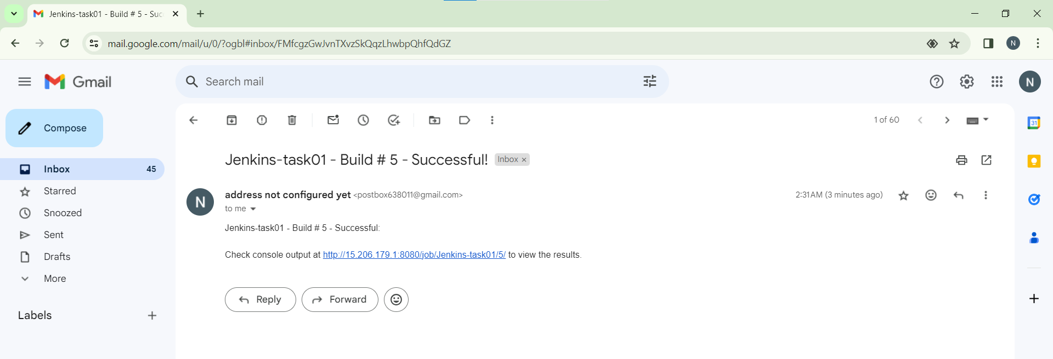

**Build running Successfully**

