**KUBERNETES TASK - 01**

**Setup minikube at your local and explore creating namespaces**

**Having Docker setup:**

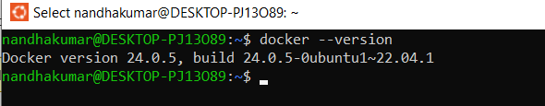

**Setting up minikube :**

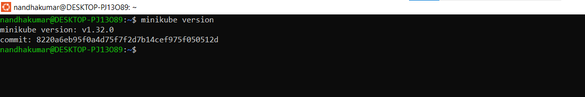

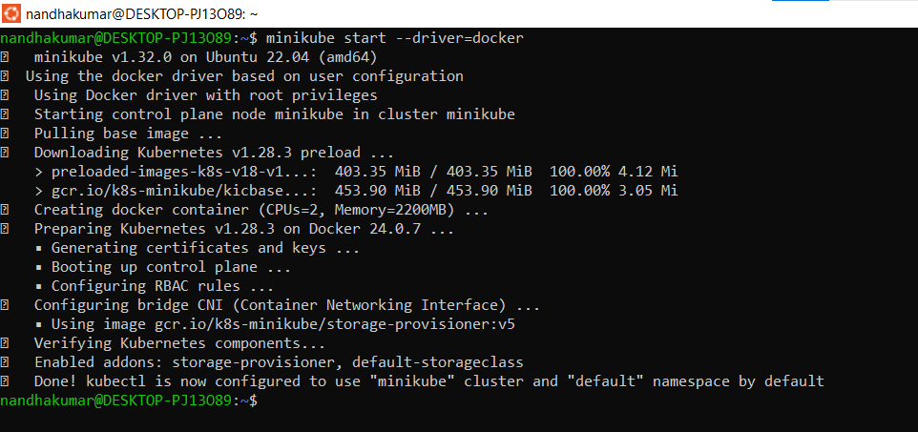

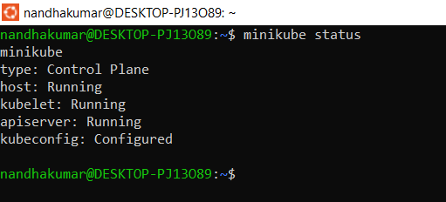

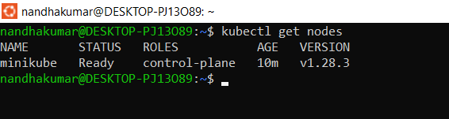

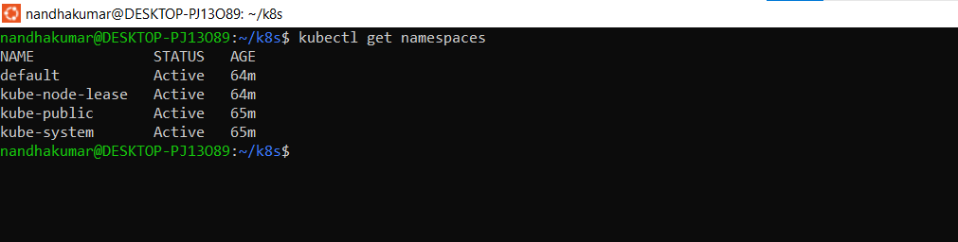

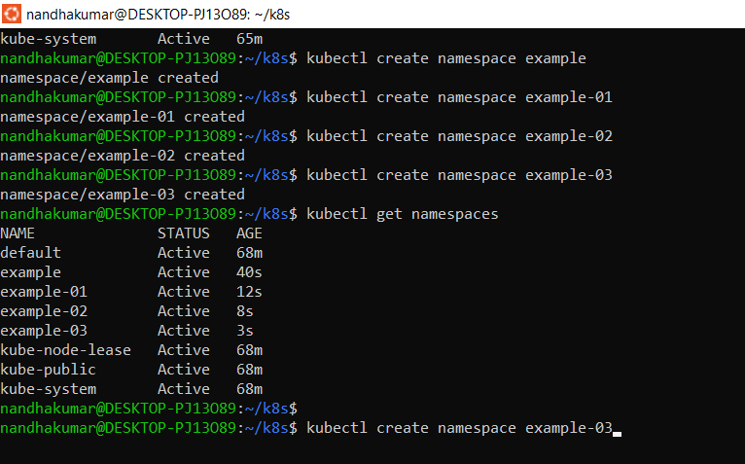

**Creating Pods in each namespace:**

