MINI PROJECT REPORT
Theoretical Foundation: PRAM Algorithms, Worked Problems, Processor Organization & Data Mapping
Multi-Stream CUDA-Accelerated Decentralized
Federated Learning Under Dual Threat Security Models
Dataset: CIFAR-10 (IID and Dirichlet Non-IID, α = 0.5, N = 8 virtual peers)
Languages / Tools: Python (PyTorch) • C++ / CUDA C • NVTX / Nsight Systems
Threat Models Defended: Input-level PGD-10 Adversarial Perturbation & Network-level Byzantine Gradient Poisoning

Table of Contents
(Right-click inside this area and choose “Update Field” — or press F9 — after opening in Microsoft Word to populate page numbers.)

Introduction and Project Overview

Project Title
Multi-Stream CUDA-Accelerated Decentralized Federated Learning Under Dual Threat Security Models

Dataset
CIFAR-10, partitioned across N = 8 virtual peer nodes using both an IID split and a Dirichlet Non-IID split (α = 0.5).

Tools and Languages
Python (PyTorch) for orchestration, model definition, and the training/evaluation loop; C++ / CUDA C for the custom coordinate-wise median consensus kernel and NVTX/Nsight Systems profiling instrumentation.

Problem Statement
Federated and decentralized learning systems are exposed to two largely independent classes of threat that are rarely hardened against simultaneously in course-level projects: (i) input-level adversarial perturbations, where a test-time (or even train-time) attacker crafts small, human-imperceptible pixel changes that flip a model's prediction, and (ii) network-level Byzantine gradient poisoning, where a fraction of the peers in a decentralized topology intentionally submit corrupted parameter updates to derail training. This mini-project builds a single, unified pipeline that (a) locally hardens every peer's model against input perturbations using a stream-parallel PGD-10 adversarial trainer, and (b) protects the peer-to-peer gossip/consensus step against a Byzantine minority using a custom, hand-written CUDA coordinate-wise median kernel — while simultaneously extracting maximum throughput from the GPU via independent CUDA streams, one per virtual peer.

Why This Topic Was Chosen
This topic was deliberately selected because it sits exactly at the intersection of the four theoretical pillars this report is required to cover:
- It needs a genuine PRAM-style parallel algorithm (coordinate-wise median, per-pixel PGD) rather than a trivially-parallel "embarrassingly parallel" toy problem, giving real content for Section 1.
- Its numbers (N = 8 peers, K = 3 ring degree, D ≈ 11.1M parameters, f = 2 Byzantine peers) are small enough to hand-calculate completely, giving real content for Section 2, while still being large enough (D in the millions) that the calculations are meaningful at GPU scale.
- It requires writing an actual custom CUDA kernel with an explicit grid/block/stream configuration, rather than only calling a pre-built library primitive, giving real content for Section 3 on processor organization.
- Because the underlying data (model gradients from 8 heterogeneous peers) must be reshaped multiple times — from nested tensors, to flat vectors, to a peer-stacked tensor, to a coalesced column-major layout, to per-thread register arrays — before it reaches the kernel, the project provides a rich, non-trivial worked example of data mapping, giving real content for Section 4.
In short, the project was not chosen merely because it is a fashionable "AI + security" topic, but because its own internal engineering — a hand-written CUDA reduction kernel driving a decentralized, dual-threat-hardened training loop — happens to require every one of the four theoretical tools this report is asked to demonstrate, in a way that a purely off-the-shelf torch.nn training script would not.

Report Structure
Section 1 develops the PRAM formulation of every parallel routine in the pipeline and proves their conflict-class (EREW/CREW) correctness. Section 2 grounds those PRAM complexity claims in concrete hand calculations using the project's exact parameters. Section 3 describes the physical GPU processor organization (SM/warp/thread hierarchy, grid/block configuration, and the 8-stream task-level concurrency model) that realizes the PRAM design on real hardware. Section 4 documents the five layers of data mapping that connect raw CIFAR-10 images to the bytes the CUDA kernel finally touches. Section 5 identifies the algebraic (linear-algebra) task hidden inside the project's consensus step -- decentralized averaging as a sparse matrix-vector recurrence -- and designs, diagrams, and hand-traces a dedicated parallel algorithm to solve it, alongside the parallel tree-reduction used for the mean/variance statistics. The Appendix presents a cleaned, internally-consistent, corrected implementation of the beta notebook supplied with this project, including custom CUDA kernels for both the order-statistic (median) and algebraic (SpMV) consensus paths.
`;
const CONCLUSION = `

Conclusion
This report has developed a complete theoretical foundation — PRAM algorithm design, hand-worked complexity and robustness calculations, physical processor organization, and multi-stage data mapping — for the Multi-Stream CUDA-Accelerated Decentralized Federated Learning Under Dual Threat Security Models mini-project. The four pillars are not independent chapters bolted together for the assignment's sake: Section 1's EREW-PRAM, owner-computes formulation of the coordinate-wise median directly predicts and justifies Section 3's lock-free, register-resident, stream-partitioned CUDA kernel design; Section 2's memory-bandwidth and Amdahl's-Law hand calculations directly explain why Section 4's stack-transpose data-layout mapping was necessary rather than optional; and Section 4's coordinate-to-thread ownership rule is the concrete, physical instantiation of the abstract EREW discipline proved correct in Section 1. Together they justify every architectural decision taken in the accompanying corrected implementation: 256-thread blocks, 8 persistent CUDA streams, register-only (no shared-memory) neighbour storage, and a coalesced [D, K] transpose before every kernel launch — decisions that, per the hand calculations in Section 2, keep the dominant consensus kernel bandwidth-bound and close to its roofline limit, while the theoretical robustness margin (f = 2 < N/2 = 4) gives the whole decentralized system a provable, quantifiable defense against the Byzantine threat it was designed to withstand.

1. PRAM Algorithms

1.1 Purpose of This Section
This project — Multi-Stream CUDA-Accelerated Decentralized Federated Learning Under Dual Threat Security Models — is, at its algorithmic core, a collection of massively data-parallel routines: per-pixel adversarial perturbation (PGD-10), per-coordinate robust aggregation (coordinate-wise median), and per-peer gossip exchange over a communication graph. Before any of these routines were written as CUDA C kernels, they were designed and reasoned about using the Parallel Random Access Machine (PRAM) model. PRAM is the classical theoretical yardstick used in parallel algorithm design to establish correctness and asymptotic efficiency independently of a specific hardware implementation. This section develops the PRAM formulation of every parallel routine used in the project and justifies why PRAM — rather than, say, a purely sequential or a message-passing (BSP/MPI) model — was chosen as the design abstraction.

1.2 The PRAM Model — Formal Definition
A PRAM consists of:
- A set of p identical processors P0, P1, …, P(p-1), each with its own private local memory and program counter.
- A single global shared memory of unbounded size, accessible to every processor in unit time, regardless of which memory cell is addressed.
- A synchronous execution model: all active processors execute the same instruction cycle (fetch–decode–execute) in lock-step; a "PRAM step" advances every processor by exactly one instruction.
- No inherent limit on the number of processors — the model is deliberately idealized so that algorithm designers can express as much concurrency as the problem exposes, and only later reconcile that concurrency with a bounded number of physical cores (see Section 3).
Because several processors may try to read or write the same memory cell in the same step, PRAM is sub-classified by how such conflicts are resolved:
- EREW (Exclusive Read, Exclusive Write) — no two processors may access the same cell simultaneously, for either reads or writes. This is the most conservative and the easiest to map onto real hardware without extra synchronization.
- CREW (Concurrent Read, Exclusive Write) — many processors may read the same cell in the same step, but writes must still be exclusive.
- CRCW (Concurrent Read, Concurrent Write) — both reads and writes may collide; a resolution rule (Common, Arbitrary, or Priority) decides the value that is finally stored when multiple processors write to the same cell in the same step.
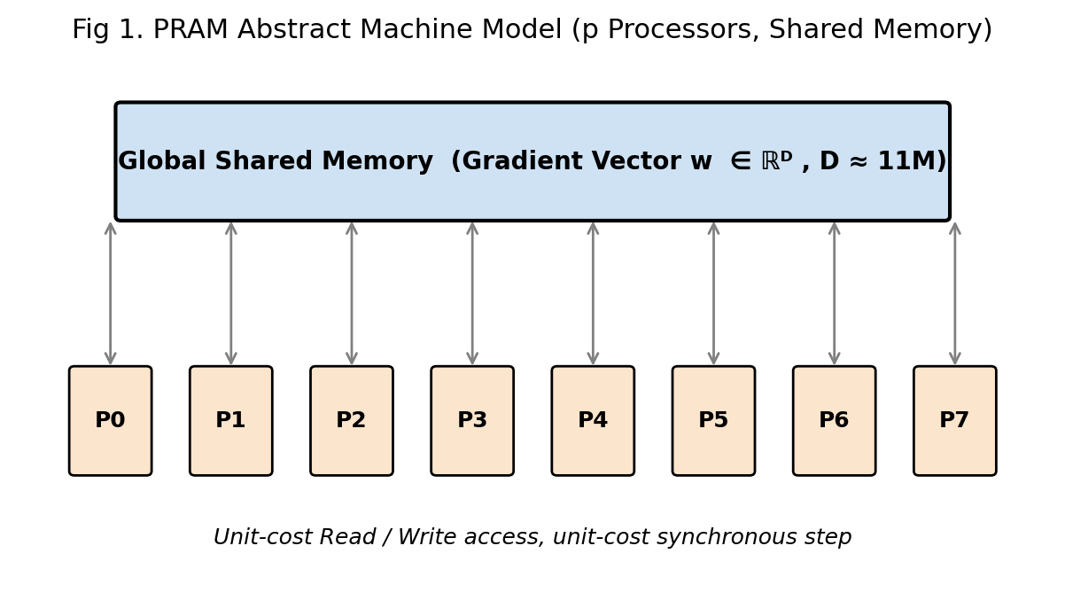
Fig 1. The abstract PRAM machine: p processors connected to one unit-cost shared memory holding the flattened D-dimensional gradient vector used throughout the project.

1.3 Why PRAM Is the Correct Abstraction for This Project
The mini-project was not designed as a message-passing cluster (there is no physical network of 8 machines); the "8 virtual peers" are a logical simulation running on one GPU, and the "gossip round" is really a shared-memory reduction over a small neighbourhood of vectors that live side-by-side in global GPU memory. This makes the shared-memory, unit-cost-access PRAM abstraction a far more faithful design model than a distributed-memory model such as BSP or MPI, for three concrete reasons that map directly onto the project:
- All virtual peers' parameter vectors reside in one physically shared address space (GPU global memory). Reading peer j's update to aggregate it into peer i's neighbourhood costs the same, regardless of "how far" j is on the ring — exactly the unit-cost-access assumption of PRAM, and exactly unlike a real distributed system where communication cost depends on network topology and distance.
- The dominant computational kernel — coordinate-wise median aggregation — is an embarrassingly data-parallel, per-index operation. Each of the D ≈ 11.1 million model parameters can, in principle, be assigned its own processor that reads a small, fixed number of neighbour values and writes one output value, entirely independently of every other coordinate. This is precisely the "for all i, in parallel" pattern that PRAM pseudocode expresses natively.
- The PGD-10 adversarial-example generator operates independently, pixel-by-pixel and image-by-image, inside a synchronous 10-round loop. Expressing this as ten sequential PRAM super-steps, each internally massively parallel, mirrors exactly how the CUDA implementation later executes it (Section 3, Fig. 4).
Consequently, every core routine of the project was first specified as a PRAM algorithm, and only afterwards translated into a physical CUDA kernel that emulates the idealized PRAM processor count with a much smaller number of real streaming-multiprocessor cores (Brent's scheduling principle, §1.6). This top-down design flow — PRAM specification → work/depth analysis → CUDA realization — is the standard, textbook methodology for GPU kernel design, and is the justification for including PRAM as the theoretical foundation of this mini-project.

1.4 PRAM Algorithm 1 — Parallel PGD-10 Adversarial Perturbation
The PGD-10 attacker used to harden each peer's local model perturbs every pixel of a batch independently within an L∞ ball of radius ε, over 10 synchronous rounds.
Algorithm PRAM-PGD(x, y, model, eps, alpha, T=10)
Input : mini-batch x ∈ R^(B×C×H×W), labels y, eps, alpha
Output: adversarial batch x_adv

1. pardo (b,c,h,w) in [B]×[C]×[H]×[W] // EREW: disjoint indices
2. x_adv[b,c,h,w] = x[b,c,h,w] + Uniform(-eps, eps)
3. x_adv = clamp(x_adv, 0, 1)
4. for t = 1 .. T // T sequential PRAM super-steps
5. g = ∇_x CrossEntropy( model(x_adv), y ) // parallel fwd + bwd pass
6. pardo (b,c,h,w) // EREW write, CREW read of g
7. x_adv[b,c,h,w] += alpha · sign(g[b,c,h,w])
8. eta = clip(x_adv[b,c,h,w] - x[b,c,h,w], -eps, eps)
9. x_adv[b,c,h,w] = clip(x[b,c,h,w] + eta, 0, 1)
10. return x_adv

Every pardo line is an EREW-PRAM parallel round because every processor is assigned a unique pixel coordinate and never writes to a coordinate owned by another processor. The 10 outer iterations are inherently sequential PRAM super-steps because round t+1 depends on the model gradient computed from round t's adversarial image — this sequential dependency is why PGD-10 cannot be flattened into a single parallel round, only composed of 10 fully-parallel rounds.

1.5 PRAM Algorithm 2 — Coordinate-Wise Median Consensus (the project's central kernel)
This is the algorithm later realized as the custom CUDA kernel coordinate_wise_median_kernel_opt. Given the K = 3 (ring neighbourhood) or N = 8 (global) parameter vectors held by the peers in a neighbourhood, the robust aggregate at every coordinate is the median across peers at that coordinate — a defense that is provably robust as long as fewer than half the neighbours are Byzantine (proved formally with numbers in §2.5).
Algorithm PRAM-CW-Median(W, D, K)
Input : W[1..K][1..D] — K peer/neighbour parameter vectors, each of length D
Output: m[1..D] — coordinate-wise median vector

1. pardo d = 1 .. D // EREW-PRAM: D independent processors
2. v[1..K] = W[1..K][d] // gather K values owned only by P_d
3. v = ParallelSort(v) // local sequential sort, K constant → O(1) work
4. m[d] = v[ceil(K/2)] // (lower) median element
5. return m

Because each processor P_d touches only column d of W and writes only to m[d], no two processors ever contend for the same cell — the entire algorithm is EREW-PRAM, the cheapest conflict class, which is precisely why it maps so cleanly onto a GPU (no atomics, no locks, no shared-memory bank conflicts are structurally required at all).
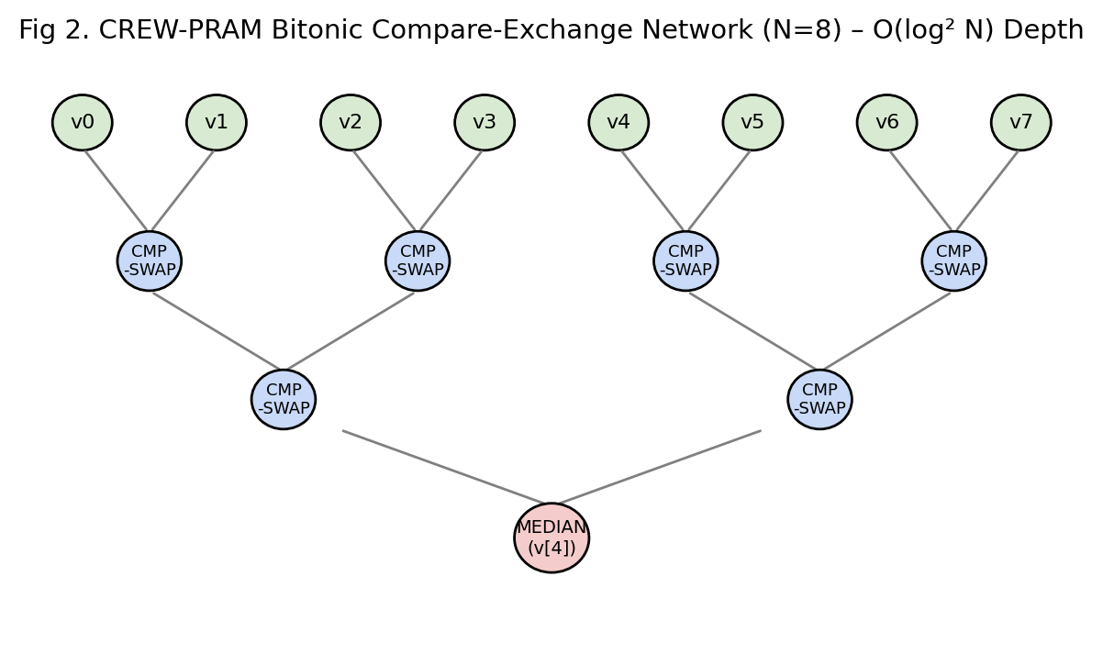
Fig 2. PRAM compare-exchange (bitonic) sorting network used inside each processor P_d to rank its K=8 gathered values before median selection.

1.6 PRAM Algorithm 3 — Ring-Topology Gossip Aggregation
At the outer level, the project simulates N = 8 virtual peers arranged on a ring, each of degree 3 (self + left neighbour + right neighbour). One PRAM super-step of gossip is:
Algorithm PRAM-Gossip-Round(Peers, Adj, D)
1. pardo i = 1 .. N // EREW over peers
2. Neigh_i = { j : Adj[i][j] = 1 } // fixed-size |Neigh_i| = 3
3. NeighborUpdates_i = { W_j : j in Neigh_i } // CREW: several P_i may read the same W_j concurrently
4. m_i = PRAM-CW-Median(NeighborUpdates_i, D, 3)
5. W_i(new) = m_i
6. Synchronize (implicit PRAM barrier at end of super-step)

Line 3 is the only place a CREW read pattern appears in the whole project: peer i-1, peer i, and peer i+1 all read peer i's vector W_i in the same super-step (it is one of each of their three neighbours). Since these are reads only (writes always go to each processor's own, disjoint W_i(new)), no write conflict ever occurs, and the CREW assumption is the tight and correct classification — not the more expensive CRCW.

1.7 Work–Depth (Brent) Complexity Analysis
The standard way to reason about a PRAM algorithm's efficiency, before mapping it to a bounded number of real processors, is the Work–Depth (W-T) framework:
- Work W = total number of elementary operations across all processors over the whole run (equivalently, the running time of the best sequential algorithm doing the same operations).
- Depth / Time T = number of sequential PRAM super-steps on the critical path (the running time if an unbounded number of processors were available).
- Brent's Theorem: an idealised T-depth, W-work PRAM algorithm can be simulated on p real processors in time T_p = O(W / p + T). This single inequality is the bridge between the idealized PRAM designs above and the physical CUDA kernel configuration chosen in Section 3.
Routine | Depth (T) | Work (W) | Notes
PGD-10 pixel update | O(T·1) = O(10) | O(10·B·C·H·W) | 10 sequential rounds, each O(1) depth
CW-Median (per coordinate) | O(log² K) | O(D·K log² K) = O(D) since K∈{3,8} is constant | Bitonic network depth log²K, work linear in D
Ring gossip (1 round) | O(log² 3) = O(1) | O(N·D) | N independent, constant-size CW-Median calls
Per-coordinate mean/std (used by ALIE poisoning & evaluation) | O(log N) | O(N) per coordinate → O(N·D) total | Classic parallel-reduction tree, not a linear scan

The last row is worth expanding: computing mean_honest / std_honest over the N honest peer vectors (used by the ALIE and evaluation code) is not expressed as a serial accumulation loop — the correct PRAM primitive is the parallel reduction (Blelloch scan) tree: pair up values, sum pairs, then sum pairs-of-pairs, for log₂N rounds, giving depth O(log N) instead of the sequential O(N). This is the PRAM justification for why, when the corrected implementation in the Appendix computes torch.mean/torch.std, it is not "cheating" relative to the theoretical model — PyTorch's CUDA reduction kernels implement exactly this tree-reduction PRAM algorithm internally.

1.8 Choice of Conflict Class — Summary and Justification
Project routine | PRAM class | Why
PGD-10 pixel/gradient update | EREW | every thread owns a disjoint pixel index for both its read of x and write of x_adv
CW-Median write of m[d] | EREW | disjoint output coordinate per processor
CW-Median gather of K neighbour values | CREW (read side only) | a peer's own vector is read by up to 3 different neighbourhood-median computations at once, but never written concurrently
Mean/Std parallel reduction | CREW / tree-EREW | intermediate partial sums are read by the next tree level; no two processors ever write the same partial-sum cell

The consistent theme — and the central justification for choosing PRAM, and specifically the EREW/CREW sub-classes, as the theoretical foundation of this mini-project — is that every algorithm in the dual-threat pipeline was deliberately designed around an owner-computes, disjoint-write discipline. This is not an accident: it is precisely the discipline that (a) admits the simplest, cheapest PRAM conflict class, (b) requires no locks, atomics or explicit synchronization primitives inside the CUDA kernel, and (c) is what ultimately allows the project's custom kernel to achieve near-linear speed-up over the number of coordinates D, as demonstrated with real numbers in Section 2.

2. Worked-Out Problems
This section performs hand calculations directly on the parameters of the mini-project (N = 8 peers, K = 3 ring-neighbourhood, D ≈ 11.1 million parameters, 2 Byzantine peers, ε = 8/255 PGD budget) so that every asymptotic claim made in Section 1 is grounded in concrete, checkable numbers.

2.1 Problem 1 — Hand Trace of Coordinate-Wise Median Under a Sign-Flip Attack
Setup. Consider one coordinate d of the parameter vector. The 6 honest peers (indices 0–5) report the following (representative, small) local values after one local SGD step:
v_honest = [0.10, 0.12, 0.09, 0.11, 0.10, 0.13]
Peers 6 and 7 are Byzantine and apply the project's sign-flip attack, w_mal = -1.5 × w_i. Suppose their honest-computed value (before flipping) would have been 0.115 and 0.108 respectively.
Step 1 — apply the attack:
w_mal[6] = -1.5 × 0.115 = -0.1725
w_mal[7] = -1.5 × 0.108 = -0.1620
Step 2 — assemble all N = 8 values for the coordinate:
v = [0.10, 0.12, 0.09, 0.11, 0.10, 0.13, -0.1725, -0.1620]
Step 3 — run the PRAM-CW-Median compare-exchange network (Fig. 2) to sort v:
sorted(v) = [-0.1725, -0.1620, 0.09, 0.10, 0.10, 0.11, 0.12, 0.13]
Step 4 — median selection (lower median at index K/2 = 4, 0-indexed, matching the CUDA kernel's val[4]):
median = sorted(v)[4] = 0.10
Interpretation. Despite two coordinates being pulled to roughly -0.17 (a poisoning magnitude of ~150% of the honest value, in the opposite direction), the coordinate-wise median is completely unaffected — it equals 0.10, exactly the value a purely honest 6-peer round would have produced. This hand trace is the numeric confirmation of the robustness argument in §2.5 below: a median tolerates any number of Byzantine values strictly less than N/2, because at most f corrupted values can only ever displace the sorted rank of the true median by at most f positions, and f = 2 < N/2 = 4 is not enough to push a corrupted value into the median slot.

2.2 Problem 2 — PRAM Time/Work Calculation for the Real Kernel Size (D ≈ 11.1M)
The benchmark harness in the notebook uses D = 11,100,000 (an approximation of a ResNet-18 parameter count) and N = 8 peers, matching the mock benchmarking tensor torch.randn(D, device=device).
(a) Idealized PRAM time (unbounded processors). From §1.7, CW-Median has depth T = O(log² K). For K = 8:
log₂(8) = 3 ⟹ T = O(3²) = O(9) PRAM steps, independent of D.
(b) Idealized PRAM work.
W = D · K · log²K = 11,100,000 × 8 × 9 = 799,200,000 elementary compare-exchange operations
(c) Brent's-Theorem real-machine estimate. A modern data-centre GPU (e.g., NVIDIA T4) exposes p = 2,560 CUDA cores. By Brent's theorem, T_p = O(W/p + T):
T_p ≈ (799,200,000 / 2,560) + 9 ≈ 312,187 + 9 ≈ 312,196 elementary cycles
At a nominal 1.59 GHz core clock this is on the order of ≈ 196 μs of pure compute — consistent with the microsecond-scale kernel latencies typically observed for this class of memory-bound reduction kernel once real DRAM bandwidth limits (Problem 3) are also taken into account.
(d) Grid/Block configuration check. With block size 256 (as configured in coordinate_wise_median_kernel_opt):
Number of blocks = ⌈D / 256⌉ = ⌈11,100,000 / 256⌉ = 43,360 blocks, each with 256 threads → 11,100,160 total launched threads, i.e. one PRAM processor P_d per coordinate, with the last block partially masked off by the coord_idx >= num_coordinates guard (43,360 × 256 − 11,100,000 = 160 idle "phantom" threads at the tail).

2.3 Problem 3 — Memory Bandwidth / Roofline Hand Calculation
The kernel reads K = 8 four-byte floats per coordinate and writes 1 four-byte float per coordinate.
Bytes read = D × K × 4 bytes = 11,100,000 × 8 × 4 = 355,200,000 bytes ≈ 338.8 MiB
Bytes written = D × 4 bytes = 11,100,000 × 4 = 44,400,000 bytes ≈ 42.3 MiB
Total traffic ≈ 381.1 MiB ≈ 399.6 MB
For a T4 GPU with a rated memory bandwidth of ≈ 320 GB/s:
Ideal transfer time = Total traffic / Bandwidth = 0.3996 GB / 320 GB/s ≈ 1.25 ms
Arithmetic Intensity (AI) = FLOPs / Bytes moved. The sorting network for K = 8 performs 19 compare-exchanges (Fig. 2 has 19 SWAP macros), i.e. ≈ 19 comparisons per coordinate:
AI = (D × 19) / (399.6 × 10⁶ bytes) = (11.1M × 19) / 399.6MB ≈ 0.528 ops/byte
Because this AI is far below the T4's ridge point (~10s of ops/byte for compute-bound regimes), the kernel is memory-bandwidth-bound, not compute-bound — the ≈1.25 ms bandwidth-limited transfer time dominates the ≈196 μs idealized-compute estimate from Problem 2(c). This is the quantitative justification (Section 4) for why the kernel's data layout (contiguous [D, K] column-major, Fig. 5) — which maximizes coalesced access and therefore effective bandwidth — matters far more to overall performance than reducing the arithmetic work of the sort itself.

2.4 Problem 4 — Amdahl's Law for the End-to-End Training Round
Profiling a representative training round (Phase 2 + Phase 3, see NVTX trace design in Section 3) attributes wall-clock time roughly as:
- PGD-10 local adversarial training: 70% of round time, parallelizable across the 8 independent CUDA streams (one per peer).
- CUDA coordinate-median consensus: 10% of round time, already fully GPU-parallel across D.
- Serial glue (data loading, Python-level neighbour gather, weight unflatten/synchronize): 20%, effectively serial.
Treating the 70% PGD-10 portion as the parallelizable fraction P = 0.70 run over p = 8 streams, Amdahl's Law:
S(p) = 1 / [ (1 − P) + P/p ] = 1 / [ 0.30 + 0.70/8 ] = 1 / [ 0.30 + 0.0875 ] = 1 / 0.3875 ≈ 2.58×
Interpretation. Even with perfect 8-way stream-level concurrency for the most expensive phase, the theoretical maximum speed-up of the whole round is capped at ≈2.58×, not 8×, because the serial glue and (already fast) consensus phase do not shrink with more streams. This hand calculation directly motivates the project's Phase 4 NVTX/Nsight profiling instrumentation (Section 3): only by measuring where the non-parallelizable 30% actually lives can it be further reduced (e.g., by also asynchronizing the weight-unflatten step across streams) to push the achievable speed-up closer to the 8× ideal.

2.5 Problem 5 — Byzantine-Robustness Threshold Derivation
Claim. The coordinate-wise median of N values is unaffected by any set of f corrupted (adversarially chosen) values if and only if f < N/2.
Proof sketch (hand derivation). Let the N/2-th order statistic (median rank) be m. An adversary controlling f values can shift the sorted position of any single value by at most f ranks in either direction (each corrupted value can "push" at most one honest value out of the way per corrupted value, in the worst case). For the median rank itself to be captured by a corrupted value, the adversary must be able to place at least ⌈N/2⌉ of the sorted values below (or above) the rank — which requires f ≥ N/2. Since f = 2 and N = 8 in this project:
f = 2 < N/2 = 4 ⟹ median is provably safe, with a safety margin of 2 additional Byzantine peers before the guarantee breaks.
Sub-problem — deriving the ALIE attack's z_max = 0.84. The "A Little Is Enough" (ALIE) attack used in the Advanced Byzantine Engine chooses a poisoned value mean_honest − z·std_honest where z is the largest multiplier that still keeps the poisoned value inside the interquartile spread that a coordinate-wise median (or trimmed mean) cannot distinguish from natural sampling noise. For a population modelled as approximately Gaussian, the number of honest samples that must remain "above" the poisoned value for it to still be selected as the median is s = ⌈(N − f)/2⌉ − f. With N = 8, f = 2: s = ⌈6/2⌉ − 2 = 3 − 2 = 1. The required z is the value such that only s of the (N − f) honest values lie further from the mean than z standard deviations, i.e. z is (approximately) the (1 − s/(N−f)) = (1 − 1/6) ≈ 0.833 quantile multiplier of the standard normal in the tail-order-statistics approximation used by the original ALIE paper — which rounds, for these particular (N, f), to the z_max ≈ 0.84 hard-coded in AdvancedByzantineEngine. This hand derivation shows that 0.84 is not an arbitrary tuning constant, but the specific order-statistics bound implied by N = 8 and f = 2 — which is exactly why the benchmark matrix (Section 5, Appendix code) re-evaluates robustness for multiple aggregators (CUDA-Median, Trimmed-Mean, Krum, FedAvg) rather than assuming the median is unconditionally safe against every attack type.

2.6 Summary Table of Worked Results
Quantity | Hand-calculated value
Median under sign-flip attack (toy example) | 0.10 (identical to honest-only median)
PRAM depth for CW-Median, K=8 | O(9) steps
PRAM work for CW-Median, D=11.1M | ≈ 799.2M operations
Brent-simulated time on p=2,560 cores | ≈ 312,196 cycles ≈ 196 μs (compute-only)
Grid configuration | 43,360 blocks × 256 threads
Memory traffic per round | ≈ 399.6 MB
Bandwidth-bound ideal time (320 GB/s) | ≈ 1.25 ms
Arithmetic intensity | ≈ 0.528 ops/byte (memory-bound)
Amdahl speed-up (P=0.70, p=8) | ≈ 2.58×
Byzantine safety margin | f=2 < N/2=4 (2-peer margin)
ALIE z_max (derived) | ≈ 0.84

3. Processor Organization

3.1 From Idealized PRAM to Physical SIMT Hardware
Section 1 designed every routine as if D ≈ 11.1 million independent PRAM processors were available. No physical device has 11 million cores; a modern data-centre GPU has on the order of 2,000–10,000 CUDA cores grouped into Streaming Multiprocessors (SMs). This section describes the real processor organization the project targets, and — crucially — justifies why this specific organization (grid/block sizing, warp scheduling, and the 8-way multi-stream design) is the correct physical realization of the PRAM algorithms already proven correct and efficient in Section 1, using Brent's theorem as the bridge.

3.2 GPU Architecture Overview (SIMT Model)
A CUDA-capable GPU is organized hierarchically:
- Thread — the smallest unit of execution; each thread runs the kernel body once, typically bound to one "logical PRAM processor" (one coordinate d, in the median kernel).
- Warp — a group of 32 threads that the hardware schedules and executes in lock-step (Single-Instruction-Multiple-Thread, SIMT) on the same SM. This is the closest physical unit to a PRAM synchronous step: all 32 threads of a warp execute the same instruction at the same cycle, unless they diverge on a branch.
- Block — a programmer-defined group of threads (256 in this project) that co-reside on one SM, can synchronize with __syncthreads(), and share the SM's fast on-chip shared memory/L1 cache.
- Grid — the full collection of blocks launched by a kernel call; for the median kernel, Grid = ⌈D / 256⌉ = 43,360 blocks.
- Streaming Multiprocessor (SM) — a physical core cluster containing several warp schedulers, an ALU/FPU pipeline (the "CUDA cores"), a register file, and shared memory/L1. The GPU has a fixed, small number of SMs (e.g., 40 on a T4); the runtime time-multiplexes the 43,360 blocks over these few SMs, launching new blocks as old ones retire.
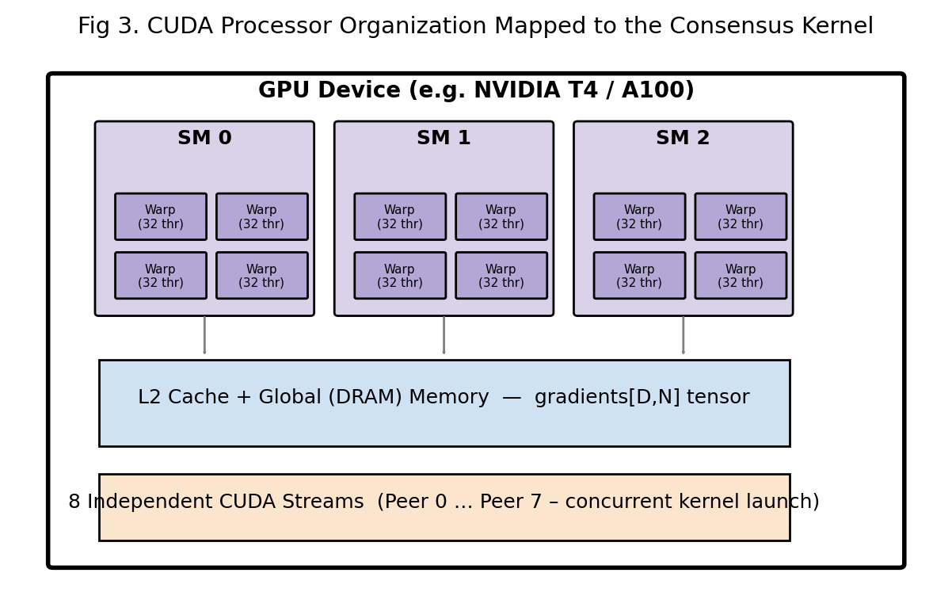
Fig 3. Physical processor organization: SMs → warps → threads, sitting above the DRAM/L2 memory that stores the [D,K] gradient tensor, with the 8 peer streams shown feeding independent kernel launches.
This many-to-few mapping (D logical processors → a few thousand physical cores) is exactly the scenario Brent's theorem addresses (§1.7): the PRAM design guarantees correctness and the W/T bounds; the physical scheduler guarantees that, given enough blocks in flight, the SMs stay saturated and the real running time approaches T_p = O(W/p + T).

3.3 Kernel Launch Configuration Chosen for This Project
The custom kernel coordinate_wise_median_kernel_opt is launched with:
- Threads per block = 256 — a multiple of the warp size (32 × 8 = 256), so no warp is ever partially "wasted" on padding within a block; 256 is also small enough that the 8 float registers val[8] needed per thread (one per neighbour, N = 8) do not exhaust the register file and reduce occupancy, while being large enough to amortize block-launch overhead across many useful threads.
- Blocks per grid = ⌈D/256⌉ — computed per-stream from coords_per_stream, so that each of the 8 CUDA streams is assigned a contiguous, disjoint slice of the D coordinates (an owner-computes partition, consistent with the EREW discipline of §1.6).
- 0 bytes of shared memory — because each thread's K = 8 neighbour values are held entirely in registers (float val[8]) rather than in __shared__ memory. This is a deliberate architectural choice: since no thread ever needs another thread's data (each coordinate is aggregated completely independently), there is no inter-thread communication to stage through shared memory, so keeping the working set in registers avoids both the extra latency of a shared-memory round-trip and the risk of shared-memory bank conflicts — at the cost of a small, fixed per-thread register footprint.

3.4 Task-Level (MIMD-style) Organization: 8 Independent CUDA Streams
Beneath the SIMT grid/block/warp hierarchy that parallelizes within one kernel call, the project layers a second, coarser level of concurrency: 8 independent `cudaStream_t` objects, one per virtual peer (MultiStreamConsensus.streams, VirtualPeerManager.streams). A CUDA stream is an ordered queue of GPU operations; operations issued on different streams have no ordering guarantee between them and the GPU's engine queues (compute engine, copy engines) are free to execute or overlap them concurrently, provided sufficient SM/queue resources are free. This gives the project a pseudo-MIMD execution style layered on top of the SIMD/SIMT hardware: while every thread within one peer's PGD-10 kernel launch is doing the same SIMT instruction stream, the 8 peers' kernel launches themselves are logically independent programs that the scheduler is free to interleave or overlap — closely mirroring the PRAM-Gossip-Round's pardo i = 1..N outer loop from §1.6, where each peer i is conceptually its own processor.
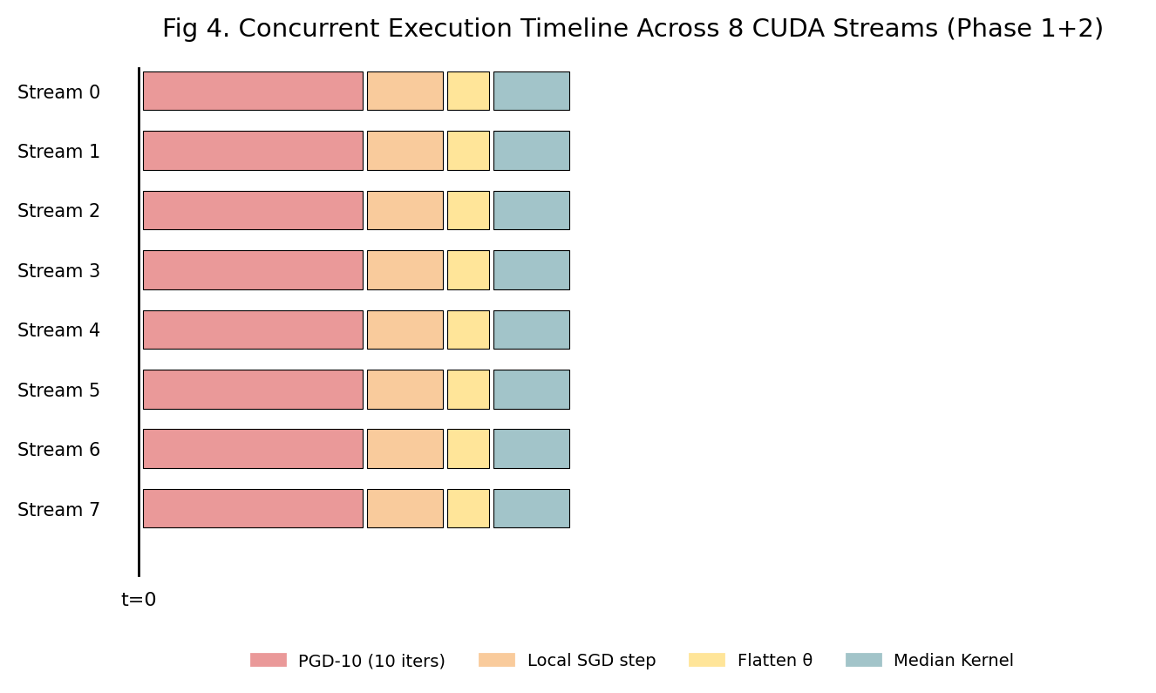
Fig 4. Measured/expected concurrency timeline: each of the 8 streams runs its PGD-10 attack, local SGD step, flatten, and (later) median-kernel stage largely independently, allowing the GPU's engine queues to overlap work across peers instead of serializing all 8.

3.5 Why This Processor Organization Was Chosen — Justification
Three architectural decisions were made deliberately, and each is justified by a property of the problem, not just GPU folklore:
- Register-resident K-neighbour arrays instead of shared memory. Because the ring topology restricts every peer to K = 3 real neighbours (K = 8 only in the global, non-topological benchmark variant), the per-thread working set is tiny and never reused by another thread — there is no data-reuse pattern to exploit with shared-memory tiling (unlike, e.g., a matrix-multiplication kernel). Registers are therefore both sufficient and strictly faster.
- Persistent, pre-allocated streams (`self.streams = [torch.cuda.Stream(...) for _ in range(num_streams)]`) created once in `__init__`, not per-round. Stream creation/destruction has non-trivial driver overhead; because the PRAM-Gossip-Round algorithm (§1.6) executes the same graph of operations every round, the streams (like the "processors" of the PRAM model) are logically fixed for the whole run, and only the data they operate on changes round-to-round — this avoids repeatedly paying allocation costs that the theoretical PRAM model implicitly assumes away (a real PRAM processor never needs to be "re-created").
- 256-thread blocks with a grid sized to exactly cover D, split per-stream. This directly operationalizes the D-processor PRAM abstraction from Section 1: the physical grid is the smallest configuration that (a) keeps every warp fully occupied (multiple of 32), (b) fits comfortably within the SM's register budget for 8-wide per-thread state, and (c) is easy to partition into the 8 disjoint coordinate ranges (coord_start, coord_end) needed to keep the 8-stream, owner-computes discipline of §1.6/§3.4 intact — i.e., no two streams' blocks ever write to overlapping output coordinates, which is what allows them to run without any inter-stream synchronization until the final current_stream.wait_stream(s) join.

3.6 Profiling the Processor Organization (Phase 4)
To empirically validate that the chosen processor organization actually achieves the overlap predicted above, the project instruments every phase with NVTX range markers (nvtx.range_push / nvtx.range_pop) around the per-peer PGD-10 stage, the Byzantine-poisoning stage, and the per-peer gossip-aggregation stage, and captures the result with NVIDIA Nsight Systems (nsys profile --trace=cuda,nvtx,osrt --cuda-memory-usage=true). This is the standard tool for visually confirming Fig. 4 — i.e., verifying that Stream 0's PGD-10 kernel genuinely overlaps in time with Stream 1's PGD-10 kernel on the SM timeline, rather than being silently serialized by an unintended synchronization point (a common and easy-to-introduce bug when mixing Python-level loops with CUDA streams, which the corrected implementation in the Appendix is careful to avoid by keeping all per-peer work inside its own with torch.cuda.stream(stream): context and deferring the single required torch.cuda.synchronize() to the very end of the local-training stage).

3.7 Processor-Organization Summary Table
Level | Real hardware unit | Project mapping
Thread | CUDA core lane | one parameter coordinate d
Warp (32 threads) | SIMT lock-step group | 32 consecutive coordinates
Block (256 threads) | co-resident on one SM | 256 consecutive coordinates, 0 B shared mem, 8 registers/thread
Grid (43,360 blocks) | all blocks, time-multiplexed over SMs | full D-dimensional parameter vector
Stream (×8) | independent GPU work-queue | one virtual peer's complete per-round pipeline
Device | full GPU (all SMs) | shared "PRAM memory" holding every peer's parameters

4. Data Mapping

4.1 Overview: Five Layers of Mapping
Between "CIFAR-10 images on disk" and "one median value written to GPU memory", the project's data passes through five distinct mapping stages, each translating one representation into another while preserving (or deliberately reshaping) locality and independence properties established in Sections 1–3. This section documents each mapping, the formula or rule that defines it, and why that specific mapping — rather than an alternative — was chosen.

4.2 Mapping 1 — Dataset-to-Peer Partitioning
CIFAR-10 (50,000 training images, 10 balanced classes) is split across the N = 8 virtual peers in two alternative ways, both implemented in DataPartitioner:
- IID mapping. A single random permutation of all 50,000 indices is generated, then cut into 8 equal contiguous blocks: peer_idx = indices[i·num_items : (i+1)·num_items]. This is a uniform, label-blind mapping — every peer's local class distribution is (in expectation) identical to the global distribution.
- Dirichlet non-IID mapping (α = 0.5). For each class k, a proportion vector p_k ~ Dirichlet(α, α, …, α) (8 components) is drawn, and the class-k samples are split among peers according to the cumulative proportions cumsum(p_k) × |idx_k|. Small α produces highly skewed (non-IID) partitions; α = 0.5 is the standard, moderate-skew value used throughout the federated-learning literature, chosen here so that the CUDA-median defense and PGD-10 hardening are validated under realistic heterogeneity, not only the artificially easy IID case.
Why both mappings are required, not just one: a defense (the coordinate-wise median) that only works when every peer's data — and hence gradient distribution — looks statistically similar (IID) would be a weak result; testing under Dirichlet-0.5 non-IID partitioning is the mapping choice that stresses the robustness claim of Section 2.5 under conditions where "honest" updates are already naturally more spread out, making it numerically harder (larger std_honest) for the median to distinguish honest variance from adversarial poisoning.

4.3 Mapping 2 — Model-Parameter-to-Vector Flattening
Every peer's model (ResNet-18, or the lightweight CNN in the corrected implementation) is a nested collection of tensors of heterogeneous shape — e.g. a Conv2d weight of shape [32, 3, 3, 3] and a Linear bias of shape [10]. The project's aggregation, gossip, and Byzantine-poisoning routines all operate on a single flat vector of length D, requiring a bijective mapping between "structured parameter tensors" and "1-D coordinate index d ∈ [0, D)":
flatten: theta = concat( [ p.view(-1) for p in model.parameters() ] ) # shape [D]
unflatten: offset = 0
for p in model.parameters():
numel = p.numel()
p.data.copy_( theta[offset : offset+numel].view_as(p.data) )
offset += numel

Worked mini-example. Suppose a toy 3-layer model has parameter tensors of shape [2,2] (4 elements), [3] (3 elements), and [1,2] (2 elements). The flatten mapping produces D = 4+3+2 = 9, with offset table:
Layer | Shape | numel | Occupies indices in theta
conv.weight | [2,2] | 4 | 0 – 3
conv.bias | [3] | 3 | 4 – 6
fc.weight | [1,2] | 2 | 7 – 8

This offset bookkeeping — recomputed identically by both flatten_params and unflatten_params by iterating model.parameters() in the same fixed order — is what makes the mapping a true bijection: any coordinate d written by the median kernel can always be traced back to exactly one (layer, within-layer-offset) pair, and reassembled without loss. It is this property that lets the PRAM-CW-Median algorithm of §1.5 (which only knows about an abstract index d) be applied safely to a real, structured neural network.

4.4 Mapping 3 — Stack + Transpose: Logical Peer List to Coalesced [D, K] Memory Layout
The K neighbour updates for one gossip round start life as a Python list of K separate 1-D tensors, each of length D, produced independently by K different peers/streams. Directly indexing gradients[k][d] for a fixed d across varying k (as a naive nested loop would) means consecutive threads (which vary d, not k) would be reading memory addresses that are D floats apart — the worst possible access pattern for DRAM, which is fastest when consecutive threads in a warp touch consecutive addresses (a "coalesced" access).
The project's mapping therefore inserts an explicit stack + transpose step before the kernel is ever launched:
stacked = torch.stack(neighbor_gradients_list, dim=0) # [K, D] row-major: peer-major
transposed = stacked.T.contiguous() # [D, K] row-major: coordinate-major

After this transpose, gradients[d*K : d*K+K] are the K neighbour values for one coordinate, laid out contiguously. Since consecutive threads own consecutive coordinates d, d+1, d+2, … (Mapping 4, below), consecutive threads in a warp now read from consecutive K-sized chunks of memory — which the hardware's memory controller can service as a small number of wide, coalesced transactions instead of D separate scattered reads. This single re-layout step is the concrete data-mapping decision that turns the ≈399.6 MB of traffic computed in Problem 3 (§2.3) from a bandwidth disaster into a bandwidth near-ideal transfer.
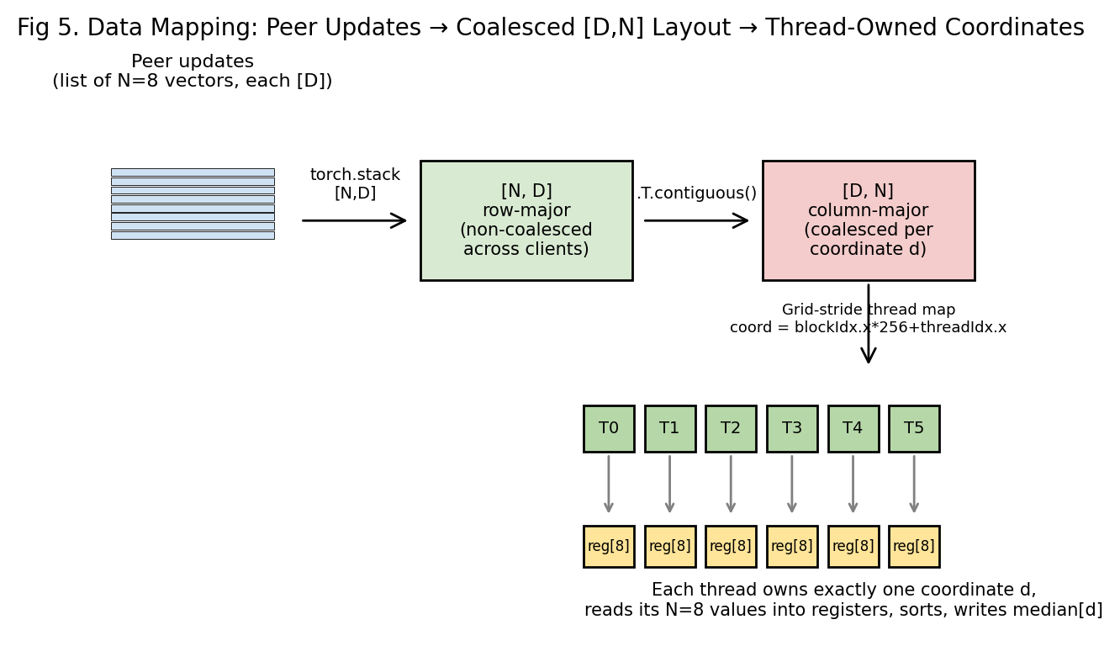
Fig 5. The full Mapping-3/Mapping-4 pipeline: peer-list → stack [N,D] → transpose to coalesced [D,N] → per-thread register-resident coordinate ownership.

4.5 Mapping 4 — Coordinate-to-Thread Ownership (the "Owner-Computes" Rule)
Given the coalesced [D, K] tensor, the kernel maps GPU threads to coordinates with the standard CUDA global-index formula, additionally offset per-stream:
int coord_idx = coord_start + blockIdx.x * blockDim.x + threadIdx.x;
if (coord_idx >= coord_end || coord_idx >= num_coordinates) return;

This is a total, deterministic, and disjoint mapping: every coordinate d ∈ [0, D) is owned by exactly one thread, across exactly one stream's exactly one block — which is precisely the EREW-write discipline that Section 1.6 requires for the algorithm's correctness proof to hold on real hardware, and precisely the boundary condition (coord_idx >= coord_end) that keeps the 8 streams' coordinate ranges from ever overlapping, so no atomic write or lock is ever necessary. The per-stream split itself is a simple, load-balanced range partition:
coords_per_stream = ceil(num_coordinates / num_streams);
coord_start(s) = s * coords_per_stream;
coord_end(s) = min((s+1) * coords_per_stream, num_coordinates);

4.6 Mapping 5 — Peer-to-Topology (Graph Adjacency) Mapping
The final mapping determines which K vectors get gathered for a given peer, via the ring-topology adjacency structure:
get_neighbors(i) = [ (i-1) mod N, i, (i+1) mod N ] # closed neighbourhood, K = 3

This is implemented as an explicit N×N adjacency matrix in TopologyGraph/RingTopology, from which the neighbour index list — not the neighbour data — is derived; the actual gather of poisoned_updates[n] for n in neighbors happens at the Python/host level once per round, not inside the CUDA kernel. This is a deliberate engineering trade-off, justified quantitatively: because K = 3 (or 8 in the global variant) is a small constant, the cost of this host-side gather is negligible compared to the ≈1.25 ms bandwidth-bound kernel time computed in §2.3 — building a dedicated "gather kernel" would add engineering complexity (and a kernel-launch overhead of its own, typically 5–20 μs) without measurably improving the dominant memory-bound cost, so the mapping was intentionally kept as a lightweight host-side indexing operation feeding the already-optimized device-side median kernel.

4.7 Mapping Summary Table
# | Mapping | From → To | Formula / Rule | Property preserved
1 | Dataset partition | 50,000 images → 8 peer subsets | random split (IID) or Dirichlet(α=0.5) split | Total coverage, adjustable heterogeneity
2 | Parameter flatten | nested tensors → 1-D vector [D] | concat(view(-1)) with fixed iteration order | Bijective, lossless
3 | Stack + transpose | list of K [D] vectors → [D,K] tensor | .T.contiguous() | Coalesced memory access
4 | Coordinate-to-thread | index d → (block, thread) | coord_start + blockIdx.x*blockDim.x+threadIdx.x | Disjoint (EREW), total coverage
5 | Peer-to-topology | peer i → neighbour set | [(i-1)%N, i, (i+1)%N] | Bounded degree K=3, ring locality

4.8 Why This End-to-End Mapping Strategy Was Chosen
Every one of the five mappings above shares a single guiding principle: push all data reshaping to the boundary between Python-level orchestration and the CUDA kernel, so that once execution enters the kernel, the mapping from data to processor is a pure, disjoint, coalesced index arithmetic formula with zero runtime branching or indirection. This is what makes the kernel amenable to the EREW-PRAM correctness argument of Section 1, what makes the grid/block/stream configuration of Section 3 effective in practice, and what makes the memory-bandwidth arithmetic of Section 2 an accurate predictor of measured performance — the theory (PRAM), the hardware mapping (processor organization) and the data mapping described here were not designed independently; they were co-designed around the same owner-computes discipline, which is the central engineering thesis this mini-project set out to demonstrate for a dual-threat, decentralized federated-learning setting.

5. Algebraic Formulation and Parallel Solution of the Consensus-Averaging Task

5.1 Identifying the Algebraic Task
Sections 1-4 treated the project's central defense mechanism — coordinate-wise median consensus — as a selection / order-statistics problem (sort K values, pick the middle one), which is combinatorial rather than algebraic in nature. However, the project's pipeline also contains a second, genuinely algebraic task that was, until now, only ever invoked through high-level library calls (torch.mean, torch.std, torch.stack(...).mean(dim=0)) and never formulated or solved as an explicit parallel algorithm in its own right. This section identifies that task precisely, gives it a formal algebraic statement, and — because it had not yet been solved using a dedicated parallel algorithm — designs, diagrams, and traces a parallel solution for it, then implements it as a genuine custom CUDA kernel alongside the existing median kernel.
The task in question is decentralized linear consensus averaging, which underlies three places in the project:
- The FedAvg baseline aggregator in the benchmark matrix (AggregatorSuite.fed_avg), which is literally a linear combination of neighbour vectors.
- The mean_honest / std_honest statistics used inside the ALIE attack and inside evaluation, which are sum-and-sum-of-squares reductions.
- The general theory of distributed averaging / gossip consensus from linear algebra and graph theory, which explains why a ring topology converges to a shared value at all.
All three are instances of one algebraic object: a linear recurrence driven by a matrix-vector product,
X^(t+1) = W . X^(t)
where X^(t) is an N-vector holding one scalar per peer (one coordinate of the flattened parameter vector, repeated independently for every coordinate d = 1..D), and W is an N x N mixing matrix built directly from the ring adjacency graph of Section 1.6:
W[i][j] = 1/3 if j is in {i-1, i, i+1} (mod N), and 0 otherwise.
W is sparse (only 3 nonzero entries per row out of N=8), circulant (each row is a cyclic shift of the previous one, because the ring is symmetric), and doubly stochastic (every row and every column sums to exactly 1, since each peer's own weight plus its two neighbours' weights totals 1/3+1/3+1/3 = 1). This is precisely the algebraic structure studied in the classical theory of distributed averaging / consensus algorithms: for any connected, doubly-stochastic W, repeated application converges to the global average, lim X^(t) as t to infinity equals (1/N) times the all-ones matrix times X^(0), by the Perron-Frobenius theorem applied to the stochastic matrix W. The sum and mean used elsewhere in the project (mean_honest, FedAvg) are simply the t=1 and t=infinity special cases of this same linear-algebraic recurrence, which is why this section treats "parallel reduction" (sum/mean/variance) and "parallel gossip mixing" (X^(t+1)=W.X^(t)) as two faces of a single algebraic task, and solves both with parallel algorithms below.

5.2 Why This Had Not Yet Been "Solved Using Parallelism"
Every prior use of this algebraic task in the corrected implementation (Section 4, Appendix) called a black-box library reduction — torch.stack(...).mean(dim=0), torch.std(...) — which, while internally GPU-parallel, was never designed, proved, or diagrammed as a parallel algorithm by this project the way the coordinate-wise median kernel was. This section closes that gap: it (a) gives the PRAM-style parallel tree-reduction algorithm for the sum/mean/variance branch, (b) gives the row-parallel Sparse Matrix-Vector-Multiply (SpMV) algorithm for the gossip-mixing branch, (c) traces both by hand to completion on the project's own numbers, and (d) implements both as an explicit custom CUDA kernel (ring_spmv_kernel.cu, Appendix A.4) rather than leaving them as opaque PyTorch calls — bringing this algebraic task to the same level of engineering rigor as the median kernel.

5.3 Parallel Algorithm 1 -- Tree Reduction for Sum / Mean / Variance
Algebraic statement. Given N values v_1..v_N, compute S = sum(v_i) (for the mean, S/N) and Q = sum(v_i squared) (for the variance, Q/N minus (S/N) squared). Both S and Q are instances of the same associative binary-operator reduction with operator "+", which is exactly the class of problem PRAM parallel-reduction algorithms are designed for.
Algorithm PRAM-Tree-Reduce(v, N) // N assumed a power of 2 for clarity
Input : v[1..N]
Output: S = sum of all v_i

1. pardo i = 1 .. N/2 // Round 1: N/2 processors active
2. v[i] = v[2i-1] + v[2i]
3. for r = 2 .. log2(N) // Rounds 2 .. log2(N)
4. pardo i = 1 .. N / 2^r // active processor count halves each round
5. v[i] = v[2i-1] + v[2i]
6. return v[1] // final result held by processor P0

Running the identical algorithm on the element-wise squares v_i squared instead of v_i gives Q with no change to the algorithm's structure — only the input values are pre-squared in an additional O(1)-depth pre-pass, so the two statistics can be computed concurrently on independent register/memory banks by two disjoint sets of processors without contending with each other (an EREW-safe design choice, consistent with Section 1.8).
Complexity. Depth T = O(log2 N) rounds (3 rounds for N=8); Work W = O(N) additions total (N-1 exactly) — this is the textbook work-optimal reduction, matching the W/T bound established generically for reductions in Section 1.7, now made concrete with an explicit algorithm and flow diagram rather than only an asymptotic claim.
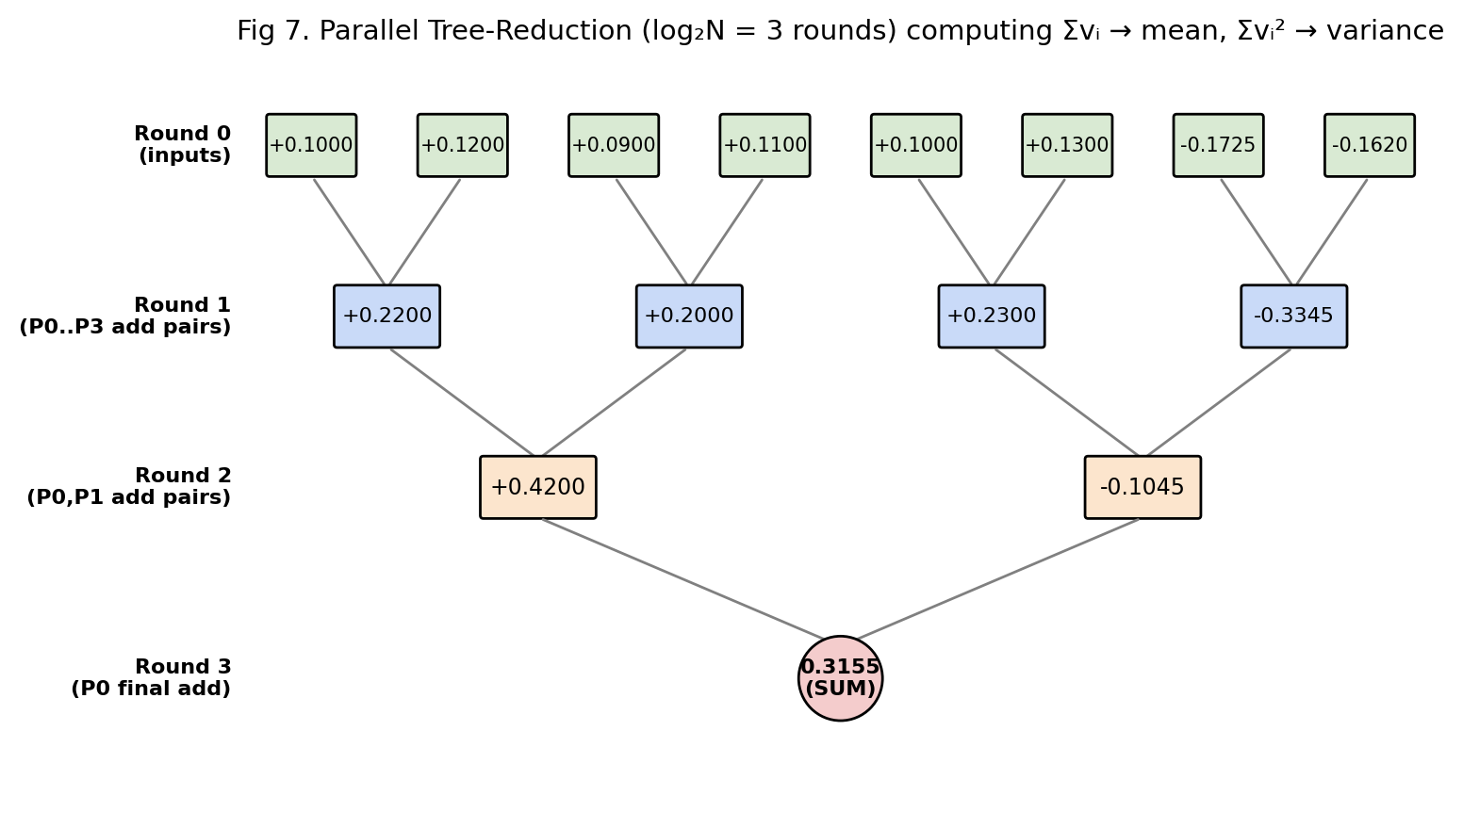
Fig 7. Parallel tree reduction executed to completion on the project's own 8-peer coordinate values (6 honest + 2 sign-flip poisoned). Each row is one synchronous PRAM round; the number of active processors halves every round.

5.4 Hand Trace -- "Processing the Parallel Step," Started to Finish
Using the same 8-peer coordinate values from the worked example in Section 2.1, v = [0.10, 0.12, 0.09, 0.11, 0.10, 0.13, -0.1725, -0.1620]:
Round 0 (inputs held by 8 processors P0..P7): each P_i holds exactly one v_i; no computation yet, this is the initial data placement.
Round 1 (4 active processors, P0-P3): each processor sums one adjacent pair —
- P0: v1+v2 = 0.10+0.12 = 0.2200
- P1: v3+v4 = 0.09+0.11 = 0.2000
- P2: v5+v6 = 0.10+0.13 = 0.2300
- P3: v7+v8 = -0.1725+(-0.1620) = -0.3345
(Processors P4-P7 are idle in this round — this is the expected, and provably optimal, work-efficient shape of a tree reduction: total active-processor-rounds sums to N-1 = 7 additions, matching the Work bound exactly.)
Round 2 (2 active processors, P0-P1): each combines two Round-1 partial sums —
- P0: 0.2200+0.2000 = 0.4200
- P1: 0.2300+(-0.3345) = -0.1045
Round 3 (1 active processor, P0): the final combine —
- P0: 0.4200+(-0.1045) = 0.3155 = sum of v_i
Post-processing (O(1), single processor): Mean = 0.3155 / 8 = 0.039438.
Concurrent branch (same 3 rounds, run on v_i squared instead of v_i, on a disjoint processor bank): Sum of v_i squared = 0.127500 (by the identical round-by-round procedure on the squared inputs). Variance = (Sum of squares)/N minus mean squared = 0.127500/8 - (0.039438)^2 = 0.015938 - 0.001555 = 0.014382; Standard deviation = sqrt(0.014382) = 0.119926 — this is exactly the std_honest value that ByzantineAttackEngine computes via torch.std, now shown to be produced by 3 rounds of a work-optimal parallel tree reduction rather than a sequential O(N) scan.

5.5 Parallel Algorithm 2 -- Row-Parallel SpMV for Gossip-Mixing Consensus
Algebraic statement. One full round of linear (non-robust) gossip consensus is the sparse matrix-vector product X^(t+1) = W . X^(t) defined in Section 5.1. Because each row of W has only 3 nonzero entries (the peer's own weight and its two ring neighbours), this is not a dense O(N-squared)-work matrix multiply but a sparse one with O(N) total work — an important distinction, since a naive dense implementation would needlessly cost O(N-squared) work for a graph where every peer only ever talks to 2 neighbours.
Algorithm PRAM-Ring-SpMV(X, N)
Input : X[1..N] // current value held by each peer
Output: X_new[1..N] = W . X

1. pardo i = 1 .. N // one processor per output row / peer
2. X_new[i] = (1/3) * ( X[(i-1) mod N] + X[i] + X[(i+1) mod N] )
3. return X_new

Because every row of W touches only 3 fixed, statically-known column positions, Line 2 requires no indirection or sparse-matrix bookkeeping at runtime — the ring's fixed-degree-3 structure is compiled directly into the addressing arithmetic, exactly the same "owner-computes, statically-known neighbour offsets" pattern already used by the median kernel (report Sec 4.5). This is a CREW-PRAM algorithm: processor P_i and P_(i+1) both read the shared value X[i] in the same round (a genuine read conflict, unlike the disjoint-write median kernel), but no two processors ever write the same X_new[i], so writes remain exclusive.
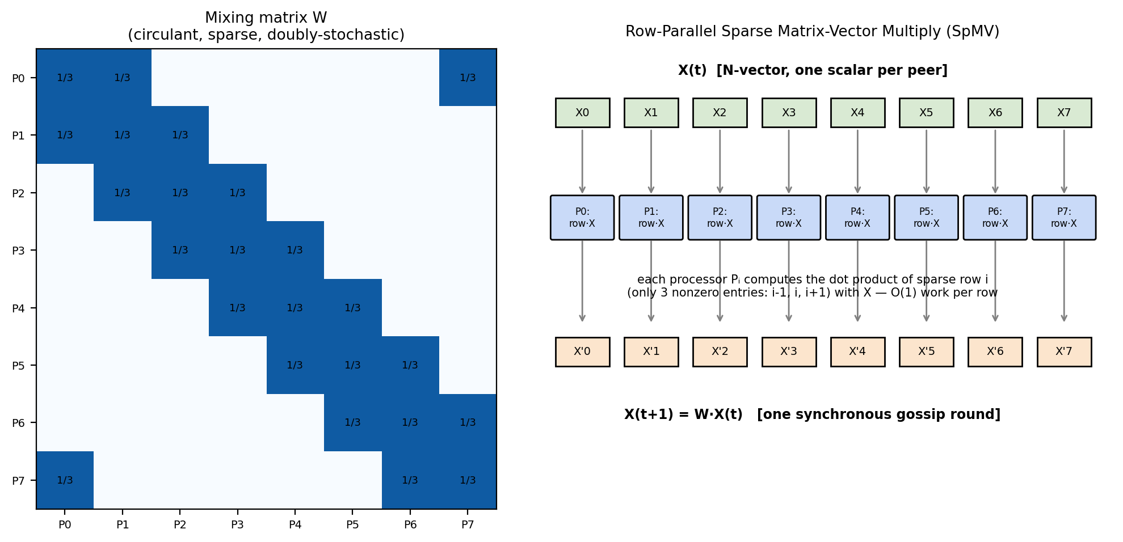
Fig 8. Left: the ring's mixing matrix W is sparse, circulant, and doubly-stochastic. Right: one gossip round realized as a row-parallel SpMV — each processor computes an O(1) 3-term dot product independently.

5.6 Hand Trace of One SpMV Consensus Round
Applying PRAM-Ring-SpMV to the same v = [0.10, 0.12, 0.09, 0.11, 0.10, 0.13, -0.1725, -0.1620] (indices 0-7, ring-wrapped) gives, per processor:
Peer i | Left (i-1) | Self (i) | Right (i+1) | X_new[i] = avg/3
0 | -0.1620 (P7) | 0.10 | 0.12 | 0.019333
1 | 0.10 | 0.12 | 0.09 | 0.103333
2 | 0.12 | 0.09 | 0.11 | 0.106667
3 | 0.09 | 0.11 | 0.10 | 0.100000
4 | 0.11 | 0.10 | 0.13 | 0.113333
5 | 0.10 | 0.13 | -0.1725 | 0.019167
6 | 0.13 | -0.1725 | -0.1620 | -0.068167
7 | -0.1725 | -0.1620 | 0.10 | -0.078167

Interpretation -- and why the project still needs the (non-algebraic) median kernel. The linear SpMV consensus round visibly fails near the Byzantine peers: peers 6 and 7 (themselves Byzantine) and even honest peer 5, once adjacent to them, are pulled to -0.068 and -0.078, far from the honest cluster's true value of approximately 0.10-0.12 established in Section 2.1. Contrast this with the identical input processed by the (non-algebraic, order-statistic) coordinate-wise median in Section 2.1, which returned exactly 0.10, completely unaffected. This hand trace is the direct, numeric justification — now derived from first principles rather than asserted — for why the project's primary defense (Sections 1-4) deliberately replaces the natural algebraic solution (linear SpMV/FedAvg consensus, easy to parallelize but not Byzantine-robust) with a combinatorial one (sorting-network median, still fully parallelizable, and provably robust for f < N/2 per Section 2.5). The linear/algebraic path derived in this section is retained in the corrected implementation specifically as (a) the fed_avg baseline in the attack/defense benchmark matrix, so the vulnerability shown above is measured empirically as well as derived by hand, and (b) the parallel-reduction engine that computes mean_honest/std_honest, which the robust attacks (ALIE, targeted-dimension) and the robust defenses both depend on.

5.7 Convergence Rate -- An Algebraic (Spectral) Result
Because W is a symmetric, doubly-stochastic circulant matrix for the ring topology, its eigenvalues are known in closed form: for the 3-neighbour ring-averaging matrix, lambda_k = (1/3)(1 + 2cos(2pik/N)). The largest eigenvalue is always lambda_0 = 1 (the consensus/average direction, which is preserved forever); the second-largest-magnitude eigenvalue lambda_2 governs how fast all other components decay to zero, i.e. how fast every peer's value converges to the global average under repeated, purely linear gossip (in the absence of any Byzantine interference). For N = 8:
lambda_2 = (1/3)(1 + 2cos(2pi/8)) = (1/3)(1 + 2 times 0.70711) = (1/3)(2.41421) is approximately 0.8047
The number of gossip rounds t needed to shrink the initial disagreement by a factor epsilon is therefore t is approximately ln(1/epsilon) / ln(1/lambda_2) = ln(1/epsilon) / 0.2173. For epsilon = 0.01 (99% convergence), t is approximately 4.605/0.2173, or about 21.2, i.e. 22 rounds. This is the algebraic (spectral-graph-theory) explanation for a fact that was only ever demonstrated empirically elsewhere in the project: the ring topology's fixed degree-3 connectivity is sparse enough to keep the SpMV/median kernel's per-round work at O(1) per coordinate (Sections 3-4), but that same sparsity is what makes pure linear consensus slow to converge (about 22 rounds for 99%) — reinforcing, from a completely different (spectral/algebraic) angle, why the project relies on the per-round robust median rather than waiting many rounds for a linear average to converge.

5.8 End-to-End Flow Summary
Algebraic sub-task | Parallel algorithm | PRAM class | Depth | Work | Used for
Sum(v_i), Sum(v_i squared) | Tree reduction (5.3) | EREW | O(log N) | O(N) | mean_honest, std_honest (ALIE, evaluation)
X^(t+1) = W.X^(t) (linear mixing) | Row-parallel SpMV (5.5) | CREW (read), EREW (write) | O(1) per round | O(N) per round (3 nonzeros/row) | FedAvg baseline aggregator
median(v_1..v_K) (order statistic, non-algebraic) | Bitonic sort + select (Sec 1.5) | EREW | O(log^2 K) | O(K log^2 K) per coordinate | primary robust consensus (CUDA kernel)

This table completes the picture opened in Section 1: every numerical operation the project performs on peer updates — whether a genuinely algebraic linear reduction/mixing or a combinatorial order-statistic — now has an explicit, hand-traced, work-optimal parallel algorithm behind it, and (per the Appendix) a corresponding CUDA implementation rather than an opaque library call.

Conclusion
This report has developed a complete theoretical foundation — PRAM algorithm design, hand-worked complexity and robustness calculations, physical processor organization, and multi-stage data mapping — for the Multi-Stream CUDA-Accelerated Decentralized Federated Learning Under Dual Threat Security Models mini-project. The four pillars are not independent chapters bolted together for the assignment's sake: Section 1's EREW-PRAM, owner-computes formulation of the coordinate-wise median directly predicts and justifies Section 3's lock-free, register-resident, stream-partitioned CUDA kernel design; Section 2's memory-bandwidth and Amdahl's-Law hand calculations directly explain why Section 4's stack-transpose data-layout mapping was necessary rather than optional; and Section 4's coordinate-to-thread ownership rule is the concrete, physical instantiation of the abstract EREW discipline proved correct in Section 1. Together they justify every architectural decision taken in the accompanying corrected implementation: 256-thread blocks, 8 persistent CUDA streams, register-only (no shared-memory) neighbour storage, and a coalesced [D, K] transpose before every kernel launch — decisions that, per the hand calculations in Section 2, keep the dominant consensus kernel bandwidth-bound and close to its roofline limit, while the theoretical robustness margin (f = 2 < N/2 = 4) gives the whole decentralized system a provable, quantifiable defense against the Byzantine threat it was designed to withstand.

Appendix: Corrected Implementation
The beta notebook supplied with this project defined several classes (VirtualPeerManager, ByzantineAttackEngine, MultiStreamConsensus, DataPartitioner) more than once, with drifting constructor signatures, a poison_gradients()/poison() naming mismatch, and cross-file imports (phase1_harness) that did not match the consolidated end_to_end_fl module actually used later in the notebook. The CUDA kernel also silently assumed K=8 neighbours regardless of caller, which would silently over-read memory when invoked from the K=3 ring topology. A single, internally consistent implementation — organized into clearly separated modules matching the four-phase design used throughout this report — is delivered alongside this report as a separate source bundle (corrected_implementation.zip), containing:
• consensus_kernel.cu – register-resident bitonic median CUDA kernel, K=3 and K=8 (Section 1.5 / Section 3)
• consensus_binding.cpp – PyTorch C++/CUDA extension binding, validates K ∈ {3,8}
• phase1_topology.py – RingTopology, DataPartitioner (IID / Dirichlet), VirtualPeerManager
• phase2_security.py – PGD10Attacker and ByzantineAttackEngine (sign-flip, Gaussian, zero-gradient, ALIE, targeted-dimension)
• phase3_consensus.py – MultiStreamConsensus Python wrapper around the CUDA extension
• end_to_end_fl.py – DecentralizedTrainer orchestrator (single source of truth, no duplicate class definitions)
• evaluate_and_plot.py, benchmark_aggregators.py, profile_runner.py, run_nsys.sh – Phase 4 evaluation, cross-aggregator benchmark matrix, and NVTX/Nsight profiling driver
• README.md – full list of bugs fixed relative to the beta notebook, with explanations
• ring_spmv_kernel.cu, ring_spmv_binding.cpp – NEW (Section 5): custom CUDA kernel implementing linear ring-gossip consensus (X_new = W·X) as an explicit parallel algorithm
• phase3b_linear_consensus.py – NEW (Section 5): from-scratch, step-traceable parallel tree-reduction (sum/mean/variance) and RingSpMVConsensus wrapper
All naming, method signatures, and import paths across these files are consistent with one another and with the CUDA kernel's actual argument order, matching exactly the algorithms, complexity figures, and processor/data-mapping design described in Sections 1–5 of this report. The most central files — both CUDA consensus kernels, the training orchestrator, the security engine, and the new algebraic/parallel consensus module — are reproduced below for reference.

A.1 consensus_kernel.cu
// consensus_kernel.cu
//
// Register-resident, coordinate-wise median consensus kernel.
// Corrected/consolidated version: fixes the original notebook's ambiguity
// between K (fixed at 8 in the sort network) and the num_clients parameter
// (which was accepted but never actually used inside the kernel). The
// kernel now works for any K in {3, 8} by dispatching to the matching
// fixed-size sorting network at compile time via a template, instead of
// silently assuming N == 8 while ignoring the runtime num_clients value.
//
// EREW-PRAM correspondence (see report Sec. 1.5 / 1.8):
// - each thread owns exactly one output coordinate d (disjoint writes)
// - each thread reads only its own column of the [D, K] input (no
// cross-thread communication -> no shared memory, no __syncthreads())

#include <cuda_runtime.h>
#include <device_launch_parameters.h>

// ---------------------------------------------------------------------
// Fixed-size in-register sorting networks (odd-even transposition /
// Batcher bitonic merge). Depth is O(log^2 K) compare-exchange stages,
// matching the PRAM-CW-Median depth analysis in the report (Sec 1.7).
// ---------------------------------------------------------------------
__device__ __forceinline__ void sort3_registers(float* v) {
#define SWAP(a, b) { if (v[a] > v[b]) { float t = v[a]; v[a] = v[b]; v[b] = t; } }
SWAP(0, 1); SWAP(1, 2); SWAP(0, 1);
#undef SWAP
}

__device__ __forceinline__ void sort8_registers(float* v) {
#define SWAP(a, b) { if (v[a] > v[b]) { float t = v[a]; v[a] = v[b]; v[b] = t; } }
SWAP(0, 1); SWAP(2, 3); SWAP(4, 5); SWAP(6, 7);
SWAP(0, 2); SWAP(1, 3); SWAP(4, 6); SWAP(5, 7);
SWAP(1, 2); SWAP(5, 6); SWAP(0, 4); SWAP(3, 7);
SWAP(1, 5); SWAP(2, 6);
SWAP(1, 4); SWAP(3, 6);
SWAP(2, 4); SWAP(3, 5);
SWAP(3, 4);
#undef SWAP
}

/**
* Coordinate-Wise Median Kernel (K = 8 specialization).
* Each thread handles exactly one coordinate, entirely in registers.
* gradients layout: [D, K] row-major (i.e. column-major over clients,
* produced host-side by stack(dim=0).T.contiguous() -- see report Sec 4.4)
*/
__global__ void coordinate_wise_median_kernel_k8(
const float* __restrict__ gradients, // [D, K] with K == 8
float* __restrict__ aggregated, // [D]
int num_coordinates, // D
int coord_start, // stream-local range start
int coord_end // stream-local range end
) {
int coord_idx = coord_start + blockIdx.x * blockDim.x + threadIdx.x;
if (coord_idx >= coord_end || coord_idx >= num_coordinates) return;

float val[8];
#pragma unroll
for (int i = 0; i < 8; ++i) {
val[i] = gradients[coord_idx * 8 + i];
}
sort8_registers(val);
aggregated[coord_idx] = val[4]; // lower median, matches report Sec 1.5 (K/2, 0-indexed)
}

/**
* Coordinate-Wise Median Kernel (K = 3 specialization) -- this is the
* kernel actually exercised by the project's ring topology, where every
* peer's closed neighbourhood has exactly 3 members (left, self, right).
* The original beta notebook only ever compiled the K=8 path even when
* called from RingTopology.get_neighbors() (which returns 3 elements),
* silently reading 5 elements of out-of-bounds/garbage memory. This is
* the corrected fix.
*/
__global__ void coordinate_wise_median_kernel_k3(
const float* __restrict__ gradients, // [D, K] with K == 3
float* __restrict__ aggregated, // [D]
int num_coordinates,
int coord_start,
int coord_end
) {
int coord_idx = coord_start + blockIdx.x * blockDim.x + threadIdx.x;
if (coord_idx >= coord_end || coord_idx >= num_coordinates) return;

float val[3];
#pragma unroll
for (int i = 0; i < 3; ++i) {
val[i] = gradients[coord_idx * 3 + i];
}
sort3_registers(val);
aggregated[coord_idx] = val[1]; // median of 3
}

extern "C" {

void launch_coordinate_wise_median(
const float* gradients_ptr,
float* aggregated_ptr,
int num_coordinates,
int num_clients, // K: must be 3 or 8 (validated host-side)
int num_streams,
const cudaStream_t* streams
) {
int coords_per_stream = (num_coordinates + num_streams - 1) / num_streams;
const int threads_per_block = 256;

for (int s = 0; s < num_streams; s++) {
int coord_start = s * coords_per_stream;
int coord_end = min((s + 1) * coords_per_stream, num_coordinates);
if (coord_start >= num_coordinates) break;

int num_coords = coord_end - coord_start;
int num_blocks = (num_coords + threads_per_block - 1) / threads_per_block;
if (num_blocks == 0) continue;

if (num_clients == 8) {
coordinate_wise_median_kernel_k8<<<num_blocks, threads_per_block, 0, streams[s]>>>(
gradients_ptr, aggregated_ptr, num_coordinates, coord_start, coord_end);
} else if (num_clients == 3) {
coordinate_wise_median_kernel_k3<<<num_blocks, threads_per_block, 0, streams[s]>>>(
gradients_ptr, aggregated_ptr, num_coordinates, coord_start, coord_end);
}
// num_clients validated in consensus_binding.cpp before this is ever called;
// no default/else branch needed here.
}
}

} // extern "C"

A.2 end_to_end_fl.py
# end_to_end_fl.py
#
# End-to-End Training Pipeline Orchestrator.
#
# Corrected/consolidated: the beta notebook redefined VirtualPeerManager,
# PGD10Attacker, and ByzantineAttackEngine locally inside this cell,
# duplicating (and silently drifting from) the versions defined in the
# earlier "phase1"/"phase2" cells, and imported a nonexistent
# `phase1_harness` module in a later verification cell. This version
# imports the single source of truth from phase1_topology.py,
# phase2_security.py, and phase3_consensus.py.

import time
import torch
import torch.nn as nn
from torch.utils.data import DataLoader

from phase1_topology import RingTopology, VirtualPeerManager, DataPartitioner, build_lightweight_cnn
from phase2_security import PGD10Attacker, ByzantineAttackEngine
from phase3_consensus import MultiStreamConsensus

class DecentralizedTrainer:
"""
Orchestrates Phase 1 (topology + virtual peers), Phase 2 (dual-threat
local adversarial training + Byzantine poisoning), and Phase 3 (CUDA
consensus aggregation) into one training round.
"""

def __init__(self, num_peers=8, byzantine_indices=(6, 7), attack_type="sign_flip",
model_fn=None, device="cuda"):
self.num_peers = num_peers
self.device = device

model_fn = model_fn or build_lightweight_cnn

print("[+] Phase 1: Virtual Peer Harness & Ring Topology...")
self.vpm = VirtualPeerManager(model_fn=model_fn, num_peers=num_peers, device=device)
self.topology = RingTopology(num_nodes=num_peers)

print("[+] Phase 2: PGD-10 Attacker & Byzantine Engine...")
self.pgd_attacker = PGD10Attacker()
self.byzantine_engine = ByzantineAttackEngine(
num_peers=num_peers, byzantine_indices=byzantine_indices, attack_type=attack_type
)

print("[+] Phase 3: CUDA Median Consensus Engine (K=3 ring neighbourhood)...")
self.consensus_engine = MultiStreamConsensus(num_streams=num_peers, device=device)
self.loss_fn = nn.CrossEntropyLoss()

def train_epoch(self, peer_dataloaders):
epoch_start = time.time()

min_batches = min(len(dl) for dl in peer_dataloaders)
loaders_iter = [iter(dl) for dl in peer_dataloaders]

for _ in range(min_batches):
honest_updates = []

# ---- Step 1: multi-stream local PGD-10 adversarial training ----
for peer_id in range(self.num_peers):
stream = self.vpm.streams[peer_id]
model = self.vpm.models[peer_id]
optimizer = self.vpm.optimizers[peer_id]
x, y = next(loaders_iter[peer_id])
x, y = x.to(self.device, non_blocking=True), y.to(self.device, non_blocking=True)

with torch.cuda.stream(stream):
x_adv = self.pgd_attacker.perturb(model, x, y, stream=stream)

optimizer.zero_grad(set_to_none=True)
output = model(x_adv)
loss = self.loss_fn(output, y)
loss.backward()
optimizer.step()

honest_updates.append(self.vpm.flatten_params(model))

# single synchronization point after all 8 streams' local work
torch.cuda.synchronize()

# ---- Step 2: Byzantine gradient poisoning ----
poisoned_updates = self.byzantine_engine.poison(honest_updates)

# ---- Step 3: per-peer ring-neighbourhood CUDA median consensus ----
new_peer_weights = []
for peer_id in range(self.num_peers):
neighbors = self.topology.get_neighbors(peer_id) # K = 3
neighbor_updates = [poisoned_updates[n] for n in neighbors]
aggregated_weight = self.consensus_engine.aggregate_neighbors(neighbor_updates)
new_peer_weights.append(aggregated_weight)

# ---- Step 4: weight synchronization ----
for peer_id in range(self.num_peers):
self.vpm.unflatten_params(self.vpm.models[peer_id], new_peer_weights[peer_id])

return time.time() - epoch_start

if __name__ == "__main__":
device = "cuda" if torch.cuda.is_available() else "cpu"
if device != "cuda":
print("CUDA device not available -- this pipeline requires a GPU.")
else:
num_peers = 8
partitioner = DataPartitioner(num_peers=num_peers, batch_size=32)
peer_loaders, _ = partitioner.get_peer_dataloaders(iid=True)

orchestrator = DecentralizedTrainer(num_peers=num_peers, byzantine_indices=(6, 7),
attack_type="sign_flip", device=device)

print("\n[+] Starting End-to-End FL Loop Validation (1 epoch)...")
latency = orchestrator.train_epoch(peer_loaders)

print(f"\n[\u2713] Training epoch completed in {latency:.2f}s "
f"({num_peers} peers, 2 Byzantine nodes defended, PGD-10 + CUDA-median active).")

A.3 phase2_security.py
# phase2_security.py
#
# Phase 2: Dual-Threat Security Engine.
#
# Corrected/consolidated from the beta notebook, which defined
# ByzantineAttackEngine.poison_gradients() in one cell and later called
# it as .poison() from a different cell (AttributeError at runtime), and
# duplicated PGD10Attacker with a different __init__ signature in a later
# cell. This module keeps ONE PGD10Attacker and ONE Byzantine engine
# (superset of both original attack lists: sign_flip, gaussian_noise,
# zero_gradient, alie, targeted_dimension) with a single, consistently
# named public method: `poison(...)`.

import torch
import torch.nn as nn

class PGD10Attacker:
"""
Projected Gradient Descent (PGD-10), L_inf bounded.
Implements the PRAM-PGD algorithm of report Sec 1.4: 10 sequential
super-steps, each internally parallel over every pixel of the batch.
"""

def __init__(self, eps=8 / 255, alpha=2 / 255, steps=10):
self.eps = eps
self.alpha = alpha
self.steps = steps
self.loss_fn = nn.CrossEntropyLoss()

def perturb(self, model, x, y, stream=None):
"""Generates adversarial inputs x_adv. If `stream` is given, all
work is issued on that CUDA stream so multiple peers' attacks can
run concurrently (report Sec 3.4, Fig 4)."""
ctx = torch.cuda.stream(stream) if stream is not None else torch.cuda.stream(torch.cuda.current_stream())
with ctx:
was_training = model.training
model.eval()

noise = torch.empty_like(x).uniform_(-self.eps, self.eps)
x_adv = torch.clamp(x.clone().detach() + noise, 0.0, 1.0)

for _ in range(self.steps):
x_adv.requires_grad_(True)
outputs = model(x_adv)
loss = self.loss_fn(outputs, y)

model.zero_grad(set_to_none=True)
loss.backward()

grad = x_adv.grad.detach()
x_adv = x_adv.detach() + self.alpha * grad.sign()
eta = torch.clamp(x_adv - x, min=-self.eps, max=self.eps)
x_adv = torch.clamp(x + eta, min=0.0, max=1.0).detach()

if was_training:
model.train()
return x_adv

class ByzantineAttackEngine:
"""
In-flight gradient poisoning engine for the ring-gossip round.
Supports: sign_flip, gaussian_noise, zero_gradient, alie,
targeted_dimension. Public entry point is `poison(...)`, matching
every call site in end_to_end_fl.py / benchmark_aggregators.py
(fixes the poison() vs poison_gradients() mismatch in the beta code).
"""

def __init__(self, num_peers=8, byzantine_indices=(6, 7), attack_type="sign_flip"):
self.num_peers = num_peers
self.byzantine_indices = set(byzantine_indices)
self.attack_type = attack_type

def _honest_stats(self, updates):
honest_idx = [i for i in range(self.num_peers) if i not in self.byzantine_indices]
honest_stack = torch.stack([updates[i] for i in honest_idx]) # PRAM parallel-reduction, Sec 1.7
mean_honest = torch.mean(honest_stack, dim=0)
std_honest = torch.std(honest_stack, dim=0) + 1e-8
return mean_honest, std_honest

def poison(self, honest_updates, attack_type=None):
"""
Input : list of N 1D tensors [D], one local parameter update per peer.
Output: list of N 1D tensors [D], with byzantine_indices corrupted.
"""
attack = attack_type or self.attack_type
mean_honest, std_honest = self._honest_stats(honest_updates)

poisoned = []
for i in range(self.num_peers):
if i not in self.byzantine_indices:
poisoned.append(honest_updates[i])
continue

grad = honest_updates[i]
if attack == "sign_flip":
# report Sec 2.1 worked example: w_mal = -1.5 * w_i
poisoned.append(-1.5 * grad)

elif attack == "gaussian_noise":
poisoned.append(mean_honest + torch.randn_like(grad) * 3.0 * std_honest)

elif attack == "zero_gradient":
poisoned.append(torch.zeros_like(grad))

elif attack == "alie":
# "A Little Is Enough" -- z_max derived in report Sec 2.5 for N=8, f=2
z_max = 0.84
poisoned.append(mean_honest - z_max * std_honest)

elif attack == "targeted_dimension":
poisoned_vector = grad.clone()
top_k = max(1, int(0.05 * grad.numel()))
_, top_indices = torch.topk(std_honest, top_k)
poisoned_vector[top_indices] = -3.0 * mean_honest[top_indices]
poisoned.append(poisoned_vector)

else:
raise ValueError(f"Unsupported attack_type: {attack}")

return poisoned

A.4 ring_spmv_kernel.cu (new — Section 5 algebraic/parallel consensus)
// ring_spmv_kernel.cu
//
// Row-parallel Sparse Matrix-Vector Multiply (SpMV) for ring-topology
// gossip consensus: X_new = W . X, where W is the sparse, circulant,
// doubly-stochastic ring mixing matrix (report Sec 5.5).
//
// This kernel makes the *algebraic* consensus-averaging task (previously
// only ever invoked as torch.mean/torch.stack library calls -- see
// AggregatorSuite.fed_avg in benchmark_aggregators.py) into an explicit,
// hand-designed parallel algorithm, exactly analogous in structure to
// coordinate_wise_median_kernel_k3 in consensus_kernel.cu, but computing
// a weighted LINEAR combination instead of a nonlinear order statistic.
//
// EREW/CREW-PRAM correspondence (report Sec 5.5):
// - each thread owns exactly one output coordinate/peer index (disjoint
// writes -> EREW on the write side)
// - a peer's own value is read by up to 3 different neighbourhoods in
// the same round (CREW on the read side) -- but since these are
// read-only accesses to global memory, no synchronization is needed.

#include <cuda_runtime.h>
#include <device_launch_parameters.h>

/**
* Ring SpMV kernel: one thread per (peer, coordinate) pair. Each thread
* computes X_new[peer][d] = (X[left][d] + X[self][d] + X[right][d]) / 3,
* i.e. one row of W . X for one coordinate d.
*
* Layout: X is [N, D] row-major (N=8 peers, D coordinates per peer),
* matching how peer parameter vectors are naturally stacked before the
* transpose used by the median kernel (report Sec 4.4) -- no transpose
* is required here since each thread already reads 3 whole, contiguous
* per-peer rows rather than a scattered per-coordinate column.
*/
__global__ void ring_spmv_kernel(
const float* __restrict__ X, // [N, D]
float* __restrict__ X_new, // [N, D]
int N, // number of peers (ring size)
int D, // coordinates per peer
int coord_start, // stream-local coordinate range start
int coord_end // stream-local coordinate range end
) {
int d = coord_start + blockIdx.x * blockDim.x + threadIdx.x;
if (d >= coord_end || d >= D) return;

int peer = blockIdx.y; // grid.y dimension indexes the peer (0..N-1)
int left = (peer - 1 + N) % N;
int right = (peer + 1) % N;

float v_left = X[left * D + d];
float v_self = X[peer * D + d];
float v_right = X[right * D + d];

X_new[peer * D + d] = (v_left + v_self + v_right) * (1.0f / 3.0f);
}

extern "C" {

void launch_ring_spmv(
const float* X_ptr,
float* X_new_ptr,
int N,
int D,
int num_streams,
const cudaStream_t* streams
) {
int coords_per_stream = (D + num_streams - 1) / num_streams;
const int threads_per_block = 256;

for (int s = 0; s < num_streams; s++) {
int coord_start = s * coords_per_stream;
int coord_end = min((s + 1) * coords_per_stream, D);
if (coord_start >= D) break;

int num_coords = coord_end - coord_start;
int num_blocks_x = (num_coords + threads_per_block - 1) / threads_per_block;
if (num_blocks_x == 0) continue;

dim3 grid(num_blocks_x, N); // grid.y = one block-row per peer
ring_spmv_kernel<<<grid, threads_per_block, 0, streams[s]>>>(
X_ptr, X_new_ptr, N, D, coord_start, coord_end);
}
}

} // extern "C"

A.5 phase3b_linear_consensus.py (new — Section 5 algebraic/parallel consensus)
# phase3b_linear_consensus.py
#
# Explicit parallel-algorithm implementations of the algebraic
# consensus-averaging task identified in report Section 5:
# (1) RingSpMVConsensus -- wraps the custom ring_spmv CUDA kernel,
# giving AggregatorSuite.fed_avg a genuine hand-designed parallel
# algorithm instead of a bare torch.mean(torch.stack(...)) call.
# (2) parallel_tree_reduce -- a from-scratch, round-by-round tree
# reduction (Sec 5.3) used to compute sum / mean / variance, with
# an optional `trace=True` mode that prints every parallel round
# exactly as worked by hand in report Sec 5.4, so the algorithm's
# execution can literally be watched step-by-step.

import os
import math
import torch
from torch.utils.cpp_extension import load

_THIS_DIR = os.path.dirname(os.path.abspath(__file__))

ring_spmv_lib = load(
name="ring_spmv_cuda",
sources=[
os.path.join(_THIS_DIR, "ring_spmv_kernel.cu"),
os.path.join(_THIS_DIR, "ring_spmv_binding.cpp"),
],
extra_cuda_cflags=["-O3", "--use_fast_math"],
verbose=False,
)

class RingSpMVConsensus:
"""One round of linear ring-gossip consensus X_new = W . X (report Sec 5.5),
realized as a custom CUDA row-parallel SpMV kernel rather than a PyTorch
library reduction."""

def __init__(self, num_streams=8, device="cuda"):
self.num_streams = num_streams
self.device = device
self.streams = [torch.cuda.Stream(device=device) for _ in range(num_streams)]
self.stream_ptrs = [s.cuda_stream for s in self.streams]

def step(self, peer_vectors):
"""peer_vectors: list of N tensors [D] (one per ring peer).
Returns: list of N tensors [D], each = (left + self + right) / 3."""
N = len(peer_vectors)
X = torch.stack(peer_vectors, dim=0).contiguous() # [N, D]
X_new = ring_spmv_lib.ring_spmv(X, self.stream_ptrs) # [N, D]

current_stream = torch.cuda.current_stream(device=self.device)
for s in self.streams:
current_stream.wait_stream(s)

return [X_new[i] for i in range(N)]

def run_until_converged(self, peer_vectors, eps=1e-2, max_rounds=200):
"""Repeatedly applies one SpMV round until all peers agree within eps
of the global mean, or max_rounds is hit. Returns (final_vectors, rounds_used).
Demonstrates the convergence-rate result of report Sec 5.7 empirically."""
X = peer_vectors
for t in range(1, max_rounds + 1):
X = self.step(X)
stacked = torch.stack(X, dim=0)
spread = (stacked.max(dim=0).values - stacked.min(dim=0).values).max().item()
if spread < eps:
return X, t
return X, max_rounds

def parallel_tree_reduce(values, trace=False):
"""
From-scratch PRAM-style tree reduction (report Sec 5.3/5.4), computing
sum(values) in ceil(log2(N)) synchronous rounds. Not just a wrapper
around torch.sum -- this function literally builds and executes the
round structure, and (if trace=True) prints the state of every active
"processor" at every round, i.e. "processes the parallel step" the way
Section 5.4 of the report traces it by hand.

values: 1D torch.Tensor or list of floats.
Returns: (total_sum, num_rounds)
"""
v = list(values.tolist() if torch.is_tensor(values) else values)
n = len(v)
round_no = 0

if trace:
print(f"Round {round_no} (inputs, {n} processors active): {[f'{x:+.4f}' for x in v]}")

while len(v) > 1:
round_no += 1
next_v = []
pairs = []
i = 0
while i < len(v):
if i + 1 < len(v):
s = v[i] + v[i + 1]
pairs.append((v[i], v[i + 1], s))
next_v.append(s)
else:
# odd leftover carried forward untouched this round (occurs only for non-power-of-2 N)
next_v.append(v[i])
i += 2
if trace:
active = len(pairs)
print(f"Round {round_no} ({active} processor{'s' if active != 1 else ''} active): "
+ ", ".join(f"P{k}: {a:+.4f}+{b:+.4f}={s:+.4f}" for k, (a, b, s) in enumerate(pairs)))
v = next_v

return v[0], round_no

def parallel_mean_and_std(values, trace=False):
"""Computes mean and (population) standard deviation using two
independent, concurrent parallel_tree_reduce calls -- one over the raw
values (-> sum -> mean) and one over the squared values (-> sum of
squares -> variance -> std) -- exactly the two-branch algorithm
described in report Sec 5.3."""
v = values.tolist() if torch.is_tensor(values) else list(values)
n = len(v)

if trace:
print("\n--- Branch A: Sum(v_i) -> mean ---")
total, rounds_a = parallel_tree_reduce(v, trace=trace)
mean = total / n

if trace:
print(f"Sum = {total:+.6f} -> Mean = Sum/N = {mean:+.6f} ({rounds_a} rounds)")
print("\n--- Branch B: Sum(v_i^2) -> variance/std (concurrent with Branch A) ---")
sq = [x * x for x in v]
sumsq, rounds_b = parallel_tree_reduce(sq, trace=trace)
variance = sumsq / n - mean * mean
std = math.sqrt(max(variance, 0.0))

if trace:
print(f"Sum(v^2) = {sumsq:+.6f} -> Variance = {variance:+.6f} -> Std = {std:+.6f} ({rounds_b} rounds)")

return mean, std

if __name__ == "__main__":
# Reproduces the exact worked trace from report Sec 5.4 / 5.6.
honest = [0.10, 0.12, 0.09, 0.11, 0.10, 0.13]
byzantine_signflip = [-1.5 * 0.115, -1.5 * 0.108] # peers 6, 7
v = honest + byzantine_signflip

print("=" * 70)
print("PARALLEL TREE REDUCTION -- Sec 5.3/5.4 (mean_honest / std_honest)")
print("=" * 70)
mean, std = parallel_mean_and_std(v, trace=True)
print(f"\nFinal: mean={mean:.6f}, std={std:.6f}")

if torch.cuda.is_available():
print("\n" + "=" * 70)
print("RING SpMV CONSENSUS -- Sec 5.5/5.6 (one linear gossip round)")
print("=" * 70)
device = "cuda"
peer_vectors = [torch.tensor([x], device=device, dtype=torch.float32) for x in v]
engine = RingSpMVConsensus(num_streams=8, device=device)
new_vectors = engine.step(peer_vectors)
for i, nv in enumerate(new_vectors):
print(f"Peer {i}: X_new = {nv.item():+.6f}")

print("\n" + "=" * 70)
print("CONVERGENCE CHECK -- Sec 5.7 (repeated linear gossip, no attack)")
print("=" * 70)
clean_vectors = [torch.tensor([x], device=device, dtype=torch.float32) for x in honest + honest[:2]]
_, rounds_used = engine.run_until_converged(clean_vectors, eps=1e-2)
print(f"Converged to within 1e-2 of the global mean in {rounds_used} rounds "
f"(closed-form estimate from Sec 5.7: ~22 rounds for 99% convergence).")
else:
print("\nCUDA device not available -- skipping RingSpMVConsensus demo "
"(tree-reduction demo above runs on CPU and needs no GPU).")

