Name: Mukilan S

Dep: ECE

Naan Mudhalvan ID: 99D3F8B1B91FA6EBE284381A7D50554D

Final Assignments

Links

1)https://www.blogger.com/u/1/blog/post/edit/4997801371266016415/2372275093065823712: poster

2)https://www.blogger.com/u/1/blog/post/edit/4997801371266016415/5804265754219612337: Infographics

3)https://www.blogger.com/u/1/blog/post/edit/4997801371266016415/382971169297697346: News

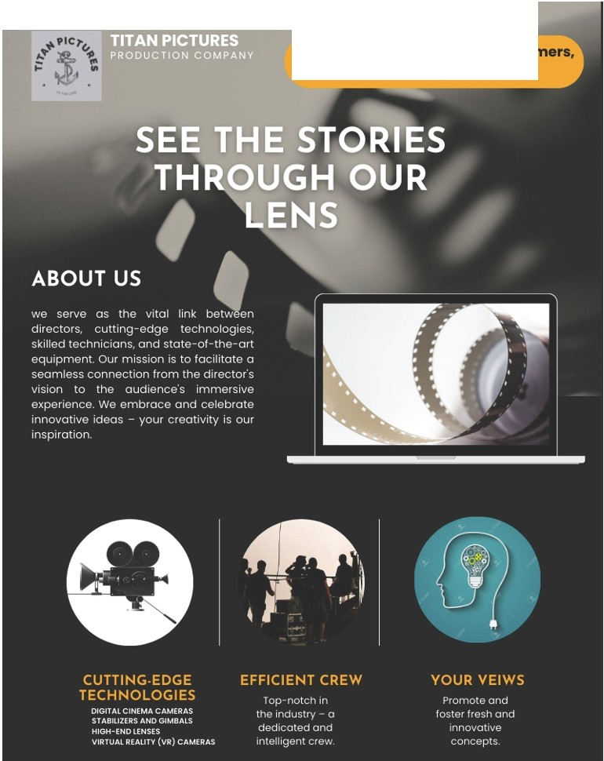

Ecstatic about gaining new customers,

Thank you!



Title

Titan Pictures NEWS letter

**r.111 Fl·** TT· N orma l •



-,,_-+.



••c,.""..'

 

. .

...

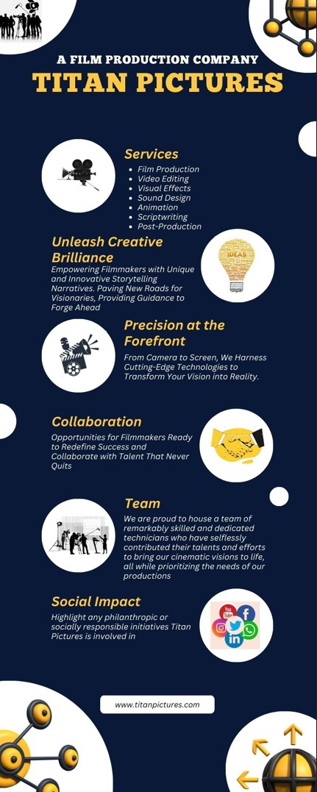



Title

Titan Pictures lnfographic

r.111 B· TT· Norma l •  



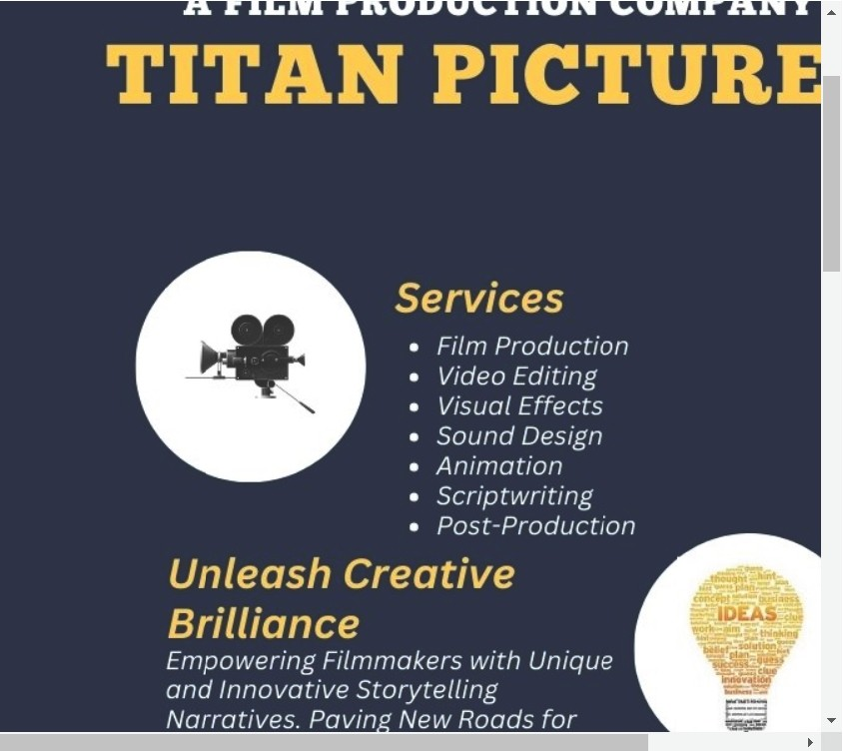

(§1

Blogger: Onboarding

x

Post Edit

x



T•tle

The New Film Production Entry!

**Fl·** TT· Norma l •   := "



**The Emerging Titan Pictures**

Introducing Titan Pictures:Ushering in a New Era of Cinematic Excellence



Lights, camera, action! The stage is set, the cameras are rolling, and a new star has risen in the world of film production -Titan Pictures. With an unwavering commitment to pushing boundaries and redefining cinematic artistry, Titan Pictures emerges as a beacon of creativity, innovation, and storytelling prowess.

A Vision Beyond the Ordinary

At the heart of Titan Pictures lies a vision that transcends the ordinary. We believe in the power of storytelling to notjust entertain, but also to inspire, provoke thought, and create lasting emotional connections. Our mission is to craft films that resonate with audiences on a profound level, leaving an indelible mark on their hearts and minds.

Unleashing Creativity

Titan Pictures prides itself on providing a nurturing environment for creative minds to flourish. We recognize that trne cinematic magic stems from the minds of passionate writers, visionary directors, dedicated producers, and a multitude of other talents. By fostering an atmosphere of collaboration and encouraging risk-taking, we aim to bring forth stories that captivate, challenge, and captivate.

Innovative Excellence

Innovation is the cornerstone of Titan Pictures. We're committed to embracing cutting-edge technologies and storytelling techniques to create a cinematic experience like no other. From mind -



