**Assignment 2: Student Information System**

**TASK : 2**

**Code :**

1. **Write an SQL query to insert a new student into the "Students" table with the following details:**
2. **First Name: John**
3. **Last Name: Doe**
4. **Date of Birth: 1995-08-15**
5. **Email:** [**john.doe@gmail.com**](mailto:john.doe@gmail.com)
6. **Phone Number: 1234567890**

***ANSWER :***

INSERT INTO Students (first_name, last_name, date_of_birth, email, phone_number) VALUES ("John","Doe",'1995-08-15',"john.doe@gmail.com",'1234567890');

1. **Write an SQL query to enroll a student in a course. Choose an existing student and course and insert a record into the "Enrollments" table with the enrollment date.**

***ANSWER:***

INSERT INTO Enrollments (student_id, course_id) VALUES (11,5);

1. **Update the email address of a specific teacher in the "Teacher" table. Choose any teacher and modify their email address.**

***ANSWER:***

UPDATE Teacher set email="rajeshmalhotra@yahoo.com" where teacher_id=1;

1. **Write an SQL query to delete a specific enrollment record from the "Enrollments" table. Select an enrollment record based on the student and course.**

***ANSWER:***

DELETE FROM Enrollments WHERE student_id = 10 AND course_id = 10;

1. **Update the "Courses" table to assign a specific teacher to a course. Choose any course and teacher from the respective tables.**

***ANSWER:***

INSERT INTO Teacher (first_name, last_name, email) VALUES

('Zack', 'Den', 'zac.den@example.com'); // optional code implemented

UPDATE Courses set teacher_id=11 where course_id=6; // main answer

1. **Delete a specific student from the "Students" table and remove all their enrollment records from the "Enrollments" table. Be sure to maintain referential integrity.**

***ANSWER:***

DELETE FROM Students where Student_id=10;

***SCREENSHOT TO SHOW REFERENTIAL INTEGRITY:***

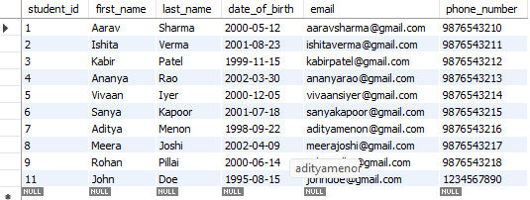

Student table where student_id=10 is deleted

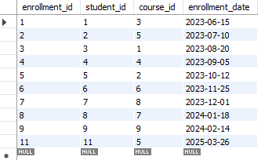

Employee table where student_id=10 automatically gets deleted as soon as the deletion happened in student table, as the student id is referenced as foreign key with “***ON DELETE CASCADE*** “

1. **Update the payment amount for a specific payment record in the "Payments" table. Choose any payment record and modify the payment amount.**

***ANSWER:***

UPDATE Payments SET amount=1600 where payment_id=1;

**FINAL TABLES VIEW**

1. **STUDENTS :**



1. **ENROLLMENTS :**



1. **PAYMENTS :**

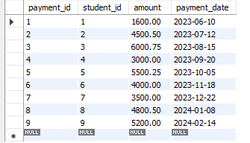

1. **COURSES :**

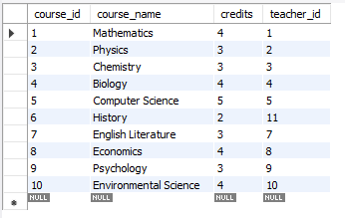

1. **TEACHER :**

