**Assignment 2: Student Information System**

**TASK : 3**

1. **Write an SQL query to calculate the total payments made by a specific student. You will need to join the "Payments" table with the "Students" table based on the student's ID**

***ANSWER:***

INSERT INTO Payments(student_id,amount,payment_date) VALUES(9,5000,'2024-02-15'); -- inserted this line for output purpose

SELECT s.student_id, s.first_name, s.email, SUM(p.amount) AS total_payment FROM payments p INNER JOIN students s ON s.student_id=p.student_id WHERE s.student_id=9 GROUP BY s.student_id; -- answer

***OUTPUT :***



1. **Write an SQL query to retrieve a list of courses along with the count of students enrolled in each course. Use a JOIN operation between the "Courses" table and the "Enrollments" table.**

***ANSWER:***

SELECT c.course_id, c.course_name, COUNT(e.student_id) AS student_count FROM courses c INNER JOIN enrollments e ON c.course_id=e.course_id GROUP BY c.course_id, c.course_name;

***OUTPUT:***

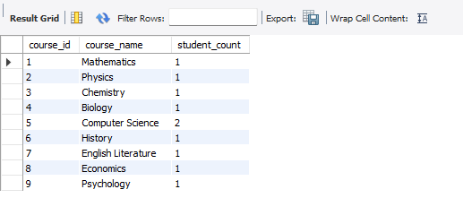

1. **Write an SQL query to find the names of students who have not enrolled in any course. Use a LEFT JOIN between the "Students" table and the "Enrollments" table to identify students without enrolment.**

***ANSWER:***

INSERT INTO Students (first_name, last_name, date_of_birth,

Email, phone_number) VALUES ("Joe","Shang",'1995-08-14',"joeshang@gmail.com",'123456765');

SELECT s.student_id, s.first_name FROM students s LEFT JOIN enrollments e ON s.student_id=e.student_id WHERE e.student_id IS NULL;

***OUTPUT :***

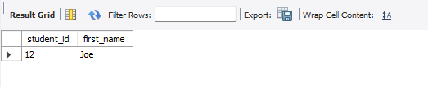

1. **Write an SQL query to retrieve the first name, last name of students, and the names of the courses they are enrolled in. Use JOIN operations between the "Students" table and the "Enrollments" and "Courses" tables.**

***ANSWER:***

SELECT s.first_name, s.last_name, c.course_name FROM students s INNER JOIN enrollments e ON s.student_id=e.student_id INNER JOIN courses c ON c.course_id=e.course_id;

**OUTPUT:**

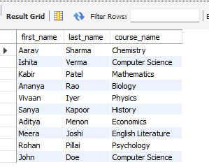

1. **Create a query to list the names of teachers and the courses they are assigned to. Join the "Teacher" table with the "Courses" table.**

***ANSWER:***

SELECT CONCAT (t.first_name,' ',t.last_name) AS teacher_name, c.course_name FROM teacher t INNER JOIN courses c ON t.teacher_id=c.teacher_id;

***OUTPUT:***

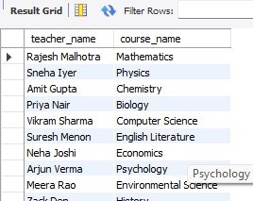

1. **Retrieve a list of students and their enrollment dates for a specific course. You'll need to join the "Students" table with the "Enrollments" and "Courses" tables.**

***ANSWER:***

SELECT s.student_id, c.course_name, e.enrollment_date FROM students s INNER JOIN enrollments e ON s.student_id=e.student_id INNER JOIN courses c ON c.course_id=e.course_id WHERE c.course_name="Computer Science";

***OUTPUT:***



1. **Find the names of students who have not made any payments. Use a LEFT JOIN between the "Students" table and the "Payments" table and filter for students with NULL payment records.**

**ANSWER:**

SELECT CONCAT (s.first_name, ' ', s.last_name) AS non_paying_student_name FROM students s LEFT JOIN payments p ON s.student_id=p.payment_id WHERE p.student_id IS NULL;

***OUTPUT:***

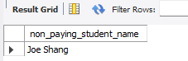

1. **Write a query to identify courses that have no enrollments. You'll need to use a LEFT JOIN between the "Courses" table and the "Enrollments" table and filter for courses with NULL enrollment records.**

**ANSWER:**

SELECT c.course_id, c.course_name FROM courses c LEFT JOIN enrollments e ON c.course_id=e.course_id WHERE e.course_id IS NULL;

***OUTPUT:***



1. **Identify students who are enrolled in more than one course. Use a self-join on the "Enrollments" table to find students with multiple enrollment records.**

**ANSWER:**

SELECT e1.student_id, COUNT(e2.course_id) as course_count FROM enrollments e1 JOIN enrollments e2 ON e1.student_id=e2.student_id GROUP BY (e1.student_id) HAVING course_count>1;

***OUTPUT:***



**10)Find teachers who are not assigned to any courses. Use a LEFT JOIN between the "Teacher" table and the "Courses" table and filter for teachers with NULL course assignments.**

**ANSWER:**

SELECT t.teacher_id, CONCAT (t.first_name,' ',t.last_name) AS teacher_name FROM teacher t LEFT JOIN courses c ON t.teacher_id=c.teacher_id WHERE c.course_id IS NULL;

***OUTPUT:***

