**Assignment 2: Student Information System**

**TASK : 4**

1. **Write an SQL query to calculate the average number of students enrolled in each course. Use aggregate functions and subqueries to achieve this.**

***ANSWER:***

SELECT AVG(student_count) AS avg_stud_count FROM

(SELECT COUNT(student_id) AS student_count FROM enrollments e group by course_id) AS stud_count_query;

***OUTPUT:***



1. **Identify the student(s) who made the highest payment. Use a subquery to find the maximum payment amount and then retrieve the student(s) associated with that amount.**

***ANSWER:***

SELECT s.student_id,s.first_name FROM payments p INNER JOIN

students s ON s.student_id=p.student_id WHERE amount=(SELECT MAX(amount) FROM payments);

***OUTPUT:***



1. **Retrieve a list of courses with the highest number of enrollments. Use subqueries to find the course(s) with the maximum enrollment count.**

***ANSWER:***

SELECT c.course_id,c.course_name,course_count

FROM (SELECT course_id,COUNT(student_id) AS course_count FROM enrollments GROUP BY course_id) AS course_counts

JOIN courses c ON course_counts.course_id=c.course_id

WHERE course_count=(SELECT MAX(course_count) FROM

(SELECT COUNT(student_id) AS course_count FROM enrollments

GROUP BY course_id) AS max_count_table);

***OUTPUT:***

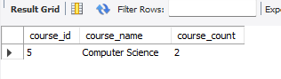

1. **Calculate the total payments made to courses taught by each teacher. Use subqueries to sum payments for each teacher's courses.**

***ANSWER:***

SELECT t.teacher_id,CONCAT(t.first_name,t.last_name) as teacher_name,c.course_id,c.course_name, (SELECT SUM(amount) FROM payments p JOIN enrollments e ON e.student_id=p.student_id JOIN courses c ON c.course_id=e.course_id WHERE t.teacher_id=c.teacher_id) AS tot_payment FROM TEACHER t INNER JOIN courses c ON t.teacher_id=c.teacher_id;

***OUTPUT:***

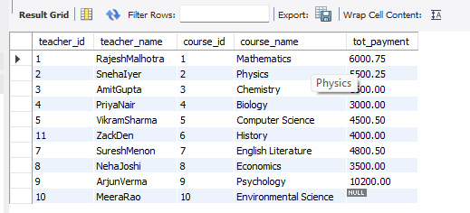

1. **Identify students who are enrolled in all available courses. Use subqueries to compare a student's enrollments with the total number of courses.**

***ANSWER:***

SELECT s.student_id,s.first_name,s.last_name

FROM students s WHERE (SELECT COUNT(*) FROM enrollments e

WHERE e.student_id=s.student_id) = (SELECT COUNT(*) FROM courses);

***OUTPUT:***



1. **Retrieve the names of teachers who have not been assigned to any courses. Use subqueries to find teachers with no course assignments.**

***ANSWER:***

SELECT t.teacher_id,CONCAT(t.first_name, ' ', t.last_name) AS teacher_name FROM teacher t WHERE t.teacher_id NOT IN (SELECT DISTINCT c.teacher_id FROM courses c);

***OUTPUT:***



1. **Calculate the average age of all students. Use subqueries to calculate the age of each student based on their date of birth.**

***ANSWER:***

SELECT AVG(YEAR(CURDATE())-YEAR(date_of_birth)) AS average_age FROM students;

***OUTPUT:***



1. **Identify courses with no enrollments. Use subqueries to find courses without enrollment records.**

***ANSWER:***

SELECT c.course_id,c.course_name FROM courses c WHERE c.course_id NOT IN (SELECT e.course_id FROM enrollments e);

***OUTPUT:***



1. **Calculate the total payments made by each student for each course they are enrolled in. Use subqueries and aggregate functions to sum payments.**

***ANSWER:***

SELECT e.student_id,e.course_id,(SELECT SUM(p.amount) FROM payments p WHERE p.student_id=e.student_id) AS total_payment FROM enrollments e JOIN students s ON e.student_id=s.student_id;

***OUTPUT:***

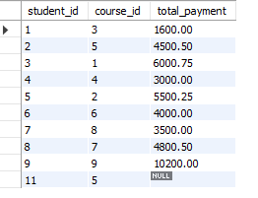

1. **Identify students who have made more than one payment. Use subqueries and aggregate functions to count payments per student and filter for those with counts greater than one.**

***ANSWER:***

SELECT student_id,(SELECT COUNT(*) FROM payments p WHERE p.student_id=s.student_id) AS payment_count FROM students s WHERE (SELECT COUNT(*) FROM payments p WHERE p.student_id=s.student_id) > 1;

***OUTPUT:***



1. **Write an SQL query to calculate the total payments made by each student. Join the "Students" table with the "Payments" table and use GROUP BY to calculate the sum of payments for each student.**

***ANSWER:***

SELECT s.student_id,CONCAT(s.first_name,' ',s.last_name) AS student_name,SUM(p.amount) AS tot_payments FROM students s INNER JOIN payments p ON p.student_id=s.student_id GROUP BY s.student_id;

***OUTPUT:***

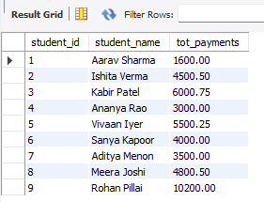

1. **Retrieve a list of course names along with the count of students enrolled in each course. Use JOIN operations between the "Courses" table and the "Enrollments" table and GROUP BY to count enrollments.**

***ANSWER:***

SELECT c.course_id,c.course_name,COUNT(e.student_id) AS tot_students FROM courses c LEFT JOIN enrollments e ON c.course_id=e.course_id GROUP BY c.course_id;

***OUTPUT:***

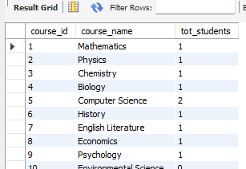

1. **Calculate the average payment amount made by students. Use JOIN operations between the "Students" table and the "Payments" table and GROUP BY to calculate the average.**

***ANSWER:***

SELECT s.student_id,CONCAT(s.first_name,' ',s.last_name) AS student_name,ROUND(AVG(p.amount),2) AS avg_amt

FROM students s INNER JOIN payments p ON s.student_id = p.student_id GROUP BY s.student_id;

***OUTPUT:***

