**Ex no: 5**

**CAPTURING AND ANALYSING PACKETS USING WIRESHARK TOOL**

Capturing packets:

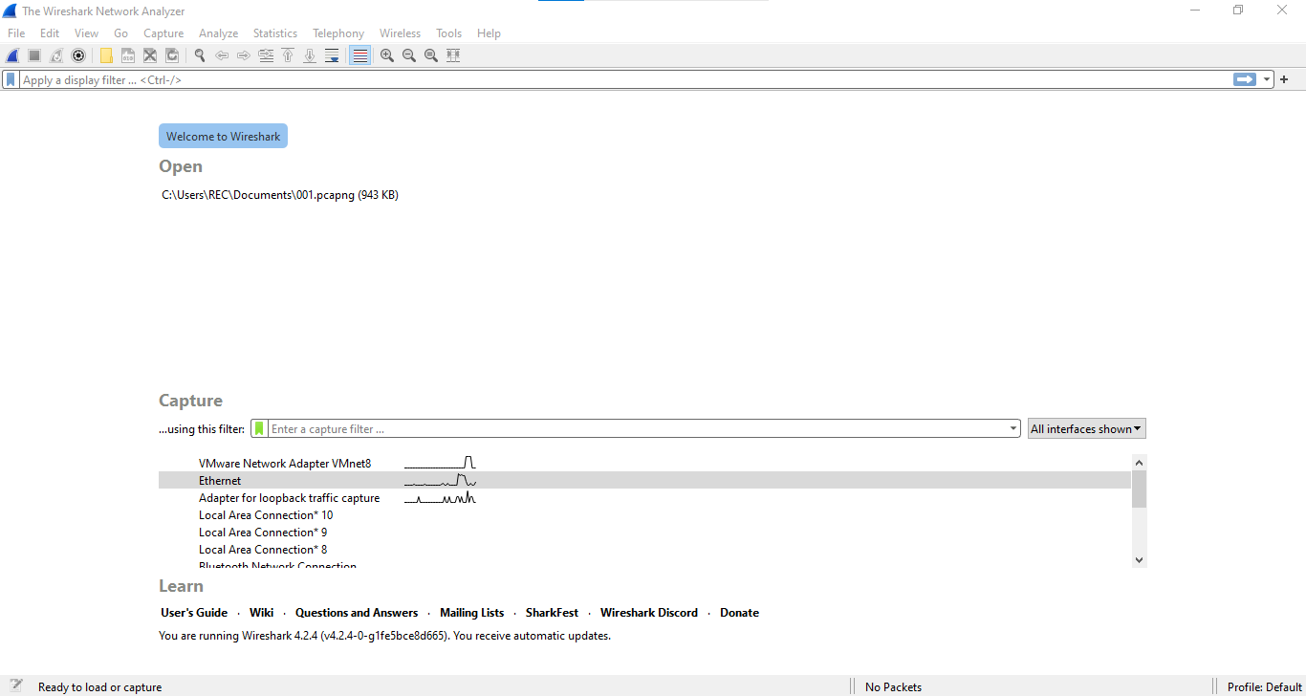

Packet list, Packet details, Packet bytes:

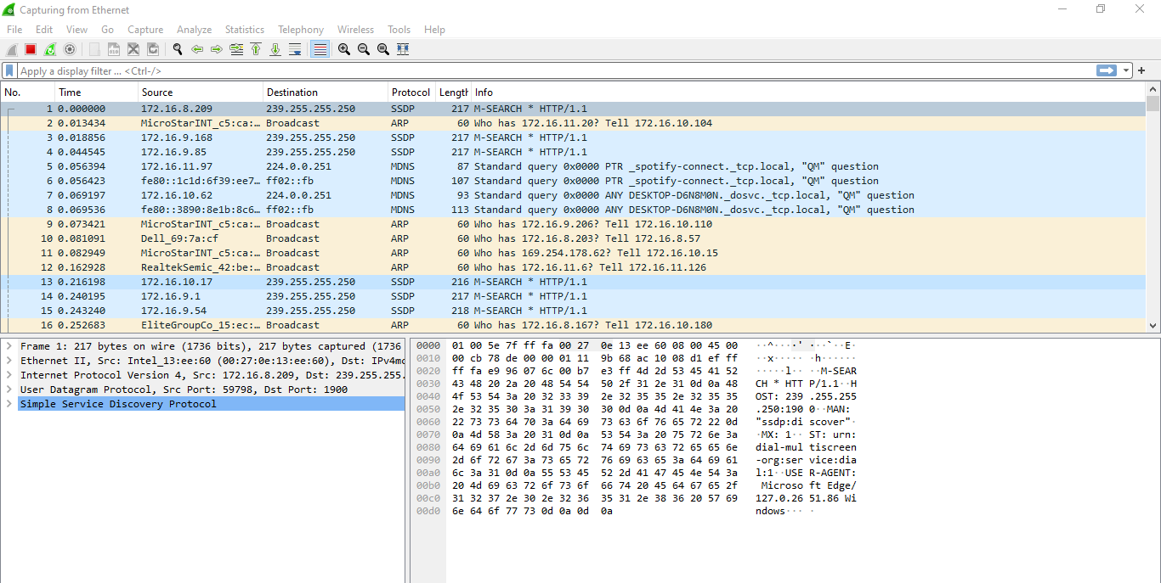

**Packet bytes**

**Packet details**

**Packet list**

Color coding:

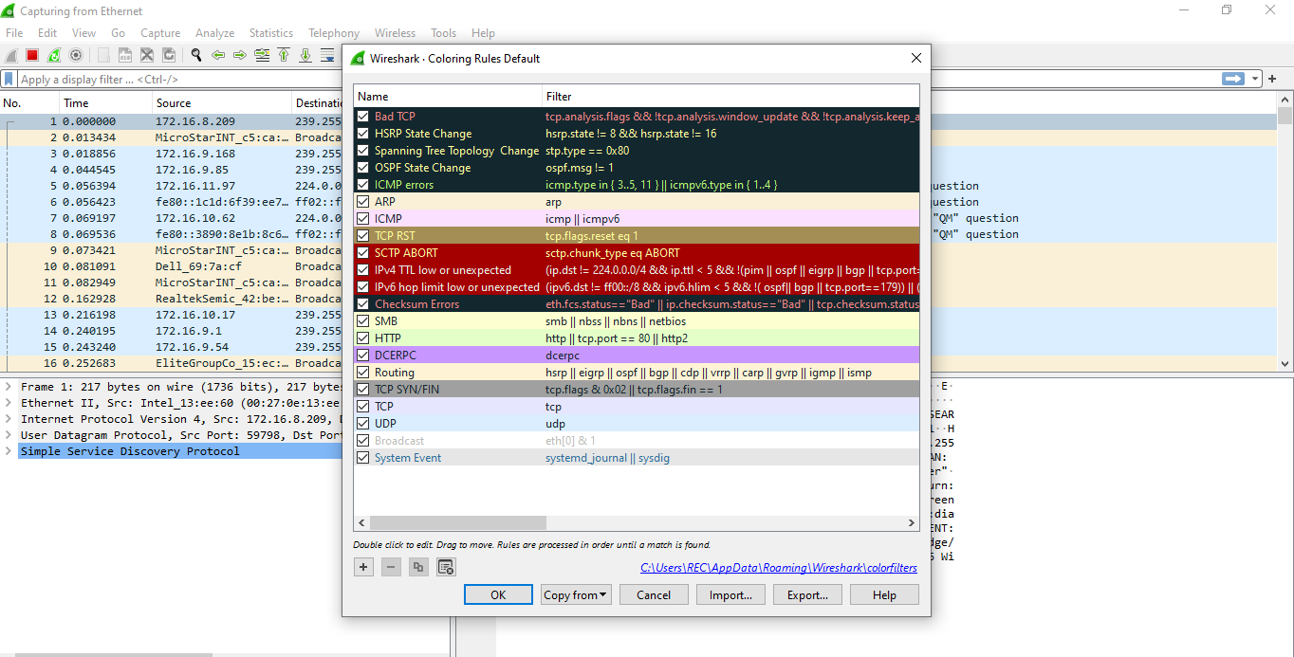

Filtering Packets:

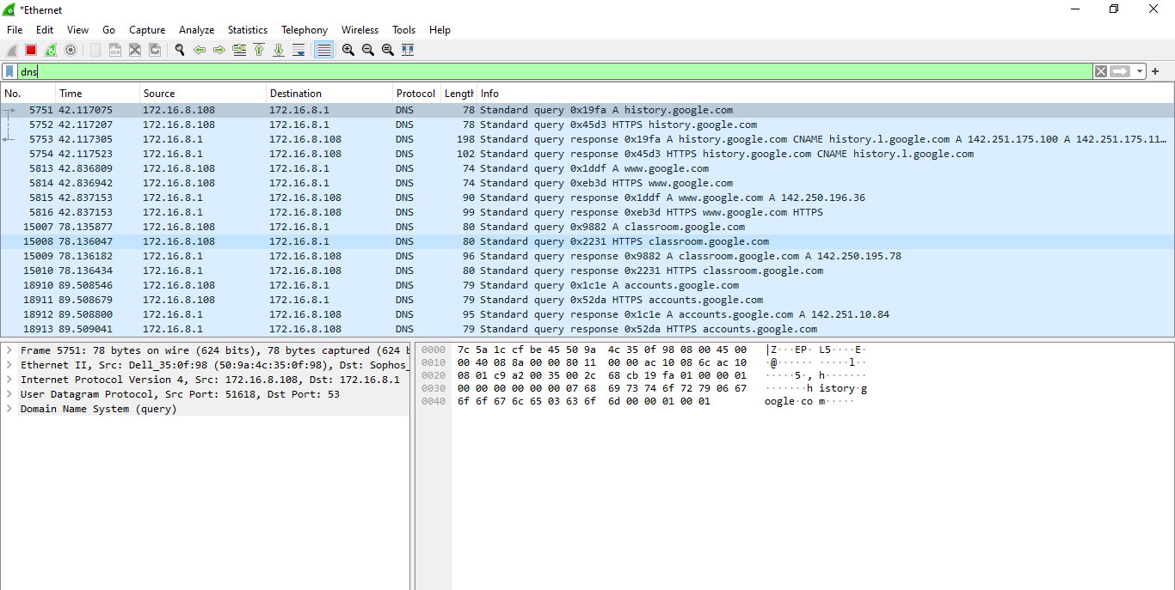

Display Filters:

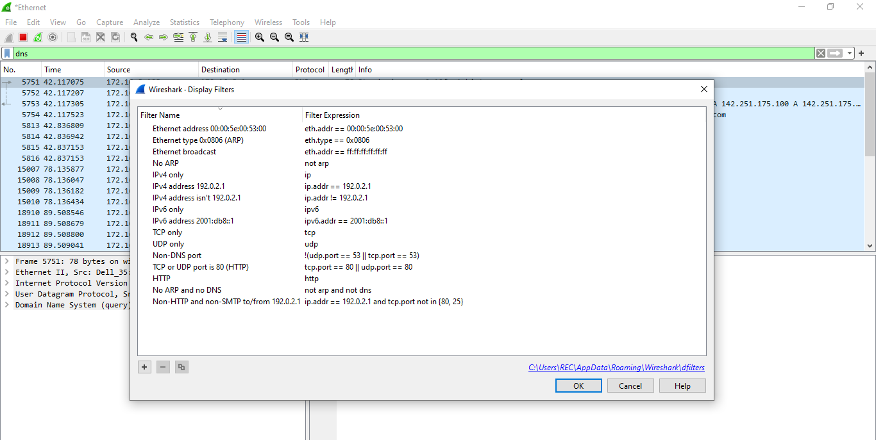

TCP Stream:

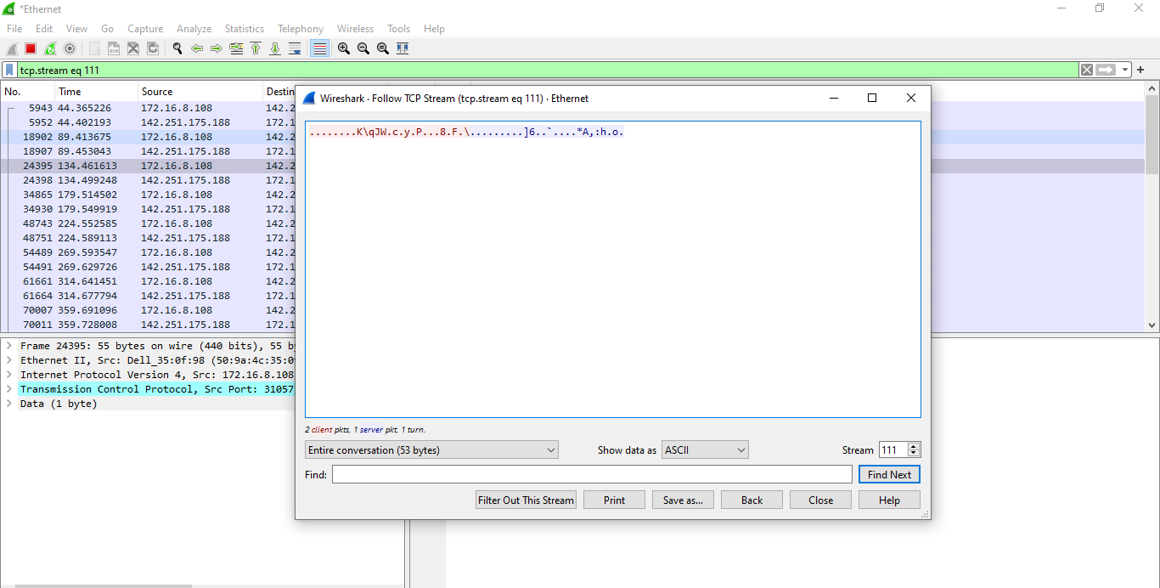

Inspecting package:

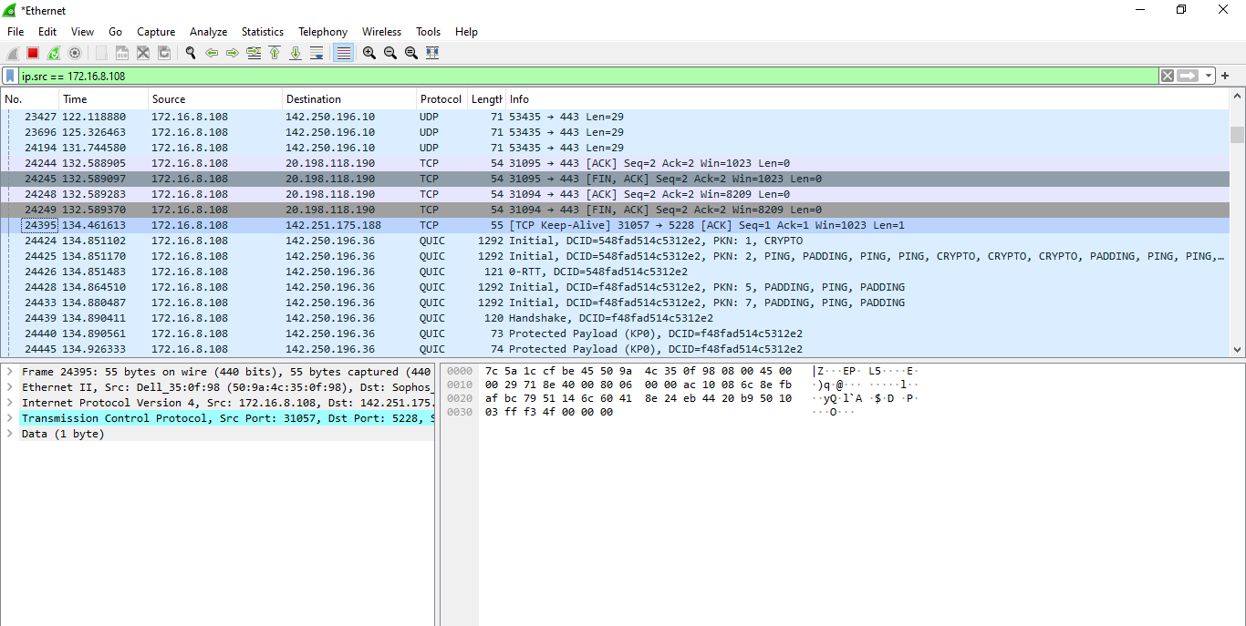

Flow Graph:

