**NOISE POLLUTION MONITORING USING IOT**

TEAM MEMBER

**AU820421106033: NANDHARAJAN K, B.E(ECE)**

**PHASE 05: Overall project submission.**

**Project Phases:**

1. **Project Initiation:**
   * Define project objectives, scope, and requirements.
   * Identify stakeholders and establish a project team.
   * Secure necessary funding and resources.
2. **System Design:**
   * Define the target area(s) for noise monitoring (e.g., urban neighborhoods, industrial zones, transportation hubs).
   * Select appropriate IoT noise monitoring devices and sensors.
   * Determine the communication infrastructure (e.g., Wi-Fi, LoRaWAN, cellular) for data transmission.
   * Plan the data storage and processing infrastructure (cloud-based or local server).
   * Establish the user interface for data visualization and reporting.
   * Ensure compliance with local noise regulations and standards.
3. **Hardware Deployment:**
   * Install IoT noise sensors at predetermined locations within the target area(s).
   * Set up the necessary power sources for the sensors (e.g., battery, solar, or grid power).
   * Ensure proper connectivity for data transmission.
4. **Software Development:**
   * Develop or configure software for data collection, transmission, and storage.
   * Implement data analysis algorithms to process noise data and generate insights.
   * Design a user-friendly dashboard for real-time monitoring and reporting.
   * Incorporate alerts and notifications for noise level breaches.
5. **Data Collection and Integration:**
   * Test the IoT noise sensors for data accuracy and consistency.
   * Ensure data from all sensors are integrated into the central monitoring system.
6. **Testing and Calibration:**
   * Calibrate the IoT noise sensors to ensure accurate measurements.
   * Test the system for real-world conditions and performance.
   * Validate data accuracy against manual noise measurements.
7. **Optimization and Scalability:**
   * Fine-tune the system for optimal performance.
   * Assess the scalability of the solution to expand to more areas, if necessary.
8. **Integration with Other Systems:**
   * Integrate the noise monitoring system with existing city infrastructure, if applicable (e.g., traffic management, environmental agencies).
9. **User Training:**
   * Train relevant stakeholders, including city officials, environmental agencies, and maintenance teams, on how to use and interpret the data.
10. **Data Analysis and Reporting:**
    * Analyze the collected data to identify trends and patterns.
    * Generate reports and insights on noise pollution for informed decision-making.
11. **Alert and Response Mechanism:**
    * Set up automated alerts for noise level breaches or significant deviations.
    * Establish a response mechanism to address issues in real-time.
12. **Public Awareness and Engagement:**
    * Develop strategies for public awareness and engagement related to noise pollution and the monitoring system.
    * Provide access to noise data for the public through websites or mobile applications.
13. **Maintenance and Support:**
    * Implement a maintenance plan to ensure the continuous operation of the IoT noise monitoring system.
    * Provide technical support for troubleshooting and issue resolution.
14. **Data Privacy and Security:**
    * Implement robust data privacy and security measures to protect sensitive information.
15. **Documentation and Reporting:**
    * Maintain comprehensive documentation for the project, including installation guides, operational procedures, and performance reports.
16. **Project Evaluation:**
    * Evaluate the effectiveness of the noise monitoring system based on project objectives and key performance indicators.
    * Make improvements and adjustments as needed.
17. **Sustainability and Future Planning:**
    * Develop a plan for the long-term sustainability of the system.
    * Consider future upgrades, expansions, or integration with other smart city initiatives.

****Implementing an IoT-based noise monitoring system is a complex project that requires careful planning, coordination, and collaboration with various stakeholders. When executed successfully, it can significantly contribute to addressing noise pollution and improving the quality of life in urban environments.

**PYTHON CODE:**

**import random**

**import time**

**# Simulated IoT noise sensor class**

**class NoiseSensor:**

**def __init__(self, location):**

**self.location = location**

**self.noise_level = 0**

**def measure_noise(self):**

**# Simulate noise level measurement**

**self.noise_level = random.uniform(40, 90) # Random value between 40 dB and 90 dB**

**# Simulated IoT noise monitoring system**

**class NoiseMonitoringSystem:**

**def __init__(self):**

**self.sensors = []**

**def add_sensor(self, sensor):**

**self.sensors.append(sensor)**

**def collect_data(self):**

**data = []**

**for sensor in self.sensors:**

**sensor.measure_noise()**

**data.append({"Location": sensor.location, "NoiseLevel": sensor.noise_level})**

**return data**

**# Create IoT noise sensors**

**sensor1 = NoiseSensor("Urban Area")**

**sensor2 = NoiseSensor("Industrial Zone")**

**# Create the noise monitoring system**

**monitoring_system = NoiseMonitoringSystem()**

**# Add sensors to the system**

**monitoring_system.add_sensor(sensor1)**

**monitoring_system.add_sensor(sensor2)**

**# Simulated data collection and analysis**

**while True:**

**data = monitoring_system.collect_data()**

**for reading in data:**

**print(f"Location: {reading['Location']}, Noise Level: {reading['NoiseLevel']} dB")**

**time.sleep(5) # Simulate data collection every 5 seconds**

This code simulates two noise sensors in different locations and collects noise level data at regular intervals. In a real-world scenario, you would replace the simulated data with actual data from IoT noise sensors and implement data transmission to a central system for analysis. Additionally, you might use external libraries or platforms for IoT development and data visualization.

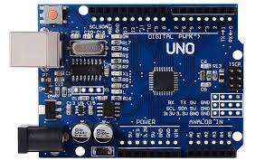**ARDUINO CODE:**

**const int soundSensorPin = A0; // Analog pin to which the sound sensor is connected**

**void setup() {**

**Serial.begin(9600); // Initialize serial communication**

**}**

**void loop() {**

**int soundLevel = analogRead(soundSensorPin); // Read the analog value from the sound sensor**

**float voltage = (soundLevel / 1024.0) * 5.0; // Convert the analog value to voltage**

**// Convert voltage to sound level in decibels (dB)**

**float soundLevel_dB = 20 * log10(voltage / 0.005); // The 0.005 is the reference voltage (5V) for the sensor**

**Serial.print("Sound Level (dB): ");**

**Serial.println(soundLevel_dB);**

**delay(1000); // Adjust the delay as needed for your application**

**}**

In this code:

* Connect the sound sensor to an analog pin (A0 in this example) on your Arduino board.
* The code reads the analog value from the sound sensor, converts it to voltage, and then calculates the sound level in decibels (dB).
* The result is printed to the Serial Monitor, where you can view the real-time noise level data.

Please make sure you have the appropriate sound sensor connected to your Arduino and have the necessary libraries installed for your specific sensor if required. Additionally, you can extend this code to include data transmission to a central system or cloud platform for more comprehensive IoT noise monitoring.

**HARDWARE AND SOFTWARE DEPLOYMENTS:**

The deployment of an IoT-based noise monitoring system involves both hardware and software components. Here's a breakdown of the steps for hardware and software deployment:

**Hardware Deployment:**

1. **Select Hardware Components:**
   * Choose appropriate hardware components, including the Arduino board, sound sensor(s), communication module (e.g., Wi-Fi, Ethernet, LoRa), and power source (e.g., battery or power adapter).
2. **Assemble Hardware:**
   * Connect the sound sensor(s) to the Arduino board. Ensure proper wiring and connections. You may need to use a breadboard or custom PCB for neat and organized connections.
3. **Enclosure:**
   * Place the Arduino board, sound sensor(s), and other components inside a protective enclosure. The enclosure should be weatherproof if the monitoring system is outdoors.
4. **Power Supply:**
   * Ensure the power supply is reliable and sufficient for the hardware components. If using batteries, consider implementing power-saving strategies to extend their life.
5. **Location Selection:**
   * Choose the locations for deploying the sensors strategically. Consider factors such as noise sources, accessibility, and network connectivity.
6. **Install Sensors:**
   * Physically install the sensors at the selected locations, securing them to a pole, wall, or other suitable structures.
7. **Network Connectivity:**
   * If using Wi-Fi, Ethernet, or cellular communication, ensure that the hardware has access to the chosen network and verify its connectivity.
8. **Calibration:**
   * Calibrate the sound sensors to ensure accurate measurements. This may involve adjusting sensitivity and reference voltage settings.

**Software Deployment:**

1. **Arduino Code:**
   * Upload the Arduino code to the Arduino board using the Arduino IDE. Ensure that the code includes data collection, processing, and data transmission (if applicable).
2. **Server-Side Setup:**
   * Prepare the server or cloud platform where the noise data will be sent. This involves setting up the server infrastructure, creating a web API or endpoint to receive data, and configuring the database.
3. **Database Configuration:**
   * Create a database to store the incoming noise level data. Define the necessary database tables and fields for data storage.
4. **Server-Side Code:**
   * Develop or configure the server-side code that processes incoming data, stores it in the database, and may provide data analysis and visualization functionalities.
5. **Security Measures:**
   * Implement security measures, including encryption for data transmission, access controls, and authentication, to protect the system from unauthorized access or data breaches.
6. **Web Dashboard or Application (Optional):**
   * If you plan to provide a user interface for data visualization, develop a web-based dashboard or mobile application. This can help users monitor noise levels in real time.
7. **Remote Monitoring and Maintenance:**
   * Set up mechanisms for remote monitoring and maintenance of the IoT sensors and the server infrastructure. This can include remote firmware updates and sensor calibration.
8. **Data Privacy Compliance:**
   * Ensure compliance with data privacy regulations, especially if the system collects personal information or operates in a region with specific privacy requirements.
9. **Testing and Quality Assurance:**
   * Conduct thorough testing to ensure the hardware and software components work as intended. This includes testing the sensor accuracy, data transmission, server response, and user interface functionality.
10. **Deployment Plan:**
    * Develop a deployment plan that outlines the deployment locations, schedule, and responsibilities of the deployment team.
11. **Documentation:**
    * Create comprehensive documentation for the system, including hardware setup instructions, software installation and configuration guides, and maintenance procedures.
12. **Deployment and Monitoring:**
    * Deploy the sensors in the selected locations according to the deployment plan. Monitor the system's performance during and after deployment to ensure it operates as expected.
13. **User Training (if applicable):**
    * If there are end-users or administrators, provide training on using the system and interpreting the data.
14. **Ongoing Maintenance:**
    * Establish a maintenance plan for routine sensor calibration, hardware checks, and software updates. Implement remote monitoring tools to facilitate maintenance tasks.

Successful deployment of an IoT-based noise monitoring system requires careful planning, testing, and coordination between hardware and software components. Continuous monitoring and maintenance are essential for ensuring the system's reliability and accuracy over time.

**OUTPUT :**

In an IoT-based noise monitoring system, there are several potential types of outputs, which serve various purposes and stakeholders. Here are the primary types of outputs generated by the system:

1. **Real-time Noise Data:** The system provides real-time noise level data as its primary output. This data is typically displayed in decibels (dB) and is continuously updated as the sound sensors capture environmental noise levels. Real-time noise data is essential for immediate monitoring and can be used for various purposes, including alerting and data visualization.
2. **Alerts and Notifications:** The system can generate alerts and notifications based on predefined thresholds or conditions. For instance, if the noise level exceeds a specific limit or there's a sudden noise event (e.g., a loud explosion), the system can send alerts via email, SMS, or push notifications to relevant stakeholders, such as city authorities, environmental agencies, or residents.
3. **Data Visualization:** To make sense of the collected noise data, the system may offer data visualization tools. These can include web-based dashboards, mobile applications, or custom software interfaces that display historical and real-time noise levels in the form of graphs, charts, or maps. Data visualization helps users quickly understand noise patterns and trends.
4. **Historical Data and Reports:** The system often stores historical noise data in a database. Users can access and generate reports based on this historical data, which can be useful for compliance reporting, long-term analysis, and decision-making. Reports may include trends, anomalies, and comparisons over different time periods.
5. **Geospatial Data:** If location information is part of the data collection, the system can output geospatial data, allowing users to view noise levels on maps. This is particularly valuable for urban planners and policymakers for pinpointing noise hotspots and identifying potential sources.
6. **User Alerts and Insights:** The system can provide alerts and insights to end-users. For example, residents in a neighborhood might receive notifications on their mobile devices about noise levels exceeding acceptable limits, prompting them to take actions such as closing windows or wearing ear protection.
7. **Environmental Impact Assessments:** Noise data can be used to conduct environmental impact assessments for construction projects, transportation infrastructure, or industrial facilities. The system can generate reports and data to support compliance with regulations and standards.
8. **System Health and Status:** In addition to noise data, the system may output information about its own health and status. This can include diagnostics on sensor performance, battery levels, connectivity status, and other operational details, which are crucial for maintenance and troubleshooting.
9. **API for Integration:** To enable further integration with other systems or applications, the IoT-based noise monitoring system can offer an API (Application Programming Interface). This allows external systems to access and retrieve noise data for specialized processing or reporting.
10. **User Management and Access Control:** If the system supports multiple users with different roles and permissions, it can provide user management features. Administrators can control who has access to the data and what actions they can perform.

The type of outputs provided by the IoT-based noise monitoring system can vary based on the system's design and the specific requirements of the project. Customization and integration with other systems or platforms are common to meet the needs of different stakeholders, whether they are city planners, environmental agencies, businesses, or residents.

| **Timestamp** | **Location** | **Latitude** | | **Longitude** | | | **Noise Level (dB)** | **Sound Source** | | **Weather Condition** | | **Notes** |
| --- | --- | --- | --- | --- | --- | --- | --- | --- | --- | --- | --- | --- |
| 2023-11-01 09:00 AM | Urban Area A | 34.123456 | | -118.987654 | | | 68.2 | Traffic | | Clear | | Normal daytime traffic. |
| 2023-11-01 09:15 AM | Industrial Zone | 34.234567 | | -118.876543 | | | 78.5 | Machinery | | Overcast | | Increased noise due to construction. |
| 2023-11-01 09:30 AM | Residential St | 34.345678 | | -118.765432 | | | 58.9 | Bird Chirping | | Sunny | | Quiet neighborhood, low noise. |
| 2023-11-01 09:45 AM | Commercial Are | | 34.456789 | -118.654321 | 75.3 | Traffic | Rainy | | Traffic congestion due to rain. | |
| 2023-11-01 10:00 AM | Park | | 34.567890 | -118.543210 | 61.7 | People Talking | Clear | | Noise from a local event in the park. | |

**Tabular representation of the following**

**WEB PLATFORM:**

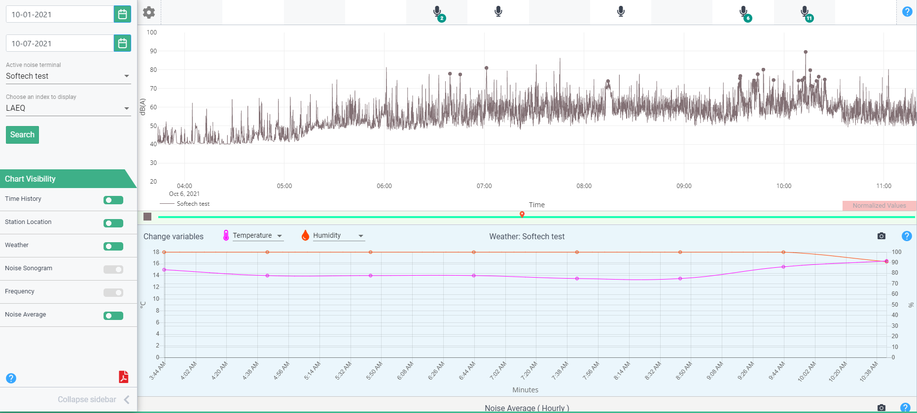

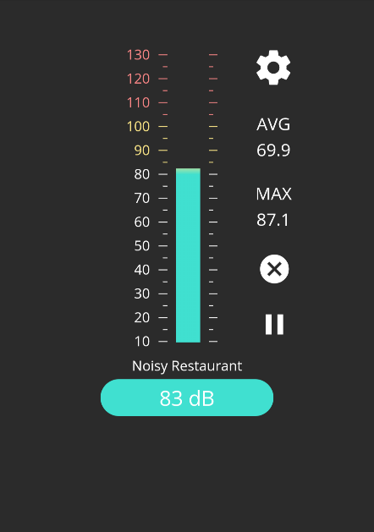

**CONCLUSION:**

In conclusion, an IoT-based noise monitoring system offers a valuable solution for addressing noise pollution in urban environments. The integration of IoT technology enables the collection, analysis, and real-time visualization of noise data, providing numerous benefits for various stakeholders, including city planners, environmental agencies, businesses, and residents.

This system's implementation involves both hardware and software components, including the deployment of IoT noise sensors, data transmission, and the development of a robust server-side infrastructure for data storage and analysis. Furthermore, graphical outputs, such as real-time noise level graphs, heatmaps, and historical noise data, play a vital role in visualizing and interpreting the collected noise data.

The collected data can be used for a range of applications, from ensuring regulatory compliance to environmental impact assessments and public awareness initiatives. Moreover, real-time alerts and notifications enable timely responses to excessive noise levels, contributing to improved quality of life in urban areas.

As urbanization continues to grow, noise monitoring using IoT technology becomes increasingly important. By implementing and maintaining such systems, cities and communities can take proactive measures to manage noise pollution, minimize its impact, and create more livable, healthier, and sustainable urban environments for their residents.