TASK 1 – OWASP JUICE SHOP
Web Application Security Vulnerability Analysis

Name: NANDHETHA VALAVANGOTHAI
Register No.: RA2511026020133
Department: CSE (AIML) - 2nd year

1. Introduction
OWASP Juice Shop is an intentionally vulnerable web application used for learning and practicing web application security. In this task, the application was run locally and different security challenges were explored.
The following four vulnerabilities/challenges are documented in this report:
- Login Admin – Injection / SQL Injection
- DOM XSS – Cross-Site Scripting
- Confidential Document – Sensitive Data Exposure
- Admin Section – Broken Access Control

2. Testing Environment
- Application: OWASP Juice Shop
- Execution: Localhost
- URL: http://localhost:3000
- Operating System: Windows
- Purpose: Authorized educational security testing

3. Vulnerability 1 – Login Admin

Vulnerability Type
Injection / SQL Injection

What is the vulnerability?
SQL Injection occurs when untrusted user input is included directly in a database query. An attacker may manipulate the input so that the application performs unintended database operations.

Exploitation / Demonstration Steps
- Open the locally hosted OWASP Juice Shop.
- Navigate to the Login page.
- Test the login functionality using the challenge input.
- The application accepts manipulated input and grants administrator access.
- Verify that the administrator account is logged in and the challenge is marked as solved.

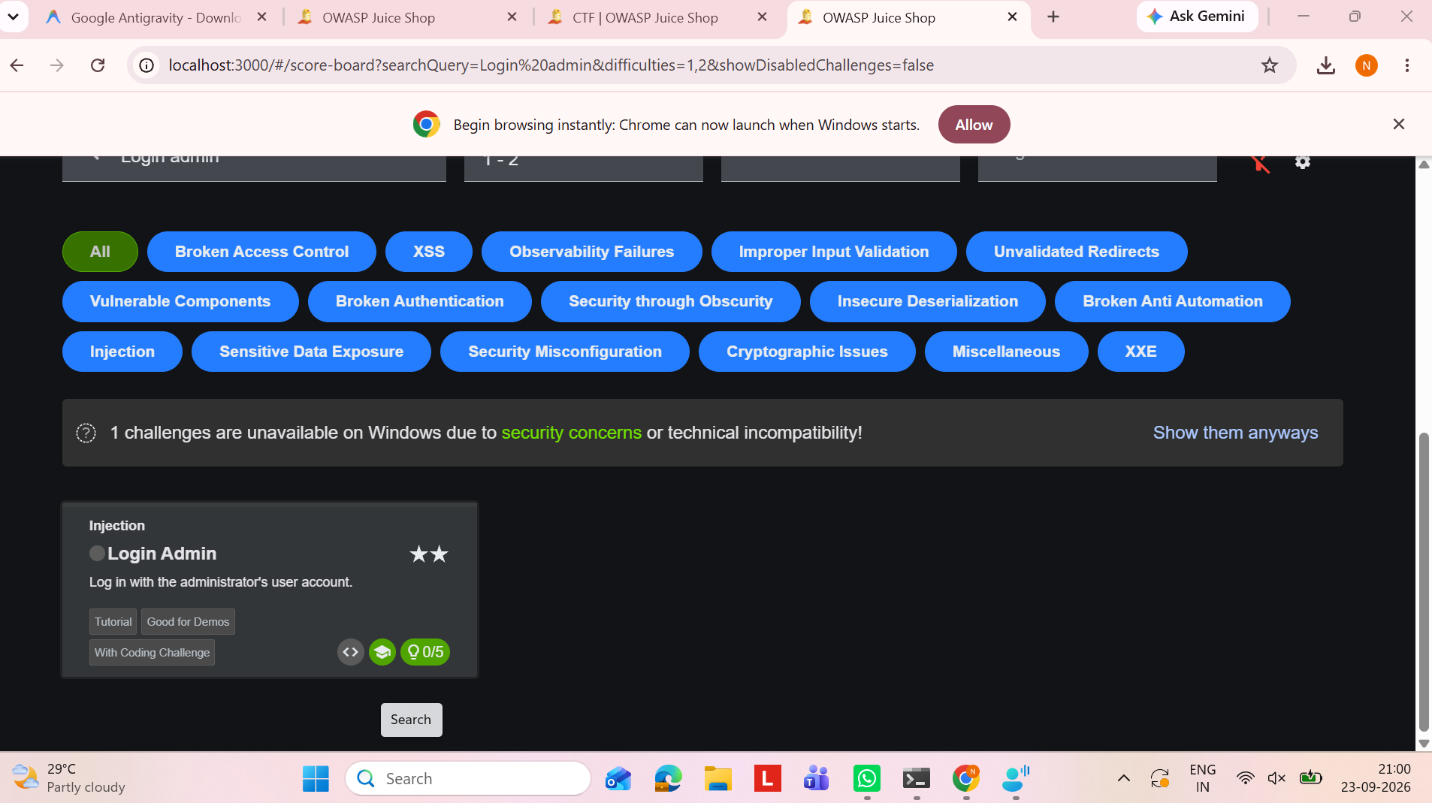
Figure 1: OWASP Juice Shop Score Board showing the Login Admin challenge.

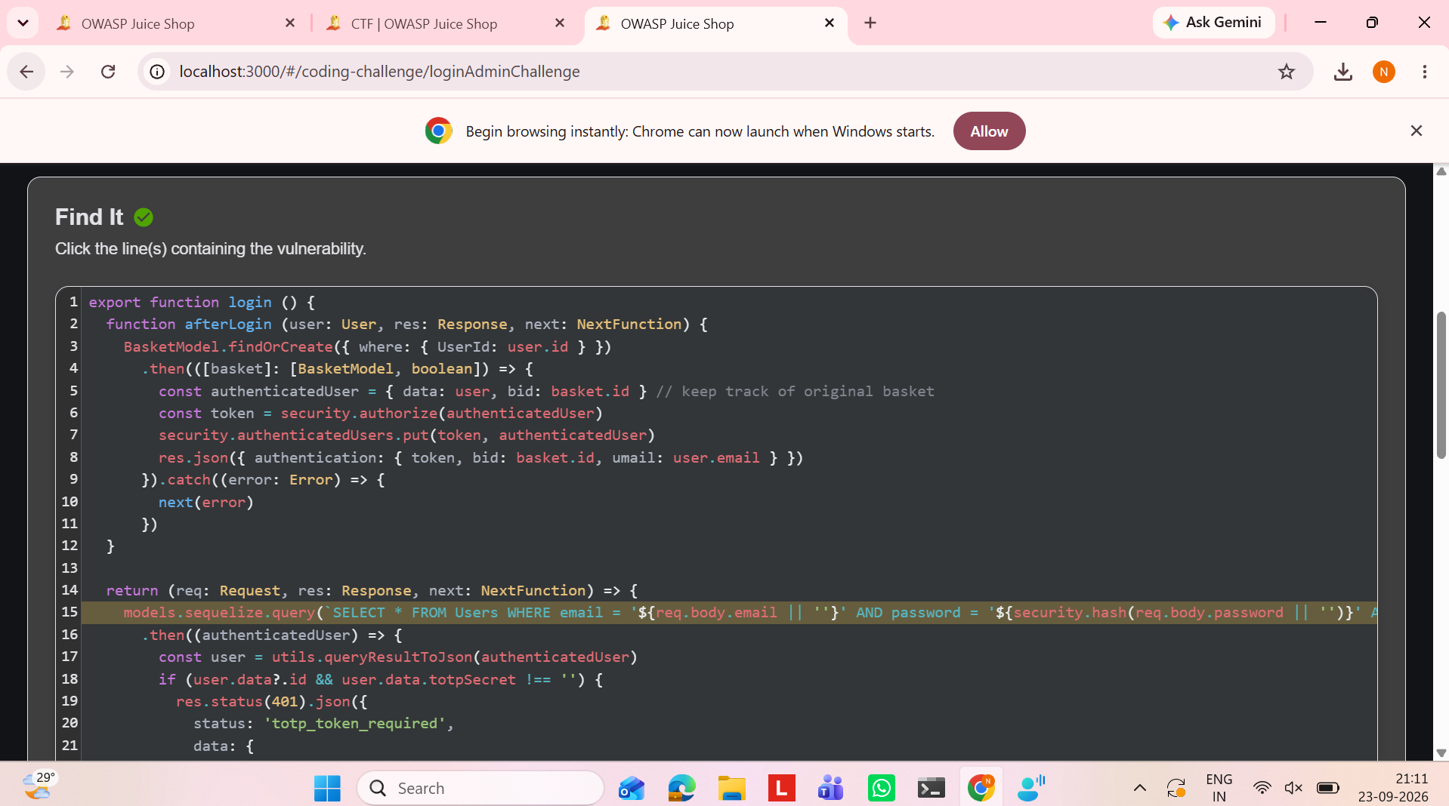
Figure 2: Login Admin coding challenge – identifying the vulnerable code.
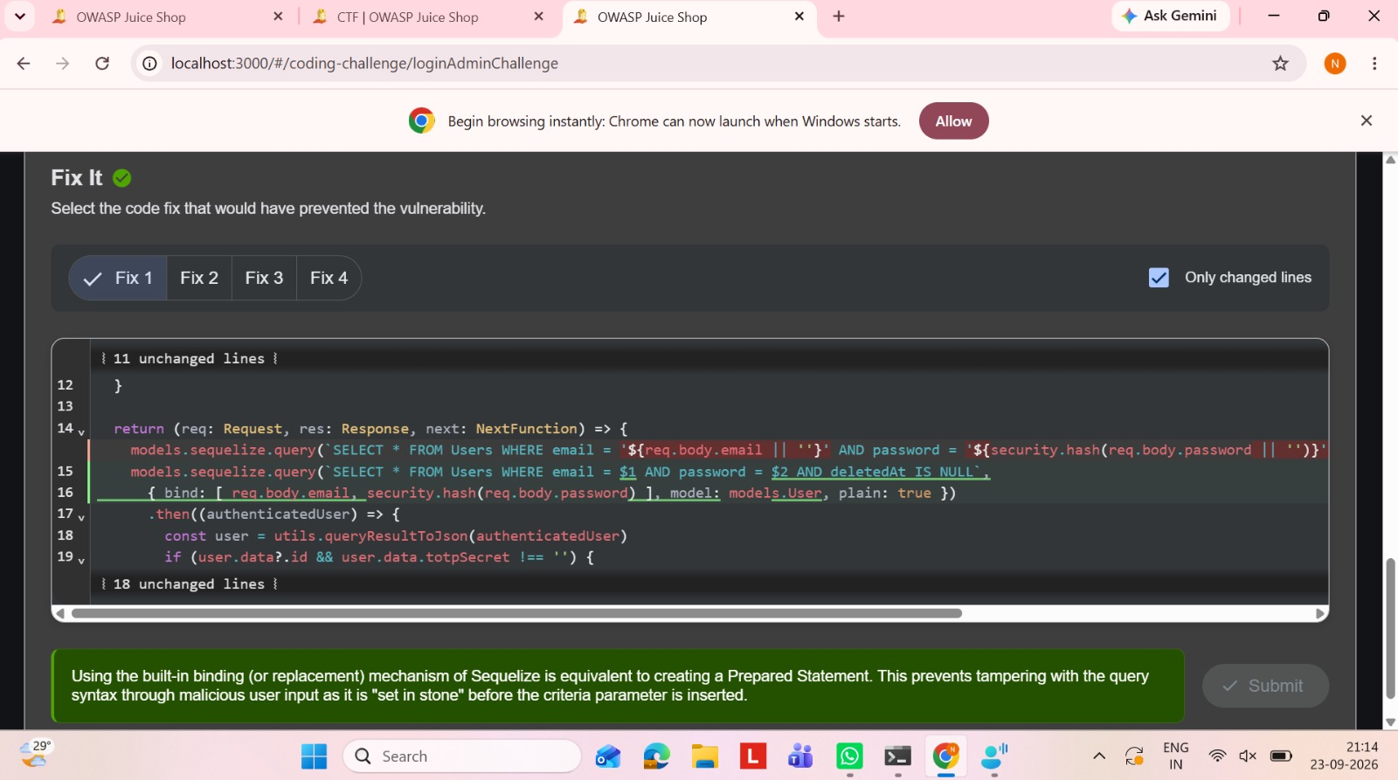
Figure 3: Login Admin coding challenge – selecting the secure code fix.

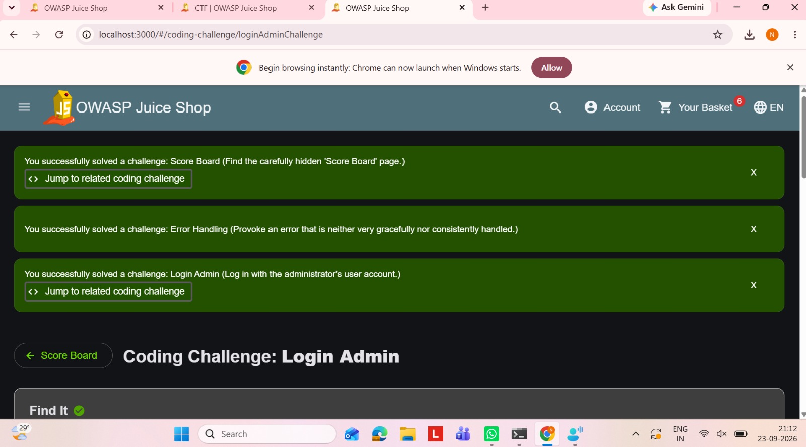
Figure 4: Login Admin challenge successfully solved.

Real-World Security Risk
SQL Injection can allow unauthorized login, access to sensitive database information, modification of records, or other unauthorized actions.

4. Vulnerability 2 – DOM XSS

Vulnerability Type
Cross-Site Scripting (XSS)

What is the vulnerability?
DOM-based XSS occurs when client-side JavaScript uses attacker-controlled input in an unsafe way, allowing JavaScript to execute in the victim's browser.

Exploitation / Demonstration Steps
- Open the Juice Shop application.
- Use the search or relevant input functionality used by the challenge.
- Enter the challenge XSS payload.
- Observe that the JavaScript executes in the browser.
- Verify that the DOM XSS challenge is marked as solved.

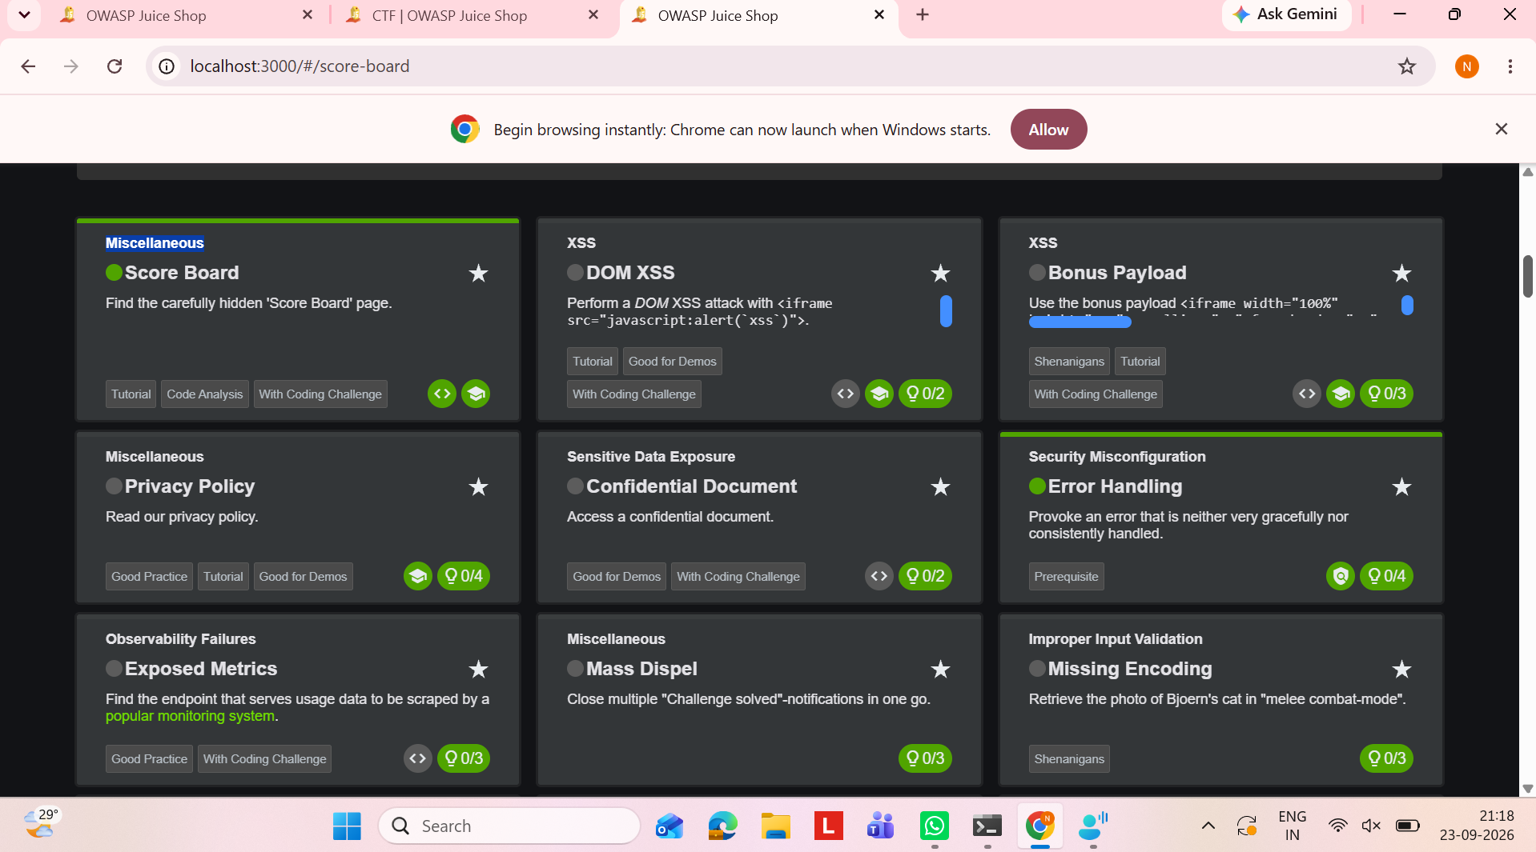
Figure 5: OWASP Juice Shop DOM XSS challenge and challenge information.
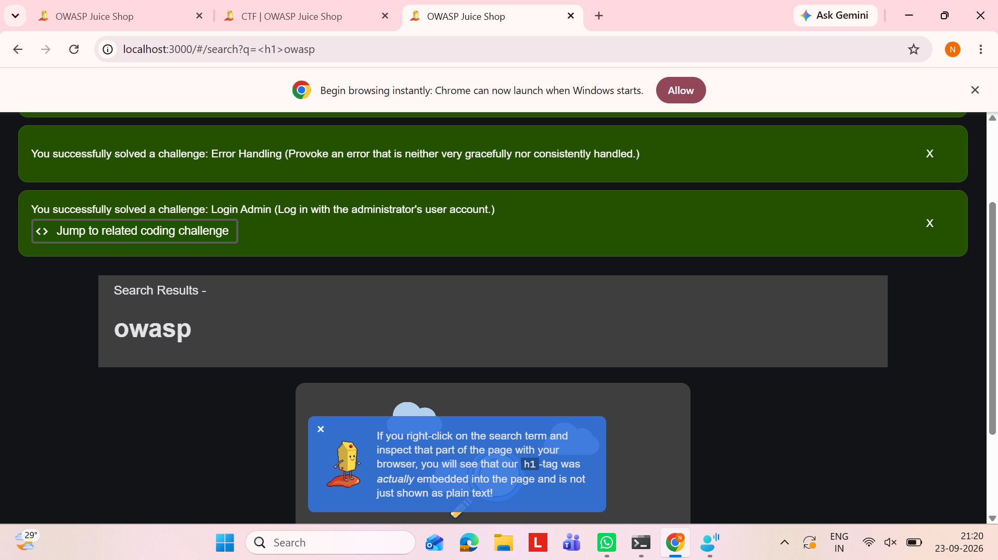
Figure 6: DOM XSS challenge – search input containing the XSS payload.

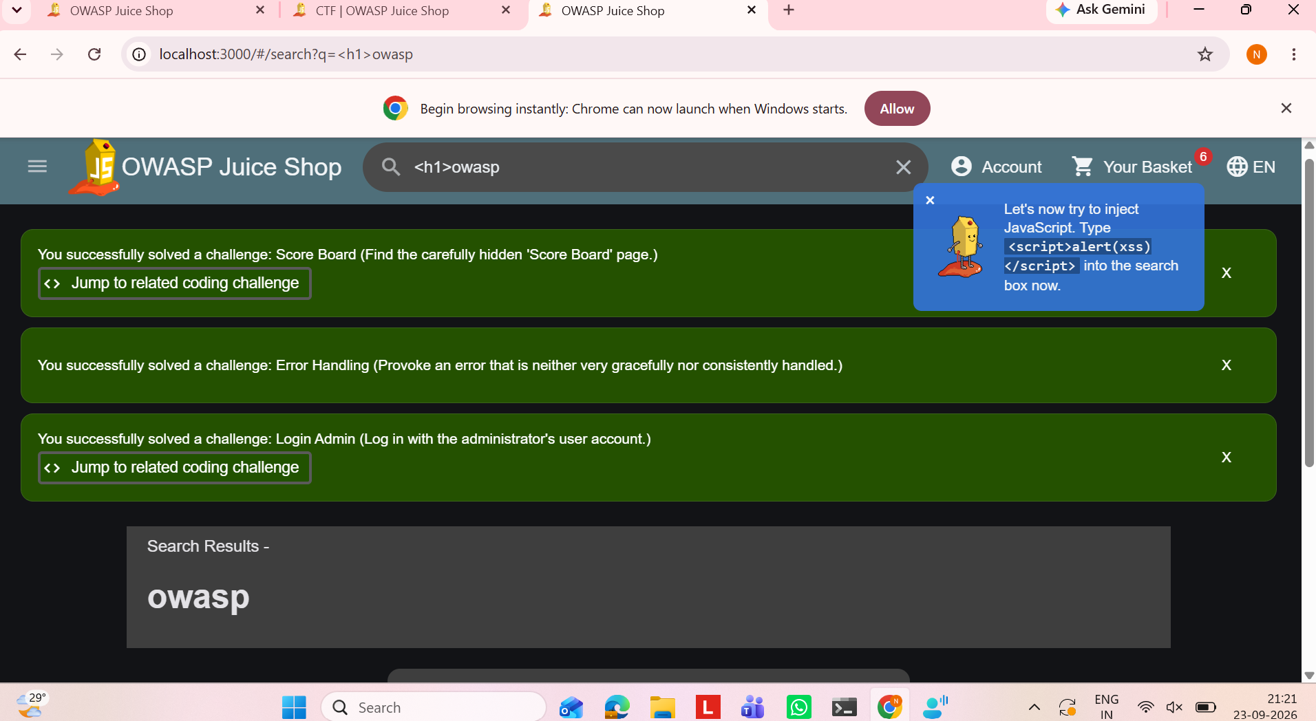
Figure 7: DOM XSS challenge – injected JavaScript payload shown in the search field.
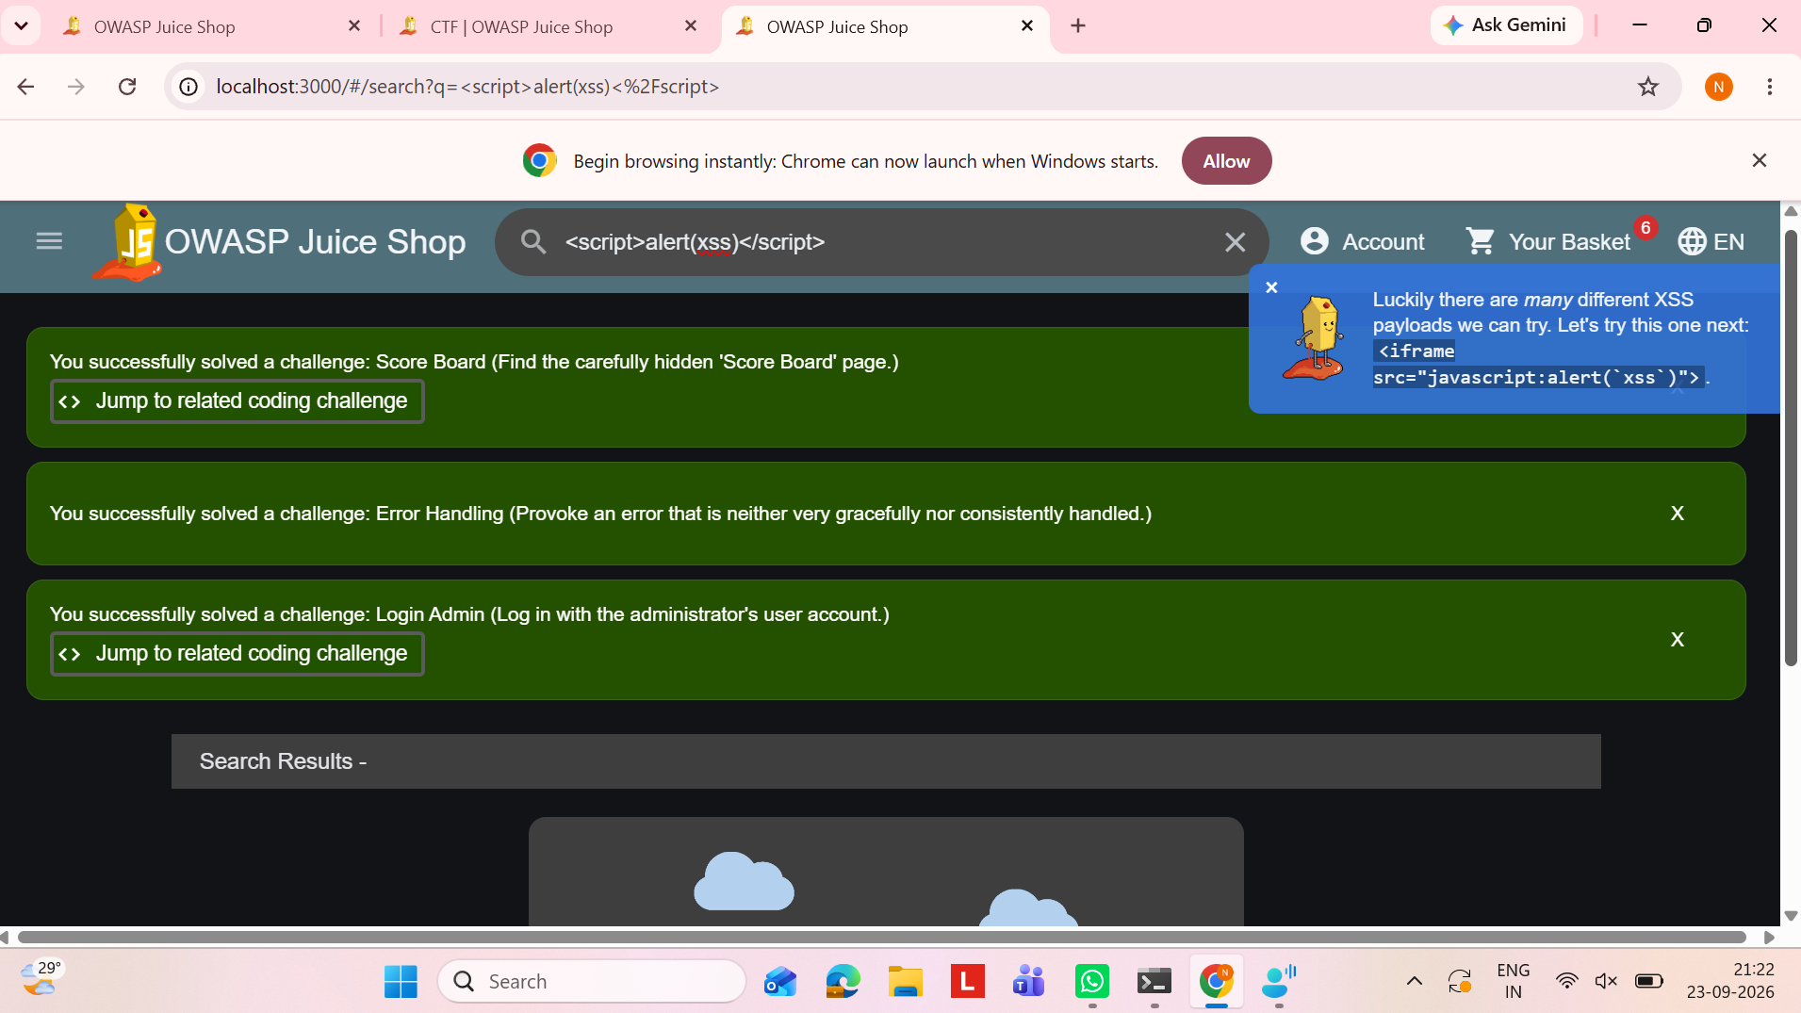
Figure 8: DOM XSS challenge – iframe-based XSS payload demonstration.

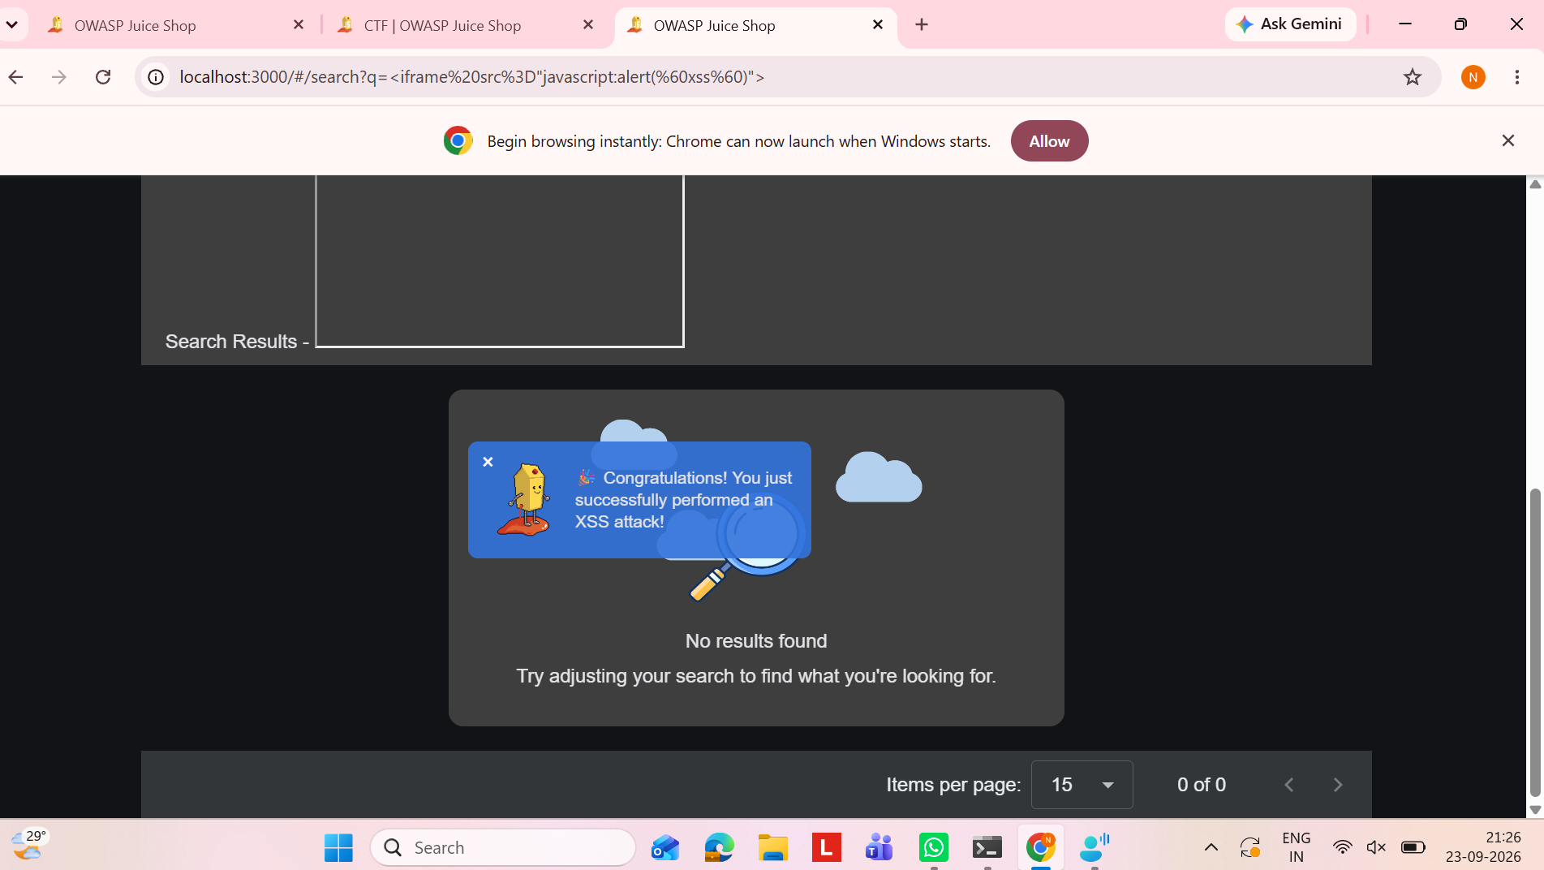
Figure 9: DOM XSS challenge – successful XSS attack confirmation.
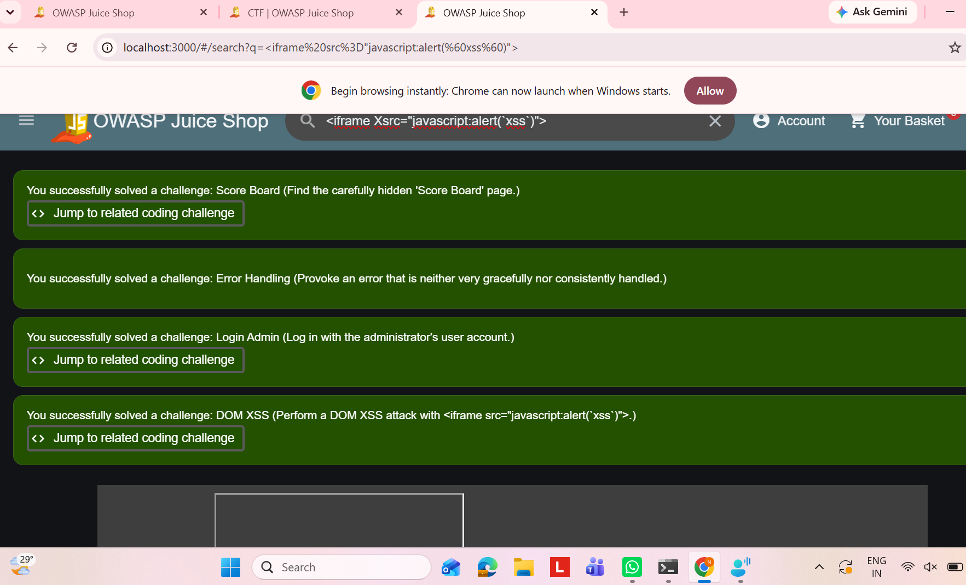
Figure 10: OWASP Juice Shop Score Board showing the DOM XSS challenge successfully solved.

Real-World Security Risk
XSS can be used to execute scripts in another user's browser, steal session information, modify page content, or perform actions on behalf of the victim.

5. Vulnerability 3 – Confidential Document

Vulnerability Type
Sensitive Data Exposure

What is the vulnerability?
Sensitive data exposure occurs when confidential files or information are accessible without proper authorization.

Exploitation / Demonstration Steps
- Open the Juice Shop application.
- Navigate to the file-access location used by the challenge.
- Open the /ftp/ path on the local Juice Shop instance.
- Locate the confidential document, such as acquisitions.md.
- Open the document and verify that the challenge is marked as solved.

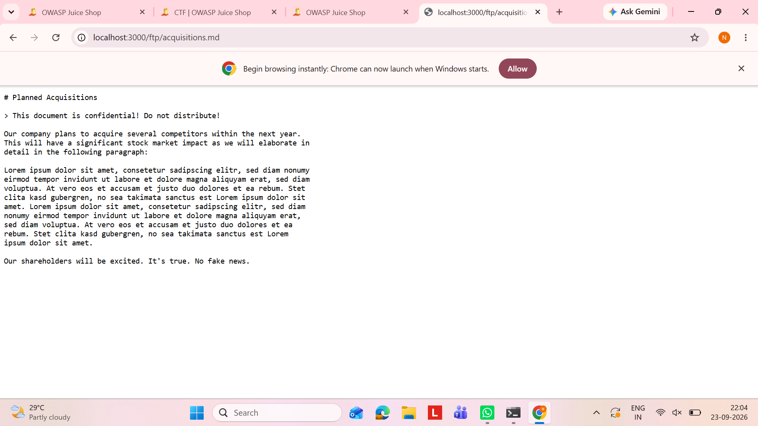
Figure 11: OWASP Juice Shop Confidential Document – sensitive information exposed through the /ftp/ path.

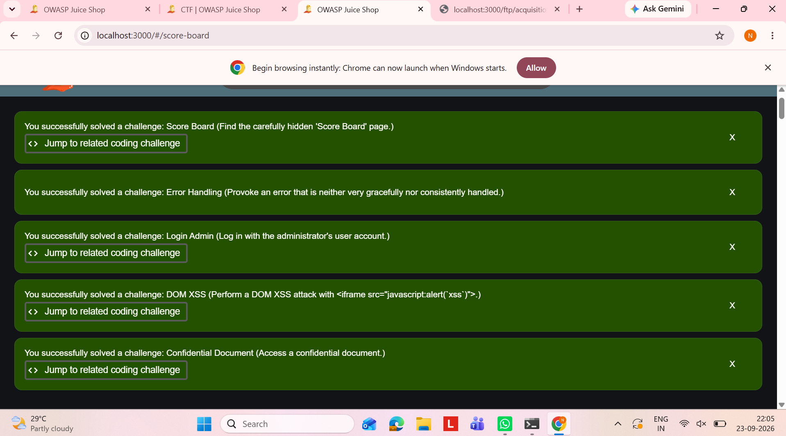
Figure 12: OWASP Juice Shop Score Board showing the Confidential Document challenge successfully solved.

Real-World Security Risk
Exposed confidential documents can reveal business information, internal data, credentials, or other information that should not be publicly accessible.

6. Vulnerability 4 – Admin Section

Vulnerability Type
Broken Access Control

What is the vulnerability?
Broken access control occurs when an application fails to properly restrict access to resources or functions that should be available only to authorized users.

Exploitation / Demonstration Steps
- Open the Juice Shop application.
- Use the route indicated by the challenge hint to access the administration section.
- Navigate to /#/administration on the local application.
- Observe the administration page.
- Verify that the challenge is marked as solved.

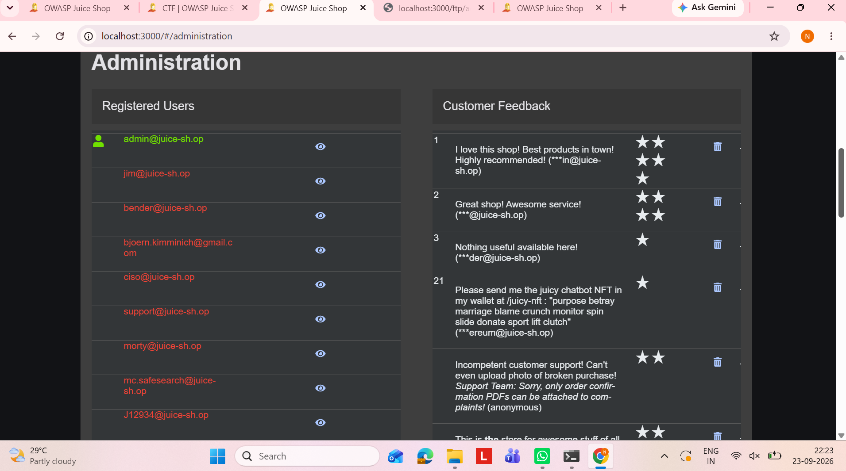
Figure 13:OWASP Juice Shop Administration page showing registered users and customer feedback.
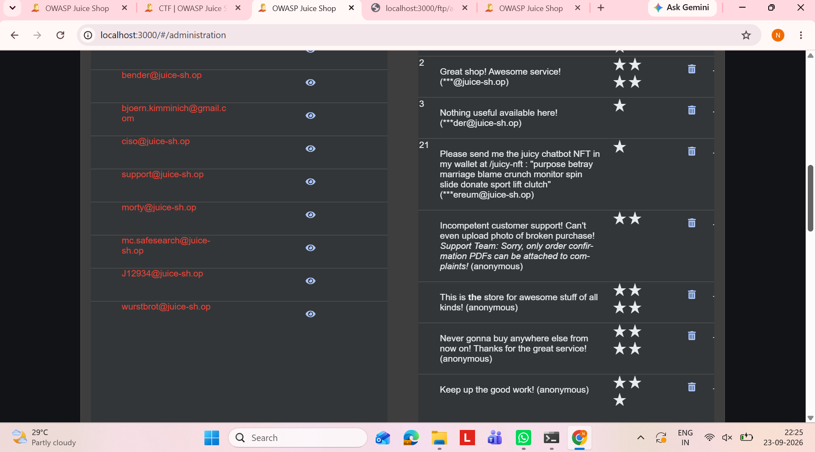
Figure 14: OWASP Juice Shop Administration page showing additional registered users and customer feedback.
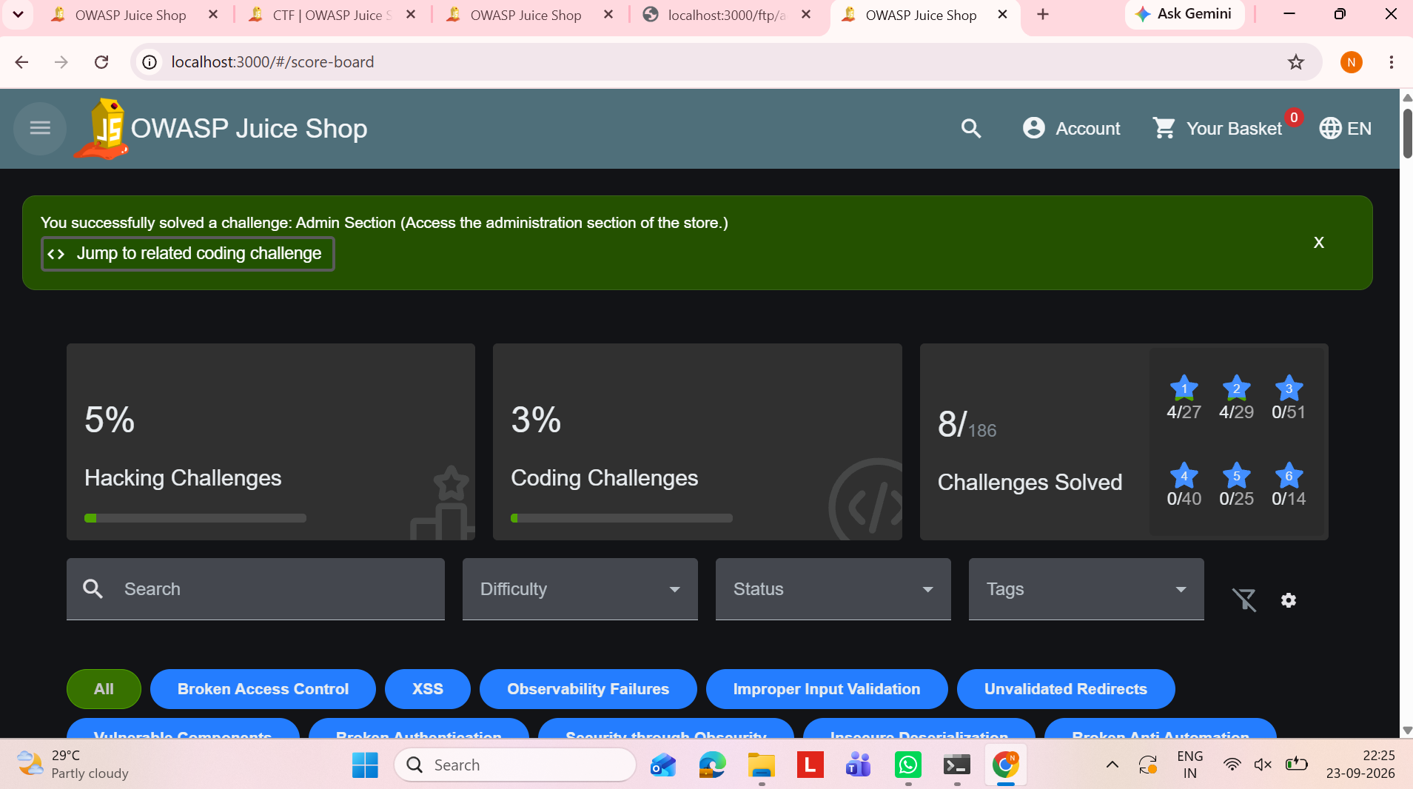
Figure 15: OWASP Juice Shop score board showing the Admin Section challenge successfully solved.

Real-World Security Risk
Broken access control can allow ordinary users to access administrator functions, view restricted information, or perform unauthorized actions.

7. Summary of Security Concepts Learned
- User input must be validated and safely handled.
- SQL queries should use parameterized statements instead of directly inserting user input.
- Web applications must properly protect against XSS.
- Confidential files must not be exposed through predictable or unprotected paths.
- Authorization checks are required for administrative functions and restricted resources.
- Security testing helps identify weaknesses before attackers can exploit them.

8. Conclusion
The OWASP Juice Shop exercise provided practical experience with common web application security issues. The challenges demonstrated how injection, XSS, sensitive data exposure, and broken access control can affect a web application. The activity also showed the importance of secure coding, authentication, authorization, input handling, and protection of sensitive information.

