TASK 2
Basic Wireshark Traffic Capture & Analysis
Protocol identification • Packet walkthrough • Security observations

Field | Details
Name | NANDHETHA VALAVANGOTHAI
Register No. | RA2511026020133
Task | Task 2: Basic Wireshark Traffic Capture & Analysis
Department | CSE(AIML ) 2nd year

1. Task Requirements
This document covers every required step shown :
- Install/open Wireshark and capture the student's own network traffic during a short session.
- Identify and document at least four protocols.
- Select one interesting exchange and explain it packet-by-packet.
- Provide a short summary of what was learned, including any unencrypted traffic noticed.
- Include Wireshark screenshots as evidence.

2. Capture and Analysis Procedure
- Open Wireshark and select the active Wi-Fi interface.
- Start the live capture.
- Generate normal traffic, such as browsing or other routine activity on the device.
- Stop the capture after enough packets have been collected and save it as my_traffic.pcapng.
- Use Wireshark display filters such as dns, tls and quic to isolate protocols.
- Select packets and inspect the packet-details pane and byte view.
- Record protocol names, source/destination addresses, ports and packet types.
- Capture screenshots showing the evidence used in the report.
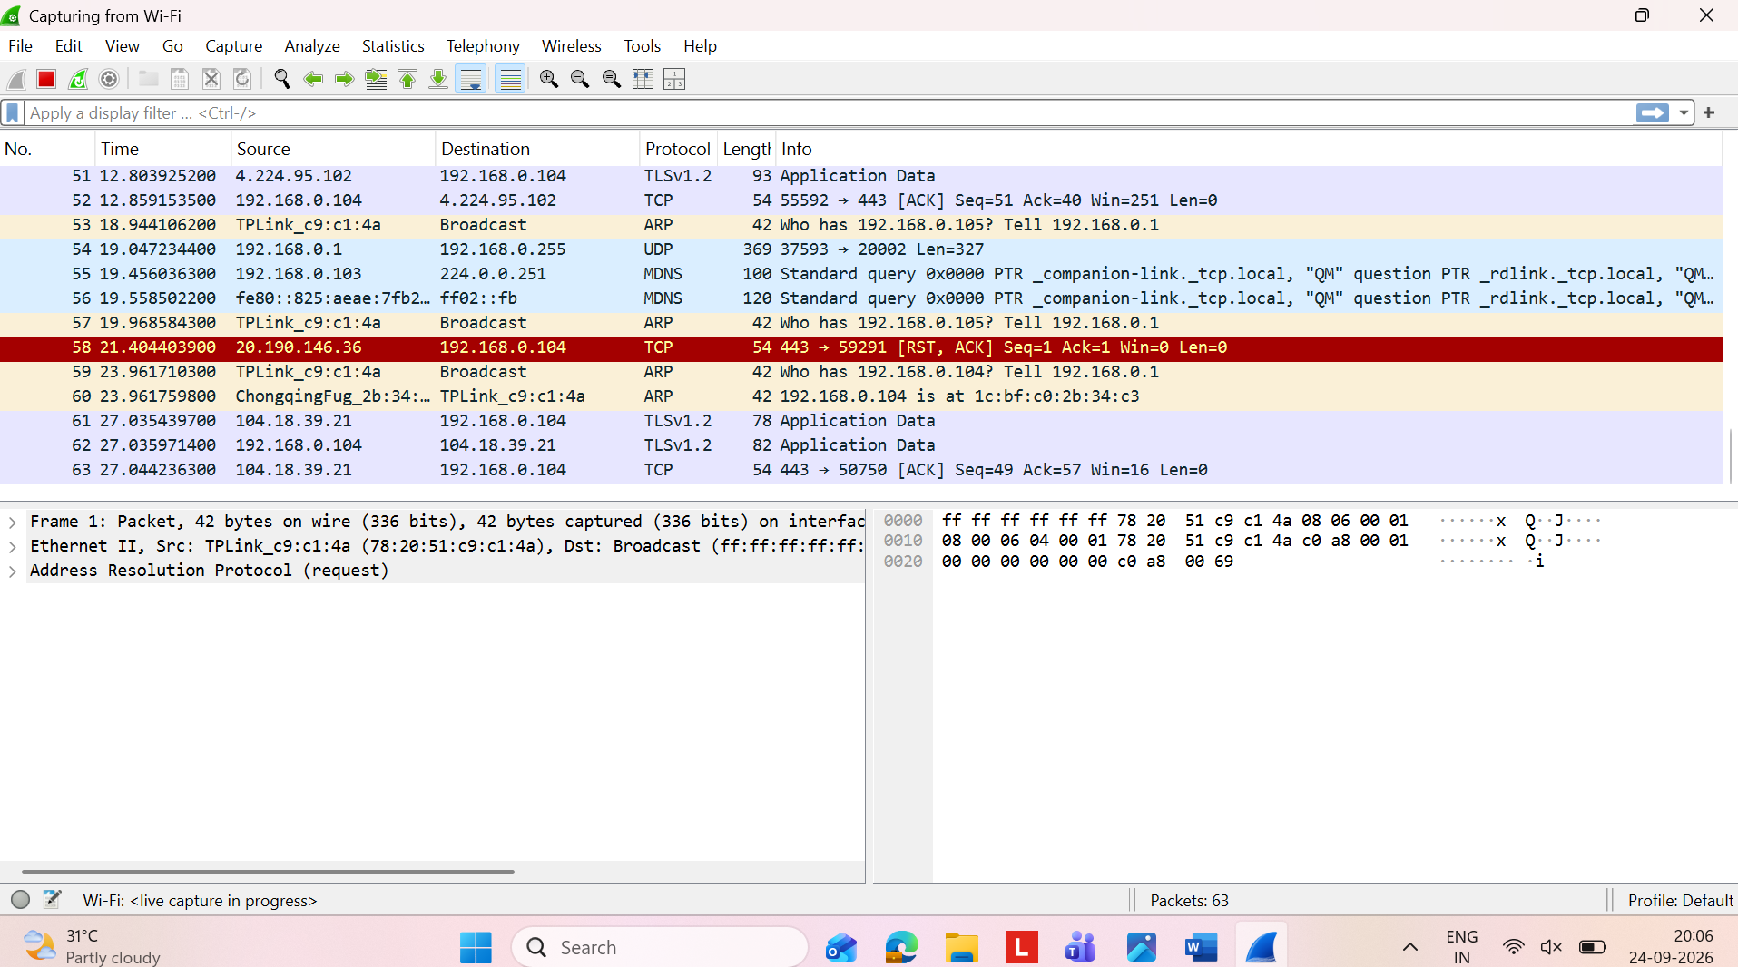
Figure 1. Live Wi-Fi capture showing ARP, TCP and TLSv1.2 traffic.

3. Protocol Breakdown
The supplied evidence contains more than the required four protocols. The following protocols are directly visible in the screenshots.
Protocol | What it does | Evidence seen | Security note
ARP | Resolves an IPv4 address to a local MAC address. | Broadcast request such as “Who has 192.168.0.105? Tell 192.168.0.1”. | Local ARP traffic is not encrypted.
DNS | Resolves domain names to IP addresses. | Queries/responses between 192.168.0.104 and 192.168.0.1; port 53. | Ordinary DNS exposes requested domain names.
TCP | Reliable, connection-oriented transport. | ACK, FIN/ACK and TCP traffic toward port 443. | Headers remain visible; application content can be protected by TLS.
TLS | Encrypts/authenticates application traffic. | TLSv1.2/TLSv1.3 Client Hello, Server Hello and Application Data. | Application data is shown as encrypted/protected.
QUIC | Modern secure transport over UDP. | Initial, Handshake and Protected Payload packets. | Protected payload is not shown as normal plaintext.
SSDP | Local device/service discovery. | NOTIFY * HTTP/1.1 to 239.255.255.250. | Discovery traffic can reveal local service information.

4. ARP Analysis
The live capture shows an ARP request. The Ethernet destination is the broadcast address, and Wireshark identifies the packet as Address Resolution Protocol (ARP). The information field asks which local device owns a specified IPv4 address. This is normal LAN address-resolution behavior.
Figure 2. ARP evidence from the live Wi-Fi capture.

5. DNS Analysis
The DNS-filtered capture shows repeated query/response pairs. The client is 192.168.0.104 and the local DNS server is 192.168.0.1. Visible examples include watson.events.data.microsoft.com, http-intake.logs.datadoghq.com, crl3.digicert.com and edge.microsoft.com.
- DNS requests use UDP with destination port 53 in the displayed example.
- The requested domain name is visible in the packet list.
- Responses can contain CNAME records, meaning a domain can resolve through aliases.
- The DNS traffic therefore demonstrates that metadata can remain visible even when later application traffic is encrypted.
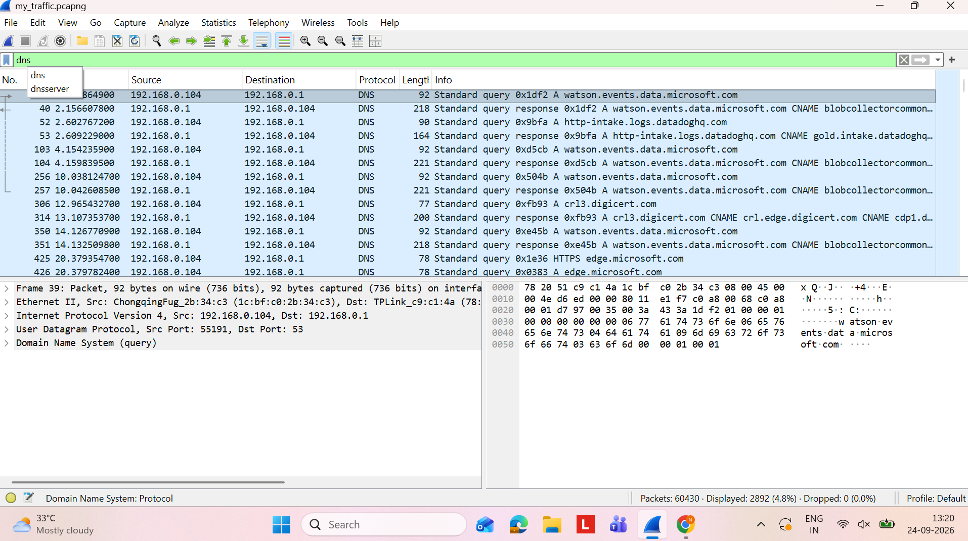
Figure 3. DNS-filtered capture showing DNS queries and responses.

6. TLS Analysis
The TLS-filtered capture contains TLSv1.2 and TLSv1.3 sessions. It shows Client Hello, Server Hello, certificate/key-exchange information, encrypted handshake messages and Application Data. The displayed SNI examples include watson.events.data.microsoft.com and http-intake.logs.datadoghq.com.
- TLSv1.2 traffic is shown over TCP port 443.
- Client Hello starts the TLS negotiation and can expose the requested server name through SNI.
- The server replies with handshake information such as Server Hello and certificate-related fields.
- After negotiation, application data is displayed as encrypted/protected rather than readable plaintext.
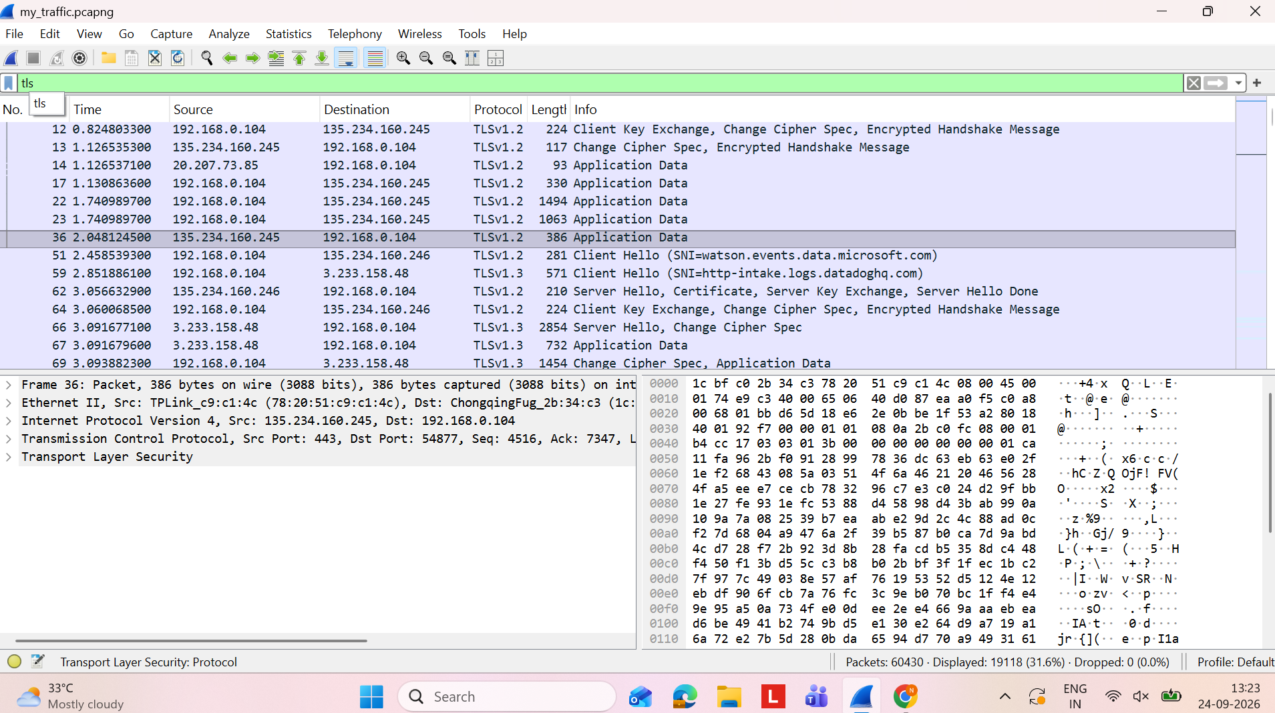
Figure 4. TLS-filtered capture showing TLSv1.2 and TLSv1.3 traffic.

7. TCP and SSDP Analysis
The second live-capture view shows SSDP notifications and TCP traffic. SSDP uses HTTP/1.1-style notification text and multicast destination 239.255.255.250. The same view contains TCP ACK and FIN/ACK packets and a TLS encrypted alert.
- SSDP NOTIFY packets are multicast for local service/device discovery.
- TCP ACK packets confirm receipt of data.
- FIN/ACK indicates connection termination.
- TLS encrypted alerts can appear when a secure session is closing or reporting a TLS-level event.
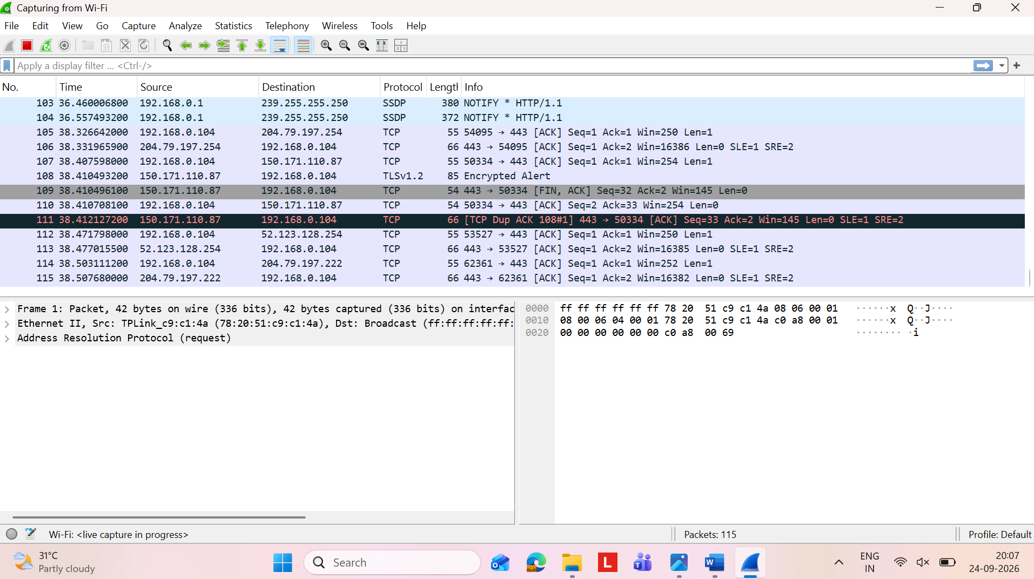
Figure 5. Live capture showing SSDP, TCP and TLS traffic.
The following screenshots provide additional evidence for the TCP connection-establishment analysis. They show SYN and SYN-ACK packets and the corresponding TCP header fields visible in Wireshark.
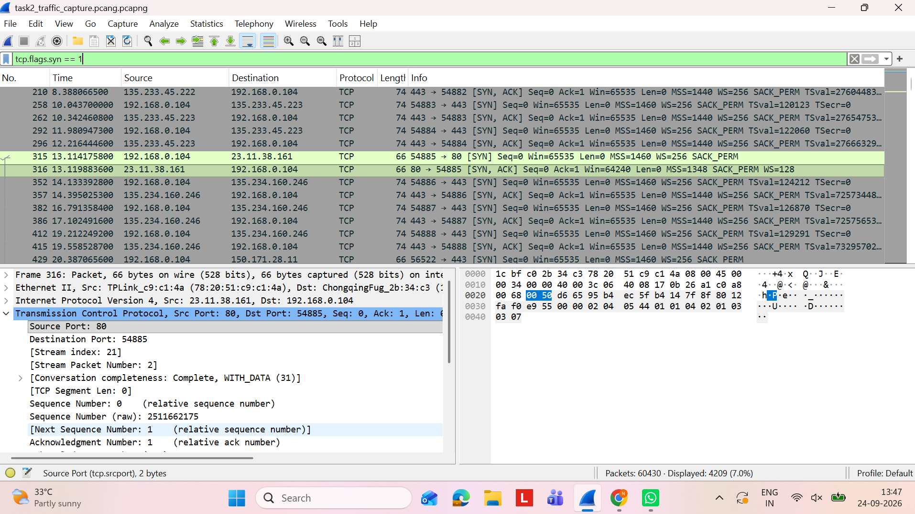
Figure 5A. TCP SYN filter showing the selected TCP connection and frame 316 (SYN-ACK).

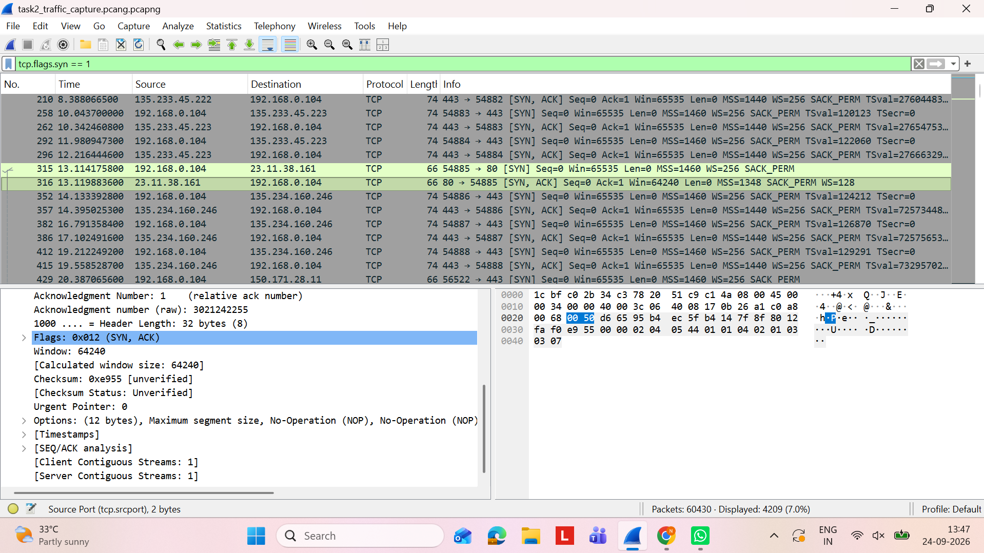
Figure 5B. TCP SYN-ACK packet details for frame 316, including the SYN and ACK flags.

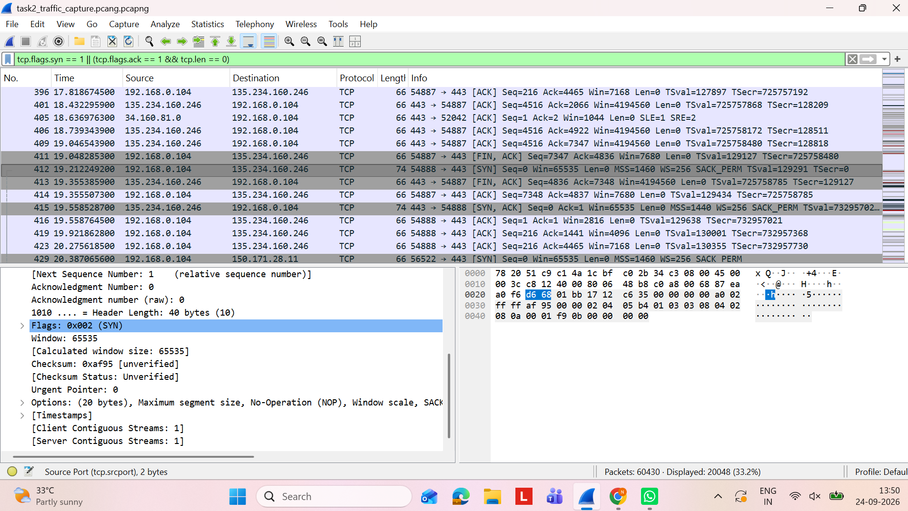
Figure 5C. TCP handshake filter showing frame 412 as a SYN packet from 192.168.0.104 to 135.234.160.246.

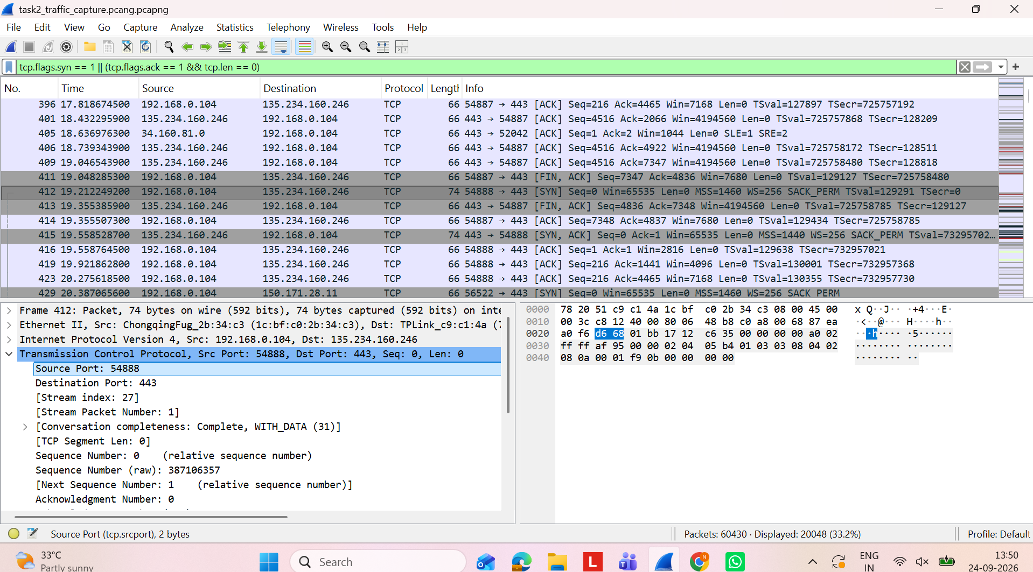
Figure 5D. TCP SYN packet details for frame 412, including source port 54888 and destination port 443.
Additional supplied TCP evidence is included below. The two screenshots show separate TCP connection attempts visible in the capture; they are not presented as one three-way handshake.
Figure 5E. TCP SYN filter showing frame 41 from 192.168.0.104:54878 to 135.234.160.246:443.
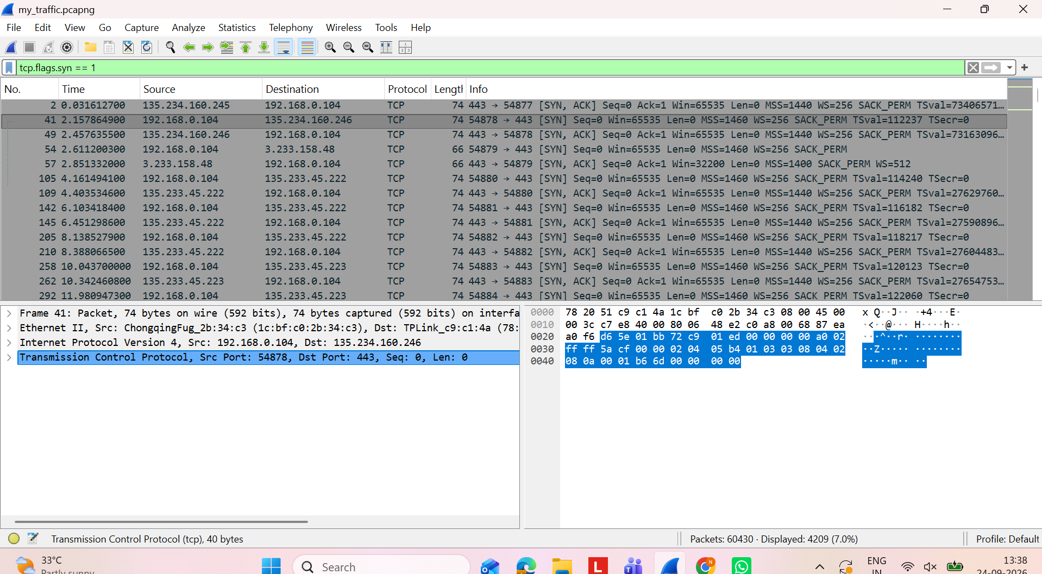
Figure 5F. TCP SYN-ACK packet details for frame 316 from 23.11.38.161:80 to 192.168.0.104:54885.
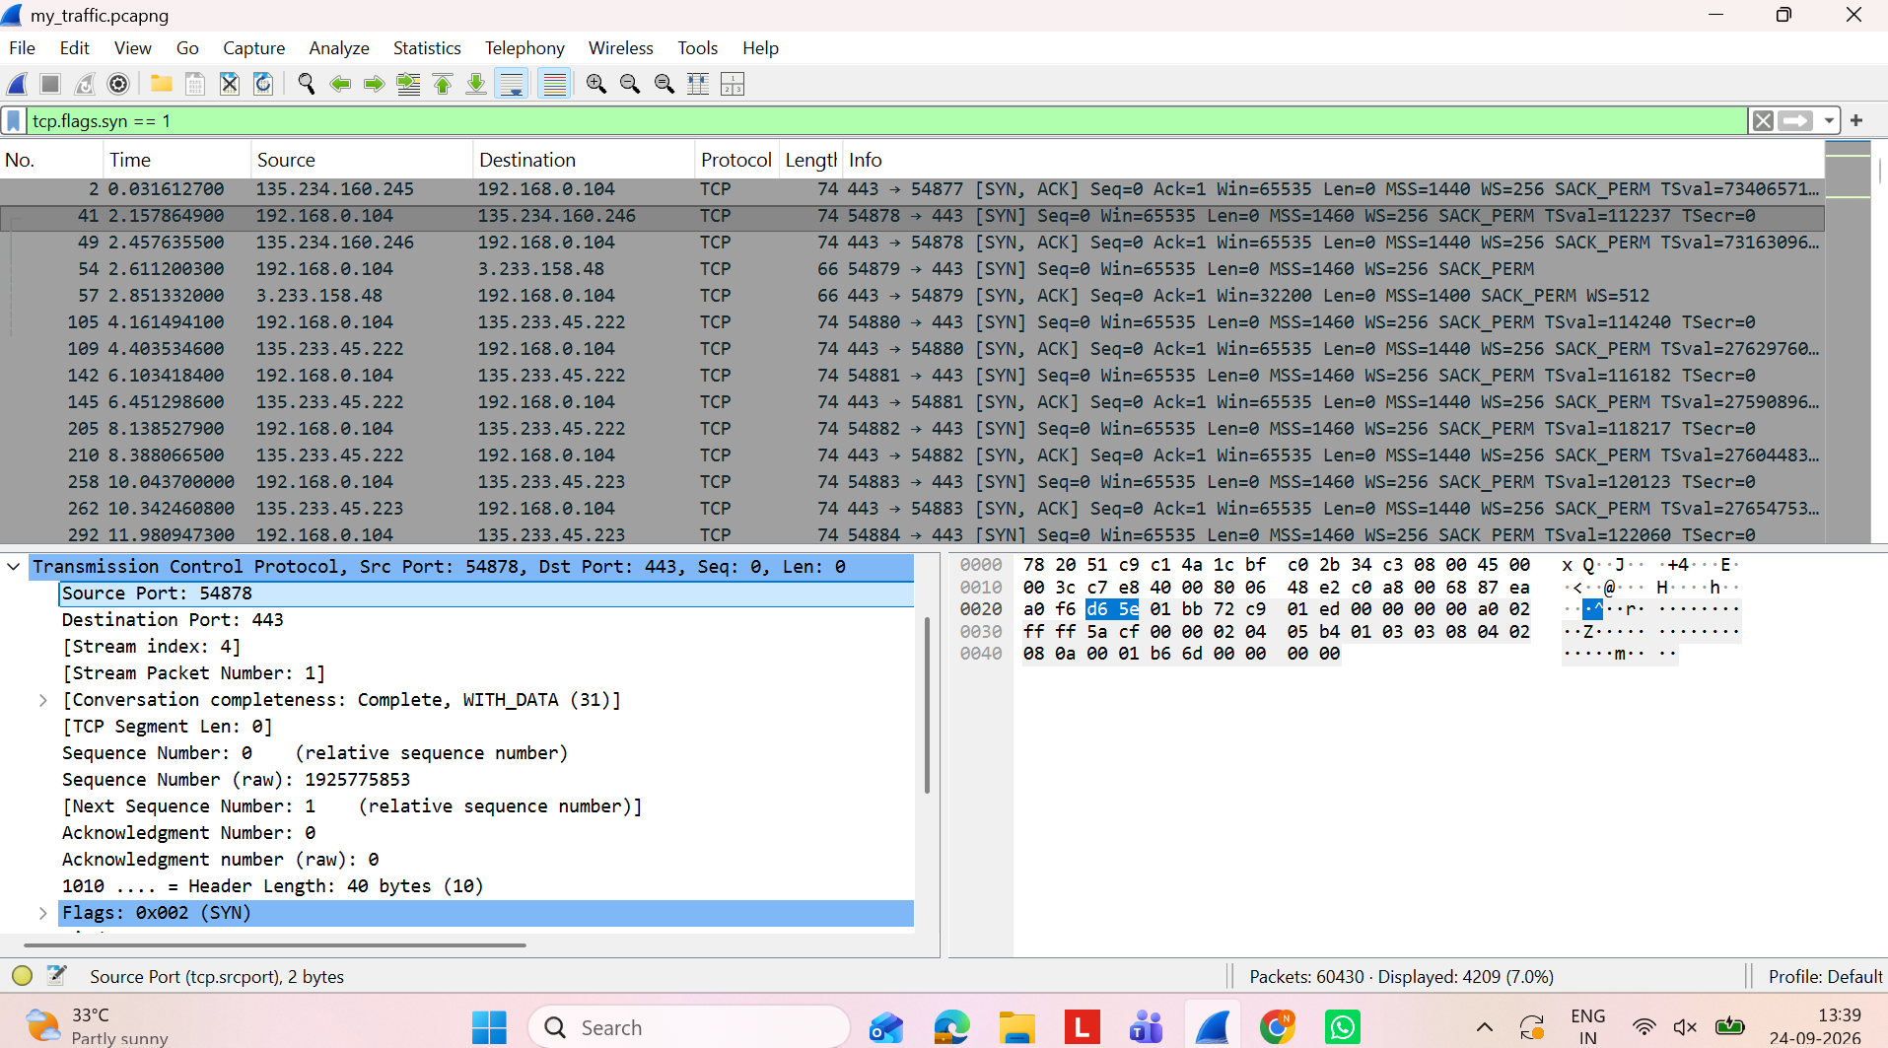

7.1 HTTP Evidence
The supplied HTTP screenshots show an HTTP-filtered view and packet details for frame 318. The selected request is a GET for /DigiCertAssuredIDRootCA.crl from 192.168.0.104 to 23.11.38.161 over destination port 80.
Figure 5G. HTTP-filtered capture showing frame 318 and related HTTP packets.
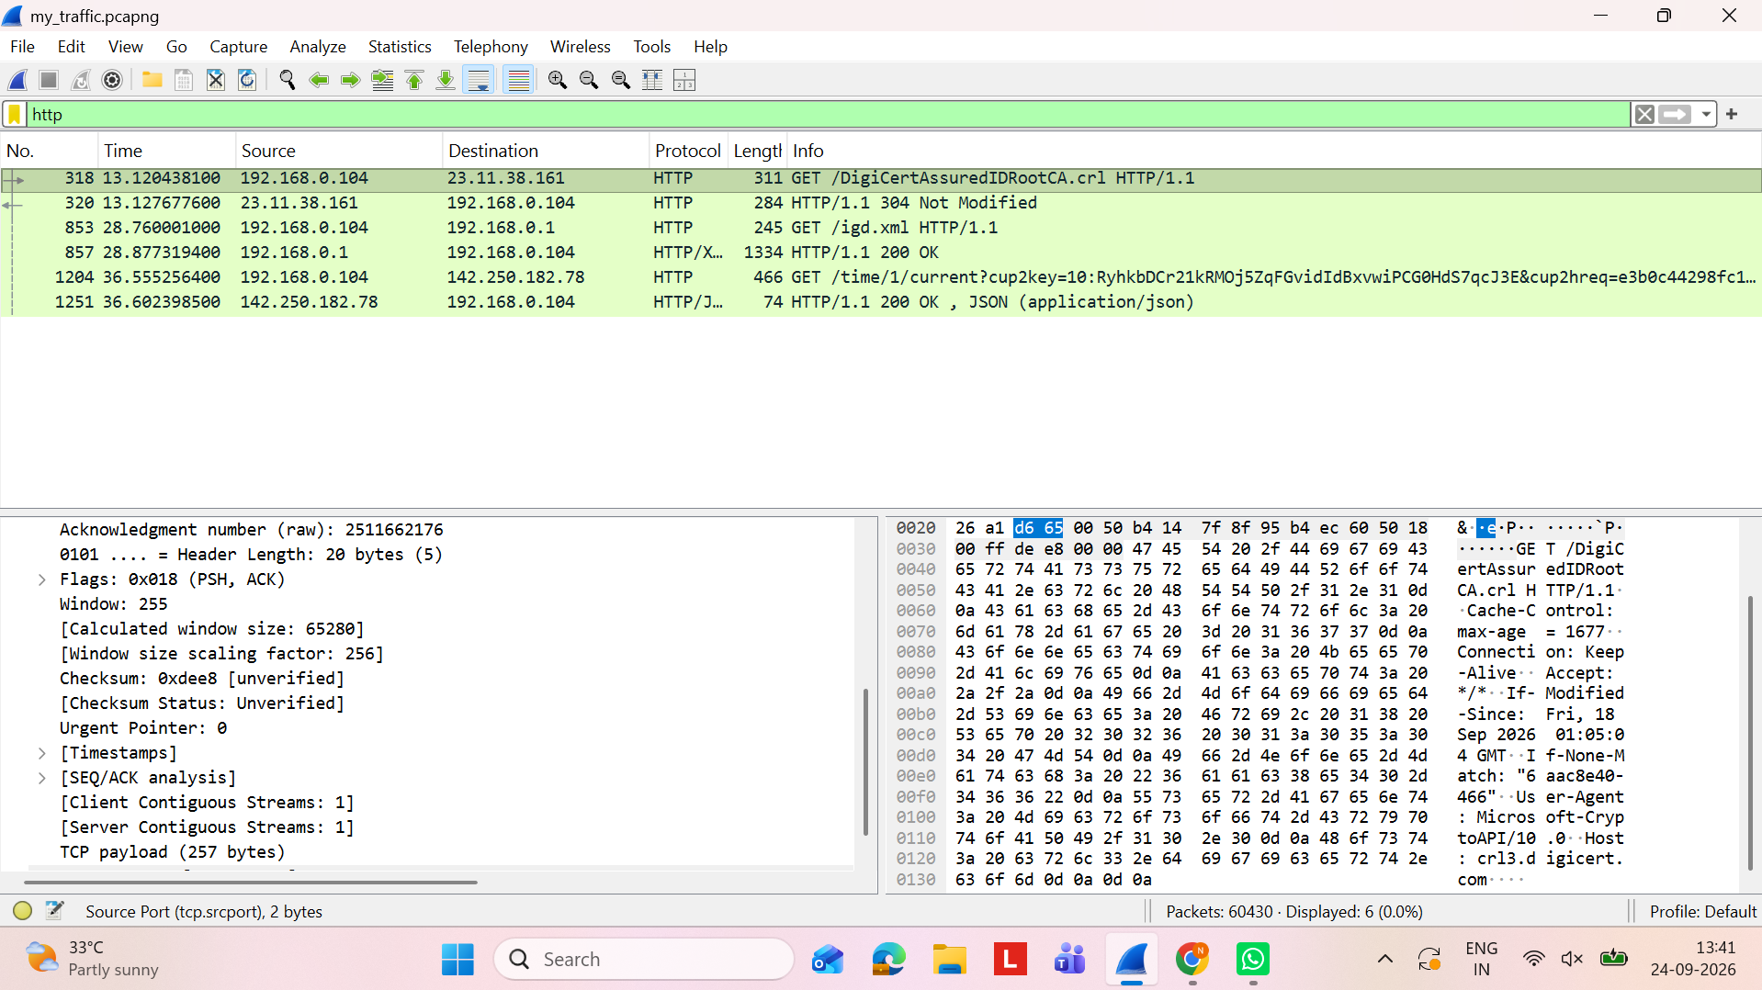
Figure 5H. HTTP packet details for frame 318, including the GET request and TCP payload.
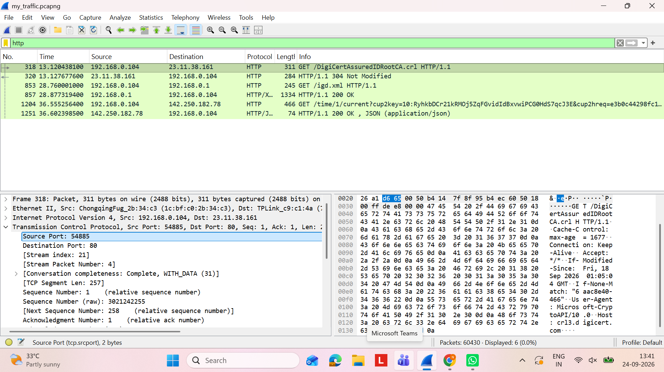
Figure 5I. HTTP-filtered capture showing the same frame 318 request and response entries.
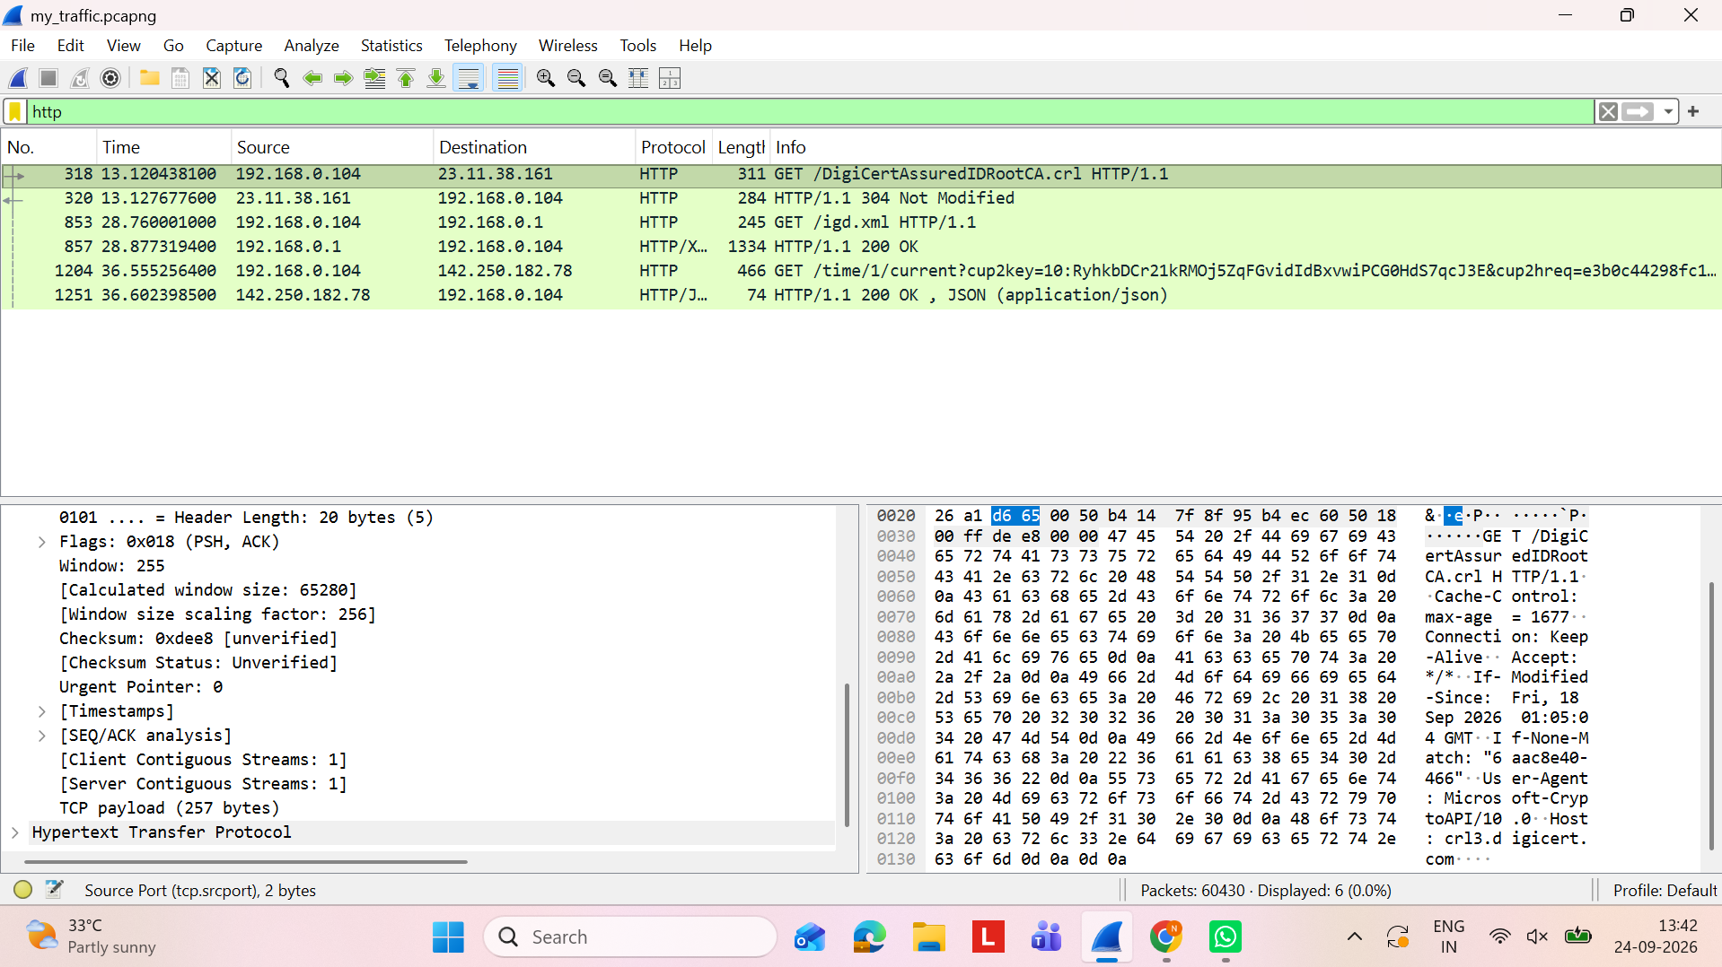

8. QUIC Analysis
The QUIC-filtered screenshots show traffic between 192.168.0.104 and 104.86.188.192 using UDP port 443. Wireshark labels the packets as Initial, Handshake and Protected Payload.
- Initial packets begin the QUIC connection and contain connection identifiers and handshake-related information.
- Handshake packets establish the secure QUIC session.
- Protected Payload packets carry subsequent application data in encrypted/protected form.
- The capture demonstrates a modern web transport where security is integrated into QUIC rather than appearing as a separate TCP + TLS stack.
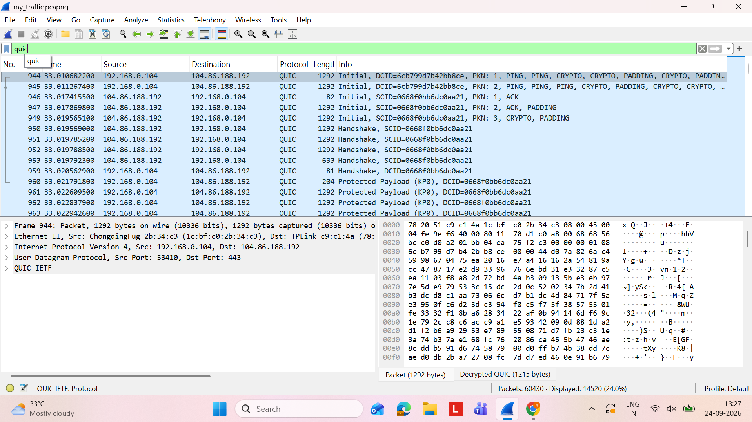
Figure 6. QUIC Initial, Handshake and Protected Payload packets.
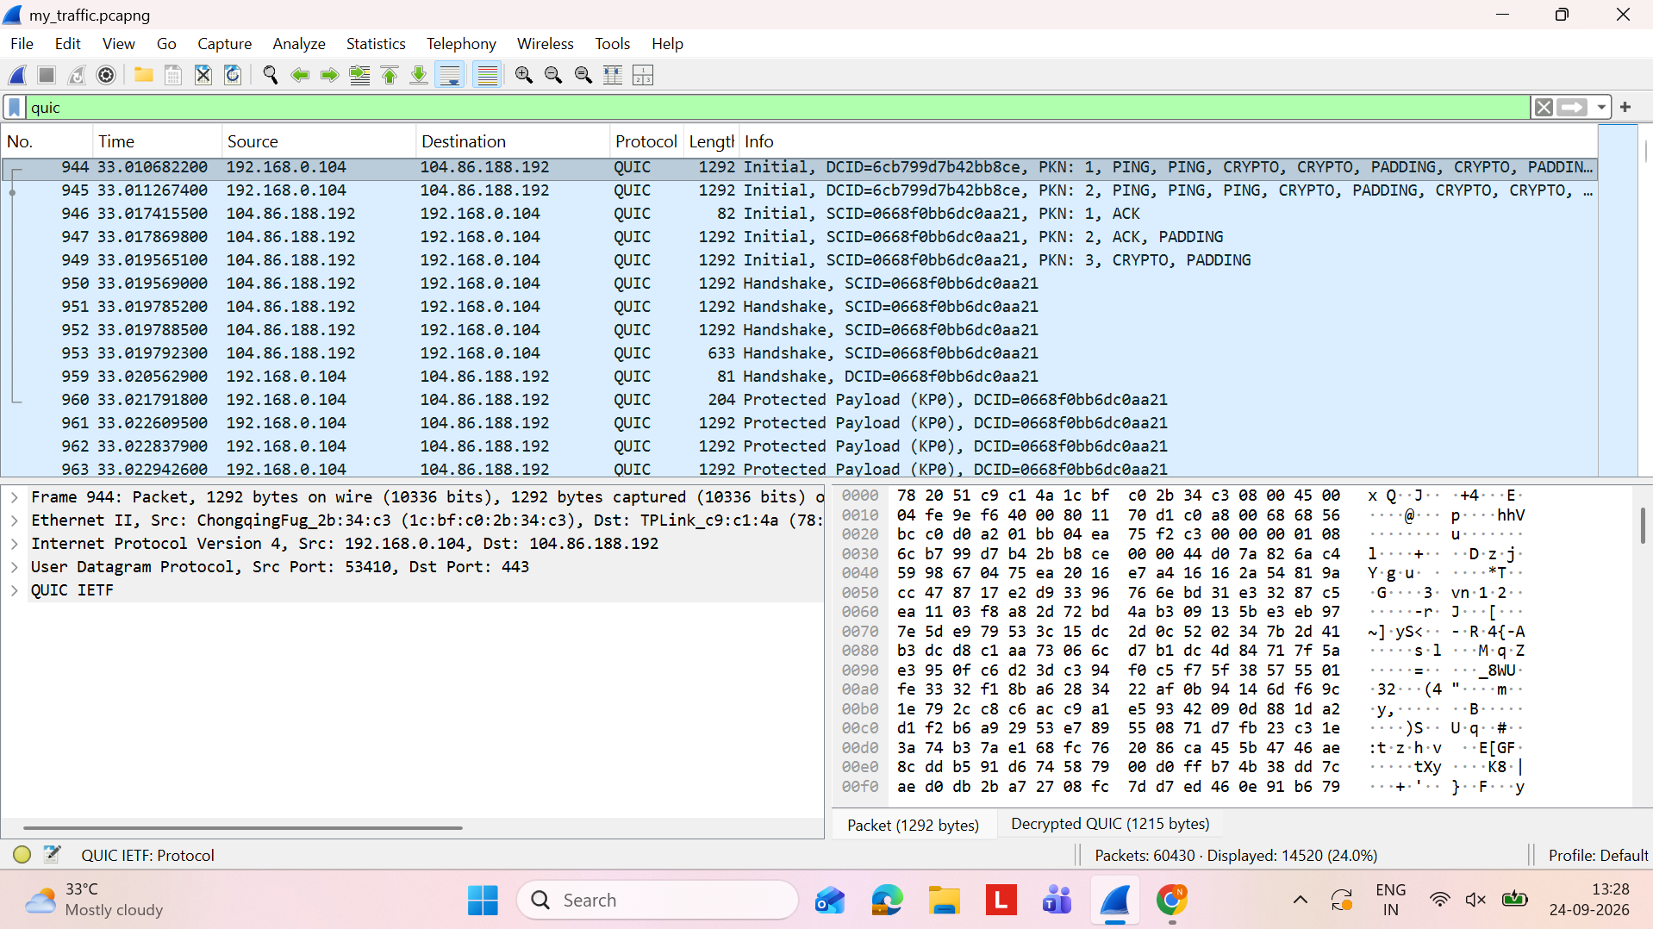
Figure 7. QUIC protected-payload traffic in the capture.

9. Packet-by-Packet Walkthrough – DNS Exchange
The DNS exchange is selected because it is clearly visible in the supplied capture and provides a simple example of how one network request becomes a response.
Packet 1 – DNS query is generated
The device 192.168.0.104 needs the address associated with watson.events.data.microsoft.com and creates a DNS question.
Packet 2 – Query is sent using UDP
The client sends the DNS request to 192.168.0.1. The displayed packet uses UDP source port 55191 and destination port 53.
Packet 3 – Domain name is visible
The DNS question contains the requested domain name. This demonstrates that ordinary DNS metadata can be read from a packet capture.
Packet 4 – DNS server processes the request
The local resolver at 192.168.0.1 receives the query and resolves it using its cache or upstream DNS service.
Packet 5 – DNS response returns
A response travels from 192.168.0.1 back to 192.168.0.104. The response corresponds to the query transaction shown in the filtered view.
Packet 6 – Client can continue
After receiving the answer, the device can connect to the resolved destination using a protocol such as TLS over TCP or QUIC over UDP.
Figure 8. DNS exchange used for the packet walkthrough.

10. Security Findings – Encrypted vs Unencrypted Traffic
Finding | What the capture shows | Meaning
DNS metadata | Domain names are visible in the DNS-filtered view. | Ordinary DNS does not hide the requested hostname from a traffic observer.
ARP | Broadcast ARP request is visible. | ARP is local network control traffic and is not encrypted.
TLS application data | TLSv1.2/v1.3 Application Data is displayed as encrypted/protected. | The application payload is not directly readable from the shown packets.
QUIC protected payload | QUIC Protected Payload packets are visible. | The payload is protected even though packet metadata remains visible.
SSDP discovery | NOTIFY * HTTP/1.1 messages are visible on multicast. | Local discovery can reveal information about available services/devices.

11. Actionable Findings / Practical Fixes
- Use encrypted DNS (for example DoH or DoT) where appropriate to reduce exposure of DNS queries.
- Prefer HTTPS/TLS for application communication and avoid sending sensitive information through unencrypted application protocols.
- Keep the operating system, browser and network applications updated.
- Use a secured Wi-Fi network with strong authentication and encryption.
- Review SSDP/UPnP and disable unnecessary local discovery services when they are not needed.
- Capture and analyze only traffic from devices/networks that you own or are explicitly authorized to monitor.

12. What I Learned
- Wireshark makes it possible to see how multiple protocols cooperate during normal network activity.
- DNS resolves human-readable domain names before many application connections.
- ARP performs local IPv4-to-MAC address resolution.
- TCP provides reliable delivery, while TLS protects application data carried over TCP.
- QUIC uses UDP and provides secure transport with Initial, Handshake and Protected Payload packet types.
- Encrypted application traffic can still leave visible metadata such as IP addresses, ports, packet sizes and DNS names.
- Packet captures are useful for both troubleshooting and cybersecurity analysis when performed with proper authorization.

13. Evidence Checklist
Requirement | Evidence in this document
Own traffic captured with Wireshark | Figures 1 and 5; saved capture name: my_traffic.pcapng
At least four protocols identified | ARP, DNS, TCP, TLS, QUIC and SSDP documented
Packet-by-packet exchange | Section 9: DNS query/response walkthrough
Unencrypted traffic noted | DNS and ARP observations in Section 10
Screenshots included | Seven evidence placements plus Appendix
Practical fixes | Section 11
Clear documentation | Structured sections, tables, captions and checklist

14. Alignment with Evaluation Rubric
Criterion | Weight | How it is addressed
Technical Depth & Understanding | 40% | Protocol explanations, packet fields, DNS walkthrough, TLS/QUIC interpretation and traffic-pattern observations.
Actionable Findings / Fixes | 30% | Concrete measures covering encrypted DNS, HTTPS/TLS, updates, Wi-Fi security and unnecessary discovery services.
Effort & Independent Sourcing | 20% | Multiple Wireshark filters and packet views are analyzed from the supplied capture evidence.
Clarity of Documentation | 10% | Numbered sections, tables, figures, captions, evidence checklist and conclusion.

15. Conclusion
The supplied Wireshark capture demonstrates a realistic mixture of network protocols. ARP handles local address resolution, DNS resolves domain names, TCP provides reliable transport, TLS protects application traffic, QUIC provides a modern encrypted UDP-based transport, and SSDP supports local discovery. The capture also shows the important security distinction between encrypted application content and visible network metadata: encryption protects the payload, but protocols such as ordinary DNS and ARP still expose information to an observer with access to the traffic.

Appendix – Wireshark Screenshots
Appendix Figure A1. Live Wi-Fi capture with ARP/TCP/TLS.
Appendix Figure A2. DNS filter.
Appendix Figure A3. TLS filter.
Appendix Figure A4. Live capture with SSDP/TCP/TLS.
Appendix Figure A5. QUIC filter – Initial and Handshake.
Appendix Figure A6. QUIC protected payload view.

