Relational and non-relational database manipulation

Monash Hospital brief

Monash Hospital treats patients who are identified by a unique patient ID. When a patient is admitted to the hospital, the hospital records the patient’s first and last name, address, date of birth and emergency contact number (if they are not already on the system). They also record the date and time of admission. The system needs to maintain a record of all admissions for a particular patient. When a patient is discharged, the date and time of their discharge for this admission is recorded. This system only deals with inpatients i.e. patients who are formally admitted to the hospital and stay for at least one night.
- While in the hospital each patient is assigned one doctor (identified by a doctor ID) as their supervising doctor. A patient's supervising doctor may be in charge of many admissions. The hospital records each doctor's first and last names and phone numbers. A doctor may have one or more specialisations (e.g. orthopaedic, renal), but not all doctors who work at the hospital have a specialisation.
- During their time in the hospital (admission), patients are prescribed procedures as part of their care by doctors. Procedures consist of tests such as 'X-rays' or 'blood tests'. They also include medical procedures which might be required such as 'Shoulder replacement'. A patient may have procedures prescribed by their supervising doctor or any other doctor working in the hospital.
- A procedure is identified by a procedure code. Each procedure has a name (such as 'Wrist X-ray') and includes a description of what the procedure involves, the time required for the procedure and the current standard patient cost for this procedure. When a particular procedure is prescribed during a patient’s admission, the date and time when the procedure is carried out are also recorded. A particular procedure is completed before any further procedures are run (two procedures cannot occur simultaneously). Some procedures, such as blood tests, are carried out by technicians; more complex procedures may require a doctor to carry out the procedure.
- If a procedure is carried out by a technician, the hospital does not record the details of the technician who completed the procedure.
- If a doctor carries out the procedure, the doctor who completes the procedure is recorded (the doctor who completes the procedure may be different from the doctor who prescribes it). Even if a team of doctors is involved in the procedure, only one doctor (the doctor in charge) is recorded as completing the procedure.
- Monash Hospital only records the details of a procedure carried out on an admission after the procedure has been completed.
- Not all admissions require a procedure to be carried out.
- Procedures may require 'extra' items such as syringes or swabs. Each item held in stock is assigned an item code. The item description, current stock and price are recorded. For accounting purposes, each item is assigned to a unique cost centre, such as Pharmacy, Radiography or Patient Aids. A cost centre is identified by a cost centre code and has recorded the cost centre title and manager's name. The quantity of each item used in a particular procedure is recorded.
- Patients are billed for the cost of the procedure itself and also any 'extra' items that are used as part of a procedure. The billed charge is based on the procedure/item cost at the date and time of the procedure. A particular patient may be charged at a rate different from the standard procedure cost or standard item cost at the doctor's/hospital's discretion.
A logic model for Monash Hospital has been developed as follows.

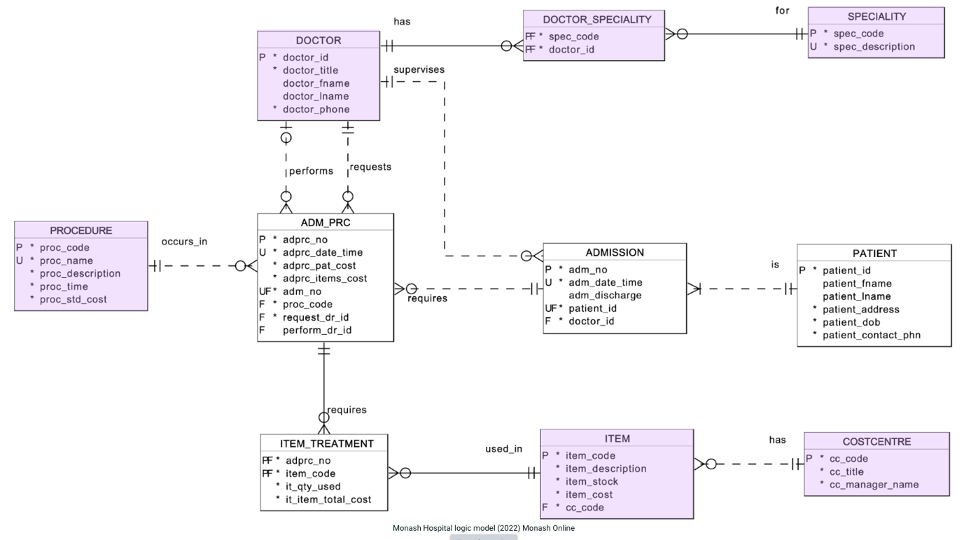

Task 1 Relational database queries – Relational algebra
Questions
- List the doctor ID, last name and phone number for all doctors specialising in vascular surgery (spec_code = "VS"). [1 mark]
- List the procedure code, procedure name and procedure standard cost for all procedures that have not been used during any admission. [2 marks]
- List the patient ID, first and last name and contact phone number for all patients who have had the procedure named "Angiogram" carried out during their admission. [3 marks]
Task 2 - Data insert

Load selected tables with your own additional test data:
Using the supplied T2-mh-insert.sql script file, add the SQL commands which will insert, as a minimum, the following sample data to represent completed services:
- 10 ADMISSIONS
  - involving at least 8 different patients
- 15 ADMISSION PROCEDURES
  - involving at least 8 different admissions
  - having at least 3 admissions that involve more than two admission procedures
- 10 ITEM_TREATMENTS
  - involving at least 5 different items
Your inserted data must conform to the following rules:
- You must treat all the data you add as a single transaction since you are setting up the initial test state for the database.
- The primary key values for this data should be hardcoded values (i.e. NOT use sequences) and must consist of values below 200000.
- Admission dates must be chosen between 1 January 2024 and 1 June 2024 (inclusive).
For this task ONLY, you are permitted to look up manually and include values from the loaded tables/data directly and also carry out external calculations where required (for example, working out the total item cost for an item treatment).
You are not required to adjust the item_stock for any item used in an item treatment. You may assume that the preloaded values represent the item stock after all of your data has been loaded.

Task 3 - Data manipulation

For the following tasks, your SQL must correctly manage transactions and use sequences to generate new primary keys for numeric primary key values (a new primary key value may not be hard-coded as a number or value).
For Task 3, if necessary, you may change the data held in the tables that were previously populated by the supplied schema file (the purple-coloured tables in the model above) via insert, delete, or update. However, you must not change the table structure created by the provided schema file, for example, by using ALTER.
Your answers for the following tasks a–e must be placed in the supplied SQL script T3-mh-dml.sql.
- Create a set of sequences that allow you to enter data into the PATIENT, ADMISSION and ADM_PRC tables. All sequences must start at 200000 and go up in steps of 10 (i.e. the ﬁrst value is 200000, the next 200010 etc.). [1 mark]
Tasks b–e are potentially related questions. Where appropriate, you can use the information given in any of the parts to answer any question e.g. use the information in c to help answer d.
- Peter Xiue, who lives at '14 Narrow Lane Clayton', was admitted on June 1st, 2024, at 1 PM as a new patient. He was born on October 1st, 1981, and has a contact phone number of 0123456789. His supervising doctor will be Dr Sawyer HAISELL (you may assume no other doctor has the same name). Peter has not been discharged yet. Add Peter's admission to the Monash Hospital system. Treat this admission as a single transaction. [2 marks]
- 26 hours after his admission, Peter Xiue had a procedure named 'SCRATCH TEST' carried out by hospital technicians based on a request submitted by his supervising doctor. The procedure was charged at the standard cost. Two items described as '70% Alcohol Antiseptic Prep Pad, Sterile' were used in this procedure. You may assume that no other item has the same description. [3 marks]
- Dr Decca BLANKHORN has changed her 'Thoracic Surgery' specialisation to 'Vascular Surgery' (you may assume no other doctor has the same name). In making this change, you may not use insert or delete. [2 marks]
- Following several legal challenges, the hospital has decided that they no longer wish to support the 'Medical Genetics' specialisation and want it removed from the areas in which a doctor can indicate a specialisation. [2 marks]

Task 4 - SQL queries

- List the patient ID, patient's full name as a single column, admission date and time, and the supervising doctor's full name (including title) as a single column for all those patients admitted on 1 June 2024. Your output must include at least two admissions on this date, which occurred at different times. Order the output by the admission time with the earliest admission ﬁrst; where several admissions occur at the same time, order them by the patient ID. Your output must have the form shown in the following image, including using the indicated column headings:
- List the procedure code, name, description, and standard cost where the procedure standard cost is less expensive than the average procedure standard cost.
The output must show the most expensive procedure ﬁrst. If two procedures have the same standard cost, order them by the procedure code. The procedure standard cost must be displayed with two decimal points and a leading $ symbol, for example, $120.66, and be right-aligned.
- List the patient's ID, last name, ﬁrst name, date of birth and the number of times the patient has been admitted to the hospital where the number of admissions is greater than 2.
The output should show patients with the most number of admissions ﬁrst and for patients with the same number of admissions, show the patients in their date of birth order.
Your output must include at least two patients with the same number of admissions. Your output must have the form shown in the following image, including using the indicated column headings.
- List the admission number, patient ID, ﬁrst name, last name and the length of their stay in the hospital for all patients who have been discharged and who were in the hospital longer than the average stay for all discharged patients.
The length of stay must be shown in the form 10 days 2.0 hrs, where hours are rounded to one decimal digit, with the output right-aligned. The output must be displayed in admission number order.
Your output must have the form that is shown in the following image (only some rows shown), including using the indicated column headings:
- Given a doctor may charge more or less than the standard charge for a procedure carried out during an admission procedure, the hospital administration is interested in ﬁnding out what variations on the standard price have been charged. The hospital terms the difference between the procedure standard cost and the average actual charged procedure cost which has been charged to patients for all such procedures carried out as the procedure "Price_Differential".
For example, Procedure 15509, X-ray Right knee, has a standard procedure cost of $75. Assuming that the average actual charged cost for this procedure is $73.37, the price differential will be -1.63 (i.e. the average cost is $1.63 below the standard cost).
For all procedures which have been carried out on an admission determine the procedure price differential. The list should show the procedure code, name, description, standard time and the procedure price differential in procedure code order. Your output must have the form shown in the following image, including using the indicated column headings.
- List for every procedure, the name of the items which have been used and the maximum number of those items used when the procedure was carried on an admission. Your list must show the procedure code, procedure name, item code, item description and the maximum quantity of this item used for the given procedure.
For example, vascular surgery may require one standard anaesthetic pack, and then a number of Bupivacaine injections; sometimes one has been used, sometimes two—the required listing will show the maximum quantity of Bupivacaine injections as 2 (see following table). If the procedure has not been carried out on any admission or has not used any items then the item code, item description and maximum quantity columns must show "---". The output must be in procedure name order and for a given procedure name in item code order. Your output must have the form shown in the following image (only some rows shown) including using the indicated column headings

Task 5 - Design modifications

These tasks should be attempted only after tasks 2, 3 and 4 have been successfully completed. They are to be completed on the 'live' database i.e. the database with the data loaded from your previous work. Also, remember as a live database, other users are using the database as you make these changes.
In completing this task, you must do the following:
- If you need to add new columns, tables or related constraints, follow the naming conventions used in the data models and schema file that have been provided.
- Provide column comments for any new columns that you add.
- Correctly manage any transactions used as part of your solution.
- The hospital administration would like to keep track of the number of patients its doctors supervise (i.e. the admissions they supervise). They have indicated that they believe, over the life of the MH system, that this number would not be higher than 9,999 for any individual doctor.
All new doctors added to the system should start with a value of zero supervision.
Change the database to satisfy this requirement. After your change has been completed, the database must be in a consistent state, i.e. the number of supervisions for each doctor must be initialised to the current state of the admissions data.
As part of your solution, provide appropriate select and desc statements to show the changes you have made. Select to show any data changes that have occurred and desc tablename, e.g. desc customer to show any table structural changes.
- The hospital administration has two further changes they would like made to the database:
  - Add to the admissions information: for each admission, the daily bed charge ($'s/day) which the stay will be charged at—this rate must be inserted when a new admission is added. The current daily bed rate for all admissions is $321; this should be set as the default charge when a new admission is added. All existing admissions should have this set as their daily bed charge.
  - For all completed admissions, record the invoice details for the amounts to be charged for the admission. The invoice details will be added after a discharge date and time have been entered for an admission; only one invoice will be raised per admission. For performance reasons and to limit nulls, the invoice details must not be stored in the admissions table. The invoice details must include:
    - an invoice number—assigned automatically by the system, starting at 100 and increasing by one for each new invoice
    - the total admission procedure costs for this admission (patient procedure and item costs)
    - the total hospital bed costs for this admission (part days are charged at the full day rate; for example, if the stay was 2.5 days, it will be charged at 3 days)
    - an indicator to show if the amount has been paid as Yes or No.
Change the database to satisfy these requirements.
As part of your solution provide appropriate select and desc statements to show the changes you have made. Select to show any data changes that have occurred and desc tablename, e.g. desc customer to show any table structural changes.

Task 6 - Non-relational database queries – MongoDB

Your answers for this task (Task 6) must be placed in the supplied SQL file T6-mh-json.sql and the supplied MongoDB VS Code playground file T6-mh-mongo.mongodb.js.
- Write an SQL statement in T6-mh-json.sql to generate a collection of JSON documents using the following structure/format from the Monash Hospital tables used in tasks 4 and 5 (code/run this after Task 5). Each document in the collection represents a doctor and contains the admissions supervised by this doctor. The document identifier (_id) is the doctor_id from the DOCTOR table:
The fields:
- no_admissions is the total number of admissions this doctor has supervised
- current_admissions is the number of these admissions which have not been discharged yet.
Note that only two documents (partial contents) are shown.

- Create a new collection named admissions and insert all the documents you generated in Task 6a above into MongoDB in this collection. [1 mark]
- List all documents which have been inserted in Task b. [1 mark]
- List the doctor's ID, name and phone number where the doctor has supervised two or more admissions and currently has an admission who has not been discharged. [2 marks]
- Select one of your doctors from Task d above and complete the following:
  - Use an appropriate db.find command which shows only the details for the doctor you have selected.
  - Write the necessary MongoDB commands to discharge one of the patients who has not been discharged (you may select any 'sensible date/time' for the discharge date/time). You may also hard-code the admission_no for the admission you wish to discharge in your statement.
  - Use an appropriate db.find command, which shows only the details for the doctor you have selected after making the change so that you show/confirm the change that was made.

