|  |  |
| --- | --- |
| A picture of a winding road and trees  AssigNment | Abstract  Workshop Assignment for GIT and GIT HUB – Sep 2025  Nandhini Ammaiappan |

Contents

Workshop-Hands-on with Git and GitHub – Sep 2025 2

Day 1 2

1. Create one directory with your student roll number 2

2. Initialize git 2

3. Create 5 files 3

4. Create at least 5 commits with proper messages 3

5. Take screen shot for git log(not one line) 4

6. Create two branches 4

7. Update file on branches and one file should create merge conflict 4

8. Merge both branch to master 5

9. Take screen shot for merge conflict in file and merge conflict message on terminal 5

10. Resolve merge conflict and commit 6

11. Take screen shot for complete git graph 7

Day 2 7

1. Build a repo using scenario: 7

2. Create new repository on github with basic README file 8

3. Clone the repo into local git 8

4. Add first basic module. 8

5. Add other modules through branches. 9

6. Raise Pull Request 12

7. Final Repo 17

# Workshop-Hands-on with Git and GitHub – Sep 2025

## Day 1

### Create one directory with your student roll number

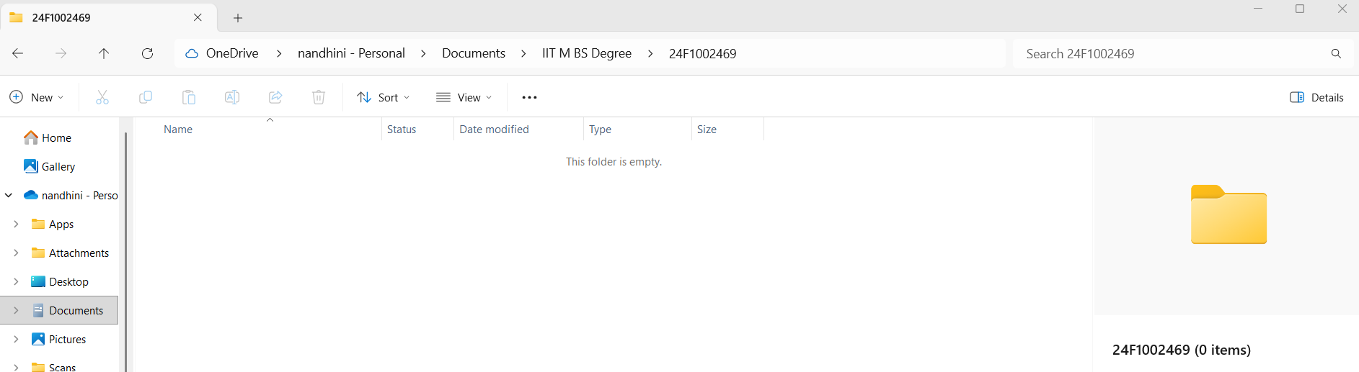

### Initialize git

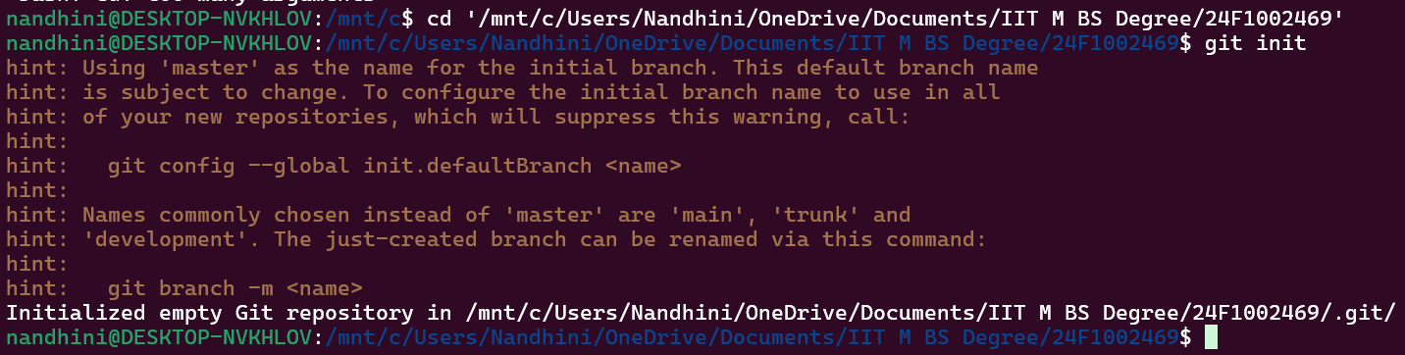

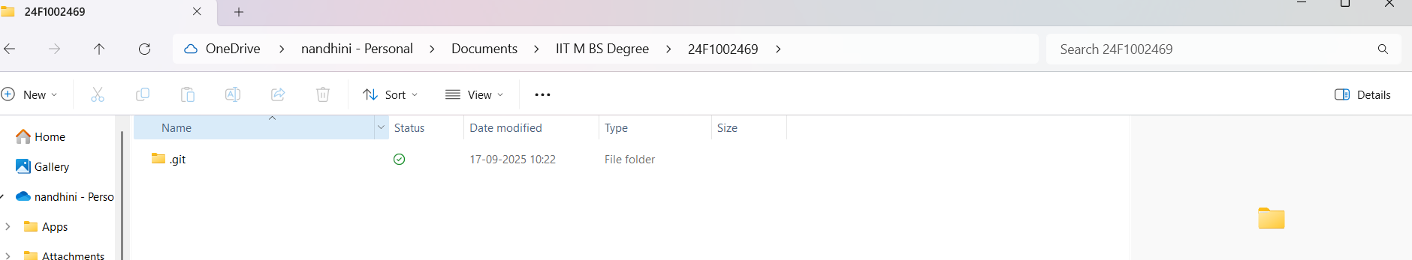

### Create 5 files

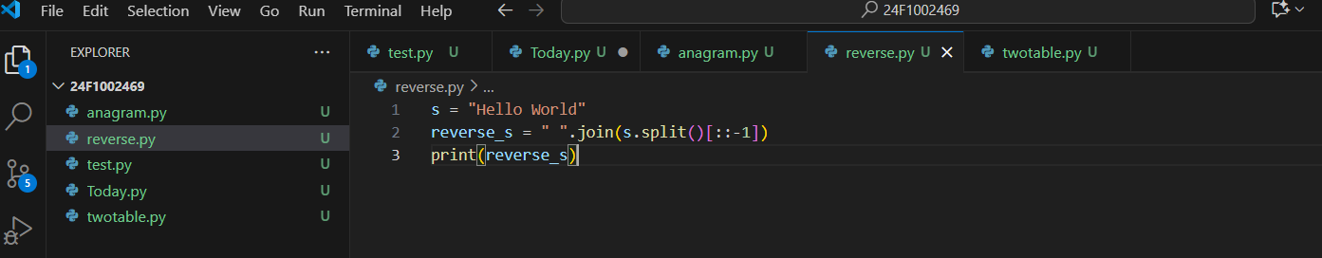

### Create at least 5 commits with proper messages



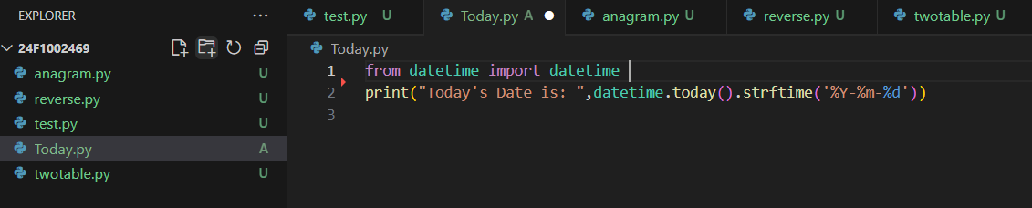

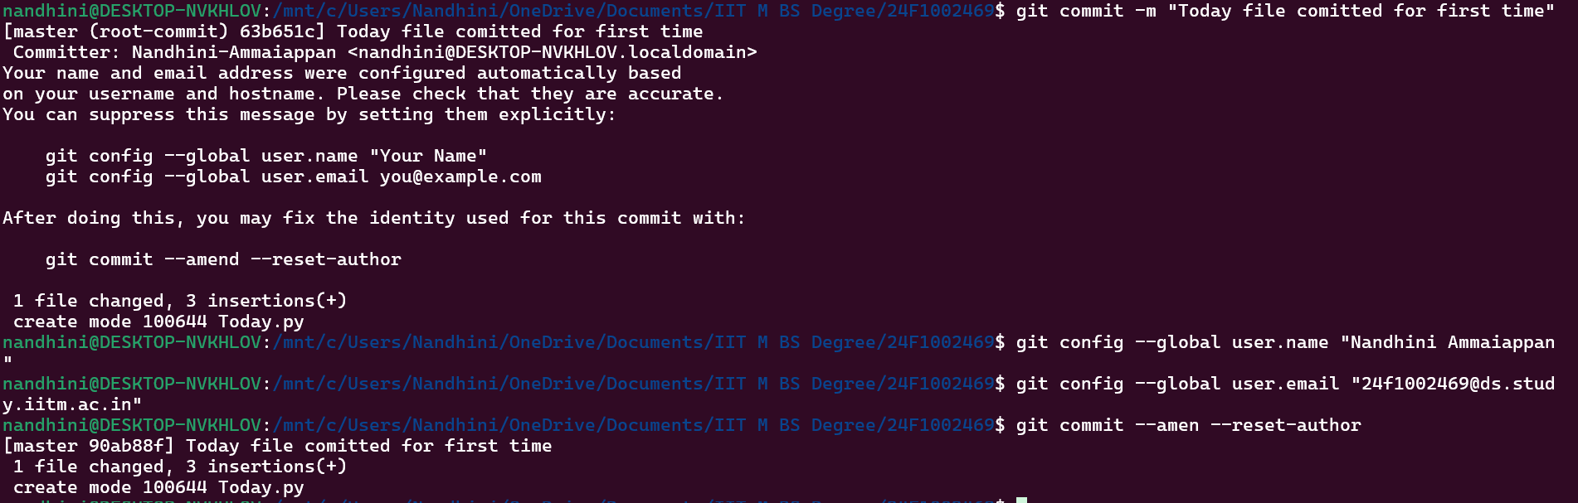

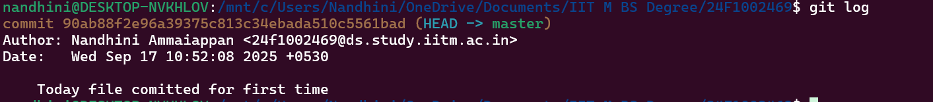

**Same process followed for other 4 files**

### Take screen shot for git log(not one line)

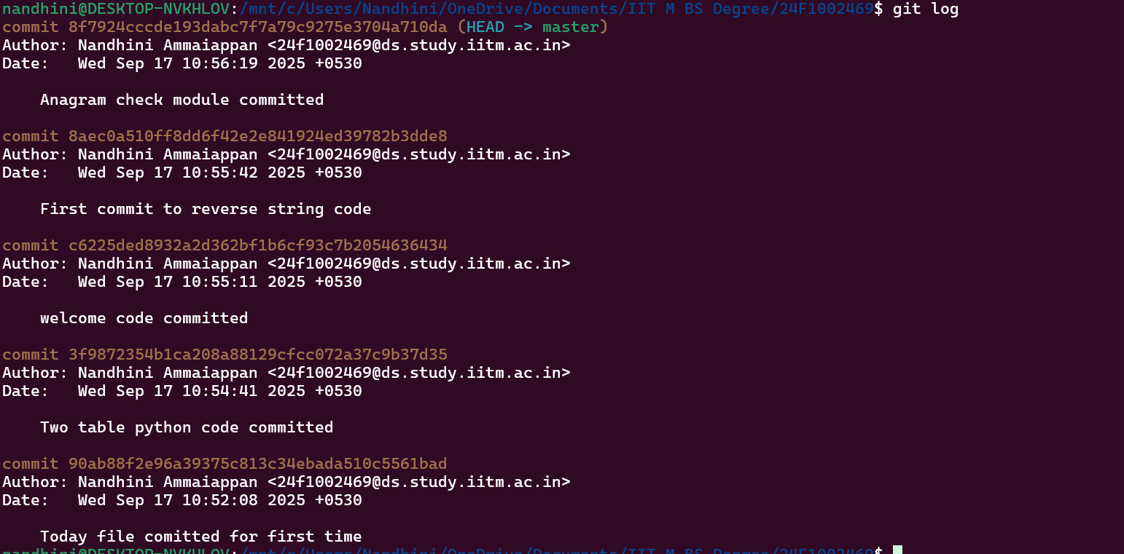

### Create two branches





### Update file on branches and one file should create merge conflict



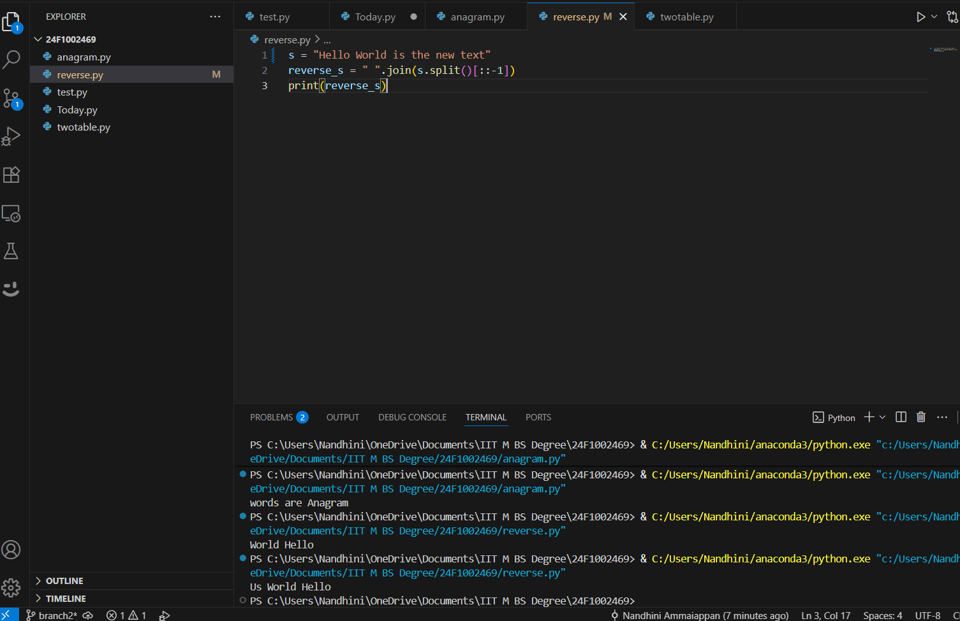

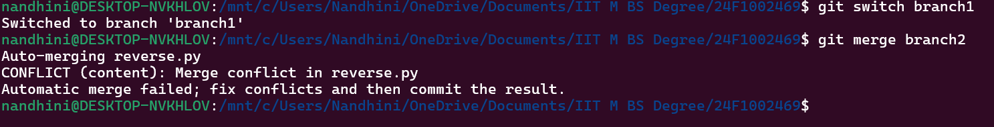

### Merge both branch to master

### Take screen shot for merge conflict in file and merge conflict message on terminal



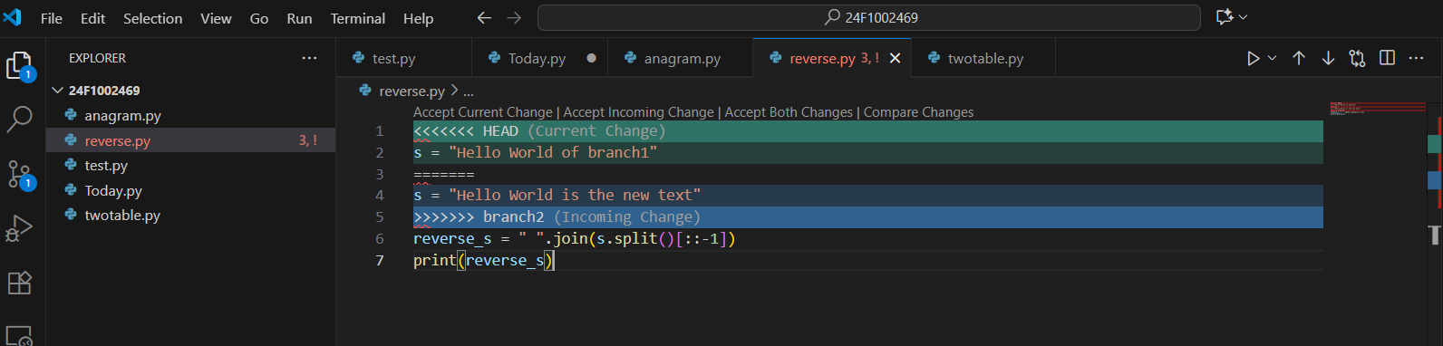

### Resolve merge conflict and commit

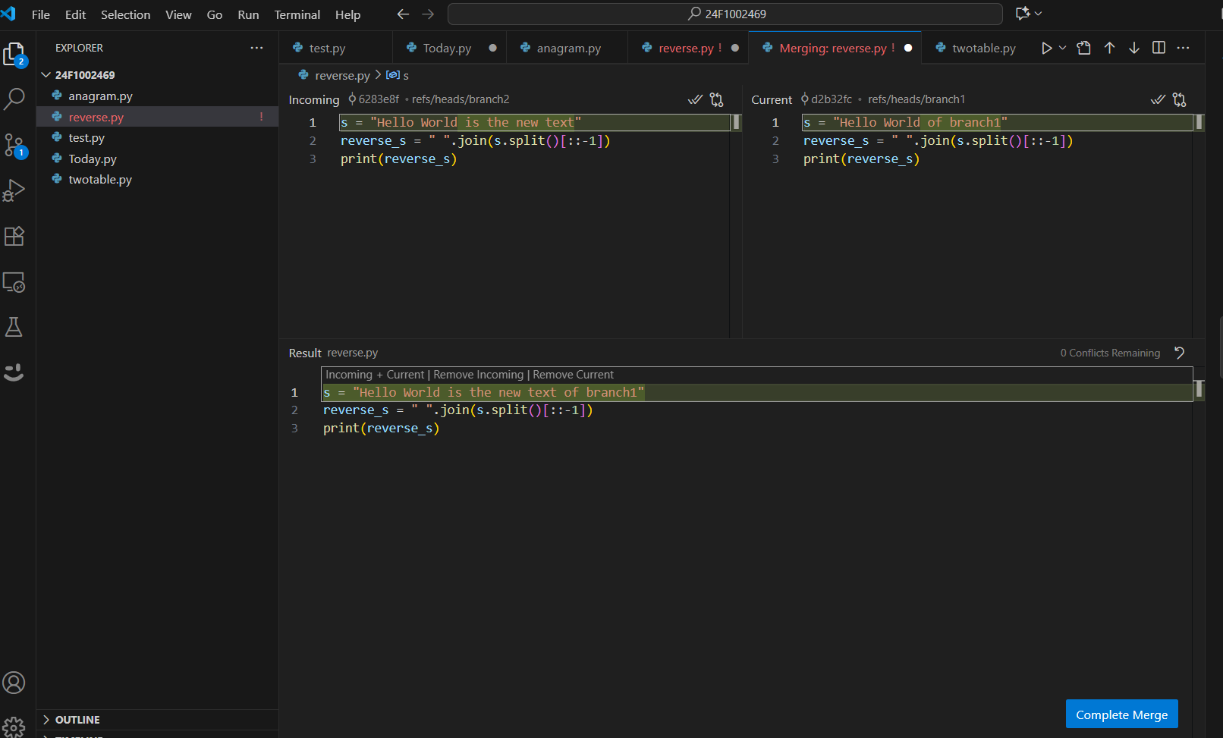

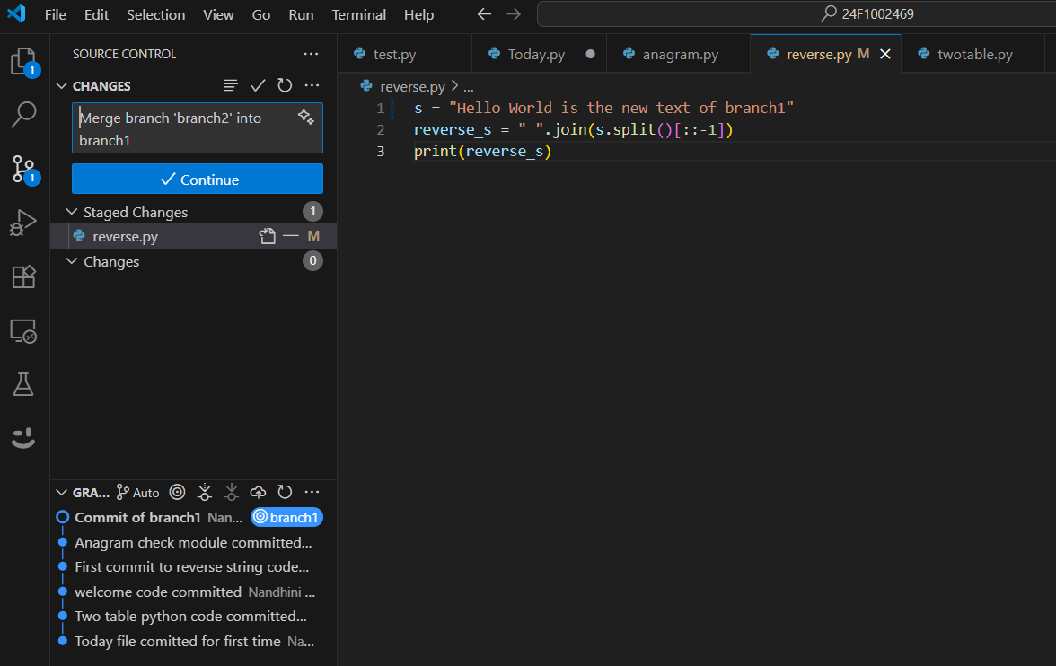

### Take screen shot for complete git graph

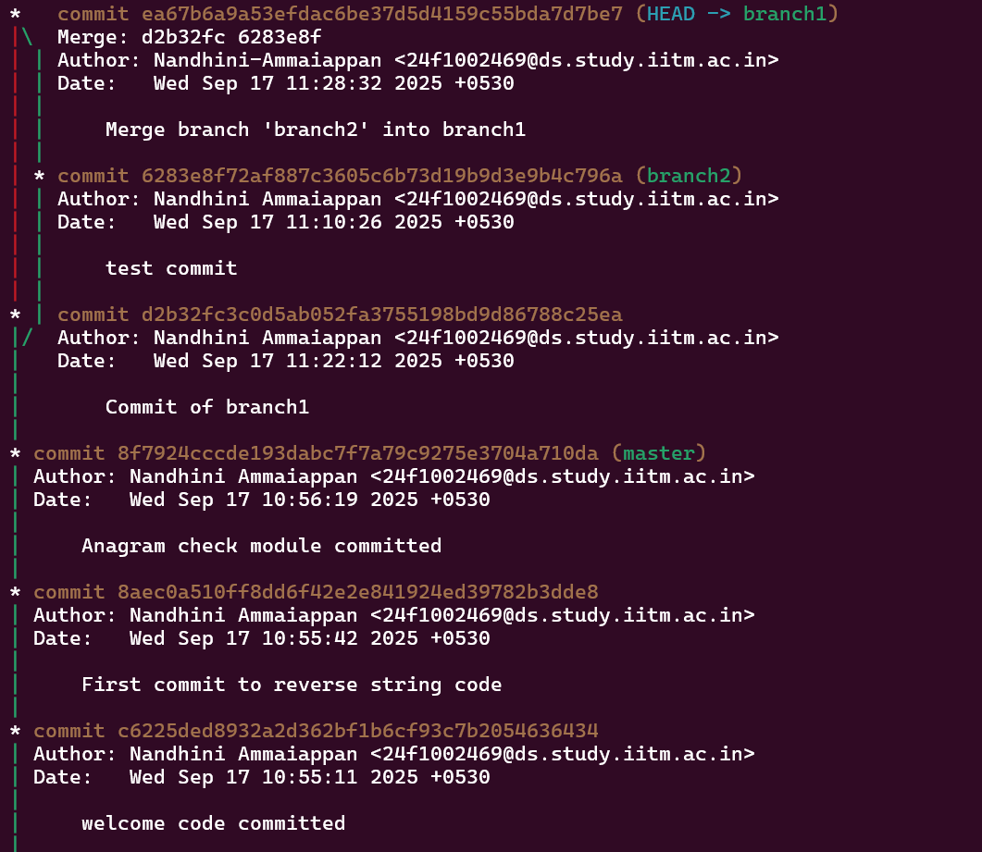

## Day 2

### Build a repo using scenario:

* Python project for arithmetic operations(sum, difference, product etc.,).

### Create new repository on github with basic README file

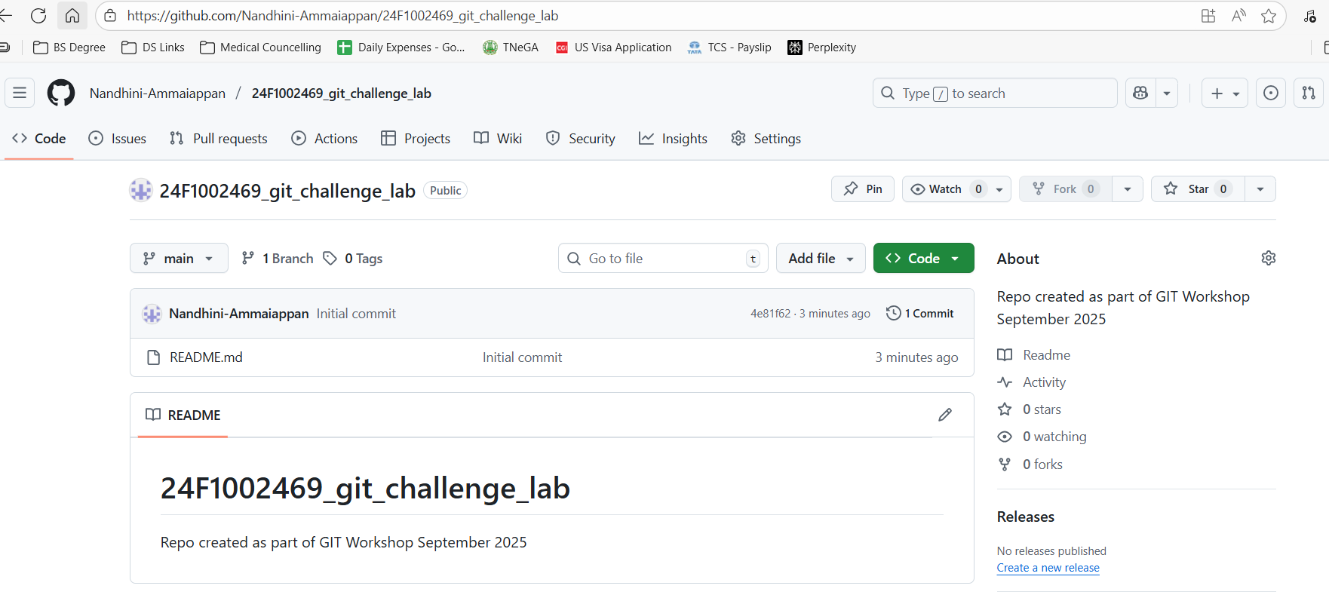

### Clone the repo into local git

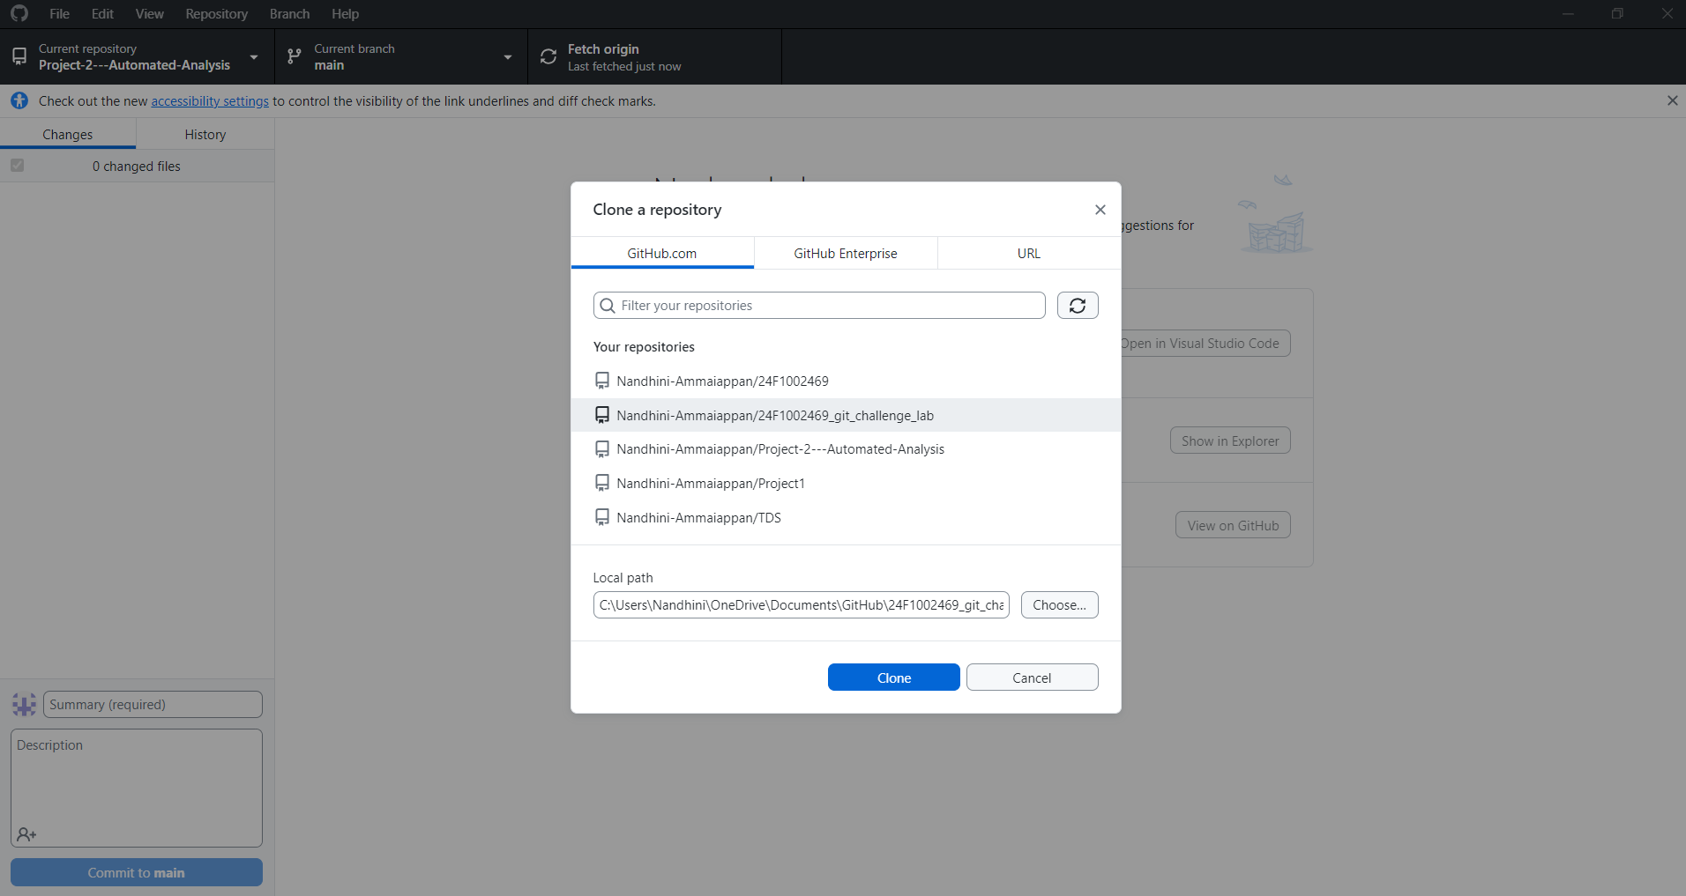

### Add first basic module.

* Initially you can add/commit/push **main.py** for python project as first file into **main/master** branch.

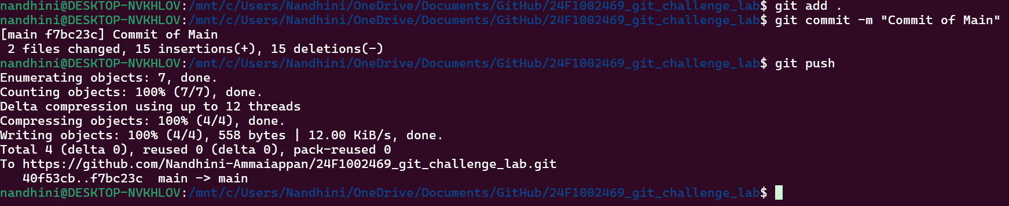

### Add other modules through branches.

* Later you can add/commit/push other module files(**sum.py, difference.py, etc)** as separate branches like **feature1, feature2** etc.,.

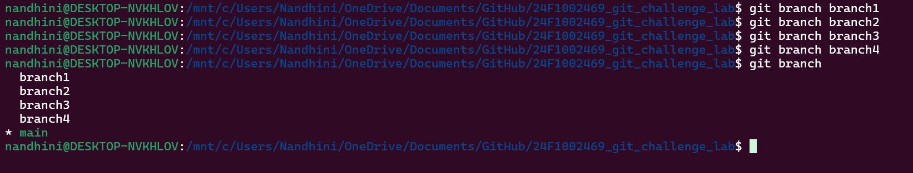

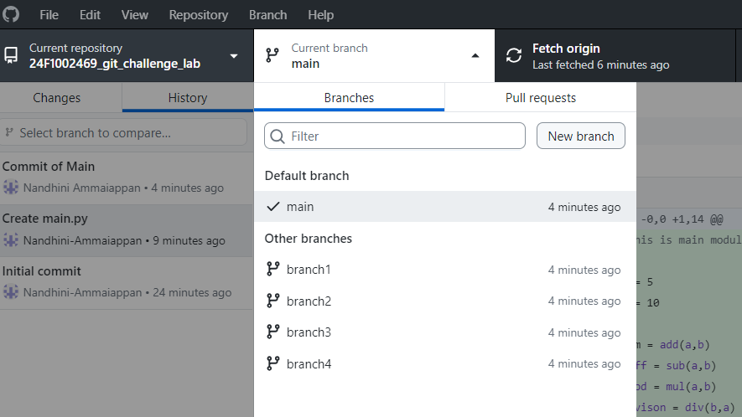

Branch 1:

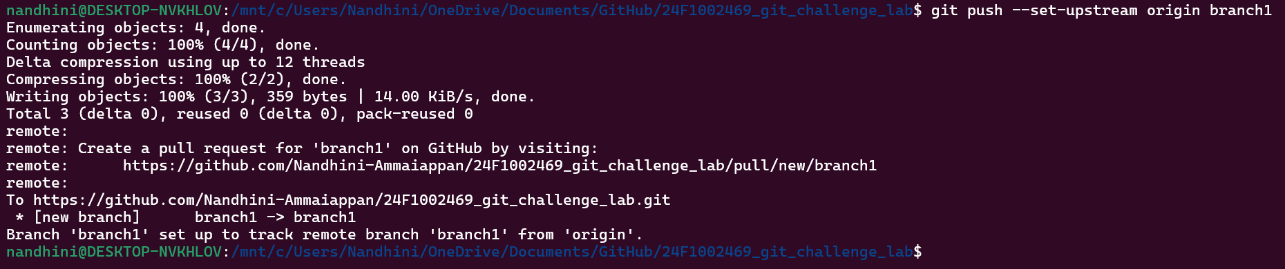

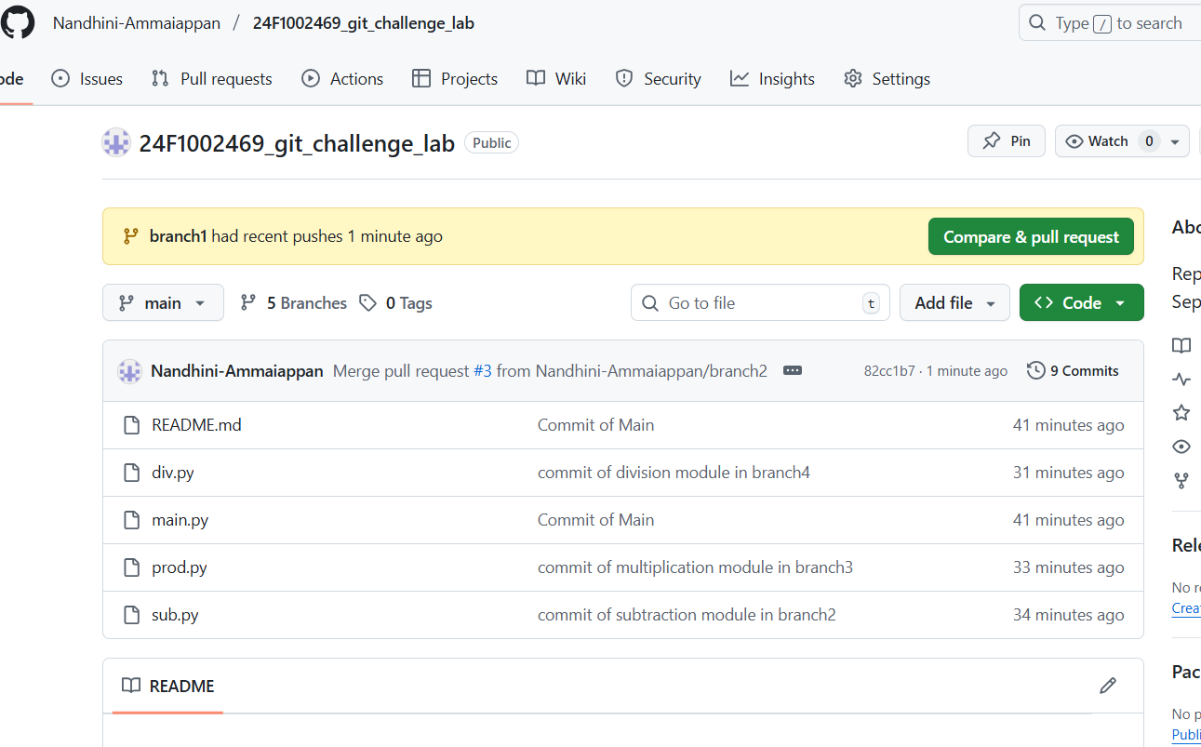

Branch 2:

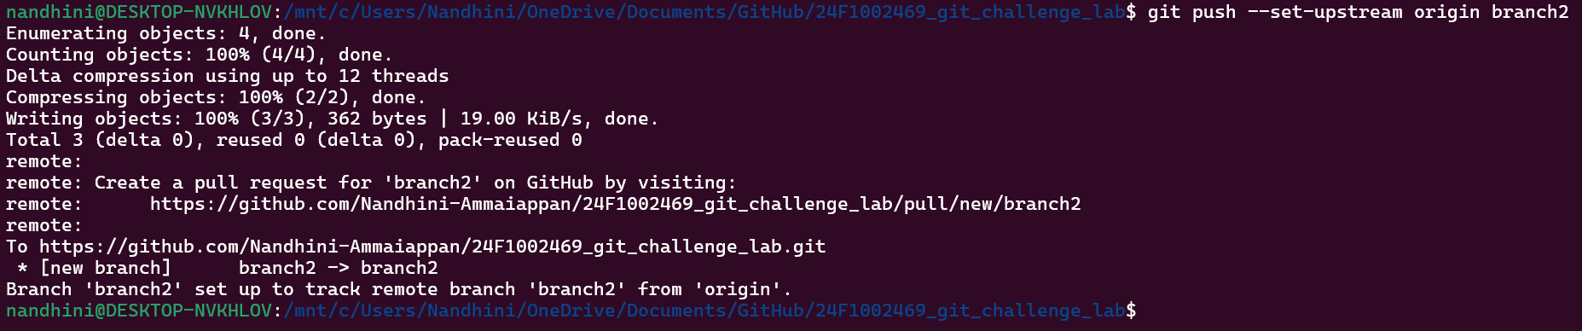

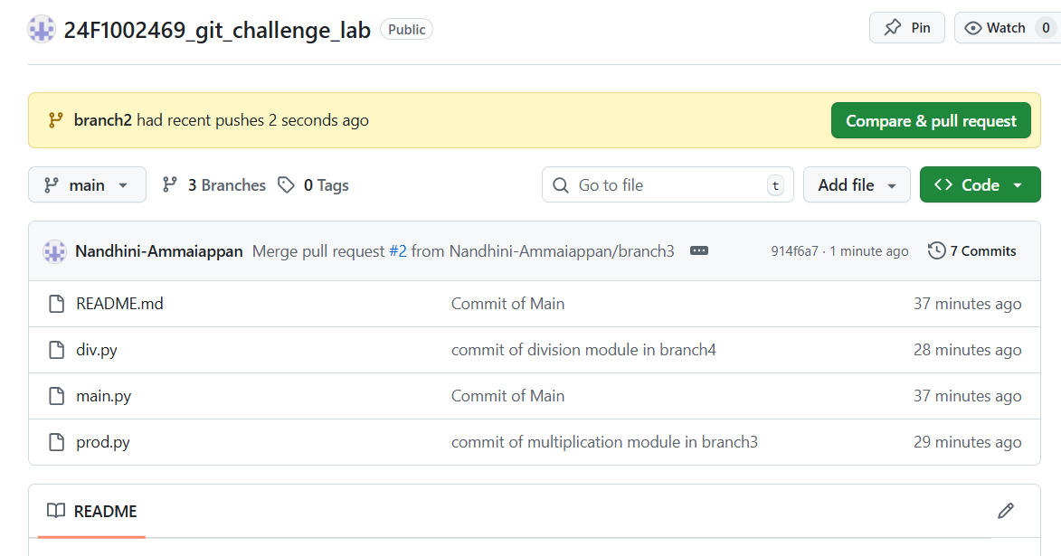

Branch 3:

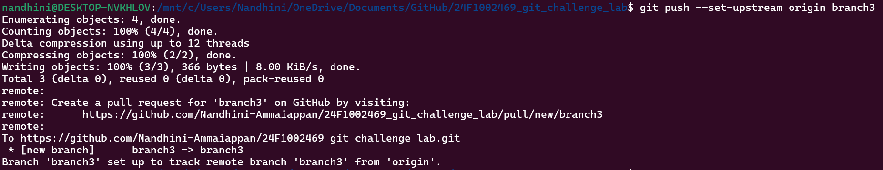

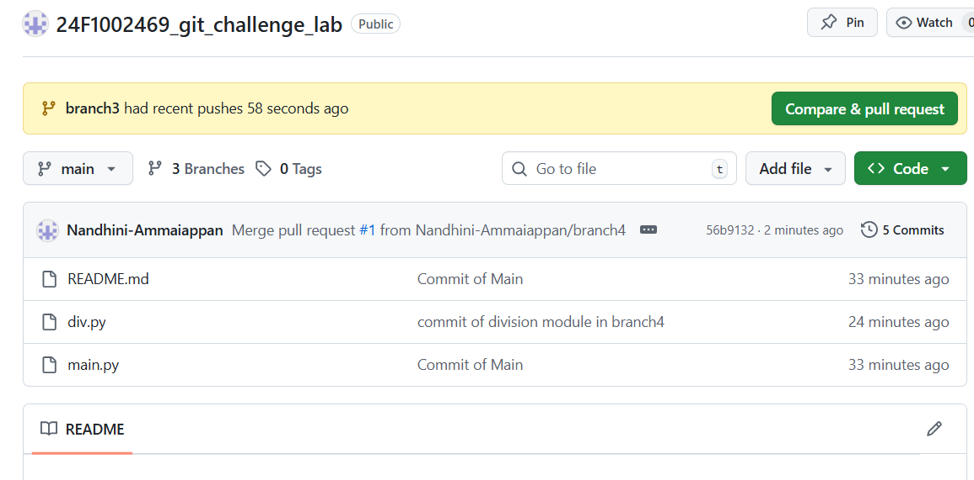

Branch 4:

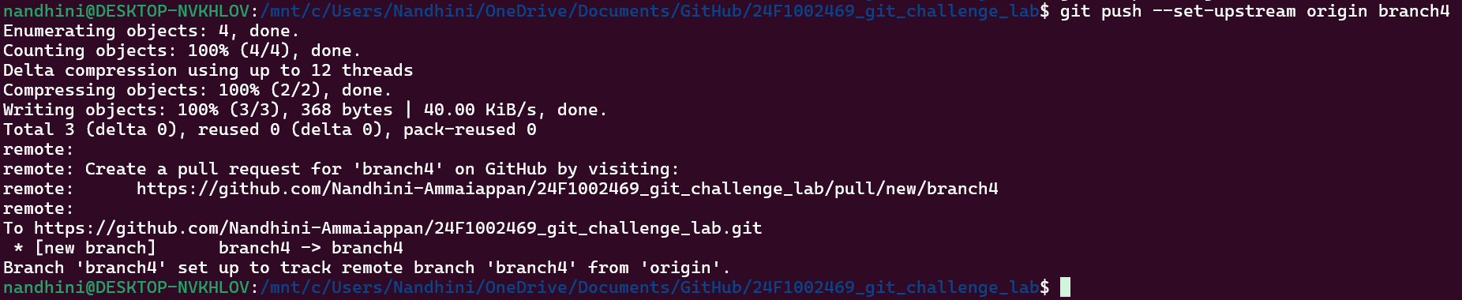

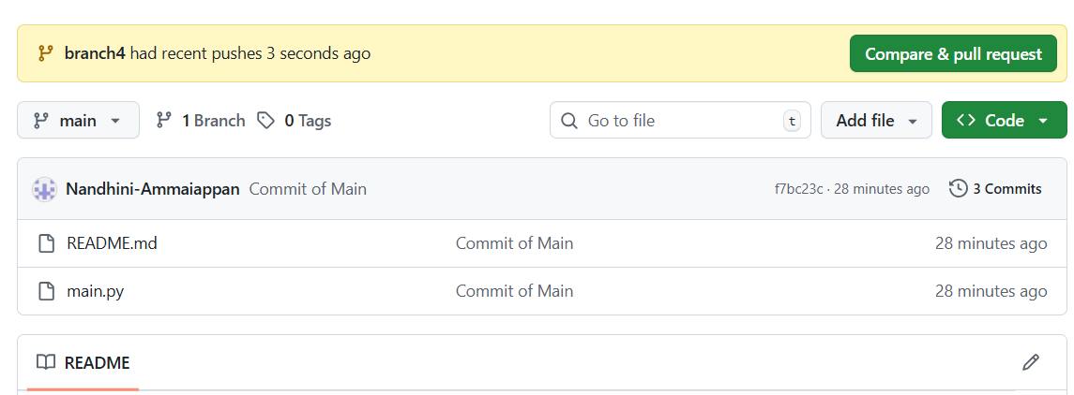

### Raise Pull Request

* Raise pull request(PR) for each branch and merge them with reliable message.

Branch 1:

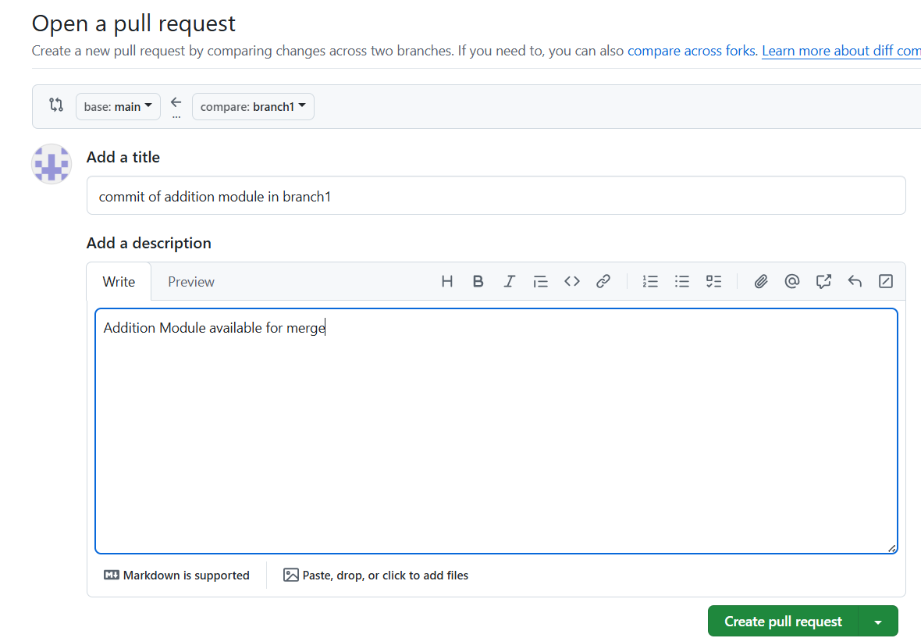

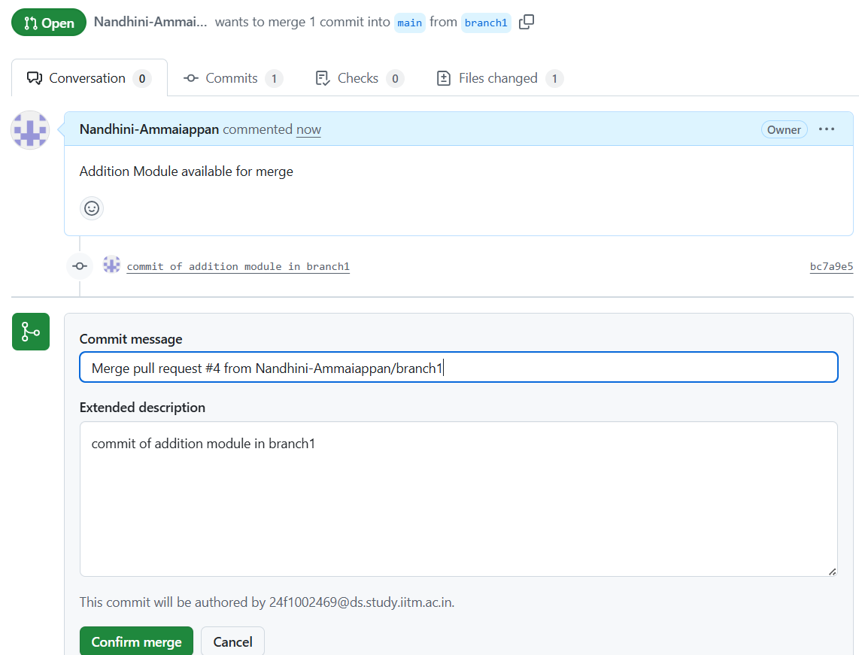

Branch 2:

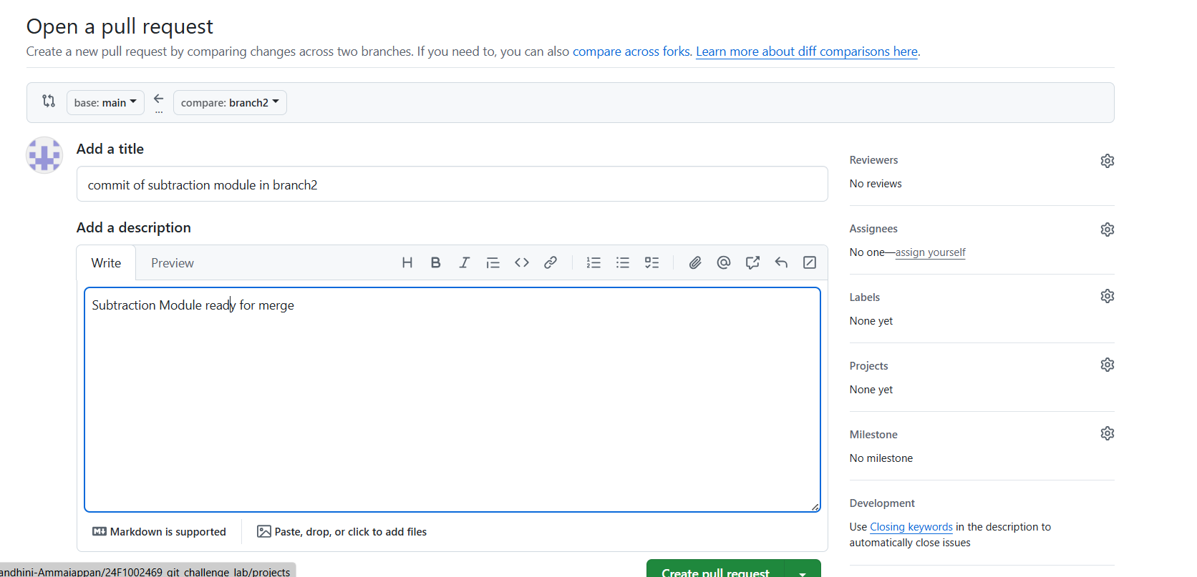

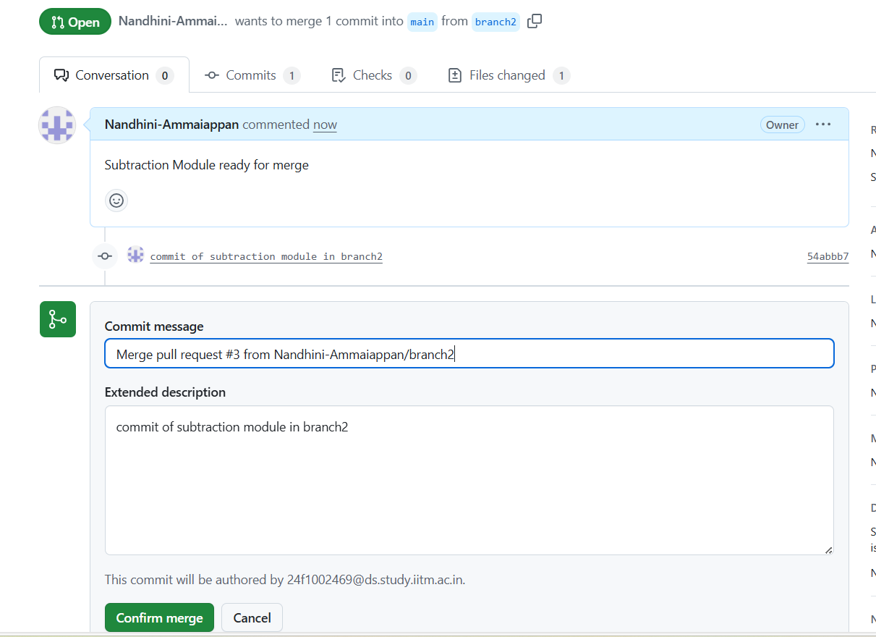

Branch 3:

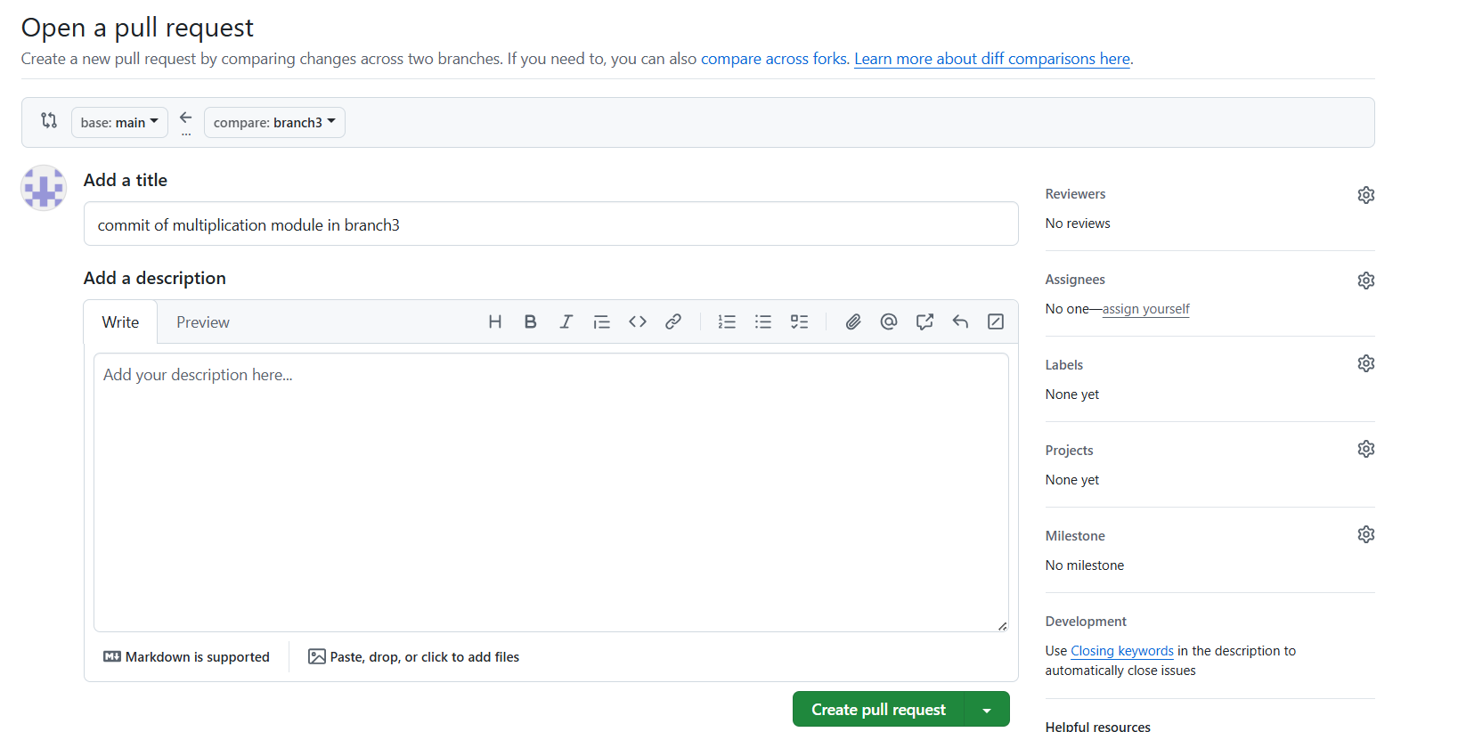

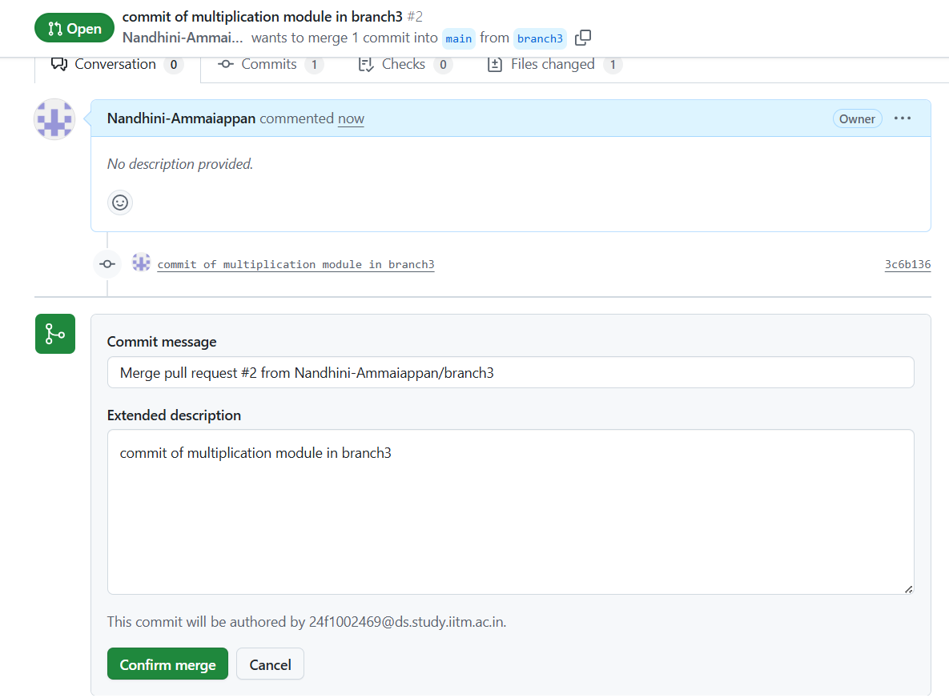

Branch 4:

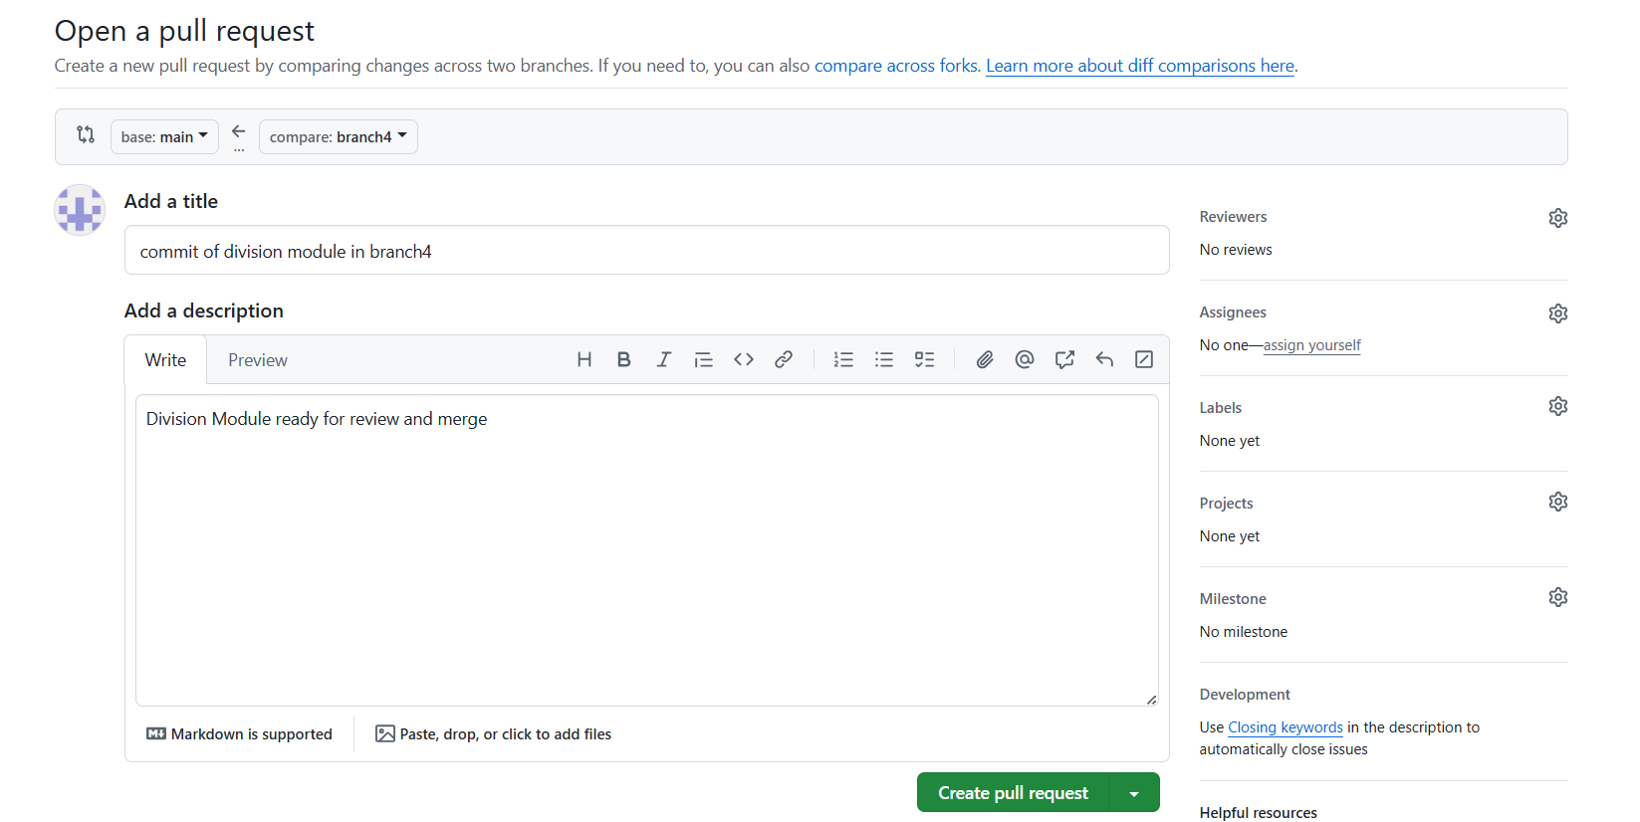

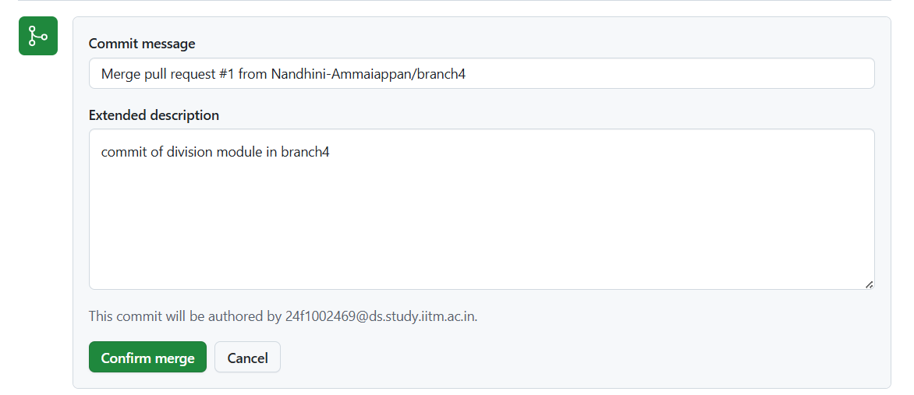

### Final Repo

