COLLECTION
- List
- Set
- Map
- ArrayLIst
- LinkedList
- HashSet
- HashMap

Data - very important part of prgm’ng. We write prgm, so that it will process upon the data & perform computations on the data to come up with some results.
Sources of Data:
CPU
Keyboard
Remote Cmptr (thru n/w or internet )
Database
File/ Hard Disk
Main Memory
Java Prgm
Stack

Heap

Prgm perform computations on the data; Data – not just single value, may be a list of values & Those values come from various sources.
Data Structure arrange & organize the data, so that they can be used in prgm efficiently

Collections builtin data structures provided by Java. Data Structures , that r imp for developing a basic useful application, not just simple program
- Representing a grp of individual obj’s into a single entity
Collection framework Define the classes & interfaces for representing grp of obj’s into a single entity ie., Collections ( like ArrayList )

Need for Collections :-
- Individual Variable
int x=10 ;
int y=3 ;
int z= 4 ;
We can represent 1 val with 1 var, 2 val with, 3 val with 3,..What if we want to store 1k or 10k values…it’s difficult to declare 10k var & also if we do so, readability of code – down ( like we don’t know which var represents what val )

- Arrays – store multiple val’s of the same datatype (size is fixed )
Student s[] = new Student[10000] ;
Here, ‘ s’ – reference var for Student Array , Each student obj – differentiated with index num’s from 0 to 9999.
Advantages: As we can represent multiple val’s with a single var , Readability of Code – improves
Limitations of Arrays :
- Fixed in size
Once we created an Array of some size, then we cannot increase or decrease the size of array based on our requirements. To use arrays, must know its size in advance , w/c not possible always.
If big array need, create new array & shift all old array elements there.
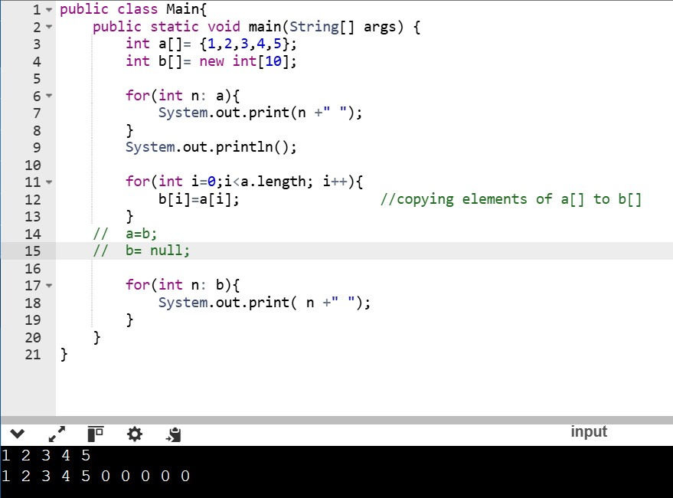

- Arrays can hold only Homogeneous datatype elements
int arr[]= new arr[5];
When we try to store val of other Datatype, get imcompatible types CT error
Soln: If need to store Heterogenous elements (ie., diff DT ), go with ‘Array of Objects‘
Object[] a= new Object[1000];
a[0] = new Student();
a[1]= new Customer();
- No underlying Data structures
Arrays are not implemented based on some std DS- no readymade mtd support avail.
Eg., when we need to insert elements in some order/ search for a particular element in array, need to write progm

Collections
Def In Java, collections are a set of classes and interfaces that implement various types of data structures. These data structures allow you to store and manipulate groups of objects in an organized and efficient way.
Overcoming Array limitations :
- Size not fixed- Variable size (ie., increase/ reduce size when we add/ delete an element)
- Can hold both Homogenous & Heterogenous obj’s
- Every collections implemented based on some std DS
With collections , can store & manipulate data ; perform various oprn’s on data like searching, sorting, insertion, manipulation , deletion.

Requirements :
Variable size collection ( ArrayList, LinkedList )
Distinct collection ( Set )
When list of obj’s in collection s/d be Unique ; no duplicate elements allowed
Sorted collection ( SortedSet )
Elements- unique/ distinct & sorted
Some cmn oprn’s that can be performed with collections : Insert, Delete, Search
Hashing (store data in key-value pairs )

Collection Hierarchy
Collection framework – data structures, Java provides Collection framework in form of Interfaces & Classes, that r organized in form of hierarchy.
Iterable
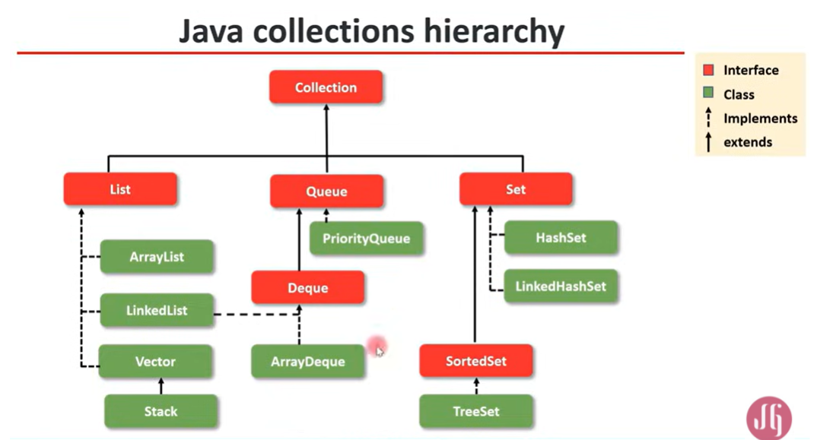

In Java Collection hierarchy,
Collection – root interface
Collection – grp of elements/items/obj’s & those things can b similar or dissimilar (ie., homogeneous or heterogenous ) ; it has mtds for adding, removing, searching for obj’s.
All the interfaces and classes are directly or indirectly inheriting from this collection interface.

List, Queue, Set – sub interfaces of collection interface
List – elements are ordered , as they ‘ve indexing ; Ordered collection with duplicate elements.
- ArrayList, LinkedList, Vector, Stack classes – implementing List interface.
( Vector & Stack cls’s – legacy cls’s ie., in the early version of java )

Set – Doesn’t allow duplicate elements ; Unordered collection with unique elements.
- SortedSet TreeSet (it’s a set, but the elements r ordered ) ; for sorting elements in ascending / descending order (Treeset cls implements SortedSet interface - this DS used for faster searching )
Hashing – a technique w/r obj’s get inserted in the DS based on their key or hash code
- HashSet , LinkedHashSet – implement Set interface
Queue – wrk’s based on FIFO; has mtds w/c support FIFO mechanism.
- PriorityQueue – a queue w/c ‘ll ‘ve elements with priority.
Deque – insert or delete elements from both the ends
- ArrayDeque cls implements Deque interface.

Java Docs – Collection Link : https://docs.oracle.com/javase/8/docs/api/java/util/package-summary.html

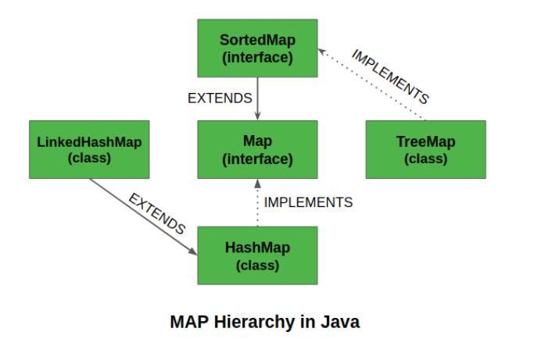

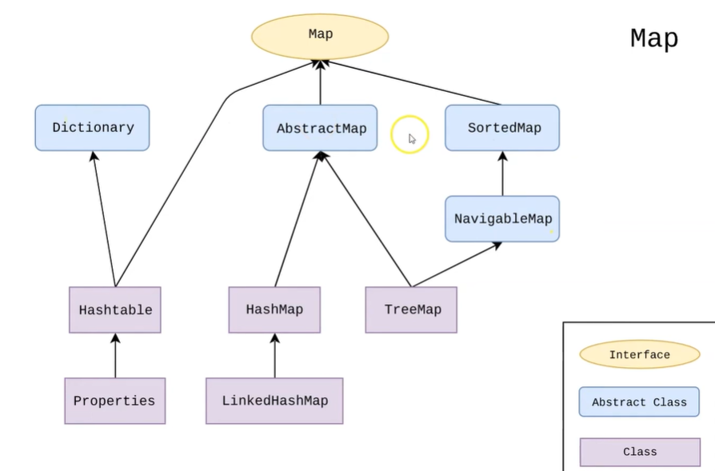
In Map Hierarchy,
Map interface – contains key-value pairs;
Implementation of Hashing technique – elements r stored in key-value pairs ( when we search, give key to get the corresponding value )
- ‘ve HashMap (mostly used cls w/c implements Map interface ), LinkedHashMap
- Hashtable – legacy cls
- SortedMap- to sort map keys& values TreeMap

Types of Collections in Java
- List: An ordered collection that allows duplicate elements. Common implementations include ArrayList and LinkedList.
- Set: A collection that doesn't allow duplicate elements. Common implementations include HashSet and TreeSet.
- Map: A collection that stores key-value pairs. Common implementations include HashMap and TreeMap.
- Queue: A collection used for storing elements in a specific order (FIFO or Priority order). Common implementations include LinkedList and PriorityQueue.
- Deque: A double-ended queue, allowing elements to be added or removed from both ends. Implemented by ArrayDeque and LinkedList.

Collection Interface
All collection Interfaces & Classes present in – ‘ java.util ‘ package
There r 4 interfaces avail : Collection | List | Set | Queue
All 3 other interfaces r extending from Collection interface

interface Collection :
- Collection classes & interfaces are generic - they support the object of any class. (like we can create array of any type )
Methods of Collection Interface :
Here, E – Datatype of obj - generic, can be any class ; e/o – obj /element

 | interface Collection
add( E e ) | Add one obj into the collection (element may be added at end of collection )
addAll( Collection < E > c ) | Add all the elements from one collection to another collection
remove ( Object o ) | Remove an obj from collection – return Boolean value whether that obj removed or not
removeAll (Collections <E > c ) | Remove all elements of c2 from c1 including any common elements  ( can remove one or multiple obj’s )
retainAll (Collection <E> c ) | Compliment of removeAll() – just retains only c2 elements & common elements of both collection & all others removed
clear ( ) | Delete all obj from collection – collection ‘ll get emptied
isEmpty () | Returns true if no obj r there in collection ie., Coln is empty
contains( Object o ) | Search for an element – Returns true if that element is present  (check for 1 element )
containsAll ( Collection <E> c) | Checks whether all obj’s from one Coln – present in given Coln  Returns Boolean val
equals ( Object o ) | Compare 2 collections whether they r equal or not  (like no.of obj’s, obj’s )
size ( ) | Size of collection ie., no.of obj’s present in Coln
iterator( ) | Iterating ~ Traversing ~ Scanning - when need to scan thru all the elements in the collection  Unidirectional (access elements in forward direction only – left to ryt )
toArray( ) | Convert a collection into an Array

Iterator()
The iterator() mtd - to retrieve an Iterator object that allows you to traverse through the elements of a collection (like a List, Set, etc.). [ used to iterate over collections to access each element sequentially ]
It is part of the java.util.Collection interface and is commonly used when you need to loop through the collection's elements without explicitly using a for loop with an index.
Syntax to use iterator():
Iterator<T> iterator = collection.iterator();
Where T - type of elements in the collection (e.g., String, Integer); iterator – ref var
Iterator<Object> iterator = list.iterator(); // Iterate over a heterogenous collection
Key Steps for Iterating over a Heterogeneous Collection:
- Use ArrayList<Object> or any collection type that holds Object as the type parameter.
- Use Iterator to iterate over the elements in the collection.
- Cast each element to the appropriate type (e.g., String, Integer) during iteration.
Type Checking: Since the list is heterogeneous (contains different types), we need to check the type of each element during iteration using instanceof to determine how to process it (casting to the correct type like String, Integer, Double, etc.).

 | Key Methods of Iterator
- hasNext() | - Returns true if the iteration has more elements.  - Returns false when there are no more elements.
- next(): | - Returns the next element in the iteration.  It throws a ‘ NoSuchElementException ‘ if there are no more elements
3. remove() | - Removes the last element returned by the iterator from the underlying collection.  -It can throw an ‘ UnsupportedOperationException ‘ if the collection does not support removal via the iterator.

List Interface
- List represents Ordered Collection of elements ( ‘ve indexing – starting from 0 )
- It maintains the insertion order ; when displaying the list content, it ‘ll display the elements in the same order in w/c they got inserted into the list.
- List gives ctrl over the position w/r we can insert an element.
- Access / search element in the list by their index.
- Can add Duplicate elements also
- Can have ‘null’ elements
- List Interface extending/ inheriting from Collection Interface
It inherits all mtds from Coln interface & has some extra mtds as well.
interface List extends Collection
( has add’l mtds using index )

add( int index, E e ) | Insert an element at specified index
addAll(int index, Collection <E> c ) | Insert all the elements from one collection to another collection,  from a starting index
remove ( int index ) | Remove an obj at specified index
get ( int index ) | Returns the element at particular index
set (int index, E e ) | Replace/ change the element/ obj at a given index  ( add mtd – insert an element by making freespace by shifting elements ; Set mtd – replace an existing element )
subList( int from, int to ) | Get a part of the list ( few elements from Coln ) from starting index to ending index
indexOf( Object o) | Give index of given obj (search from 0th index / beginning – left to ryt )
lastIndexOf( Object o ) | Give index of given obj (search from n-1th index / ending – ryt to left )
clear ( ) | Removes all elements from the list
listIterator() | Access elements in either direction (from forward / backward )  Can access previous / next element also  (bi-directional access )
listIterator( int index ) | get the listIterator from the beginning of a list or from some starting point.  Mention the index here.

- In interfaces (list, set ), all the mtds r abstract (ie., only definitions r available ) & implementations r in implemented cls’s (ArrayList, LinkedList)
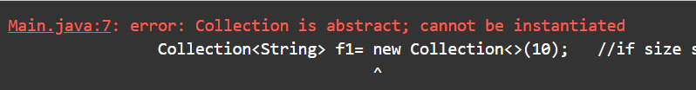

ListIterator()
ListIterator - special type of iterator in Java that allows iteration through a list in both forward and backward directions.
It is part of ‘ java.util ‘package & specifically designed for lists (w/c implement List interface).
Unlike a regular Iterator, a ListIterator provides more functionality, such as ability to iterate in both directions, modify elements, and add elements.

 | Key Methods of ListIterator
- hasNext()  (ReturnType : Boolean ) | Checks if there are more elements when iterating forward.  - Returns true if there are more elements to iterate over in the forward direction.
- next():  (ReturnType : E , ie., type of the list elements ) | Returns the next element in the list and moves the cursor forward.  - Moves the iterator to the next element and returns it.
- hasPrevious()  • Return Type: boolean | Checks if there are more elements when iterating backward.  - Returns true if there are more elements to iterate over in the backward direction.
- previous( )  • Return Type: E (the type of the list elements) | Returns the previous element in the list and moves the cursor backward.  Usage: Moves the iterator to the previous element and returns it.
- nextIndex()  • Return Type: int | Returns the index of the element that would be returned by a subsequent call to next().  Usage: Gives the index of the next element in the list (if any).
- previousIndex()  • Return Type: int | Returns the index of the element that would be returned by a subsequent call to previous().  Usage: Gives the index of the previous element in the list (if any).
- set( E e)  • Return Type: void | Replaces the last element returned by next() or previous() with the specified element.  Usage: You can modify elements while iterating by using set().
- add( E e)  Return Type: void | Inserts the specified element into the list at the current position of the iterator.  Usage: You can add elements during iteration. New element is added before the element that would be returned by next().

Advantages of ListIterator:
- Bidirectional Iteration: ListIterator allows you to iterate both forward and backward through the list, unlike a regular Iterator which can only iterate forward.
- Modifying the List: can add and modify elements while iterating, providing more flexibility than using a standard Iterator.
- Positioning: can start iterating at any position in the list (not just at the beginning). – listIterator( int index ).

Linked List
- class in the Java Collections Framework that implements the List and Deque interfaces.
- stores elements as nodes in a doubly linked list, where each node contains the element and pointers to the next and previous nodes. insertion and removal of elements from both ends of the list.
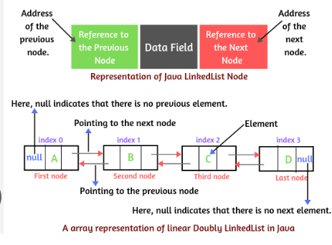

https://www.scientecheasy.com/2020/09/java-linkedlist.html/

Key Characteristics of LinkedList :
- Doubly Linked List:
  - LinkedList is implemented as a doubly linked list,
ie.,each node has a reference to both the next and previous nodes ( pointer ). This enables traversing the list in both directions (forward and backward).
- Dynamic Size:
  - Similar to ArrayList, LinkedList can grow dynamically as elements are added.
cannot specify size initially, as nodes r created only when elements are inserted
- Efficient Insertions/Deletions:
  - Used w/r frequent additions & deletions are performed, especially at the beginning or middle of the list, because no shifting of elements is required, unlike ArrayList.
- Slower Access:
  - Random access (using an index) is slower compared to ArrayList, as it requires traversing the list node by node from the beginning (or end, depending on where the index is located).
- Allows Null Elements:
  - Similar to ArrayList, LinkedList allows storing null values.
- Implements Deque:
  - In addition to implementing the List interface, LinkedList also implements the Deque interface, which means it can be used as a queue or stack. It provides methods for adding, removing, and inspecting elements from both ends of the list.

Mtds in LinkedList :
- List Mtds (from List interface )
Inherits all mtds from List interface like add, add(index ), get , set, remove.

 | Deque Mtds (from Deque interface )
addFirst( E e )  R- void | Adds an element at the beginning of the list (head )
addLast( E e )  R- void | Adds an element at the end of the list ( tail )
removeFirst ( )  R- Obj | Removes & returns the 1st element of list
removeLast ( ) | Removes & returns the last element of list
peek()  [ Stack mtd ] | Retrieves, but does not remove, the first element of the list.  If the list is empty, it returns null
peekFirst() | Returns the 1st element w/o removing it
peekLast() | Returns the last element w/o removing it
poll( ) | Retrieves and removes the first element of the list.  If the list is empty, it returns null (removes the element from the front)
pollFirst( ) | Retrieves and removes the first element of the list.  - to remove the element from the front of the LinkedList.
pollLast() | Retrieves and removes the last element of the list.  - to dequeue an element from the end of list or remove the last element.
pop( )  [ stack impl’n] | removes and returns the first element of the list, similar to pollFirst(). However, it throws an exception (NoSuchElementException) if the list is empty
push( e )  [ stack impl’n] R- void | adds an element to the beginning of the list, just like a stack's push() operation.
offerFirst(E e)  R- boolean | Adds an element to the front of the list.
offerLast(E e)  R- boolean | Adds an element to the end of the list.
Also, getFirst, getLast ,..

Queue Interface
- support FIFO (First In First Out ) mechanism
ie., elements r inserted from one end & deleted from another end.
- interface Queue extends Collection ( has few xtra mtds )
Ref https://www.scientecheasy.com/2020/12/queue-in-java.html/
- Some queues have capacity limit

 | interface Queue extends Collection
Methods for Insertion (Enqueue)
add( E e ) | Insert a new element to queue , at the last as it follows FIFO mechanism (no index need to mention )  - Throws an ‘ IllegalStateException ‘ if the element cannot be added (e.g., if the queue has a fixed capacity and is full).
offer(E e) | Adds the specified element to the queue, returning true if it was successfully added.  - Returns false if it cannot add the element (for instance, when the queue has a capacity limit).
Methods for Removal (Dequeue)
poll( ) | Removes & returns the head (1st element ) of the queue  - Return ‘null’ if queue is empty
remove ( ) | Same as poll() remove & returns the head of queue  - throws ‘ NoSuchElementException ‘ when element not there ; ready to handle it by catch
Methods for Viewing the Head (Front) Element
peek( ) | Give the first element / obj in the queue  ( we can see what’s there in the queue before removing it )  - Return null if queue is empty
element ( ) | Retrieves the first element in queue  - Throws ‘NoSuchElementException’ if queue is empty

Common Implementations of Queue Interface
- LinkedList: Implements both Queue and Deque. It can be used for general-purpose queue operations with efficient add and remove operations.
- PriorityQueue: A queue where elements are ordered based on their priority (natural ordering or a custom comparator – ascending order).
If you iterate over a PriorityQueue, the elements may not appear in priority order, but will only be removed in priority order.
- ArrayDeque: Implements both Queue and Deque. It is often preferred over LinkedList due to its better performance for stack and queue operations.

When to Use a Queue in Java?
- FIFO Data Structure: If you need a collection where elements are processed in the same order they were added, the Queue interface is ideal.
- Task Scheduling: Queues are often used in task scheduling, thread pools, and handling requests in the order they are received.
- Breadth-First Search (BFS): Queues are commonly used in graph algorithms like BFS, where elements are processed in layers (FIFO).
- Buffering: Queues are useful for buffering tasks, like in producer-consumer problems where one thread produces data and another thread consumes it.

- Queues are useful in a variety of real-world scenarios such as task scheduling, event processing, and more.

Priority Queue
- Elements r arranged & deleted based on priority ( natural ordering > num – ascending order; String > alphabetical order ) depending on the element
ie., elements can be inserted at any order of choice, but deleted based on their priority (High priority element , small element - deleted first )
If no comparator provided in Constructor, default natural ordering using Comparable interface or We can define ordering with custom comparator.
- Underlying DS ‘ Heap’ ie., Binary Heap - implemented using ‘Array’ as basic DS
When smaller val having higher priority Min Heap
Change the order & make larger val element to Higher priority ie., Max Heap Define Comparator to change order
Heap implemented using Binary Tree DS
- Java PriorityQueue doesn’t permit null elements.

Custom Comparator
A comparator is an object for sorting- to define a specific order for the elements in the queue.
It implements the Comparator interface and overrides the compare method.
By default, a PriorityQueue orders its elements according to their natural ordering (i.e., the Comparable interface). However, you can provide a custom comparator to change this order.
Def’g Custom Comparator: implement the Comparator interface and override the compare method to define your custom ordering logic.

Comparable Interface
to define the natural ordering of objects. It is found in the java.lang package and has a single method, compareTo, which you need to implement.
We can also give power to cls , so that it compares it obj with others (use this & that )
compareTo( ) :
The compareTo method compares the current object with the specified object for order. It returns:
- A negative integer if the current object is less than the specified object.
- Zero if the current object is equal to the specified object.
- A positive integer if the current object is greater than the specified object.

Comparator Interface
An interface or concept using w/c we can define our own logic for sorting. It is found in the java.util package and has a single method, compare, which you need to implement.
Compare( ):
The compare method compares its two arguments for order. It returns:
- A negative integer if the first argument is less than the second.
- Zero if the first argument is equal to the second.
- A positive integer if the first argument is greater than the second.
Custom comparator > define a custom comparator for ordering integers in descending order
ways to implement comparator
- Anonymous Inner class
create an anonymous inner class that implements the Comparator interface:
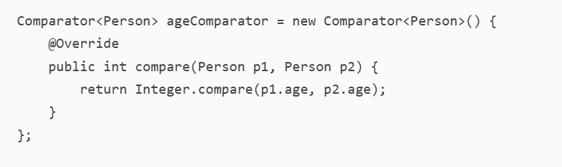
- Separate Comparator class
- define a separate class that implements the Comparator interface:
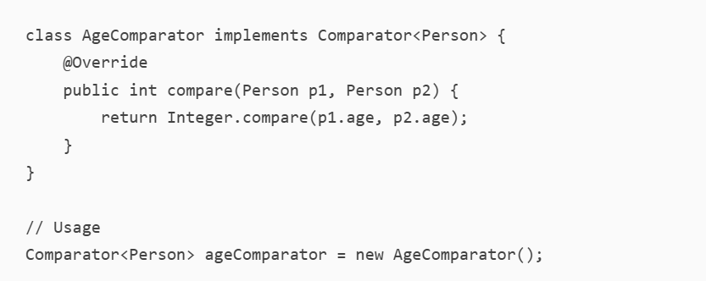
- Lambda Expression
- Method reference
- Chaining Comparators
- Using Comparator Static methods

- Comparable Interface: Used for natural ordering. Implement the compareTo method.
- Comparator Interface: Used for custom ordering. Implement the compare method.
- Custom Comparator: Define custom logic in the compare method and use it in data structures like PriorityQueue.

Collections Class in Java
- Utility cls in Java Collection Framework – in ‘ java.util ‘ package
- This class consists exclusively of static methods that operate on or return collections. The methods of this class all throw a ‘ NullPointerException ‘ if the collections or class objects provided to them are null.

Some useful Mtds : Use – Collections.addAll( al, “new”, “lluca”, 1, 2 )
 | Collections cls mtds
addAll( Coln c, n elements… )  R- boolean | to insert the specified collection elements to the specified collection.  - throws NullPointerException if elements contains one or more null  values and c does not permit null elements, or if c or elements are null
fill( List l, Obj o ) | replaces all of the elements of specified list with specified element.
copy( list1, list2 ) | Copy all elements from one list to another
frequency (Coln c, Obj o )  R- int | counts the frequency of the specified element in the given Coln  Note – case sensitive  - throws Null Pointer Exception if the Collection c is null.
max( )  R- Max element | returns the maximum element of the given collection, according to  the natural ordering (ascending order ) of its elements.  - ClassCastException – if the collection contains elements that are  not mutually comparable (for example, strings and integers).  - NoSuchElementException – if the collection is empty
max( Coln c, Comparator )  Cmptor- Collections.reverseOrder()  R- Max element | return the maximum element of the given collection, according to the order  induced by the specified comparator.  - Same exception as max()
Same as Max ~ min(),
min( Coln c, Comparator )
replaceAll( List l, old val, new val )  R- boolean | to replace all occurrences of one specified value in a list with another.
swap (list l, int i , int j )  i,j - index | swaps the elements at the specified positions in the specified list.  - throws IndexOutOfBoundsException, if either i or j is out of range
reverse( List l ) | reverses the order of the elements in the specified list  - throws UnsupportedOperationException if the specified list or its  list-iterator does not support the set operation.  UseCases : Reversing an ArrayList, Reversing a LinkedList, Reversing an array
rotate( List l, distance ) | Rotate the elements in specified list of Coln by some distance  - Throws same reverse() mtd exception
sort( List l) | Sort the specified list into ascending order
sort( List l, comparator ) | sorts the specified list according to the order induced by the specified  comparator.  Collections.sort() method sorts the list, and  Collections.reverseOrder() ensures the sorting is in descending order.
reverseOrder()  R- Comparator | returns a comparator that imposes the reverse of the natural ordering on  a collection of objects that implement the Comparable interface.

Collections cls Ref : https://www.geeksforgeeks.org/collections-class-in-java/

PQ Ref : https://www.scientecheasy.com/2020/12/priorityqueue-in-java.html/

A PriorityQueue in Java is a type of queue where elements are ordered based on their natural ordering or by a Comparator provided at queue construction time. This means that the element with the highest priority is always at the head of the queue. Here’s a detailed explanation:
Key Characteristics
- Ordering: Elements are ordered according to their natural ordering (if they implement Comparable) or by a Comparator provided at queue construction time.
- Heap-based Implementation: Internally, PriorityQueue is implemented using a binary heap, which ensures that the element with the highest priority is always at the root.
- Unbounded: The queue is unbounded, but it has an internal capacity that grows as elements are added.
- Non-thread-safe: PriorityQueue is not thread-safe. If multiple threads access it concurrently, external synchronization is required.
Basic Operations
- Insertion (add() or offer()): Adds an element to the queue. If the queue is full, add() throws an exception, while offer() returns false.
- Removal (remove() or poll()): Removes the element with the highest priority. remove() throws an exception if the queue is empty, while poll() returns null.
- Examination (element() or peek()): Retrieves, but does not remove, the element with the highest priority. element() throws an exception if the queue is empty, while peek() returns null.
PriorityQueue is created with a custom comparator that orders elements in reverse order.
Use Cases
- Task Scheduling: Managing tasks with different priorities.
- Dijkstra's Algorithm: Finding the shortest path in a graph.
- Event Simulation: Managing events that occur at different times.

Deque Interface
Deque – Double ended queue ; elements can be inserted & deleted at both ends. ie., from both the sides head & tail
part of the java.util package and can be implemented using classes like ArrayDeque and LinkedList.
ArrayDeque class can be implemented if deque is used as a LIFO queue (or a stack).
LinkedList implementation performs better if deque is used as a FIFO queue (or simply as a queue).
Insert
Delete

Head |  |  |  |  |  |  | Tail
Insert
Delete

Queue – FIFO ; inserting from one end & deleting from one end
Stack (top ) – LIFO ; inserting & deleting from same end (top)

Ref : https://docs.oracle.com/javase/8/docs/api/java/util/Deque.html
https://www.scientecheasy.com/2021/01/java-deque.html/

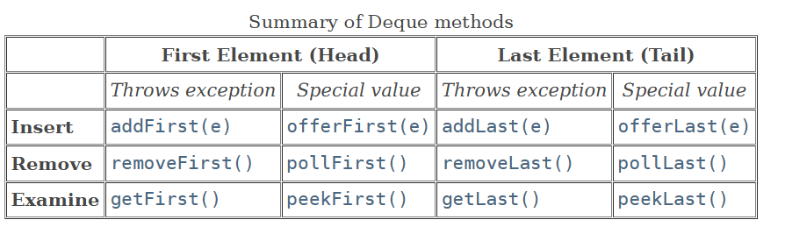
** Spl val – null or false

 | Deque Mtds
- Insertion Mtds

addFirst( E e )  R- void | Inserts the specified element at the front.  - throws an exception named ‘ IllegalStateException ‘  if a capacity-restricted deque is out of space.
addLast( E e )  R- void | Inserts the specified element at the end.
offerFirst(E e)  R- boolean | Inserts the specified element at the front/head of queue  (returns false if it fails).
offerLast(E e)  R- boolean | Inserts the specified element at the end /tail of queue  (returns false if it fails).
- Removal Mtds

removeFirst ( )  R- Obj | Removes & returns the 1st element  - Throws ‘ NoSuchElementException’ if queue ie empty
removeLast ( )  R- Obj | Removes & returns the last element
pollFirst( ) | Retrieves and removes the first element, or  - returns null if the deque is empty.
pollLast( ) | Retrieves and removes the last element, or  - returns null if the deque is empty.
- Examine Mtds
getFirst( )  R- obj | Retrieves, but does not remove, the first element.  - Throws ‘ NoSuchElementException’
getLast( ) | Retrieves, but does not remove, the last element.  - Throws ‘ NoSuchElementException’
peekFirst()  R- obj | Retrieves, but does not remove, the first element, or  returns null if the deque is empty.
peekLast() | Retrieves, but does not remove, the last element, or  returns null if the deque is empty.
- Others [ push, pop,peek – Stack cls mtds ]

push( E e)  R- void | Adds an element to head of the deque  - Throw ‘IllegalStateException ‘
pop( )  R- Obj | Removes & returns head (1st element ) of deque  Throws ‘ NoSuchElementException’ if deque is empty
removeFirstOccurrence(E e )  R- boolean | Removes the first occurrence of the specified element from  the deque.  (when traversing the deque from head to tail).  Return true- if successfully removed ; false- no specified element
removeLastOccurrence(E e )  R- boolean | Removes the last occurrence of the specified element from  the deque.  Return true- if successfully removed ; false- no specified element
size() | Returns the no.of elements in deque
isEmpty() | Check if queue is empty
iterator() | Returns an iterator over the elements in the deque.
Iterator<E> descendingIterator( ) | returns an iterator object that iterate over its elements in reverse order (from tail to head).

This interface provides two methods to remove interior elements, removeFirstOccurrence and removeLastOccurrence.
Unlike the List interface, this interface does not provide support for indexed access to elements.

Key Features of Deque:
- Double-Ended Operations: Allows insertion and removal of elements from both ends (front and rear).
- No Capacity Restrictions: Unlike stacks and queues, deques do not have a fixed capacity.
- Null Elements: Deques generally do not allow null elements.
- Thread Safety: Deques are not thread-safe. For concurrent access, you can use ConcurrentLinkedDeque.

ArrayDeque
- Generic cls – supports an type of Obj’s & implementing interfaces like Queue, Deque
- This cls Array as base DS; elements r stored like Array; elements r inserted & deleted from both the ends like Deque.
- ArrayDeque cls faster than Stack (legacy class ) when used as Stack & faster than LinkedList when used as a Queue [ runs at const time ]

- concrete class that creates a dynamic array (resizable array) to store its elements from both sides of the queue.
- a resizable-array implementation of deque interface ~ array double-ended queue or simply array deck.
- Since ArrayDeque has no capacity restrictions, ArrayDeque is especially useful for implementing stacks and queues whose sizes are not known in advance.

Ref : https://www.scientecheasy.com/2021/01/arraydeque-in-java.html/

Hashing Techinque
Java use Hashing technique in cls’s like :
- HashSet – takes only value
- HashMap - takes Key as well as value
- LinkedHashSet
- LinkedHashMap
- HashTable (legacy cls )
- Properties
Buckets – each of the storage locations
each bucket hold value or key – value
There may be one or more entries

Entries
Key value
Hash Table
Initial size – 16 ; size self-adjustable

Hash function - used to insert key/ values in a hash table in a const time
Hashing store data in a Hash table in Key-value pairs, with the keys computed using hash function.
ie., given keys r conveted into hash values using hash function & these hash values r the index of hash table to store the associated data

HashTable collection of key-value pairs ; Each key-value pair – entry ie., Entry< K, V > - has 2 pieces of data – key, value
These key, value – any type like Int, string,…

Eg1 : here entries, key – int rollNo, val- String name
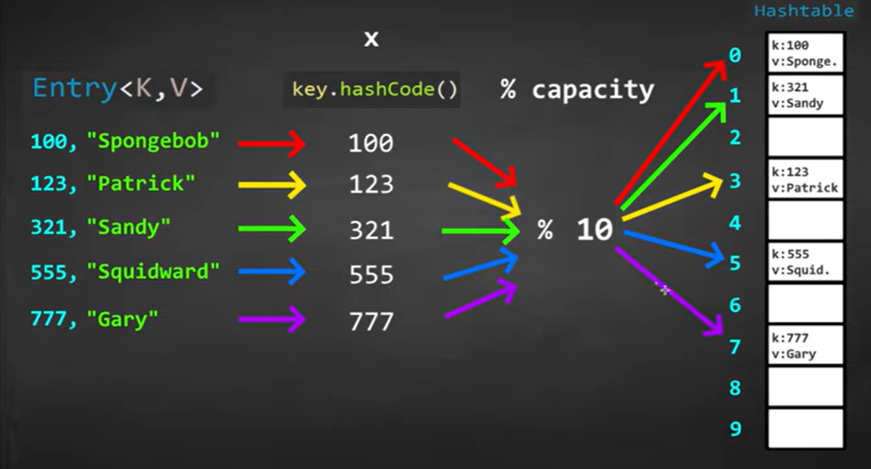
Formula
Hash
If two hash’s have the same value, located in same index – Collision
Eg2 : Each key is a string & each entry is a pair of string ie., “123”, “Nani”
  - Here, need to find hash of string keys, hashCode() use diff formula ; ie., take ASCII val of each char in the string & pass into formula – find hash value
  - Next, divide each hash values with the capacity of hash table – find reminder
Soln for Collision :
- Chaining if already has an entry, turn each bucket into a LinkedList, stored in node & add addr of next entry in 1st entry & goes on..
Here, at each bucket , can hold more than 1 entry
If we r looking up for a key, there r more than 1 entry in that index & search linearly thru the bucket until we find the key - this process is k/n as Chaining
the less the collision, the more efficient hashTable be ;
in this mtd of hashing, size of hashtable remains the same &hashFunction remains same
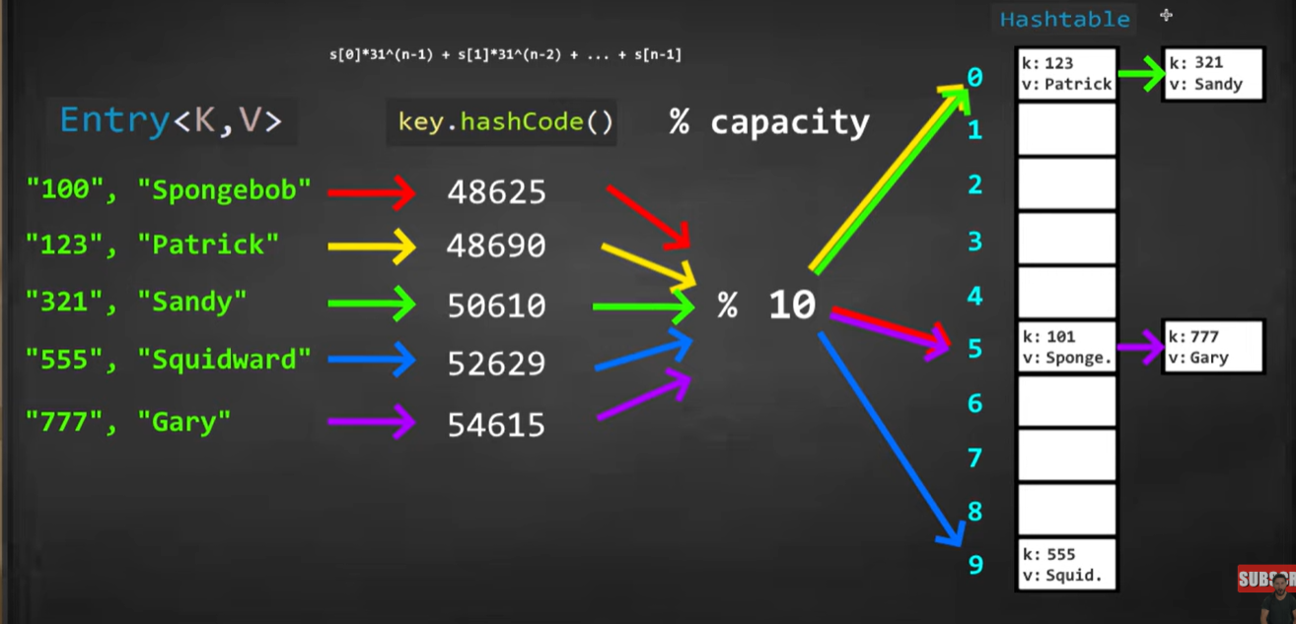

- Open addressing - Storing a key at next place / index in a hashtable when there is a collision
Here, search for a key-value goes until val found or a null/ bank space - a hashtable must ‘ve 25% of blank spaces – this percentage of filling Loading factor

No.of elements in the table
Load factor=
Size of table

in this mtd- of hashing, for new entries ie.., storing more values – increase the size of the hash table & hash function also changes - also rearrange the keys as they r arranged based on hash function (w/c is based on size of hash table )
Table size changed – hashFunc change – keys r re-hashed

Set Interface
- Unordered collection of obj’s – doesn’t preserve the order in w/c elements r stored & elements can be retrieved in any order.
- Have distinct/ unique collection of obj’s ( No duplicates )
- interface Set extends Collection (has no xtra mtds )

HashSet
- implements Collection & Set interfaces
- (set) No duplicates - store only unique elements, doesn’t allow duplicates.
- Unordered – elements in HashSet r not ordered (‘ve no indexing )- doesn’t maintain any specific order of elements, the order of elements can change over time.
- Can store only one null element (if more than one added, still return only one null value )
- (hash) – uses hashTable – internally uses hashing technique – takes const time for performing oprn like add, remove (whereas in ArrayList & LinkedList takes linear time ie ., O(n) )

Ref : https://docs.oracle.com/javase/8/docs/api/java/util/HashSet.html
https://www.scientecheasy.com/2020/10/java-hashset.html/

Mtds : add( E e)
addAll(Coln c)
remove(Obj o)
contains( Obj o)
size()
isEmpty()
clear()
clone(), equals(obj o), hashCode().

Compare Objects using equals() & hashCode()

How to use a Custom class with HashSet in Java ? [ the code Alchemist YT ]
equals( ) :
equals() method is used to compare two objects for equality.
Note : when we add duplicates of primitive types( INTEGER, String ), hashSet checks if values exists, ignored null elements & stores only unique elements.
But , when we store obj of a cls, Hashset allows duplicates – bcoz that doesn’t override equals() thru w/c Set filters the duplicates
Override the equals() in the cls to compare obj’s of that cls
For primitive datatypes like, we can check equality with ‘==’ & for String , check with .equals()
For objects , we need to define like if these parameters (like age, salary, empId) r equal , then that emp obj is equal
can use emp1.equals(emp2) - to check whether 2 employee obj’s r equal ; but here equals mtd check only references of emp obj’s ; not the actual values.

hashCode() :
The hashCode() method returns an integer hash code value for the object. This value is used by hash-based collections like HashSet to efficiently locate objects. When overriding equals(), it is essential to also override hashCode() to maintain the general contract for the hashCode() method, which states that equal objects must have equal hash codes.
Rather than checking with every values of obj, have some quick way of checking whether values are equal are not. (ie., value – hash code )
For every obj there’s a hashCode, if their hashcodes r diff, obj’s r not same (ie., both r diff obj’s )
If hashCodes r same, it further checks their equality.

Overriding hashCode()
Objects.hashCode(Object o) method in Java is a utility method provided by the java.util.Objects class. It is used to generate a hash code for an object, handling null values
The method returns the hash code of the given object. If the object is null, it returns 0.
When we have multiple fields,
@Override
public int hashCode() {
return Objects.hash(Objects.hashCode(empId), Objects.hashCode(name), Objects.hashCode(doj));
}

Ref : Coding Simplified YT
- By default equals method only compare the reference object
- To compare based on Object value, override the equals & hashcode method
- First compare by hashcode(), if hashCode of both Objects are different, then objects are not equal
- but if hashcode of both Objects are same, then we check the equals method
- hashcode is used to quickly check the equality
- Now whenever you're adding Object in Set or Map (any cls that implements Set or Map), then also you need to override the equals() & hashcode()
- Because, Set & Map check the equality & if Object are equal it won't add again so you need to add equality

Why Both Methods Are Important:
- Consistency: If two objects are considered equal according to the equals() method, they must have the same hash code. This consistency is crucial for the correct functioning of hash-based collections.
- Efficiency: The hashCode() method allows the HashSet to quickly locate the bucket where the object might be stored. The equals() method is then used to check for actual equality within that bucket.
Example Scenario:
When you add an Employee object to the HashSet, the following steps occur:
- Hash Code Calculation: The hashCode() method is called to determine the bucket where the object should be placed.
- Equality Check: If there are already objects in that bucket, the equals() method is used to check if the new object is equal to any existing objects. If an equal object is found, the new object is not added.
By overriding both equals() and hashCode(), we ensure that the HashSet correctly identifies and handles duplicate Employee objects based on their empId.

Sorted Set
- SortedSet Interface extends Set interface
- Used to store elements in some order (ascending order default) in a set. – when we need elements in a set to be sorted
Inorder to use the functionalities of SortedSet interface, use TreeSet w/c implements it.
(b/c cannot create obj of interface directly, use particular cls to declare obj of interface & call its mtd’s )
//SortedSet implementation by TreeSet class
SortedSet<String> animals= new TreeSet<>();

Add’l Methods of SortedSet :
As this set is sorted, can access 1st, last elements
- first( ) returns the first element of the set
- last() returns the last element of the set
- headSet(E toElement ) returns all the elements of the set before the specified element
- tailSet( E fromElement ) returns all the elements of the set after the specified element [ including specified element ]
- subSet( E fromElement, E toElement) returns all the elements b/n element1 & element2 [ including element1 ]

TreeSet
- TreeSet implements NavigableSet interface, w/c extends SortedSet interface.
- Internally uses TreeMap to store elements, so that elements r sorted in ascen’g order.
(ie., TreeSet cls of Java Coln FW provides the functionality of Tree DS )
- When unique elements needs to be stored & retrieved in sorted order, go with TreeSet

Features :
- Sorted Order - Elements in a TreeSet are stored in ascending order, either according to their natural ordering or by a specified comparator.
- No duplicates
- No null elements – TreeSet doesn’t allow null elements, if try- ‘NullPointerException ‘
- NavigableSet interface – implements, provide mtds to navigate thru the set.
- Performance- TreeSet provides guaranteed log(n) time cost for the basic operations (add, remove, and contains).

Ref : https://www.scientecheasy.com/2020/10/treeset-in-java.html/#:~:text=TreeSet%20is%20a%20powerful%20data,of%20elements%20present%20in%20it.

Mtds of TreeSet :
- Insert elements to TreeSet add( E e), addAll( Coln c)
- Access TreeSet elements 1. Directly print ts obj (inbuilt toString() )
2. Thru iterator() of iterator interface – ascen’g order
3. descendingIterator() – descending order
- Remove elements from TreeSet remove( Obj ), removeAll( Coln c)

Mtds defined by SortedSet interface (6) :
- first( ), last( ), headset(), tailSet( ), subSet()
- Comparator comparator() It returns comparator that is used to order elements in the set. If the TreeSet uses the natural ordering, this method returns null.

Mtds defined by NavigableSet interface (8) :
Element e / Object o ;
- ceiling( E e ) Returns the least element in the set >= given element, or null if there is no such element.
- floor( E e ) Returns the greatest element in this set <= given element, or null if there is no such element.
- higher( E e) Returns the least element in this set strictly > given element, or null if there is no such element.
- lower( E e) Returns the greatest element in this set strictly < given element, or null if there is no such element.
- pollFirst() retrieves & remove 1st element in the set ; return null if set is empty
- pollLast() retrieves & remove last element in the set ; return null if set is empty
- NavigableSet descendingSet( ) returns set elements in reverse order
- NavigableSet headSet(Object toObject, boolean inclusive) returns a view of the portion of this set whose elements are less than (or equal to, if inclusive is true) toElement.
- NavigableSet tailSet(Object fromElement, boolean inclusive) It returns elements from the set that is greater than or equal to (if, inclusive is true) the specified element.
- NavigableSet subSet(Object fromElement, boolean fromInclusive, Object toElement, boolean toInclusive) This method returns elements from the set that lie between the specified range.

When storing custom cls objects in a TreeSet – sorting, filtering duplicates ?
TreeSet filters duplicates when storing custom class objects, but it depends on how the objects are compared.
TreeSet relies on the natural ordering of the elements (if the class implements Comparable) or a provided Comparator to determine the uniqueness of the elements.
How TreeSet Filters Duplicates
- Using Comparable:
  - If your custom class implements the Comparable interface, the compareTo method is used to compare objects.
  - If two objects are considered equal (i.e., compareTo returns 0), the TreeSet treats them as duplicates and only keeps one of them.
- Using Comparator:
  - If you provide a Comparator when creating the TreeSet, the Comparator's compare method is used to compare objects.
  - If the compare method returns 0 for two objects, the TreeSet treats them as duplicates and only keeps one of them.

TreeSet Vs HashSet :
- Sorting : Unlike HashSet , elements in TreeSet are sorted & stored in order( default ascen’g order)
- Navigation mtds : TreeSet provides mtds for easy navigation eg.,first(), last(), headset(), tailSet(),…
- Performance : HashSet is faster than TreeSet for basic opr’n like add, remove, contain, size
( b/c treeSet use some algorithm to preserve order of elements )

Comparing two Strings
1. equals() - checks if two strings are exactly equal, considering case sensitivity.
2. equalsIgnoreCase() - checks if two strings are equal, ignoring case differences.
3. compareTo() - compares two strings lexicographically ( alphabetical order ).
Str1.compareTo( Str2 )
It returns:
- 0 if the strings are equal.
- A negative integer if the first string is lexicographically less than the second string.
- A positive integer if the first string is lexicographically greater than the second string.
4. compareToIgnoreCase() - compares two strings lexicographically, ignoring case differences.

Integer compare : 1. num1.compareTo(num2)
2. Integer.compare(num1, num2)
Return -> 1 ( if num1 > num2 )
- > -1 ( if num1 < num2 )
-> 0 ( if num1 = num2 )

Map Interface
- Map in Java stores elements in the form of Key-value pairs
- Every cls that implements map interface follow this arrangement
- Each key – unique element (obj) & corresponds/ associated to only 1 value
- A Map doesn't allow duplicate keys, but you can have duplicate values.
To maintain the uniqueness of keys, keys r stored as a Set ( as set cannot contain duplicates , store only unique elements )
- Map uses Set to store keys ; List to store values
- part of the Java Collections Framework and provides methods for adding, removing, and accessing elements based on their keys.
Usecase : Instances where we need to store in a key-value kind of arrangement
Eg., Employee directory / database in a company ; Each employee has a unique ID & we store name , other details associated with these IDs.
{ Emp ID (key ) : Emp name( value) }

Features of the Map Interface
- Key-Value Pairs: Each entry in a Map consists of a key and a value. Keys are unique, and each key maps to exactly one value.
- No Duplicate Keys: A Map cannot contain duplicate keys. Each key can map to at most one value.
- Null Values and Keys: Depending on the implementation, a Map can contain null values and a single null key (e.g., HashMap allows null keys and values, while TreeMap does not).
- Different Implementations: There are several implementations of the Map interface, each with different performance characteristics and use cases, such as HashMap, TreeMap, LinkedHashMap, and ConcurrentHashMap.

Concrete Classes implementing Map interface :
- TreeMap – sorting order by default (sorting only for keys )
- HashMap – random access, preserves no insertion order, no natural sorting order ; store & retrieve entry in random order
- LinkedHashMap – ‘ve properties of HashMap (elements r stored & displayed in random order ) & LinkedList ( sequence is maintained, preserves the insertion order – ordering (not natural ordering ), elements in inserting order )
- HashTable - similar to HashMap ; it is thread safe – multiple threads cannot manipulate it at a time, allows only 1 thread at a time – slower compared to HashMap, TreeMap

Ref : https://www.scientecheasy.com/2020/10/map-in-java.html/#:~:text=A%20map%20in%20Java%20is,the%20values%20associated%20with%20keys.

Map Interface mtds
(Key k, Value v, Obj o, Element e )

- Adding Entries

put( k, v)  R- void | Add an entry with specified key and value in the map  - If we call put() with an entry, checks whether key exists- if yes  updates it with new value ; if not add new entry to table
putIfAbsent( k, v)  R- void | Add specified value with specified key only if the entry not exist already
putAll(Map m)  R- void | Add all entries from one map to another
- Accessing values

get(Obj k )  R- value | Returns the value for the specified key in the map
containsKey ( obj k)  R- boolean | Returns true if map contains an entry for the specified key
containsValue( obj v)  R- boolean | Returns true if the map contains the value
replace( k key, v value)  R- old val | Replace specific val for specific key
replace( k key, v oldVal, v newVal )  R- boolean | Replace old val with a new val for a specified key
- Removing Entry
remove( Obj k) | Delete an entry for the specified key  - Return null if key is not in the map
remove (k, v )  R- boolean | Remove the specified key with associated value
- Map.Entry mtds
getKey()  R- key | Retrieve the key for map entry
getValue  R- value | Retrieve the value for map entry
setValue( v )  R- void | change the value associated with a specific key in a Map.Entry.  Use : Inside the loop, we check for a specific key (in this case, key 2) and  use the setValue() method to update its value.
- Coln view/ iterating
keySet( ) //Iterating over keys  R- Set< k> | Returns a Set view of the keys contained in the map  Set<Integer> keys = map.keySet();
values( ) //Iterating over values  R- Collection< v> | Returns a Collection view of the values contained in the map  Collection<String> values = map.values();
entrySet()  // Iterating over entries | Returns a Set view of the mappings in the map  Set<Map.Entry<Integer, String>> entries = map.entrySet();
- Comparing & Hashing
equals( Obj o )  < Map.entry mtd > | Compares the specified object with this map for equality.
hashCode()  R- int | Returns the hash code value for an obj  - returns an integer value, called the hash code, that represents the  object's memory address.  When you put an object into a HashMap, the hashCode() of the key is used to determine the bucket location where the entry should be stored.
- Others
size( )  R- int | returns the number of entries (number of key/value pairs) in the map.
isEmpty( )  R- boolean | check whether the map contains any entries.  - returns false if it contains at least one key.
clear( ) | Remove all the mappings from the map

Storing Map entries in a Set :
To store a Map in a Set, you can store the Map.Entry objects in the Set. Each Map.Entry object represents a key-value pair from the Map.
create a HashSet and initialize it with the entries of the Map using map.entrySet(). This converts the Map entries into a Set of Map.Entry objects.

// Iterating over entries
// Creating a Set to store Map entries
Set<Map.Entry<Integer, String>> entrySet = new HashSet<>(map.entrySet());
(or )
Set<Map.Entry<Integer, String>> entries = map.entrySet();

for (Map.Entry<Integer, String> entry : entries) {
System.out.println("Key: " + entry.getKey() + ", Value: " + entry.getValue());
}

Iterating over Map Entries :
- Using entrySet() with a For-Each Loop
- Using keySet() with a For-Each Loop
- Using values() with a For-Each Loop
- Using an Iterator with entrySet() - itr.remove() - remove the last entry of a hash map while iterating. [ also with, values(), keyset() ]
Note: in iterator, remove use with iterator obj , not with map ( if so, get ‘ ConcurrentModification Exception ‘
- Using Java 8 forEach Method
- Using Stream API
- Using Lamba Expression

HashMap
- part of the Java Collections Framework and is used to store data in key-value pairs.
- Underlying data Str - HashTable
- A key-value pair data structure, ie., internally maintains a table that contains keys & value
- Allows only one null key, no duplicate keys ; can hold null values
- Better for frequent search oprn
- time complexity of O(1) for insertion and retrieval of objects
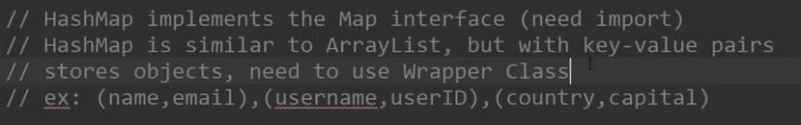
Features of HashMap
- Key-Value Pairs: HashMap stores data in key-value pairs, where each key is unique and maps to exactly one value.
- Hashing: It uses a hash table to store the map entries. The hash code of the key is used to determine the bucket location where the entry is stored.
- HashMap stores each key-value pair in Node Obj form. ,[ Node obj contains hash code, key, value & link of nxt node ]
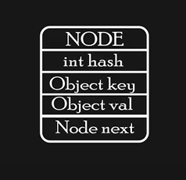

- HashMap internally maintains a HashTable to store all the nodes
[ default size of HashTable – 16 ]

Ref : https://youtu.be/VsbSZwTekoE?si=gr2UQY1DxdXjDh2j
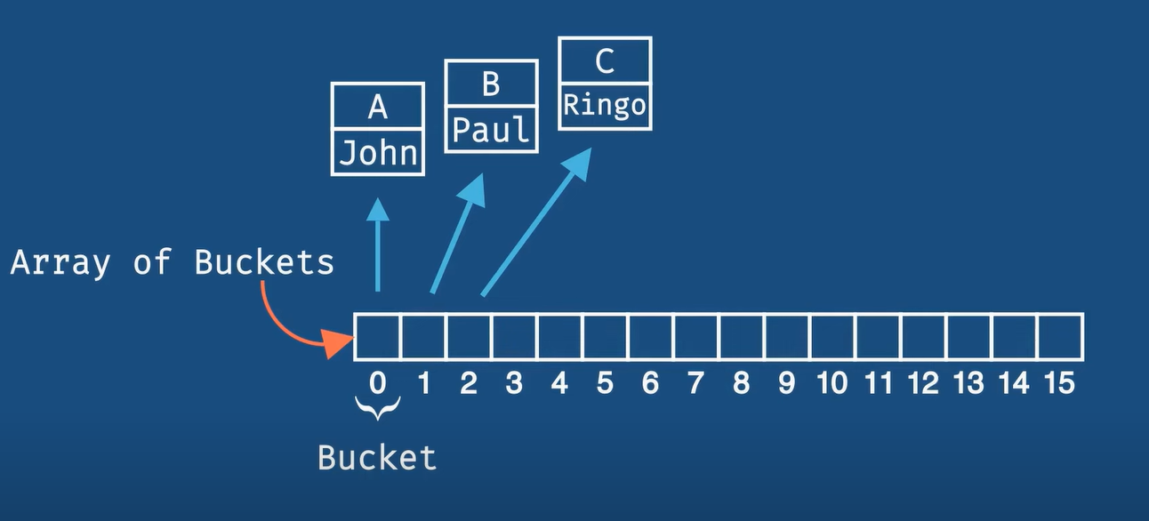
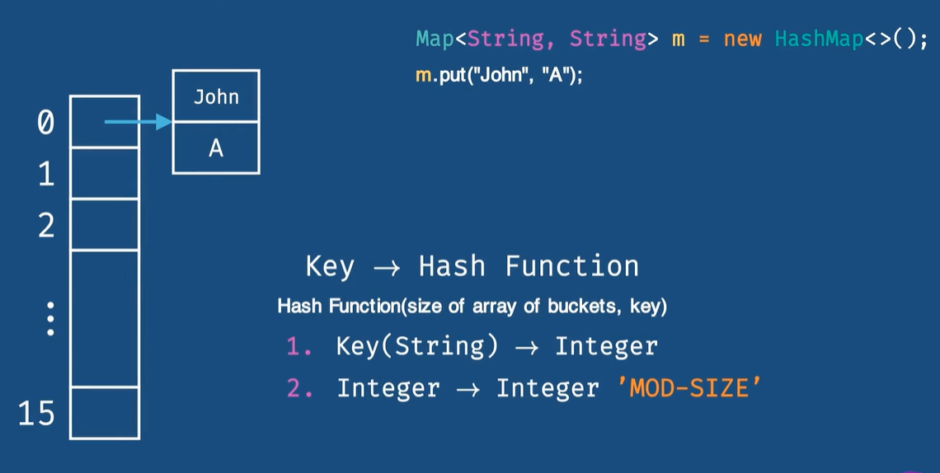
Object.hashCode = integer [ hash code val ]
Index calculated from hash val using logical AND oprn : index= hashVal & (n-1)
Integer % size (16) = index

- Sometimes we get same hash key (index) for diff obj’s – collision
Here, new node obj connected to existing node obj; next node link points to new node obj.
- HashTable maintains a separate LinkedList for each index (bucket )

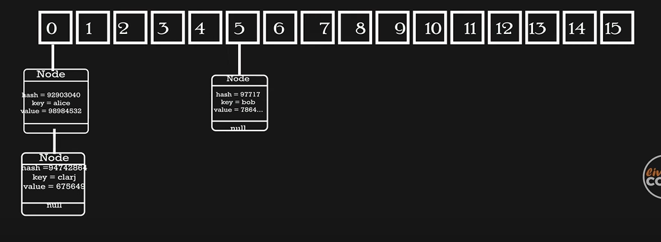

get() mtd wrk’g :
  - Hash code calculated for given key using Hash func
  - Index val calculated from hash code
  - Get node from index 5 & checks hash val of that key with current key’s hash val using equals() - if both r same checks node’s key val with G. key value - if both same , returns the key value.

- In java8, improved HashTable’s storage slightly – replaced LinkedList with Balance tree Each index stores Balanced tree instead of LinkedList
Time Complexity improved : O (n) O(log n)
Ref Internal wrk’g of hashMap
- Null Values and Keys: HashMap allows one null key and multiple null values.
- Non-Synchronized: HashMap is not synchronized, meaning it is not thread-safe. If multiple threads access a HashMap concurrently, and at least one of the threads modifies the map structurally, it must be synchronized externally.
- Iteration Order: The order of iteration over the entries is not guaranteed. It can change if the map is modified.

Ref https://www.scientecheasy.com/2020/11/hashmap-in-java.html/

getOrDefault( k, defaultValue )
The getOrDefault method in HashMap is a convenient way to retrieve a value associated with a given key, and if the key is not present in the map, it returns a default value instead. This method helps avoid null checks and simplifies code.
Syntax
V getOrDefault(Object key, V defaultValue)

TreeMap
- Implements interfaces : Map<k,v >, SortedMap< k,v >, NavigableMap< k,v >
- Underlying Data str – Red black tree ( Self- balancing binary search tree)
- TreeMap maintains & stores entries in sorted order based on keys
Determines order of entries by using either Comparable interface or Comparator class
Mappings r sorted acc to natural ordering or by a comparator.
- log(n) time for basic operations – checking, adding, retrieval, removal
- No null key, can have multiple null values
If put a null key in put(), throws ‘NullPointerException’
- modify values of a key of treemap during iteration
can modify the values of a key in a TreeMap during iteration - avoid modifying the structure of the map (such as adding or removing entries) while iterating, as this can lead to a ‘ ConcurrentModificationException’.

Ref https://www.scientecheasy.com/2020/11/treemap-in-java.html/

NavigableMap mtds :
- Navigational mtds

firstKey ()  R- key | Retrives key of first entry in sorted map  - Throw “NoSuchElementException” if treeMap is empty
lastKey( )  R- key | Retrives key of last entry in sorted map  - Throw “NoSuchElementException” if treeMap is empty
*********
Map.Entry<K, V> firstEntry() | Returns the least entry (key-value pair) in map  - Null if map is empty
Map.Entry<K, V> lastEntry() | Returns the greatest entry (key-value pair) in map  - Null if map is empty
Map.Entry<K, V> pollFirstEntry() | Removes and returns a key-value mapping associated with the least key  - null if the map is empty.
Map.Entry<K, V> pollLastEntry() | Removes and returns a key-value mapping associated with the greatest key  - null if the map is empty.
*********
floorKey(K key) | Returns the greatest key <= G.key  - Return Null if there’s no such key
lowerKey(K key) | Returns the greatest key strictly < G.key
ceilingKey(K key) | Returns the least key >= G.key
higherKey(K key) | Returns the least key strictly > G.key
*********
Map.Entry<K, V> floorEntry(K key) | Returns a key-value pair associated with greatest key <= G.key  - Return Null if there’s no such key
Map.Entry<K, V> lowerEntry(K key) | returns a key-value pair associated with greatest key strictly < G.key
Map.Entry<K, V> ceilingEntry(k key) | Returns a key-value pair associated with least key >= G.key  - Return Null if there’s no such key
Map.Entry<K, V> higherEntry(k key) | Returns a key-value pair associated with least key strictly > G.key  - Return Null if there’s no such key
********
NavigableSet<K> navigableKeySet() | Returns a NavigableSet view of the keys contained in this map.
NavigableSet<K> descendingKeySet() | Returns a reverse order NavigableSet view of the keys contained in this map.
NavigableMap<K, V> descendingMap() | Returns a reverse order view of the mappings contained in this map.
- Sub-Map Views

SortedMap<K, V> headMap(K toKey) | Returns a view(key-value pairs) of portion of the map whose keys r < toKey  - Throws ‘ClassCastException’ & ‘NullPointerException’
SortedMap<K, V> tailMap(K fromKey) | Returns a view(key-value pairs) of portion of the map whose keys r >= fromKey
SortedMap<K, V> submap( fromKey, toKey ) | Returns a view of the portion of this map whose keys range from  fromKey (inclusive ) , to toKey, ( exclusive ).
headMap(K toKey, boolean inclusive) | NavigableMap<K, V> headMap(K toKey, boolean inclusive);
tailMap(K fromKey, boolean inclusive) | NavigableMap<K, V> tailMap(K fromKey, boolean inclusive);
subMap(K fromKey, boolean fromInclusive, K toKey, boolean toInclusive)
subMap(K fromKey, boolean fromInclusive, K toKey, boolean toInclusive)

Refer ?
Red black trees & its implementation in Treemap ?
Red black tree – balanced binary tree
