Getting user inputs

Int sc.nextInt()
Double sc.nextDouble()
String sc.next() // only 1 word , excludes the words after space
sc.nextLine() //grp of words or sentence, with spaces also
Boolean sc.nextBoolean()
Char sc.next().charAt(0) // scanner.next() reads the next token (word) as a String, and charAt(0) extracts the first character of that string.

Why so, when I used to take string input through nextLine method of scanner class in Java, it does not read my input?
nextLine() method of Scanner skips the console input, when we use it after next(), nextInt() and all nextXXX() methods. Because next() and nextXXX() input methods doesn’t process/consider the newline character (When you press ENTER key after input them) and that newline character processed by nextLine() method.
Therefore nextLine() method doesn’t read the input . To overcome this problem, you have to invoke an extra nextLline() method after next() and nextXXX().

Output Formatting
2 mtds to format o/p in java printf() & format()

printf()
an optional mtd to ctrl, format & display text to the console window [ % - format specifier]
takes 2 arguments : printf( format string, [obj/ var/ val ] )
% [flags] [precision] [width] [conversion-character] fields after %

> [ conversion character] // %b, %s, %f,….
Specific to each DT : Boolean b, char c, String s, int d, Double / float f,…
> [width]
Minimum num of characters to be written as o/p
Sout.printf( “ String %10s”, str);
> [precision]
Sets no.of digits of precision when outputting floating point values
Sout.printf( “Decimal: %.2f”, d);
> [flags]
Adds an effect to o/p based on the flad added to format specifier
- : left-justify (mostly all r Ryt justified)
+ : o/p a plus (+) or minus (-) sign for a numeric value
0 : numeric values r zero padded
, : comma grouping separator if numbers > 1000
System.out.printf("String width:%-5s \n", s); //left justify
System.out.printf("int: %+d \n", n); // o/p plus or minus sign for numeric value
System.out.printf("int: %05d \n", n);
System.out.printf("double: %,f", d);

String.format()
Wrks in same way as printf() , the thing is we ‘ve to give them in a print/ println() to display them in console.
System.out.print( String.format("String:%5s'", str) );

Type Casting & Conversion
Primitive Datatypes :
- byte: 1 byte (8 bits) -128 to 127 = -2^8 to 2^8-1
- short: 2 bytes (16 bits) -32,768 to 32,767 = 2^15
- int: 4 bytes (32 bits) 2^31
- long: 8 bytes (64 bits) 2^63
- float: 4 bytes (32 bits)
- double: 8 bytes (64 bits)
- char: 2 bytes (16 bits)
- boolean: 1 bit

- Type conversion not applies for char to Boolean or vice versa ; but applies to anything from byte to double numeric DT.
byte b= 12;
int a= 258;
a = b; Type Conversion implicitly - storing smaller sized DT in a bigger one
b =a; b= (byte)a ; //b = 2
Type Casting – explicit DT conversion
Here, while converting int to byte, when its range not in -128 to 127 ie., 256 no’s , int num gets divided by 256, we get just Reminder value ( after conversion )
float f= 3.6f;
int n= (int)f;

byte b= 127;
int i= 258;
b= (byte)i;

Wrapper class
- Java not purely object oriented lang – 99.99% Oops as everything s/d b obj in pure OOP lang,
This is b/c of Primitive datatypes, they r not extending obj.
However, helps Java to improve performance, as it directly works with fixed site value not in heap memory like Obj , which takes time to access val.
- Every Cls in java extends Obj cls, but not the 8 primitive val’s
Wrapper cls : for every primitive type, there ‘ll b class for it , where that cls extends the Obj cls. So, can use Primitive types as objects. ( ‘ve multiple classes for byte to double, chsr, Boolean )
Must use wrapper classes, for eg., when working with Collection objects, such as ArrayList, where primitive types cannot be used (the list can only store objects)

https://www.w3schools.com/java/java_wrapper_classes.asp

int num= 7; //primitive var
Integer num1 = 3; //reference var – obj Wrapper_cls name = val ;

Integer num1 = 3; // boxing – taking a primitive val & storing that in a primitive obj or wrapper obj
Integer num1 = num; // autoboxing - when u assign/ store a primitive type val in the Obj directly , instead manually
Assigning obj val again as a primitive val,
int num2 = num1.intValue(); // unboxing – doin manually
int num2 = num1 // auto-unboxing – when we take/ fetch primitive val from the obj

parseInt() - String to Int
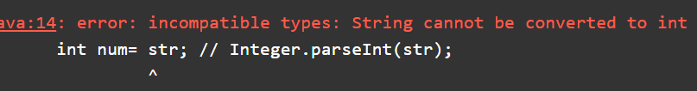
To convert String to Integer – this mtd take the string & it will convert that into integer
String str= "23";
int num= Integer.parseInt( str );
System.out.println( num*2 );

Convert Interger to String
‘ve do with 2 mtds,
String str= Integer.toString( num );
String str1= String.valueOf( num );

Length of String
int l= str.length();

Exception Handling

Errors
a mistake or fault in the code that causes the prgm to behave unexpectedly or fail to execute.
Types of Errors:
- Compile-time Error – Syntax errors, detected while in compilation itself
Eg., Missing semi colons, paranthesis, ,…

- Run-time Error - detected during the execution of prgm.
Eg.,if user inputs a data of string format when computer is expecting an integer.
Runtime Error caused by dividing by zero , Runtime Error caused by Assigning/Retrieving Value from an array using an index which is greater than the size of the array
Java

- Logical Error - when your program compiles and executes, but does the wrong thing or returns an incorrect result ( actual o/p != expected o/p ) or no output when it should be returning an output.,
- due to a mistake in the algorithm or logic used in the code.
Eg., Using ‘/’ operator to get the reminder instead using ‘%’

Exceptions
Exceptions - errors that may stops the execution of prgm, but we can handle them ie., Run time errors.
handling these exceptions – Exception Handling
to handle the runtime errors so that the normal flow of the application can be maintained.
All exceptions extends from “Exception “ class which extends from “Throwable” class’
[ Anything ending with ‘able’ is an Interface, but Throwable is a class ]

Checked Exceptions - compile time exceptions
IO exception, ClassNotFound Exception
UnChecked Exceptions - run time exceptions
Arithmetic Exception, ArrayIndexOutofBound Exception

Exception handling keywords ( 5 ) :
Purpose of these is that without them , when exception occurs in certain line of code, execution stops, & rest of lines r not executed.
When they r, try block throws the exception / error, catch block handles that & rest of lines r executed .
try – specify the code ie., critical lines in which exception may or may not occur in try block
- can’t be used alone, s/d be followed by either catch or finally block.
catch – to handle the exception thrown from try block .
- must used after try block, can’t be used alone, can be followed by finally block also
int n=0;
int m=0;
try{
m= 12/n ;
}catch(Exception e){
System.out.println("Something went wrong !" + e );
}
System.out.println(m);
System.out.println("Reached end");

Try with multiple catch :
In java, try-catch block – to handle exceptions , allows us to write code that handles exceptions that may be thrown during the execution of prgm.
- can also handle different types of exceptions with multiple catch blocks

Code https://onlinegdb.com/yjCUe-Zwn

Handling parents & child exceptions both :
- when catching both child & parent exceptions in a try-catch block, mostly catch child excetions before the parent exception.
- b/c if u catch the parent exception before the child exception, catch block of parent exception catch any child exceptions that r subclasses of parent exception.
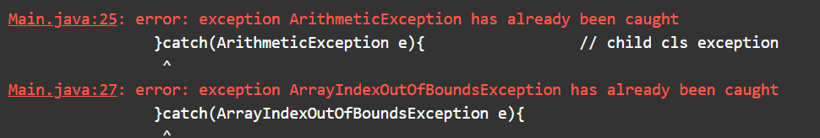
When we catch parent exceptions before catching child exceptions, will give compile time error
ie., Arithmetic exception ( child ) already caught by Exception ( parent cls )
- this makes it difficult to handle child exceptions separately.

File Handling
- Storing of data ( writing) & retrieving that data ( reading ).

Type 1 – Buffered class

Writing to a txt file

import java.io.*; //import java.io package - contains classes for i/p and o/p operations.
//enclose in try-catch block , may throw IOException
try{
BufferedWriter bw= new BufferedWriter(
new FileWriter("C:\\Users\\NANRAMAS\\Documents\\Test\\output.txt"));
// Create a BufferedWriter Obj & pass FileWriter Obj to its Constructor
//FileWriter Constructor takes the ‘ file path’ enclosed in “ C:\\ ….\\test.txt “
// insert \\ for file path or else will get compilation error
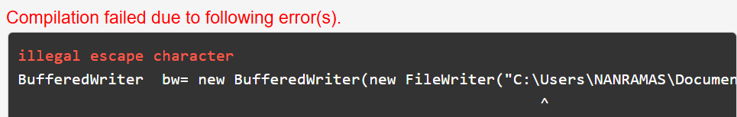
bw.write("New file \n");
bw.write("Created \n");
bw.write("In this file done \n");

bw.close();
}catch(Exception e){
System.out.println(e);
}

Note : 1st time when we run , it creates the file; the nxt time when we run, it overwrites the file.
BufferedWriter - Writes text to a character-output stream
FileWriter - Constructs a FileWriter object given a file name.
- Parameters: fileName String The system-dependent filename.
- Throws: IOException

write() - Writes a string.
- Parameters: str String to be written

Reading from a txt file
try{
BufferedReader br= new BufferedReader(
new FileReader("C:\\Users\\NANRAMAS\\Documents\\Test\\output.txt"));
// Create a BufferedReader Obj & pass FileReader Obj to its Constructor
// FileReader Constructor takes the ‘ file path’ enclosed in “ C:\\ ….\\test.txt “

String s;
// br.readLine() reads a line of text from the file and assigns it to s. The while loop continues as long as br.readLine() does not return null (which indicates the end of the file).
while((s= br.readLine()) != null){
System.out.println(s);
}

br.close();
}catch(Exception e){
System.out.println(e);
}

BufferedReader - to read from the file specified by the path.
readLine() method - returns null when the end of the file is reached.

Reading & Writing to another file – Buffered cls
BufferedReader br= new BufferedReader(new FileReader("File.txt"));
BufferedWriter bw= new BufferedWriter(new FileWriter("File-copy.txt"));

String s;
while((s= br.readLine()) != null){
bw.write(s + "\n");
}

br.close();
bw.close();

Type2 -Read thru Scanner Cls

Read input from standard input (STDIN) / console I/p
until reach EOF & prints it to standard output (STDOUT) with line numbers.

import java.io.*; // contain classes for input/output operations
import java.util.*; // contain classes for utility functions

Scanner sc= new Scanner(System.in);
// creates a Scanner object to read input from the standard input (usually the keyboard).
int i=1;

while(sc.hasNext()){
String s= sc.nextLine();
System.out.println(i+ " "+ s);
i++;
}

boolean java.util.Scanner.hasNext() - Returns true if this scanner has another token in its input.

Read from a file – using Scanner cls

File f= new File("output.txt");
Scanner sc= new Scanner(f);

while(sc.hasNextLine()){
System.out.println(sc.nextLine());
}

sc.close();

hasNextLine() - Returns true if there is another line in the input of this scanner

Write to File – FileWriter cls

File f= new File("output.txt");
FileWriter fw= new FileWriter(f);

fw.write("1. New file \n");
fw.write("2. This takes File class \n");
fw.write("3. New file done \n");

fw.close();

Static Keyword in Java
Why main mtd static in Java ?
purpose of String[] args ?
Local variable – can only be shared/ used among any particular block ie., mtd, constructor,…
Global variable – can be used by the entire class & every instance belonging to that class.

With ‘static’ keyword- making something as a class member, not an obj member
Ie., when we r using static keyword with Var, block, mtd., it b/m independent of obj., all obj r able to access that.

Four place we can use static keyword
before variable declaration
e.g class Calc{ static int s; }
before a block
class Calc{
static {
System.out.println("this is static block);
}}
during method creation
class Calc{public static void add(int num1,int num2){};}
with concept of inner class
class OuterClass {
int x = 10;
static class InnerClass { int y = 5; } }

Note: - we can use static property, member inside non static block or method without object creation.
- But we cannot use non static property or method inside static block or method without object creation.

Static Variable
- declared with ‘ static ‘ keyword ; class-level variable shared among all instances.
-Only one copy of a static variable exists, all instances share the same value of the static variable; when we change the value, it affects all the obj’s
- saving memory, as not every obj ‘ve their own value/ copy for it
- Accessed/ used with class name (w/o creating obj’s) as well as Obj name as it is Independent of obj’s.
- can use Static variables in a non-static mtd as well

When memory get allocated = for that we need to know some term
a)stack area b)heap area c)class loader system
Step 1: when you compile the code you get .class file
Step 2: when you are executing (java MainClass) first class loading to class loader System. Step 3: During class loading static variable initialize, static block get executed.
ie., initialized when the class is first loaded into memory.
Step 4: Since, static variable got memory in heap before object creation. Now we can say that it is independent of object.

Static variable vs Instance variable

 | Static Variable | Instance Variable
Definition | Belong to the class itself rather than any specific instance. | Belong to a specific instance of a class
Memory Allocation | Allocated memory only once when the class is loaded | Allocated memory each time an instance is created
Access | Can be accessed using the class name without creating an instance | Accessed through the instance of the class
Scope | Shared among all instances of the class. | Unique to each instance of the class
Use Case | Useful for constants or shared data across all instances | Useful for storing data that is unique to each instance

We can access static var thru class , also thru obj/ instance ; but, instance variable referred by instance /obj only.
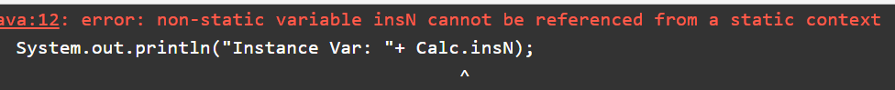

Code https://www.onlinegdb.com/edit/oIMQlxrmN

Static Method
- to wrk/ call a non-static mtd , need to create an obj of that class & thru it can access
Defined with ‘static ‘ keyword
- call a static mtd directly with Class name
can use Static var inside a Static mtd, but not a non-static var in a Static mtd directly ;
b/c a non-static variable can belong to any instance , & static mtd don’t which one to refer
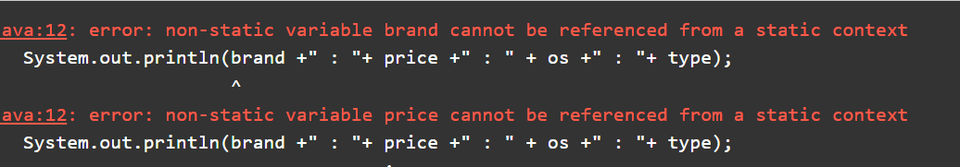
- indirectly, can pass the obj itself to the mtd, so that with obj reference can access

Static Vs Non-static mtd:
can call static method with object reference or class name
e.g ClassName.staticMethod() or objReference.statiMethod()
non static method dependent on object so it can be called only by object reference.
e.g objReference.nonStaticMethod();

Code https://www.onlinegdb.com/edit/FHvxchGAr

Static Block
Every time we create obj, takes 2 steps :
1. Class loads - class loaded from library, also calls the static block once as class loading happens only once for any no.of obj’s
2. Obj’s r instantiated/ created
A static block is used to initialize static variables and is executed when the class is loaded, before the main method is executed. (for one-time initialization tasks)
Class.forName("class name") – for class loading w/o obj creation

