**IMAGE RECOGNITION WITH IBM CLOUD VISUAL RECOGNITION**

**Problem statemant :**

Create an IBM Cloud account, set up the Visual Recognition

service, and obtain API keys. Design a simple web interface where users can upload images and view the AI-generated captions.

**Solution :**

**Step 1:** Create an IBM cloud account.

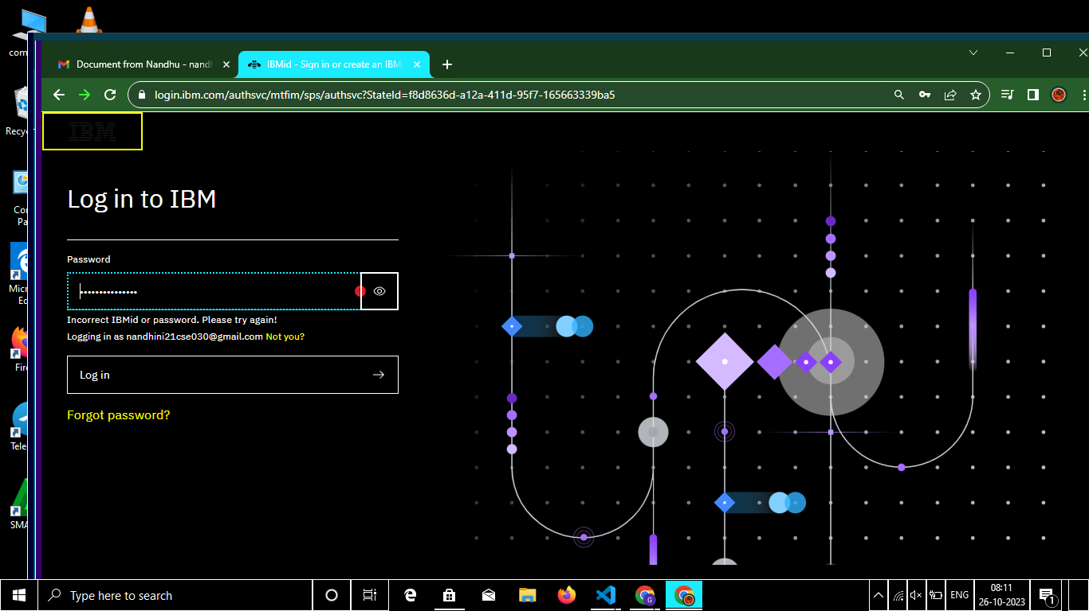

**Step 2 :** Obtaining API keys.

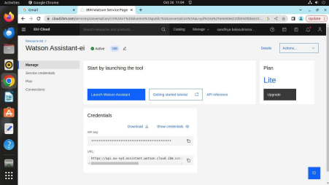**Step 3 :** Designing a web interface to upload images and get AI generated captions. **HTML code :**

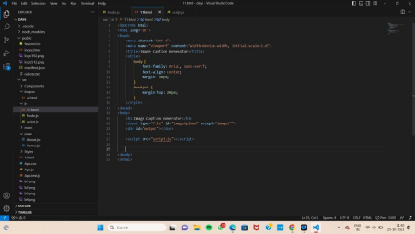

**Script.js :**

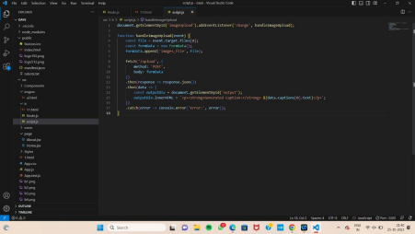**Node.js :**

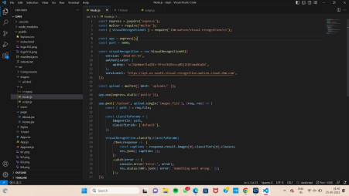

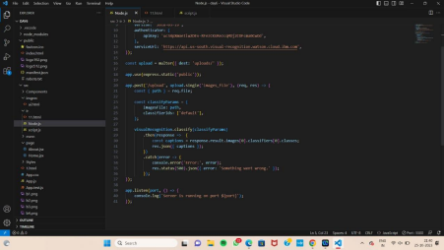**Step 4 :** Obtaining output

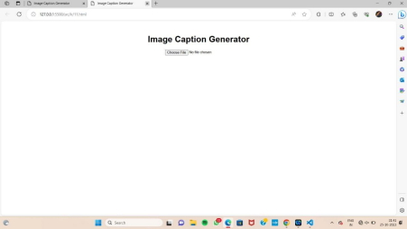

Choosing a image :

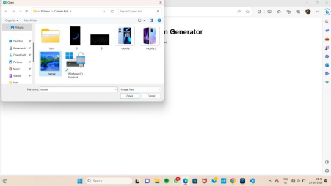

**Final Output :**

