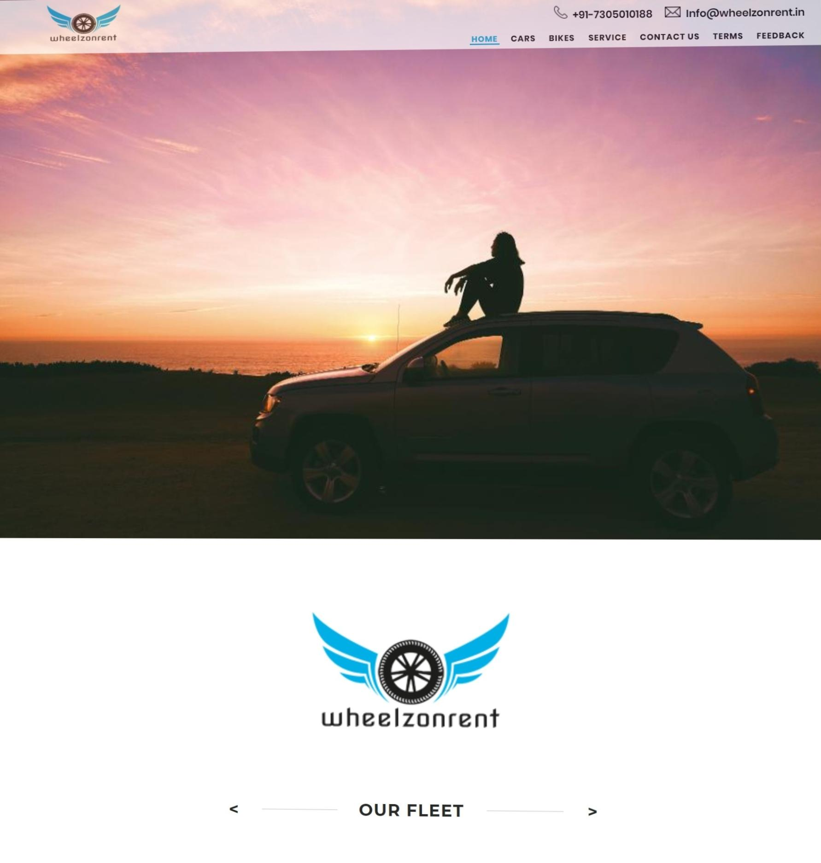
Fig.2.4.1.Home Page

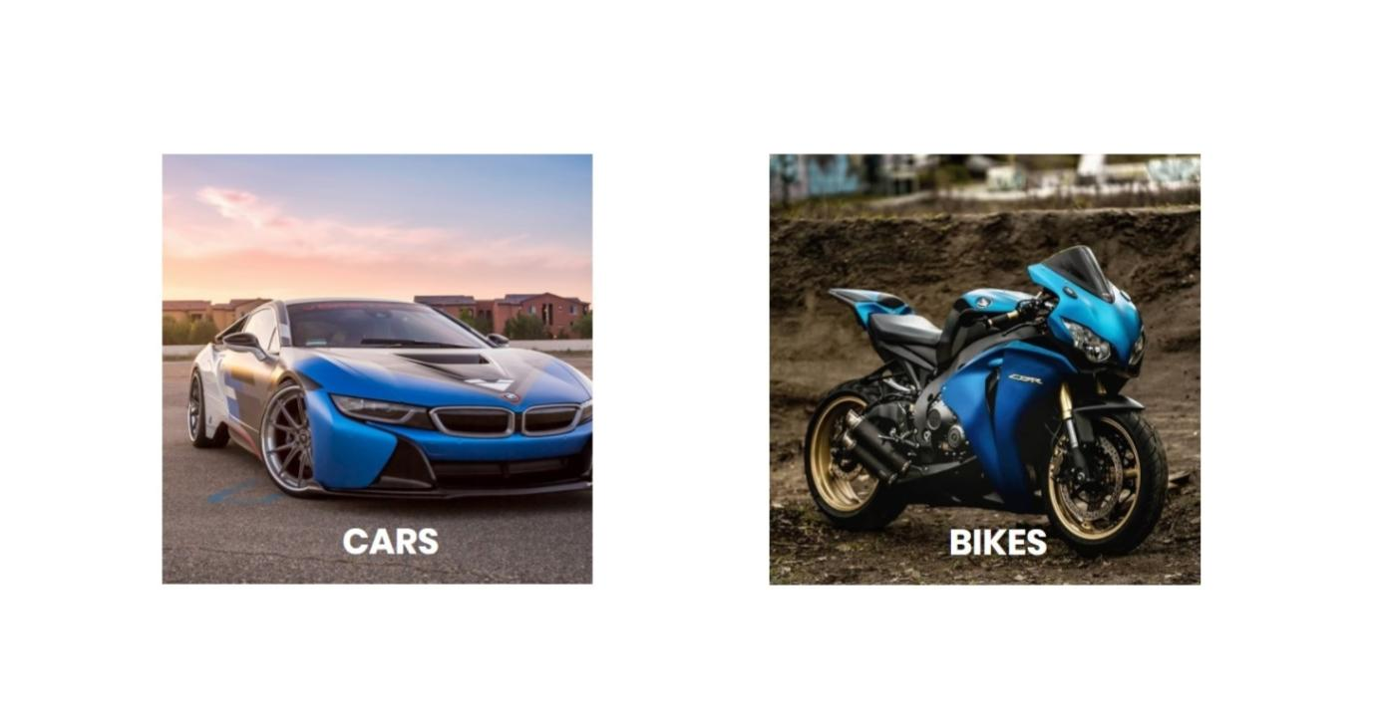
Fig.2.4.2.Menu Option Page
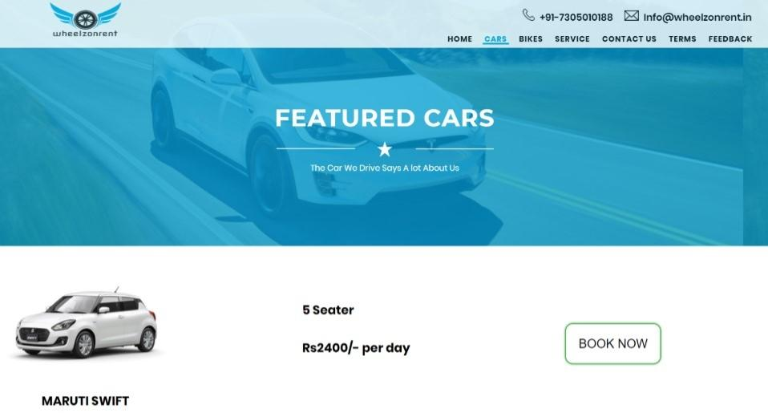
Fig.2.4.3.View Car Page

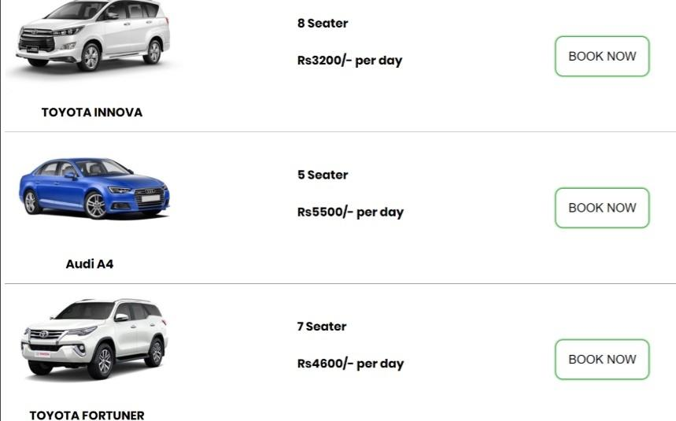

Fig.2.4.4.Rental Car Page

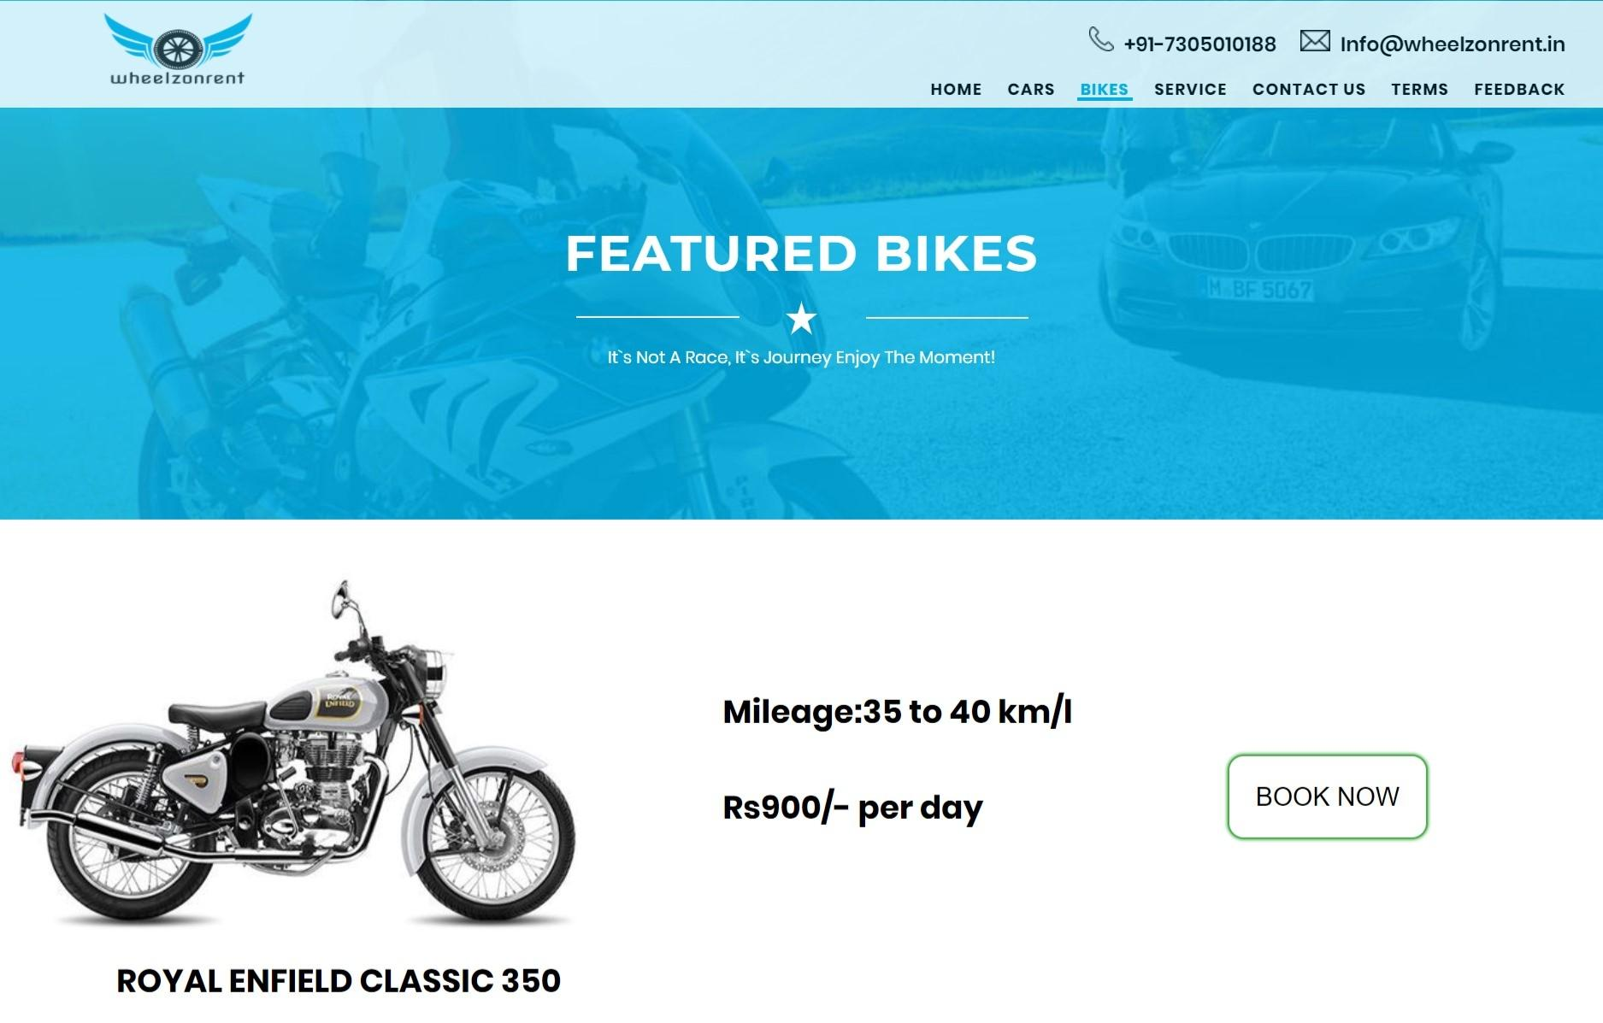Fig.2.4.5.View Bike Page
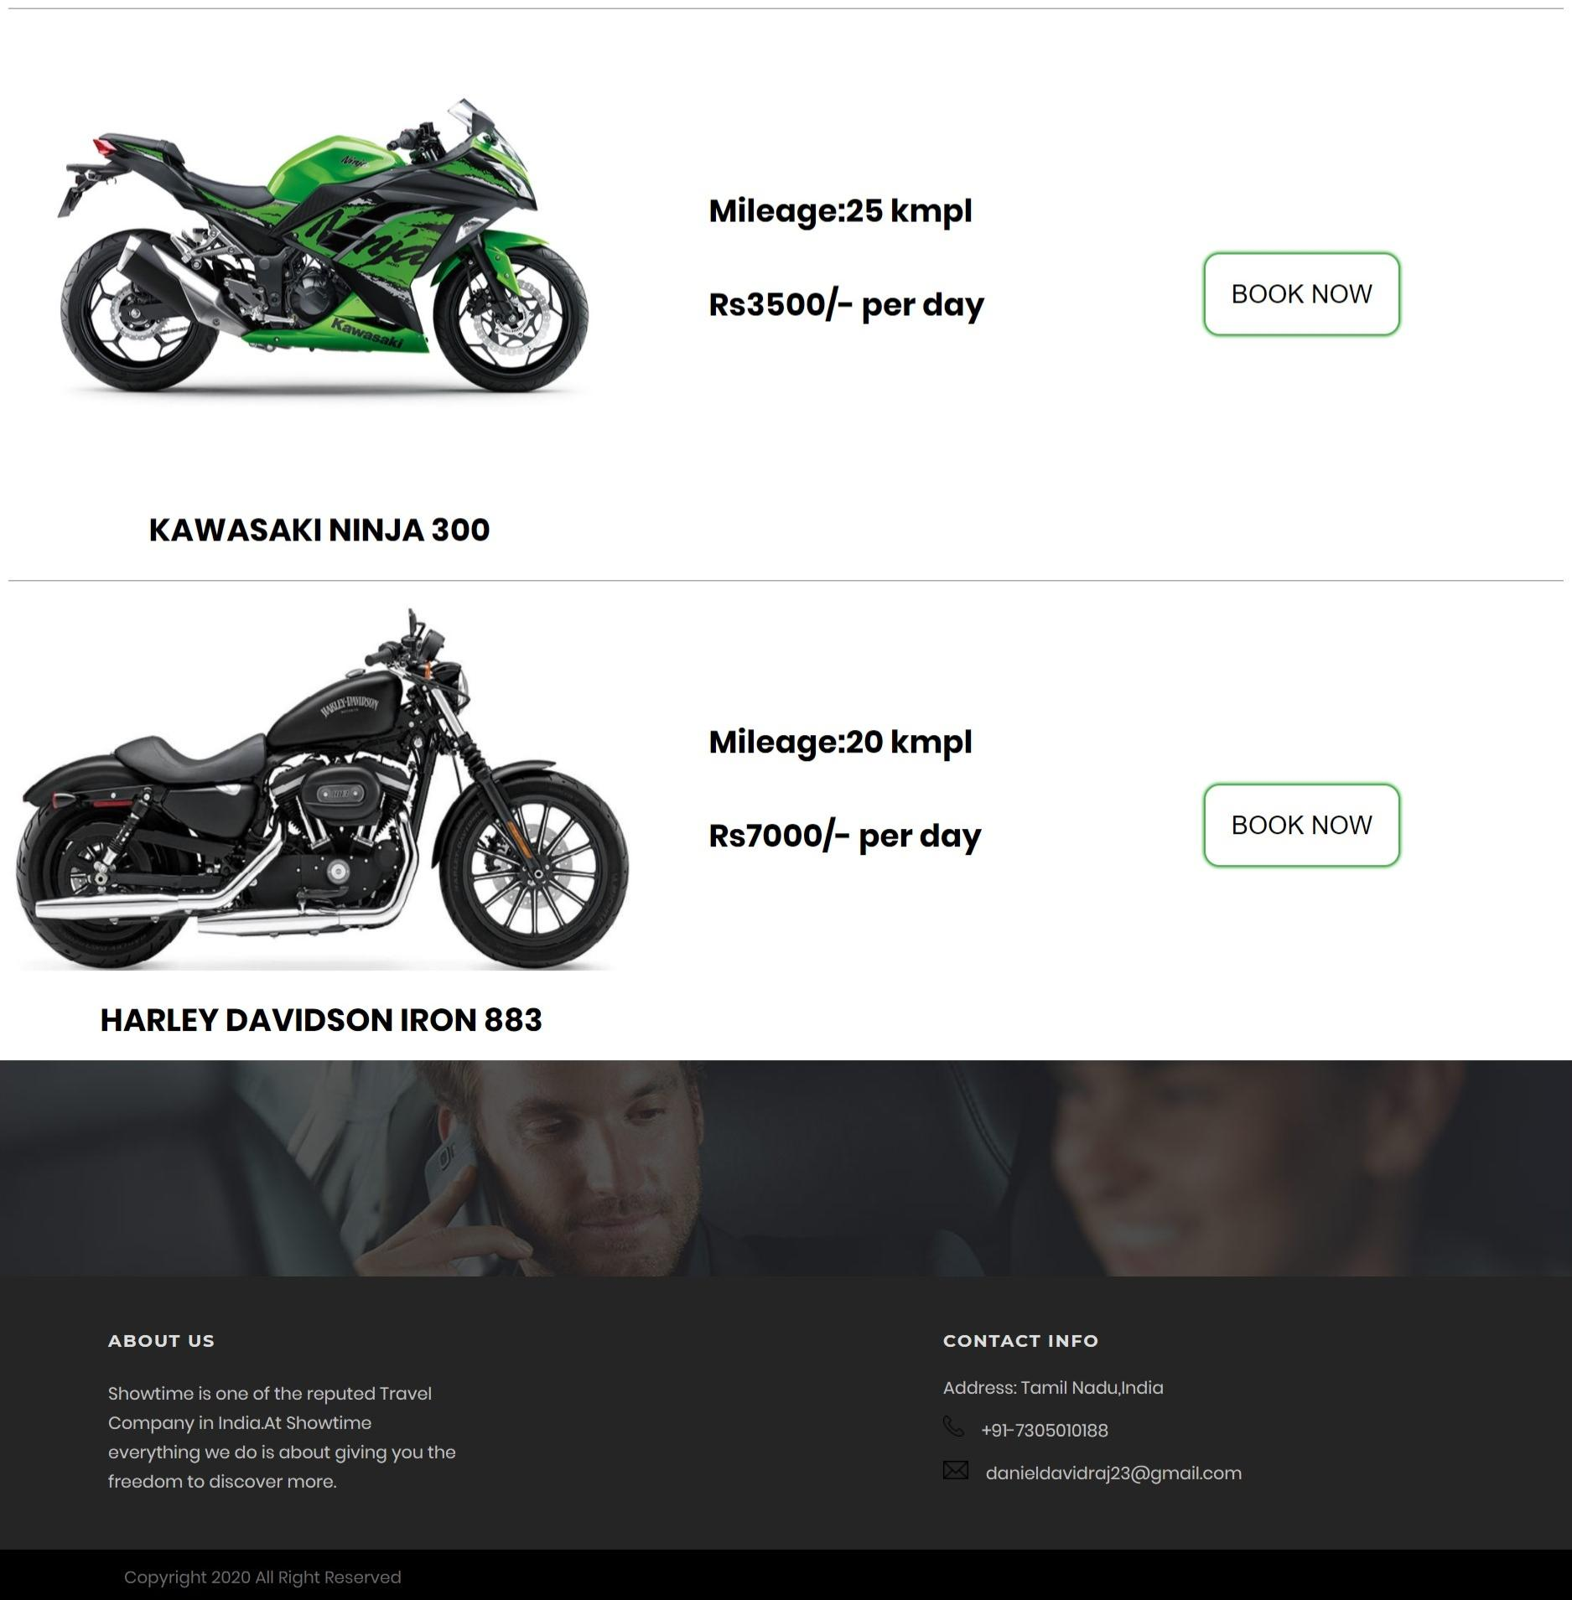

Fig.2.4.6.Rental Bike Page

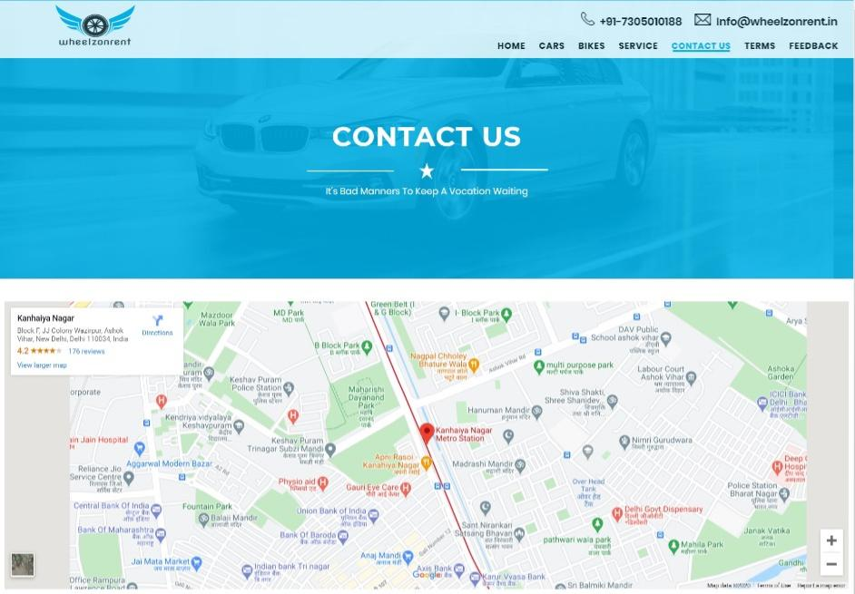Fig.2.4.7.Map Route Page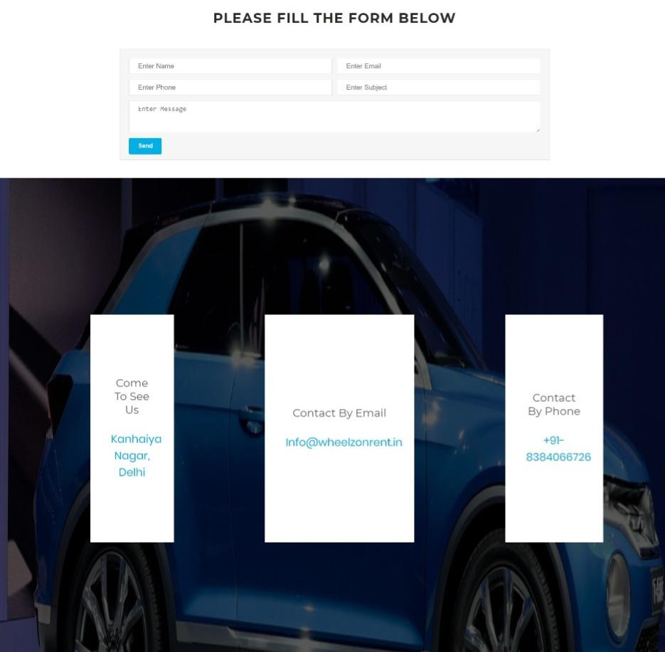Fig.2.4.8.Contact Page
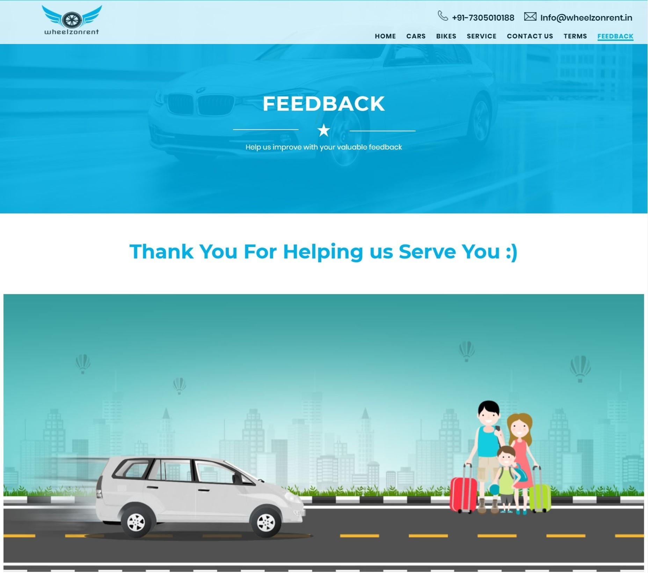

Fig.2.4.9.Feedback and Successfully Checkout Page

