PROJECT DOCUMENTATION

Auto Ticket Classification Using Flow Designer

- Team ID - SWTID-2026-4467

- Team Leader - Nandhini L
Mail ID - 202400515@sigc.edu
3.Team Members
Nandhini K - 202400115@sigc.edu
Tharani B - 202400688@sigc.edu
Mohanapriya B - 202400127@sigc.edu

ABSTRACT:
This project automates IT ticket classification using ServiceNow Flow Designer. When a student creates a support ticket, the system checks the Short Description for keywords such as WiFi, Projector, Password, or Slow.
Based on the keyword, it automatically assigns the appropriate Category and Subcategory and sends an email confirmation to the caller.

The solution uses a custom Incident Workflow table, dependent choice fields, and a no-code Flow Designer workflow to reduce manual effort and improve ticket routing.

INTRODUCTION:
The project focuses on automating the first-level classification of IT support tickets. A student only needs to provide the caller details and a short description of the problem. The system identifies keywords and fills the correct Category and Subcategory.
The reference project uses ServiceNow Flow Designer because it provides a no-code way to create the automation.The implementation is structured into requirement analysis, backend configuration, automation, testing, deployment and documentation.

PROBLEM STATEMENT:
The school IT helpdesk receives multiple incident requests every day from students and teachers.Common requests include Wi-Fi issues, projector failures, password problems and slow computers.
At present, IT staff manually review each request, identify the issue type and select the correct category and subcategory. This manual process is time-consuming, error-prone and difficult to scale when the number of requests increases.

OBJECTIVES:
- Automatically classify incidents at the time of creation.
- Reduce manual effort for IT agents.
- Improve ticket routing efficiency.
- Send an automatic confirmation email to the caller.
- Implement a no-code and easily maintainable solution.

BUSINESS REQUIREMENTS:
- Automatically classify IT tickets based on the issue description.
- Assign both Category and Subcategory without manual intervention.
- Support dependent choice logic between Category and Subcategory.
- Send an automated email notification to the caller when a ticket is created.
- Store ticket information in a structured and standardized format.
- Keep the solution easy to maintain and scalable for future requirements.

SYSTEM / PROJECT WORKFLOW:
- Student creates an IT support ticket.
- The ticket is stored in the Incident Workflow table.
- Flow Designer starts when a new record is created and Category is empty.
- The flow checks the Short Description for predefined keywords.
- Category and Subcategory are automatically updated.
- A confirmation email is sent to the caller.
The result is tested using sample ticket descriptions.

PHASE 1 – REQUIREMENT ANALYSIS&PLANNING:
In this phase, the existing helpdesk process is studied and the automation requirements are identified.The main focus is to remove repetitive manual classification while keeping ticket information standardized.

Main Issues Identified:
    - Manual identification of issue type.
    - Manual selection of category and subcategory.
    - Extra effort for IT staff.
    - Possibility of incorrect classification.
    - Difficulty in handling a growing number of requests.

Update Set Creation:
- Go to All menus and search for Update Set.
- Open System Update Sets  Local Update Sets.
- Click New.
- Set Name as Project Update Set.
- Set State as In progress.
- Set Application as Global.
- Save the form.
- Under Related Links, click Make This My Current Set.

PHASE 2 – BACKEND DEVELOPMENT&CONFIGURATION
The backend configuration creates the table that stores ticket records and the fields required for structured ticket data.

CUSTOM TABLE CREATION:
- Open All menus and search for Tables.
- Under System Definition, select Tables.
- Click New.
- Set Label as Incident WorkFlow.
- Uncheck Create module.
- Save the form.
- Open the Controls section and enable Auto Number.
- Save the form again.
- Use Configure / Form Designer to create the required fields.

FIELD CREATION AND DATA TYPE CONFIGURATION:
The project creates fields with suitable data types so that ticket information is stored in a consistent format.
Field Label
Type
Reference / Choice
Number

Auto Number
___________
Caller
Reference
sys_user
Category
Choice
Network, Hardware, Access, Performance
Subcategory
Choice
Wi-Fi, Projector, Forgot Password, Slow Computer
Short Description
String
___________
Description
String
___________
State
Choice
New, In progress, On hold, Resolved, Closed
Assigned Group
Reference
Sys_user_ group
Assigned to
Reference
Sys_user
Choice values are added to Category, Subcategory and State using the form configuration. The form is then saved and reloaded.

CATEGORY AND SUBCATEGORY DEPENDENCY

The Subcategory field is configured as dependent on Category. This means the available subcategory options changeaccording to the selected category.
- Open the created table form.
- Right-click the Subcategory field.
- Select Configure Dictionary.
- Open Advanced view from Related Links.
- Find the Dependent Field section.
- Enable Use dependent field.
- Select Category in the Dependent on field.
- Save the form.
Dependency mapping
Subcategory
Wi-fi
Network
Projector
Haradware
Forgot password
Access
Slow computer
Performance

PHASE 3 – AUTOMATION USING FLOW DESIGNER
The automation is implemented using ServiceNow Flow Designer. When a student creates a new IT support ticket, the flow checks the Short Description and automatically classifies the ticket.
Flow Creation
- Go to All menus and search for Flow Designer.
- Open Flow Designer under Process Automation.
- Click New and select Flow.
- Set Flow Name as Auto Classify School IT Tickets.
- Set Application as Global.
- Click Build Flow.

FLOW TRIGGER CONFIGURATION
- Trigger: Record Created
- Table: Incident Workflow
- Condition: Category is Empty
This trigger ensures that the flow mainly works on newly created tickets where the category has not already been Selected.

AUTOMATIC TICKET CLASSIFICATION LOGIC
The flow uses If / Else If conditions and Update Record actions. The Short Description is checked for predefined words and the matching Category and Subcategory are assigned.
Wi-Fi Issue Classification
    - Condition checks whether Short Description contains Wi-Fi or Network.
    - If matched, Update Record is used.
    - Category is set to Network.
    - Subcategory is set to Wi-Fi.
Projector Issue Classification
    - Else If condition checks whether Short Description contains Projector.
    - Category is set to Hardware.
    - Subcategory is set to Projector.
Password Issue Classification
    - Else If condition checks for Forgot Password in the Short Description.
    - Category is set to Access.
    - Subcategory is set to Forgot Password.
Slow Computer Classification
    - Else If condition checks for Slow Computer in the Short Description.
    - Category is set to Performance.
    - Subcategory is set to Slow Computer.

EMAIL NOTIFICATION
After ticket classification, the flow sends an email notification to the caller. This gives the student or teacher a confirmation that the request has been submitted.
Value
Action
Send Email
To
Caller-Email
Subject
Your Request for the issue has been submitted.
Body
Ticket confirmation message
After all flow actions are configured, the flow is activated using the Activate button.

TESTING AND VALIDATION:
Testing checks whether the complete automation works correctly, including ticket creation, automatic classification and email notification.

Validation Checks
    - Mandatory fields are captured correctly.
    - Auto-number is generated without duplication.
    - Reference fields resolve correctly to user and group tables.
    - Category and Subcategory values are stored accurately.

Test Scenario 1 – Wi-Fi
- Enter one Caller Name.
- Short Description: WiFi not working in library.
- Save the form.
- Reload the form.
- Verify Category = Network.
- Verify Subcategory = WiFi.
- Verify that an email is sent to the caller.

Test Scenario 2 – Projector
- Enter one Caller Name.
- Short Description: Projector not turning on.
- Save the form.
- Reload the form.
- Verify Category = Hardware.
- Verify Subcategory = Projector.
- Verify that an email is sent to the caller.

CHECKING EMAIL NOTIFICATION
- Open All menus and search for Emails.
- Under System Logs, select Emails.
- Search using the given subject name.
- Open the matching email record.
- Under Related Links, select Preview mail.
The reference material shows that the email notification is generated after classification and sent to the caller email address.

DEPLOYMENT AND FINAL DOCUMENTATION
After testing is completed, the Update Set is moved from In progress to Complete and can be exported as XML for sharing or moving the configuration to another environment.
- Go to All menus and search for Local Update Sets.
- Open System Update Sets  Local Update Sets.
- Open Project Update Set.
- Change State from In progress to Complete.
- Save the form.
- Under Related Links, click Export to XML.
- The Update Set data is downloaded in XML format.
- The downloaded file can be shared through email or other permitted methods.

ADVANTAGES
- Reduces manual ticket classification work.
- Automatically selects Category and Subcategory.
- Provides consistent ticket classification.
- Reduces common manual selection errors.
- Sends immediate ticket confirmation by email.
- Uses a no-code Flow Designer approach.
- The configuration can be maintained and extended later.

FUTURE SCOPE
The reference material states that the solution can be extended in the future with features such as assignment automation, SLA tracking and predictive intelligence.
    - Automatic assignment to support groups.
    - SLA tracking and escalation.
    - Additional ticket categories and keywords.
    - More advanced classification features.

CONCLUSION
The Auto Ticket Classification using Flow Designer project provides an end-to-end automation solution for a school IT helpdesk. The system classifies tickets based on the Short Description, automatically sets Category and Subcategory and sends an email confirmation to the caller.
The project uses a custom Incident Workflow table, structured fields, dependent choices and Flow Designer automation.Testing confirms the expected classification for sample Wi-Fi and Projector tickets. The reference material concludes that the solution is scalable, maintainable and suitable for small to medium educational environments.
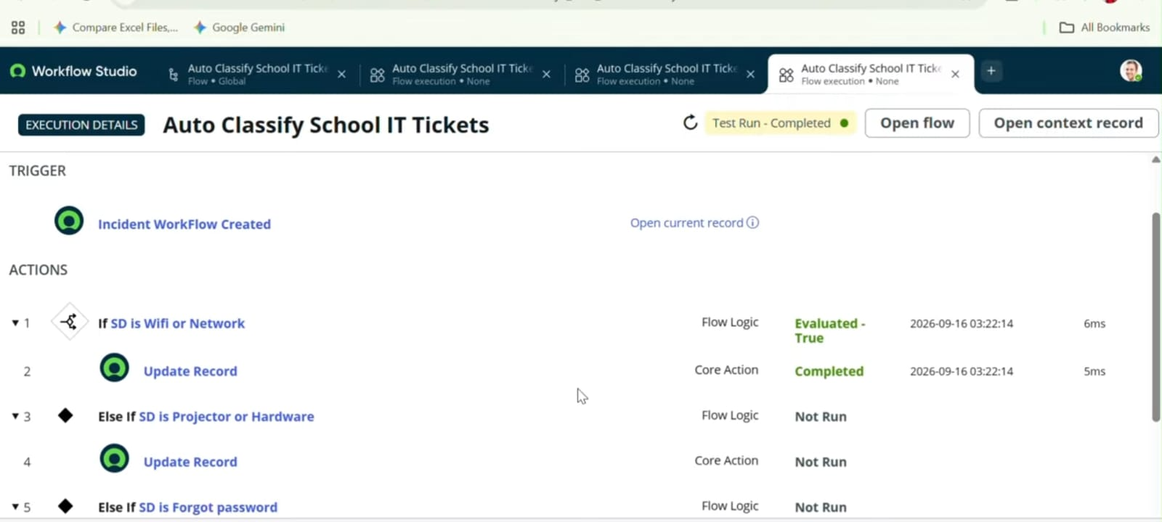

DEMO LINK AND GITHUB LINK:
DEMO LINK: https://drive.google.com/file/d/1BpWvwo1WofT_fygiAxQxKKftow3qQNf9/view?usp=drivesdk
GITHUB LINK:
https://github.com/Nandhini0666/Auto-Ticket-Classification-.git

