MicroGoals – Secure Goal Management Backend API

Team Id : SWTID-2026-7636
Team Leader : NANDHINI.L
Team Member :MOHANAPRIYA.B
Team Member :THARANI.B
Team Member :NANDHINI.K

INTRODUCTION

The MicroGoals project is a goal management system that helps users achieve their goals by breaking big tasks into small and simple steps called micro goals.

PROJECT OVERVIEW
MicroGoals is a secure backend RESTful API developed using Node.js, Express.js, and MongoDB. It enables users to register, log in, and manage their personal goals through CRUD operations. The system uses JWT authentication and middleware to ensure data security and user-specific access control.
The system includes:
- User Registration & Login
- JWT-based Authentication
- CRUD Operations for Goals
- Protected Routes
- Centralized Error Handling
The main objective is to provide a secure and scalable backend system for digital goal management.
Project Instruction
- The project follows REST API principles.
- Authentication is handled using JWT.
- MongoDB is used as the database.
- APIs are tested using Thunder Client.
- The project follows MVC architecture.
Pre-requisites
Before running the project, the following tools are required:
- Node.js (v18 or higher)
- Express.js
- MongoDB (Local / Atlas)
- VS Code
- Thunder Client (Extension)
- Basic knowledge of JavaScript & REST APIs

FEATURES
- User Registration
- Secure Login with JWT
- Create Goal
- Update Goal
- Delete Goal
- View User-specific Goals
- Protected Routes
- Centralized Error Handling
USERS FLOW
- User registers
- User logs in
- JWT token generated
- User sends token in header
- Access protected routes
- Perform CRUD operations

Folder Structure
MicroGoals/
├── middleware/
│ ├── authMiddleware.js
│ └── errorMiddleware.js
├──Schema/
├──User.js
├──GoalSchema.js
├── models/
│ ├── userModel.js
│ └── goalModel.js
│
├── routes/
│ ├── authRoutes.js
│ └── goalRoutes.js
│
├── .env
├── Index.js
└── package.js
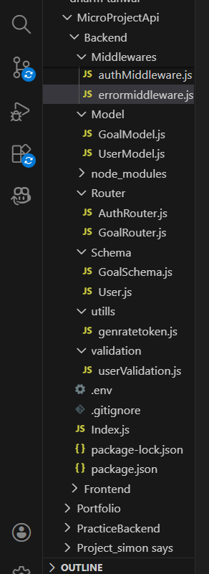
BACKEND DEVELOPMENT
- Created Express Server
An Express server was set up to handle API requests, connect routes, and enable JSON parsing for backend operations
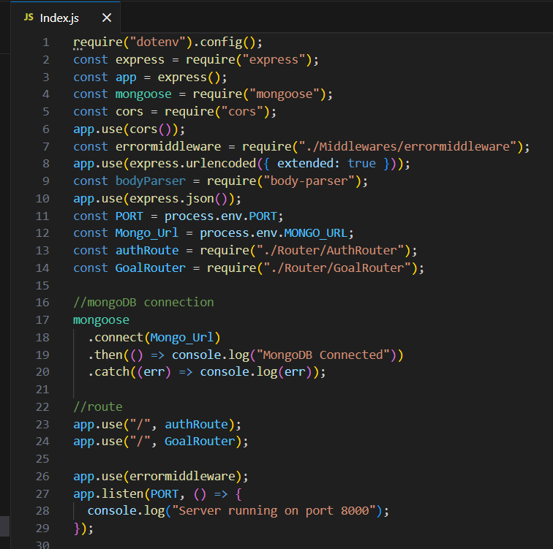


For Connection with MongoDB:-
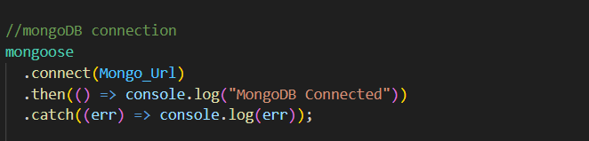
Implemented Authentication APIs
User registration and login APIs were created with password hashing and JWT token generation for secure authentication.
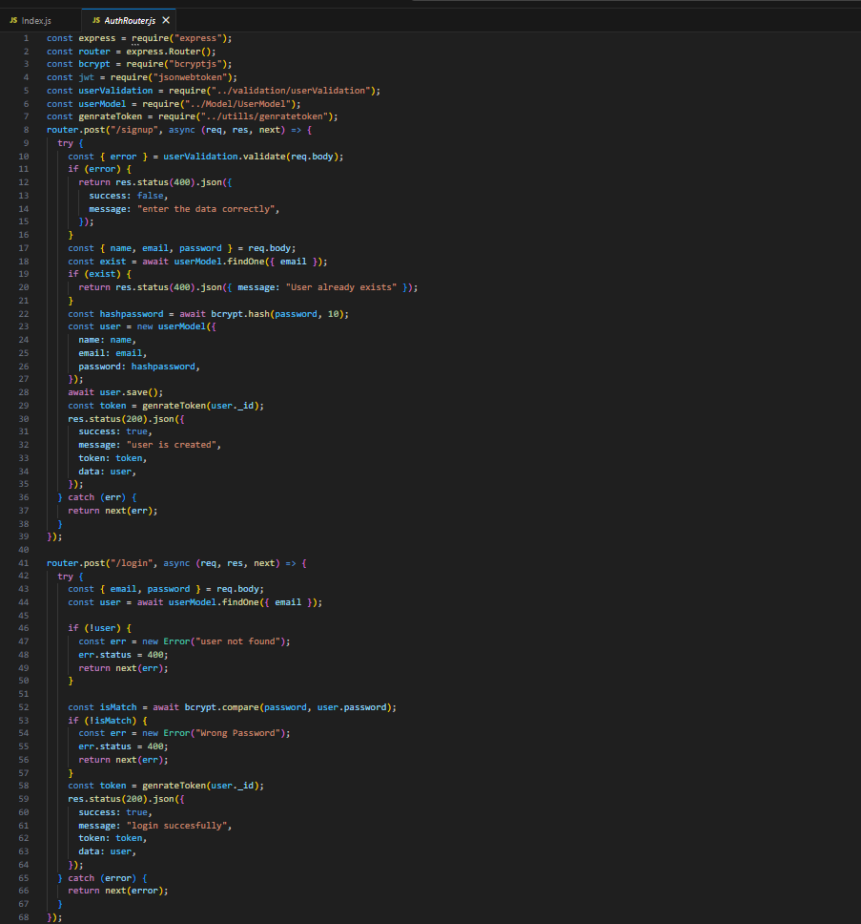

- Implemented Goal CRUD APIs
Goal CRUD APIs were implemented to allow authenticated users to perform full Create, Read, Update, and Delete operations on their personal goals. These APIs follow RESTful architecture principles and are designed to ensure secure and structured data management.
The Create API enables users to add new goals to the database. Each goal is associated with a specific user using a userId reference, ensuring user-specific data isolation.
The Read API allows authenticated users to retrieve only their own goals from the database. Data filtering is applied using the authenticated user's ID to prevent unauthorized data access.
The Update API enables users to modify existing goals. Proper validation checks ensure that only the owner of the goal can update it.
The Delete API allows users to permanently remove their goals from the system.

const express = require("express");
const router = express.Router();
const goalModel = require("../Model/GoalModel");
const authmiddleware = require("../Middlewares/authMiddleware");

router.post("/create", authmiddleware, async (req, res, next) => {
try {

const { title } = req.body;
const goal = new goalModel({
title: title,
user: req.user,
});
await goal.save();
res.status(200).json({
success: true,
data: goal,
});
} catch (err) {
return next(err);
}
});

router.get("/:id", authmiddleware, async (req, res, next) => {
try {
const id = req.params.id;
const data = await goalModel.findOne({
_id: id,
user: req.user,
});
res.status(200).json({

- Added Auth Middleware
- Auth middleware was implemented to verify JWT tokens and secure protected routes from unauthorized access.
DATABASE DEVELOPMENT
CONFIGURE MongoDB
- Use MongoDB Atlas or Local MongoDB
- Store connection string in .env
CREATE DATABASE CONNECTION
Index.js file:
- Use mongoose.connect()

Project Execution Steps
- Start MongoDB
- Run server
- Test APIs in Thunder Client
- Register User

- Login and get JWT

Project Output Screenshots
- Successful User Registration(Signup/Login)
- In this Api call the user register or login and token was genrated
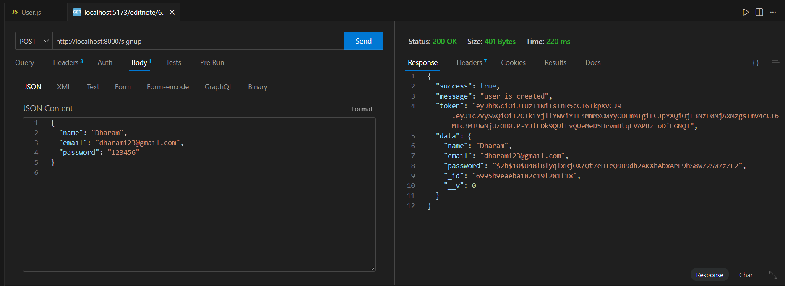
- JWT Token Response
After successful login user the api generate the token and these token was sent with every request to every api
CONCLUSION & FUTURE ENHANCEMENTS

MicroGoals provides a secure backend for goal management. JWT ensures authentication. MongoDB stores user-specific goals. Future Improvements: Add frontend (React / Angular) Add goal reminders Mobile app integration Email notifications

Project Demo Video

Video link:
https://drive.google.com/file/d/1IggIW7qyMlWnI4WkLKOxPkj7fPOFTH33/view?usp=sharingvv

Github link:
https://github.com/Nandhini0666/microgoal.git

