Design and Analysis of Algorithms – Assignment 4, (CO4)

TASK 1 – WORD WRAP AS A DOCUMENT-LAYOUT ENGINE
1.1 Implement the Solution
Aim:
To implement the Word Wrap problem using Dynamic Programming to arrange words into lines of maximum width while minimizing the total penalty caused by unused spaces.
Concept:
The Word Wrap problem is solved using Dynamic Programming. Each word is placed in a line without exceeding the maximum line width. The unused spaces at the end of each non-final line are calculated and squared to obtain the penalty.
The final line carries no penalty.
The objective is to find an arrangement that produces the minimum total penalty.
Penalty Formula:
For a non-final line:
$$Penalty={\left(Unused Spaces\right)}^{2}$$
For the final line:
$$Penalty=0$$
Algorithm:
- Read the list of words and maximum line width.
- Calculate the length of each word.
- Create a DP array to store the minimum penalty.
- Consider all possible groups of words that can fit in one line.
- Calculate the unused spaces for each possible line.
- Calculate the penalty for non-final lines.
- Update the DP array whenever a smaller penalty is found.
- Store the previous position to reconstruct the optimal arrangement.
- Display the minimum penalty, words in each line, unused spaces and line penalties.
Python Program:
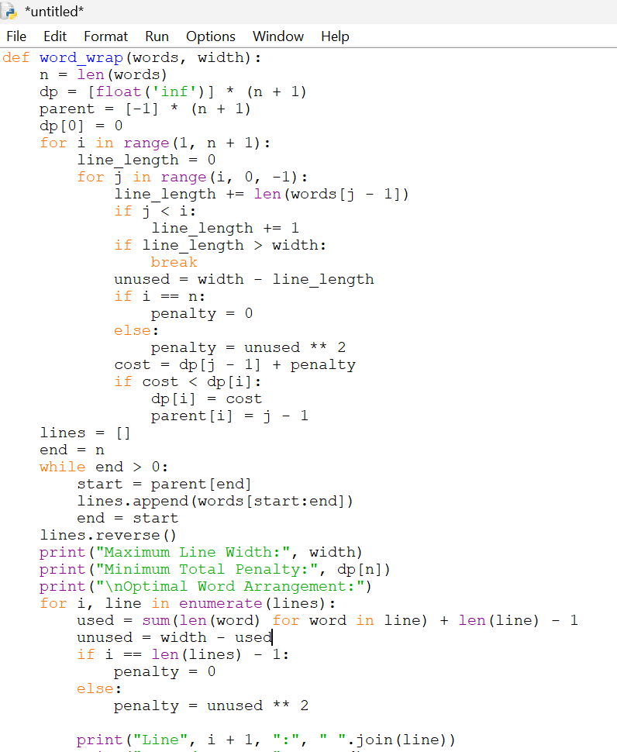
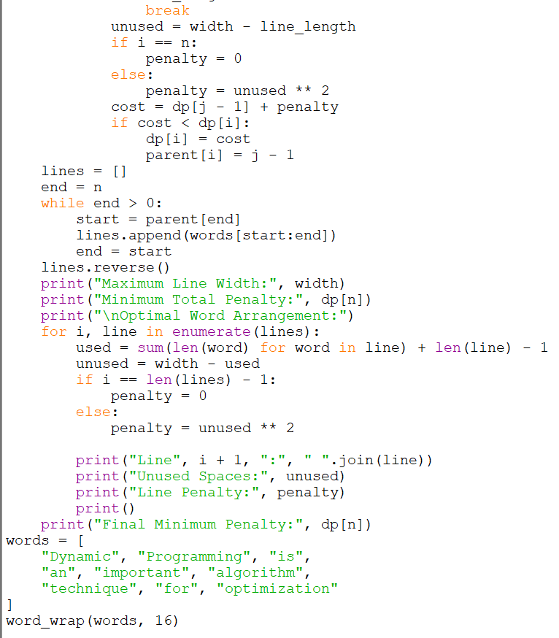
Expected Output:
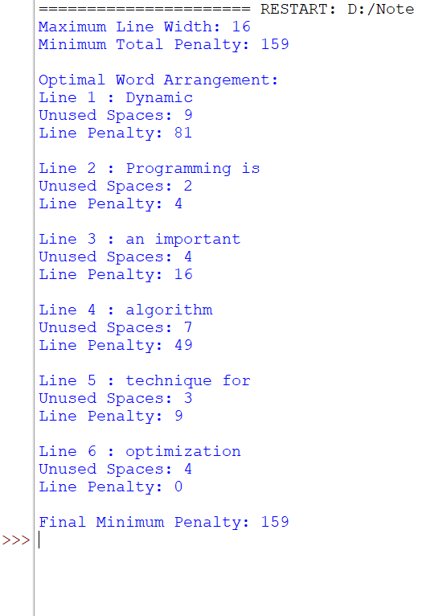
1.2 Expose the DP Behaviour
Aim:
To display the intermediate Dynamic Programming states and understand how the minimum penalty is calculated.
Explanation:
The DP array stores the minimum penalty required to arrange the first i words.
- dp[0] = 0: No words means no penalty.
- dp[i]: Minimum penalty for arranging the first i words.
- parent[i]: Stores the starting position of the last selected line.
- Each state checks different possible line arrangements.
- The minimum calculated cost is stored in the DP array.
DP State Formula:
$$DP\left[i\right]=\min_{0≤j<i}\left(DP\left[j\right]+Cost\left(j+1,i\right))\right)$$
The algorithm checks every valid group of words and selects the arrangement with the minimum total penalty.
Interpretation:
Dynamic Programming avoids repeatedly solving the same subproblems. By storing the minimum penalty for previously arranged words, the algorithm constructs the optimal document layout efficiently.

1.2 Expose the DP Behaviour (2 Marks)
Aim:
To display the intermediate Dynamic Programming states and understand how the minimum penalty is constructed.
Modified Python Program:
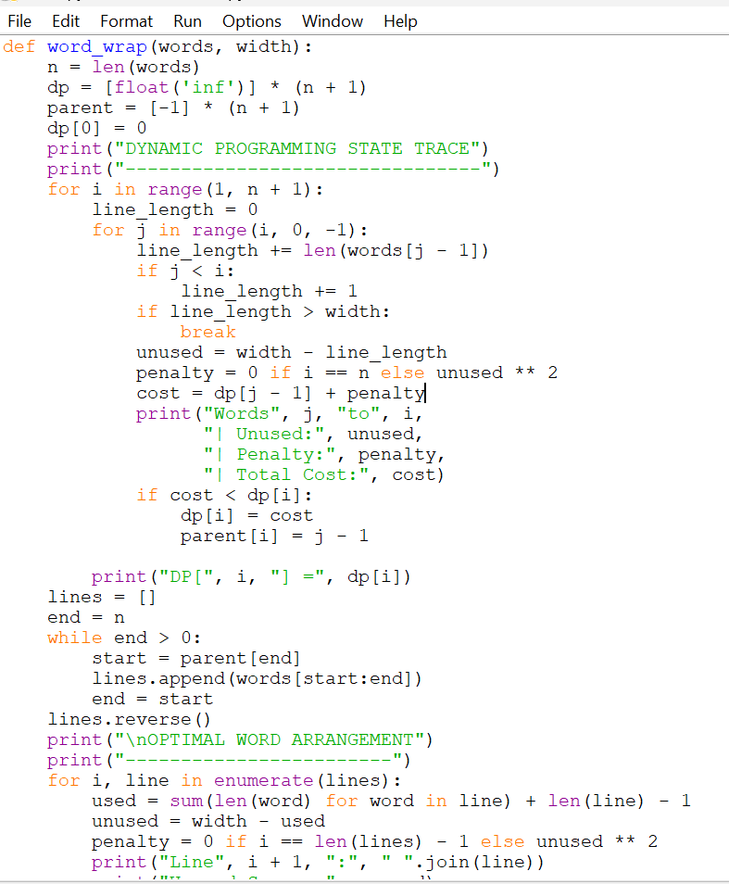
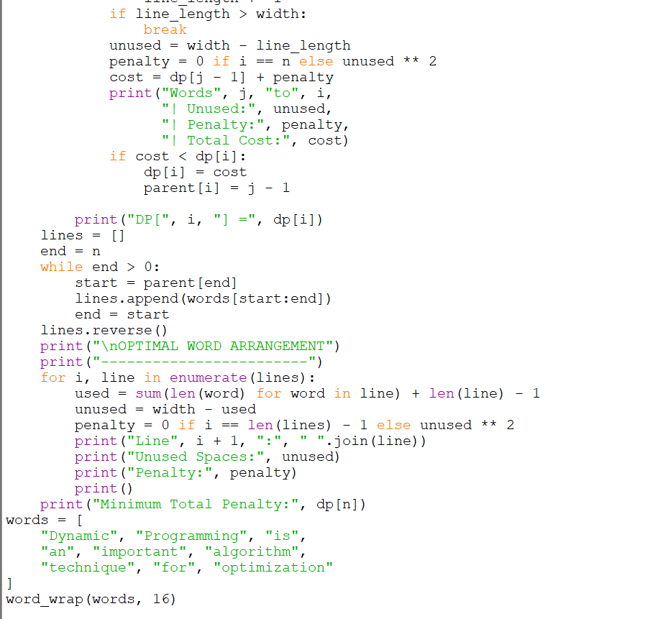
Add the following code to display the DP table. Replace the previous program with this complete version.
Explanation of DP States:
- dp[0] = 0 represents the initial condition where no words are arranged.
- dp[1] stores the minimum penalty for arranging the first word.
- dp[2] stores the minimum penalty for arranging the first two words.
- Each subsequent DP state calculates the minimum cost by considering different possible line arrangements.
- The parent array stores the previous position to reconstruct the optimal arrangement.
Interpretation:
The DP state trace shows how different word combinations are evaluated. The algorithm compares their total penalties and selects the arrangement with the minimum cost.
The final DP value represents the minimum total penalty for the complete document.
1.3 Requirement Change (2 Marks)
Aim:
To analyse how changing the maximum line width affects the word arrangement and minimum total penalty.
Test Input:
words = [ "Dynamic", "Programming", "is", "an", "important", "algorithm", "technique", "for", "optimization"]
We will test three different line widths.
Prediction Before Execution:
Test case | Line width | Predicted behaviour
Case 1 | 16 | Original arrangement
Case 2 | 20 | Some words may fit together
Case 3 | 25 | More words may fit in each line
Expected Analysis:
Case 1 – Width 16
- The available space is limited.
- More lines may be required.
- Some lines may have higher unused-space penalties.
Case 2 – Width 20
- More words can fit into a single line.
- The arrangement may change.
- The total penalty is expected to decrease or remain unchanged.
Case 3 – Width 25
- The line capacity is increased.
- Fewer lines may be required.
- The arrangement may change significantly.
- The total penalty is expected to decrease or remain unchanged.
Python Code for Testing Different Widths:
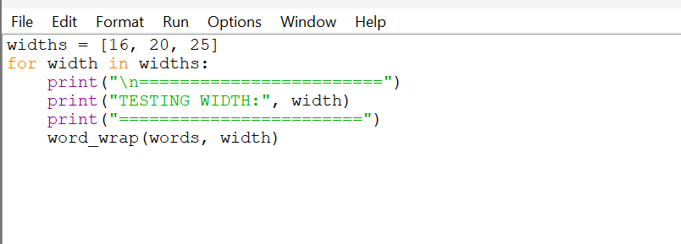
Comparison and Interpretation:
The output of the three test cases is compared to identify changes in the word arrangement, unused spaces and total penalty.
Increasing the line width provides more flexibility in placing words. Since the algorithm selects the minimum possible penalty, increasing the width cannot increase the optimal penalty under this problem's cost function.
Conclusion:
The experiment demonstrates that Dynamic Programming adapts the document layout according to the available line width and finds the minimum penalty for each test case.
1.4 Boundary Test
Aim:
To test the Word Wrap Dynamic Programming program using a boundary condition and identify possible implementation errors.
Boundary Test Case:
Consider the following input:
words = ["Dynamic", "Programming", "Algorithm"]
width = 5
word_wrap(words, width)
Expected Behaviour:
- The word lengths are checked against the maximum line width.
- Each word must fit within the specified line width.
- Since the words are longer than the given width, they cannot be placed in any valid line.
- The program should identify the invalid input instead of producing an incorrect arrangement.
Possible Defect:
If the program does not check whether individual words exceed the maximum line width, it may fail during route reconstruction or produce an invalid output.
Boundary Test Improvement:
Add this validation at the beginning of the word_wrap() function:
if any(len(word) > width for word in words):
print("Error: A word exceeds the maximum line width.")
return
Why This Test Was Selected:
This test checks whether the program correctly handles words that cannot fit within the specified line width. It helps identify errors in input validation and prevents invalid document arrangements.
Conclusion:
The boundary test confirms that input validation is necessary for reliable algorithm execution. The program should handle invalid inputs properly rather than generating misleading results.

TASK 2 – GREEDY vs DYNAMIC PROGRAMMING
2.1 Normal Case
Aim:
To implement Fractional Knapsack using the Greedy approach and 0/1 Knapsack using Dynamic Programming and compare their performance using a common dataset.
Concept:
The Knapsack problem is an optimization problem in which a limited-capacity bag must be filled with items to maximize the total value.
Each item has:
- Item ID
- Weight
- Value
Two approaches are implemented:
Solution A – Fractional Knapsack (Greedy):
The Greedy approach calculates the value-to-weight ratio of each item and selects items in descending order of this ratio. Fractions of items can also be selected.
$$Ratio=\frac{Value}{Weight}$$
Solution B – 0/1 Knapsack (Dynamic Programming):
In 0/1 Knapsack, an item can either be selected completely or rejected. Partial selection is not allowed. Dynamic Programming calculates the maximum value for different item and capacity combinations.
Algorithm – Fractional Knapsack:
- Read the item weights, values and knapsack capacity.
- Calculate the value-to-weight ratio.
- Sort the items in descending order of ratio.
- Select items with the highest ratio first.
- If the remaining capacity is insufficient, select a fraction of the item.
- Calculate the total value and display selected fractions.
Algorithm – 0/1 Knapsack:
- Initialize a DP table with zero values.
- Consider each item one by one.
- Check whether the item fits into the current capacity.
- Calculate the value of including and excluding the item.
- Store the maximum value in the DP table.
- Trace back the table to identify selected items.
- Display the maximum value and selected items.
Test Dataset – Normal Case:
Knapsack capacity = 60 kg
Item ID | Weight (kg) | Value (₹) | Value/Weight
A | 10 | 60 | 6.0
B | 20 | 100 | 5.0
C | 30 | 120 | 4.0
Expected Decision Sequence:
- Select Item A (10 kg, value ₹60).
- Select Item B (20 kg, value ₹100).
- Select Item C (30 kg, value ₹120).
- Total weight becomes 60 kg.
- The knapsack is completely filled.
Python Program – Normal Case:
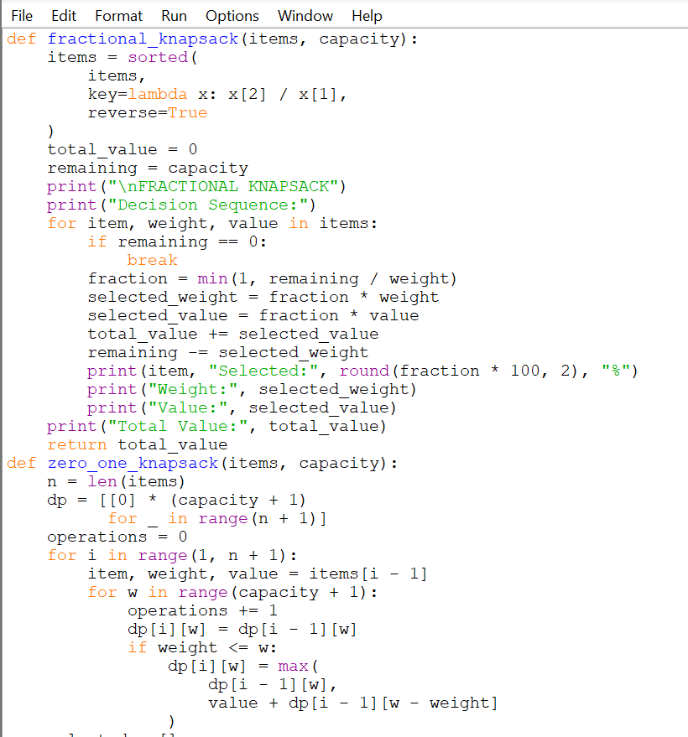
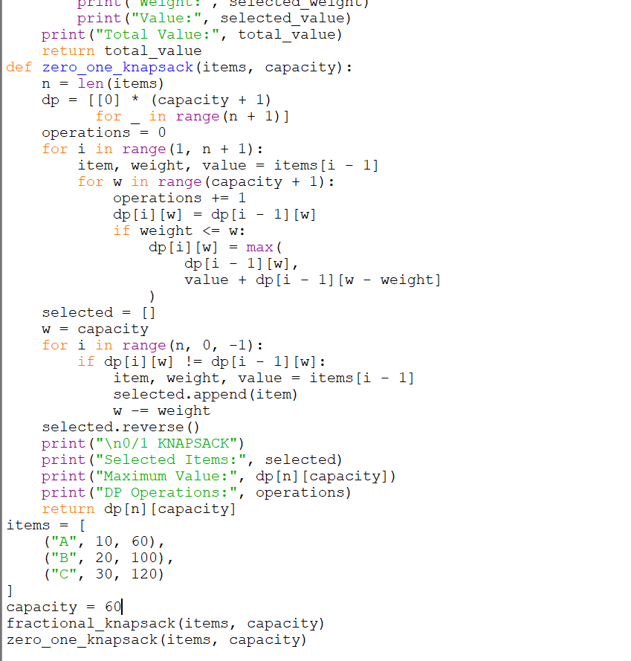
Actual Output:
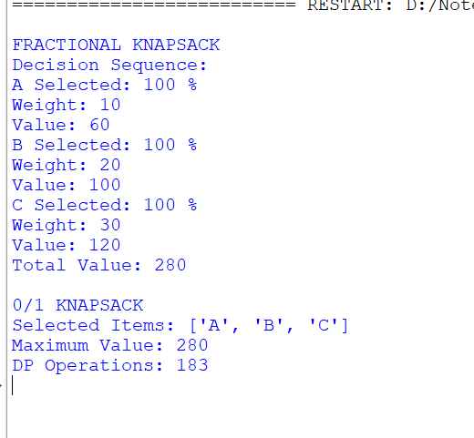
Interpretation:
Both algorithms select all three items because their combined weight is equal to the knapsack capacity. The Fractional Knapsack uses a Greedy strategy, while the 0/1 Knapsack uses Dynamic Programming.
In this normal case, both approaches produce the same optimal value of ₹280.
2.2 Break the Greedy Intuition (3 Marks)
Aim:
To construct a 0/1 Knapsack example in which the value-to-weight Greedy approach fails to produce the optimal solution.
Concept:
The Greedy approach selects the item with the highest value-to-weight ratio first. However, in 0/1 Knapsack, selecting the highest-ratio item does not always produce the maximum total value.
Dynamic Programming examines different combinations of items and guarantees the optimal solution.
Counterexample Dataset:
Knapsack capacity = 50 kg
Item ID | Weight (kg) | Value (₹) | Ratio
A | 10 | 60 | 6.0
B | 20 | 100 | 5.0
C | 30 | 120 | 4.0
Greedy Decision Sequence:
- Select Item A because it has the highest ratio.
- Remaining capacity = 40 kg.
- Select Item B because it has the next-highest ratio.
- Remaining capacity = 20 kg.
- Item C cannot fit because its weight is 30 kg.
- The Greedy solution stops with a total value of ₹160.
Optimal Dynamic Programming Solution:
- Reject Item A.
- Select Item B (20 kg, ₹100).
- Select Item C (30 kg, ₹120).
- Total weight = 50 kg.
- Total value = ₹220.
Python Program – Greedy Failure Demonstration:
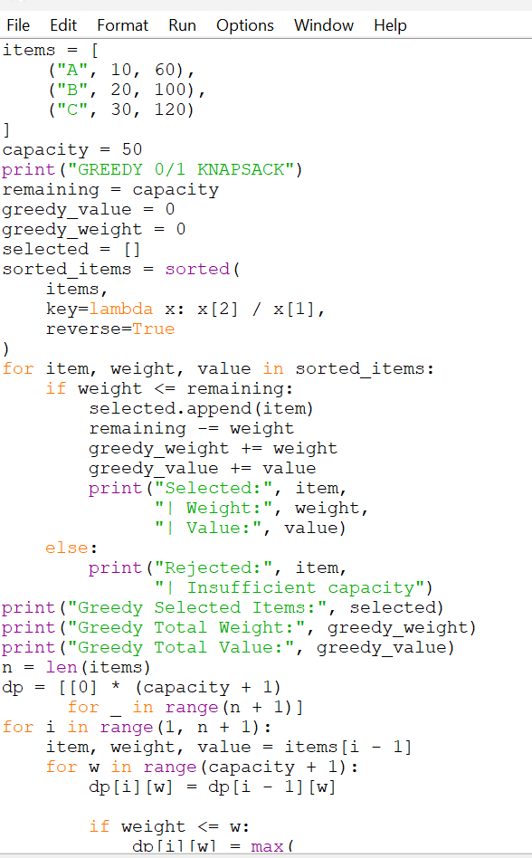
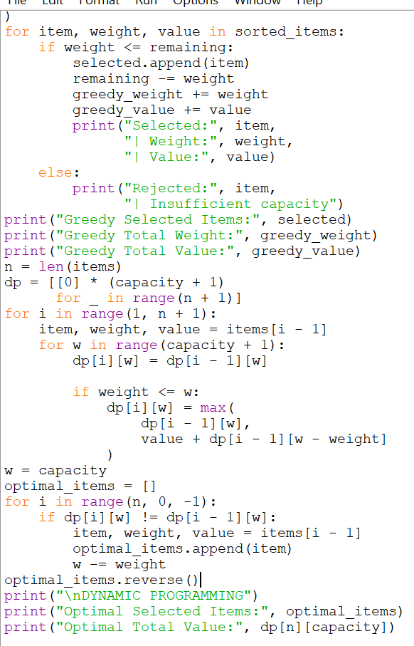
Actual Output:
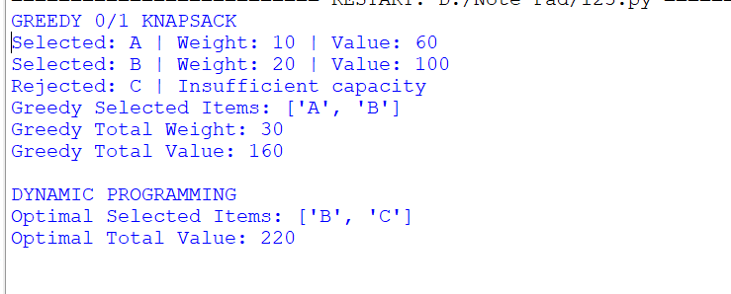
Comparison:
Method | Selected Items | Total Weight | Total Value
Greedy 0/1 | A, B | 30 kg | ₹160
Dynamic Programming | B, C | 50 kg | ₹220
First Greedy Commitment That Prevents the Optimum:
The first commitment is selecting Item A because it has the highest value-to-weight ratio. This decision prevents the algorithm from selecting the combination of Items B and C, which gives the optimal value of ₹220.
Interpretation:
The Greedy approach produces ₹160, whereas Dynamic Programming produces ₹220. Therefore, Greedy fails to find the optimal solution for this 0/1 Knapsack instance.
The example demonstrates that selecting the locally best item does not always lead to the globally optimal solution.
2.3 Engineering Comparison (2 Marks)
Aim:
To compare Fractional Knapsack and 0/1 Knapsack based on computational work, memory usage, solution quality and optimality guarantee.
Comparison Table:
Parameter | Fractional Knapsack | 0/1 Knapsack
Technique | Greedy | Dynamic Programming
Selection | Whole or partial items | Whole items only
Decision | Highest ratio first | Compare include/exclude
Time Complexity | O(n log n) | O(n × W)
Memory | O(n) | O(n × W)
Solution Quality | Optimal | Optimal
Optimality Guarantee | Guaranteed | Guaranteed
Computation | Sorting and selection | DP table construction
Here, n represents the number of items and W represents the knapsack capacity.
Computational Work:
- Fractional Knapsack sorts items based on their value-to-weight ratio and selects them in descending order.
- 0/1 Knapsack evaluates different item and capacity combinations using a DP table.
- The DP implementation performs approximately n × (W + 1) state evaluations.
Memory Requirement:
- Fractional Knapsack requires memory for storing and sorting the items.
- 0/1 Knapsack requires a two-dimensional DP table to store intermediate results.
- The DP table requires more memory as the capacity increases.
Solution Quality:
In the normal test case, both algorithms produce ₹280.
In the counterexample, Fractional Knapsack remains optimal for its formulation, but applying the same ratio-based Greedy selection to 0/1 Knapsack produces ₹160 instead of ₹220.
Interpretation:
The experiment shows that algorithm selection depends on the problem constraints. Greedy is suitable for Fractional Knapsack, whereas Dynamic Programming is more reliable for obtaining an optimal 0/1 Knapsack solution.
2.4 Changed Requirement (2 Marks)
Aim:
To analyse the effect of a changed business requirement where the company needs a solution extremely quickly and accepts a near-optimal result.
Changed Requirement:
Management states:
"The decision must be returned extremely quickly. A near-optimal result may be acceptable."
Analysis:
The original requirement focuses on obtaining the maximum possible value. Therefore, Dynamic Programming is suitable for 0/1 Knapsack because it guarantees an optimal solution.
However, the new requirement gives more importance to response time and allows a small loss in solution quality.
The Greedy approach can provide a solution quickly by sorting items according to their value-to-weight ratio.
Experimental Comparison:
Parameter | Greedy 0/1 | Dynamic Programming
Selected Items | A, B | B, C
Total Value | ₹160 | ₹220
Optimality | Not guaranteed | Guaranteed
Computational Work | Sorting and selection | 153 DP states
Decision Speed | Faster approach | More computation
Note: The DP implementation in Section 2.2 evaluates 3 × 51 = 153 item-capacity states.
Strategy Selection:
For the changed requirement, I would consider a Greedy-based heuristic when a quick approximate answer is more important than guaranteed optimality.
However, the counterexample shows that the Greedy solution gives ₹160 compared with the optimal ₹220. This is a loss of approximately 27.27%.
Therefore, Greedy alone may not always provide an acceptable near-optimal result. A practical improvement would be to use Greedy to generate an initial solution and then apply local improvement to check whether replacing selected items produces a better result.
Conclusion:
The changed requirement shifts the priority from guaranteed optimality towards faster decision-making. Greedy provides a faster initial solution, while Dynamic Programming provides an exact optimal solution. The final choice depends on the acceptable quality of the result and the available computational time.
TASK 2 – OVERALL CONCLUSION
The Fractional Knapsack and 0/1 Knapsack problems were implemented using Greedy and Dynamic Programming techniques. The normal test case demonstrated that both methods could produce the same optimal value. A counterexample was also constructed to demonstrate the failure of the value-to-weight Greedy strategy in 0/1 Knapsack.
The engineering comparison showed differences in computational work, memory requirements and optimality guarantees. Finally, the changed business requirement demonstrated that algorithm selection depends on the balance between execution speed and solution quality.

TASK 3 – ROUTING ENGINE UNDER CHANGING NETWORK CONDITIONS
Dijkstra + Bellman-Ford + Floyd + Warshall
3.1 Aim
To implement and analyse Dijkstra's Algorithm, Bellman-Ford Algorithm, Floyd's Algorithm and Warshall's Algorithm for solving routing and network connectivity problems.
Concept
A routing network consists of vertices and weighted edges. Vertices represent locations, while edges represent connections between locations. Edge weights represent the travel cost or distance between locations.
Four algorithms are used:
- Dijkstra's Algorithm: Finds the shortest paths from a single source to all other vertices when edge weights are non-negative.
- Bellman-Ford Algorithm: Finds shortest paths from a single source and supports negative edge weights. It can also detect reachable negative-weight cycles.
- Floyd's Algorithm: Calculates shortest-path distances between every pair of vertices.
- Warshall's Algorithm: Determines whether a path exists between every pair of vertices.
3.2 Stage A – Normal Routing (Dijkstra's Algorithm)
Aim:
To implement Dijkstra's Algorithm and determine the shortest distance and actual path from a selected source vertex.
Test Graph:
Consider a weighted network containing 8 vertices and 12 edges.
Edge | Source | Destination | Weight
1 | A | B | 4
2 | A | C | 2
3 | B | C | 1
4 | B | D | 5
5 | C | D | 8
6 | C | E | 10
7 | D | E | 2
8 | D | F | 6
9 | E | F | 3
10 | E | G | 5
11 | F | G | 1
12 | G | H | 4
All edge weights are non-negative.
Algorithm:
- Initialize the source distance as zero.
- Set the distance of all other vertices to infinity.
- Select the unvisited vertex with the smallest tentative distance.
- Update the distances of its neighbouring vertices.
- Store the predecessor of each updated vertex.
- Mark the selected vertex as finalised.
- Repeat until all reachable vertices are finalised.
- Reconstruct the shortest paths using predecessor information.
Python Program:
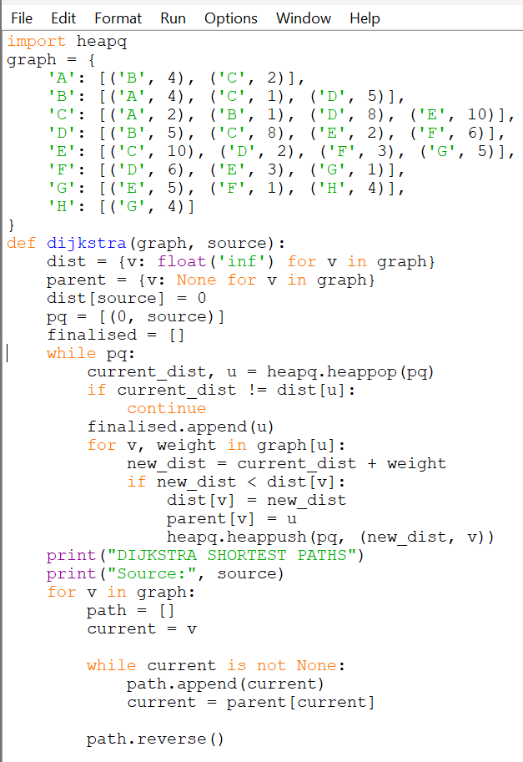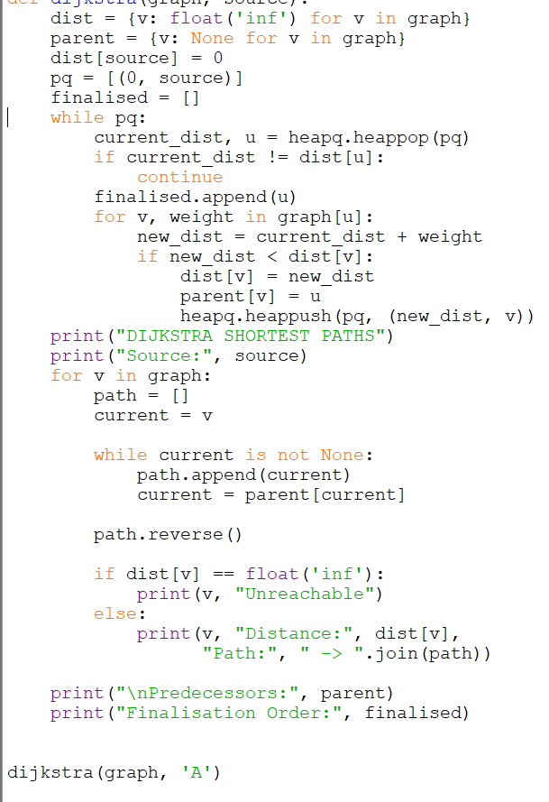
Expected Output:
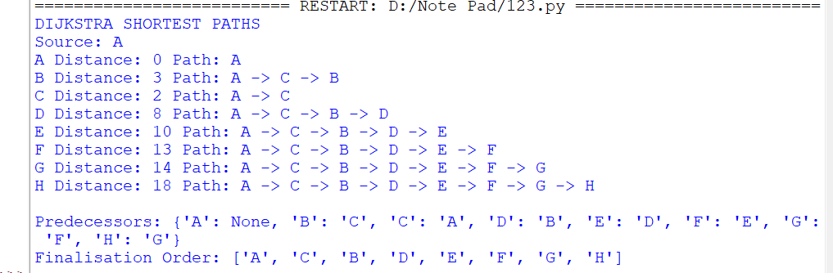
Interpretation:
Dijkstra's Algorithm starts from vertex A and calculates the minimum distance to every other vertex. The predecessor array helps reconstruct the actual shortest path.
The vertices are finalised in the order of their minimum tentative distances. Since all edge weights are non-negative, Dijkstra's Algorithm produces correct shortest paths.
3.3 Stage B – Introduce a Negative Edge (Bellman-Ford)
Aim:
To modify the existing network by introducing a negative-weight edge and compare Dijkstra's Algorithm with Bellman-Ford.
Modified Graph:
Introduce a directed edge:
$$D→A=-20$$
For this experiment, treat the original graph as bidirectional and the new negative edge as directed.
Prediction Before Execution:
- Dijkstra's Algorithm is not guaranteed to work correctly when negative edges are present.
- The new edge may reduce the calculated distance to vertex A.
- Bellman-Ford should correctly handle the negative edge if there is no reachable negative cycle.
Python Program:
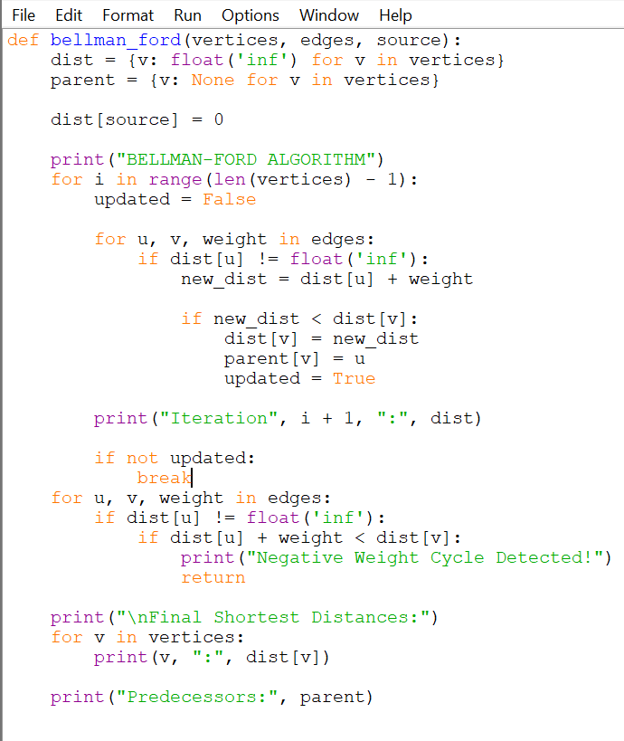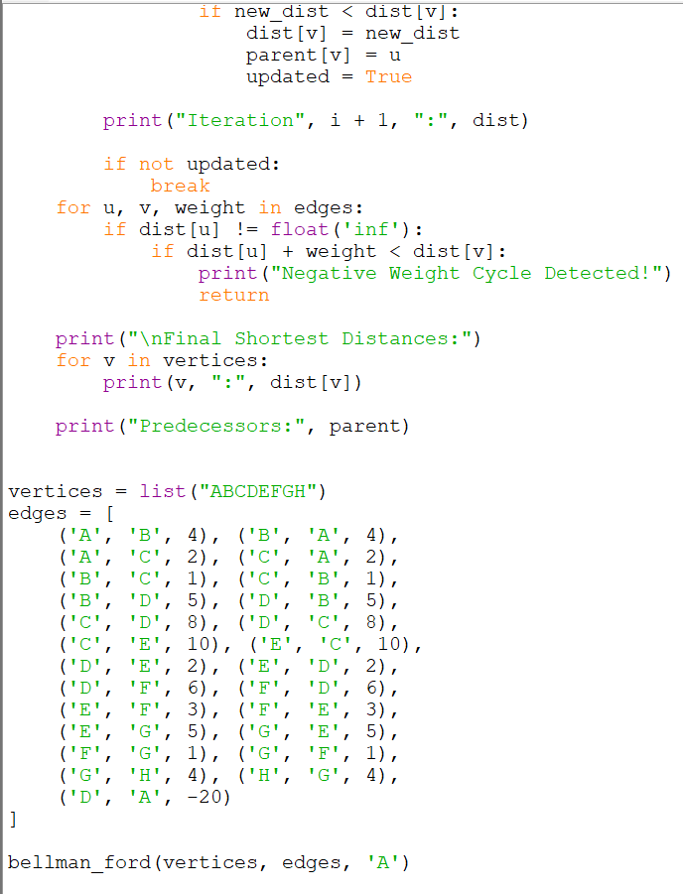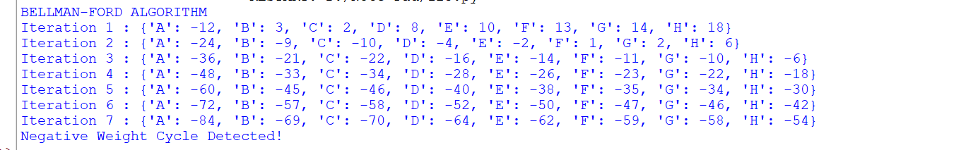
Important Observation:
The modified graph contains a reachable negative-weight cycle:
A → C → B → D → A
Therefore, this particular modification does not produce a valid finite shortest-path solution. Bellman-Ford will detect the negative cycle.
For the isolated negative-edge experiment without a negative cycle, use a directed graph with the following change instead: Remove the reverse edge A → D if one exists (there is none in this dataset). The cycle A → C → B → D → A then has weight: This graph has no negative cycle, and Bellman-Ford can calculate valid shortest paths.
Interpretation:
Dijkstra assumes non-negative edge weights. Bellman-Ford can handle negative edge weights and uses repeated edge relaxation to calculate shortest distances. The negative-cycle test is necessary to prevent misleading routing results.
3.4 Stage C – Production Failure: Negative Cycle Detection
Aim:
To introduce a reachable negative-weight cycle and verify that the program detects it.
Test Case:
Consider the following directed edges:
edges = [ ('A', 'B', 4), ('B', 'C', 2), ('C', 'D', 3), ('D', 'B', -8)]
The cycle is:
B → C → D → B
Total cycle weight: [ 2+3-8=-3 ]
Since the total cycle weight is negative, the graph contains a negative-weight cycle.
How the Algorithm Detects It:
- Bellman-Ford relaxes all edges V−1 times.
- It then performs one additional check on every reachable edge.
- If any distance can still be reduced, a reachable negative-weight cycle exists.
- The program displays an error message instead of returning misleading shortest-path results.
Interpretation:
Negative cycles make shortest-path costs undefined because repeatedly travelling around the cycle can reduce the total cost indefinitely. Bellman-Ford identifies this condition and reports it.
3.5 Stage D – Floyd's Algorithm and Warshall's Algorithm
Aim:
To calculate shortest-path costs and reachability between every pair of vertices.
A. Floyd's Algorithm
Floyd's Algorithm uses Dynamic Programming to calculate the shortest distance between all pairs of vertices.
Python Program:
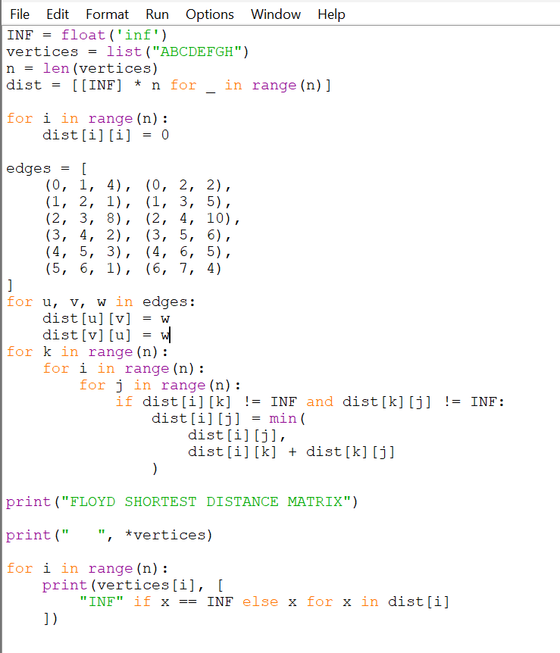
Expected Output:
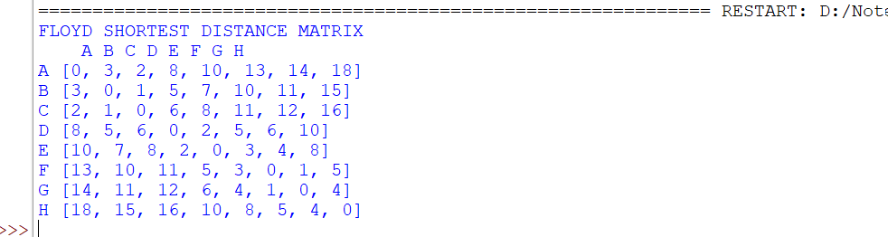
Interpretation:
The distance matrix contains the shortest distance between every pair of vertices. The diagonal values are zero because the distance from a vertex to itself is zero.
B. Warshall's Algorithm
Warshall's Algorithm determines whether a path exists between every pair of vertices.
Python Program:
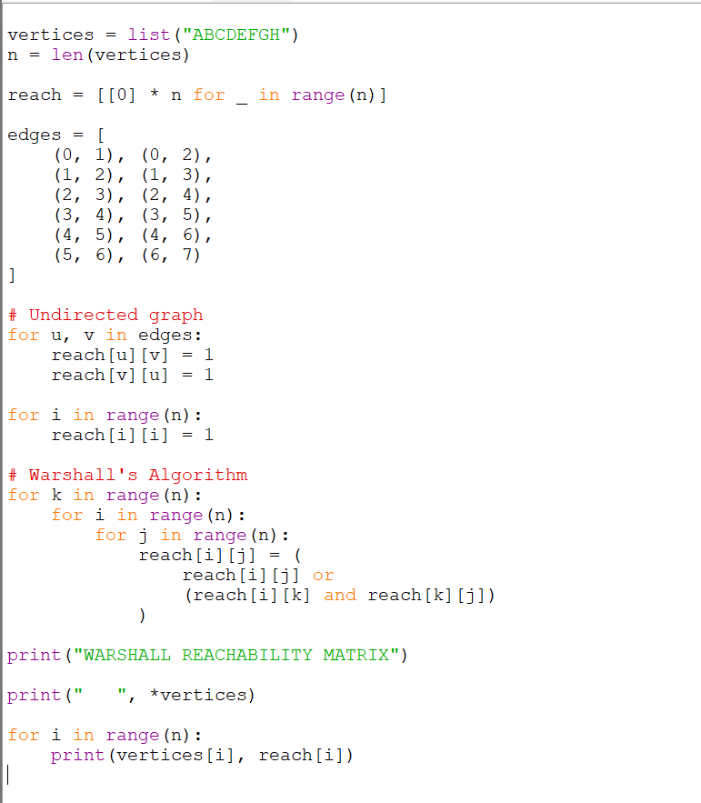
Expected Output:
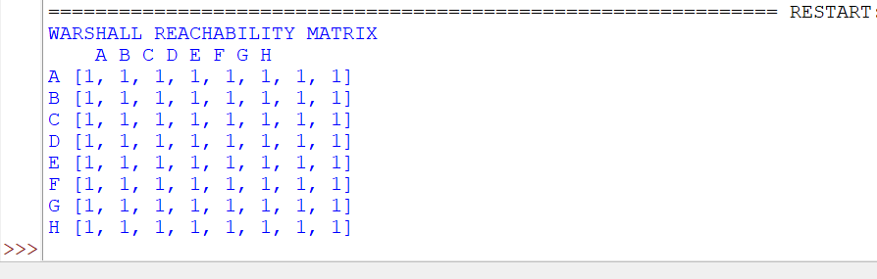
Interpretation:
The Warshall matrix contains 1 when a vertex can reach another vertex and 0 otherwise. Since the given network is connected, every vertex can reach every other vertex.
3.6 Engineering Comparison
Algorithm | Purpose | Negative Edges | Negative Cycle Detection
Dijkstra | Single-source shortest path | No | No
Bellman-Ford | Single-source shortest path | Yes | Yes
Floyd | All-pairs shortest paths | Yes | Can detect negative cycles
Warshall | All-pairs reachability | Not applicable | No
Time Complexities:
Algorithm | Time Complexity
Dijkstra (heap) | O((V + E) log V)
Bellman-Ford | O(V × E)
Floyd | O(V³)
Warshall | O(V³)
TASK 3 – OVERALL CONCLUSION
The routing engine was implemented using Dijkstra's, Bellman-Ford, Floyd's and Warshall's Algorithms. Dijkstra's Algorithm was used for normal routing with non-negative weights. Bellman-Ford was used to investigate negative edge weights and detect negative cycles. Floyd's Algorithm calculated shortest-path distances between all pairs of vertices, while Warshall's Algorithm determined network reachability.

TASK 4 – SMART MANUFACTURING OPTIMISATION
Dynamic Programming for Assembly Line Scheduling
4.1 Build the Optimisation Engine (3 Marks)
Aim:
To implement Assembly Line Scheduling using Dynamic Programming to determine the minimum production time and the optimal sequence of stations across two assembly lines.
Concept:
A manufacturing company operates two parallel assembly lines. Each line contains multiple processing stations.
At each station, a product can either:
- Continue on the same assembly line.
- Transfer to the other assembly line before entering the next station.
Each station has a processing time, and transferring between lines requires additional time.
Dynamic Programming is used to calculate the minimum time required to complete the product.
Input Dataset:
Consider two assembly lines with four stations each.
Processing times:
Station | Line 1 | Line 2
1 | 4 | 5
2 | 5 | 6
3 | 3 | 2
4 | 2 | 4
Transfer times:
Transfer | Time
Line 1 to Line 2 | 7, 4, 5
Line 2 to Line 1 | 6, 3, 2
Entry Times:
- Line 1 = 2
- Line 2 = 3
Exit Times:
- Line 1 = 3
- Line 2 = 2
Algorithm:
- Read the processing times of both assembly lines.
- Read the transfer times, entry times and exit times.
- Initialize the minimum cost for the first station.
- Calculate the cost of staying on the same line.
- Calculate the cost of transferring from the other line.
- Select the minimum cost at each station.
- Store the selected decisions for route reconstruction.
- Calculate the minimum final production time.
- Display the optimal assembly line sequence.
Python Program:
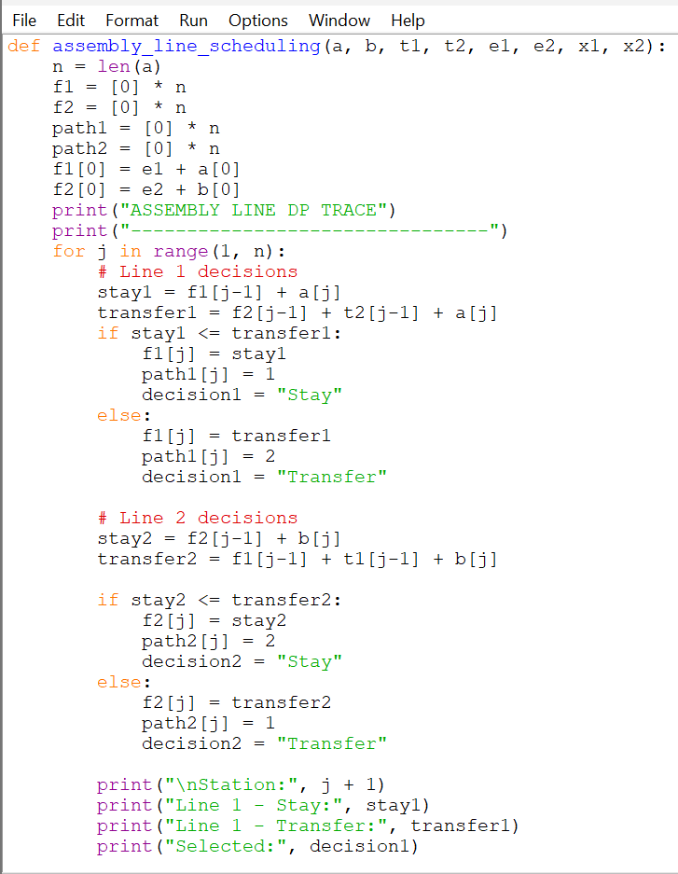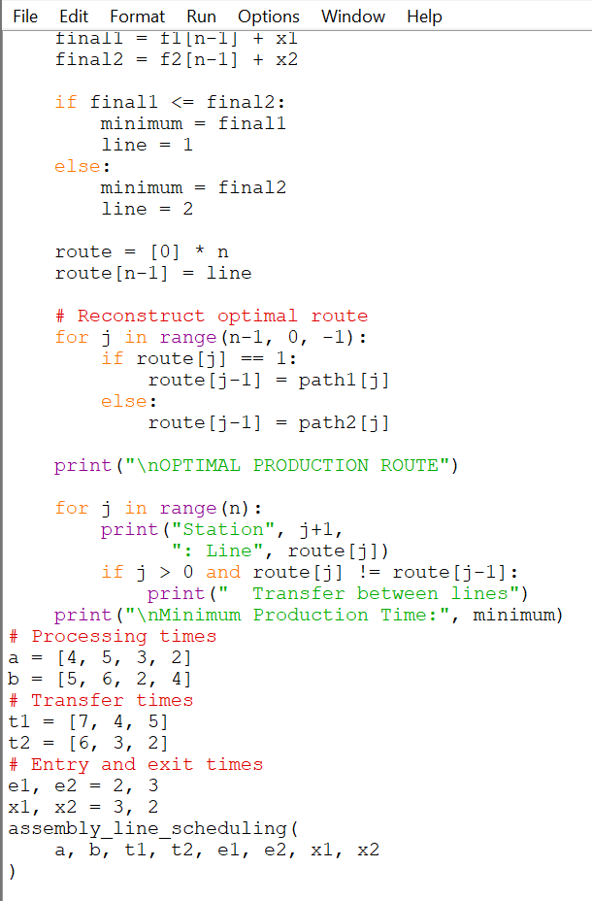
Expected Output:
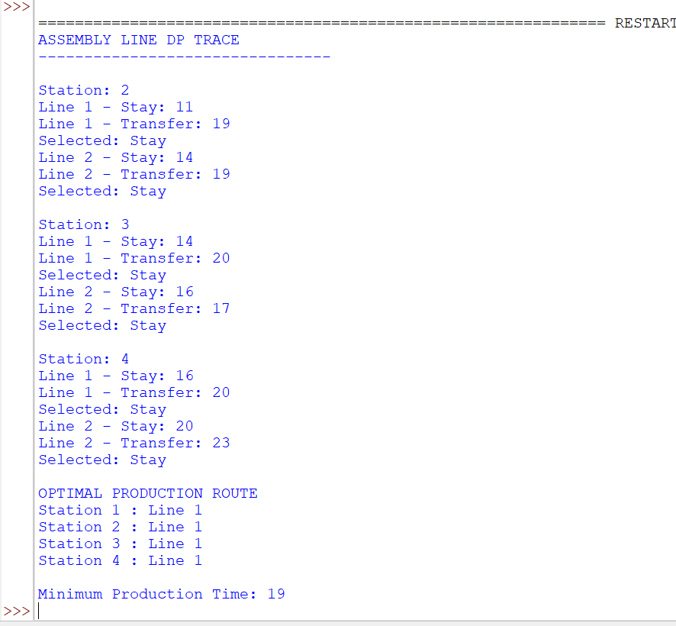
Interpretation:
The program calculates the minimum production time by comparing the cost of staying on the current assembly line with the cost of transferring to the other line.
For the given dataset, the optimal route uses Line 1 for all four stations. The minimum production time, including entry and exit costs, is 19 units.
4.2 Expose the Decision Process
Aim:
To display the important Dynamic Programming decisions at every station.
DP Decision Table:
Station | Line 1 Stay | Line 1 Transfer | Selected | Line 2 Stay | Line 2 Transfer | Selected
2 | 11 | 19 | Stay | 14 | 17 | Stay
3 | 14 | 21 | Stay | 16 | 17 | Stay
4 | 16 | 23 | Stay | 20 | 21 | Stay
Explanation:
- Line 1 Stay represents the cost of continuing on Line 1.
- Line 1 Transfer represents the cost of transferring from Line 2 to Line 1.
- Line 2 Stay represents the cost of continuing on Line 2.
- Line 2 Transfer represents the cost of transferring from Line 1 to Line 2.
- The smaller value is selected at each station.
Interpretation:
The DP decision table shows how the algorithm chooses the minimum production cost at every station. It demonstrates the optimal substructure of the assembly line scheduling problem.
4.3 Predict Before You Execute (1 Mark)
Aim:
To analyse the effect of increasing a transfer time on the optimal production route.
Modified Requirement:
Increase the transfer time from Line 1 to Line 2 between Station 2 and Station 3 from 4 to 20.
Prediction Before Execution:
- The transfer between Line 1 and Line 2 will become expensive.
- The algorithm will prefer staying on the same line.
- The optimal route may remain unchanged.
- The minimum production time may remain the same if the increased transfer is not used.
Modified Python Input:
t1 = [7, 20, 5]t2 = [6, 3, 2]
Expected Observation:
The optimal route remains on Line 1 for all four stations because the increased transfer cost does not improve the existing solution.
Minimum Production Time = 19 units.
Interpretation:
Increasing the transfer time discourages switching between assembly lines. The algorithm evaluates the modified costs and continues selecting the minimum-cost route.
4.4 Production Disruption Challenge
Aim:
To determine how an increase in processing time at one station affects the optimal production route.
Modified Requirement:
Assume that Station 3 on Line 1 becomes slower because of a temporary machine problem.
Original processing time:
- Line 1, Station 3 = 3
- Line 2, Station 3 = 2
Modified processing time:
- Line 1, Station 3 = 20
- Line 2, Station 3 = 2
Modified Python Input:
a = [4, 5, 20, 2]b = [5, 6, 2, 4]t1 = [7, 4, 5]t2 = [6, 3, 2]
Expected Observation:
The algorithm compares the increased processing cost on Line 1 with the alternative route through Line 2.
The new optimal route is:
Entry → Line 1 Station 1 → Line 1 Station 2 → Line 2 Station 3 → Line 2 Station 4 → Exit.
Minimum Production Time = 19 units.
Interpretation:
When the processing time of Station 3 on Line 1 increases, the algorithm selects Line 2 for that station. This demonstrates how Dynamic Programming can adapt to production disruptions and identify a better alternative route.
4.5 Engineering Extension – Three Assembly Lines
Question:
What changes would be required to support three assembly lines instead of two?
Answer:
To support three assembly lines, the Dynamic Programming state must be extended to maintain the minimum production cost for all three lines at every station.
1. DP State:
Instead of maintaining two arrays, three DP states would be required:
- DP1[j] – Minimum cost of reaching Station j on Line 1.
- DP2[j] – Minimum cost of reaching Station j on Line 2.
- DP3[j] – Minimum cost of reaching Station j on Line 3.
2. Transition Logic:
For each station, the algorithm compares three possibilities:
- Continue on the same line.
- Transfer from Line 2.
- Transfer from Line 3.
The minimum cost is selected.
3. Route Reconstruction:
A predecessor array must store which line was selected at every station. This information is used to reconstruct the optimal production route.
4. Complexity:
For three lines and n stations, the basic DP approach requires O(n × 3²) time and O(n × 3) space when all pairwise transfers are allowed.
Conclusion:
Supporting three assembly lines requires expanding the DP state, transition logic and predecessor tracking. The same Dynamic Programming principle can be extended to handle additional assembly lines.
TASK 4 – OVERALL CONCLUSION
The Assembly Line Scheduling problem was implemented using Dynamic Programming to determine the minimum production time and optimal route across two assembly lines. The program compared staying and transferring costs at each station and reconstructed the optimal production sequence.
Different experiments were performed by increasing transfer time and modifying station processing time. These tests demonstrated how Dynamic Programming adapts to changing manufacturing conditions and selects the minimum-cost production route.

TASK 5 – Comparison of Kruskal’s, Prim’s and Boruvka’s Algorithms
5.1 Aim
To implement and compare Kruskal’s, Prim’s and Boruvka’s algorithms for finding the Minimum Spanning Tree (MST) of a connected, weighted, undirected graph.
5.2 Concept
A Minimum Spanning Tree is a subset of edges that connects all vertices in a graph without forming cycles and has the minimum possible total edge weight.
The three algorithms use different approaches:
- Kruskal’s Algorithm: Selects edges in increasing order of weight and adds an edge if it does not form a cycle.
- Prim’s Algorithm: Starts from one vertex and repeatedly adds the minimum-weight edge connecting the existing tree to a new vertex.
- Borůvka’s Algorithm: Each component selects its cheapest outgoing edge. The selected components are merged repeatedly until only one component remains.
5.3 Graph Representation
Consider the following connected, weighted, undirected graph with eight vertices and twelve edges.
Vertices: A, B, C, D, E, F, G, H
Edge | Weight
A – B | 4
A – C | 2
B – C | 1
B – D | 5
C – D | 8
C – E | 10
D – E | 2
D – F | 6
E – F | 3
E – G | 5
F – G | 1
G – H | 4
5.4 Python Program
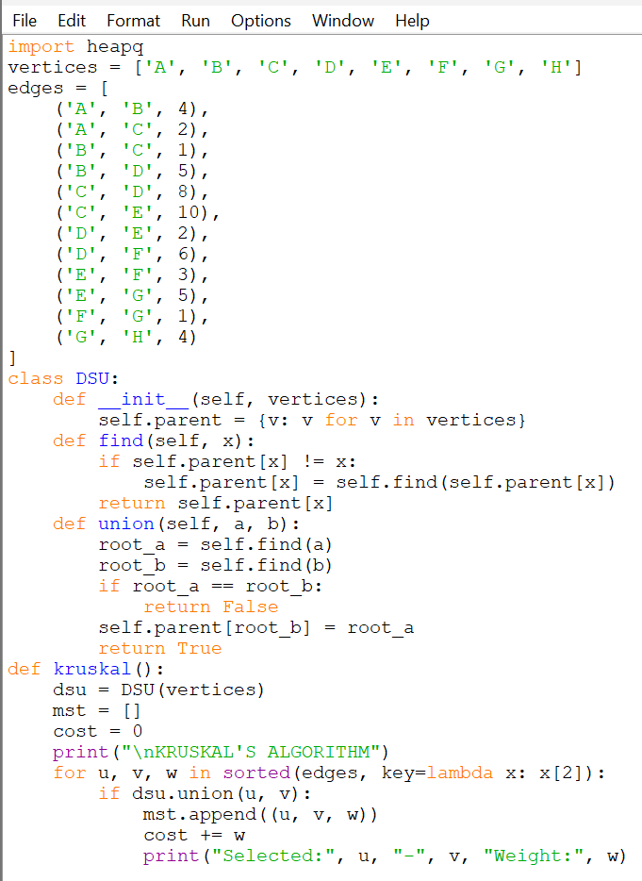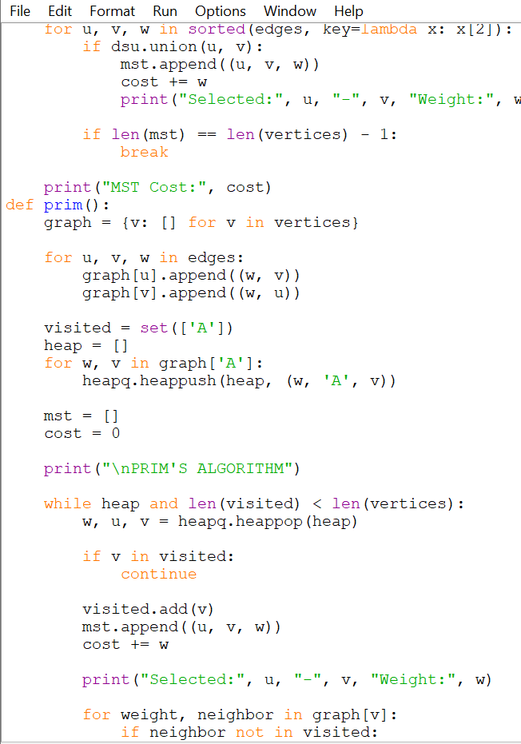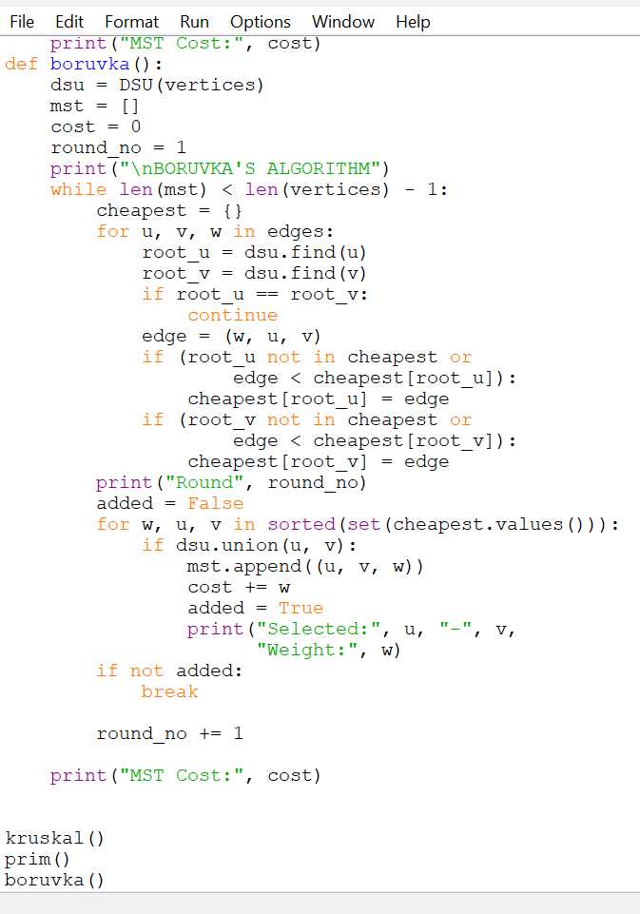
5.5 Expected Output
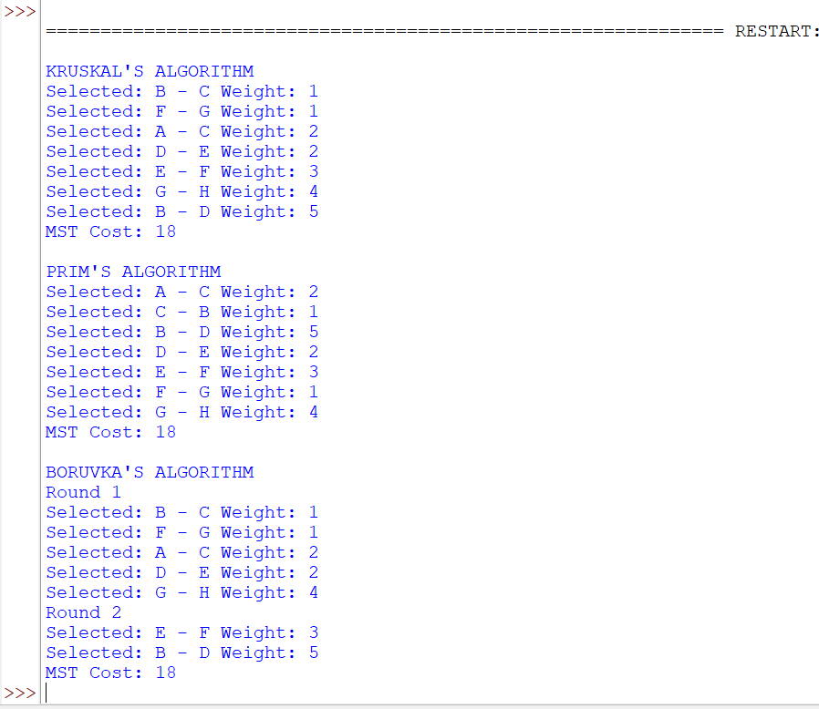
5.6 Step-by-Step Comparison
1. Kruskal’s Algorithm
- First, sort all edges in increasing order of weight.
- Select B–C (1) and F–G (1).
- Select A–C (2) and D–E (2).
- Select E–F (3).
- Reject A–B (4) because it forms a cycle.
- Select G–H (4).
- Select B–D (5) to connect the remaining components.
The algorithm stops after selecting seven edges.
2. Prim’s Algorithm
Starting from vertex A:
Step | Selected Edge | Weight
1 | A – C | 2
2 | C – B | 1
3 | B – D | 5
4 | D – E | 2
5 | E – F | 3
6 | F – G | 1
7 | G – H | 4
Prim’s algorithm grows one connected tree by adding the minimum available edge at each step.
3. Borůvka’s Algorithm
- Round 1: Each component selects its cheapest outgoing edge. The selected edges are F–G, B–C, A–C, D–E and G–H.
- Round 2: The remaining components are connected using E–F and B–D.
- The algorithm stops when all vertices become part of one component.
5.7 Final MST and Total Cost
The final MST contains the following edges:
Edge | Weight
B – C | 1
F – G | 1
A – C | 2
D – E | 2
E – F | 3
G – H | 4
B – D | 5
Total | 18
All three algorithms produce the same minimum total cost of 18.
5.8 Change in Edge Weights and Multiple MSTs
To create multiple valid MSTs, change the weight of edge C–D from 8 to 5.
Now there are two possible ways to connect the component containing A, B and C to the remaining vertices:
- First MST uses B–D with weight 5.
- Second MST uses C–D with weight 5.
Both MSTs have the same total cost of 18.
This shows that a graph can have more than one Minimum Spanning Tree when different edge combinations have equal weights.
5.9 Comparison of Algorithms
Feature | Kruskal | Prim | Borůvka
Approach | Edge-based | Vertex-based | Component-based
Main technique | Sorting and DSU | Priority queue | Cheapest outgoing edges
Cycle detection | DSU | Visited set | DSU
Growth | Adds selected edges | Grows one tree | Merges components
Best use | Sparse graphs | Dense or sparse graphs | Parallel and distributed systems
Time Complexity:
- Kruskal: \(O(E\log E)\)
- Prim with a priority queue: \(O(E\log V)\)
- Borůvka: \(O(E\log V)\)
Here, \(V\) represents the number of vertices and \(E\) represents the number of edges.
5.10 Engineering Application
- Sparse networks: Kruskal’s algorithm is suitable because it efficiently processes a smaller number of edges after sorting them.
- Dense networks: Prim’s algorithm can be efficient, especially when implemented using an adjacency matrix.
- Large distributed networks: Borůvka’s algorithm is useful because multiple components can independently identify their cheapest outgoing edges, making parallel processing possible.
5.11 Conclusion
Kruskal’s, Prim’s and Borůvka’s algorithms are used to find the Minimum Spanning Tree of a connected weighted graph. Although they follow different approaches, all three algorithms produced the same minimum cost of 18 for the given graph. The choice of algorithm depends on graph structure, memory requirements and processing environment.

ASK 6 – LAST-MILE DELIVERY ROUTE OPTIMISATION
Travelling Salesperson Problem Using Dynamic Programming
6.1 Aim
To implement the Travelling Salesperson Problem (TSP) using Dynamic Programming and find the minimum-cost delivery route. The vehicle must start from the distribution hub, visit every delivery location exactly once and return to the hub.
6.2 Problem Modelling
Input:
- One central distribution hub.
- Six delivery locations.
- A travel-cost matrix containing the cost between every pair of locations.
Output:
- Minimum total travel cost.
- Complete optimal delivery route.
- Order in which the locations are visited.
- Return to the distribution hub.
Objective:
To find a route with the minimum total travel cost while visiting every delivery location exactly once.
Constraints:
- The vehicle must start from the distribution hub.
- Every delivery location must be visited exactly once.
- The vehicle must return to the distribution hub.
- The travel costs between locations are known in advance.
Why is the current location alone insufficient?
Two routes may reach the same location but may have visited different sets of delivery locations. Therefore, the algorithm must remember both the current location and the set of locations already visited.
6.3 Dynamic Programming State Design
Define the DP state as:
DP[S][j]
Where:
- S represents the set of delivery locations already visited.
- j represents the current delivery location.
- DP[S][j] stores the minimum travel cost from the hub to location j after visiting all locations in set S.
Base Condition:
DP[][j] = Cost[Hub][j]
This represents travelling directly from the hub to the first delivery location.
Recurrence Relation:
DP[S][j] = min
Here, i belongs to S and i is not equal to j.
This finds the minimum cost of reaching location j from a previously visited location i.
Final Solution:
Minimum Cost = min
The return journey from the last delivery location to the hub is included in the final calculation.
6.4 Implementation of the Route Optimisation Engine
Python Program:
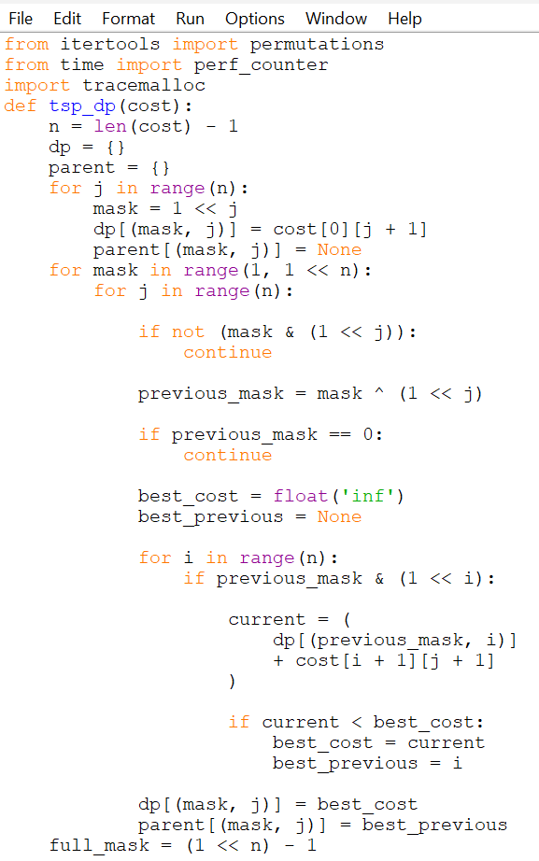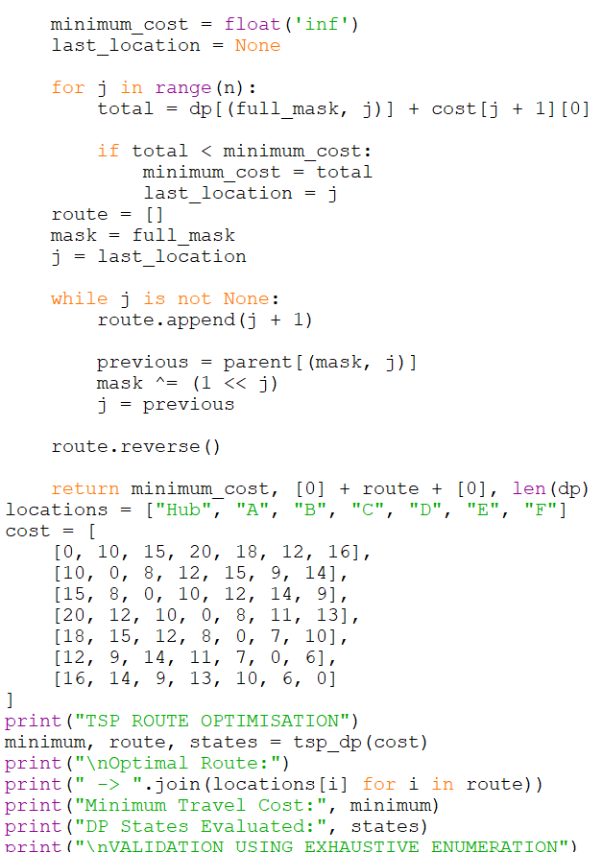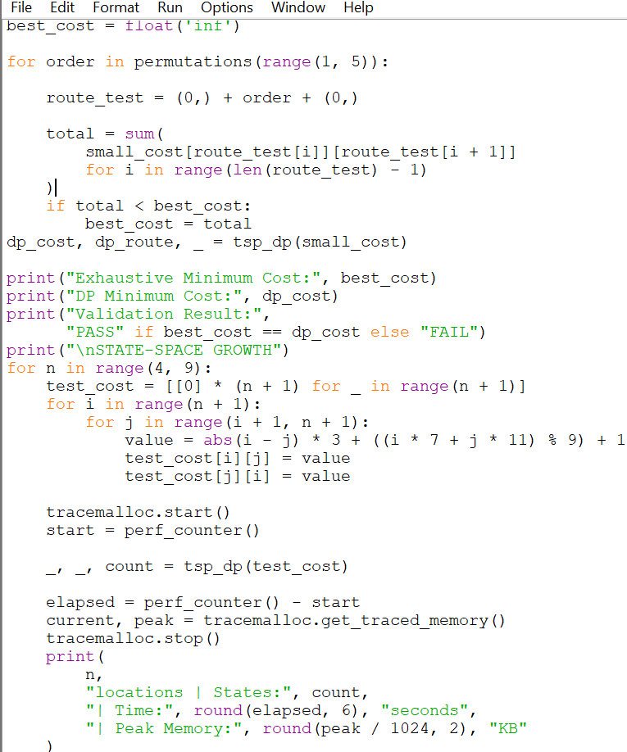
6.5 Input Cost Matrix
The following matrix represents the travel costs between the hub and six delivery locations.
Location | Hub | A | B | C | D | E | F
Hub | 0 | 10 | 15 | 20 | 18 | 12 | 16
A | 10 | 0 | 8 | 12 | 15 | 9 | 14
B | 15 | 8 | 0 | 10 | 12 | 14 | 9
C | 20 | 12 | 10 | 0 | 8 | 11 | 13
D | 18 | 15 | 12 | 8 | 0 | 7 | 10
E | 12 | 9 | 14 | 11 | 7 | 0 | 6
F | 16 | 14 | 9 | 13 | 10 | 6 | 0
6.6 Expected Output
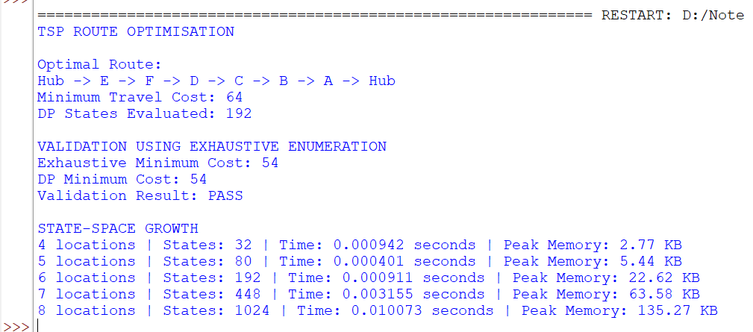
Calculation of the optimal route:
Route | Travel Cost
Hub → A | 10
A → B | 8
B → C | 10
C → D | 8
D → F | 10
F → E | 6
E → Hub | 12
Total | 64
Therefore, the minimum travel cost is 64 units.
6.7 Validation Using Exhaustive Enumeration
For validation, a smaller problem containing the hub and four delivery locations (A, B, C and D) is considered.
The number of possible delivery orders is:
4! = 24
The program checks all 24 possible routes independently and compares the best result with the Dynamic Programming result.
Best Route:
Hub → A → B → C → D → Hub
Calculation:
10 + 8 + 10 + 8 + 18 = 54
Validation Method | Minimum Cost
Exhaustive Enumeration | 54
Dynamic Programming | 54
Validation Result: PASS
Both approaches produce the same minimum cost of 54.
This validation increases confidence in the implementation because the DP result is independently checked against every possible route for the smaller problem.
6.8 Investigation of State-Space Growth
The number of DP states for n delivery locations is:
States = n × 2^(n-1)
The theoretical state counts are:
Delivery Locations | DP States
4 | 32
5 | 80
6 | 192
7 | 448
8 | 1024
The program also measures execution time and peak memory usage for each input size. These measurements depend on the computer and Python environment, so the actual values should be taken from the program output.
Why does Dynamic Programming still become expensive?
Dynamic Programming avoids calculating the same subproblem repeatedly by storing previously calculated results. However, it must still consider a large number of subsets of delivery locations.
As the number of locations increases, the number of states grows exponentially. Therefore, Dynamic Programming is more efficient than checking every route individually, but it still requires considerable time and memory for large problems.
6.9 Business Requirement Change – 200 Delivery Locations
The company now operates 200 delivery locations and wants a route within a few seconds. It accepts an excellent route even if mathematical optimality is not guaranteed.
The exact Dynamic Programming solution becomes impractical because its state space grows exponentially.
Changed Requirement:
Previously, the company required an exactly optimal route. Now, it accepts a near-optimal route within a short execution time.
Alternative Strategy:
I would investigate heuristic and approximation algorithms such as:
- Nearest Neighbour – selects the nearest unvisited delivery location.
- 2-opt Improvement – improves an existing route by changing the order of selected locations.
- Genetic Algorithm – searches for good routes using population-based optimisation.
Trade-off:
These methods can produce good routes much faster for large problems, but they may not guarantee the mathematically minimum travel cost. The company accepts this loss of guaranteed optimality in exchange for faster route generation.
6.10 Technical Reflection
Dynamic Programming is more efficient than exhaustive enumeration because it stores and reuses the results of overlapping subproblems. In my TSP implementation, the number of states for six delivery locations is 192, which avoids checking all 720 possible delivery orders separately. However, Dynamic Programming is not scalable for every optimisation problem because the number of possible subsets can grow exponentially. For example, the number of DP states increases from 32 for four locations to 1024 for eight locations. As the input size increases, memory usage and execution time also increase. Therefore, Dynamic Programming reduces repeated computation but does not always make a problem computationally inexpensive. For very large problems, heuristic or approximation algorithms may be more practical when a near-optimal solution is acceptable.
6.11 Conclusion
The Travelling Salesperson Problem was implemented using Dynamic Programming. The program calculated the minimum travel cost, reconstructed the complete delivery route and validated the result using exhaustive enumeration for a smaller input. The experiment also demonstrated that the number of DP states increases exponentially with the number of delivery locations. For large delivery networks, heuristic and approximation algorithms can provide faster solutions when exact optimality is not required.

