SIMATS ENGINEERING
ASSESSMENT TOOL 1: Simulation Task

COURSE NAME: Embedded Systems
COURSE CODE: ECA14

COURSE OUTCOME COVERED

CO2: Apply Embedded C programming concepts, including structured design, real-time constraint handling, and SystemC-based modeling, to develop and analyze embedded applications for industrial use cases. (BL5)

Assessment Tool Weightage: 30%
Assessment Tool : Simulation Task
Duration : Self Learning
Marks : 30
Type of Assessment conduction : Self Learning
Topics Covered : Embedded C programming: Features of
embedded programming languages, Difference between C and Embedded C, Key Characteristics of Embedded C, Standard Embedded C Data Types, Block Diagram Explanation of Embedded C, Basic Embedded C Programming Steps, Vibration Monitoring Node design, Industrial HVAC Control Firmware design

Description
- Assessment will be carried out through rubric-based evaluation, where students complete the assigned task independently.
- Simulation will be done in SystemC, for the given specification and interpret the results.
- Each question will be assigned to one student, and he/she is required to collaboratively discuss the given problem and present his/her responses with clear justification.
- It will be upload in Github

Evaluation Type : Embedded C/SystemC Simulation Assessment
Result Generation : Rubric-based evaluation

Q16 – Smart Energy Meter with Data Transmission
1. Title
Design and Simulation of a Smart Energy Meter with Data Transmission Using Arduino and Proteus
2. Aim
To design and simulate a smart energy meter using Arduino that measures voltage and current, calculates electrical power and energy consumption, displays the measured values on an LCD, and transmits the energy data through UART serial communication using Proteus simulation.
3. Problem Statement
Conventional energy meters mainly provide information about energy consumption without offering an easy way to monitor and transmit the measured data. The proposed smart energy meter overcomes this limitation by using an Arduino UNO to collect voltage and current measurements, process the sensor data, calculate power and energy consumption, display the results on a 16×2 LCD, and transmit the information through serial communication. The complete system is simulated in Proteus, allowing the operation of the smart energy meter to be tested without requiring physical hardware.
4. Objectives
The main objectives of the project are:
- To simulate a smart energy meter using Arduino UNO.
- To obtain voltage and current input values from simulated sensors.
- To calculate electrical power from the measured voltage and current.
- To calculate energy consumption over a specified period.
- To display voltage, current, power, and energy values on a 16×2 LCD.
- To transmit the measured data using UART serial communication.
- To display the transmitted data using the Virtual Terminal in Proteus.
- To identify abnormal conditions such as excessive current.
- To test and analyze the system under different input conditions.
- To demonstrate the practical use of Embedded C programming in an energy-monitoring application.
5. Hardware/Software Requirements
Hardware Components
The following components are required for the Proteus simulation:
Component | Purpose
Arduino UNO | Main microcontroller
Voltage input/sensor | Provides voltage measurement
Current input/sensor | Provides current measurement
16×2 LCD | Displays measured values
Virtual Terminal | Displays transmitted serial data
Resistors | Circuit protection/current limiting
Potentiometer | LCD contrast adjustment
Power supply | Provides required circuit power
Ground | Common circuit reference
Software Requirements
- Arduino IDE – for writing and compiling the Embedded C/Arduino program.
- Proteus 8 – for designing and simulating the circuit.
- Arduino HEX file – generated from the Arduino IDE and loaded into the Arduino UNO component in Proteus.
6. Working Principle
The smart energy meter operates in the following sequence:
- The voltage and current sensors provide the electrical measurements to the Arduino UNO.
- The Arduino reads the sensor values through its input pins.
- The program processes the measured values.
- Electrical power is calculated using:
Power = Voltage × Current
- Energy consumption is calculated using the power and measurement time.
- The calculated values are displayed on the 16×2 LCD.
- The Arduino sends the readings through its TX serial pin.
- The Proteus Virtual Terminal receives the serial data.
- The transmitted values are displayed on the Virtual Terminal.
7. Algorithm / Flowchart
Algorithm
- Start.
- Initialize Arduino pins.
- Initialize LCD.
- Initialize serial communication.
- Read voltage.
- Read current.
- Calculate power.
- Calculate energy consumption.
- Check whether current exceeds the overload limit.
- Display the values on the LCD.
- Transmit the values through UART.
- Display transmitted data on the Virtual Terminal.
- Wait for the next measurement interval.
- Repeat steps 5–13.
- Stop.
8. Embedded C Program
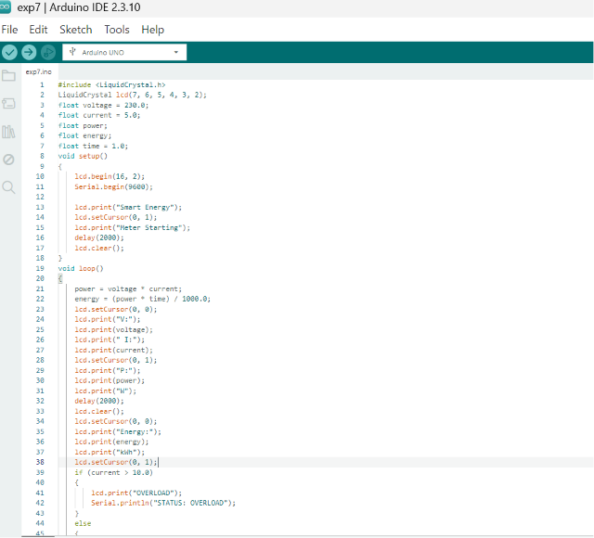
9. Data Transmission Method
The system uses UART serial communication for data transmission.
The Arduino UNO uses:
- TX (Pin 1) → Virtual Terminal RX
- RX (Pin 0) → Virtual Terminal TX, if two-way communication is required
- GND → Common ground
10.Sample Outputs
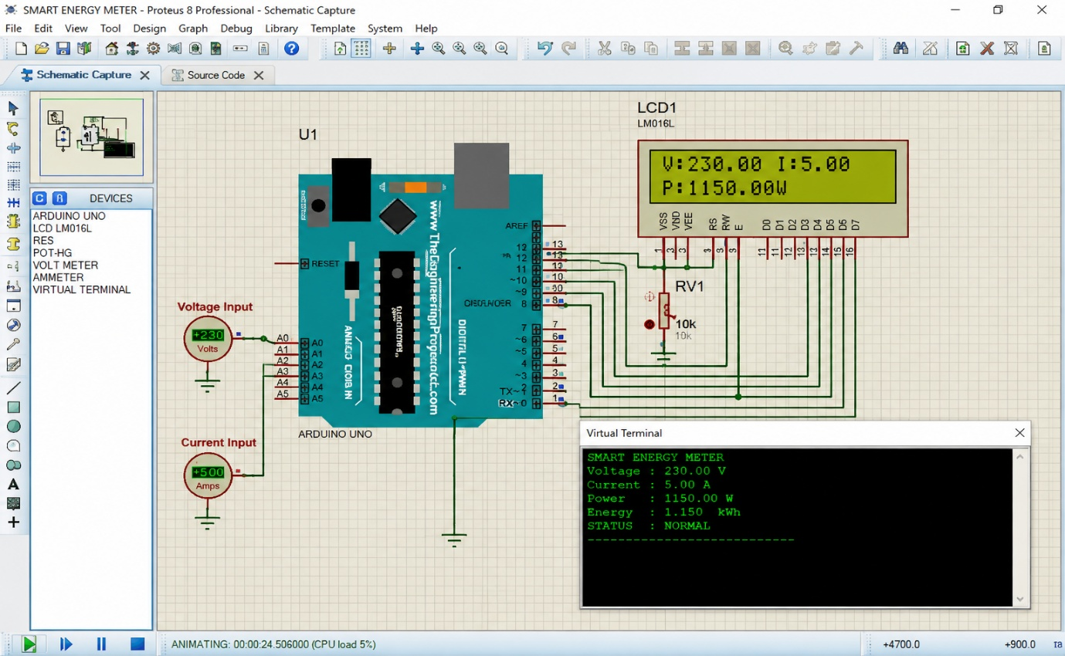

11. Result Analysis
The simulation is evaluated by changing the voltage and current inputs and observing the calculated results. When the voltage is 230 V and current is 5 A, the calculated power is 1150 W. For a one-hour period, the energy consumption is 1.15 kWh. When the current is increased to 12 A, the calculated power increases to 2760 W. Since the current exceeds the defined safe limit, the system identifies the condition as OVERLOAD. The LCD provides local monitoring, while UART communication allows the same information to be transmitted to an external monitoring system.
Thus, the simulation demonstrates the complete process of:
Measurement → Processing → Display → Analysis → Data Transmission

12. Advantages
- Provides real-time energy monitoring.
- Automatically calculates power and energy.
- Provides overload detection.
- Displays measurements locally using an LCD.
- Supports serial data transmission.
- Easy to simulate using Proteus.
- Modular Embedded C design simplifies debugging.
- Can be extended to wireless communication.
- Reduces the need for manual energy monitoring.
13. Conclusion
The Smart Energy Meter with Data Transmission was successfully designed as an Arduino-based Embedded C simulation using Proteus.
The system reads voltage and current inputs, calculates power and energy consumption, checks the operating status, displays the measurements on an LCD, and transmits the data through UART to a Virtual Terminal.
The simulation demonstrates the application of Embedded C programming, sensor interfacing, data processing, LCD interfacing, serial communication, and real-time monitoring in an energy-management application.
The modular design also makes the system suitable for further development into a practical smart energy-monitoring system.
14. Future Enhancement
The proposed system can be enhanced by:
- Adding Wi-Fi or GSM for remote data transmission.
- Connecting the system to an IoT cloud platform.
- Adding an electricity tariff calculation module.
- Storing historical energy consumption data.
- Providing a mobile/web dashboard.
- Adding real-time alerts for abnormal energy consumption.
- Using calibrated voltage and current sensors for improved accuracy.
- Adding automatic load control during overload conditions.

Evaluation Rubric (30 Marks per Question)

Criteria | Weightage | Level 4 (Exemplary) | Level 3 (Proficient) | Level 2 (Developing) | Level 1 (Beginning)
Requirements Analysis & Conceptual Understanding | 20% | Clearly identifies all system requirements and demonstrates comprehensive understanding of the embedded application | Identifies most requirements with minor omissions | Partial understanding of requirements and concepts | Poor understanding of requirements and concepts
System Design & Simulation Model Development | 25% | Develops a complete, modular, and technically accurate simulation/model independently | Develops a functional model with minor design issues | Develops a partially complete model requiring guidance | Unable to develop a proper simulation model
Implementation & Tool Usage | 20% | Correctly implements the simulation using Embedded C/SystemC tools with proper execution and debugging | Implementation is mostly correct with minor errors | Limited implementation with several errors | Unable to implement or execute the simulation
Testing, Validation & Result Analysis | 20% | Thoroughly tests the system, validates outputs, and provides accurate interpretation of results | Adequate testing and analysis with minor gaps | Limited testing and superficial analysis | Little or no testing and analysis performed
Documentation | 15% | Presents results clearly with proper documentation and structured reporting | Documentation is adequate with minor issues | Poorly organized or incomplete documentation | No proper documentation or presentation

Performance Levels
Level | Description
Level 4 – Exemplary | Complete and technically accurate simulation with correct design, implementation, testing, and analysis.
Level 3 – Proficient | Functional simulation with minor technical errors and good analysis.
Level 2 – Developing | Partially functional simulation with noticeable design, implementation, or testing gaps.
Level 1 – Beginning | Incomplete simulation with limited understanding and execution.

Code of Conduct:

I __M.NANDHINI(192472318)_______ (Name / Reg No) certify that this submission is my original work and that I have adhered to the guidelines specified for this assessment.
I understand that any violation of academic integrity rules will result in disciplinary action.
Signature of the student: M.NANDHINI

