Questions:
1.Write five advantages of Java and compare Java with C/C++.
2.Install Java successfully and submit a screenshot along with the output of the Hello World program.
3. Write programs demonstrating variable scope and lifetime.
4.Write programs for array sum, average, reverse, and second-largest element.

Answers:
1. Write Five Advantages of Java
- Platform Independent
  - Java follows the principle "Write Once, Run Anywhere (WORA)" because Java programs run on the Java Virtual Machine (JVM).
- Object-Oriented
  - Java is based on Object-Oriented Programming (OOP) concepts such as encapsulation, inheritance, polymorphism, and abstraction.
- Secure
  - Java provides built-in security features like bytecode verification, exception handling, and no direct pointer access.
- Robust
  - Java has automatic garbage collection, strong memory management, and exception handling, making programs more reliable.
- Multithreading Support
  - Java allows multiple threads to execute simultaneously, improving application performance.
2. Comparison of Java with C/C++
Feature | Java | C/C++
Platform | Platform Independent | Platform Dependent
Programming Style | Object-Oriented | C is Procedural, C++ is OOP
Memory Management | Automatic Garbage Collection | Manual (malloc/free, new/delete)
Pointers | Not Supported | Supported
Security | More Secure | Less Secure
Compilation | Compiles to Bytecode (JVM) | Compiles to Machine Code
Multiple Inheritance | Through Interfaces | Supported in C++
Portability | High | Low
3.Hello World Program
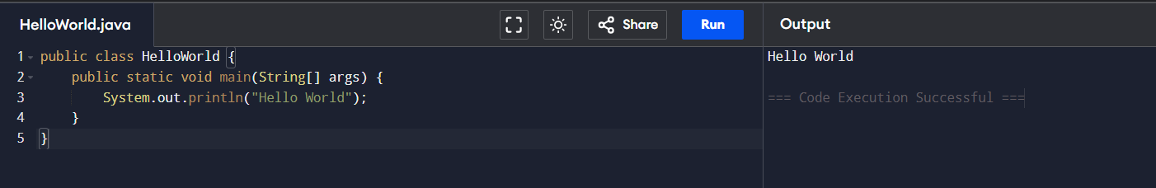
4. Program Demonstrating Variable Scope and Lifetime
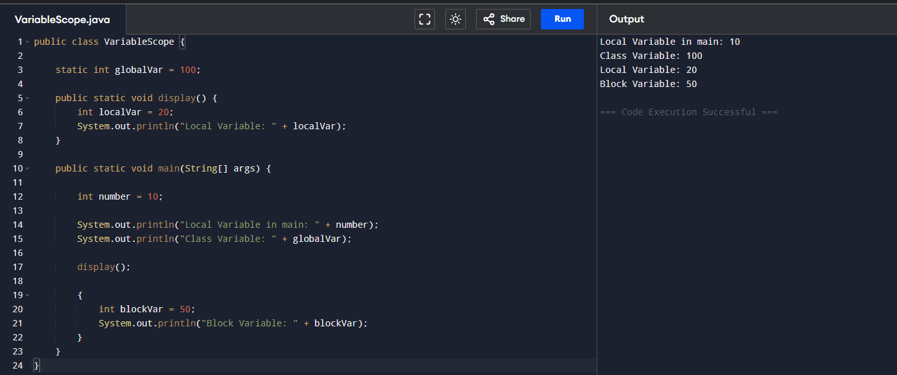
5.Program to Find Sum and Average of an Array
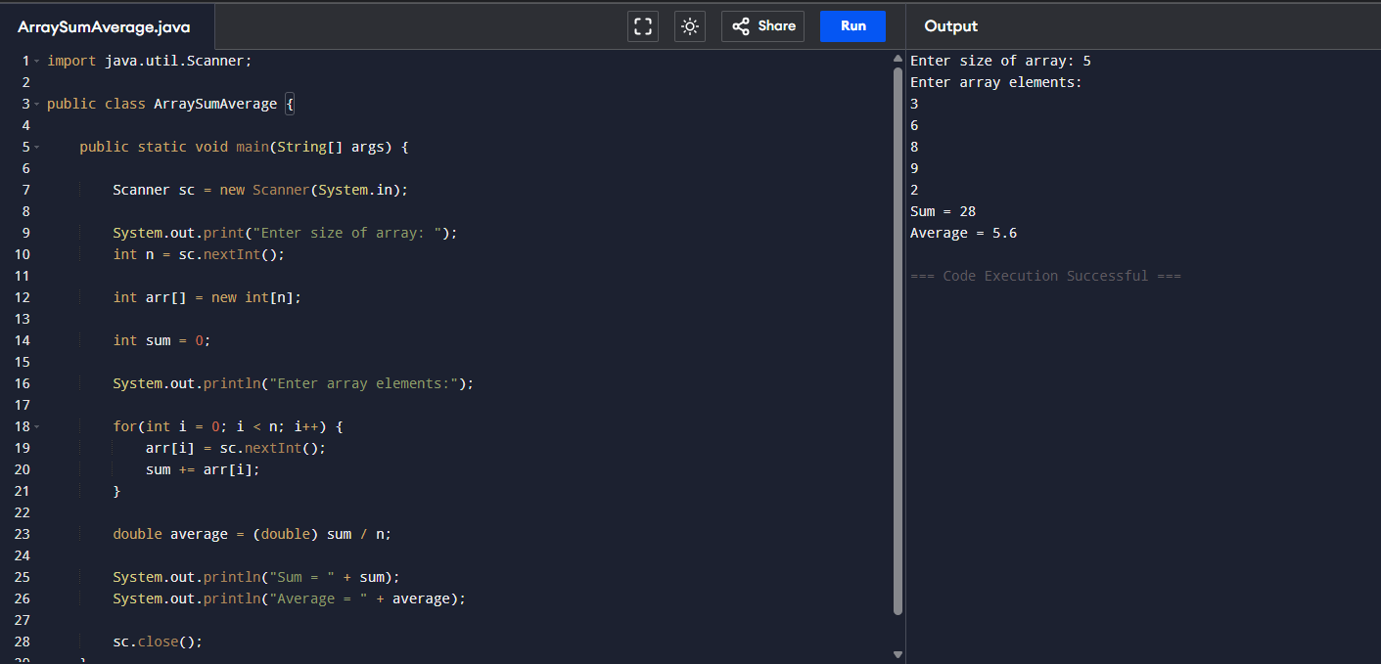
6.Program to Reverse an Array
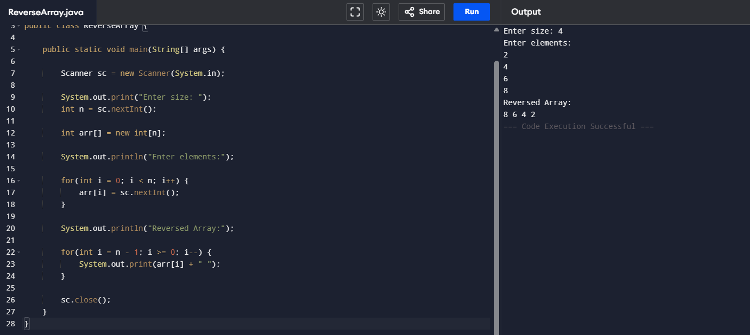
7.Program to Find the Second Largest Element in an Array
