Class activity-CO5
Name: C Sahasra
Reg.no:192472078
- Read and Write data using File Input and File Output Stream (single data and bulk data)
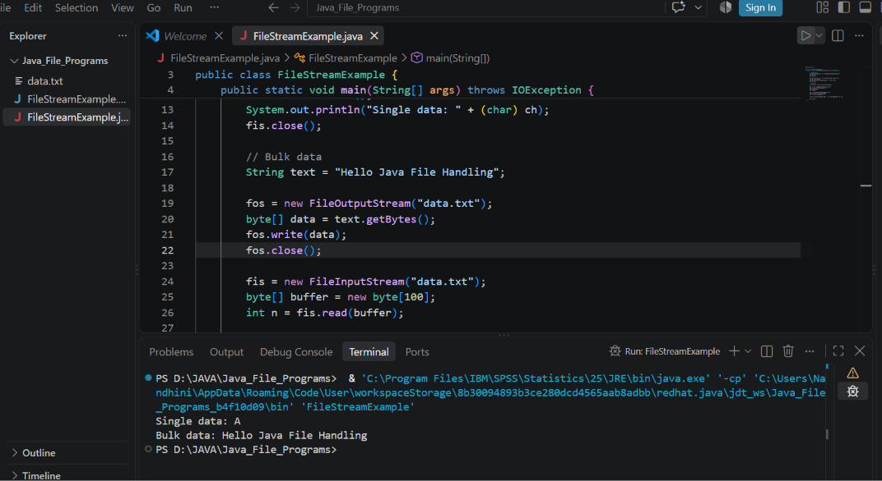
2. Read and Write data using File Reader and File Writer (single data and bulk data)
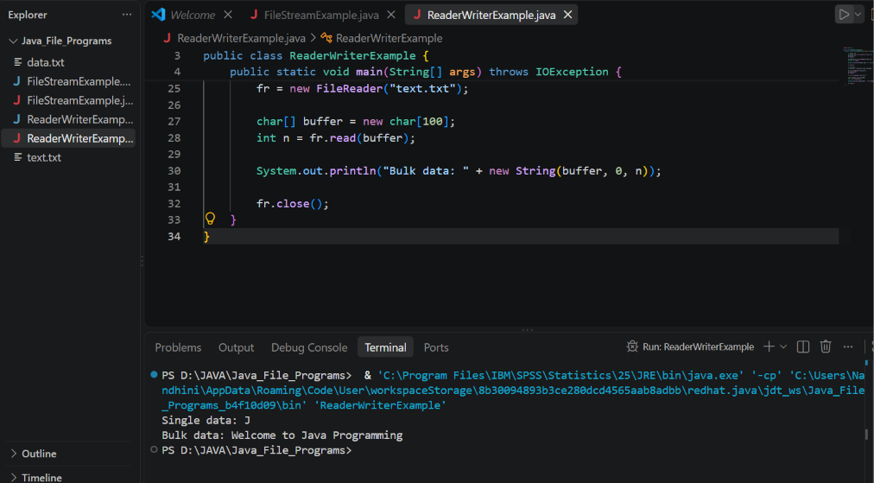

3. Read no of line and no of chars in a file
4. two files should be opened in read mode and one file should be write mode, Hint: SequenceFileStream.
