

SIMATS ENGINEERING

Saveetha Institute of Medical and Technical Sciences
Chennai- 602105

Student Name: M.Nandhini Reg. No.: 192472318
Course Code: ECA1418 Slot: B
Course Name: Embedded Systems
Course Faculty: Dr. H. Shree Kumar
Project Title:
Adaptive Path Planning for Autonomous Warehouse Robots Using Deep Reinforcement Learning

Module Photographs:
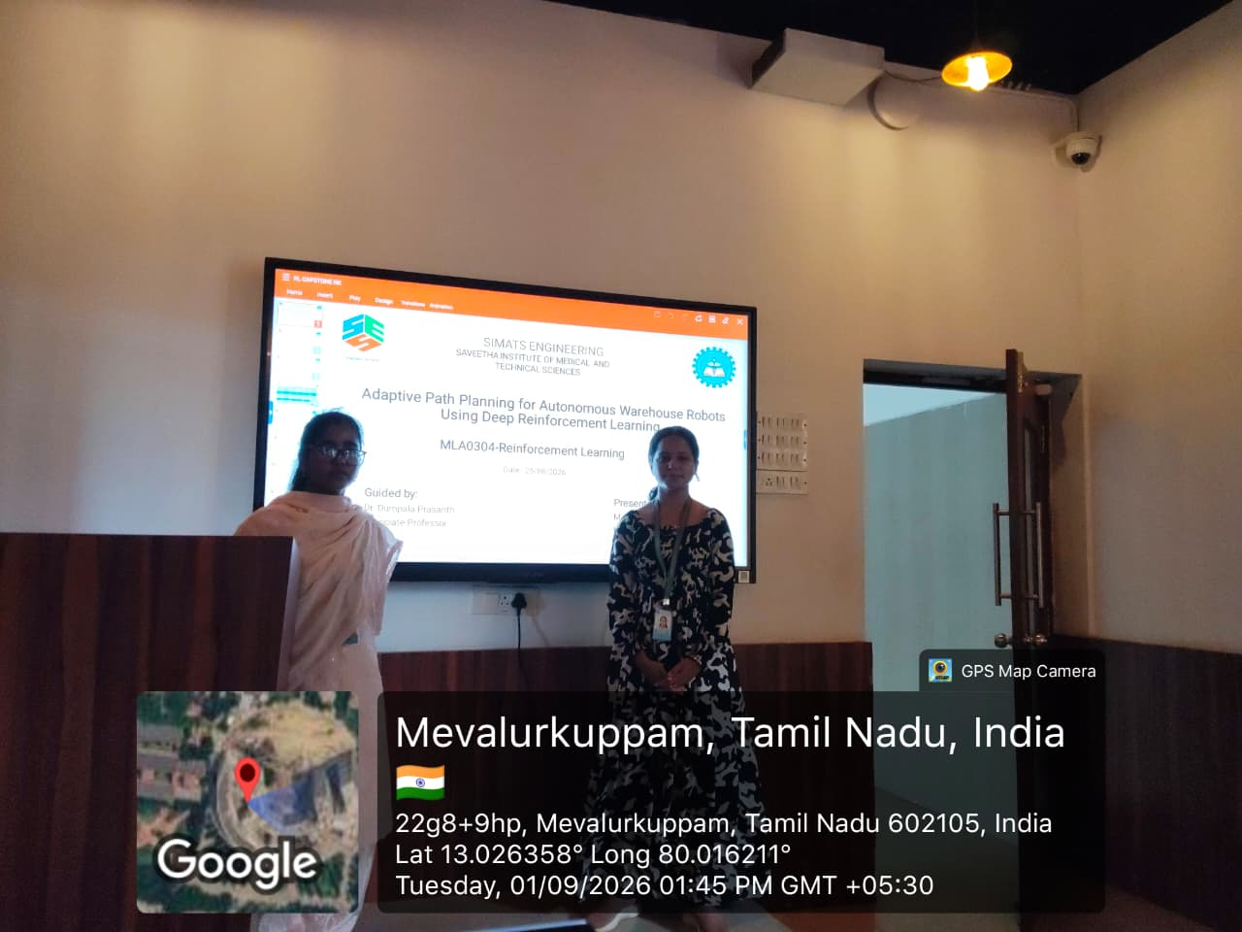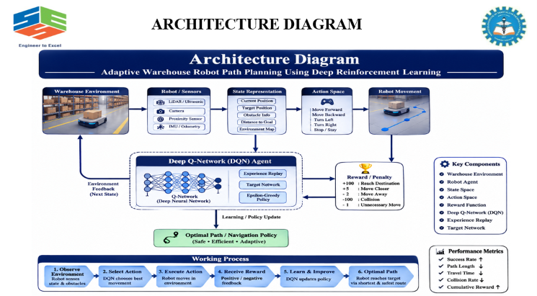
Project Description:
The IoT-Enabled Smart Medicine Reminder System with Real-Time Patient Monitoring is developed to help patients take their medicines on time and enable caregivers to monitor their medication and health status remotely. The system is particularly useful for elderly people and patients who require regular medication. It addresses problems such as missed medicines, lack of medicine intake tracking, and limited remote caregiver support. The proposed system uses an ESP32 microcontroller and an RTC module to maintain accurate time and manage medication schedules. When it is time to take medicine, the system provides alerts using a buzzer, displays reminder messages, and sends notifications through the Blynk cloud platform. The system can also track whether the patient has taken the medicine and store the medication status for remote monitoring. In addition, the system monitors important health parameters such as heart rate, SpO₂, and body temperature. If abnormal health readings or missed medication are detected, an emergency alert is generated and a notification is sent to the caregiver.

Student Signature Guide Signature

