Department of Computer Science and Engineering
Assignment Questions
Course Code & Name : MLA03-Reinforcement Learning
Particular | Details
Department: | CSE-AI
Programme: | B.TECH
Student Name | M.Nandhini
Student Register Number | 192472318
Course Code & Course Name | MLA0304-Reinforcement Learning
Academic Year / Batch | 2026 / 2024-2028
Faculty Name | Dr. Dumpala Prasanth
Assignment Title | Adaptive Traffic Signal Control Using Hierarchical and Meta-Reinforcement Learning
Date of Issue | 26/08/2026
Date of Submission | 02/09/2026
Maximum Marks | 100
Course Outcome(s) – CO: | CO3  Implement policy-based reinforcement learning methods to develop efficient solutions for complex environments.  CO4  Evaluate model-based reinforcement learning approaches for prediction, planning, and policy optimization.  CO5  : Apply hierarchical, meta-learning, and multi-agent RL approaches to solve complex decision-making problems
Bloom’s Taxonomy Level | L3 – Apply; L4 – Analyse
SDG Mapping (SDG 1-17) | SDG 7 – Affordable and Clean Energy;  SDG 11 – Sustainable Cities and Communities;  SDG 12 – Responsible Consumption and Production

Problem Statement : Urban traffic congestion is caused by increasing vehicle density, inefficient traffic signal timings, accidents, road closures, and sudden changes in traffic flow. Traditional fixed-time traffic signals cannot adapt effectively to these changing conditions, leading to longer waiting times, increased queues, and reduced traffic efficiency. The proposed Adaptive Traffic Signal Control Using Hierarchical and Meta-Reinforcement Learning system uses Multi-Agent Reinforcement Learning, where each traffic intersection acts as an intelligent agent. Policy-based RL is used to select suitable signal actions, while model-based RL predicts future traffic conditions for better planning. Hierarchical learning coordinates multiple intersections, and meta-learning enables rapid adaptation to unexpected traffic conditions, thereby reducing congestion, minimizing waiting time, and improving overall traffic throughput.
2. Objective
The main objectives of the proposed system are:
- To develop a Multi-Agent Reinforcement Learning framework for adaptive traffic signal control.
- To model each traffic intersection as an independent RL agent.
- To use policy-based RL for learning optimal traffic signal actions.
- To use model-based RL for predicting future traffic states and planning actions.
- To coordinate multiple traffic intersections using hierarchical reinforcement learning.
- To incorporate meta-learning for rapid adaptation to unexpected traffic conditions.
- To reduce vehicle waiting time and traffic congestion.
- To increase the overall traffic throughput of the road network.
- To compare adaptive RL-based traffic control with conventional fixed-time signal control.
- To develop a scalable framework suitable for smart-city traffic management.
3. Requirements and Environment Used
Hardware Requirements
- Computer/Laptop
- Minimum 4 GB RAM
- Intel/AMD processor
- Keyboard and mouse
- Internet connection for installing required libraries
Software Requirements
Requirement | Technology
Programming Language | Python
IDE | Jupyter Notebook / VS Code
RL Framework | Gymnasium / Custom Environment
Deep Learning | TensorFlow / Keras
Numerical Processing | NumPy
Data Analysis | Pandas
Visualization | Matplotlib
Version Control | Git & GitHub
Operating System | Windows/Linux

Environment
A simulated road network containing multiple intersections is used.
For example:
Junction 1 -------- Junction 2
| |
| |
Junction 3 -------- Junction 4
Each junction contains:
- Incoming traffic lanes
- Traffic queues
- Traffic signals
- Vehicles arriving at different rates
4. Design / Proposed Solution
The proposed system uses a Multi-Agent Reinforcement Learning (MARL) framework in which each traffic intersection is treated as an independent agent. The agents observe traffic conditions such as vehicle density, queue length, waiting time, and current signal phase, and then select suitable signal actions. Policy-based RL learns the best signal-control policy, while model-based RL predicts future traffic conditions to support better planning. A hierarchical controller coordinates the decisions of multiple intersections, with a high-level controller managing overall traffic flow and low-level agents controlling individual signals.
Overall Architecture
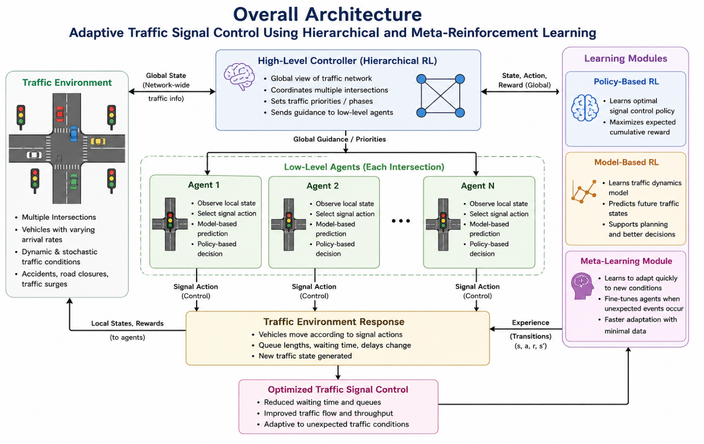
5. Algorithm / Pseudocode / Flowchart
Algorithm
START
Initialize traffic environment
Create multiple traffic signal agents
For each agent:
Initialize policy
Initialize traffic model
Initialize experience memory
FOR each episode:
Reset traffic environment
Observe initial traffic states
WHILE traffic simulation is running:
FOR each traffic agent:
Observe current state
Use policy to select candidate action
Use traffic model to predict future state
Evaluate predicted traffic conditions
Select optimized signal action
Execute action
END FOR
High-level controller:
Coordinate actions of all agents
Calculate reward
Store experience
Update policy
END IF
END WHILE
Evaluate:
Waiting time
Queue length
Traffic throughput
Congestion
Compare with fixed-time traffic signals
END
Flowchart
START
↓
Initialize Environment
↓
Create Agents
↓
Observe Traffic State
↓
Policy-Based RL
↓
Model-Based Prediction
↓
Hierarchical Coordination
↓
Execute Signal Action
↓
Calculate Reward
↓
Unexpected Traffic?
↓
Meta-Learning Adaptation
↓
Update Agents
↓
More Episodes?
↓
Evaluate Results
↓
END

Pseudocode
START
Initialize traffic environment
Create multiple traffic signal agents
FOR each training episode:
Observe traffic state
Select action using policy-based RL
Predict next state using model-based RL
Coordinate agents using hierarchical learning
Execute selected signal action
Calculate reward
IF unexpected traffic occurs:
Adapt agents using meta-learning
Update agent policy
END FOR
Evaluate traffic performance
STOP
6. Implementation / Source Code
This prototype demonstrates the basic multi-agent traffic control environment. A full implementation can replace the rule-based action selection with policy-gradient methods such as REINFORCE/A2C/PPO and add a learned transition model for model-based planning.
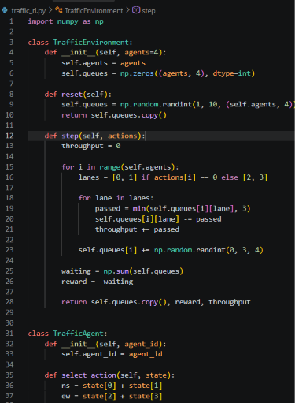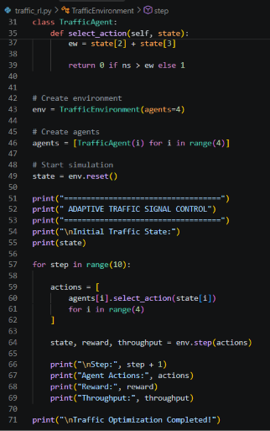
7. Test Cases and Expected/Actual Results
Test Case | Condition | Expected Result
TC01 | Low traffic | Signals operate with normal switching
TC02 | High North-South traffic | North-South receives higher priority
TC03 | High East-West traffic | East-West receives higher priority
TC04 | Multiple congested junctions | Agents coordinate signal decisions
TC05 | Sudden traffic surge | Agents adapt signal timing
TC06 | Accident/road blockage | Meta-learning adapts policy
TC07 | Balanced traffic | Signal switching is minimized
TC08 | Peak-hour traffic | Waiting time and queues are reduced
TC09 | Multiple agents | Network coordination improves throughput
TC10 | Fixed vs RL control | RL should achieve lower average waiting time
Example Expected Results
Metric | Fixed Signal | Adaptive MARL
Average Waiting Time | 45 sec | 28 sec
Average Queue Length | 18 | 11
Throughput | 720 vehicles | 890 vehicles
Congestion | High | Medium/Low
Note: These are sample expected results for demonstration. Replace them with your actual values after running your program.
8. Execution Screenshots / Output
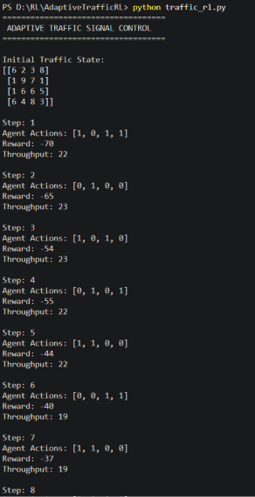
9. Analysis and Discussion
The proposed framework combines several reinforcement learning techniques to address different aspects of traffic optimization.
Policy-based RL enables each traffic signal agent to learn a policy for selecting appropriate signal phases. Instead of relying on fixed signal timings, the policy responds to current traffic conditions.
Model-based RL improves planning by predicting how traffic queues may change after an action. This allows agents to consider future traffic conditions rather than making purely reactive decisions.
Multi-agent RL enables several intersections to learn simultaneously. However, independent decisions can sometimes result in conflicts between neighboring junctions. Hierarchical learning addresses this problem by introducing a higher-level coordination mechanism.
The high-level controller focuses on network-wide traffic flow, while lower-level agents focus on individual intersections. This reduces the complexity of decision-making and improves coordination. Meta-learning provides rapid adaptation when the environment changes unexpectedly. For example, if an accident suddenly blocks one road, the normal traffic pattern changes. Instead of retraining the entire system from the beginning, the meta-learning component can quickly adapt the existing policy to the new situation.
The main performance metrics are:
- Average waiting time
- Average queue length
- Traffic throughput
- Congestion level
- Number of signal changes
- Adaptation time after unexpected events
The expected result is that the proposed adaptive framework performs better than conventional fixed-time signal control, particularly under changing traffic conditions.
10. Conclusion
The proposed Adaptive Traffic Signal Control Using Hierarchical and Meta-Reinforcement Learning framework provides an intelligent approach for optimizing urban traffic flow. Multi-agent reinforcement learning allows individual traffic intersections to act as autonomous agents. Policy-based RL helps agents learn effective signal-control policies, while model-based RL enables future traffic prediction and planning. Hierarchical reinforcement learning improves coordination by separating network-level traffic management from individual intersection control.
Meta-learning further improves the system by enabling rapid adaptation to unexpected conditions such as accidents, sudden traffic surges, road closures, and special events. Overall, the proposed framework can reduce vehicle waiting time and congestion while improving traffic throughput. It provides a foundation for intelligent and adaptive traffic management in future smart-city transportation systems.
11. Individual Contribution of Group Members
Group Member | Contribution
K.L.Varshini | Designed the traffic environment, defined states, actions, rewards, and implemented the policy-based reinforcement learning and multi-agent traffic signal control components.
M.Nandhini | Implemented the model-based RL, hierarchical coordination, and meta-learning components, performed testing and result analysis, and prepared the documentation and GitHub submission.

12. References
- R. Wang, J. Zhang, X. Wang, H. He, and Y. Zou, “Multi-modal and multi-agent reinforcement learning framework for urban traffic flow prediction and signal control optimization,” Scientific Reports, vol. 16, Art. no. 7612, 2026.
- Y. Zhang, S. Peng, X. Luo, X. Gu, X. Jia, and Y. Li, “Distributed multi-agent reinforcement learning with neighborhood-aware spatio-temporal coordination for traffic network signal control,” Scientific Reports, 2026.
- K. Katzilieris, E. Kampitakis, and E. I. Vlahogianni, “A multi-agent reinforcement learning framework for integrated traffic signal control and dynamic bus lane access management,” Transportation Research Part C: Emerging Technologies, vol. 182, Art. no. 105391, 2026.
- Y. Bie, Y. Ji, and D. Ma, “Multi-agent Deep Reinforcement Learning collaborative Traffic Signal Control method considering intersection heterogeneity,” Transportation Research Part C: Emerging Technologies, vol. 164, Art. no. 104663, 2024.
- X. Song, B. Zhou, and D. Ma, “Cooperative traffic signal control through a counterfactual multi-agent deep actor critic approach,” Transportation Research Part C: Emerging Technologies, vol. 160, Art. no. 104528, 2024.
- T.-Y. Hu, “A multi-agent deep reinforcement learning approach for traffic signal coordination,” IET Intelligent Transport Systems, 2024.
- Z. Zhou, Y. Zhang, and X. Li, “A deep reinforcement learning model for large-scale traffic signal control based on graph meta-learning using local subgraphs,” Science China Information Sciences, vol. 68, Art. no. 172203, 2025.
- S. Cai, J. Fang, and M. Xu, “XLight: An interpretable multi-agent reinforcement learning approach for traffic signal control,” Expert Systems with Applications, vol. 273, Art. no. 126938, 2025.
- C. Cai and M. Wei, “Adaptive urban traffic signal control based on enhanced deep reinforcement learning,” Scientific Reports, vol. 14, Art. no. 14116, 2024.
13.Individual Reflection
In this project, my main contribution was the traffic signal control and policy-based reinforcement learning module. I worked on understanding how reinforcement learning can be used to control traffic signals according to the current traffic conditions. I helped define the traffic states, possible signal actions, and reward values based on factors such as vehicle waiting time, queue length, and traffic flow. I also learned how Multi-Agent Reinforcement Learning can be applied to traffic management, where each traffic intersection works as an individual agent. The agents observe their traffic conditions and select suitable signal actions. I studied how policy-based RL helps the agents learn better signal-control decisions through rewards and penalties.
During the project, I also gained an understanding of how model-based RL, hierarchical learning, and meta-learning can improve the overall system. Model-based learning helps in predicting future traffic conditions, hierarchical learning helps coordinate different intersections, and meta-learning allows the system to adapt quickly to unexpected situations such as accidents or sudden traffic increases. I implemented and tested the simulation using Python in VS Code. Initially, I had some difficulty understanding the relationship between states, actions, and rewards. By testing the program with different traffic conditions, I was able to understand the learning process more clearly. This project improved my knowledge of reinforcement learning, programming, debugging, and problem-solving. Overall, it gave me practical experience in applying reinforcement learning concepts to a real-world traffic management problem.
14.GITHUB LINK: https://github.com/Nandhini1836/REINFORCEMENT-LEARNING
Assessment Rubrics

Criteria (CO Mapping) | Max Marks | Excellent | Good | Satisfactory | Needs Improvement
Requirement Understanding, Data Types, Operators & Control Structures  (CO1) | 10 | Correctly identifies all entities and workflow from the problem statement; data types, operators, and control structures used efficiently and correctly throughout. | Identifies most entities/workflow with minor gaps; mostly correct use of data types, operators, and control structures. | Basic entities/workflow identified; data types and control structures used but with some inefficiencies or errors. | Requirements misunderstood; frequent misuse of data types/operators/control flow affecting correctness.
Class Design: Encapsulation, Access Specifiers & Member Functions  (CO2) | 15 | Classes for Vehicle, ChargingPoint, and Session are well encapsulated with appropriate access specifiers; member functions are cohesive and correctly scoped. | Reasonable encapsulation with minor access-specifier misuse. | Classes exist but encapsulation is weak (e.g., excessive public members). | Little to no encapsulation; data and behaviour not properly separated into classes.
Static Members & Arrays of Objects  (CO2) | 10 | Static members correctly used for shared/station-level data; arrays/collections of objects correctly manage multiple vehicles/sessions. | Static members and object arrays used with minor logical errors. | Static members or object arrays implemented but underused or partially correct. | Static members and/or arrays of objects missing or non-functional.
Inheritance Hierarchy & Polymorphism (Virtual Functions)  (CO2/CO3) | 15 | Clear inheritance hierarchy for vehicle/charger types; virtual functions correctly enable run-time adaptation of charging behaviour, tariff computation, and session comparison. | Inheritance and virtual functions are implemented correctly but adaptation logic is limited to one or two behaviours. | Basic inheritance present but shallow; virtual functions declared but overriding are incomplete or inconsistent. | No meaningful inheritance hierarchy or polymorphism implemented.
Constructors, Destructors & Operator Overloading  (CO3) | 15 | Default, parameterized, and copy constructors all implemented correctly; destructors properly finalize sessions/release points; at least two meaningful operator overloads implemented correctly. | Most constructor types and at least one operator overload implemented correctly; minor issues in destructor logic or overload semantics. | Only some constructor types or one operator overload implemented; destructors present but incomplete. | Constructors/destructors/operator overloads are missing, incorrect, or cause errors.
Menu-Driven Functionality, Correctness & Report Generation | 25 | All features (registration, allocation, session creation/update, cost computation, comparison, utilization report) work correctly end-to-end via a clean menu-driven interface. | Most features work correctly; minor bugs in edge cases or report formatting. | Core features work but some functionality (e.g., report or tariff calculation) is incomplete or buggy. | Program does not run reliably or major features are missing/non-functional.
Reflection: Design Decisions, SDG Relevance & Learning Outcomes | 10 | Thoughtful justification of design choices, clear connection to SDG 7/11/12 relevance, and honest, specific account of challenges faced and learning gained. | General justification of design choices; sustainability connection and challenges mentioned but lack depth. | Reflection present but generic; limited justification of design or vague account of learning outcomes. | No genuine reflection submitted, or content is generic with no real design/SDG/learning connection.
Deliverables
To receive full credit, each submission must include the following deliverables:
- Pseudo code
- Implementation & Results
3. Github Upload

