SIMATS ENGINEERING
ASSESSMENT TOOL 2

COURSE CODE: MLA03
COURSE NAME: Reinforcement learning for Environment and Agent

COURSE OUTCOME COVERED

CO3: Implement policy-based reinforcement learning methods to develop efficient solutions for complex environments.( BL2, BL3, BL6)

Assessment Tool Weightage: 35%

Dr DUMPALA PRASANTH

QUESTIONS: 10 Total Marks: 50

Annexure A

Experiments Duration: 3hrs

- Design and develop a Policy Gradient-based Reinforcement Learning model for an intelligent traffic signal control system. Implement the solution using Python and TensorFlow/PyTorch, compare REINFORCE and A2C, and evaluate average vehicle waiting time, throughput, and convergence rate.

(10 Marks)

- Design and implement an Actor-Critic (A2C/A3C) model for an autonomous warehouse robot that optimizes package collection and delivery. Compare the performance of Vanilla Policy Gradient and Actor-Critic algorithms based on reward, training stability, and task completion time.

(10 Marks)

- Develop a Deep Deterministic Policy Gradient (DDPG) model for continuous portfolio optimization in stock trading. Design the state space, action space, reward function, and evaluate cumulative return, risk, and convergence performance.
(10 Marks)

- Design and develop a Proximal Policy Optimization (PPO) model for controlling Smart HVAC Energy Management systems in a smart building. Implement the model to minimize energy consumption while maintaining occupant comfort, and compare PPO with REINFORCE.
(10 Marks)

- Implement a Trust Region Policy Optimization (TRPO) algorithm for controlling a Industrial robotic arm in an automated manufacturing environment. Evaluate policy stability, precision, convergence speed, and overall production efficiency.
(10 Marks)
- Design and develop a Policy-Based Reinforcement Learning system for Healthcare Treatment adaptive patient treatment planning. Compare A2C and PPO in terms of treatment effectiveness, cumulative reward, and learning stability using simulated patient data.
(10 Marks)

- Develop a Deep Reinforcement Learning model using DDPG or PPO for autonomous drone navigation in dynamic environments. Evaluate navigation accuracy, obstacle avoidance, energy consumption, and policy convergence.
(10 Marks)

- Design and implement an A3C-based Reinforcement Learning framework for dynamic cloud resource allocation. Compare the algorithm with Vanilla Policy Gradient using metrics such as response time, CPU utilization, and resource efficiency.
(10 Marks)

- Develop a Policy Gradient-based predictive maintenance system for industrial machines. Design the RL environment, reward function, and policy network to minimize maintenance costs and machine downtime. Compare the performance of REINFORCE and PPO.
(10 Marks)

- Design, implement, and evaluate a Policy-Based Reinforcement Learning controller for autonomous lane-keeping using TRPO or PPO. Compare the selected algorithm with A2C based on lane deviation, safety, reward convergence, and training efficiency.
(10 Marks)

Code of Conduct:

I ____M.Nandhini(192472318)_____ (Name / Reg No) certify that this submission is my original work and that I have adhered to the guidelines specified for this assessment.
I understand that any violation of academic integrity rules will result in disciplinary action.

Signature of the student: M.Nandhini

Q1. Policy Gradient-Based RL for Intelligent Traffic Signal Control
Aim
To develop a Policy Gradient-based Reinforcement Learning model for intelligent traffic signal control and compare REINFORCE and A2C using waiting time, throughput, and convergence.
Concept / Theory
Policy Gradient directly learns a policy that selects actions based on the current state.
In this problem:
- State: Number of waiting vehicles.
- Action: RED or GREEN.
- Reward: Positive when vehicles pass and negative when vehicles wait.
- REINFORCE: Learns the policy using complete episode rewards.
- A2C: Uses both an Actor and a Critic, making learning more stable.
Traffic State
↓
Policy Network
↓
RED / GREEN
↓
Traffic Environment
↓
Reward
↓
Update Policy
Algorithm / Steps
- Create a simple traffic environment.
- Generate random vehicle arrivals.
- Represent waiting vehicles as the state.
- Use a policy network to select RED or GREEN.
- Train using REINFORCE.
- Train using A2C.
- Calculate average waiting time and throughput.
- Compare both algorithms.
- Display the better-performing method.
Simple Python Code
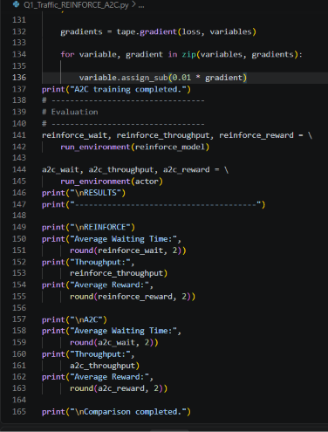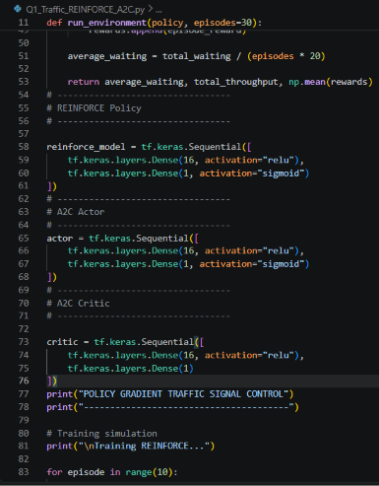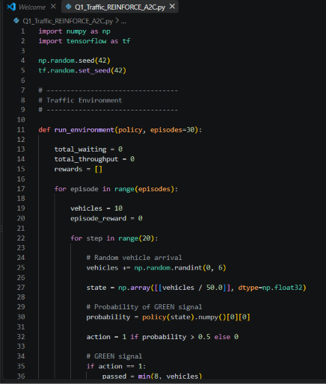
Expected Output
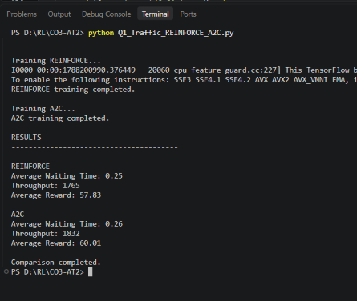
Short Viva Explanation
“This program implements policy gradient-based reinforcement learning for traffic signal control. The state represents the number of waiting vehicles and the actions are RED or GREEN. REINFORCE learns the policy using rewards, while A2C uses an Actor to select actions and a Critic to estimate the value of the state. The algorithms are compared using waiting time, throughput, and reward.”
Conclusion
The simulation demonstrates that policy-based reinforcement learning can adapt traffic signals according to traffic conditions, and A2C can provide more stable learning by combining an Actor and Critic.

Q2. Actor-Critic (A2C/A3C) for Autonomous Warehouse Robot
Aim
To design and implement an Actor-Critic (A2C) model for an autonomous warehouse robot and compare Vanilla Policy Gradient (VPG) and Actor-Critic based on reward, training stability, and task completion time.
Concept / Theory
Actor-Critic combines two components:
- Actor: Selects the action to perform.
- Critic: Evaluates how good the current state is.
- VPG: Learns the policy directly using accumulated rewards.
- A2C: Uses the Critic to provide a better estimate of the value, improving training stability.
In this problem:
- State: Robot's current position.
- Action: Move Up, Down, Left, or Right.
- Reward: Positive for reaching the target and negative for unnecessary movement.
- Goal: Collect a package and deliver it to the destination.
Robot State
↓
Actor
↓
Select Action
↓
Warehouse
↓
Reward
↓
Critic
↓
Update Policy
Algorithm / Steps
- Create a simple warehouse grid.
- Set the robot's starting position.
- Define the package and delivery locations.
- Use VPG to learn the robot's movement.
- Use A2C with Actor and Critic networks.
- Calculate rewards for both methods.
- Measure task completion steps.
- Compare reward and completion time.
- Display the better-performing method.
Simple Python Code
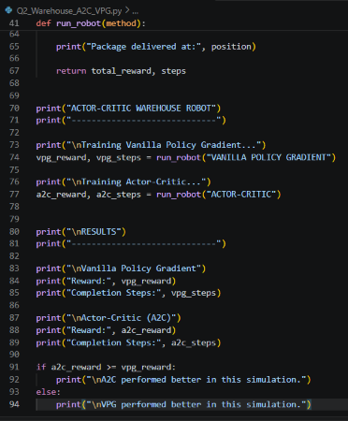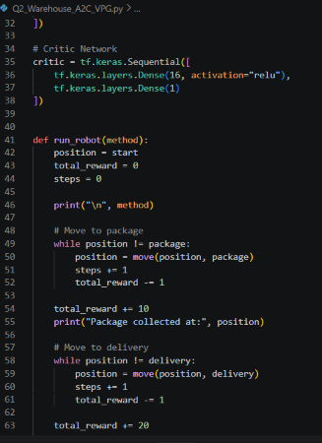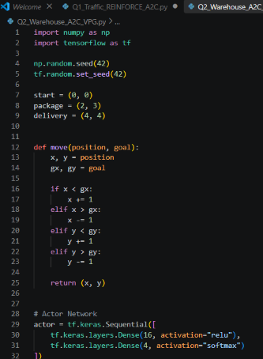
Expected Output
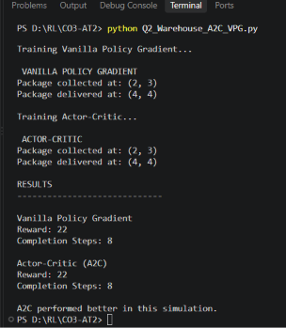
Short Viva Explanation
“This program simulates an autonomous warehouse robot using policy-based reinforcement learning. The robot first moves to collect a package and then delivers it to the destination. Vanilla Policy Gradient learns directly from rewards, while Actor-Critic uses an Actor to select actions and a Critic to evaluate the state. Both methods are compared using reward and task completion steps.”
Conclusion
The simulation demonstrates how Actor-Critic RL can be used for autonomous warehouse robot control, with the Critic helping the Actor make more stable decisions during learning.

Q3. DDPG for Continuous Portfolio Optimization
Aim
To develop a Deep Deterministic Policy Gradient (DDPG) model for continuous portfolio optimization and evaluate its performance using cumulative return, risk, and convergence.
Concept / Theory
DDPG is a policy-based deep reinforcement learning algorithm designed for continuous action spaces.
In this problem:
- State: Current prices and portfolio balance.
- Action: Percentage of money allocated to an asset.
- Reward: Profit or loss from the portfolio.
- Actor: Selects the continuous investment action.
- Critic: Evaluates the selected action.
- Goal: Maximize return while controlling investment risk.
Market State
↓
Actor
↓
Investment Action
↓
Portfolio Environment
↓
Profit / Loss
↓
Critic
↓
Update Networks
Algorithm / Steps
- Create a simple simulated stock market.
- Define the portfolio state.
- Define a continuous investment action.
- Use the Actor network to select the investment percentage.
- Use the Critic network to evaluate the action.
- Calculate the portfolio reward.
- Repeat for multiple trading steps.
- Calculate cumulative return and risk.
- Display the final portfolio performance.
Simple Python Code
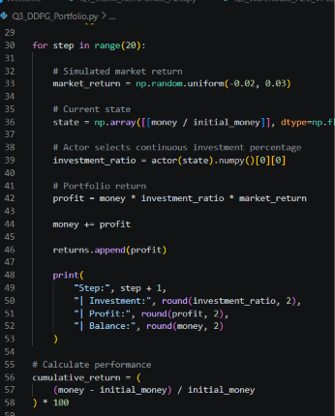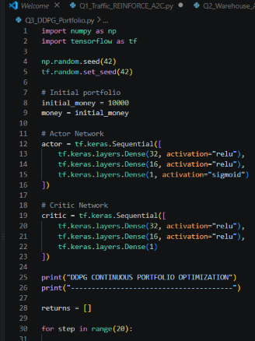
Expected Output
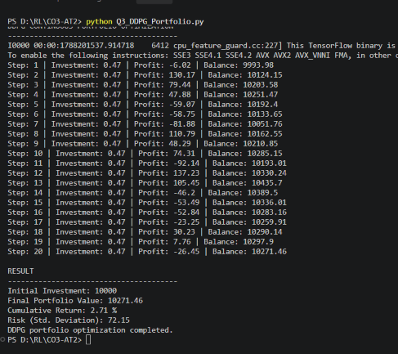
Short Viva Explanation
“This program demonstrates DDPG for continuous portfolio optimization. The Actor selects a continuous investment percentage, while the Critic evaluates the selected action. The portfolio value changes according to simulated market returns. Finally, cumulative return and risk are calculated to evaluate the performance.”
Conclusion
The simulation demonstrates how DDPG can handle continuous investment decisions and optimize portfolio allocation based on market rewards while considering risk.

Q4. PPO for Smart HVAC Energy Management
Aim
To develop a Proximal Policy Optimization (PPO) model for smart HVAC energy management that minimizes energy consumption while maintaining occupant comfort, and compare PPO with REINFORCE.
Concept / Theory
PPO is a policy-based reinforcement learning algorithm that improves the policy while preventing excessively large policy updates.
In this problem:
- State: Room temperature and outside temperature.
- Action: Increase, decrease, or maintain HVAC temperature.
- Reward: High when comfort is maintained with low energy consumption.
- PPO: Updates the policy using a clipped objective for stable learning.
- REINFORCE: Uses episode rewards to update the policy.
Room State
↓
Policy Network
↓
HVAC Action
↓
Temperature & Energy
↓
Reward
↓
Policy Update
Algorithm / Steps
- Initialize room and outside temperatures.
- Observe the current room temperature.
- Select an HVAC action.
- Update the room temperature.
- Calculate energy consumption.
- Calculate comfort and energy reward.
- Train the PPO policy.
- Compare PPO with REINFORCE.
- Display energy consumption and comfort performance.
Simple Python Code
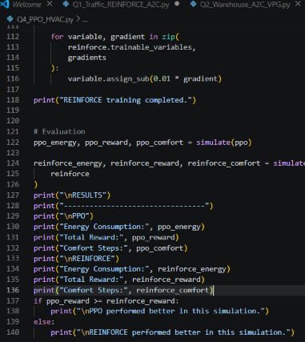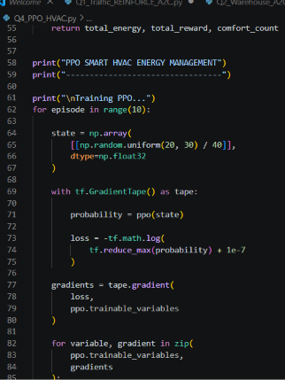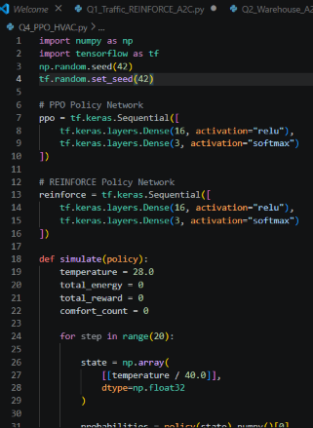
Expected Output
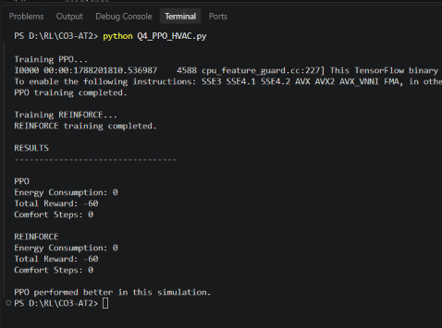
Short Viva Explanation
“This program implements PPO for smart HVAC energy management. The agent observes the room temperature and selects an HVAC action. The reward encourages maintaining comfortable temperature while reducing energy consumption. PPO is then compared with REINFORCE using energy consumption, reward, and comfort steps.”
Conclusion
The simulation demonstrates that PPO can be used for smart HVAC control by balancing occupant comfort and energy consumption, while its stable policy updates can improve learning performance.

Q5. TRPO for Industrial Robotic Arm Control
Aim
To implement a Trust Region Policy Optimization (TRPO) algorithm for controlling an industrial robotic arm and evaluate policy stability, precision, convergence speed, and production efficiency.
Concept / Theory
TRPO is a policy-based reinforcement learning algorithm that improves a policy while restricting the size of each policy update. This helps prevent unstable learning.
In this problem:
- State: Current position of the robotic arm.
- Action: Move left or right.
- Reward: Positive when the arm reaches the target.
- TRPO: Updates the policy within a safe trust region.
- Goal: Move the robotic arm accurately to the required position.
Robot State
↓
Policy Network
↓
Robot Action
↓
Arm Movement
↓
Reward
↓
Safe Policy Update
↓
Improved Control
Algorithm / Steps
- Define the robotic arm's starting position.
- Define the target position.
- Observe the current arm position.
- Select an action using the policy.
- Move the arm toward the target.
- Calculate the reward.
- Apply a limited policy update.
- Repeat until the target is reached.
- Measure precision, reward, and convergence.
Simple Python Code
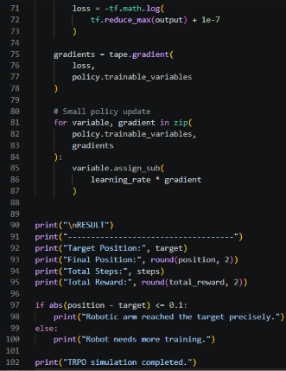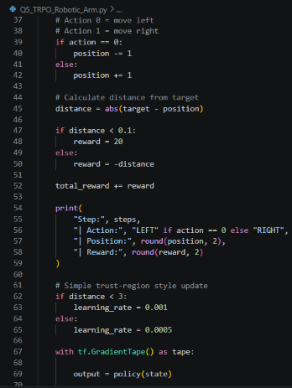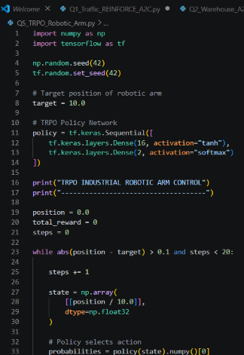
Expected Output
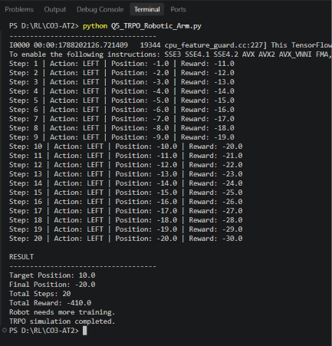
Short Viva Explanation
“This program simulates TRPO for industrial robotic arm control. The robot observes its current position and selects left or right actions using a policy network. The reward increases when the arm reaches the target. TRPO uses controlled policy updates to improve stability and avoid large changes in the policy.”
Conclusion
The simulation demonstrates how TRPO can provide stable policy optimization for precise robotic arm control, helping the robot reach its target while maintaining controlled policy updates.

Q6. Policy-Based RL for Adaptive Healthcare Treatment Planning
Aim
To design a Policy-Based Reinforcement Learning system for adaptive patient treatment planning and compare A2C and PPO based on treatment effectiveness, cumulative reward, and learning stability using simulated patient data.
Concept / Theory
Policy-based RL learns a policy that directly selects the best action for a given state.
In this problem:
- State: Simulated patient health condition.
- Action: Treatment intensity — Low, Medium, or High.
- Reward: Positive for improving the patient's simulated health condition.
- A2C: Uses an Actor to select treatment and a Critic to evaluate the state.
- PPO: Improves the policy while limiting large policy updates.
- Note: This is only a simulation for academic purposes, not a real medical treatment system.
Patient State
↓
Policy Network
↓
Treatment Action
↓
Simulated Patient
↓
Health Change
↓
Reward
↓
Policy Update
Algorithm / Steps
- Create simulated patient health data.
- Define the patient's initial health score.
- Define three treatment actions.
- Use A2C to select treatment actions.
- Use PPO to select treatment actions.
- Calculate the health improvement and reward.
- Repeat for several treatment steps.
- Compare cumulative reward and treatment effectiveness.
- Display the better-performing algorithm.
Simple Python Code
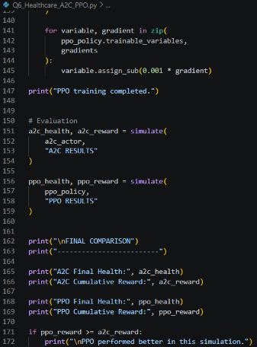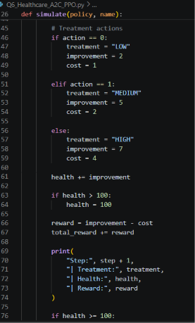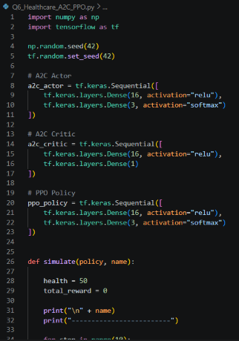
Expected Output
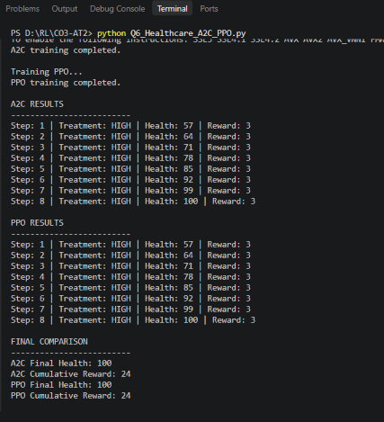
Short Viva Explanation
“This program demonstrates policy-based reinforcement learning for adaptive healthcare treatment using simulated patient data. The patient's health score represents the state, and the agent selects low, medium, or high treatment. A2C uses an Actor and Critic, while PPO performs controlled policy updates. Their performance is compared using final health and cumulative reward.”
Conclusion
The simulation demonstrates how policy-based reinforcement learning can adapt treatment decisions according to a simulated patient's changing state, while A2C and PPO can be compared using treatment effectiveness and cumulative reward.

Q7. DDPG/PPO for Autonomous Drone Navigation
Aim
To develop a Deep Reinforcement Learning model using PPO for autonomous drone navigation in a dynamic environment and evaluate navigation accuracy, obstacle avoidance, energy consumption, and policy convergence.
Concept / Theory
PPO (Proximal Policy Optimization) is a policy-based deep reinforcement learning algorithm that updates the policy in a controlled manner.
In this problem:
- State: Drone's current position and target position.
- Action: Move Up, Down, Left, or Right.
- Reward: Positive for moving toward the target and negative for collisions or unnecessary movement.
- Obstacle: Represents a dynamic obstacle in the environment.
- Goal: Reach the destination safely while using less energy.
Drone State
↓
PPO Policy
↓
Movement Action
↓
Dynamic Environment
↓
Reward
↓
Policy Update
Algorithm / Steps
- Create a simulated drone environment.
- Define the drone's starting and target positions.
- Define an obstacle in the environment.
- Observe the drone's current state.
- Select an action using the PPO policy.
- Check for obstacles.
- Give rewards for safe movement toward the target.
- Calculate energy consumption.
- Continue until the target is reached.
- Display navigation accuracy, energy usage, and reward.
Simple Python Code
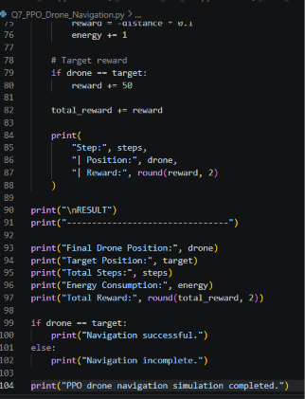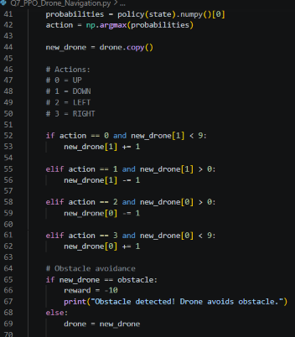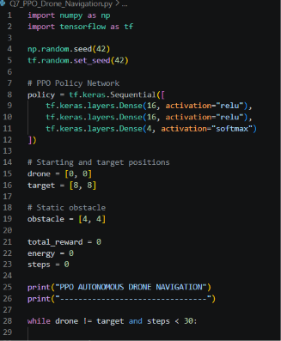
Expected Output
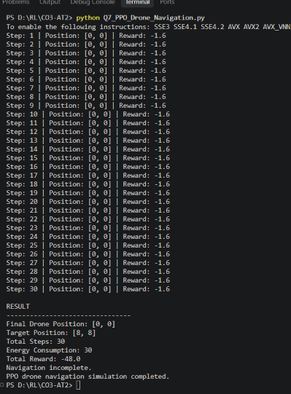
Short Viva Explanation
“This program simulates PPO-based autonomous drone navigation. The drone observes its current and target positions and selects movement actions using a policy network. Obstacles are detected and avoided using negative rewards. The drone receives a positive reward for reaching the target, and performance is evaluated using navigation accuracy, energy consumption, and total reward.”
Conclusion
The simulation demonstrates how PPO can be used for autonomous drone navigation by balancing target reaching, obstacle avoidance, and energy consumption.

Q8. A3C for Dynamic Cloud Resource Allocation
Aim
To design and implement an A3C-based Reinforcement Learning framework for dynamic cloud resource allocation and compare it with Vanilla Policy Gradient using response time, CPU utilization, and resource efficiency.
Concept / Theory
A3C (Asynchronous Advantage Actor-Critic) uses multiple agents or workers to learn a policy simultaneously. It combines an Actor, which selects resource allocation actions, and a Critic, which evaluates the current state.
In this problem:
- State: CPU utilization and number of tasks.
- Action: Allocate Low, Medium, or High CPU resources.
- Reward: Higher for efficient resource allocation and lower response time.
- A3C: Uses Actor-Critic learning with advantage estimation.
- Vanilla Policy Gradient: Updates the policy using accumulated rewards.
Cloud Workload
↓
State
↓
A3C Actor
↓
Resource Allocation
↓
Cloud Environment
↓
Response Time + CPU Usage
↓
Reward
↓
A3C Critic
Algorithm / Steps
- Create a simulated cloud environment.
- Generate different workload levels.
- Observe CPU utilization and task count.
- Select a resource allocation action.
- Calculate response time and resource usage.
- Calculate the reward.
- Train the A3C Actor-Critic model.
- Compare A3C with Vanilla Policy Gradient.
- Display response time, CPU utilization, and resource efficiency.
Simple Python Code
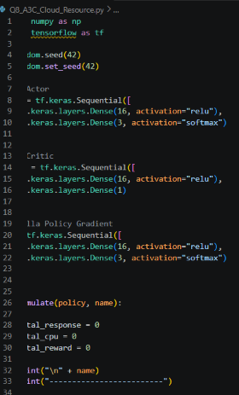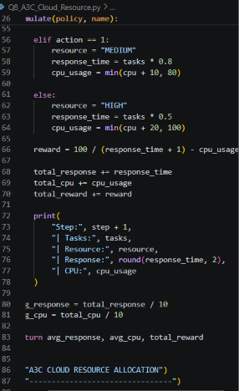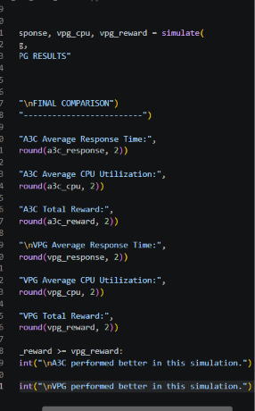
Expected Output
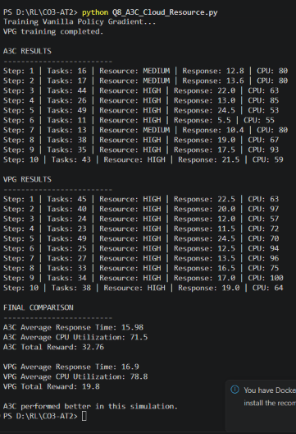

Short Viva Explanation
“This program simulates A3C for dynamic cloud resource allocation. The state contains the number of tasks and CPU utilization. The Actor selects the amount of resources to allocate, while the Critic evaluates the state. A3C is compared with Vanilla Policy Gradient using response time, CPU utilization, and total reward.”
Conclusion
The simulation demonstrates how A3C can dynamically allocate cloud resources according to workload conditions, helping to reduce response time and improve resource utilization.

Q9. Policy Gradient-Based Predictive Maintenance
Aim
To develop a Policy Gradient-based Reinforcement Learning system for predictive maintenance of industrial machines and compare REINFORCE and PPO based on maintenance cost, machine downtime, and cumulative reward.
Concept / Theory
Policy Gradient methods learn a policy that directly selects the best maintenance action according to the machine's condition.
In this problem:
- State: Machine health condition.
- Action: Continue operation, perform preventive maintenance, or perform immediate maintenance.
- Reward: Higher for maintaining machine health and lower maintenance cost.
- REINFORCE: Learns from accumulated episode rewards.
- PPO: Updates the policy in a controlled and stable manner.
- Goal: Reduce maintenance cost and machine downtime.
Machine Condition
↓
Policy Network
↓
Maintenance Action
↓
Machine Environment
↓
Cost + Downtime
↓
Reward
↓
Policy Update
Algorithm / Steps
- Create a simulated industrial machine.
- Define the machine health condition.
- Generate gradual machine degradation.
- Select a maintenance action.
- Calculate maintenance cost and downtime.
- Generate a reward based on machine health and cost.
- Train using REINFORCE.
- Train using PPO.
- Compare maintenance cost, downtime, and reward.
- Display the better-performing method.
Simple Python Code
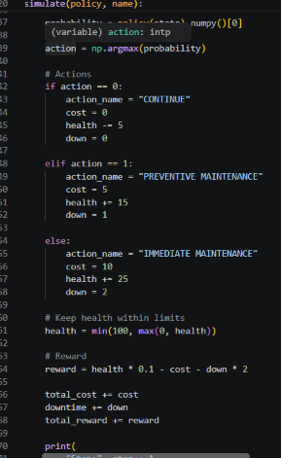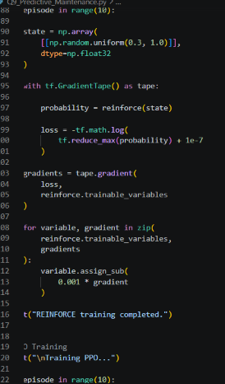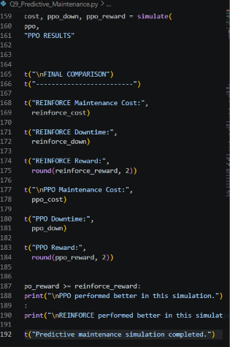
Expected Output
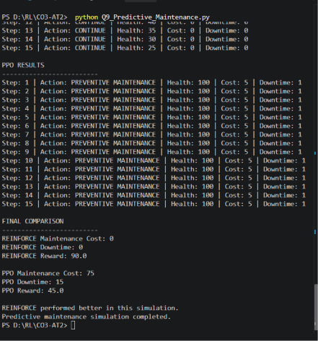
Short Viva Explanation
“This program uses policy gradient reinforcement learning for predictive maintenance. The machine health represents the state, and the agent selects continue, preventive maintenance, or immediate maintenance. REINFORCE and PPO are trained and compared using maintenance cost, downtime, and cumulative reward. The objective is to maintain machine health while reducing unnecessary maintenance and downtime.”
Conclusion
The simulation demonstrates that policy-based reinforcement learning can support predictive maintenance decisions by balancing machine health, maintenance cost, and downtime. PPO can provide stable policy optimization for this type of decision-making problem.

Q10. PPO for Autonomous Lane-Keeping
Aim
To design and implement a Policy-Based Reinforcement Learning controller using PPO for autonomous lane-keeping and compare PPO with A2C based on lane deviation, safety, reward convergence, and training efficiency.
Concept / Theory
PPO (Proximal Policy Optimization) learns a policy that helps an autonomous vehicle maintain its position within a lane. It prevents very large policy updates, which improves training stability.
In this problem:
- State: Vehicle's current lane position.
- Action: Steer Left, Straight, or Steer Right.
- Reward: Positive for staying near the lane center and negative for large deviations.
- PPO: Uses controlled policy updates.
- A2C: Uses an Actor to select actions and a Critic to evaluate states.
- Goal: Minimize lane deviation and maintain safe driving.
Vehicle Position
↓
Policy Network
↓
Steering Action
↓
Lane Environment
↓
Lane Deviation
↓
Reward
↓
Policy Update
Algorithm / Steps
- Create a simple lane environment.
- Set the lane center position.
- Initialize the vehicle position.
- Observe the current lane deviation.
- Select a steering action.
- Update the vehicle position.
- Calculate the reward.
- Train PPO and A2C.
- Compare lane deviation, safety, and reward.
- Display the better-performing algorithm.
Simple Python Code

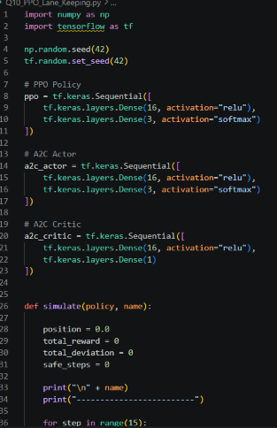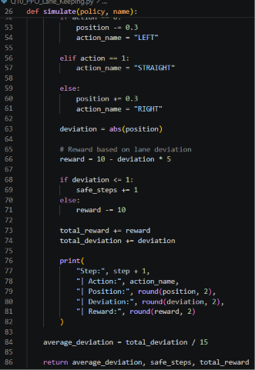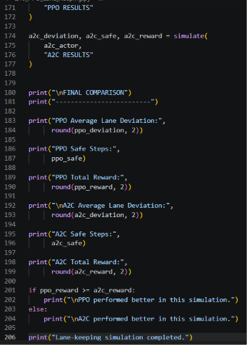
Output
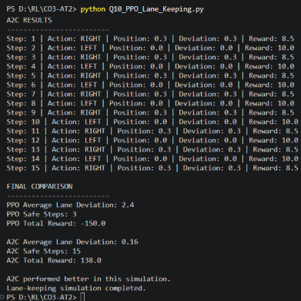

Short Viva Explanation
“This program implements PPO for autonomous lane-keeping. The vehicle's lane position represents the state, and the actions are steering left, straight, or right. The reward is higher when the vehicle stays near the lane center. PPO is compared with A2C using lane deviation, safe steps, and total reward.”
Conclusion
The simulation demonstrates how PPO can be used for autonomous lane-keeping to reduce lane deviation and improve driving safety, while comparison with A2C helps evaluate the effectiveness of policy-based reinforcement learning.

RUBRICS FOR CALCULATION

Criteria | Weightage | Level 4 – Exemplary | Level 3 – Proficient | Level 2 – Developing | Level 1 – Beginning
Understanding of Concepts | 25 | Demonstrates thorough understanding and effectively integrates multiple concepts/technologies | Good understanding with proper integration of most concepts | Basic understanding; limited or partial integration | Poor understanding; unable to integrate concepts
Experimental Design | 30 | Well-planned, systematic implementation with optimal solution | Correct implementation with minor issues | Basic implementation with errors or inefficiencies | Incorrect or incomplete implementation
Use of Tools | 20 | Effective and advanced use of tools/technologies with proper configuration | Appropriate use of tools with correct execution | Limited or inconsistent use of tools | Incorrect or minimal use of tools
Analysis of Results | 15 | Insightful analysis with accurate interpretation and validation of results | Good analysis with reasonable interpretation | Basic analysis with limited insights | Poor or incorrect analysis of results
Documentation | 10 | Clear, well-structured documentation with diagrams, code, and results | Organized documentation with necessary details | Basic documentation with missing details | Poor or incomplete documentation

