**Adaptive Mail: A Flexible Email Client App**

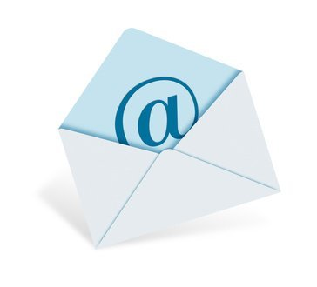

**1 Introduction**

* 1. **Overview**

Adaptive Mail app is a sample project that demonstrates how to use the Android

Compose UI toolkit to build a conversational UI. The app simulates a messaging

Interface, allowing the user to send and receive messages, and view a history of

Previous messages. It showcases some of the key features of the Compose UI

Toolkit, data management, and user interactions.

**1.2 Purpose**

The app simulates a messaging interface, allowing the user to send and receive messages, and view a history of previous messages.

It showcases some of the key features of the Compose UI toolkit, data management, and user interactions

**2.Problem Definition & Design Thinking**

**2.1 Empathy map**

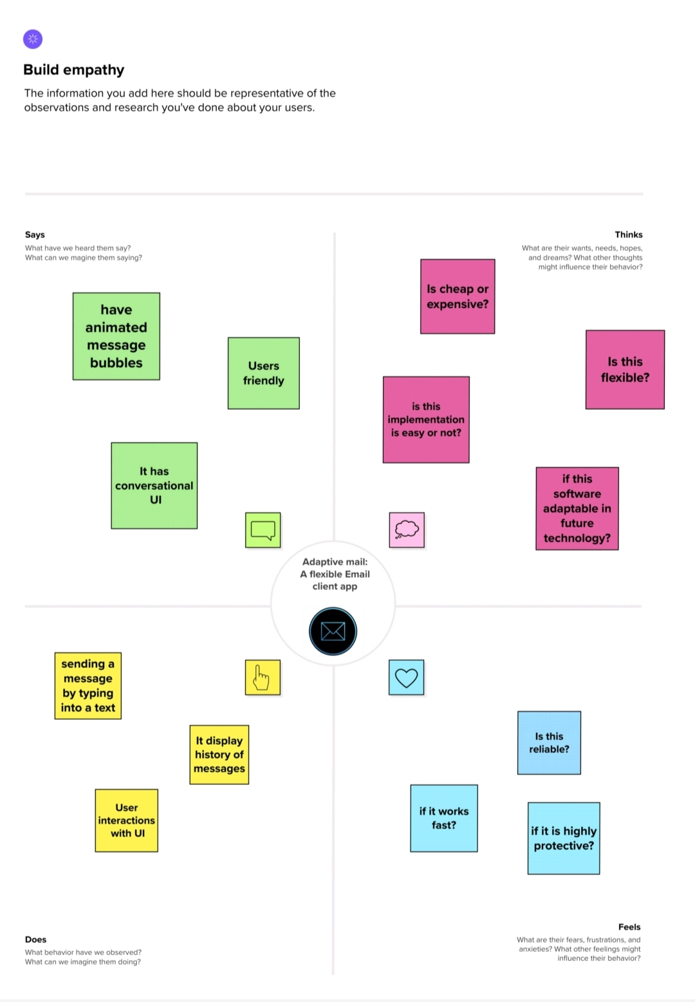

* 1. **Ideation & brainstorming**

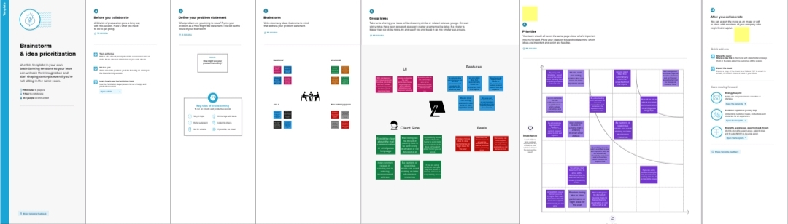

**3 Result**

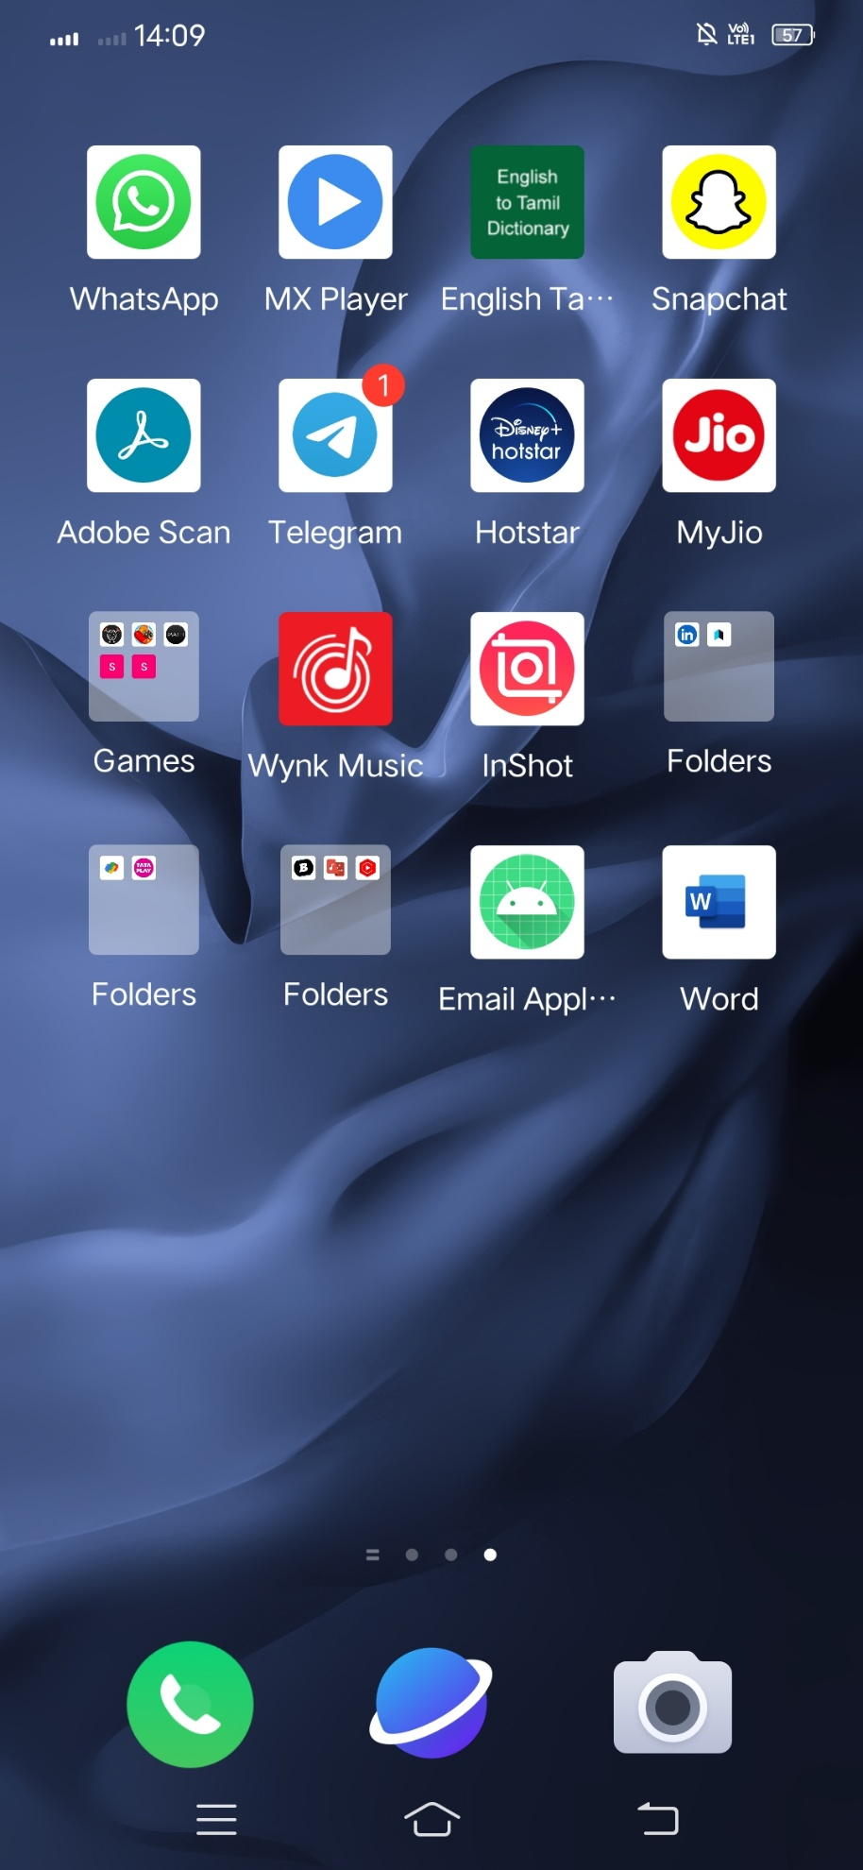

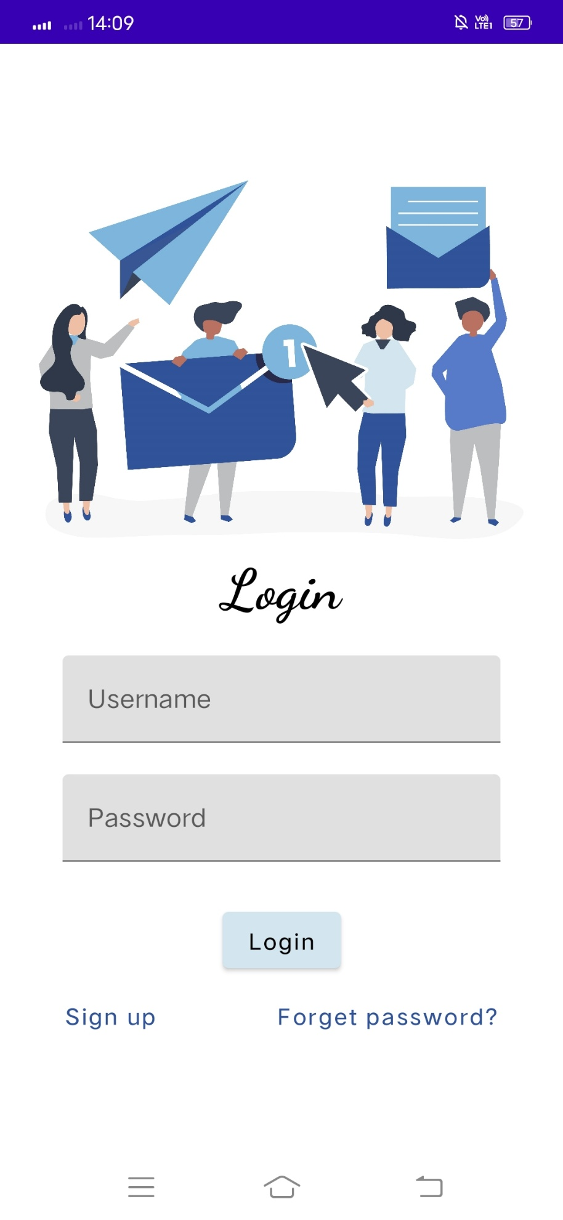

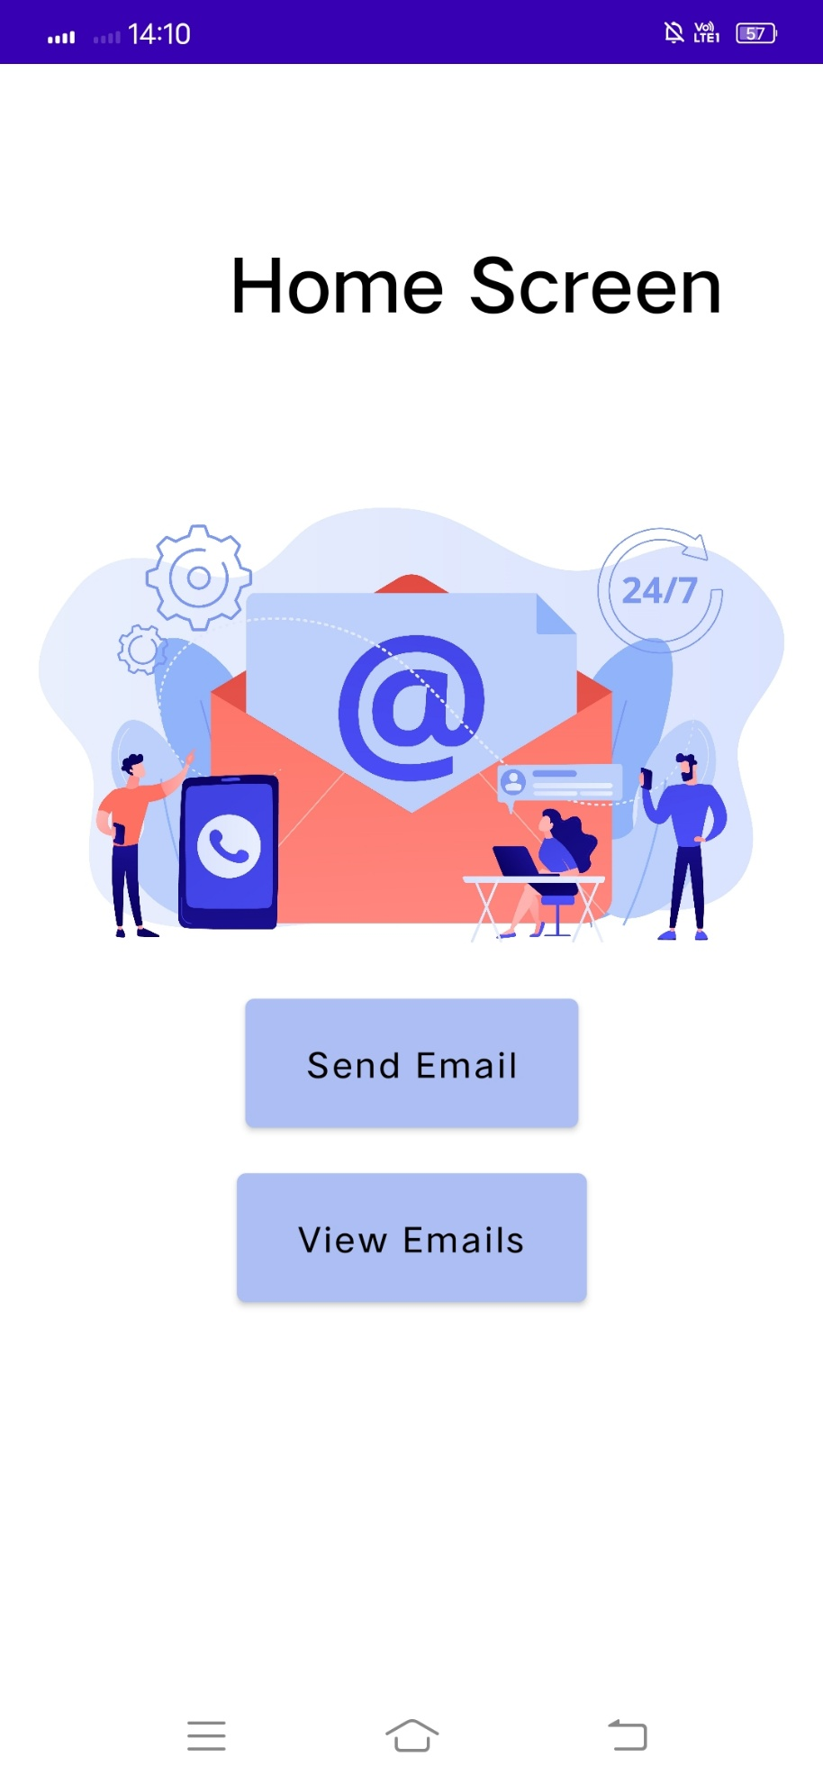

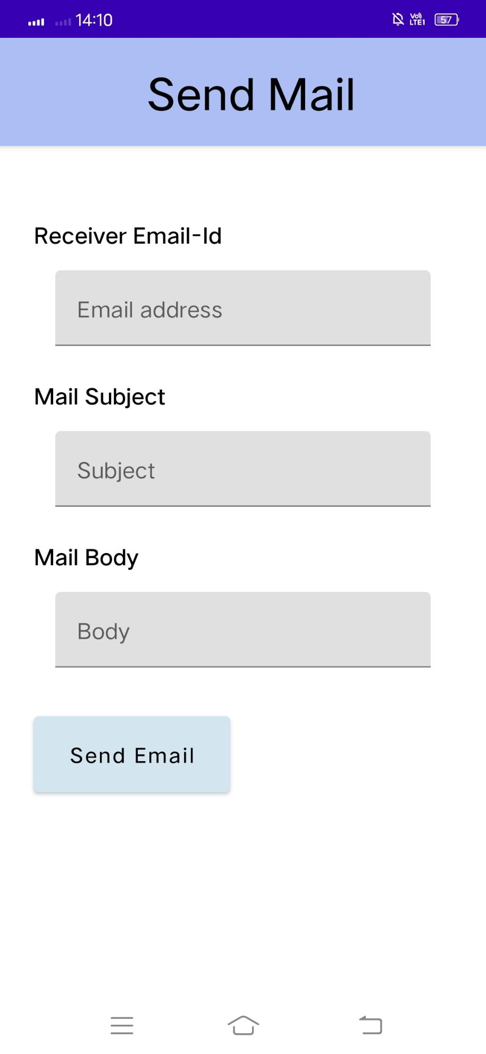

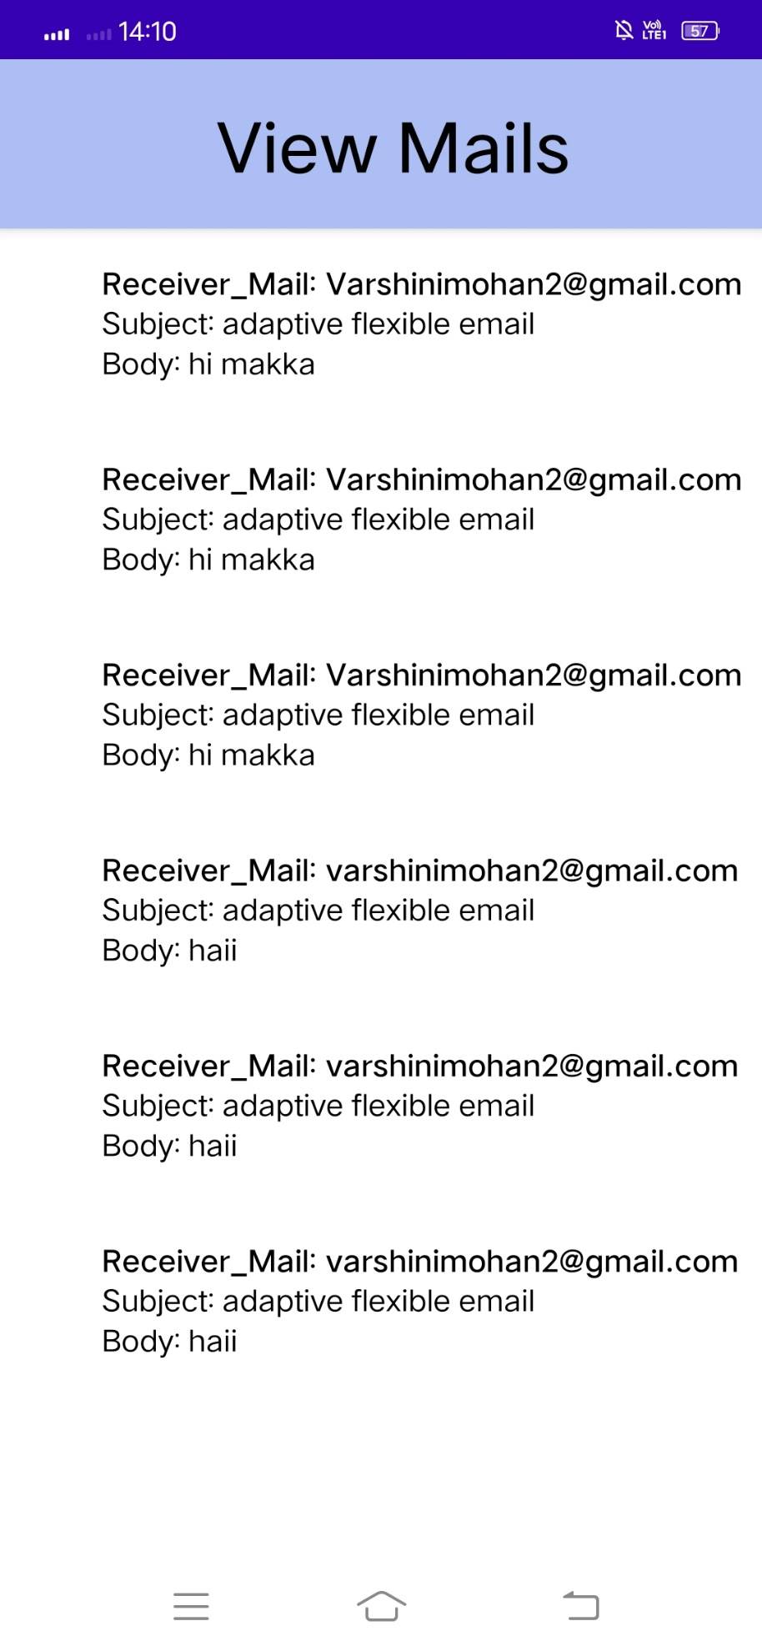

**4 Advantages and Disadvantages of E-mail**



**Advantages of E-mail :**

E-mails provides faster and easy mean of communication. One can send message to any person at any place of world by just clicking mouse.

Various folders and sub-folders can be created within inbox of mail, so it provide management of messages.

It is effective and cheap means of communication because single message can be send to multiple people at same time.

E-mails are very easy to filter. User according to his/her priority can prioritize e-mail by specifying subject of e-mail.

E-mail is not just only for textual message. One can send any kind of multimedia within mail.

E-mail can be send at any hour of day, thus ensures timeliness of message.

It is secure and reliable method to deliver our message.

It also provide facility for edition and formatting of textual messages.

There is also facility of auto-responders in e-mail i.e. to send automated e-mails with certain text.

To write an e-mail there is no need of any kind of paper, thus it is environment friendly.

**Disadvantages of E-mail :**

It is source of viruses. It is capable to harm one’s computer and read out user’s e-mail address book and send themselves to number of people around the world.

It can be source of various spams. These spam mails can fill up inbox and to deletion of these mail consumes lot of time.

It is informal method of communication. The documents those require signatures are not managed by e-mail.

To use facility of e-mail, user must have an access to internet and there are many parts of world where people does not have access to Internet.

Sometimes, e-mails becomes misunderstood as it is not capable of expressing emotions.

To be updated, user have to check inbox from time-to-time.

**5 Applications**

Email is used for many different purposes, including contacting friends, communicating with professors and supervisors, requesting information, and applying for jobs, internships, and scholarships.

Depending on your purposes, messages you send will differ in their formality, intended audience, and desired outcomes.

**6 Conclusion**

At the end of the day, email is still one of the most effective forms of marketing. If you use it correctly, you can target prospective customers with relevant information, at precisely the right time – gaining brand loyalists for life.

**7 Future Scope**

But the future of email looks bright: it’s an essential tool for internal and external communications. In 2021, about 319.6 billion emails were sent and received daily—that’s 4.1% more emails sent than the previous year. The number of email users globally is only expected to grow in the next four years.