**1.1** Given an array of strings words, return the **first palindromic string in the array.** If there is no such string, return an empty string "". A string is palindromic if it reads the same forward and backward.

**AIM**

To design a Python program that finds and returns the first palindromic string from a list of words.

**ALGORITHM**

1. Start with the given list of words.
2. Traverse each word in the list sequentially.
3. For each word, check if it is equal to its reverse.

- If yes, return that word immediately.

1. If no palindrome is found after traversing the entire list, return an empty string "".

**PROGRAM**

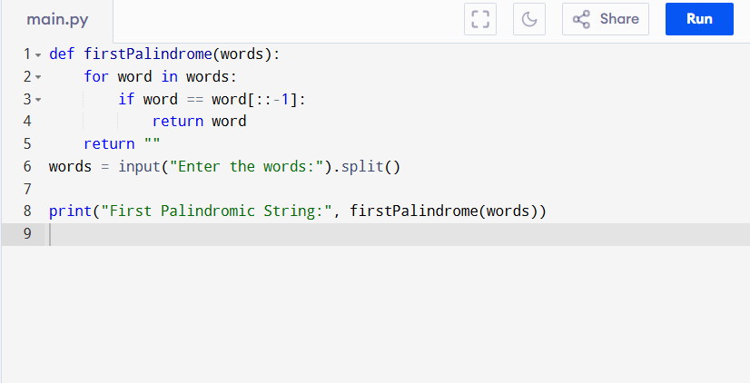

Input:

An array of strings.  
["abc", "car", "ada", "racecar", "cool"]

Output:

**RESULT:**

Thus the first palindromic string in the array program is successfully executed and the output is verified.

**PERFORMANCE ANALYSIS:**

* Time Complexity:
  + Checking each word takes O(n) where n is the length of the word.
  + For m words, worst case = O(m * n).
* Space Complexity:
  + Uses only a few variables, so O(1) (constant extra space).