Student Registration CRM using Salesforce
Project Documentation
Prepared based on the implemented Salesforce project.
Introduction:
Student Registration CRM is a cloud-based Customer Relationship Management (CRM) application developed using the Salesforce Lightning Platform. The application is designed to simplify the process of managing student information by storing student details in a centralized system. Instead of maintaining student records manually, the CRM allows administrators to create, update, and manage records efficiently.
The project demonstrates both Salesforce Administration and Salesforce Development concepts. It includes custom objects, custom fields, validation rules, automation using Flows, Apex programming, security configuration, reports, dashboards, and testing. The system provides an easy-to-use interface for managing student information while ensuring data accuracy through validation and automation.

Project Overview
The Student Registration CRM application is developed to maintain student records in an organized manner. The application enables administrators to store important student information such as student name, roll number, department, email address, phone number, and status. It also includes automation features that improve efficiency and reduce manual work.
The application uses Salesforce's low-code and pro-code capabilities to implement validation rules, record-triggered flows, Apex classes, Apex triggers, reports, dashboards, and security settings. These features ensure that the application is reliable, secure, and easy to maintain.

Objectives
• The primary objectives of this project are:
- To develop a Student Registration CRM application using Salesforce.
- To maintain student information in a centralized database.
- To reduce manual effort through automation.
- To improve data accuracy using validation rules.
- To demonstrate Salesforce Administration concepts.
- To demonstrate Salesforce Development concepts using Apex.
- To generate reports and dashboards for better analysis.
- To implement security using Profiles, Permission Sets, and Role Hierarchy.
- To provide a user-friendly interface for managing student records.

Business Requirements
Educational institutions often maintain student information using spreadsheets or manual registers, making it difficult to update records, search information, and generate reports. Manual systems are time-consuming and increase the possibility of duplicate records and data entry errors.
The Student Registration CRM addresses these issues by providing a centralized cloud-based solution where authorized users can create, edit, and manage student records efficiently. The system also supports automation, reporting, and security features to improve operational efficiency.

Scope of the Project
The scope of this project includes the development of a Salesforce CRM application for managing student records. The project focuses on creating a custom Student object with relevant fields, implementing automation using Record-Triggered Flows, validating user input using Validation Rules, and developing Apex classes and triggers for business logic.
The application also includes reporting and dashboard functionalities to analyze student data. Security features such as Profiles, Permission Sets, Role Hierarchy, Matching Rules, Duplicate Rules, and Field History Tracking are implemented to ensure controlled access and maintain data integrity.
The project is designed as a prototype that can be extended in the future by integrating approval processes, lookup relationships, sharing rules, Lightning Web Components (LWC), and AI-powered features.

Chapter-2:Requirement Analysis & Planning

Requirement Analysis
Requirement analysis is the first and one of the most important phases of software development. It involves understanding the needs of users, identifying the problems in the existing system, and defining the functionalities that the new system should provide. In this project, the objective was to develop a cloud-based Student Registration CRM using Salesforce to simplify the management of student information.
The Student Registration CRM is designed to help educational institutions maintain student records in a secure and organized manner. Instead of relying on paper-based records or spreadsheets, all student information is stored in Salesforce, making it easily accessible, searchable, and manageable. The application also reduces manual effort by using Salesforce automation features such as Flows and Validation Rules.

Existing System
In many educational institutions, student information is maintained manually using registers or spreadsheet applications. Although this method is simple, it has several limitations.

Problems in the Existing System
- Student records are stored manually.
- Data duplication is common.
- Searching for student details takes more time.
- Reports have to be prepared manually.
- Updating student information is difficult.
- There is no centralized database.
- Data security is limited.
- Manual errors occur frequently.
- No automation is available for repetitive tasks.
- Record tracking is difficult.
Because of these limitations, educational institutions require a better solution that can securely manage student information while reducing manual work.

2.3 Proposed System
The proposed system is a Salesforce-based Student Registration CRM that provides a centralized platform for storing and managing student information. The system uses Salesforce Lightning Experience to create a user-friendly application with automation, validation, reporting, and security features.
Administrators can create, update, delete, and search student records easily. Validation Rules ensure that users enter correct information. Record-Triggered Flows automate business processes, while Apex programming is used for implementing additional business logic. Reports and Dashboards help administrators analyze student data effectively.
The proposed system offers improved security through Profiles, Permission Sets, Role Hierarchy, Duplicate Rules, and Field History Tracking.

Advantages of the Proposed System
The Student Registration CRM provides several advantages over the existing manual system.
- Centralized student database.
- Easy creation and maintenance of student records.
- Reduced manual work.
- Better data accuracy through Validation Rules.
- Automated business processes using Flows.
- Secure access using Salesforce security features.
- Prevention of duplicate student records.
- Easy report generation.
- Dashboard-based data visualization.
- Cloud-based access from anywhere.
These advantages improve the efficiency of managing student information while ensuring data consistency and security.

Functional Requirements
Functional requirements describe the features and operations that the system must perform.
The Student Registration CRM should be able to:
- Create new student records.
- Edit existing student records.
- Delete student records.
- View student details.
- Store student information such as Name, Roll Number, Department, Status, Email, and Phone.
- Validate mandatory fields.
- Automatically process records using Record-Triggered Flow.
- Execute Apex Trigger during record creation.
- Display reports based on student information.
- Display dashboards for student analysis.
- Prevent duplicate records.
- Track field history.
- Import student records using Data Import Wizard.

Non-Functional Requirements
Non-functional requirements define the quality attributes of the system.

Performance
The application should provide fast response while creating and updating student records.

Security
Only authorized Salesforce users should be able to access the application based on assigned Profiles and Permission Sets.

Reliability
The system should maintain accurate student information with minimal errors.

Availability
Since Salesforce is cloud-based, the application should be available whenever users require access.

Scalability
The application should support future enhancements such as Approval Processes, Lookup Relationships, Sharing Rules, Lightning Web Components, and AI-based features.

Maintainability
The system should be easy to maintain by updating Salesforce configurations whenever business requirements change.

Project Scope
The scope of the Student Registration CRM is limited to managing student information within Salesforce.
The project includes:
- Student Custom Object
- Custom Fields
- Validation Rule
- Formula Field
- Record Triggered Flow
- Apex Class
- Apex Trigger
- Apex Test Class
- Lightning App
- Reports
- Dashboard
- Profiles
- Permission Set
- Role Hierarchy
- Field History Tracking
- Matching Rule
- Duplicate Rule
- Data Import Wizard
The project does not include advanced integrations such as payment gateways, external APIs, chatbot integration, or Lightning Web Components. These can be implemented in future versions.

Data Model
The Student Registration CRM uses one custom object called Student to store all student information.

Student Object
The Student object contains the following custom fields:
Field Name | Data Type | Description
Student Name | Text | Stores the student's full name
Roll Number | Text | Stores the unique roll number
Department | Picklist | Stores the student's department
Status | Picklist | Indicates the current status of the student
Email | Email | Stores the student's email address
Phone | Phone | Stores the student's mobile number
Student Info | Formula (Text) | Displays student information using a formula
The Student object acts as the central repository for all student-related data.
📸 Screenshot to insert: Student Object → Fields & Relationships
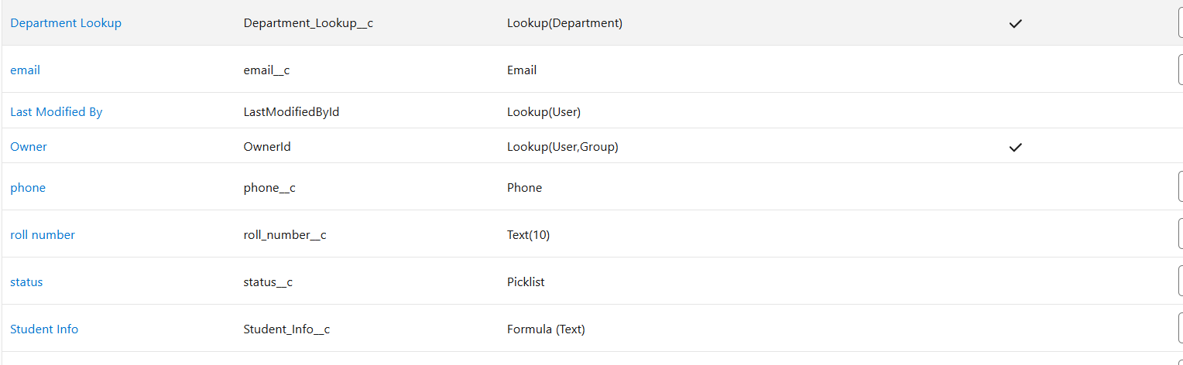

Security Model
Salesforce provides robust security mechanisms to ensure that only authorized users can access the Student Registration CRM.
The following security features were implemented:

Profiles
- System Administrator
- Standard User

Permission Set
A custom Permission Set named Student Manager was created to provide Create, Read, and Edit permissions on the Student object.

Role Hierarchy
A simple Role Hierarchy was configured:
Administrator
│
Student User

Duplicate Management
Matching Rules and Duplicate Rules were configured to identify duplicate student records based on the Email field.

Field History Tracking
Field History Tracking was enabled to monitor changes made to important student fields.
These security features help protect sensitive student information and maintain data integrity.
📸 Screenshots to insert:
- Profiles
- Permission Set
- Role Hierarchy
- Duplicate Rule
- Matching Rule
- Field History Tracking
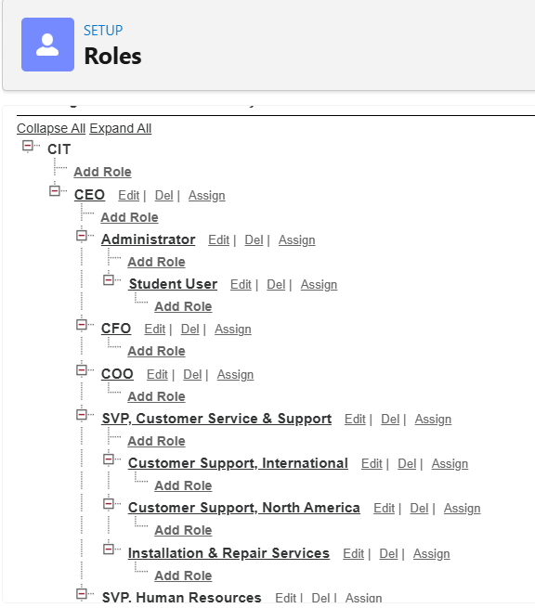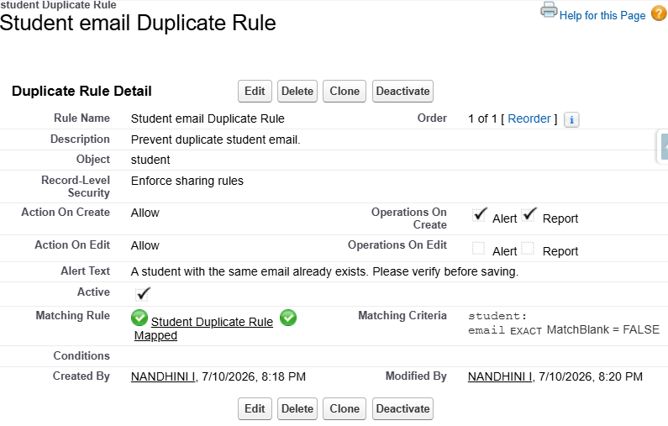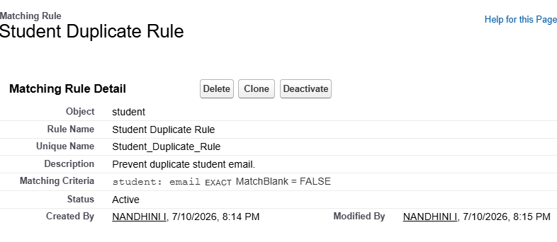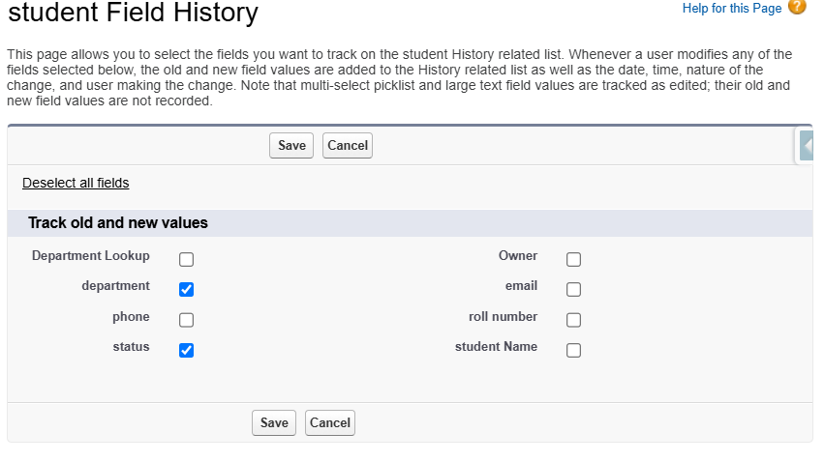

CHAPTER 3 – SALESFORCE DEVELOPMENT (BACKEND & CONFIGURATIONS)

Introduction
Salesforce provides a cloud-based platform for developing Customer Relationship Management (CRM) applications with both declarative (click-based) and programmatic (code-based) development. In this project, Salesforce Administration and Salesforce Development concepts were combined to create a Student Registration CRM application.
The backend of the application includes custom objects, custom fields, validation rules, formula fields, automation using Record-Triggered Flow, Apex Class, Apex Trigger, and Apex Test Class. These components work together to ensure accurate data entry, automation of business processes, and efficient management of student information.

Salesforce Environment Setup
The Student Registration CRM was developed using the Salesforce Lightning Platform. The development environment provided a secure and cloud-based workspace for building, testing, and managing CRM functionalities.

Development Environment
Component | Description
Platform | Salesforce Lightning
Organization | Salesforce Developer Org
Development Method | Declarative + Apex Programming
IDE | Developer Console
Browser | Google Chrome
Language | Apex
Automation | Record Triggered Flow
The Salesforce Setup menu was used to configure custom objects, security, automation, reports, dashboards, and user management.
📸 Screenshot: Salesforce Home Page / Setup Page
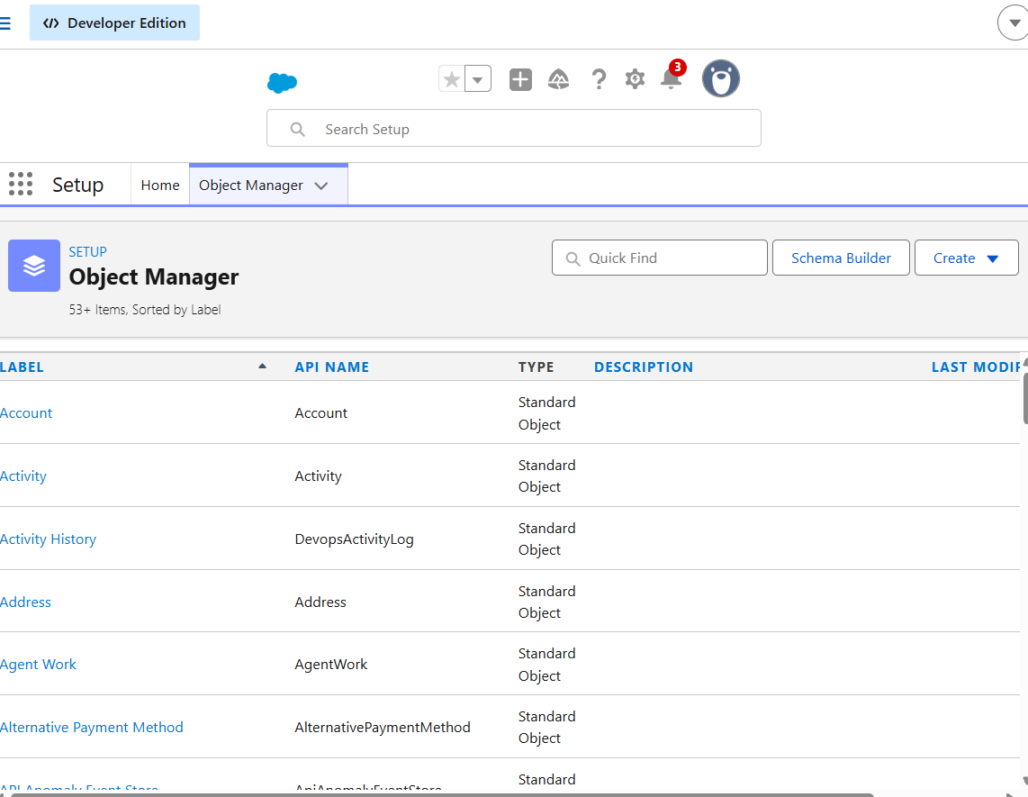

Lightning Application
A custom Lightning Application named Student Registration CRM was created using the Salesforce App Manager.
The application provides a centralized interface where users can manage student records efficiently. It includes navigation items such as the Student object, Reports, and Dashboards.

Features of the Lightning App
- Easy navigation
- User-friendly interface
- Centralized record management
- Access to Reports and Dashboards
- Lightning Experience support
📸 Screenshot: App Manager showing Student Registration CRM

Student Custom Object
A custom object named Student was created to store student information.
The Student object serves as the primary database table in the CRM application.
Each record represents one student.

Purpose
The Student object allows administrators to:
- Register new students
- Update student information
- Search student records
- View reports
- Track student details
📸 Screenshot: Student Object in Object Manager
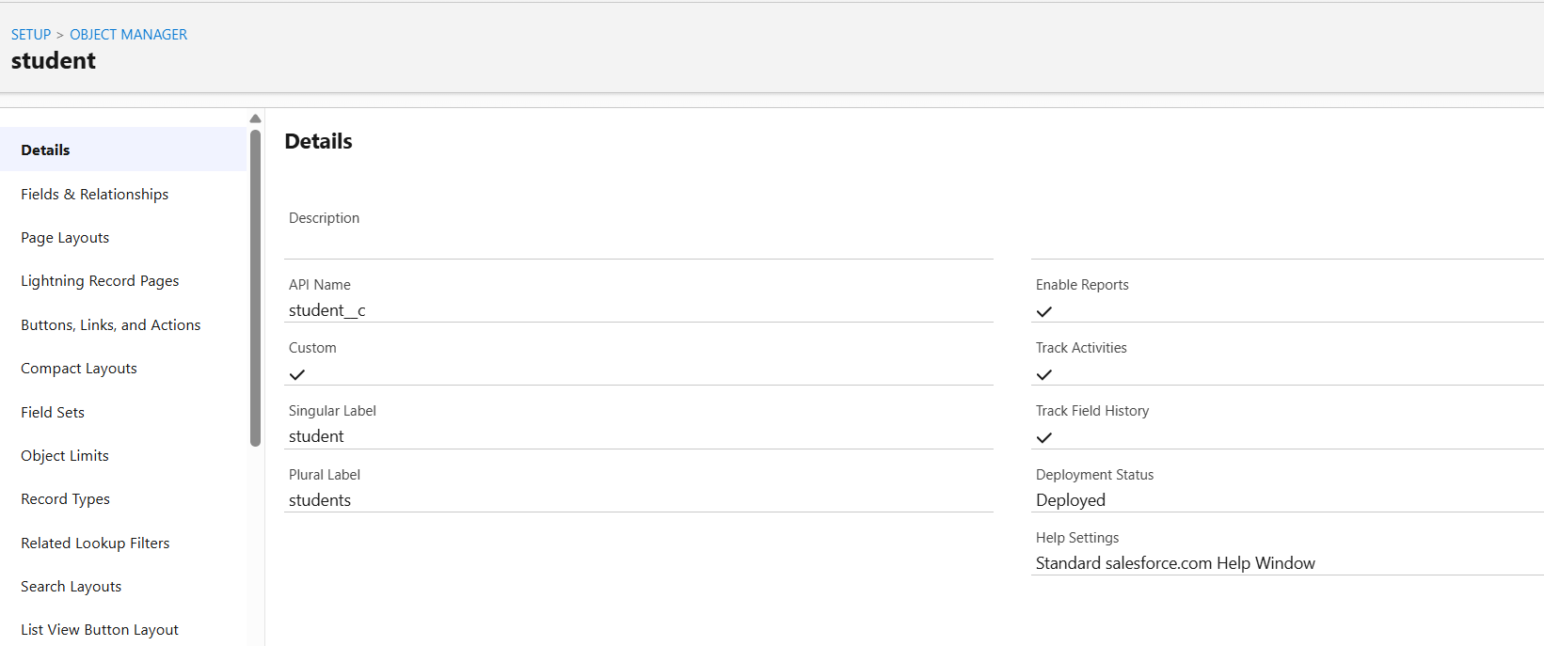

Custom Fields
Several custom fields were created to store student information.
Field Name | Data Type | Description
Student Name | Text | Stores student's full name
Roll Number | Text | Stores student's roll number
Department | Picklist | Stores department name
Status | Picklist | Indicates current student status
Email | Email | Stores email address
Phone | Phone | Stores mobile number
These fields ensure that complete student information is maintained within the Salesforce CRM.
📸 Screenshot: Student → Fields & Relationships
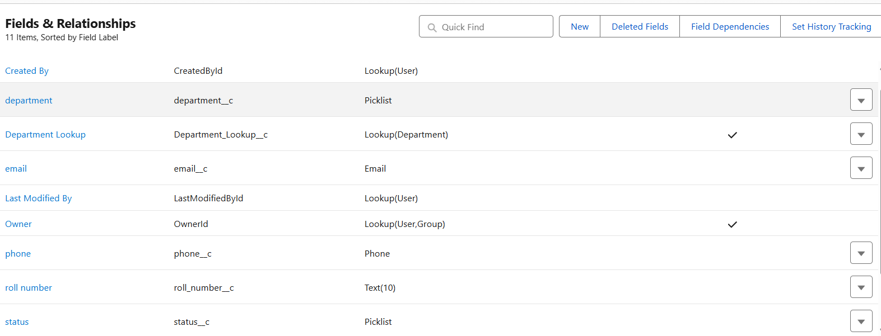

Validation Rule
Validation Rules are used to ensure that users enter valid and complete information before saving records.
A Validation Rule was created to prevent users from saving incomplete student information.

Purpose
- Prevent invalid data entry
- Maintain data accuracy
- Improve record quality

Benefits
- Reduces manual errors
- Ensures mandatory information is entered
- Maintains consistency in the database
📸 Screenshot: Validation Rule
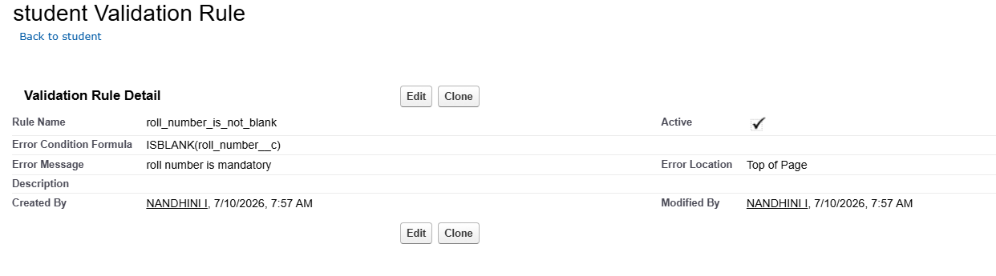

Formula Field
A Formula Field named Student Info was created to display calculated information automatically.
Formula Fields do not store data physically; instead, Salesforce calculates the value whenever the record is viewed.

Purpose
The Formula Field combines student-related information into a single readable value, improving visibility without requiring additional data entry.

Advantages
- Automatically updates
- No manual maintenance
- Reduces redundant data
📸 Screenshot: Formula Field
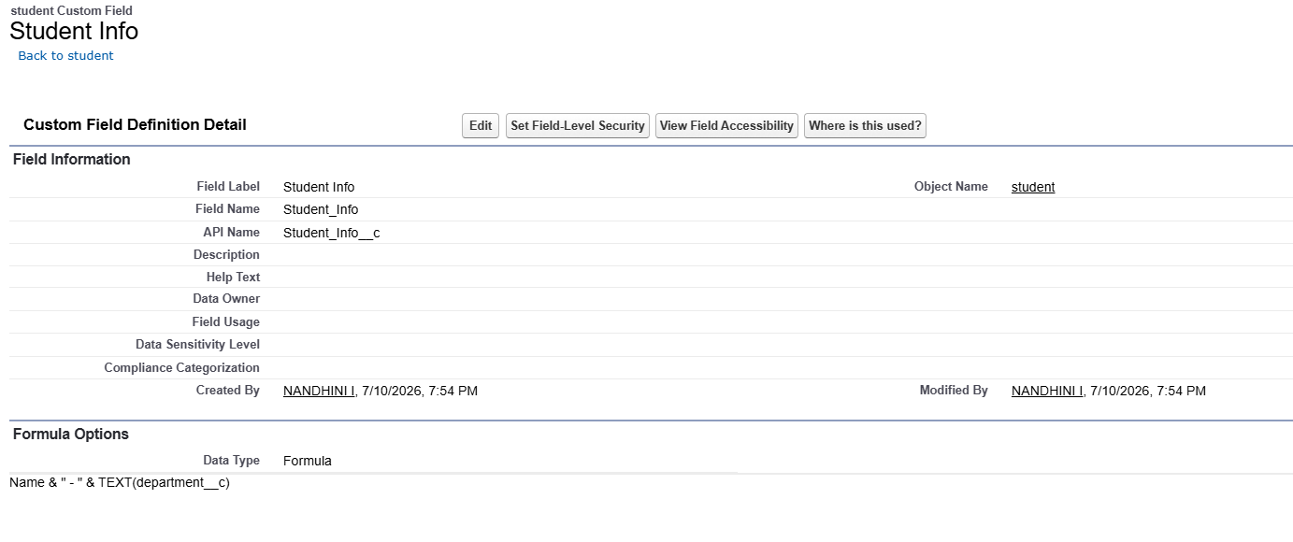

Record Triggered Flow
Salesforce Flow is a declarative automation tool used to automate business processes without writing code.
A Record Triggered Flow was created to automate actions whenever a Student record is created or updated.

Purpose
The Flow automates business logic and reduces manual work.

Benefits
- Low-code automation
- Faster processing
- Improved efficiency
- Easy maintenance

Flow Type
Record Triggered Flow

Trigger
Student Object

Event
After Save / Before Save (choose the one you actually used)
📸 Screenshot: Flow Builder
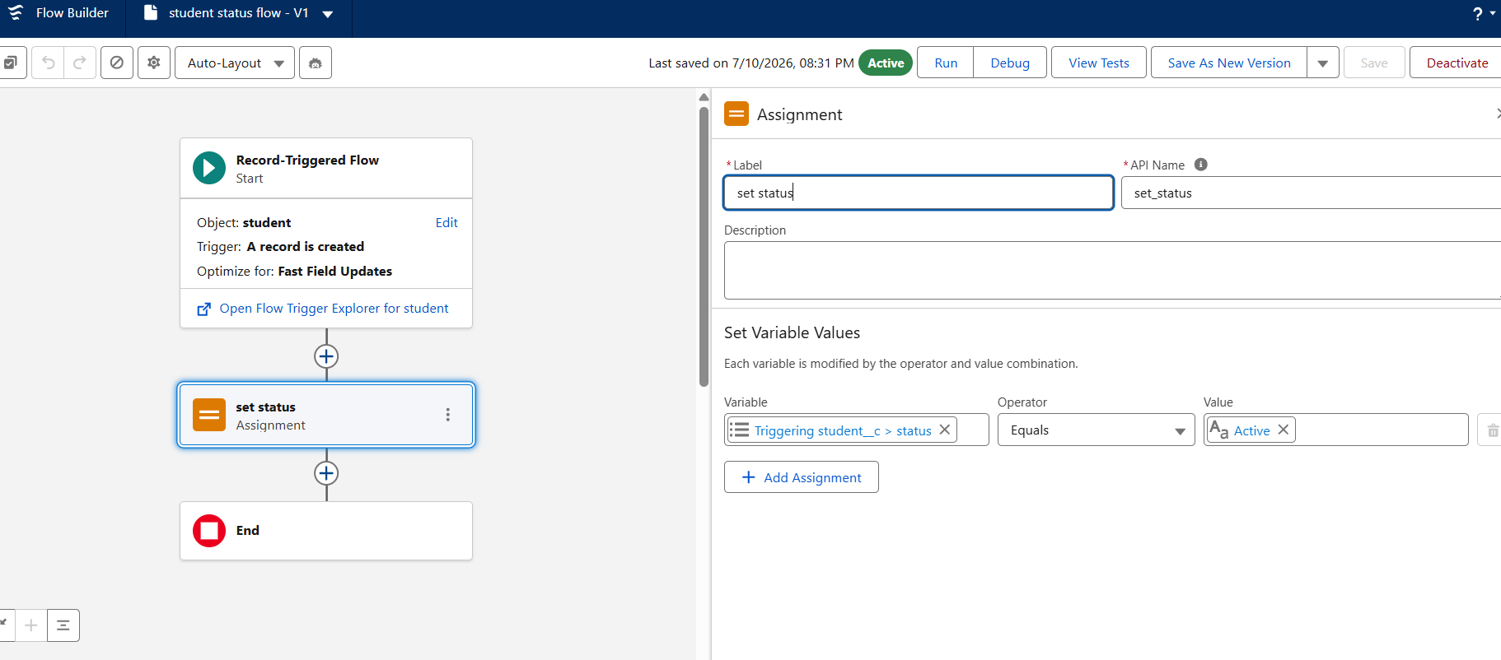

Apex Class
A custom Apex Class named StudentController was developed.

Purpose
The Apex Class retrieves the total number of Student records stored in Salesforce.

Apex Code
public class StudentController {

public static Integer getTotalStudents() {

return [SELECT COUNT() FROM Student__c];

}

}

Explanation
The getTotalStudents() method executes a SOQL query to count the total number of Student records in the Student object. This method can be reused in future enhancements such as Lightning Components or Visualforce pages.

Advantages
- Reusable code
- Improved maintainability
- Supports future integration
📸 Screenshot: Apex Class
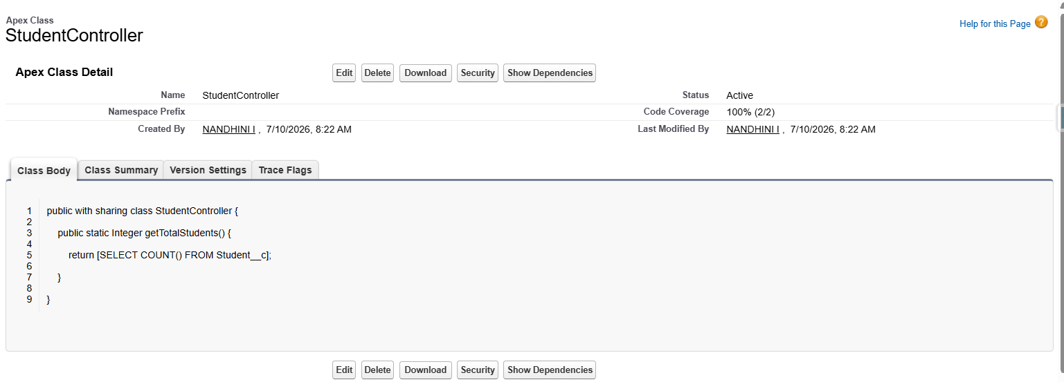

Apex Trigger
A Trigger named StudentTrigger was created.

Purpose
The trigger automatically converts the Student Name into uppercase before inserting the record into the database.

Apex Code
trigger StudentTrigger on Student__c (before insert) {

for(Student__c s : Trigger.new){

if(s.Name != null){

s.Name = s.Name.toUpperCase();

}

}

}

Explanation
The Trigger executes before a Student record is inserted into Salesforce. It converts the value entered in the Student Name field into uppercase letters, ensuring consistent formatting of student names.

Benefits
- Standardizes student names
- Eliminates manual formatting
- Improves data consistency
📸 Screenshot: Apex Trigger
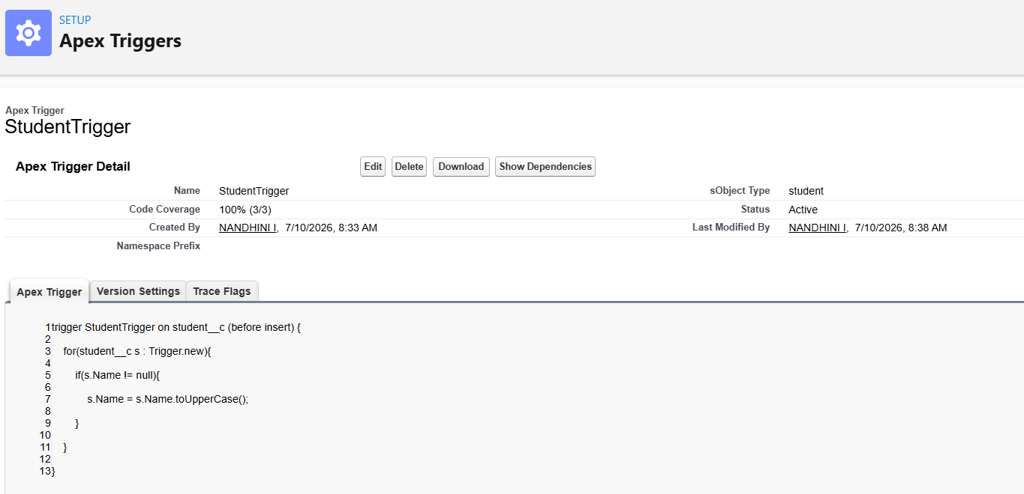

Apex Test Class
Salesforce requires Apex code to be tested before deployment.
A Test Class named StudentControllerTest was created to verify the functionality of the Apex Class.

Purpose
- Validate Apex logic
- Ensure correct execution
- Improve code quality

Test Class
@isTest
public class StudentControllerTest {

@isTest
static void testStudent(){

Student__c s = new Student__c(

Name='Nandhini',

Roll_Number__c='23IT113'

);

insert s;

Integer total = StudentController.getTotalStudents();

System.assertEquals(1,total);

}

}

Result
The test class executed successfully with adequate code coverage, confirming that the Apex Class functions correctly.
📸 Screenshot: Test Class + Test Execution
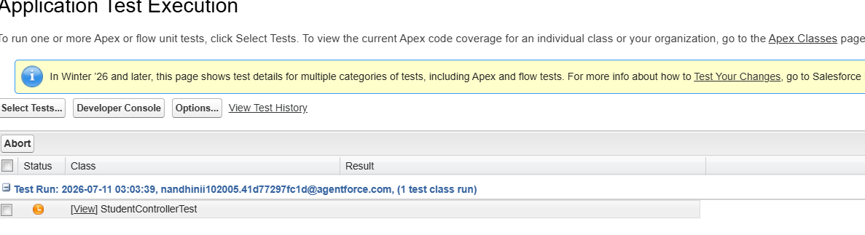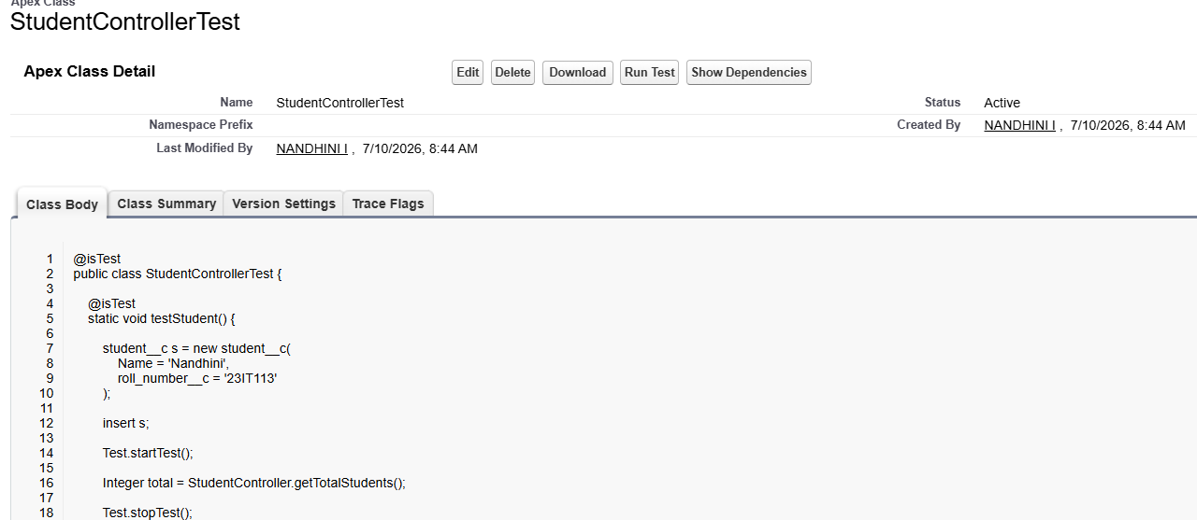

Summary
The Salesforce backend development for the Student Registration CRM successfully combines declarative and programmatic features. Custom objects, custom fields, validation rules, formula fields, automation using Flows, Apex Classes, Apex Triggers, and Test Classes work together to create a secure and efficient application for managing student records. These components ensure data accuracy, reduce manual effort, and provide a scalable foundation for future enhancements.

CHAPTER 4 – UI/UX DEVELOPMENT & CUSTOMIZATION

Introduction
A well-designed User Interface (UI) plays an important role in improving the usability of any CRM application. Salesforce Lightning Experience provides a modern, responsive, and user-friendly interface that allows users to access records, perform operations, and analyze data efficiently.
In the Student Registration CRM, the user interface was customized using Lightning App Builder, Page Layouts, Lightning Record Pages, Reports, Dashboards, and User Management. These customizations help users easily navigate through the application and manage student records effectively.

Lightning Application
A custom Lightning Application named Student Registration CRM was created using Salesforce App Manager. The application serves as the main interface for accessing all project components.
The Lightning App contains:
- Student Object
- Reports
- Dashboards
The application allows users to quickly navigate between different features without accessing the Salesforce Setup menu.

Advantages
- User-friendly interface
- Easy navigation
- Faster access to records
- Better user experience
📸 Screenshot: Student Registration CRM Lightning App
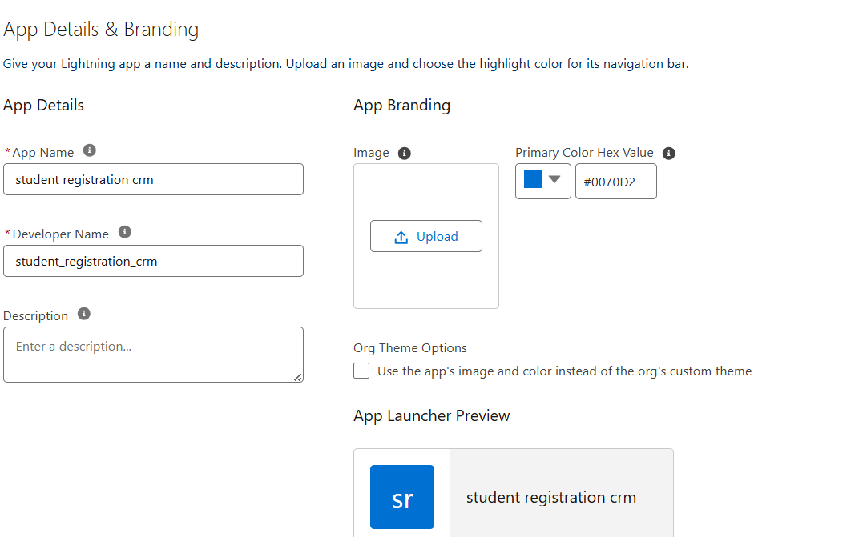

App Navigation
The navigation bar of the Student Registration CRM contains the essential tabs required by users.

Navigation Items
- Home
- Student
- Reports
- Dashboards
These navigation items help users quickly access different parts of the application.

Benefits
- Improved accessibility
- Reduced navigation time
- Organized workspace
📸 Screenshot: Navigation Bar
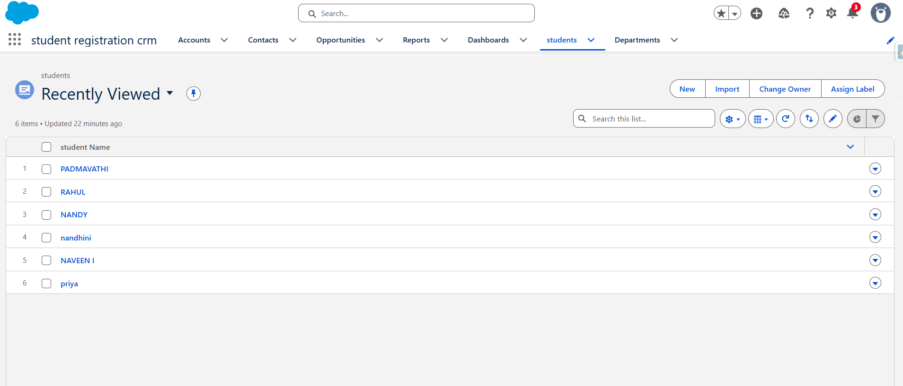

Page Layout
Page Layouts control how information is displayed on the Student record page.
A customized Page Layout was created to display student information in an organized manner.
The Information section contains:
- Student Name
- Roll Number
- Department
- Status
- Email
- Phone
This arrangement improves readability and makes data entry easier for users.

Advantages
- Organized interface
- Easy data entry
- Better user experience
- Reduced confusion
📸 Screenshot: Student Page Layout
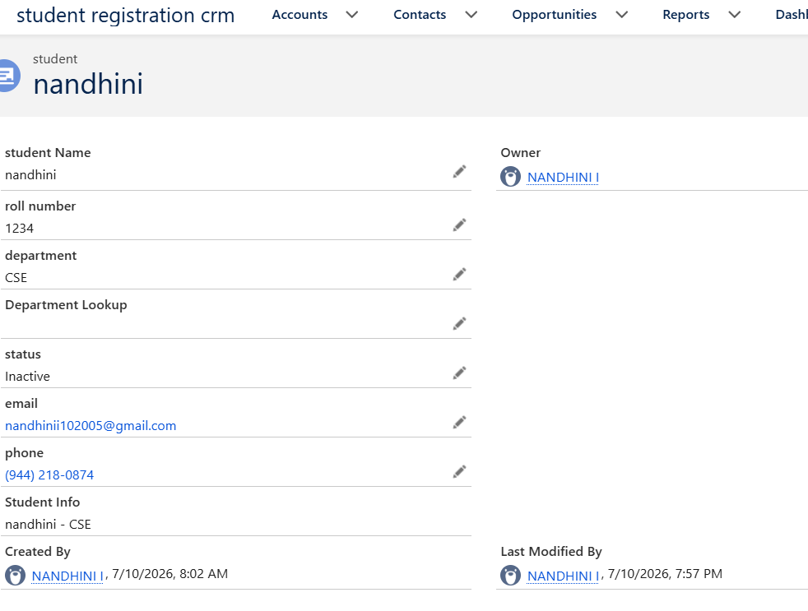

Lightning Record Page
The Lightning Record Page was customized using Lightning App Builder.
The customized page displays student information in a structured format, making it easier for users to view and update records.

Features
- Standard Record Details Component
- Related Lists
- Highlights Panel
- Activity Section
The Lightning Record Page provides a responsive interface that works well on desktop devices.

Benefits
- Modern UI
- Improved accessibility
- Better record visibility
📸 Screenshot: Lightning Record Page
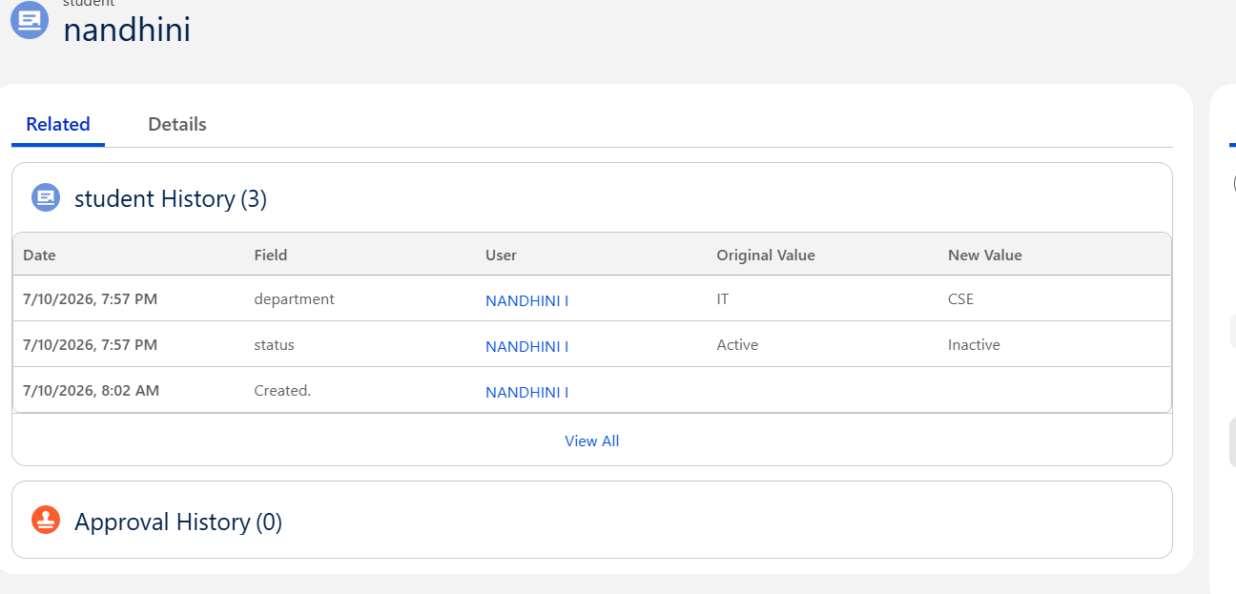

Student Record Management
The application allows users to perform all basic CRM operations on Student records.

Operations Performed
- Create Student Record
- Edit Student Record
- View Student Record
- Delete Student Record (if permitted)
- Search Student Record
Users can manage student information without writing any code.

Benefits
- Easy record management
- Faster updates
- Centralized student information
📸 Screenshot: Student Record
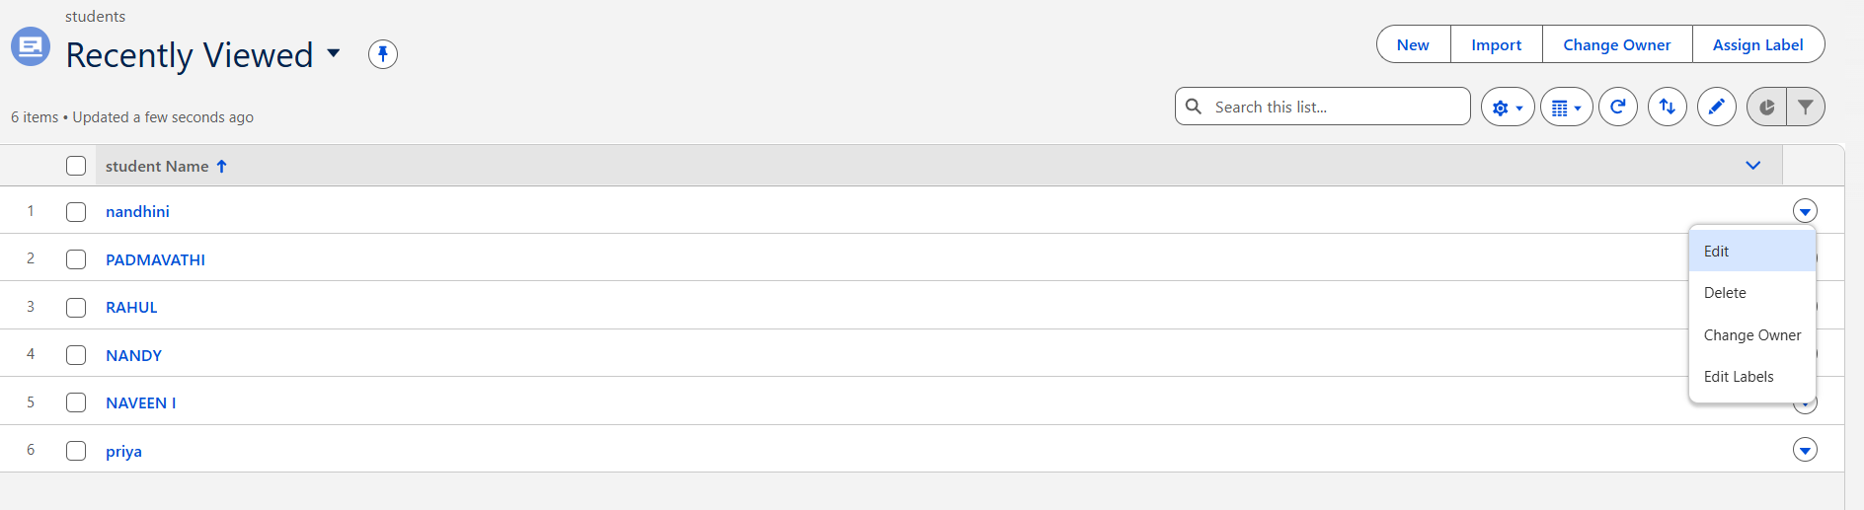

User Management
Salesforce provides secure user management through Profiles, Permission Sets, and Roles.
In this project, the following user management features were implemented:

Profiles
- System Administrator
- Standard User
The System Administrator profile has full access to the Student Registration CRM, while the Standard User has limited access based on assigned permissions.

Permission Set
A Permission Set named Student Manager was created to provide additional Create, Read, and Edit permissions on the Student object.

Role Hierarchy
The following Role Hierarchy was created:
Administrator
│
Student User
The Role Hierarchy improves record access and organizational structure.

Advantages
- Secure access control
- Flexible permission management
- Better data security
📸 Screenshots:
- Profiles
- Permission Set
- Role Hierarchy
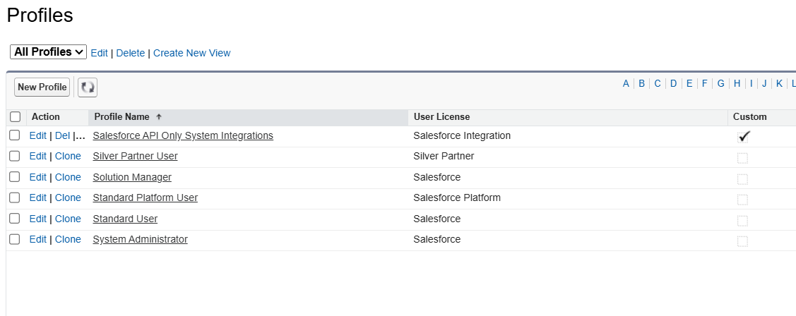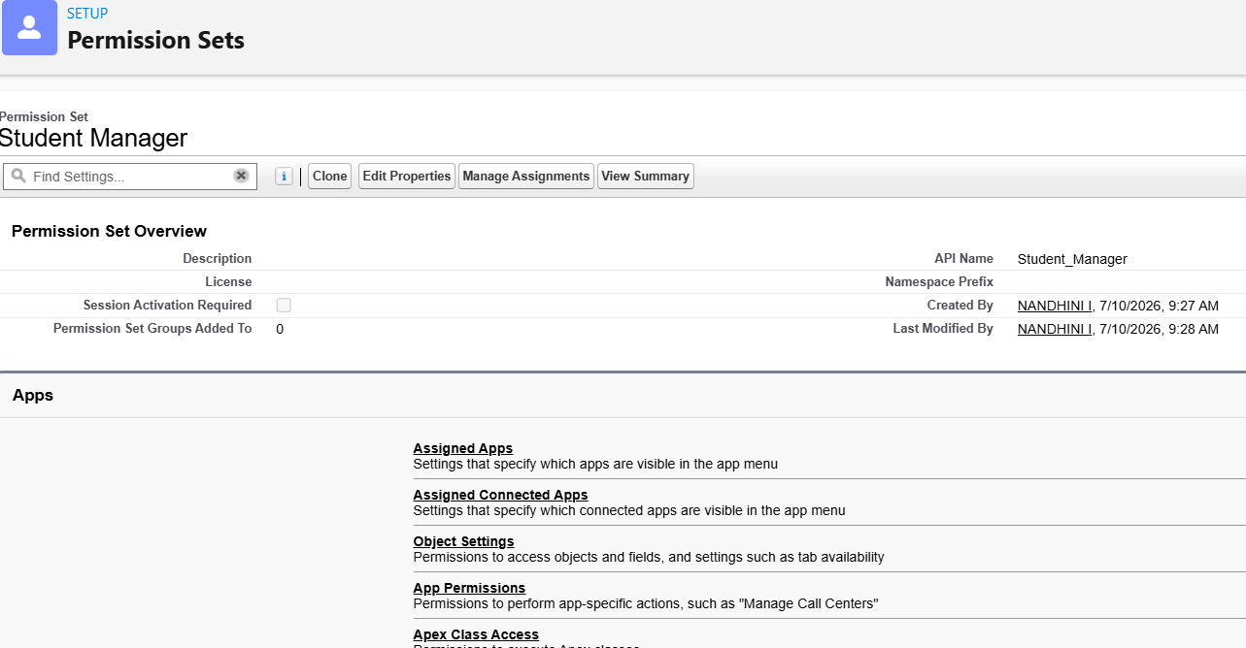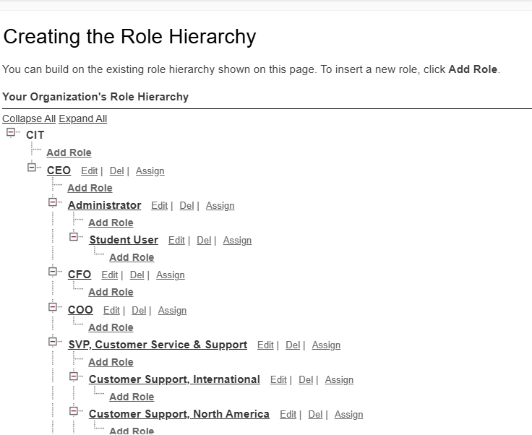

Reports
Reports help users analyze student information stored in Salesforce.
A report named Students by Department was created.
The report groups students according to their department and displays the number of students in each department.

Purpose
- Analyze student distribution
- Generate department-wise reports
- Improve decision-making

Benefits
- Easy analysis
- Real-time information
- Better reporting
📸 Screenshot: Students by Department Report
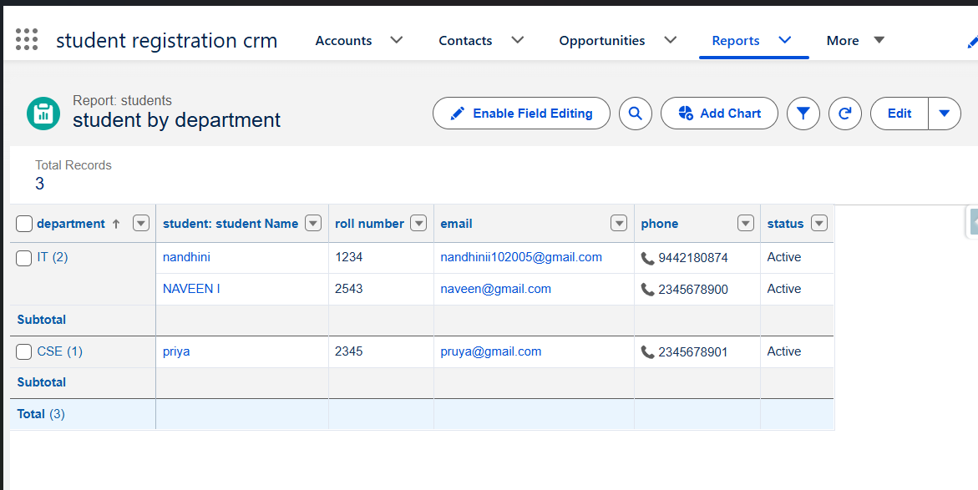

Dashboard
Dashboards provide graphical representations of Salesforce reports.
A dashboard was created to display student information visually.

Dashboard Components
- Total Students
- Students by Department
The dashboard enables administrators to monitor student records quickly without opening multiple reports.

Advantages
- Better visualization
- Quick analysis
- Real-time monitoring
- Improved decision-making
📸 Screenshot: Dashboard
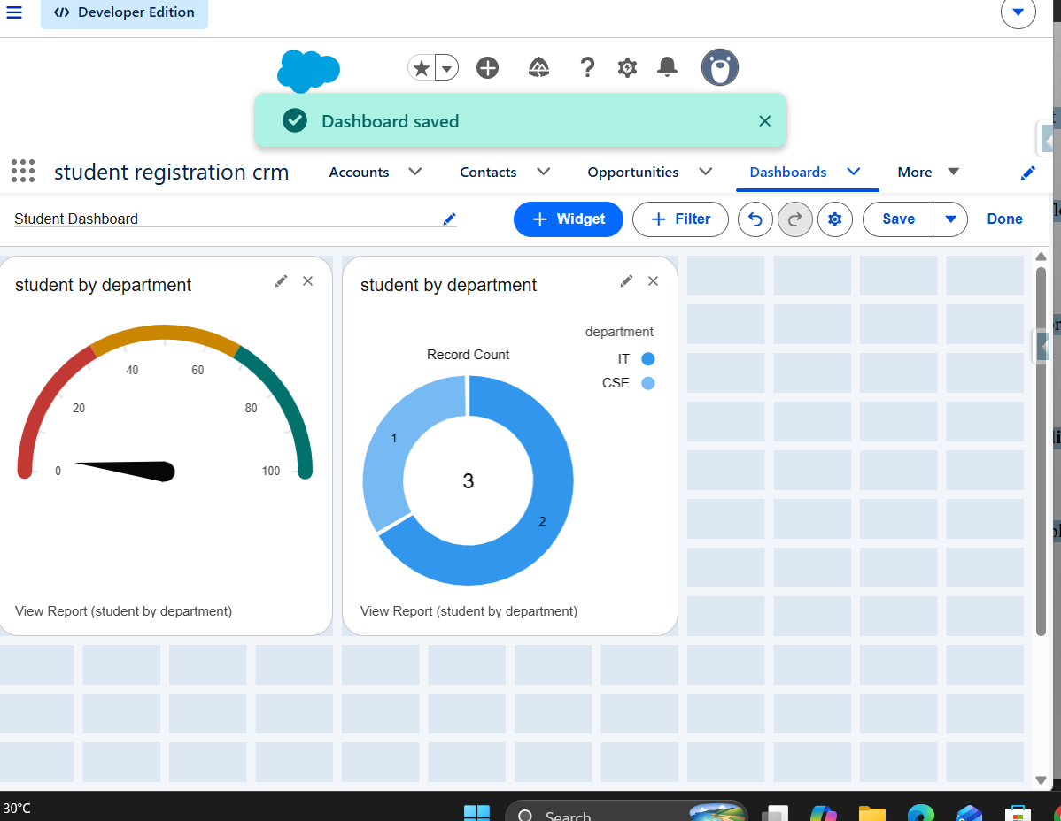

User Experience
The Student Registration CRM was designed to provide a simple and user-friendly experience.
Important UI features include:
- Easy navigation through Lightning App
- Organized Page Layout
- Responsive Lightning Record Page
- Simple data entry forms
- Interactive Reports
- Visual Dashboards
These features improve productivity and reduce the time required to manage student records.

Summary
The UI/UX customization of the Student Registration CRM improves the usability and accessibility of the application. The Lightning App, customized Page Layouts, Lightning Record Pages, Reports, Dashboards, and User Management features together provide an efficient environment for managing student records. The interface is simple, organized, and suitable for users with basic Salesforce knowledge.

CHAPTER 5 – DATA MIGRATION, TESTING & SECURITY

Introduction
Data migration, testing, and security are essential phases in Salesforce CRM development. After designing and developing the Student Registration CRM, it is important to verify that the application functions correctly, protects sensitive information, and allows only authorized users to access the system.
In this project, Salesforce's Data Import Wizard was used to import student records, security features were implemented using Profiles, Permission Sets, and Role Hierarchy, and testing was performed to ensure that all features worked as expected. Additional security measures such as Duplicate Rules, Matching Rules, and Field History Tracking were also configured to improve data quality and maintain data integrity.

Data Migration
Data migration is the process of importing data from an external source into Salesforce. Salesforce provides the Data Import Wizard, which allows administrators to import records using CSV files without writing any code.
In this project, the Data Import Wizard was used to import sample student records into the Student object.

Imported Fields
- Student Name
- Roll Number
- Department
- Status
- Email
- Phone

Advantages
- Faster record creation
- Easy bulk import
- Reduces manual data entry
- Improves productivity
📸 Screenshot: Data Import Wizard
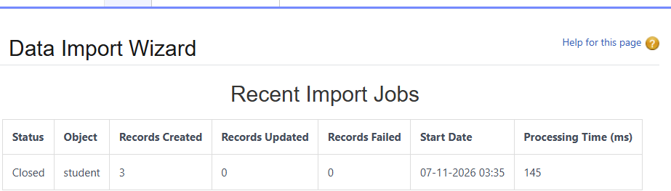

Profiles
Profiles control the basic permissions assigned to Salesforce users.
The following standard profiles were used:

System Administrator
The System Administrator profile has complete access to all Student Registration CRM features. Users with this profile can create, edit, delete, and manage records, configure Salesforce settings, and customize the application.

Standard User
The Standard User profile has limited access and is primarily responsible for creating and updating student records based on assigned permissions.

Advantages
- Secure user access
- Controlled permissions
- Better data management
📸 Screenshot: Profiles


Permission Set
A Permission Set named Student Manager was created to provide additional access to the Student object.
The Permission Set grants:
- Read
- Create
- Edit
permissions on the Student object.
Using Permission Sets allows additional permissions to be assigned without modifying the user's Profile.

Advantages
- Flexible permission management
- Better security
- Easy maintenance
📸 Screenshot: Permission Set
-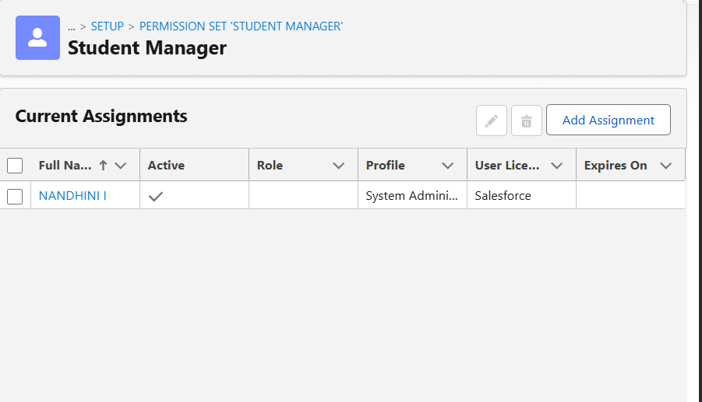

Role Hierarchy
Role Hierarchy controls record visibility based on an organization's structure.
The following hierarchy was created:
Administrator
│
Student User
This hierarchy ensures that higher-level users can access records owned by users below them in the hierarchy.

Advantages
- Controlled record access
- Better organizational structure
- Secure sharing of records
📸 Screenshot: Role Hierarchy
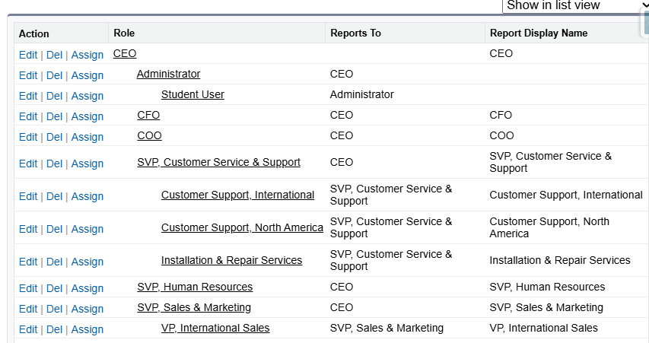

Field History Tracking
Field History Tracking was enabled to monitor changes made to important fields in the Student object.
The following fields were tracked:
- Status
- Department
Whenever a tracked field is modified, Salesforce records:
- Previous Value
- New Value
- Modified By
- Date and Time

Benefits
- Audit trail
- Easy monitoring
- Better accountability
📸 Screenshot: Field History Tracking
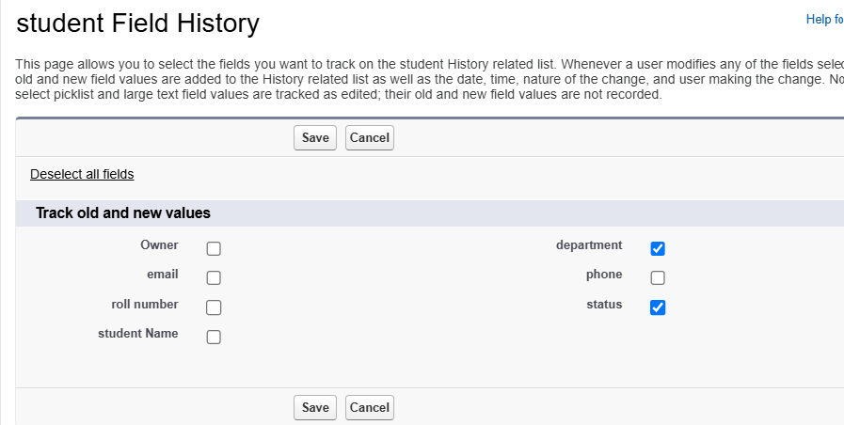

Matching Rule
A Matching Rule was created to detect duplicate student records based on the Email field.
Whenever a new Student record is created, Salesforce compares the Email value with existing records.
If a matching Email address is found, Salesforce identifies it as a potential duplicate.

Benefits
- Improves data quality
- Prevents duplicate entries
- Maintains data consistency
📸 Screenshot: Matching Rule
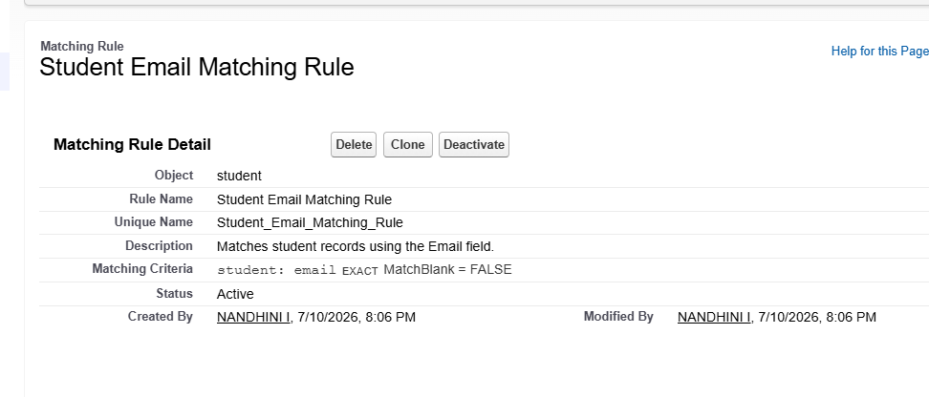

Duplicate Rule
A Duplicate Rule was configured using the Matching Rule.
The Duplicate Rule checks whether another Student record already exists with the same Email address.
If a duplicate is detected, Salesforce displays a warning message to the user.

Advantages
- Prevents duplicate student records
- Improves database quality
- Reduces manual verification
📸 Screenshot: Duplicate Rule
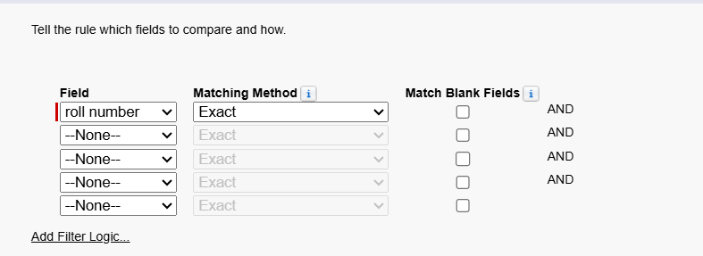

Apex Testing
Salesforce requires Apex code to be tested before deployment.
A Test Class named StudentControllerTest was created to verify the functionality of the Apex Class.
The Test Class performs the following operations:
- Creates a Student record
- Calls the Apex Class
- Verifies the number of Student records
- Uses assertions to validate the output
The test executed successfully and achieved the required code coverage.
📸 Screenshot: Apex Test Execution


Manual Testing
Manual testing was performed to ensure that all functionalities of the Student Registration CRM worked correctly.
The following features were tested:
- Student Record Creation
- Validation Rule
- Formula Field
- Record Triggered Flow
- Apex Trigger
- Apex Class
- Duplicate Rule
- Matching Rule
- Reports
- Dashboard
- Data Import Wizard
All implemented features functioned successfully according to the expected business requirements.

Test Cases
Test Case ID | Feature | Test Input | Expected Result | Actual Result | Status
TC01 | Student Record | Enter valid student details | Record created successfully | Record created | Pass
TC02 | Validation Rule | Leave mandatory field empty | Error message displayed | Error displayed | Pass
TC03 | Formula Field | Create Student record | Formula value displayed automatically | Displayed correctly | Pass
TC04 | Record Triggered Flow | Create Student record | Flow executes successfully | Executed | Pass
TC05 | Apex Trigger | Enter student name in lowercase | Name converted to uppercase | Converted | Pass
TC06 | Apex Class | Execute getTotalStudents() | Total records returned | Correct value returned | Pass
TC07 | Apex Test Class | Run Test | Test executes successfully | Passed | Pass
TC08 | Report | Generate Students by Department | Report generated | Generated | Pass
TC09 | Dashboard | Open Dashboard | Dashboard displayed | Displayed | Pass
TC10 | Permission Set | Assign Permission Set | User gets object permissions | Assigned | Pass
TC11 | Role Hierarchy | Login with different role | Records accessible based on hierarchy | Working | Pass
TC12 | Duplicate Rule | Create duplicate Email | Warning displayed | Warning displayed | Pass
TC13 | Matching Rule | Create same Email | Duplicate detected | Detected | Pass
TC14 | Field History Tracking | Update Status | History recorded | Recorded | Pass
TC15 | Data Import Wizard | Import CSV | Records imported | Imported | Pass

Security Summary
The Student Registration CRM uses Salesforce security features to protect student information.
Implemented security features include:
- System Administrator Profile
- Standard User Profile
- Permission Set
- Role Hierarchy
- Duplicate Rule
- Matching Rule
- Field History Tracking
These configurations ensure that student records remain secure while allowing authorized users to perform their tasks efficiently.

Summary
The Student Registration CRM successfully completed data migration, testing, and security implementation. The Data Import Wizard simplified record import, while Profiles, Permission Sets, and Role Hierarchy ensured secure access. Duplicate Rules, Matching Rules, and Field History Tracking improved data integrity. Manual testing and Apex Test Classes confirmed that the application functions correctly and satisfies the project requirements.

CHAPTER 6 – DEPLOYMENT, DOCUMENTATION & MAINTENANCE

Introduction
After the successful development and testing of the Student Registration CRM, the application is prepared for deployment and future maintenance. Deployment is the process of moving the application from the development environment to another Salesforce organization, such as a testing or production environment. Proper documentation and maintenance ensure that the application remains reliable, secure, and easy to enhance in the future.
This chapter explains the deployment strategy, documentation approach, system maintenance, and troubleshooting methods adopted for the Student Registration CRM project.

Deployment Strategy
Deployment is an essential stage in the Salesforce application lifecycle. It ensures that all developed components are transferred from the Developer Organization to another Salesforce environment without affecting existing functionality.
For this project, the recommended deployment method is Change Sets, which is the standard deployment tool provided by Salesforce.

Deployment Components
The following components are included during deployment:
- Custom Object (Student)
- Custom Fields
- Validation Rule
- Formula Field
- Record Triggered Flow
- Apex Class
- Apex Trigger
- Apex Test Class
- Lightning App
- Reports
- Dashboards
- Permission Set
- Role Hierarchy
- Matching Rule
- Duplicate Rule
Using Change Sets ensures that all configurations are migrated in an organized and secure manner.

Benefits
- Secure deployment
- Reliable migration of metadata
- Easy validation before deployment
- Supports version control and testing

Documentation
Project documentation plays a vital role in understanding, maintaining, and extending the Salesforce CRM application. This document records all configurations, customizations, automation, security settings, testing activities, and deployment information.
The documentation includes:
- Project Overview
- Requirement Analysis
- Salesforce Development
- UI Customization
- Security Configuration
- Data Migration
- Testing
- Deployment Strategy
- Maintenance Plan
- Future Enhancements
Well-prepared documentation helps developers, administrators, and future users understand the application without referring to the original developer.

System Maintenance
After deployment, the application requires regular maintenance to ensure smooth operation and accommodate changing business requirements.
The following maintenance activities are recommended:

Data Maintenance
- Regularly review student records.
- Remove duplicate or outdated records.
- Update student information when necessary.

Application Maintenance
- Modify Validation Rules if business requirements change.
- Update Flows to accommodate new processes.
- Review Apex code periodically.
- Refresh reports and dashboards as needed.

Security Maintenance
- Review user permissions regularly.
- Update Profiles and Permission Sets when new users are added.
- Monitor Field History Tracking logs.

Backup
Salesforce provides cloud-based storage and data export features that can be used to maintain regular backups of student records.

Troubleshooting
During development, several issues were encountered and resolved. Proper troubleshooting ensured the successful completion of the Student Registration CRM.

Issue 1 – Validation Rule Error
Problem: Student record could not be saved due to missing mandatory fields.
Solution: Entered valid values for all required fields before saving the record.

Issue 2 – Apex Trigger Error
Problem: Trigger failed when the Student Name field was empty.
Solution: Added a null check before converting the name to uppercase.

Issue 3 – Formula Field Error
Problem: Picklist fields cannot be concatenated directly in a Formula(Text) field.
Solution: Used the TEXT() function to convert picklist values into text before concatenation.

Issue 4 – Matching Rule Not Detecting Duplicates
Problem: Duplicate records were not detected.
Solution: Activated the Matching Rule and Duplicate Rule before testing.

Issue 5 – Approval Process Error
Problem: "No applicable approval process was found."
Solution: Correctly configured the entry criteria and activated the approval process.

Issue 6 – Field History Not Displaying
Problem: Field history was not visible in the Student record.
Solution: Added the Student History related list to the Page Layout and updated the tracked fields

Project Achievements
The Student Registration CRM successfully achieved the following:
- Developed a custom CRM application using Salesforce.
- Implemented custom objects and fields.
- Configured validation rules and formula fields.
- Automated business processes using Record Triggered Flow.
- Developed Apex Class, Apex Trigger, and Test Class.
- Created Reports and Dashboards.
- Configured Profiles, Permission Sets, and Role Hierarchy.
- Implemented Matching Rules, Duplicate Rules, and Field History Tracking.
- Imported student records using Data Import Wizard.
- Successfully tested all implemented features.
These achievements demonstrate both Salesforce Administration and Salesforce Development skills.

Summary
The deployment and maintenance phase ensures that the Student Registration CRM is ready for real-world use. A structured deployment strategy, comprehensive documentation, regular maintenance, and effective troubleshooting practices improve the application's reliability and scalability. The project provides a strong foundation for future enhancements and demonstrates best practices in Salesforce CRM development.

CHAPTER 7 – CONCLUSION

Conclusion
The Student Registration CRM developed using the Salesforce Lightning Platform successfully fulfills the objective of managing student information in an efficient, secure, and organized manner. The project demonstrates how Salesforce can be used to develop a cloud-based Customer Relationship Management (CRM) application using both declarative and programmatic development approaches.
The application enables users to create, update, and manage student records while maintaining data accuracy through Validation Rules and Formula Fields. Business processes were automated using Record-Triggered Flows, reducing manual effort and improving operational efficiency. Apex programming was used to implement custom business logic through an Apex Class and Apex Trigger, while an Apex Test Class ensured that the developed code met Salesforce testing requirements.
Security was enhanced through the implementation of Profiles, Permission Sets, Role Hierarchy, Matching Rules, Duplicate Rules, and Field History Tracking. These features help maintain data integrity, control user access, and provide an audit trail for important field changes.
Reports and Dashboards provide meaningful insights into student information, enabling administrators to analyze records and make informed decisions. The Data Import Wizard simplifies the migration of student data into Salesforce, making the application suitable for handling bulk records.
Overall, the Student Registration CRM successfully combines Salesforce Administration and Salesforce Development concepts into a single application. The project provides hands-on experience in designing, developing, testing, and securing a CRM solution while following Salesforce best practices. The application is scalable and can be extended with additional features in the future to meet evolving business requirements.

Project Outcomes
The following outcomes were achieved during the development of the Student Registration CRM:
- Developed a cloud-based CRM application using Salesforce.
- Created a custom Student object with relevant custom fields.
- Configured Validation Rules to improve data quality.
- Implemented a Formula Field to display calculated information.
- Automated business processes using a Record-Triggered Flow.
- Developed an Apex Class to retrieve student information.
- Implemented an Apex Trigger to automatically convert student names to uppercase.
- Created an Apex Test Class to validate Apex functionality.
- Designed Reports and Dashboards for data analysis.
- Configured Profiles, Permission Sets, and Role Hierarchy for user management.
- Enabled Field History Tracking for auditing changes.
- Implemented Matching Rules and Duplicate Rules to prevent duplicate student records.
- Imported sample student data using the Data Import Wizard.
- Successfully tested all implemented features.
These outcomes demonstrate practical knowledge of Salesforce Administration and Development concepts.

Business Benefits
The Student Registration CRM provides several benefits to educational institutions:
- Centralized storage of student information.
- Faster student registration and record management.
- Improved data accuracy through validation.
- Reduced manual effort with automation.
- Better security using Salesforce access controls.
- Easy generation of reports and dashboards.
- Prevention of duplicate records.
- Cloud-based accessibility from anywhere.
- Easy maintenance and scalability.
- Improved decision-making through data analytics.
These benefits make the application suitable for educational institutions that require an efficient and secure system for managing student information.

Learning Outcomes
During the development of this project, the following Salesforce concepts were learned and implemented:

Salesforce Administration
- Custom Objects
- Custom Fields
- Validation Rules
- Formula Fields
- Record-Triggered Flows
- Reports
- Dashboards
- Profiles
- Permission Sets
- Role Hierarchy
- Matching Rules
- Duplicate Rules
- Field History Tracking
- Data Import Wizard

Salesforce Development
- Apex Programming
- SOQL Queries
- Apex Classes
- Apex Triggers
- Apex Test Classes
The project also improved problem-solving skills, understanding of Salesforce architecture, and practical experience in CRM application development.

Summary
The Student Registration CRM project successfully demonstrates the capabilities of the Salesforce platform in building secure, scalable, and user-friendly CRM applications. By combining declarative tools with Apex programming, the project provides a complete solution for managing student records. The implementation of automation, security, reporting, and testing ensures that the application is reliable and ready for future enhancements.

CHAPTER 8 – FUTURE ENHANCEMENTS

Introduction
The Student Registration CRM developed using Salesforce successfully meets the current requirements of managing student records in a secure and organized manner. Although the application includes several important Salesforce Administration and Development features, there is always scope for further improvement. Future enhancements can increase automation, improve user experience, strengthen security, and integrate advanced Salesforce technologies.
The following enhancements are proposed to make the application more efficient and suitable for large-scale educational institutions.

Approval Process
Currently, student records are created and updated directly by authorized users. In future versions, an Approval Process can be implemented to ensure that important changes are reviewed before being accepted.
For example, when a student's status changes to Pending, the record can automatically be sent to an administrator for approval. Once approved, the status can be updated to Approved, ensuring better control over sensitive data modifications.

Benefits
- Improves data accuracy
- Provides controlled approval workflow
- Reduces unauthorized updates
- Maintains accountability

Lookup Relationship
The current project stores student information in a single custom object. In future, Lookup Relationships can be introduced to connect the Student object with other custom objects such as Department, Faculty, or Course.
For example:
- Student → Department
- Student → Course
- Student → Faculty
This enhancement will reduce data redundancy and improve data organization.

Benefits
- Better data relationships
- Easier record management
- Improved scalability
- Reduced duplicate information

Sharing Rules
Although Profiles, Permission Sets, and Role Hierarchy are implemented, Sharing Rules can be added to provide more flexible record-level access.
For example, department coordinators can be granted access only to the student records belonging to their department, while administrators continue to have access to all records.

Benefits
- Improved collaboration
- Secure record sharing
- Better control over record visibility
- Enhanced security

Lightning Web Components (LWC)
Lightning Web Components (LWC) provide a modern and interactive user interface.
Future versions of the Student Registration CRM can include LWCs for:
- Student Registration Form
- Student Search Component
- Department Dashboard
- Student Statistics
- Recent Student Records
Using LWC will make the application more responsive and provide a better user experience.

Benefits
- Faster performance
- Reusable components
- Attractive user interface
- Better user experience

Email Notifications
Automatic email notifications can be implemented using Salesforce Flows or Apex.
Examples include:
- Notify students after successful registration.
- Inform administrators when new student records are created.
- Send reminders for incomplete student information.
- Notify users when approval requests are completed.

Benefits
- Improved communication
- Reduced manual follow-up
- Better workflow automation

AI-Based Student Analytics
Salesforce Einstein AI can be integrated in future versions to provide intelligent insights.
Possible AI features include:
- Student performance prediction
- Department-wise trend analysis
- Student activity monitoring
- Automated recommendations
- Predictive reports

Benefits
- Better decision-making
- Intelligent reporting
- Improved planning
- Enhanced data analysis

Mobile Accessibility
Although Salesforce provides a mobile application, future versions can be optimized specifically for mobile users.
Features may include:
- Student registration using mobile devices
- Mobile dashboards
- Push notifications
- Mobile approval requests

Benefits
- Access from anywhere
- Increased productivity
- Better user convenience

Integration with External Systems
The Student Registration CRM can be integrated with external systems using Salesforce APIs.
Possible integrations include:
- College Management System
- Learning Management System (LMS)
- Attendance Management System
- Examination Portal
- Email Services
Such integrations will eliminate duplicate data entry and improve overall efficiency.

Benefits
- Centralized information
- Seamless data exchange
- Improved automation
- Better operational efficiency

Overall Future Scope
The Student Registration CRM has been designed with scalability in mind. As the number of students and users grows, the application can be extended by adding more custom objects, automation, security features, integrations, and advanced Salesforce capabilities.
With continuous improvements, the application can evolve into a comprehensive Student Information Management System that supports all academic and administrative processes.

Summary
The Student Registration CRM provides a strong foundation for managing student information. Future enhancements such as Approval Processes, Lookup Relationships, Sharing Rules, Lightning Web Components, AI-powered analytics, mobile access, and external system integration will further improve the application's functionality, usability, and scalability. These enhancements will enable the CRM to support more complex business requirements and provide greater value to educational institutions.

Chapter 9 – References & Appendix

References
The following resources were referred to during the development and implementation of the Salesforce Student Registration CRM Application.

Salesforce Official Documentation
- Salesforce Developer Documentation
Salesforce Developer documentation was used to understand Apex programming, triggers, classes, SOQL queries, Lightning components, and Salesforce platform development concepts.
Reference:
https://developer.salesforce.com/docs
- Salesforce Trailhead Learning Platform
Trailhead modules were used for learning Salesforce Administration concepts, Object Management, Security Settings, Automation using Flow Builder, and Apex development.
Reference:
https://trailhead.salesforce.com/
- Apex Developer Guide
The Apex Developer Guide was referred to understand Apex syntax, classes, methods, exception handling, database operations, and best coding practices.
Reference:
https://developer.salesforce.com/docs/atlas.en-us.apexcode.meta/apexcode/
- SOQL and SOSL Reference Guide
The SOQL documentation helped in creating efficient queries to retrieve and manipulate student registration records.
Reference:
https://developer.salesforce.com/docs/atlas.en-us.soql_sosl.meta/soql_sosl/
- Salesforce Lightning Experience Documentation
The Lightning Experience documentation was used for designing user-friendly record pages, layouts, and Salesforce UI components.
Reference:
https://help.salesforce.com/

Apex Class

Apex Class: Student Registration Controller

Purpose
The Apex class is responsible for handling business logic related to student registration records. It performs database operations and provides methods to create and retrieve student information.

Apex Code
public class StudentRegistrationController {

// Method to create a new student record
public static Student__c createStudent(
String studentName,
String email,
String department
) {

Student__c student = new Student__c();

student.Name = studentName;
student.Email__c = email;
student.Department__c = department;

insert student;

return student;
}

// Method to retrieve student records
public static List<Student__c> getStudents(){

List<Student__c> students =
[SELECT Id, Name, Email__c, Department__c
FROM Student__c];

return students;
}

}

Explanation
- The class contains methods to manage student registration records.
- The createStudent() method inserts new student details into Salesforce.
- The getStudents() method retrieves student records using SOQL.
- Database operations are performed using Salesforce DML statements.

Apex Trigger

Apex Trigger: Student Registration Trigger

Purpose
The trigger automatically executes when a student record is created or updated. It is used to perform automated validations and update related information.

Apex Code
trigger StudentRegistrationTrigger
on Student__c (before insert, before update) {

for(Student__c student : Trigger.new){

if(student.Email__c == null){

student.addError(
'Student Email cannot be empty'
);

}

}

}

Explanation
- The trigger runs before inserting or updating Student records.
- It validates whether the student's email field is entered.
- If the email field is empty, the record creation process is stopped.
- Trigger.new contains the new versions of records being processed.

Apex Test Class

Apex Test Class: Student Registration Controller Test

Purpose
The test class validates the functionality of Apex classes and ensures that the code meets Salesforce code coverage requirements.

Apex Code
@isTest
public class StudentRegistrationControllerTest {

@isTest
static void testCreateStudent(){

Student__c student =
StudentRegistrationController.createStudent(
'Nandhini',
'student@gmail.com',
'Information Technology'
);

System.assertNotEquals(
null,
student.Id
);

}

@isTest
static void testGetStudents(){

Student__c student = new Student__c();

student.Name = 'Test Student';
student.Email__c = 'test@gmail.com';
student.Department__c = 'IT';

insert student;

List<Student__c> students =
StudentRegistrationController.getStudents();

System.assert(
students.size() > 0
);

}

}

Explanation
- The test class verifies whether Apex functionality works correctly.
- @isTest annotation defines a Salesforce test method.
- Test data is created inside the test class.
- Assertions are used to verify expected results.
- This ensures reliable deployment of Apex code.

SOQL Query Explanation and Code Snippets

Introduction to SOQL
Salesforce Object Query Language (SOQL) is used to retrieve data from Salesforce objects. It is similar to SQL but designed specifically for Salesforce database objects.

Query 1: Retrieve All Student Records

SOQL Query
SELECT Id, Name, Email__c, Department__c
FROM Student__c

Explanation
This query retrieves:
- Student Record ID
- Student Name
- Email Address
- Department
from the custom object Student__c.

Query 2: Retrieve Students From a Specific Department

SOQL Query
SELECT Name, Email__c
FROM Student__c
WHERE Department__c = 'Information Technology'

Explanation
The WHERE clause filters records based on department.
Only students belonging to Information Technology department are displayed.

Query 3: Count Total Registered Students

SOQL Query
SELECT COUNT()
FROM Student__c

Explanation
The aggregate function COUNT() returns the total number of registered students.

Query 4: Sort Student Records

SOQL Query
SELECT Name, Email__c
FROM Student__c
ORDER BY Name ASC

Explanation
The ORDER BY clause sorts student records alphabetically based on student name.

Conclusion
This chapter provides supporting technical resources and implementation details of the Salesforce Student Registration CRM application.
The references helped in understanding Salesforce platform features, while the appendices demonstrate the practical implementation of Apex classes, triggers, testing methods, and SOQL queries used in the project.
The completed documentation represents the complete development lifecycle of the Salesforce CRM solution, including requirement analysis, design, implementation, automation, security, testing, and deployment.

