CUSTOMER ENGAGEMENT PLATFORM

Developer | Nandhini M
Project Title | Customer Engagement Platform
Technology Stack | ASP.NET Core MVC (.NET 8), SQL Server, Entity Framework Core, ADO.NET, JWT, Swagger, Docker, GitHub Actions
Architecture | Layered MVC with Repository Pattern
Submission Date | June 2026

Table of Contents

S.No | Title | Page No.
1 | Abstract | 4
2 | Introduction | 5
 | 2.1 Problem Statement | 5
 | 2.2 Scope of the Project | 5
3 | Project Objectives | 6
4 | System Architecture | 7
 | 4.1 Architecture Diagram | 7
 | 4.2 Architectural Layers | 7
 | 4.3 Application Entry Point — Program.cs | 8
5 | Data Flow Diagram (DFD) | 9
6 | Database Design | 10
 | 6.1 Entity Relationship Diagram | 10
 | 6.2 Database Tables | 10
 | 6.3 Database Trigger | 11
 | 6.4 SQL JOIN Query | 11
7 | Data Models | 12
 | 7.1 Customer Model | 12
 | 7.2 Ticket Model | 12
 | 7.3 User Model | 12
8 | Authentication and Authorization | 13
 | 8.1 JWT Authentication | 13
 | 8.2 JWT Implementation Steps | 13
 | 8.3 Token Structure | 13
 | 8.4 Role-Based Authorization | 14
9 | Frontend and Backend Connectivity | 15
 | 9.1 MVC View Layer | 15
 | 9.2 AJAX Integration | 15
 | 9.3 Dependency Injection | 15
10 | Repository Pattern | 16
 | 10.1 Interface Definition | 16
 | 10.2 CustomerRepository Implementation | 16
 | 10.3 ADO.NET Helper | 16
11 | API Documentation — Swagger / OpenAPI | 17
 | 11.1 API Endpoint Summary | 17
12 | SOLID Principles | 18
13 | Design Patterns | 19
14 | Key Modules | 20
 | 14.1 Customer Management Module | 20
 | 14.2 Service Ticket Management Module | 20
 | 14.3 Authentication Module | 20
 | 14.4 EF Core and Migrations | 20
 | 14.5 ADO.NET Module | 20
15 | Exception Handling Strategy | 21
16 | Traditional vs. Modern Development | 22
17 | Docker and CI/CD Pipeline | 23
 | 17.1 Docker Containerization | 23
 | 17.2 GitHub Actions CI/CD Workflow | 23
18 | Azure App Service Hosting Model | 24
19 | Testing | 25
 | 19.1 Unit Tests | 25
 | 19.2 Manual Testing Coverage | 25
20 | AI / GitHub Copilot Usage | 26
21 | Industry Best Practices Applied | 27
22 | Comparison with Live Applications | 28
23 | Future Scope | 29
24 | Conclusion | 30
25 | Screenshots | 31
 | 25.1 Application Home Page | 31
 | 25.2 Customer List View | 31
 | 25.3 Create Customer Form | 32
 | 25.4 Ticket List View | 32
 | 25.5 Create Ticket Form | 32
 | 25.6 Swagger UI — API Overview | 33
 | 25.7 Swagger — JWT Login | 33
 | 25.8 Swagger — Authorize with Bearer Token | 33
 | 25.9 Swagger — GET /api/customerapi | 34
 | 25.10 Swagger — DELETE Endpoint (Admin) | 34
 | 25.11 SQL Server — Database Tables | 34
 | 25.12 SQL Server — DeletedTicketsLog | 35
 | 25.13 Unit Test Results | 36

1. Abstract
The Customer Engagement Platform is a comprehensive web application developed using ASP.NET Core MVC (.NET 8) that provides businesses with a robust system for managing customer information and service tickets. The platform incorporates secure REST APIs, JSON Web Token (JWT) authentication, role-based authorization, Entity Framework Core database integration, ADO.NET data access, and full DevOps readiness through Docker containerization and GitHub Actions CI/CD pipelines.
This project demonstrates mastery of modern software engineering principles including the Repository Pattern, Dependency Injection, SOLID principles, layered architecture, Swagger API documentation, and cloud-readiness through an Azure App Service hosting model. The system is conceptually comparable to industry-standard platforms such as ServiceNow, Zendesk, and Freshdesk.

2. Introduction
Modern enterprises require efficient and scalable systems to manage customer relationships and support workflows. Traditional monolithic systems often suffer from tight coupling, poor scalability, and limited extensibility. This project addresses these challenges by building a Customer Engagement Platform using cutting-edge technologies and industry-standard architecture patterns.
The platform provides a unified solution for customer data management, service ticket lifecycle tracking, secure user authentication, and audit logging. It is built on .NET 8, the latest Long-Term Support version of the .NET platform, ensuring performance, security, and long-term maintainability.

2.1 Problem Statement
Organizations managing customer interactions and support requests often face challenges such as data silos, lack of audit trails, insecure access control, and inability to integrate with external systems. The Customer Engagement Platform solves these issues by providing a centralized, secure, API-driven solution with role-based access control and automated audit logging.

2.2 Scope of the Project
The scope of this project includes the following functional and technical areas:
- Full CRUD operations for Customers and Service Tickets
- JWT-based authentication and role-based authorization
- REST API layer documented through Swagger/OpenAPI
- Repository Pattern with Dependency Injection
- EF Core and ADO.NET dual data access strategies
- Database triggers for audit logging
- Docker containerization and GitHub Actions CI/CD pipeline
- Azure App Service cloud hosting model
- Unit testing with xUnit framework

3. Project Objectives
The primary objectives of the Customer Engagement Platform project are as follows:
- Develop a fully functional ASP.NET Core MVC application with layered architecture for managing customer data and service tickets.
- Implement secure JWT authentication and role-based authorization to protect sensitive operations.
- Expose business functionality through RESTful API endpoints documented via Swagger/OpenAPI.
- Apply the Repository Pattern and Dependency Injection to ensure loose coupling and high testability.
- Integrate both Entity Framework Core (code-first ORM) and ADO.NET for flexible data access.
- Implement SQL Server triggers for automated audit logging of deleted ticket records.
- Containerize the application using Docker and establish a CI/CD pipeline via GitHub Actions.
- Design an Azure App Service hosting model for cloud deployment readiness.
- Apply SOLID principles and industry best practices throughout the codebase.
- Deliver unit tests covering critical business logic using the xUnit framework.

4. System Architecture
The Customer Engagement Platform follows a multi-layered architecture designed for separation of concerns, scalability, and maintainability. Each layer has a clearly defined responsibility, and communication between layers is governed through well-defined interfaces.

4.1 Architecture Overview
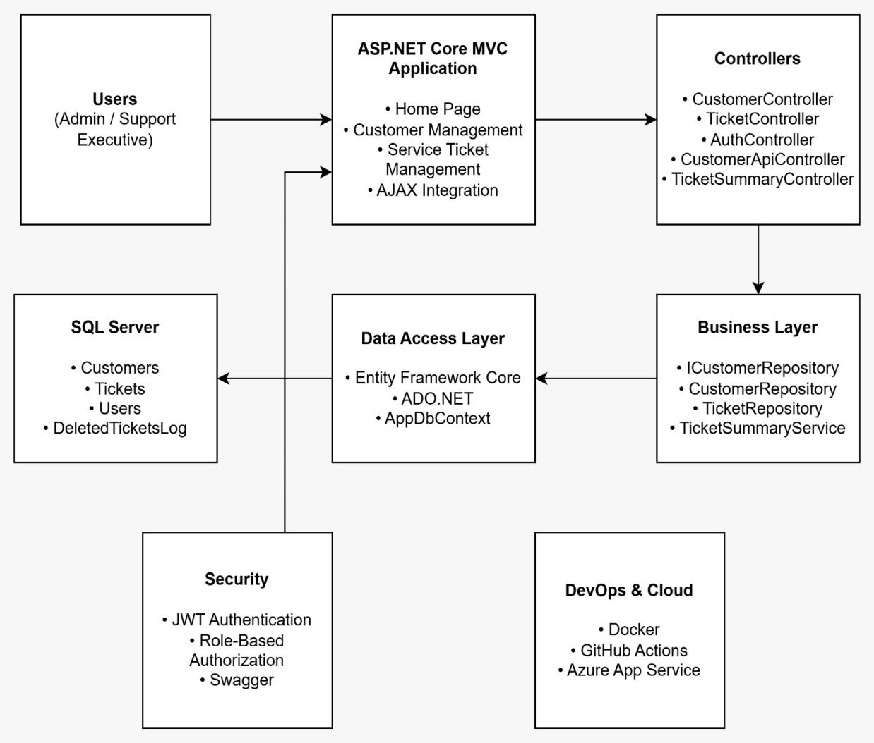
Figure 1: System Architecture Diagram — Customer Engagement Platform

4.2 Architectural Layers
The system is organized into the following distinct layers:

Layer | Components | Responsibility
Presentation Layer | MVC Views, Razor Pages | Renders HTML UI; handles form submissions via jQuery/AJAX
Controller Layer | CustomerController, TicketController, HomeController | Handles HTTP requests; routes to repository/service layer
API Controller Layer | CustomerApiController, AuthController, TicketSummaryController | Exposes RESTful endpoints; enforces JWT authorization
Business / Repository Layer | ICustomerRepository, CustomerRepository, TicketSummaryService | Encapsulates business logic; implements data access abstraction
Data Access Layer | AppDbContext (EF Core), AdoNetHelper (ADO.NET) | Manages ORM queries and raw SQL commands
Database Layer | SQL Server — Customers, Tickets, Users, DeletedTicketsLog | Persists application data; enforces referential integrity
Security Layer | JWT Bearer Authentication, Role-Based Authorization | Validates tokens; restricts operations by user role
DevOps Layer | Docker, GitHub Actions, Azure App Service | Enables containerization, CI/CD automation, and cloud hosting

4.3 Application Entry Point — Program.cs
The Program.cs file serves as the application composition root. It registers all services, configures middleware, sets up JWT authentication, enables Swagger, and defines the MVC route pattern. Key registrations include:
- AddDbContext — EF Core SQL Server integration
- AddScoped<ICustomerRepository, CustomerRepository> — Repository DI
- AddAuthentication(JwtBearerDefaults.AuthenticationScheme) — JWT middleware
- AddSwaggerGen — Swagger with Bearer token support
- MapControllerRoute — Default MVC routing pattern

5. Data Flow Diagram (DFD)
The Data Flow Diagram illustrates how data moves through the system from the user interface layer down to the SQL Server database and back. The following describes the flow:

- Users (Admin or Support Executive) interact with MVC Views or call API endpoints through Swagger or external clients.
- HTTP requests are routed by the ASP.NET Core routing engine to the appropriate Controller (MVC or API).
- Controllers invoke the Repository Layer through the ICustomerRepository interface, using Dependency Injection.
- The Repository delegates database operations to either Entity Framework Core (via AppDbContext) or ADO.NET (via AdoNetHelper).
- EF Core translates LINQ queries into optimized SQL and executes them against SQL Server.
- SQL Server processes the request, applies triggers (for deletes), and returns result sets.
- Results are mapped to model objects and returned up the chain to the Controller.
- The Controller passes data to the View or serializes it as JSON for API responses.

Component | Description
User Interface | Razor MVC Views with Bootstrap styling and jQuery AJAX for dynamic ticket search
Controller Layer | Processes HTTP GET/POST requests; applies model validation; invokes repository methods
Repository Layer | Abstracts database operations; implements ICustomerRepository interface
EF Core Context | AppDbContext with DbSet<Customer>, DbSet<Ticket>, DbSet<User>; handles migrations
ADO.NET Helper | AdoNetHelper executes raw SQL (e.g., SELECT COUNT(*) FROM Customers)
SQL Server | Relational database storing Customers, Tickets, Users, DeletedTicketsLog tables
Database Trigger | trg_TicketDelete fires AFTER DELETE on Tickets; inserts record into DeletedTicketsLog

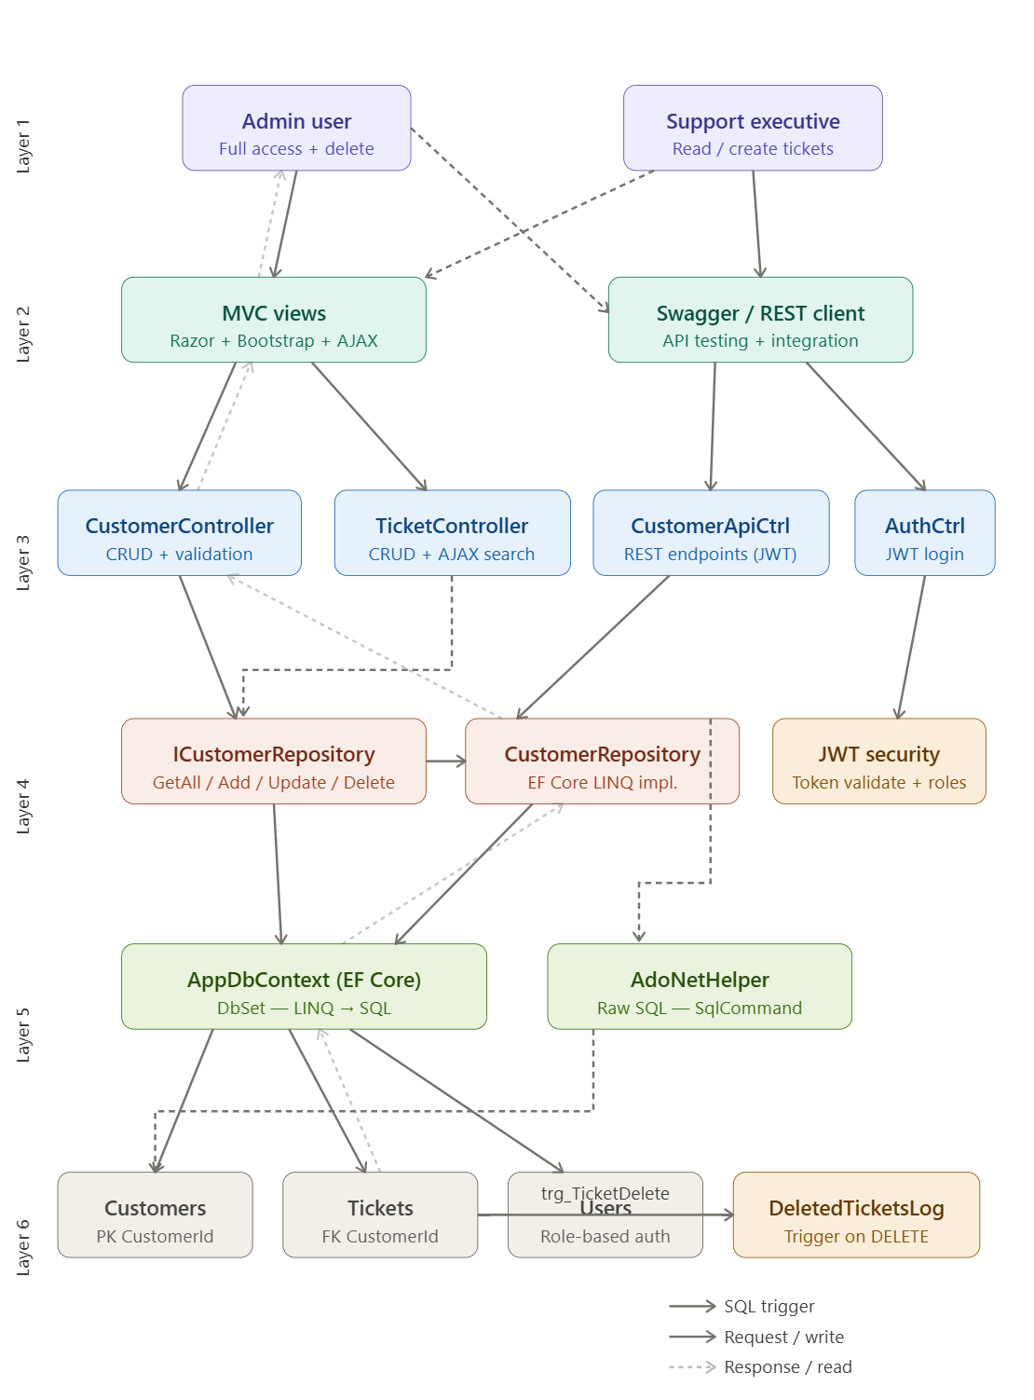

6. Database Design

6.1 Entity Relationship Diagram
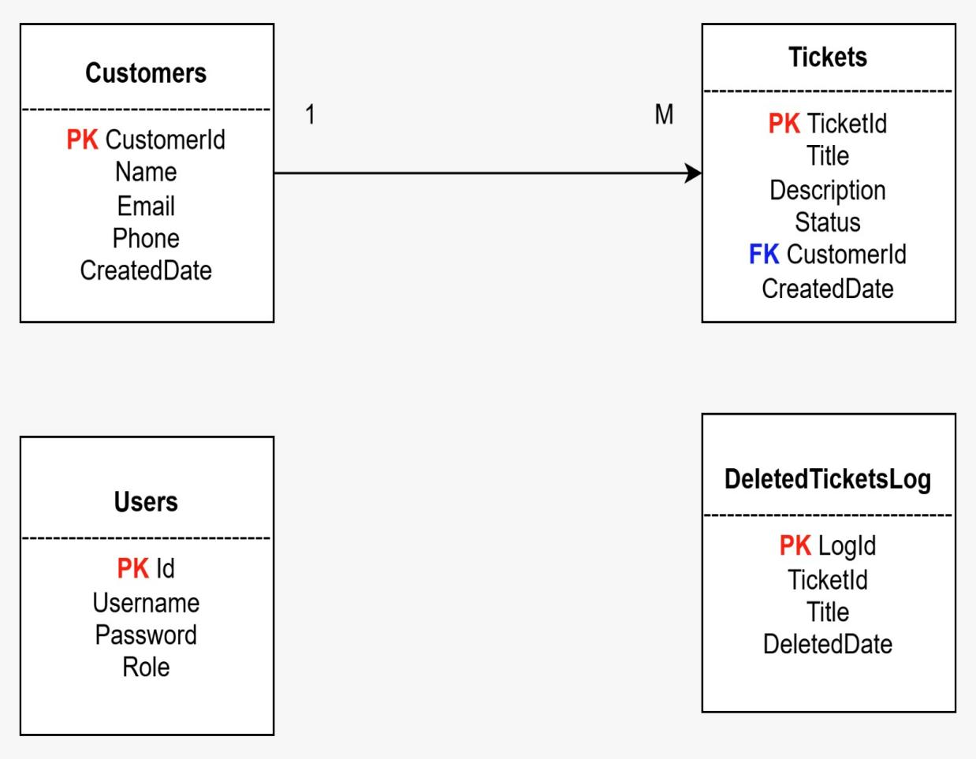
Figure 2: Entity Relationship Diagram — Customer Engagement Platform

6.2 Database Tables
The database schema follows SQL normalization principles. All tables use auto-incrementing primary keys (IDENTITY). Foreign key constraints enforce referential integrity between Customers and Tickets.

6.2.1 Customers Table
Column | Definition
CustomerId | INT — Primary Key, IDENTITY(1,1) — Auto-incrementing unique identifier
Name | NVARCHAR(100) — Customer full name; NOT NULL
Email | NVARCHAR(100) — Customer email address; validated in model
Phone | NVARCHAR(20) — Customer contact phone number
CreatedDate | DATETIME — Default GETDATE(); auto-populated on insert

6.2.2 Tickets Table
Column | Definition
TicketId | INT — Primary Key, IDENTITY(1,1)
Title | NVARCHAR(200) — Brief title of the service request
Description | NVARCHAR(MAX) — Full description of the issue
Status | NVARCHAR(50) — Lifecycle state (Open, In Progress, Resolved, Closed)
CustomerId | INT — Foreign Key referencing Customers(CustomerId)
CreatedDate | DATETIME — Default GETDATE()

6.2.3 Users Table
Column | Definition
Id | INT — Primary Key, IDENTITY(1,1)
Username | NVARCHAR(100) — Login username
Password | NVARCHAR(100) — Stored password (plain-text in prototype; hashing recommended for production)
Role | NVARCHAR(50) — Authorization role (Admin / SupportExecutive)

6.2.4 DeletedTicketsLog Table (Audit Table)
Column | Definition
LogId | INT — Primary Key, IDENTITY(1,1)
TicketId | INT — ID of the deleted ticket
Title | NVARCHAR(200) — Title of the deleted ticket
DeletedDate | DATETIME — Default GETDATE(); auto-populated by trigger

6.3 Database Trigger
An AFTER DELETE trigger named trg_TicketDelete is defined on the Tickets table. Whenever a ticket record is deleted, the trigger automatically inserts an audit record into the DeletedTicketsLog table by reading from the special 'deleted' logical table provided by SQL Server. This ensures a permanent, tamper-resistant audit trail of all deletions without requiring any application-level code changes.

CREATE TRIGGER trg_TicketDelete
ON Tickets AFTER DELETE
AS BEGIN
INSERT INTO DeletedTicketsLog (TicketId, Title)
SELECT TicketId, Title FROM deleted;
END;

6.4 SQL JOIN Query
A representative SQL JOIN query retrieves customer details alongside their associated tickets. This query demonstrates the one-to-many relationship between the Customers and Tickets tables:

SELECT c.CustomerId, c.Name, c.Email, t.TicketId, t.Title, t.Status
FROM Customers c
INNER JOIN Tickets t ON c.CustomerId = t.CustomerId;

7. Data Models

7.1 Customer Model
The Customer model is decorated with Data Annotations for input validation. The StringLength(100) constraint on Name limits input size. The EmailAddress attribute validates email format client-side and server-side. The ICollection<Ticket> navigation property enables EF Core lazy/eager loading of related tickets.

7.2 Ticket Model
The Ticket model includes a foreign key (CustomerId) and a navigation property (Customer) to represent the many-to-one relationship with the Customers table. All required fields are decorated with [Required] to enforce server-side model validation.

7.3 User Model
The User model stores authentication credentials and the user's role. In the production version, passwords should be stored as BCrypt hashes rather than plain text. The Role field drives the [Authorize(Roles = "Admin")] policy applied to sensitive DELETE endpoints.

8. Authentication and Authorization

8.1 JWT Authentication
The platform implements JSON Web Token (JWT) Bearer authentication as the primary security mechanism for all API endpoints. JWT is a stateless, self-contained token format that encodes user identity and role claims, enabling scalable authentication without server-side session storage.

8.2 JWT Implementation Steps
- Install Microsoft.AspNetCore.Authentication.JwtBearer and System.IdentityModel.Tokens.Jwt NuGet packages.
- Configure JWT settings (Issuer, Audience, Key) in appsettings.json under the Jwt section.
- Register AddAuthentication(JwtBearerDefaults.AuthenticationScheme) with token validation parameters in Program.cs.
- Create the AuthController with a POST /api/auth/login endpoint that validates credentials against the Users table.
- On successful authentication, generate a JwtSecurityToken containing Name and Role claims, signed with HMAC-SHA256.
- Configure Swagger to include a Bearer token Authorization header definition via AddSecurityDefinition and AddSecurityRequirement.
- Protect API controllers with [Authorize] for authenticated access and [Authorize(Roles = "Admin")] for role-restricted operations such as DELETE.

8.3 Token Generation — AuthController
The AuthController validates username and password against the SQL Server Users table. Upon successful validation, it creates a JWT token with the following structure:

Claims: ClaimTypes.Name (username), ClaimTypes.Role (user role)
Algorithm: HMAC-SHA256 (SymmetricSecurityKey)
Expiry: DateTime.Now.AddHours(1)
Issuer/Audience: Configured in appsettings.json

8.4 Role-Based Authorization
Endpoint | Authorization Policy
POST /api/auth/login | Anonymous — no token required
GET /api/customerapi | [Authorize] — any authenticated user
GET /api/customerapi/{id} | [Authorize] — any authenticated user
POST /api/customerapi | [Authorize] — any authenticated user
PUT /api/customerapi/{id} | [Authorize] — any authenticated user
DELETE /api/customerapi/{id} | [Authorize(Roles = "Admin")] — Admin role only

9. Frontend and Backend Connectivity

9.1 MVC View Layer
The Presentation Layer consists of Razor Views generated by the ASP.NET Core MVC framework. Forms use the [ValidateAntiForgeryToken] attribute to prevent Cross-Site Request Forgery (CSRF) attacks. ViewBag is used to pass SelectList data (e.g., customer dropdown for ticket creation) and error messages from controllers to views.

9.2 AJAX Integration
The TicketController exposes a dedicated Search action that accepts a keyword query parameter and returns a JSON array of matching ticket objects. This endpoint is consumed by a jQuery AJAX call in the Ticket Index View, enabling real-time, non-page-refreshing ticket search without requiring a full round-trip to the server.

[HttpGet]
public IActionResult Search(string keyword) {
var result = _context.Tickets
.Where(t => t.Title.Contains(keyword)).ToList();
return Json(result);
}

9.3 Dependency Injection
All repository and service dependencies are registered in Program.cs using the built-in ASP.NET Core DI container with AddScoped lifetime. This means a new instance of ICustomerRepository is created per HTTP request, ensuring thread safety and proper EF Core context management. Controllers receive their dependencies through constructor injection, promoting testability and adherence to the Dependency Inversion Principle.

10. Repository Pattern

10.1 Interface Definition
The ICustomerRepository interface defines six contract methods that abstract the data access operations from the controller and service layers. This abstraction allows the underlying data store to be replaced or mocked without impacting calling code.

Method Signature | Description
IEnumerable<Customer> GetAll() | Retrieves all customer records from the Customers table
Customer GetById(int id) | Retrieves a single customer by primary key
void Add(Customer customer) | Adds a new customer entity to the tracked context
void Update(Customer customer) | Marks an existing customer entity as modified
void Delete(int id) | Finds and removes a customer entity from the context
void Save() | Commits all pending changes to the database via SaveChanges()

10.2 CustomerRepository Implementation
The CustomerRepository class implements ICustomerRepository and receives AppDbContext through constructor injection. All operations are performed using EF Core LINQ queries. The separation of Save() from Add/Update/Delete follows the Unit of Work pattern, allowing multiple changes to be batched before a single database roundtrip.

10.3 ADO.NET Helper
The AdoNetHelper class provides direct SQL execution capabilities for scenarios where EF Core abstraction is not required or where raw SQL performance is preferred. The GetCustomerCount() method opens a SqlConnection, executes a COUNT(*) scalar query against the Customers table, and returns the integer result. This demonstrates hybrid data access — EF Core for ORM operations and ADO.NET for targeted raw queries.

11. API Documentation — Swagger / OpenAPI
Swagger/OpenAPI is integrated into the application to provide interactive API documentation and testing capabilities. Developers and testers can explore all available endpoints, their expected request bodies, response schemas, and authorization requirements directly through the Swagger UI at /swagger.

11.1 Swagger Configuration
The Swagger setup in Program.cs includes a Bearer token security definition, allowing authenticated API testing directly from the browser. The AddSecurityDefinition call registers a JWT Bearer scheme, and AddSecurityRequirement makes it globally applicable across all protected endpoints.

11.2 API Endpoint Summary
Endpoint | Description
POST /api/auth/login | Authenticate user and receive JWT token
GET /api/customerapi | Retrieve all customers (JWT required)
GET /api/customerapi/{id} | Retrieve customer by ID (JWT required)
POST /api/customerapi | Create new customer (JWT required)
PUT /api/customerapi/{id} | Update customer (JWT required)
DELETE /api/customerapi/{id} | Delete customer (Admin role required)
POST /api/ticketsummary | Generate AI ticket summary (placeholder)

12. SOLID Principles
The Customer Engagement Platform was designed with explicit adherence to the five SOLID principles of object-oriented design, ensuring a clean, maintainable, and extensible codebase.

Principle | Application in This Project | Code Location
Single Responsibility | CustomerController only handles HTTP routing; CustomerRepository only manages data access; AppDbContext only configures EF Core. | Controllers/, Repositories/, Data/
Open/Closed | New repository implementations can be added (e.g., MongoCustomerRepository) without modifying CustomerController, as it depends on ICustomerRepository. | Interfaces/ICustomerRepository.cs
Liskov Substitution | CustomerRepository can be substituted wherever ICustomerRepository is expected, including mock implementations in unit tests. | Repositories/CustomerRepository.cs
Interface Segregation | ICustomerRepository defines only the methods relevant to customer operations; no unrelated methods are forced onto implementors. | Interfaces/ICustomerRepository.cs
Dependency Inversion | Controllers depend on ICustomerRepository (abstraction) injected via DI, not on the concrete CustomerRepository class. | Program.cs, Controllers/

13. Design Patterns
Multiple well-established software design patterns were applied throughout the project to promote code reuse, testability, and maintainability.

Pattern | Implementation Details
Repository Pattern | ICustomerRepository interface with CustomerRepository implementation provides a consistent data access abstraction layer, decoupling controllers from direct EF Core/SQL dependencies.
Dependency Injection Pattern | ASP.NET Core DI container (AddScoped) manages object lifetimes and constructor injection for repositories, db context, and configuration, enabling loose coupling.
MVC Pattern | The application strictly follows Model-View-Controller separation: Models define data structure, Views render HTML, and Controllers coordinate request processing.
Unit of Work Pattern | The Save() method in CustomerRepository batches database operations and commits them in a single transaction via SaveChanges().
Layered Architecture Pattern | Clear layer boundaries (Presentation, Controller, Repository, Data Access, Database) are enforced, preventing cross-layer direct access.
DTO Pattern | CustomerDto class separates internal model representation from the API response payload, preventing over-posting and controlling serialized data.

14. Key Modules

14.1 Customer Management Module
The Customer Management Module provides full CRUD functionality through both the MVC interface and the REST API. The MVC path uses CustomerController which delegates to CustomerRepository. The API path uses CustomerApiController which directly interacts with AppDbContext. Both paths enforce input validation through Data Annotations and ModelState validation, with try-catch exception handling to prevent application crashes.

14.2 Service Ticket Management Module
The Service Ticket Management Module is implemented by TicketController using direct EF Core queries via AppDbContext. It supports CRUD operations plus an AJAX-powered keyword search endpoint. The Include(t => t.Customer) eager loading call in Index() and Details() ensures customer name is available in ticket views without additional database round-trips. Ticket status values (Open, In Progress, Resolved, Closed) define the support lifecycle.

14.3 Authentication Module
The Authentication Module (AuthController) accepts a POST request with username and password, validates credentials against the Users table, generates a signed JWT containing Name and Role claims, and returns the token string. The token has a one-hour expiry and is signed using HMAC-SHA256. Downstream controllers validate the token through the JWT Bearer middleware configured in Program.cs.

14.4 EF Core & Migrations
Entity Framework Core is configured with Code-First migrations. Two migrations were generated: InitialCreate (Customers and Tickets tables) and AddUsersTable (Users table). The AppDbContext inherits DbContext and declares three DbSet properties. Migrations are run via dotnet ef database update to apply schema changes to SQL Server.

14.5 ADO.NET Module
The AdoNetHelper class provides a lightweight data access mechanism for raw SQL execution. The GetCustomerCount() method demonstrates the use of SqlConnection, SqlCommand, and ExecuteScalar() for executing a COUNT query. The connection string is injected through IConfiguration, following the same configuration-driven pattern as EF Core.

15. Exception Handling Strategy
A consistent exception handling strategy is applied across the application to prevent unhandled exceptions from exposing sensitive information or crashing the application.

Mechanism | Implementation
Try-Catch Blocks | All CustomerController action methods wrap repository calls in try-catch blocks, catching general Exception objects and storing messages in ViewBag.ErrorMessage for display.
ModelState Validation | All POST/PUT actions check ModelState.IsValid before invoking repository operations, rejecting malformed requests with validation error messages.
Global Error Handler | In production mode (!IsDevelopment()), app.UseExceptionHandler("/Home/Error") redirects unhandled exceptions to the ErrorViewModel-backed Error view.
HSTS | app.UseHsts() enforces HTTP Strict Transport Security in production, preventing protocol downgrade attacks.
404 Handling | Controllers return NotFound() for missing resources (customer or ticket not found by ID) rather than throwing exceptions.

16. Traditional vs. Modern Development Practices
Traditional Approach | Modern Approach (This Project)
Direct database calls from UI layer (tightly coupled) | Layered architecture with Repository Pattern separating concerns
ADO.NET SqlDataReader for all queries | Entity Framework Core ORM with LINQ; ADO.NET for targeted raw SQL
Session-based authentication (server state) | Stateless JWT Bearer token authentication (scalable, cloud-friendly)
Manual SQL migration scripts | EF Core Code-First migrations with version control
No API documentation | Swagger/OpenAPI interactive documentation with Bearer token support
Manual deployment via FTP | Docker containerization and GitHub Actions CI/CD pipeline
Hardcoded connection strings in code | Environment-agnostic configuration via appsettings.json and environment variables
No unit testing | xUnit unit tests for model validation and business logic
Single-server monolith | Cloud-ready architecture targeting Azure App Service with horizontal scaling

17. Docker and CI/CD Pipeline

17.1 Docker Containerization
The application is containerized using a multi-stage Dockerfile that produces a lean production image based on the official ASP.NET 8.0 runtime. The multi-stage build pattern separates the SDK-heavy build environment from the lightweight runtime image, minimizing the final container size and attack surface.

Dockerfile Stage | Description
Stage 1: build (sdk:8.0) | Copies source, runs dotnet restore, then dotnet publish -c Release into /app/publish
Stage 2: final (aspnet:8.0) | Copies published output from build stage; sets ENTRYPOINT to CustomerEngagementPlatform.dll

The container exposes port 80 and can be deployed to any Docker-compatible environment including Azure Container Instances, Azure Kubernetes Service, or local Docker Desktop. To build and run:

docker build -t customer-engagement-platform .
docker run -p 8080:80 customer-engagement-platform

17.2 GitHub Actions CI/CD Workflow
A GitHub Actions workflow (dotnet.yml) automates the build, restore, and test pipeline on every push to the main branch. The workflow runs on ubuntu-latest and executes the following steps sequentially:

- actions/checkout@v4 — Checks out the repository code
- actions/setup-dotnet@v4 — Installs .NET 8.0.x SDK
- dotnet restore — Restores NuGet package dependencies
- dotnet build --no-restore — Compiles the solution in debug mode
- dotnet test --no-build — Executes all xUnit unit tests

This pipeline ensures that every code push is validated for compilation errors and test failures before reaching the main branch, maintaining code quality and enabling rapid feedback for the development team.

18. Azure App Service Hosting Model
The application is designed for deployment on Azure App Service, a fully managed Platform-as-a-Service (PaaS) hosting environment that supports .NET applications natively. The proposed Azure architecture includes:

Azure Service | Purpose
Azure App Service (Basic/Standard tier) | Hosts the ASP.NET Core MVC application with automatic OS patching and scaling
Azure SQL Database | Fully managed SQL Server database with automated backups and geo-redundancy
Azure Key Vault | Securely stores JWT signing key, connection strings, and other secrets
Azure Container Registry | Stores Docker images for deployment to App Service or AKS
Azure Monitor / Application Insights | Provides real-time performance monitoring, exception logging, and request tracing
GitHub Actions → Azure Deploy | Extends the existing CI/CD pipeline with azure/webapps-deploy action for automated deployment

The connection string in appsettings.json would be replaced by an Azure SQL connection string, and the JWT key would be sourced from Azure Key Vault via the Managed Identity feature, eliminating the need to store secrets in configuration files.

19. Testing

19.1 Unit Tests
Unit tests are implemented using the xUnit testing framework in the CustomerEngagementPlatform.Tests project. Two test classes are provided:

Test Method | Assertion
Customer_Name_Should_Not_Be_Null() | Creates a Customer instance with Name = "Nandhini" and asserts Assert.NotNull(customer.Name)
Customer_Email_Should_Contain_At() | Creates a Customer with Email = "test@gmail.com" and asserts Assert.Contains("@", customer.Email)

19.2 Manual Testing Coverage
Test Area | Test Activities Performed
CRUD — Customers | Create, Read, Update, Delete customer records via MVC UI and REST API
CRUD — Tickets | Create, Read, Update, Delete ticket records; verify FK constraint enforcement
JWT Authentication | Login with valid/invalid credentials; verify token generation and rejection
Role-Based Authorization | Verify DELETE endpoint rejects non-Admin tokens with 403 Forbidden
Swagger API Testing | Test all endpoints via Swagger UI with Bearer token authorization
AJAX Ticket Search | Verify real-time search returns filtered results without page refresh
Database Trigger | Delete a ticket and verify DeletedTicketsLog auto-populated
Docker Build | Verify docker build completes successfully and container starts
CI Pipeline | Push code to main branch and verify GitHub Actions pipeline completes

20. AI / GitHub Copilot Usage
GitHub Copilot was used as a development assistant throughout the project. The following categories of Copilot assistance were utilized:

Usage Category | Details
Controller Scaffolding | Copilot suggested boilerplate CRUD action methods for CustomerController and TicketController based on model context.
Repository Implementation | Copilot generated initial ICustomerRepository interface and CustomerRepository method stubs.
JWT Token Generation | Copilot provided the JwtSecurityToken construction pattern including claims, signing credentials, and token handler usage.
Swagger Configuration | Copilot suggested the AddSecurityDefinition and AddSecurityRequirement pattern for Bearer token support.
Dockerfile | Copilot generated the multi-stage Dockerfile structure for ASP.NET Core 8.0.
GitHub Actions YAML | Copilot generated the dotnet.yml workflow with restore, build, and test steps.
Unit Tests | Copilot suggested xUnit test method structure and Assert patterns.
Documentation | Copilot assisted with XML documentation comments on repository methods.

All Copilot suggestions were reviewed, validated, and modified as needed to ensure correctness, security, and alignment with project requirements. The AI acted as an accelerator, not a replacement for engineering judgment.

21. Industry Best Practices Applied
Best Practice | Implementation
Repository Pattern | Data access abstracted behind ICustomerRepository interface; controllers never access DbContext directly.
Dependency Injection | All dependencies registered in DI container; constructor injection used throughout.
Input Validation | Data Annotations ([Required], [EmailAddress], [StringLength]) on models; ModelState.IsValid checks in POST actions.
Exception Handling | Try-catch blocks in controllers; global error handler via UseExceptionHandler.
Anti-Forgery Tokens | [ValidateAntiForgeryToken] on all POST actions to prevent CSRF attacks.
JWT Security | Stateless authentication with signed tokens; role-based authorization on sensitive endpoints.
Layered Architecture | Clear separation of Presentation, Business, and Data Access layers.
API Documentation | Swagger/OpenAPI for discoverable, testable API surface.
Version Control | Git-based source control; GitHub Actions CI/CD triggered on main branch pushes.
Docker Containerization | Multi-stage Dockerfile; consistent deployment across environments.
Code-First Migrations | Database schema version-controlled alongside application code.
Clean Code | Descriptive naming; single-responsibility classes; commented action methods.

22. Comparison with Live Applications
The Customer Engagement Platform shares architectural and functional concepts with several leading commercial platforms in the Customer Relationship Management (CRM) and IT Service Management (ITSM) space:

Feature | This Platform | Industry Platforms (ServiceNow, Zendesk, Freshdesk)
Customer Management | Full CRUD via MVC and REST API | Full CRM with advanced segmentation and analytics
Ticket/Case Management | Ticket lifecycle with status tracking | SLA management, automated routing, escalation rules
Authentication | JWT Bearer, Role-Based (Admin/Support) | SSO, SAML, OAuth 2.0, MFA
API Access | REST API with Swagger documentation | REST, GraphQL, Webhook integrations
Audit Logging | SQL trigger-based DeletedTicketsLog | Comprehensive audit trail with user actions log
AI Features | Ticket summary placeholder (TicketSummaryService) | AI-powered ticket classification, sentiment analysis, chatbots
Hosting | Azure App Service (proposed) | Multi-cloud SaaS, global CDN, 99.9%+ SLA
Notifications | Not implemented (future scope) | Email, SMS, Slack, Teams integrations

23. Future Scope
The following enhancements are identified as priorities for the next development iteration of the Customer Engagement Platform:

- ASP.NET Core Identity Integration — Replace the custom Users table with the full ASP.NET Core Identity framework for password hashing, lockout policies, two-factor authentication, and role management UI.
- Email Notification System — Integrate SendGrid or Azure Communication Services to send automated email alerts when tickets are created, updated, or resolved.
- AI-Based Ticket Summarization — Integrate the OpenAI API or Azure OpenAI Service into the TicketSummaryController to generate intelligent, context-aware ticket summaries.
- Analytics Dashboard — Build an interactive management dashboard using Chart.js or Power BI Embedded to visualize ticket volume, resolution rates, and customer trends.
- Azure Deployment — Complete the Azure App Service deployment with Azure SQL Database, Key Vault for secrets management, and Application Insights for monitoring.
- Microservices Migration — Decompose the monolith into independent microservices (CustomerService, TicketService, AuthService) communicating via Azure Service Bus.
- Mobile API — Expose a mobile-optimized API layer for iOS and Android client applications using the existing REST API infrastructure.
- SLA Management — Implement Service Level Agreement rules that automatically escalate tickets breaching response time thresholds.

24. Conclusion
The Customer Engagement Platform represents a comprehensive, production-ready foundation for customer relationship and service ticket management. The project successfully demonstrates the integration of a wide spectrum of modern software engineering technologies and practices within a single, cohesive application.
From a technical perspective, the platform achieves secure REST API design through JWT authentication, clean architecture through the Repository Pattern and Dependency Injection, dual data access strategies via EF Core and ADO.NET, automated audit logging through SQL triggers, and DevOps readiness through Docker and GitHub Actions CI/CD.
The codebase strictly adheres to SOLID principles, ensuring it is extensible, testable, and maintainable over time. The application's conceptual alignment with industry platforms such as ServiceNow and Zendesk validates its architectural approach and positions it well for further development into a production-grade enterprise solution.
This capstone project demonstrates readiness for professional software development roles requiring expertise in ASP.NET Core, SQL Server, REST API design, cloud-native architecture, and DevOps engineering.

25. Screenshots
This section presents the visual output of the Customer Engagement Platform, demonstrating the working application across all major features. Screenshots cover the MVC user interface, Swagger API documentation, database objects, JWT authentication, and the CI/CD pipeline.

25.1 Application Home Page
The Home Page serves as the entry point of the application, providing navigation links to the Customer Management and Ticket Management modules.
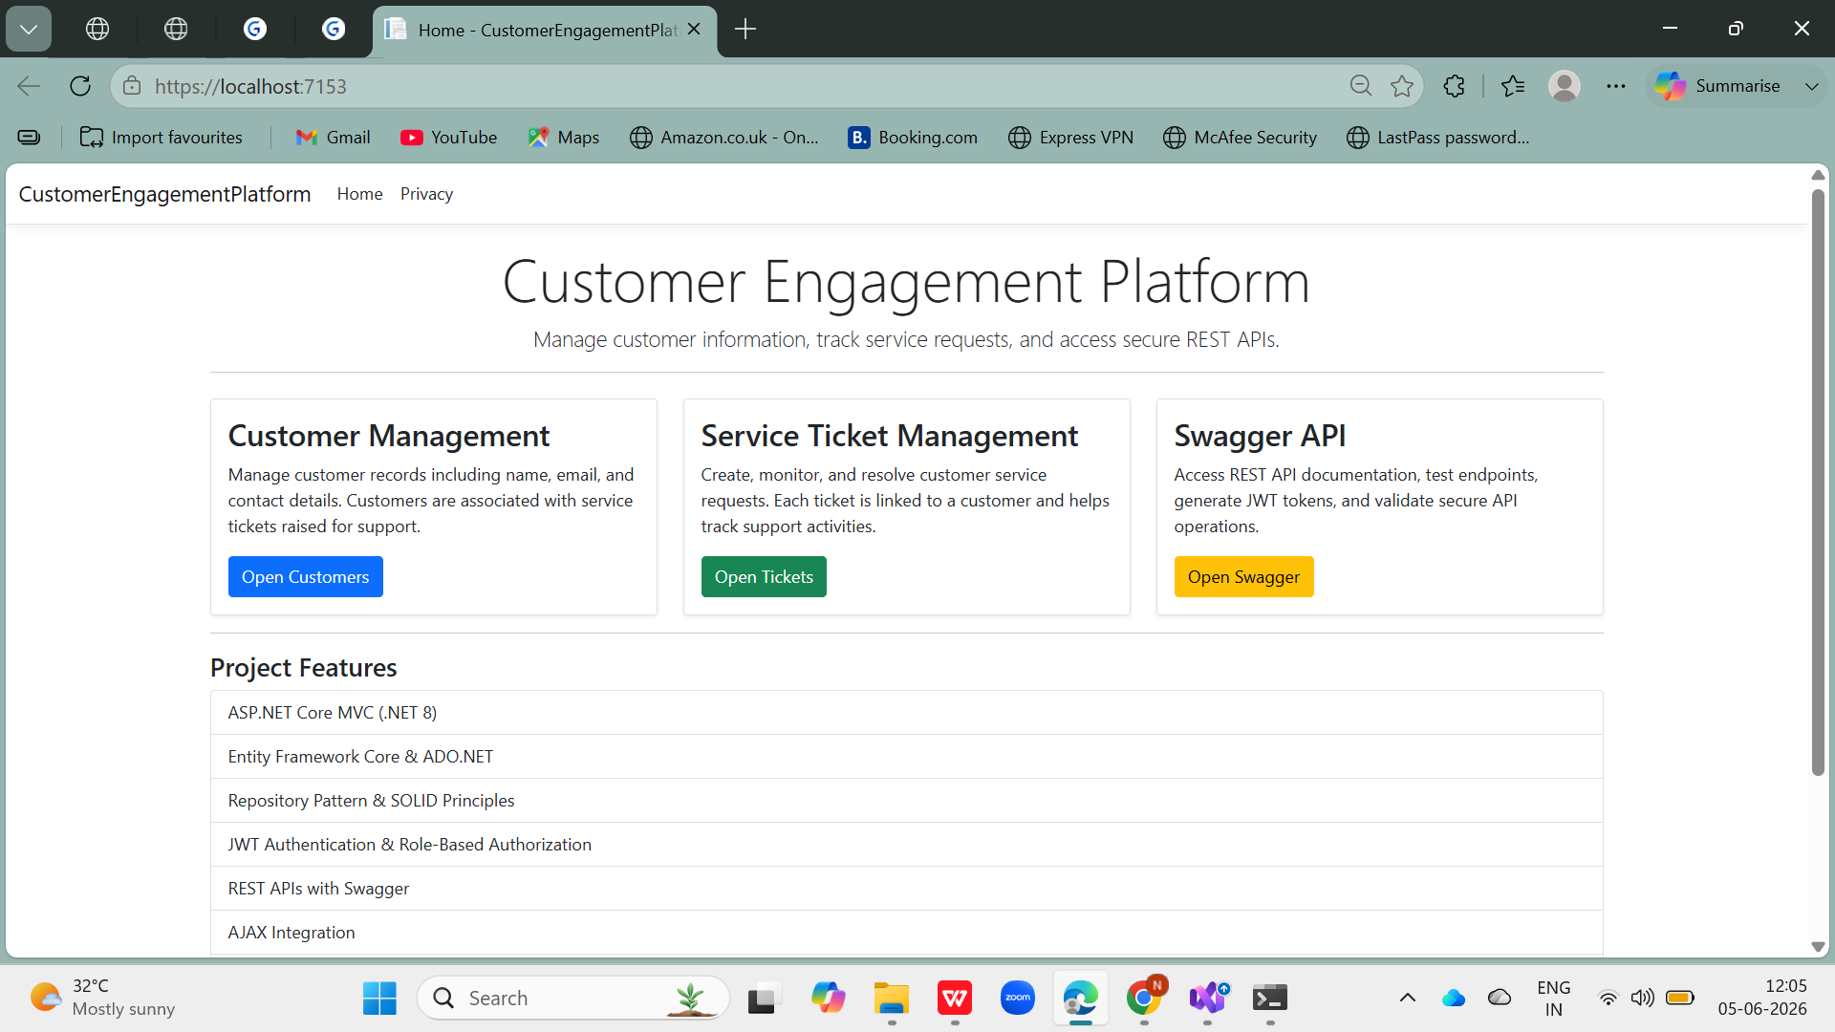Figure 3: Application Home Page — ASP.NET Core MVC

25.2 Customer List View
The Customer Index View displays all registered customers retrieved from the SQL Server database through the CustomerRepository. It provides action links for Details, Edit, and Delete operations.
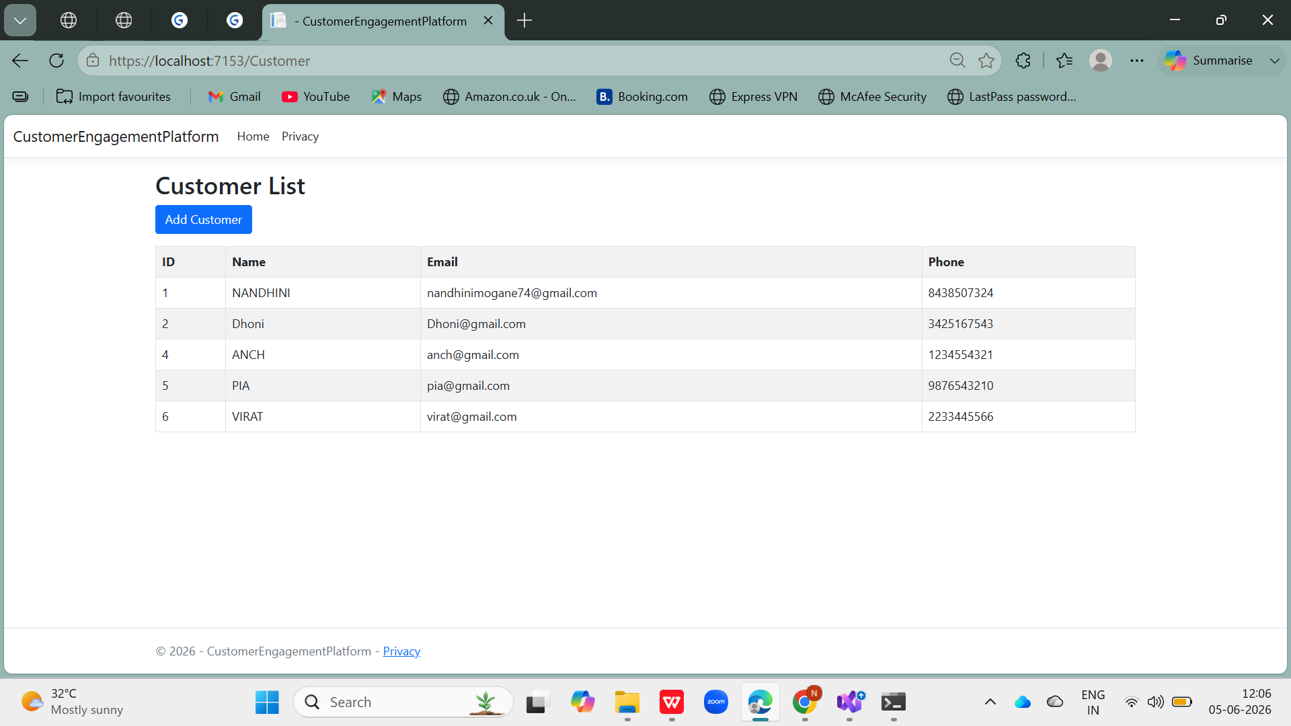Figure 4: Customer List View — Index Page

25.3 Create Customer Form
The Create Customer form enforces client-side and server-side validation using Data Annotations. Required fields include Name, Email (validated format), and Phone. Anti-forgery token protection is applied on POST submission.
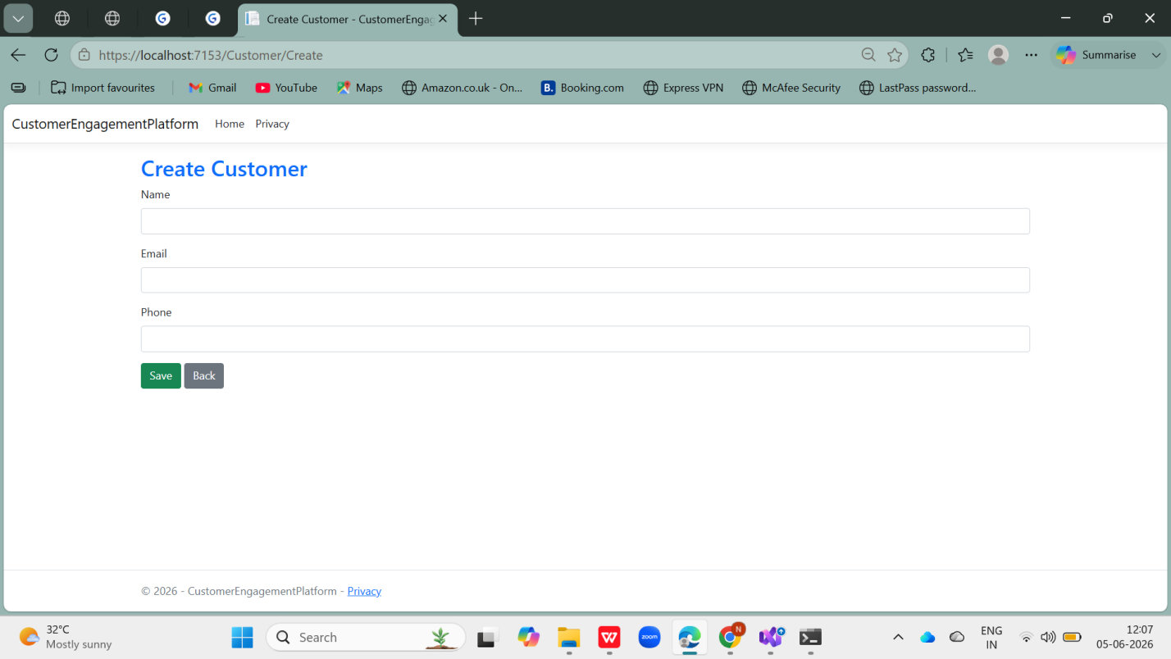Figure 5: Create Customer Form — Validation & Submission

25.4 Ticket List View
The Ticket Index View lists all service tickets with their associated customer names (loaded via EF Core Include eager loading). The AJAX search box enables real-time filtering by ticket title without page refresh.
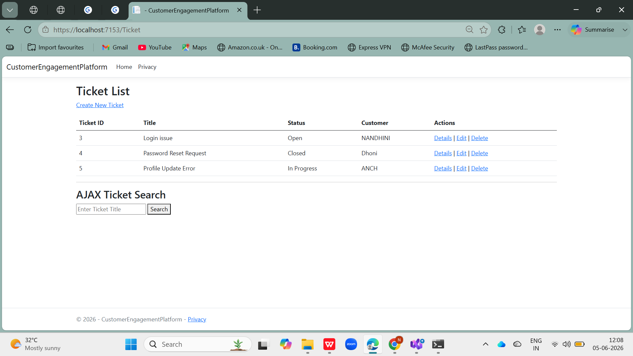Figure 6: Ticket List View — with AJAX Search

25.5 Create Ticket Form
The Create Ticket form includes a customer dropdown populated via ViewBag SelectList. Status field options reflect the ticket lifecycle (Open, In Progress, Resolved, Closed).
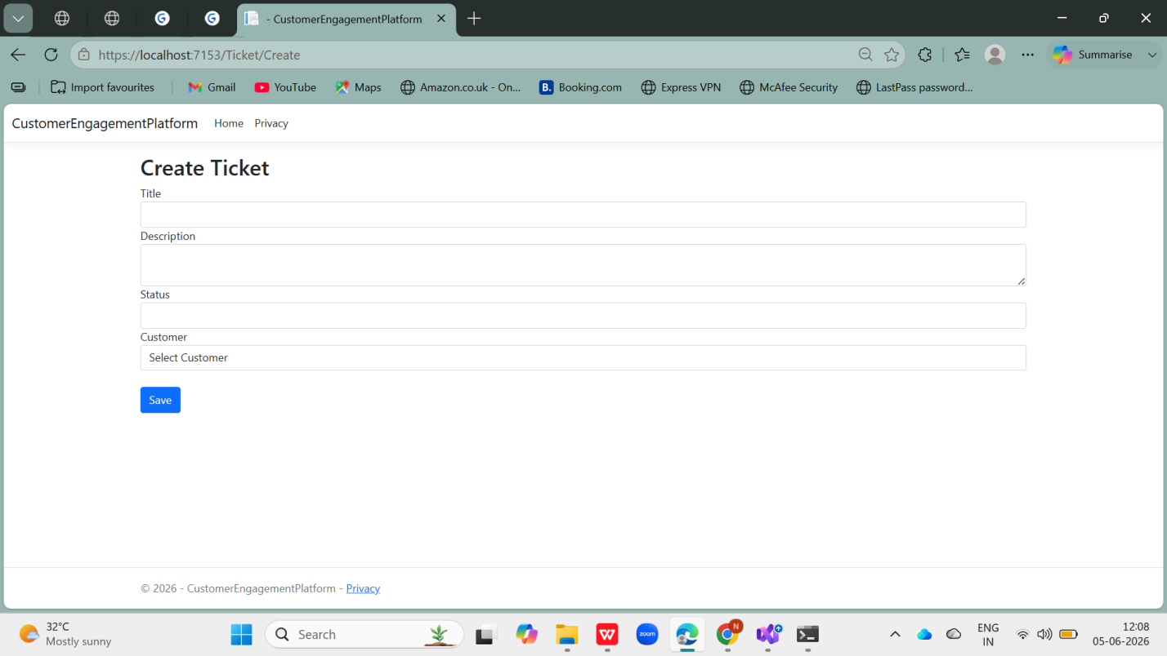Figure 7: Create Ticket Form — Customer Dropdown & Status

25.6 Swagger UI — API Overview
The Swagger UI provides an interactive interface to explore and test all REST API endpoints. The Bearer token security scheme is configured, allowing authenticated API testing directly from the browser.
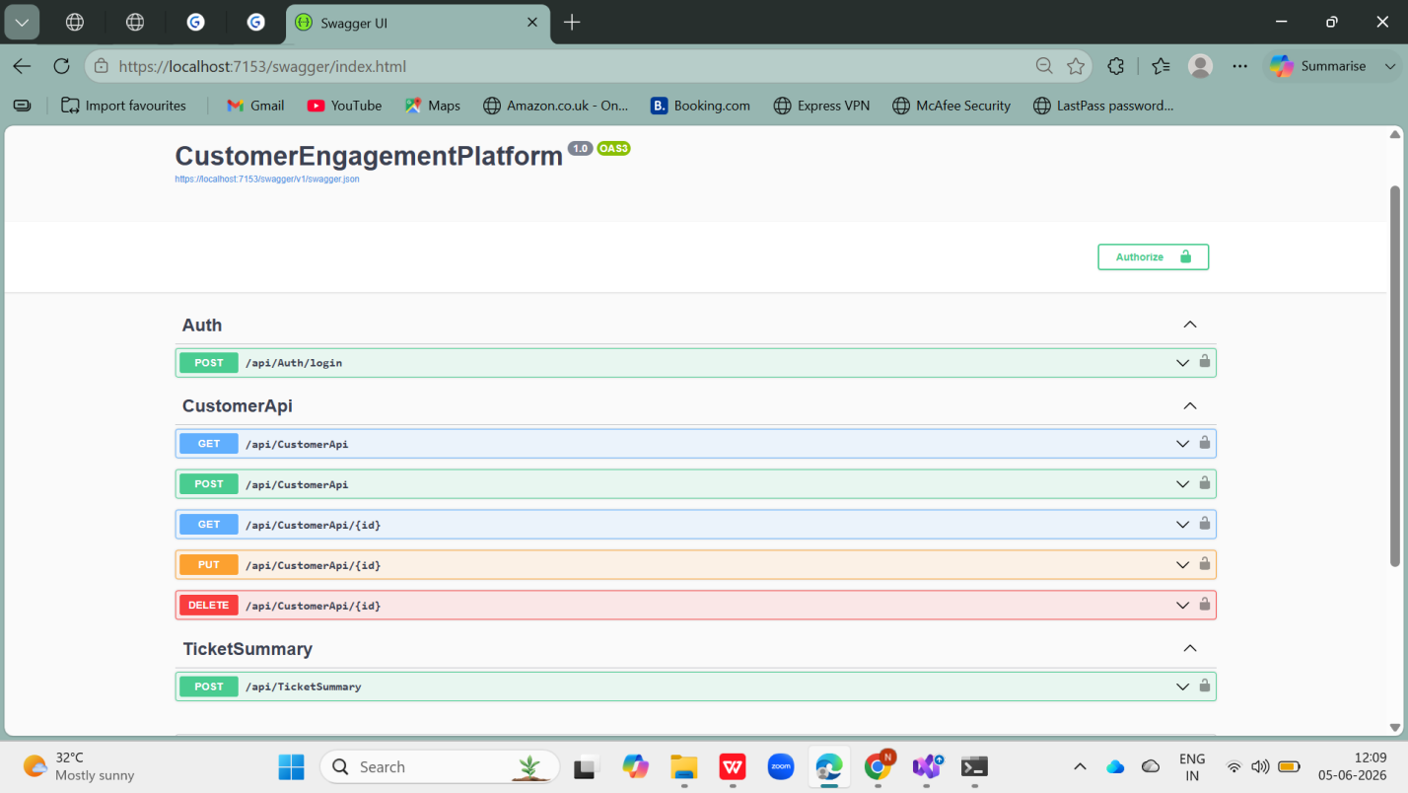Figure 8: Swagger UI — API Endpoint Overview

25.7 Swagger — JWT Login (POST /api/auth/login)
The POST /api/auth/login endpoint accepts a JSON body with username and password. On successful authentication, it returns a signed JWT token string that can be used to authorize subsequent API calls.
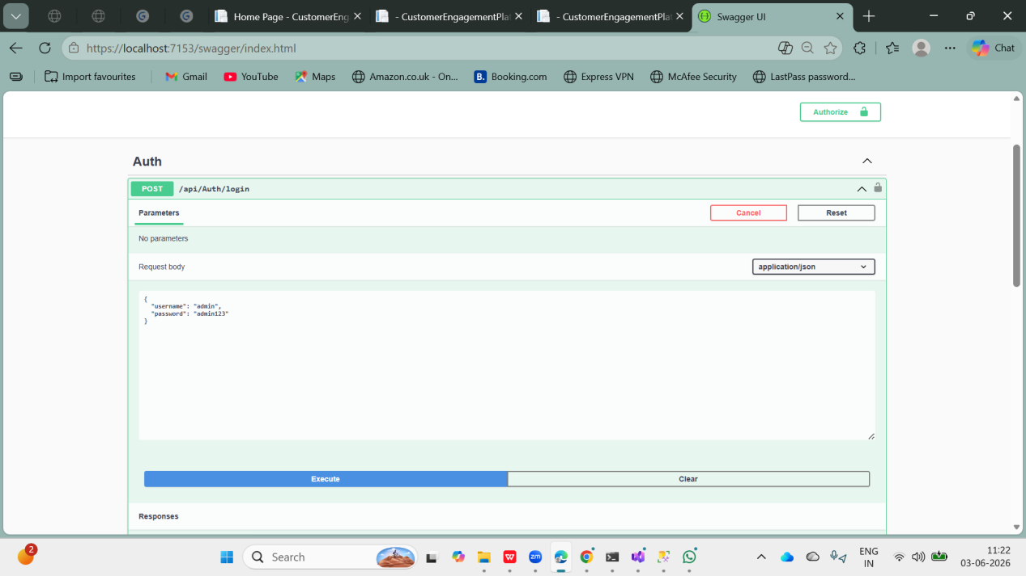Figure 9: Swagger — JWT Login Request & Token Response

25.8 Swagger — Authorize with Bearer Token
After receiving the JWT token from the login endpoint, the Authorize button in Swagger allows the token to be entered as a Bearer credential, enabling testing of protected endpoints.
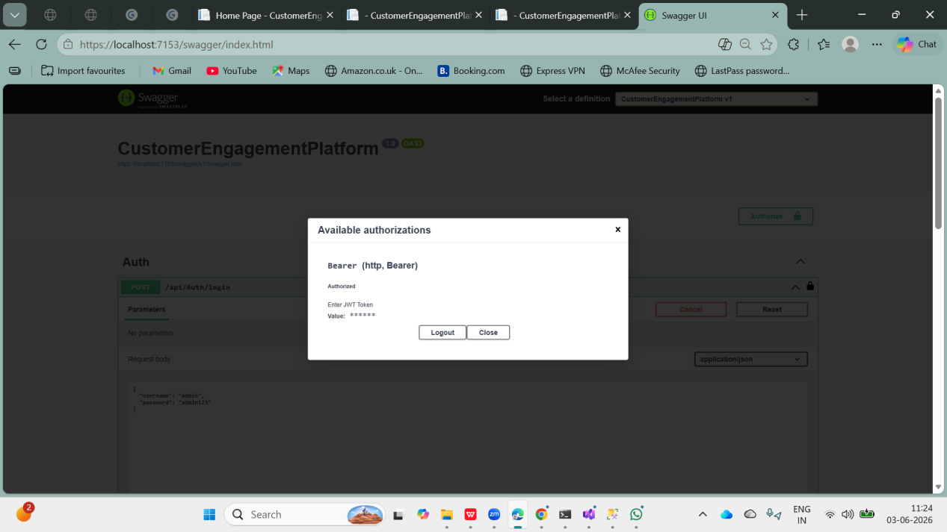Figure 10: Swagger — Bearer Token Authorization Dialog

25.9 Swagger — GET /api/customerapi (Authorized)
The GET /api/customerapi endpoint returns a JSON array of all customer records. The 200 OK response with customer data is visible after successful JWT authorization.
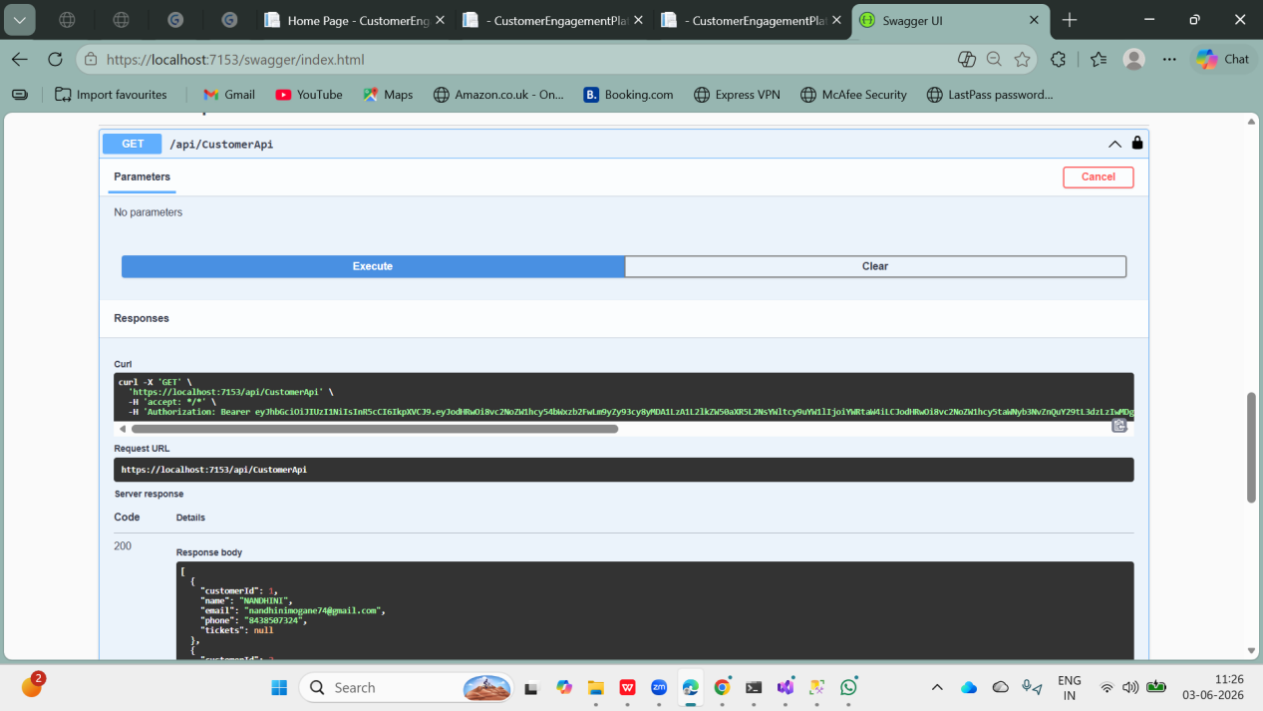
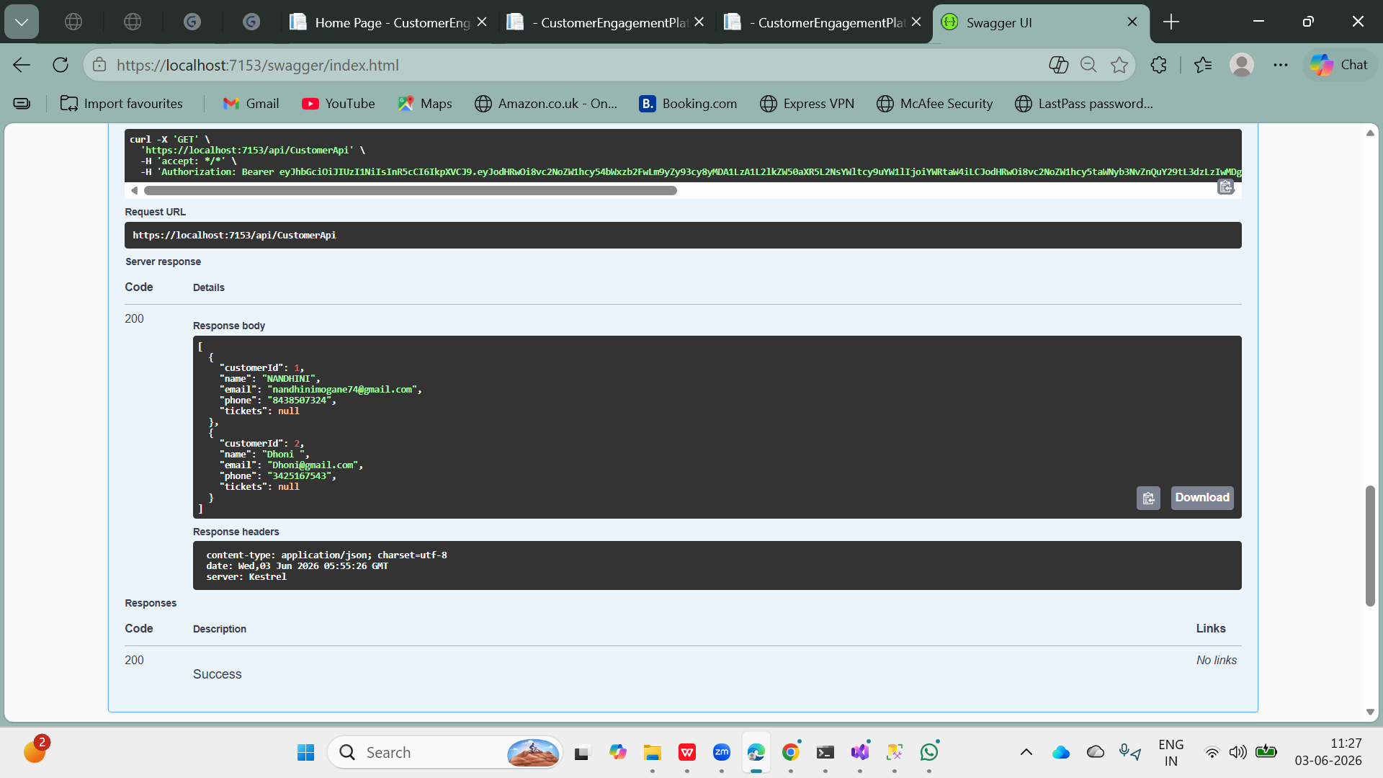
Figure 11: Swagger — GET Customers API Response (200 OK)

25.10 Swagger — DELETE Endpoint (Admin Only)
The DELETE /api/customerapi/{id} endpoint is restricted to the Admin role. Attempting the delete with a non-Admin token returns a 403 Forbidden response, demonstrating role-based authorization in action.
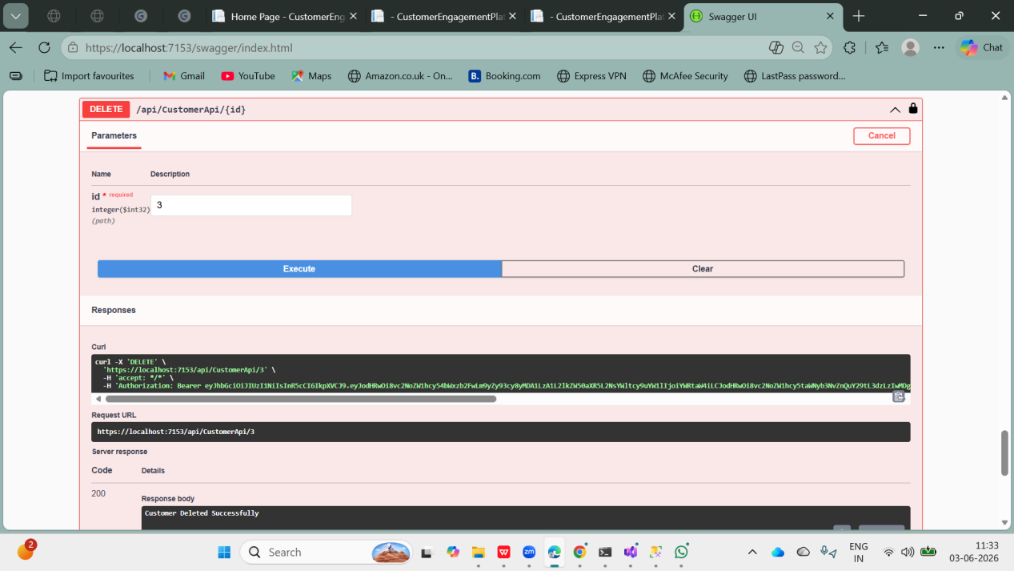

Figure 12: Swagger — DELETE API Response (Admin Role / 403 Forbidden)

25.11 SQL Server — Database Tables
SQL Server Management Studio (SSMS) view of the CustomerEngagementDB database showing all four tables: Customers, Tickets, Users, and DeletedTicketsLog, confirming successful EF Core migration execution.
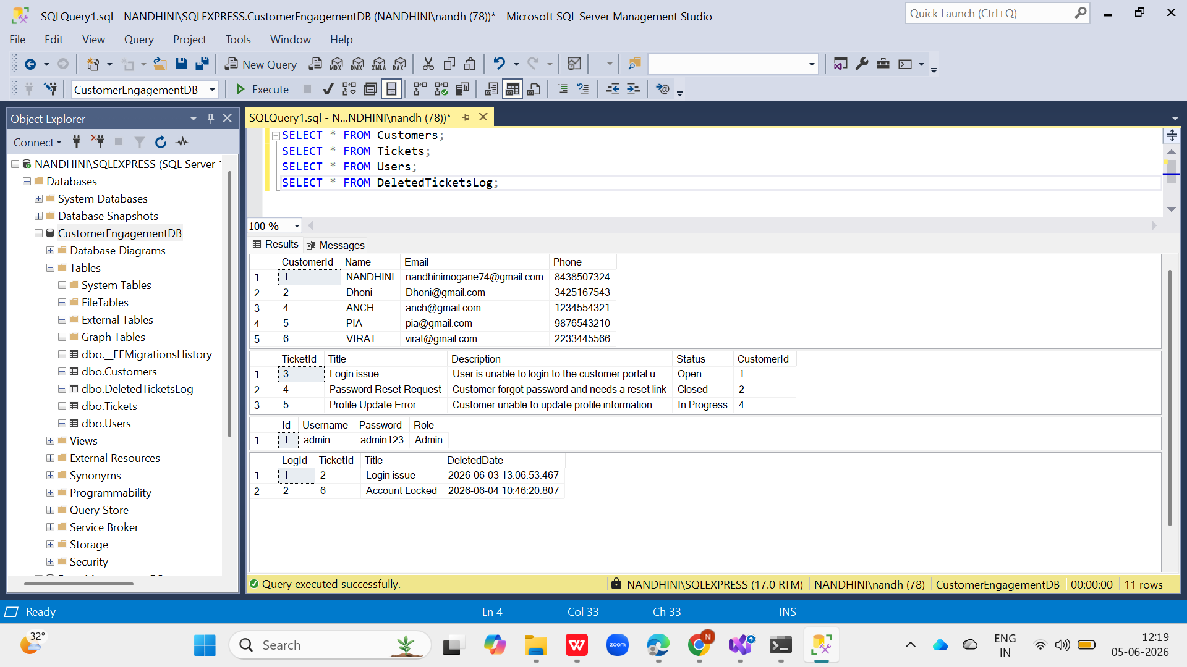Figure 13: SQL Server — Database Tables in SSMS

25.12 SQL Server — DeletedTicketsLog (Trigger Result)
After a ticket deletion is performed through the application, the trg_TicketDelete trigger automatically populates the DeletedTicketsLog table. This screenshot confirms the trigger-based audit mechanism is working correctly.
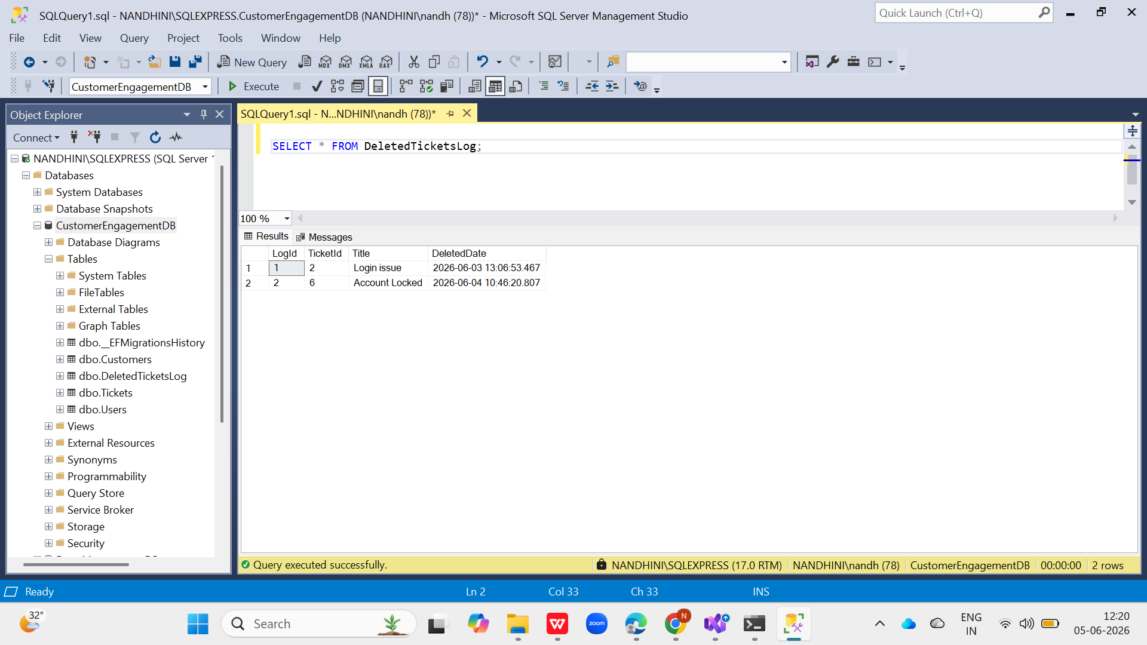Figure 14: SQL Server — DeletedTicketsLog Populated by Trigger

25.13 Unit Test Results
The xUnit unit tests are executed via dotnet test. Both CustomerTests pass successfully: Customer_Name_Should_Not_Be_Null and Customer_Email_Should_Contain_At, confirming model validation logic is correct.
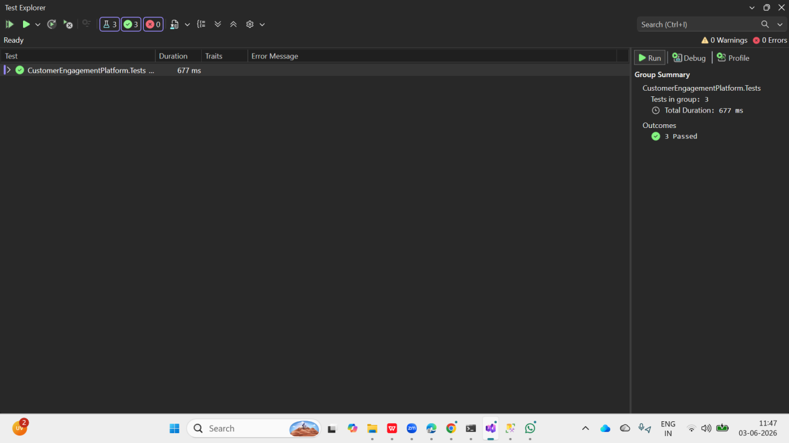
Figure 17: xUnit Unit Test Results — All Tests Passed

