FIORI Application Development

Install the following in order:

SAP Machine - SapMachine | Fast. Reliable. Open.- https://sapmachine.io/
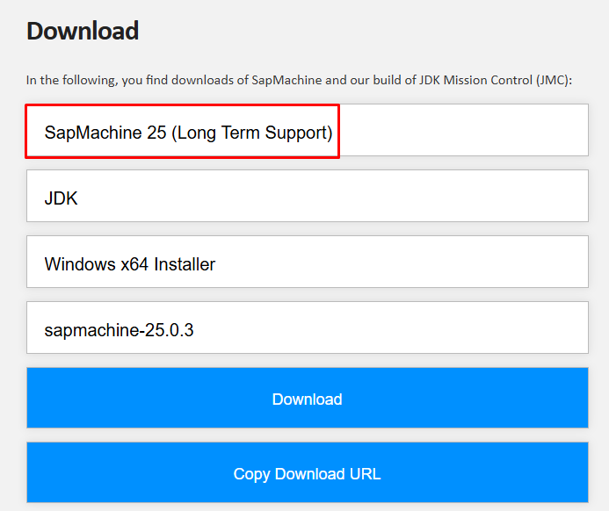

Cloud connector - SAP Development Tools - https://tools.hana.ondemand.com/#cloud

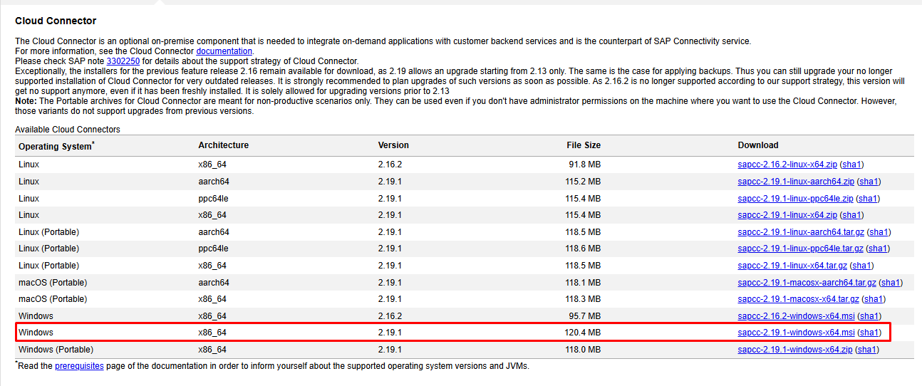

Login to the following accounts with your credentials:

a) Cloud Connector - https://localhost:8443/
Importantly note password

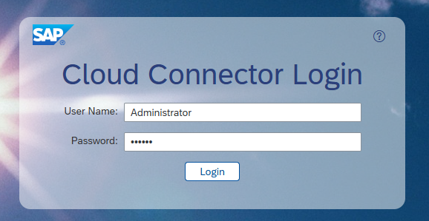

Cloud Connector - https://localhost:8443/

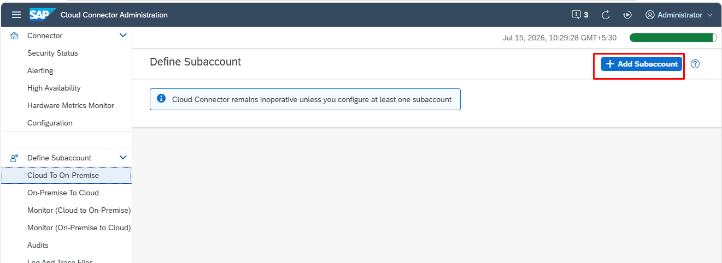
Don’t give any details just next
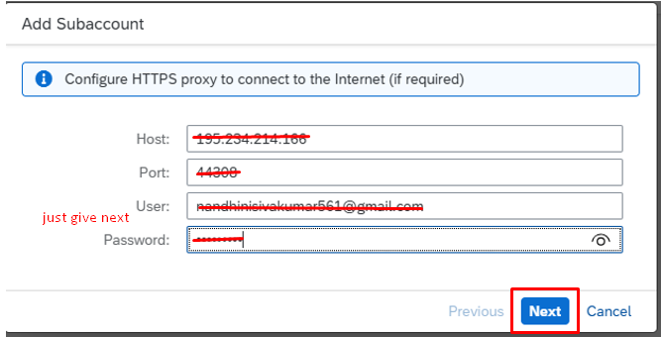

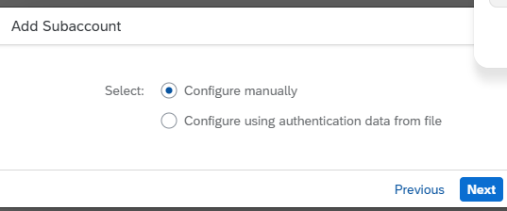
Refer details from - https://account.hanatrial.ondemand.com/trial
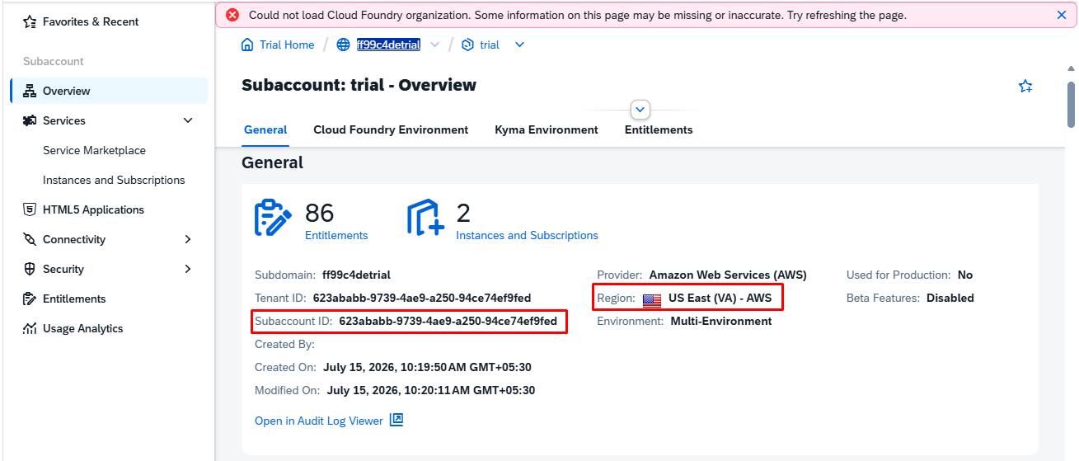

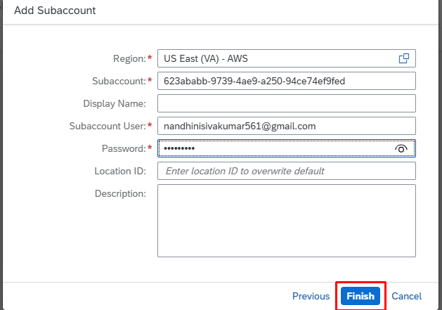

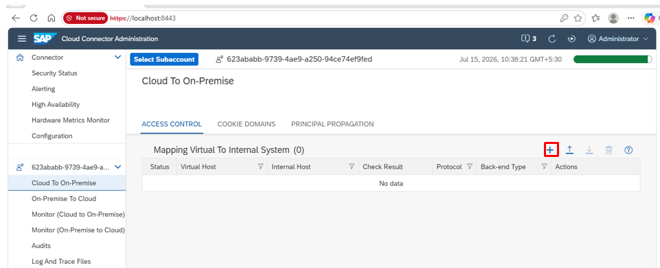

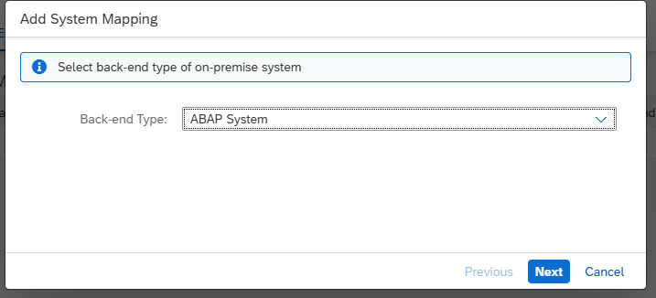

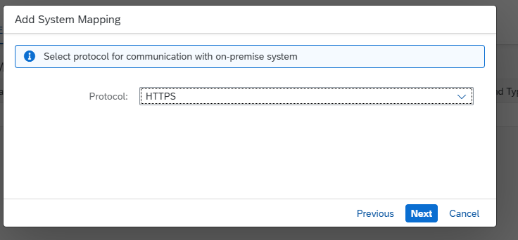

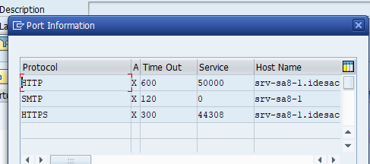
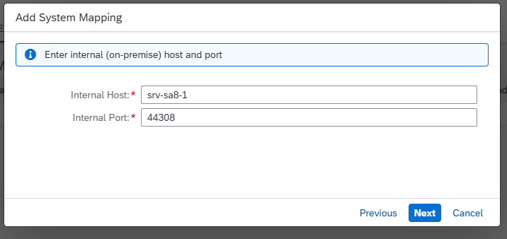

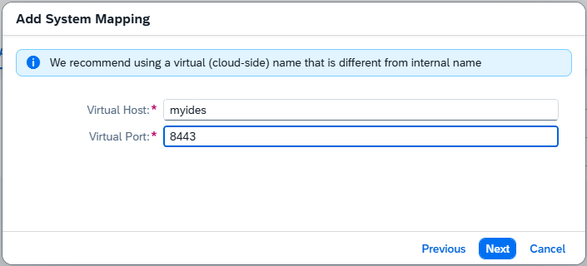
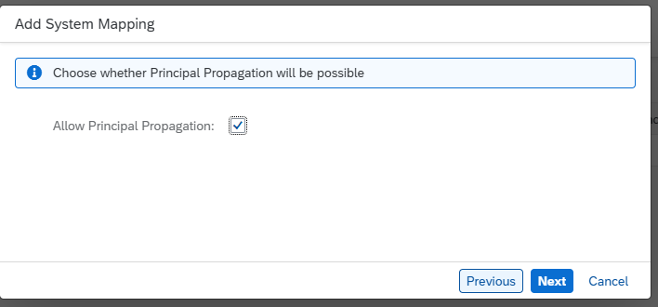
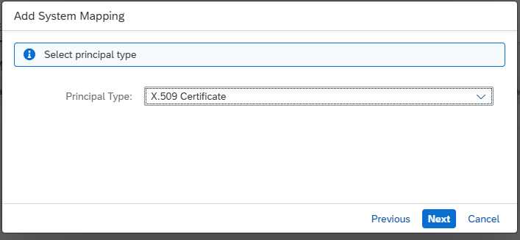

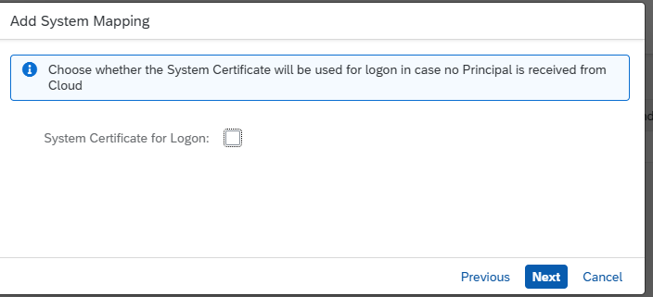

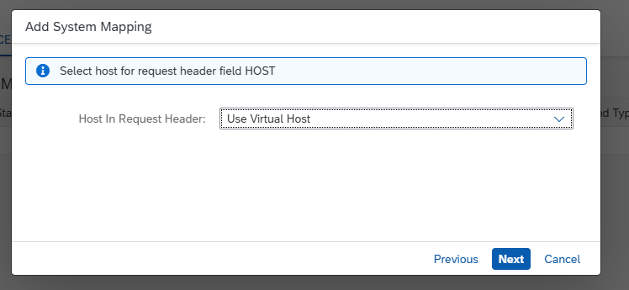

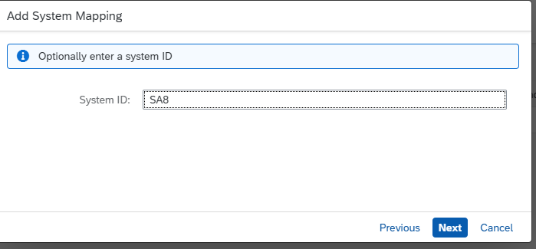

Status will be not reachable, follow the next instruction
Next -> Finish

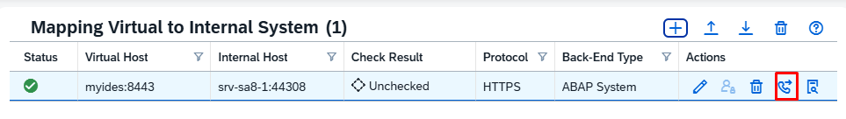
Verify the below details
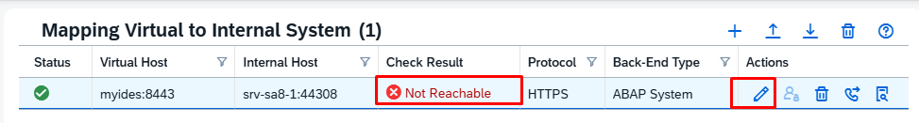
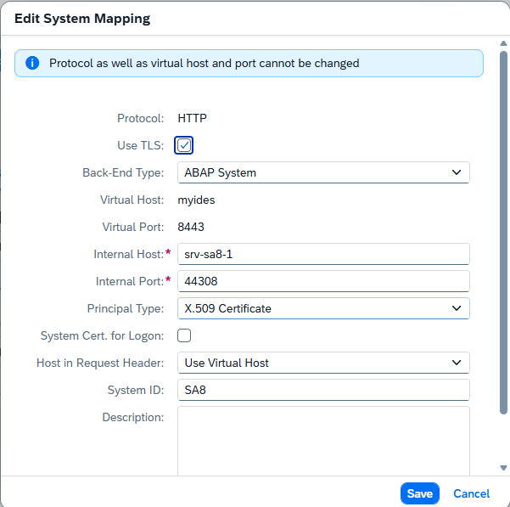

Add certificate

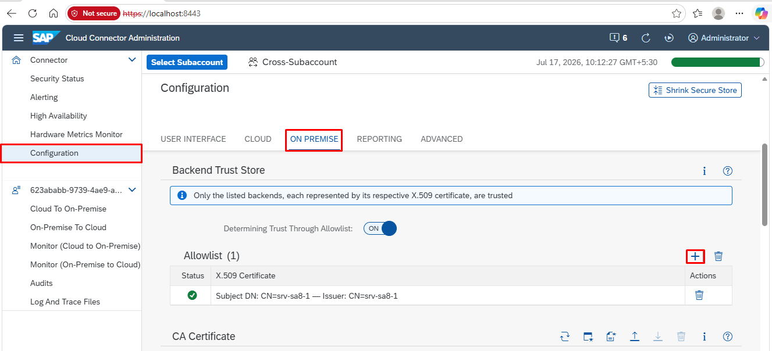

Check Result - Reachable

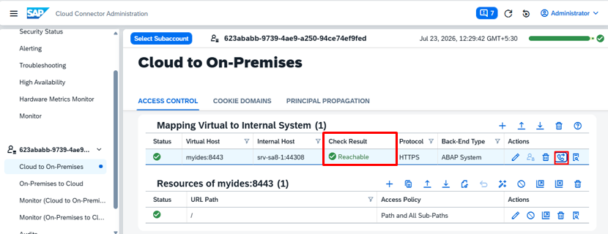

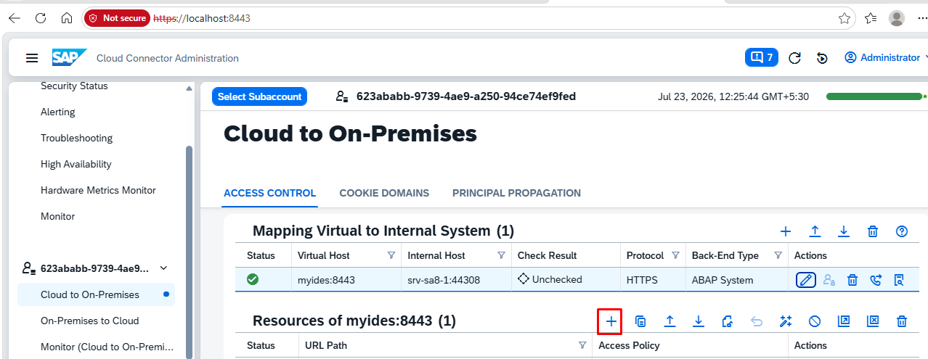
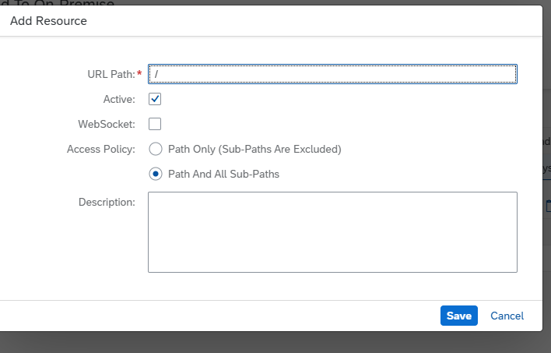

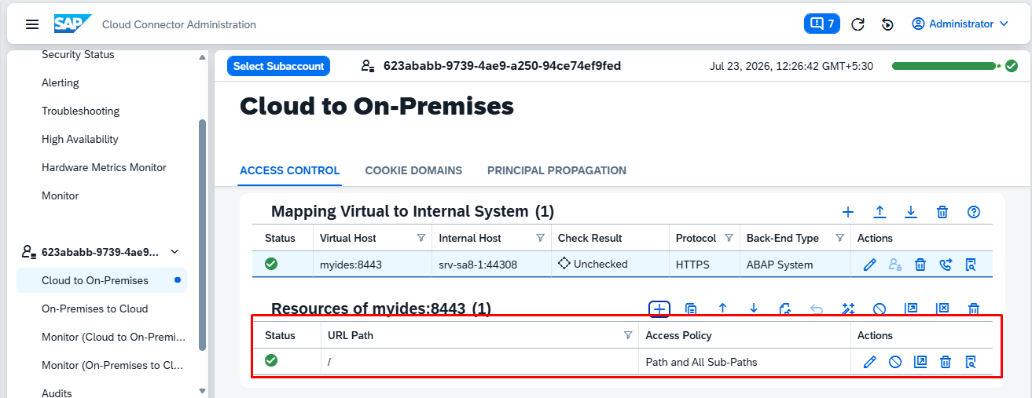

C:\Windows\System32\drivers\etc

b) BTP Cockpit Home - Trial Home - SAP BTP Cockpit –
https://account.hanatrial.ondemand.com/trial/#/home/trial
Login with credentials
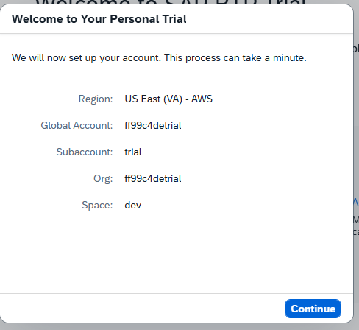

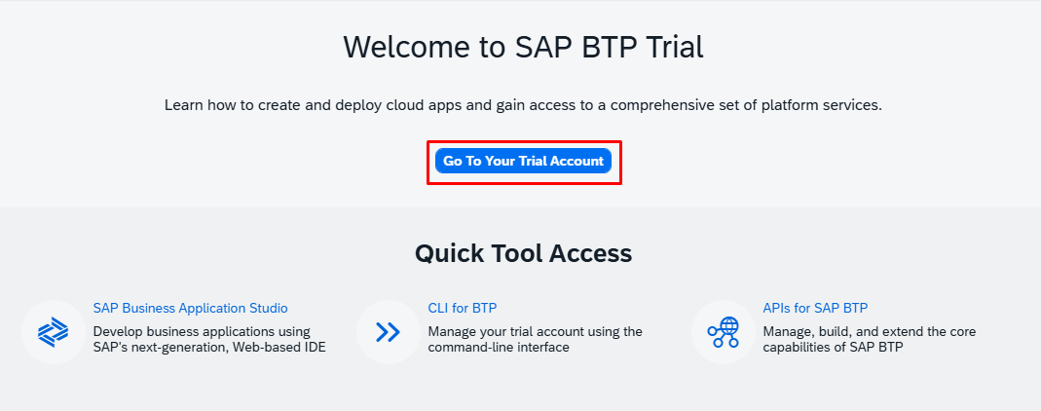

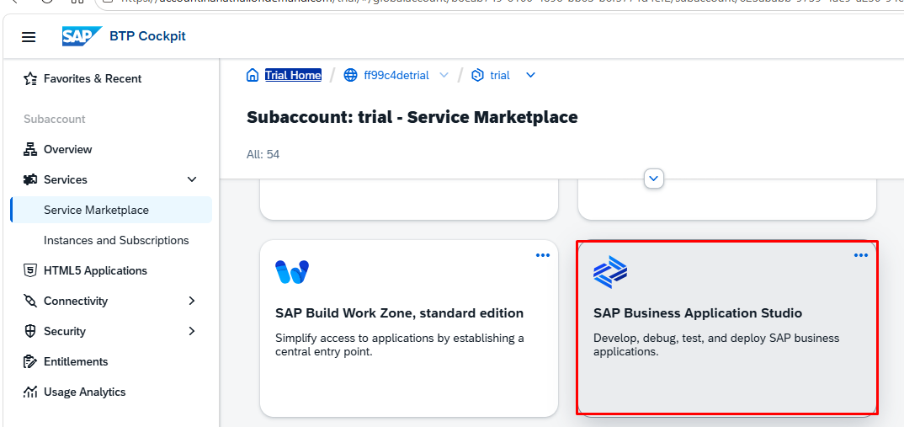

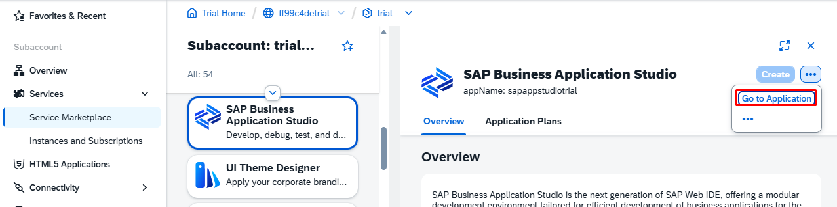

Business Application Studio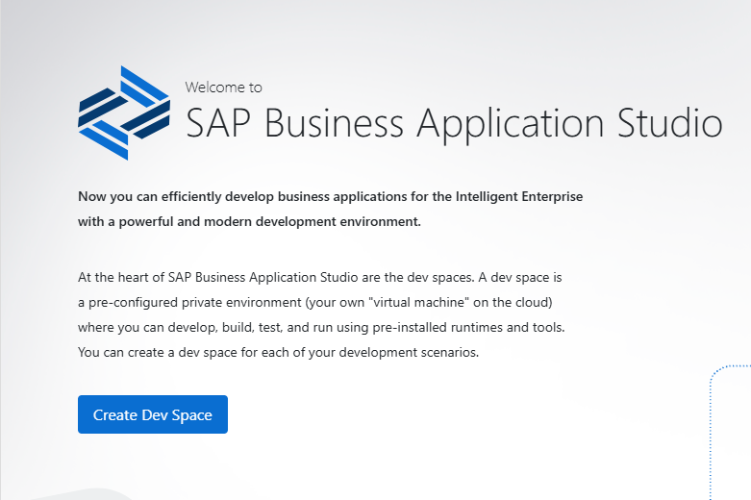
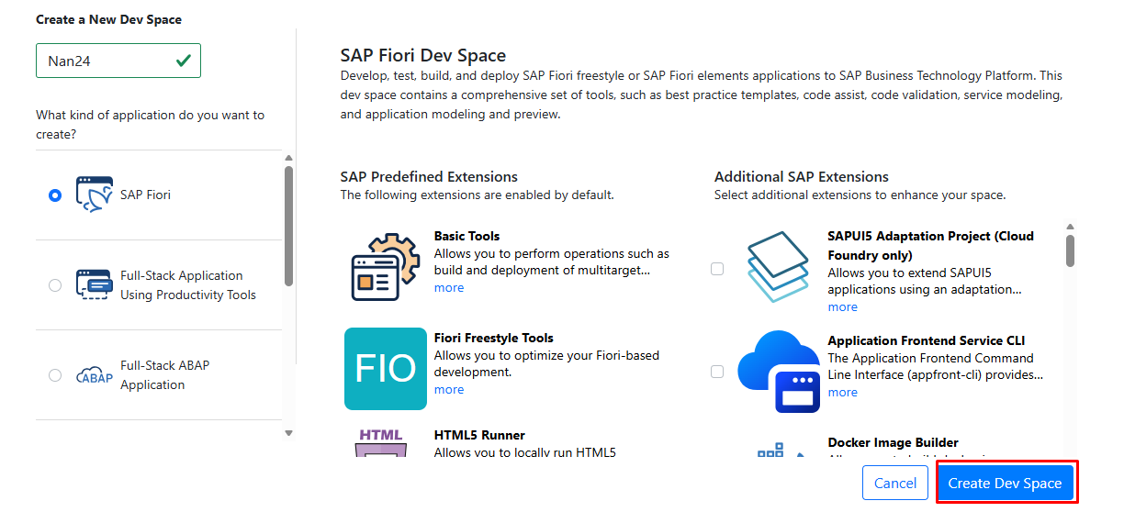

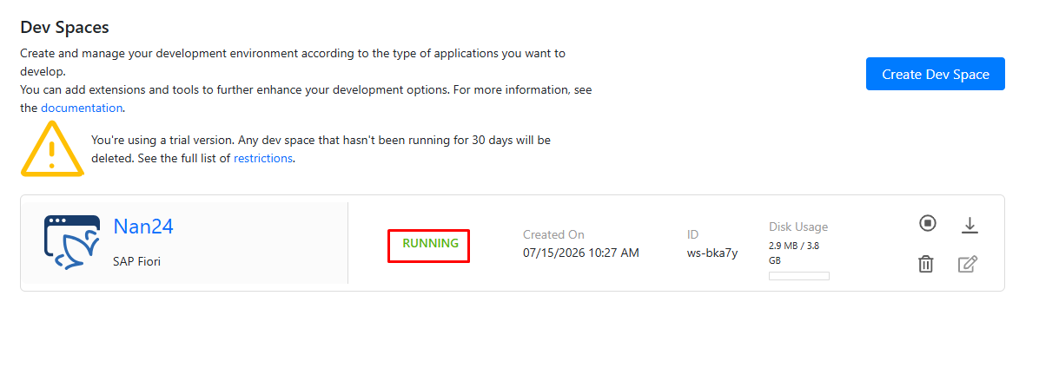

Devspace Will be launched
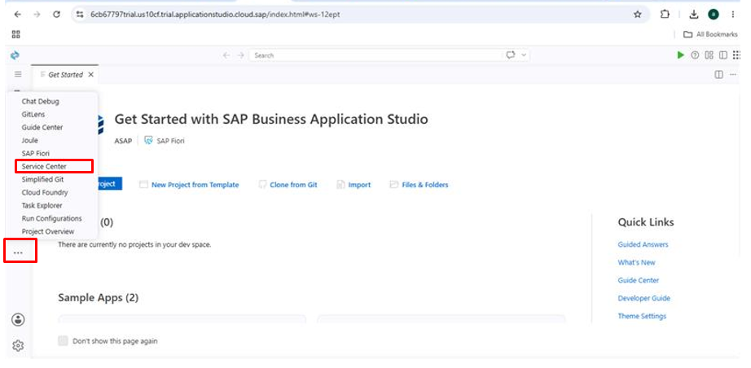

Add system
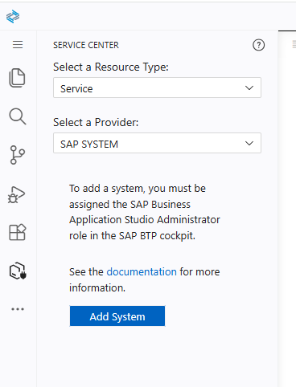
Add System – Add
URL – Give your virtual host from cloud connector
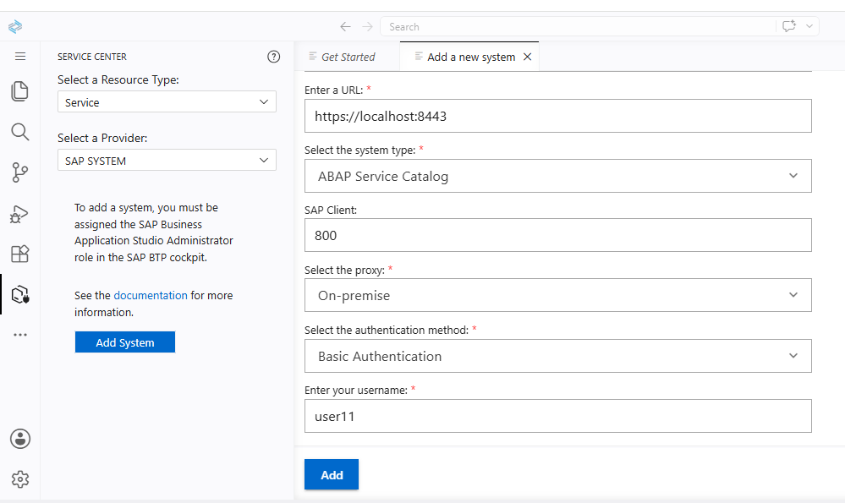

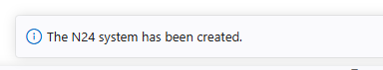

Refresh

Service added successfully

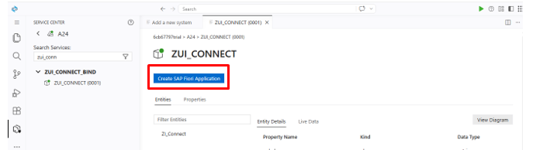

- Choose Start from Template.
- Select Fiori Application.
- Choose Basic / the appropriate basic application template.
- Enter the application name, namespace, and other project details.
- BAS generates the Fiori project.
New project will be created.
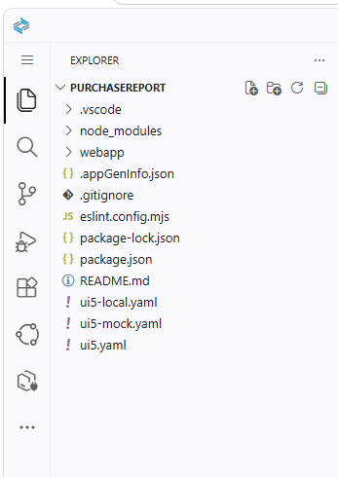

Backend

a) Creation of CDS Views
  - Data Definition
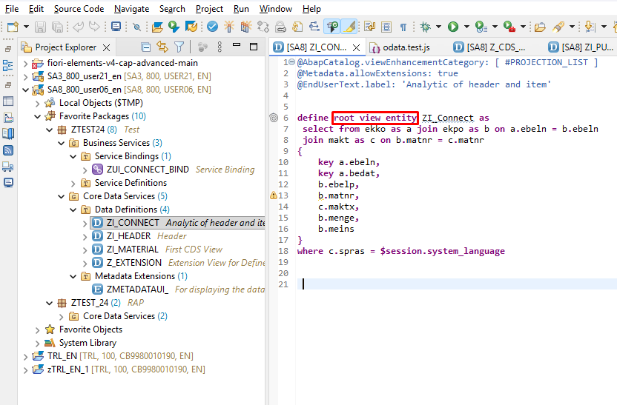

Metadata Extension
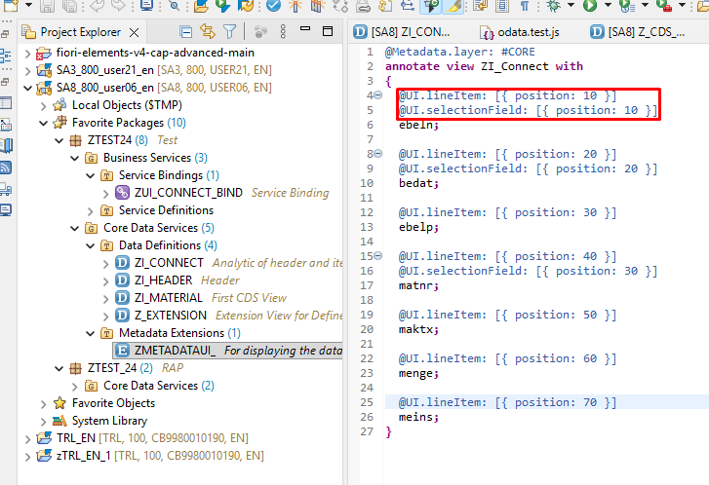

Business Service Creation
    - Service Definition

    - Service Bindings

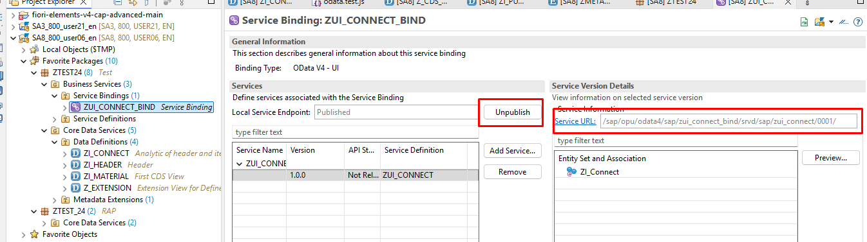

SAPUI5
HTML | SAPUI5
<div> | <VBox>, <HBox>, <FlexBox>
<input> | <Input>
<button> | <Button>
<table> | <Table>
<select> | <Select>
<img> | <Image>
<form> | <SimpleForm>
• Learn the common controls: Button, Input, Label, Text, Table.
• Learn layout containers: VBox, HBox, FlexBox.
• Learn data binding (this is one of the biggest differences from plain HTML).
• Learn SimpleForm and ResponsiveGridLayout for business forms.

Feature | Fiori Elements | SAPUI5 (Freestyle)
Development | Low-code | Full coding
UI Design | Generated automatically | You build every screen
Flexibility | Limited to framework patterns | Full customization
Coding | Mostly annotations and configuration | XML + JavaScript/TypeScript
Speed | Very fast | Slower to develop
Best for | Standard business apps | Complex or custom apps
Coding | Annotation table. | create XML table.
SAP automatically generates:
- List Report
- Object Page
- Create/Edit forms
- Search
- Filters
- Tables
- Navigation
ID | Name | Department
Fiori Elements can generate:
- Employee list
- Search
- Filter by department
- Employee details page
- Create/Edit/Delete functionality
Best for:
- Sales Orders
- Purchase Orders
- Material Master
- Employee records
- Approval apps
Standard navigation in Fiori Elements
List Report (Page 1)
│
▼
Object Page (Page 2)
│
▼
Sub Object Page (Page 3, optional)

this.getOwnerComponent().getModel(); - gets the OData model configured in manifest.json.

Steps to connect BAS App to /n/ui2/flp…
1. Add manifest.json
"deploy": "ui5 build --config=ui5.yaml --clean-dest && fiori deploy --config ui5-deploy.yaml",

- Add deploy.yaml
specVersion: "3.0"
metadata:
name: salesreport

type: application

resources:
configuration:
paths:
webapp: webapp

builder:
customTasks:
- name: deploy-to-abap
afterTask: generateCachebusterInfo
configuration:
target:
url: https://srv-sa8-1.idesaccess.com:44308
destination: N24
app:
name: ZSALESREPORT
description: Sales Register
package: ZRAP
transport: SA8K900827
exclude:
- /test/
- Run - npm run deploy
- This will create a bsp application in se80
  - /N/IWFND/MAINT_SERVICE check /ui5/abap_repository_srv exits.
- Create tile in flp - /N/UI2/FLPD_CUST
- Choose Target Mapping → Create.
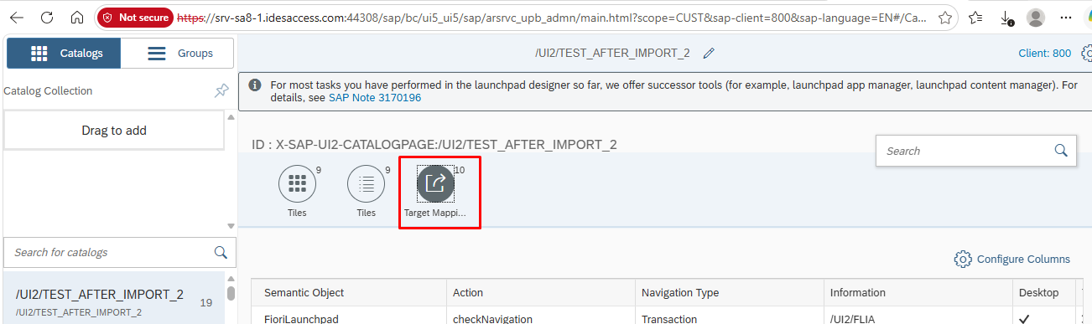  Field | Value
Semantic Object | salesreport
Action | display
Application Type | SAPUI5 Fiori App
Title | Sales Register
URL | /sap/bc/ui5_ui5/sap/zsalesreport
SAPUI5 Component ID | salesreport

- Add tile
- Add role PFCG
Uses semanuc name as sap.app id

