**CHARTING THE COURSE OF INNOVATION : A STARTUP ANALYSIS**

Index

|  |  |  |
| --- | --- | --- |
| **S.No** | **Contents** | **Page no.** |
| **1** | **Introduction** | **02** |
| **2** | **Problem definition and design thinking** | **04** |
| **3** | **Result** | **06** |
| **4** | **Advantage and disadvantage of the project.** | **08** |
| **5** | **Application** | **10** |
| **6** | **Conclusion** | **12** |
| **7** | **Future Scope** | **14** |
| **8** | **Appendix** | **16** |

1.Introduction:

1.1 Overview

Startup analysis is the process of evaluating the feasibility and potential of a new business venture. It involves assessing various factors such as the market opportunity, the strength of the team, the uniqueness of the product or service, and the financial viability of the business model.

1.2 Purpose

Startup analysis is the process of examining and evaluating the potential of a new business venture. The purpose of startup analysis is to assess the viability and potential of a new business idea, and to identify the risks, challenges, and opportunities associated with launching a new venture.

* **Identifying the market opportunity**: The analysis helps to determine whether the business idea is addressing a real need in the market, and whether there is sufficient demand to support the new venture.
* **Assessing the competition**: The analysis helps to understand the competitive landscape and the potential barriers to entry in the market. This information can be used to refine the business idea and develop a competitive strategy.

**2.Problem definition and design thinking:**

**2.1Empathy Map**

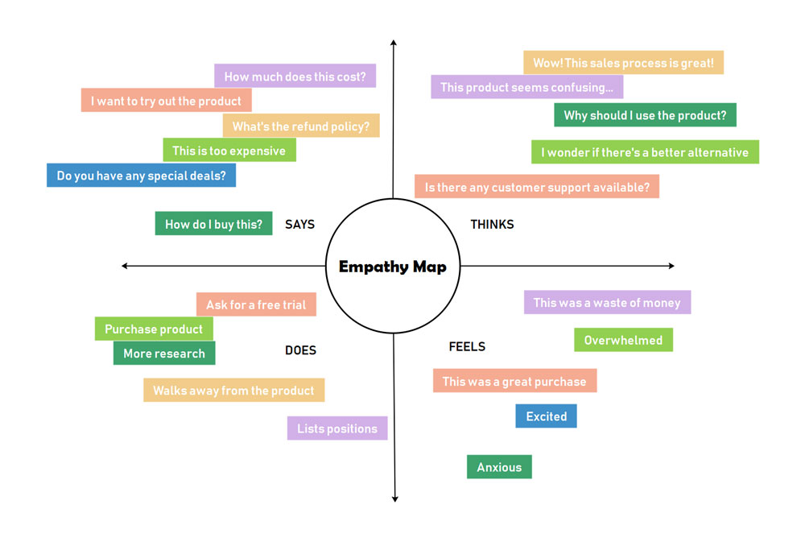

2.2 Brainstorming Map

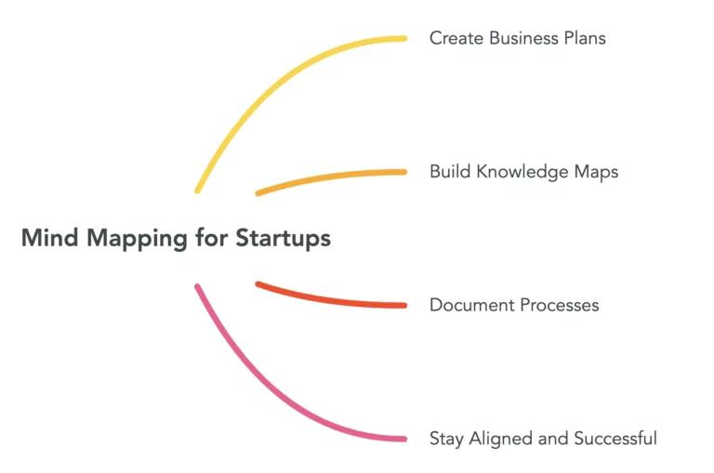

**3.Results:**

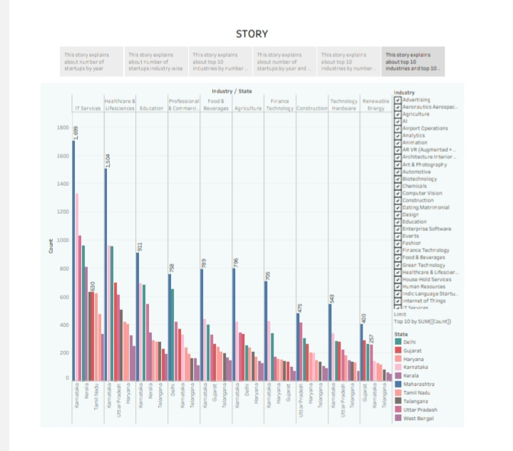

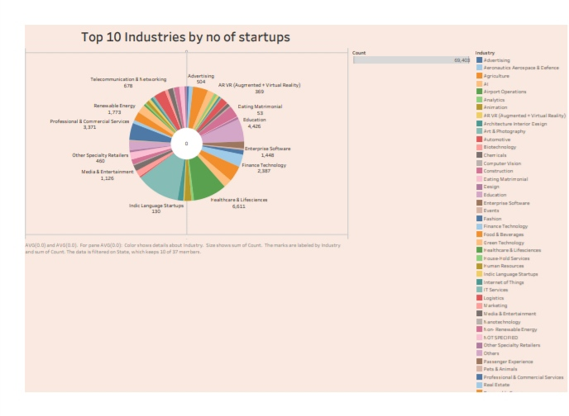

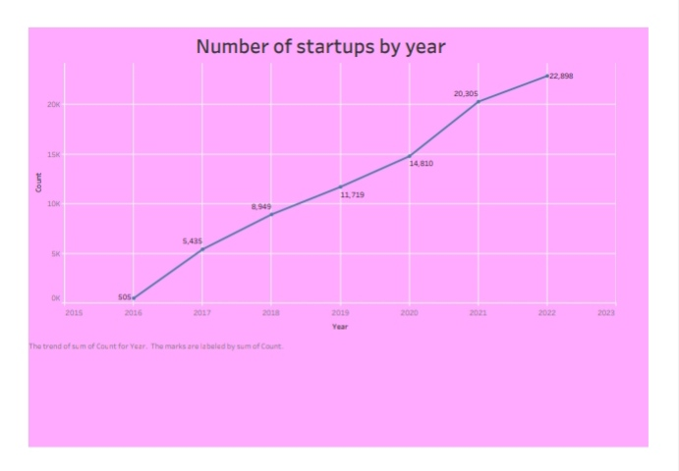

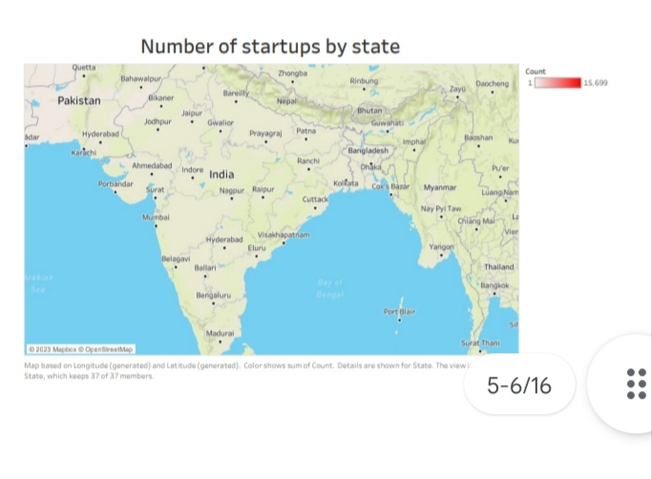

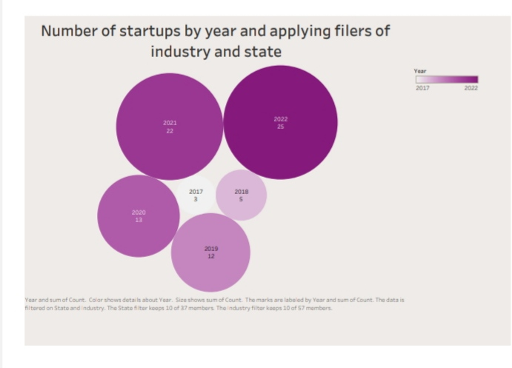

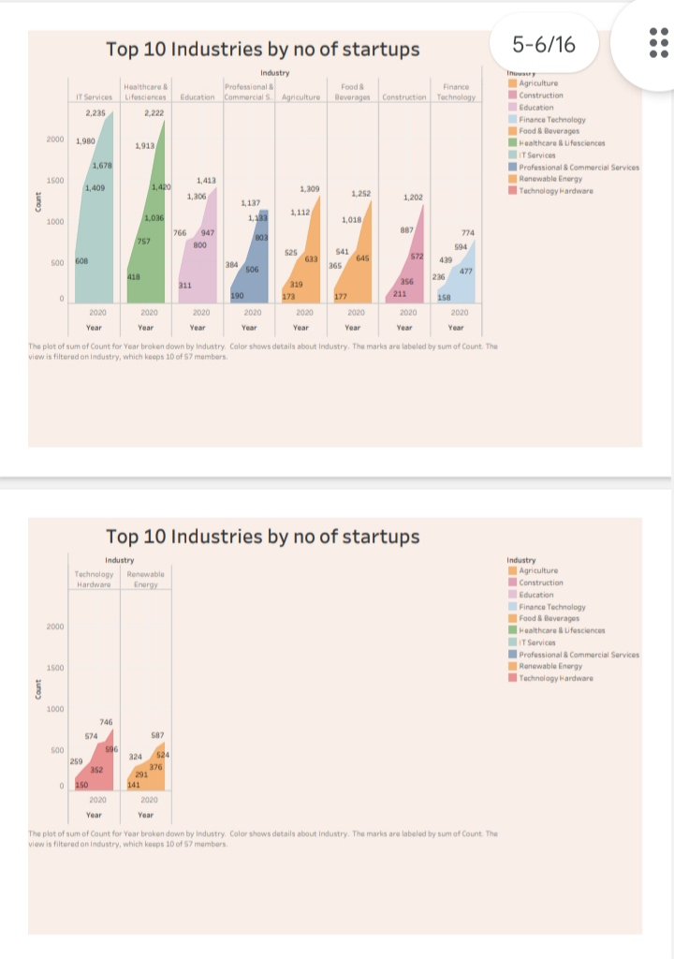

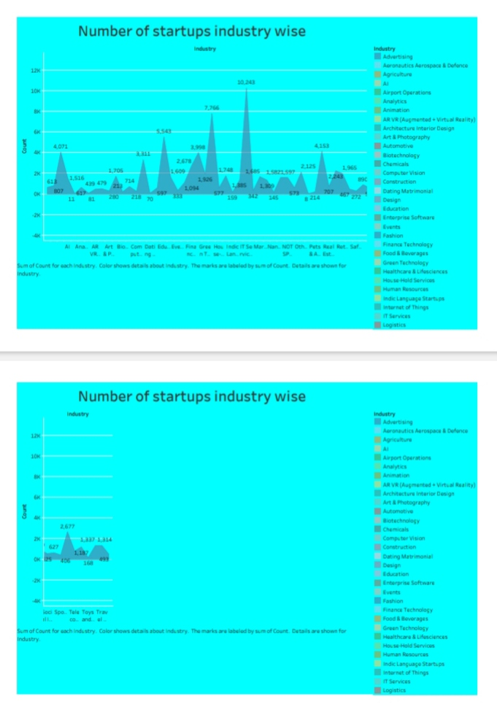

**Dashboard:**

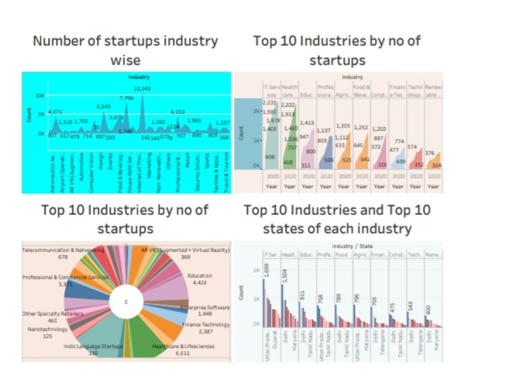

**4.Advantages and Disadvantages of the Project:**

**4.1 Advantages**

Identifying potential risks: By conducting a thorough analysis of a startup, potential risks can be identified early on, allowing the founders to take appropriate measures to mitigate them.

Evaluating market opportunities: Startups are often founded to address gaps in the market. Analyzing the market and its potential for growth can help founders determine whether their product or service is likely to succeed.

**4.2 Disadvantages**

Limited data: Startups are often in their early stages and may not have a lot of data available for analysis. This can make it difficult to accurately predict their success or failure.

Uncertainty: Startups operate in a highly uncertain environment and face a lot of risks. This makes it difficult to accurately predict their future performance.

Bias: The analysis of startups can be influenced by bias, particularly if the analyst has a personal connection to the startup or its founders.

|  |  |
| --- | --- |
|  |  |

**5.Applications:**

1. A startup analysis helps entrepreneurs identify potential challenges, opportunities, and threats to their business idea. By conducting an analysis, they can develop a robust business plan that outlines their strategy, target market, marketing plan, and financial projections.
2. Investors use startup analysis to evaluate potential investments. By reviewing key metrics such as market size, competition, and revenue projections, they can assess the potential return on investment and make an informed decision about whether to invest.
3. Startups use market analysis to identify their target market, customer needs, and preferences. This information can help them develop products and services that meet the needs of their target audience
4. **6.Conclusion:**

By conducting a startup analysis, entrepreneurs can develop a robust business plan, identify their target market, and evaluate their product's potential. Investors can use this analysis to evaluate potential investments and determine their potential return on investment.

**7.Future Scope:**

Sustainability and social impact: There is a growing focus on sustainability and social impact in the business world, and startup analysis could reflect this trend by evaluating startups based on their environmental and social impact. This could include identifying startups that are developing products or services that promote sustainability or that have a positive social impact.

**8.Appendix:**

<https://public.tableau.com/views/Book1_16812947282340/Sheet1?:language=en-US&:display_count=n&:origin=viz_share_link>

<https://startupanalysis.nicepage.io/?version=25bee2fd-5fc7-458c-938f-49c52513334e>

<https://drive.google.com/file/d/13DKQy7NdDvUkQ0XVRvhUi2BTWH7sLKx_/view?usp=drivesdk>