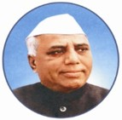 |  | 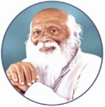

Rayat Shikshan Sanstha's
YASHAVANTRAO CHAVAN INSTITUTE OF SCIENCE, SATARA
Constituent College of Karmaveer Bhaurao Patil University, Satara
Department of Electronics
Centre of Excellence in Artificial Intelligence Applications Development (COE-AIAD)

Training Program on
"{{PROGRAM_NAME}}"

CERTIFICATE

This is to certify that Dr./Mr./Ms./Mrs. {{RECIPIENT_NAME}} of Yashavantrao Chavan Institute of Science, Satara has Worked as Trainer in Research Training Program on "{{PROGRAM_NAME}}" from on 11/04/2026 – 21/05/2026 at Yashavantrao Chavan Institute of Science, Satara organized by Centre of Excellence in Artificial Intelligence Applications Development (COE-AIAD)
Grey italic fields — title, name, and dates — are placeholders. Fill them per certificate (Find & Replace, or drive from a mail-merge data source).

Mr. S. S. Barkade  Co-ordinator,COE-AIAD | Mr. Satish Doke  Head, Dept. of Electronics | Riya Salunkhe  Director, Riyatrix | Dr. S.T. Salunkhe  Principal, YCIS, Satara

