🎓 Final Year Engineering Project Presentation Structure

Slide 1: Title Slide
Include:
- Project Title (clear and specific)
- Your Name
- Roll Number
- Branch & Department
- College Name
- Guide Name
- Academic Year

What to say: Introduce yourself and your project title confidently.

Slide 2: Problem Statement
Include:
- Real-world problem
- Why it is important
- Current challenges
- Supporting statistics (if any)
What to say:
Explain the problem clearly in simple language. Make the audience understand why this problem matters.

Slide 3: Motivation
Include:
- Why you selected this topic
- Real-world need
- Industry relevance
- Personal/technical interest
Tip: Use a small real-life example.

Slide 4: Objectives
Include:
- 3–5 clear project objectives
- Measurable goals
- Expected outcome
Example:
- To design and develop…
- To improve efficiency by…
- To reduce cost by…

Slide 5: Literature Survey
Include:
- Existing methods/technologies
- Research papers reviewed
- Limitations of current systems
- Comparison table (optional)
What to say:
Explain how your project is different or improved from existing systems.

Slide 6: Proposed System
Include:
- Your solution overview
- Key idea
- Working principle
Add:
- Block diagram (very important)

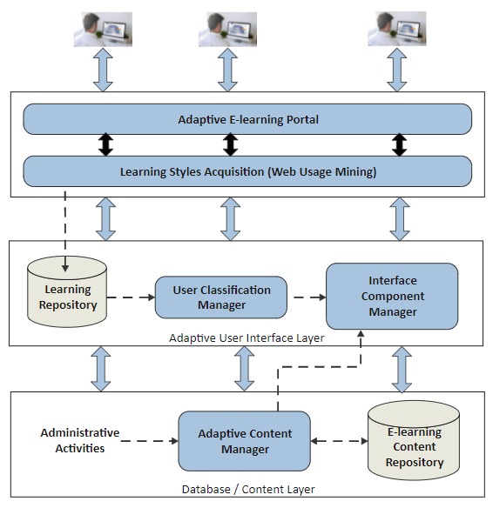
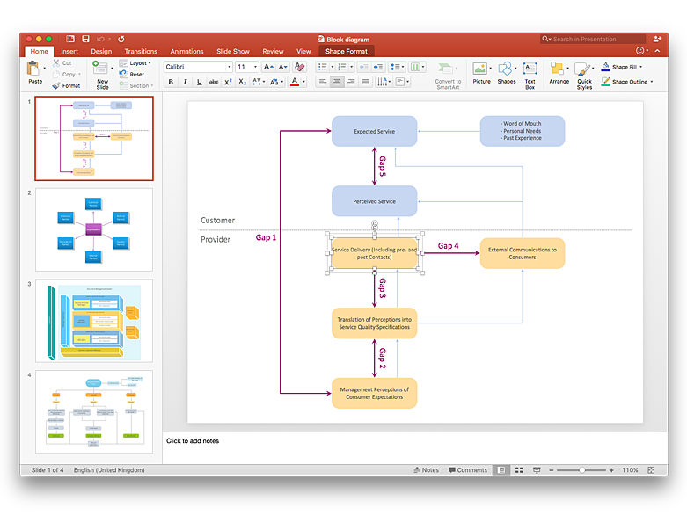
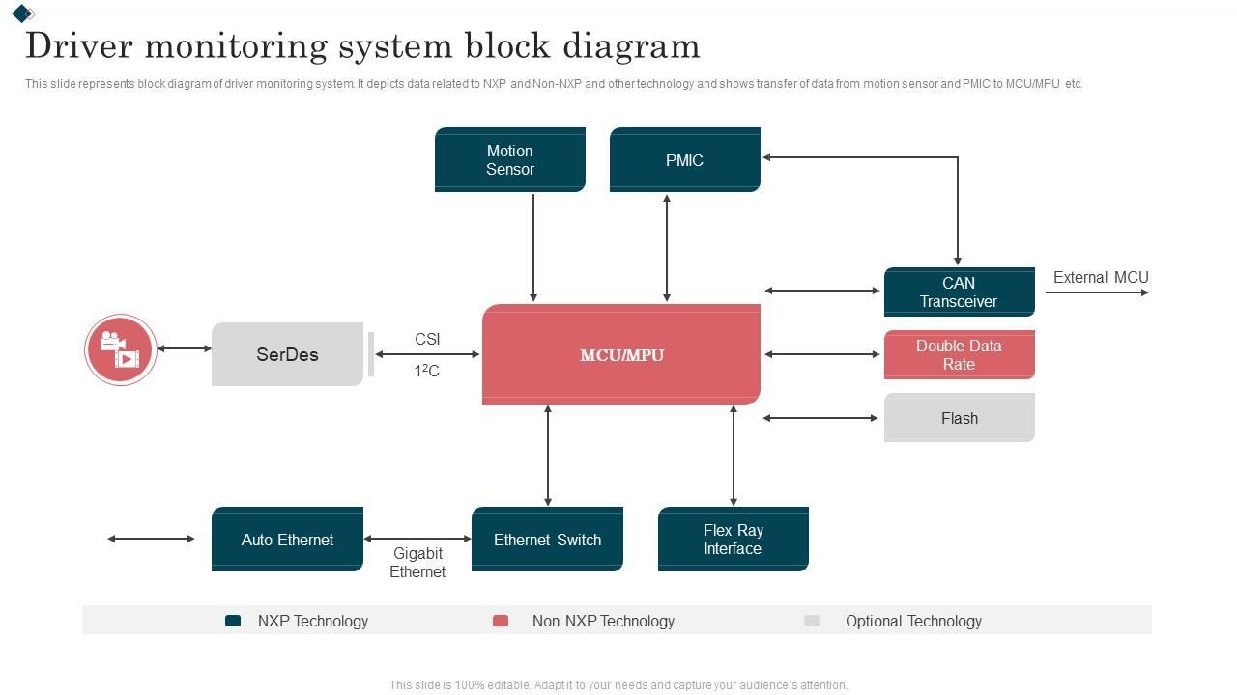
What to say:
Explain the block diagram step by step (input → processing → output).

Slide 7: Methodology / Working Process
Include:
- Step-by-step process
- Flowchart
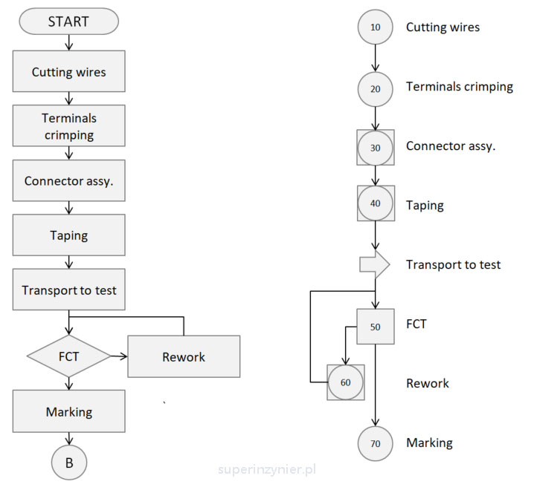
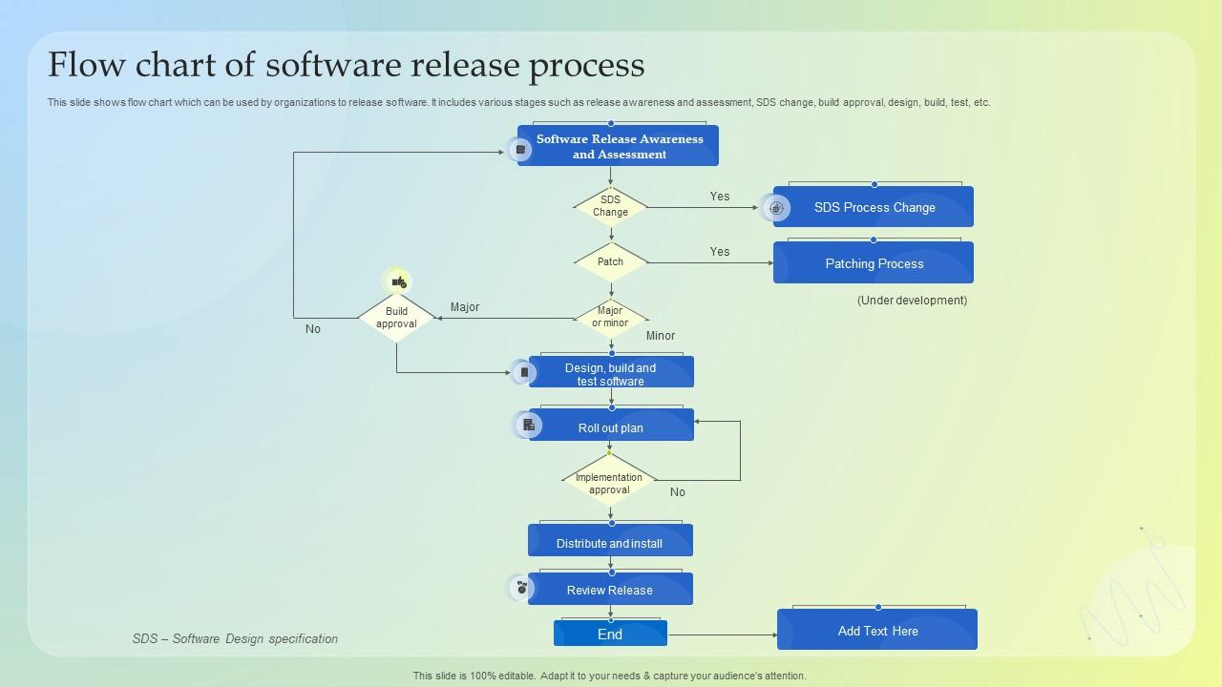

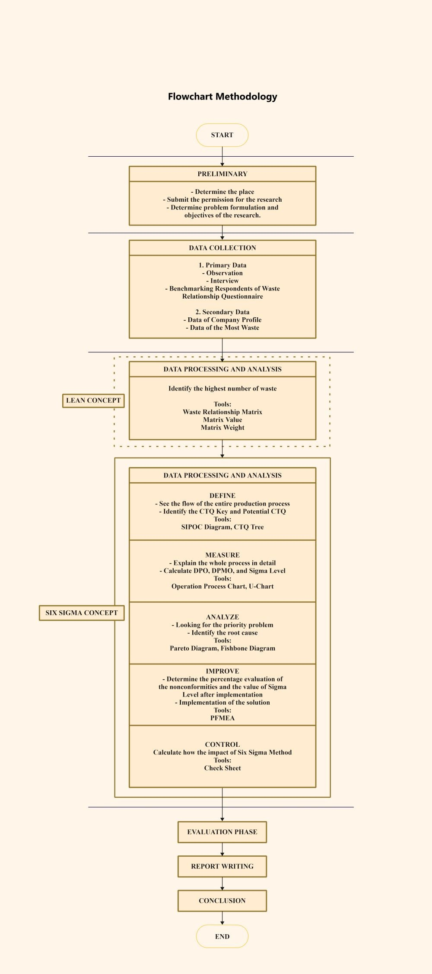
Explain:
- Data Collection / Input
- Processing
- Analysis
- Output

Slide 8: Hardware Components (If Applicable)
Include:
- List of components
- Why each is used
- Specifications
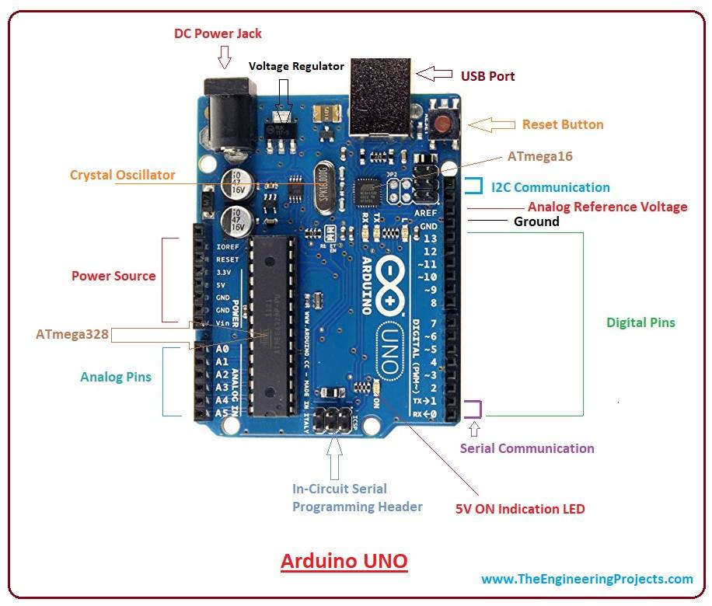
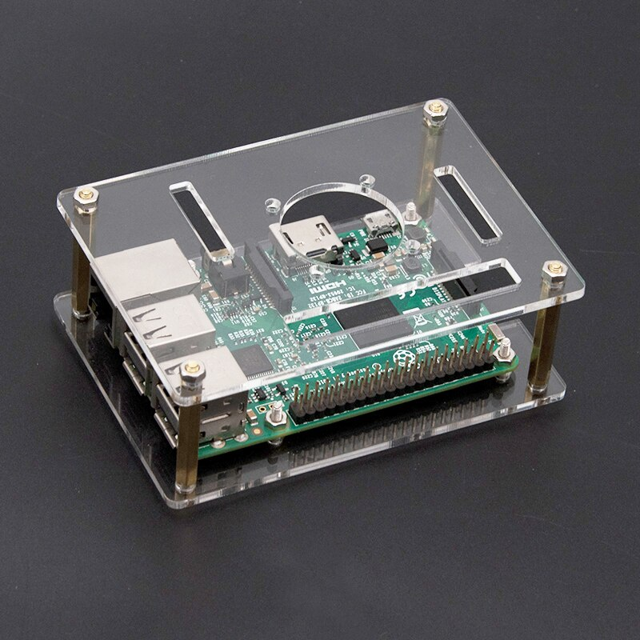

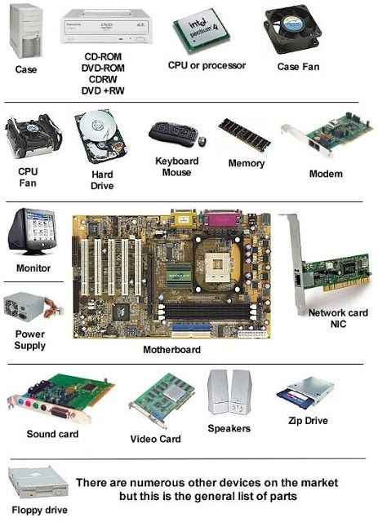

Slide 9: Software Requirements
Include:
- Programming Language
- Tools & IDE
- Libraries
- Database (if any)
Example:
- Python / Java / MATLAB
- VS Code / Arduino IDE
- MySQL / Firebase

Slide 10: Implementation
Include:
- Screenshots
- Prototype images
- Coding snippet (small)
- Circuit diagram (if hardware)


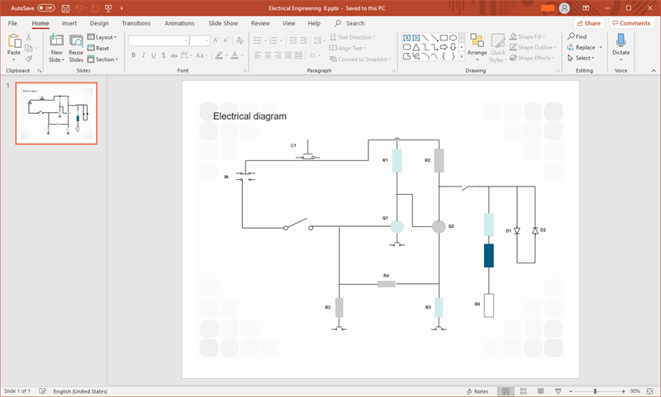
Explain what you implemented and how.

Slide 11: Results
Include:
- Graphs
- Tables
- Output screenshots
- Performance comparison
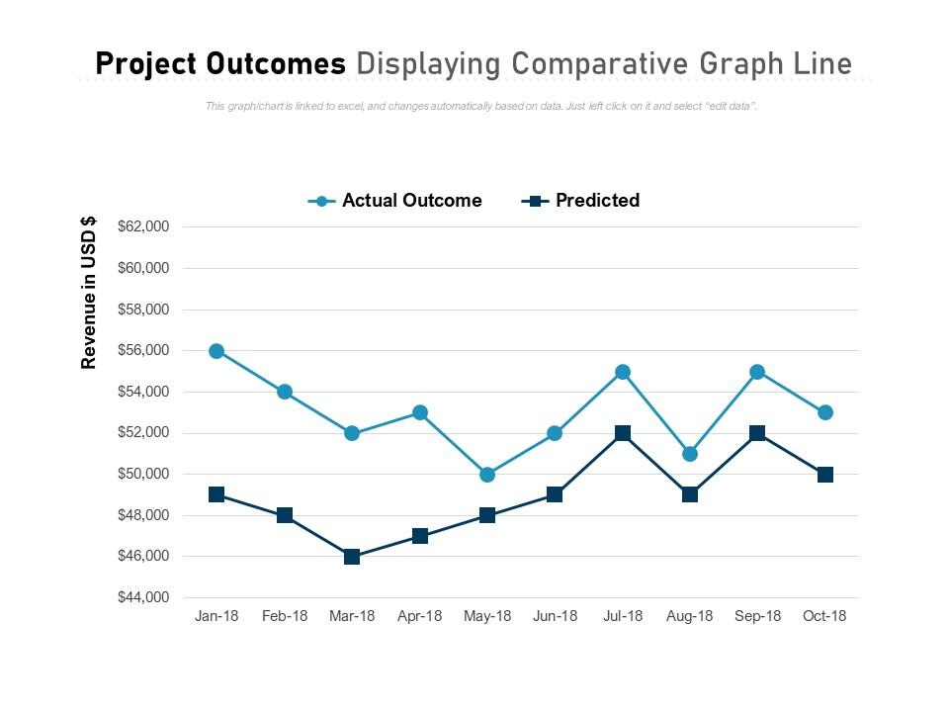
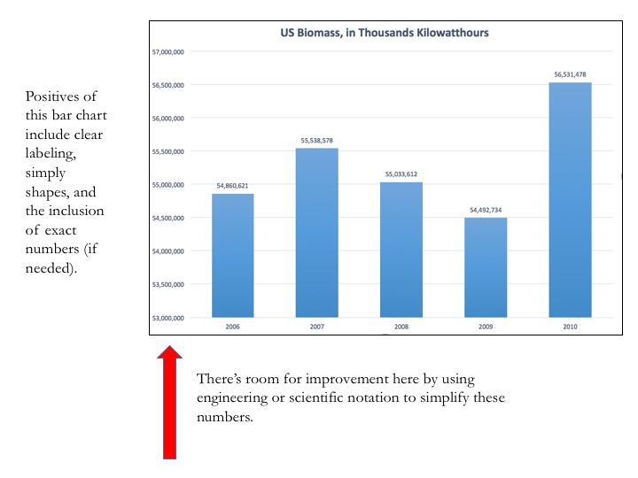

Explain:
- Accuracy
- Efficiency
- Cost reduction
- Time saved

Slide 12: Advantages
Include:
- Key benefits
- Improvement over existing system
- Practical usability
Keep it short (4–5 bullet points).

Slide 13: Limitations
Include:
- Technical constraints
- Resource limitations
- Future challenges
Be honest. Examiners appreciate realistic evaluation.

Slide 14: Future Scope
Include:
- Possible improvements
- Industry application
- Scalability
- Advanced features

Slide 15: Conclusion
Include:
- Summary of problem
- Your solution
- Key results
- Final achievement
Keep it concise and impactful.

Slide 16: References
Include:
- IEEE papers
- Journals
- Websites
- Books
Follow proper citation format.

Slide 17: Acknowledgment
- Guide
- HOD
- Faculty
- Team members

Slide 18: Thank You
Add:
“Thank you. I am ready to answer your questions.”

