**Assignment 3**

Nandhakumar

CB.EN.U4CSE20242

In 2010, the ACLU presented a report on jury selection in Alameda County, California. Therefore, concluded that certain ethnic groups are under-represented among jury panellists in Alameda County, and suggested some reforms of the process by which eligible jurors are assigned to panels. In this section, we will perform our own analysis of the data and examine some questions that arise as a result.

Ho – Jurors were selected randomly

Ha – Jurors were NOT selected randomly

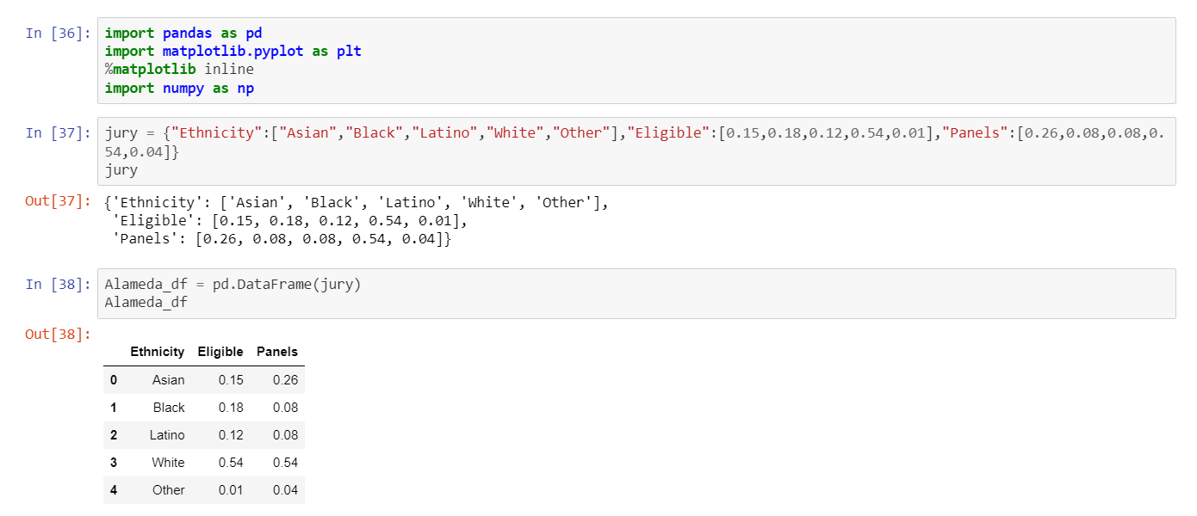

Comparison b/w eligible jurors from population and jurors from selection panel alone

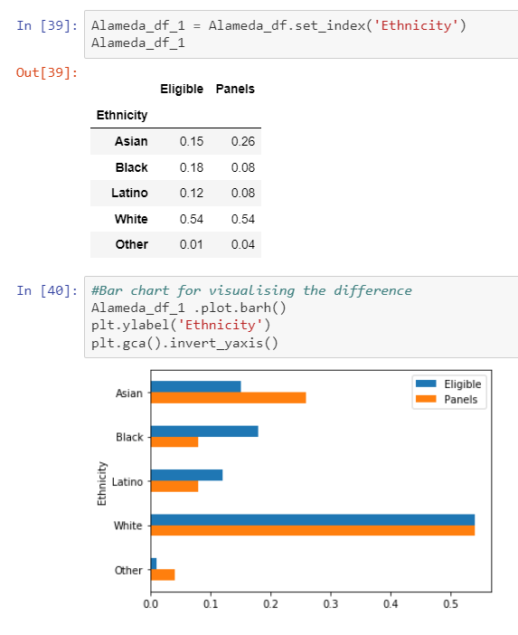

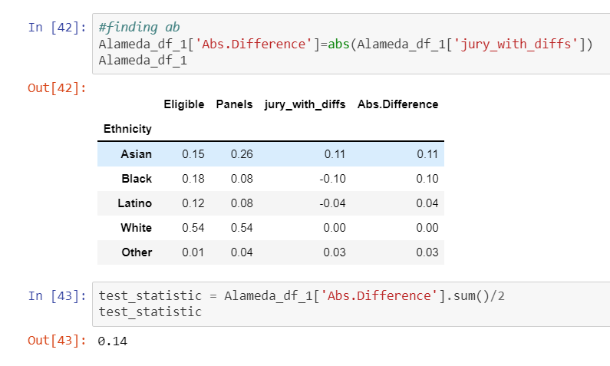The distance between the eligible juror population and the distribution in the panels is 0.14. It is called Total Variance Distance.

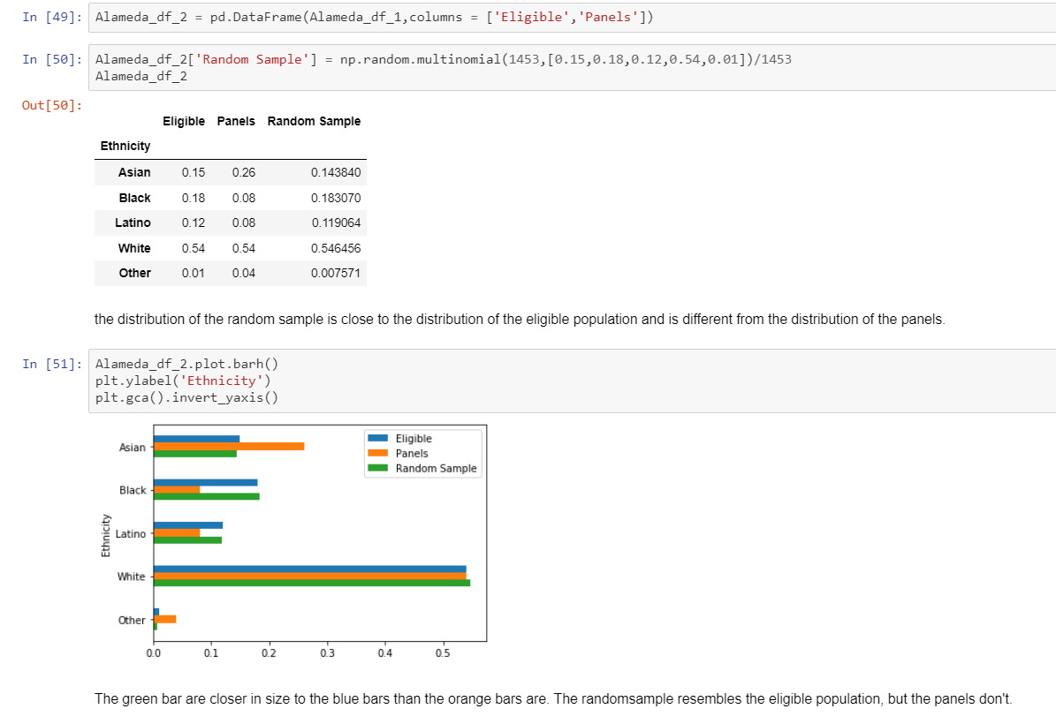Here, we are simulating our own graph with values to represent how the eligibility for jurors actually should have appeared like. As you can see, they don’t align naturally.

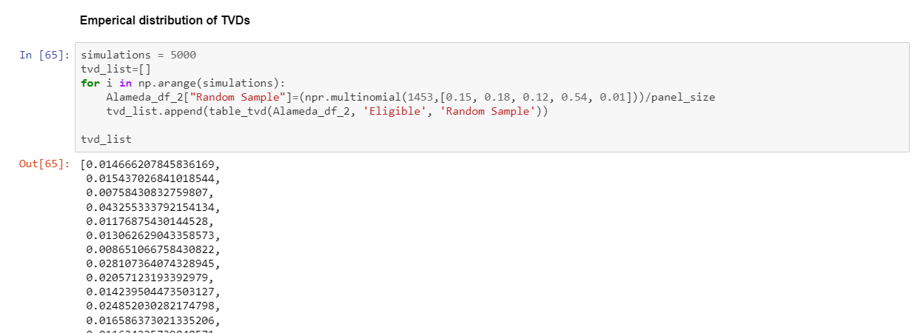

5000 samples stored in another array for display

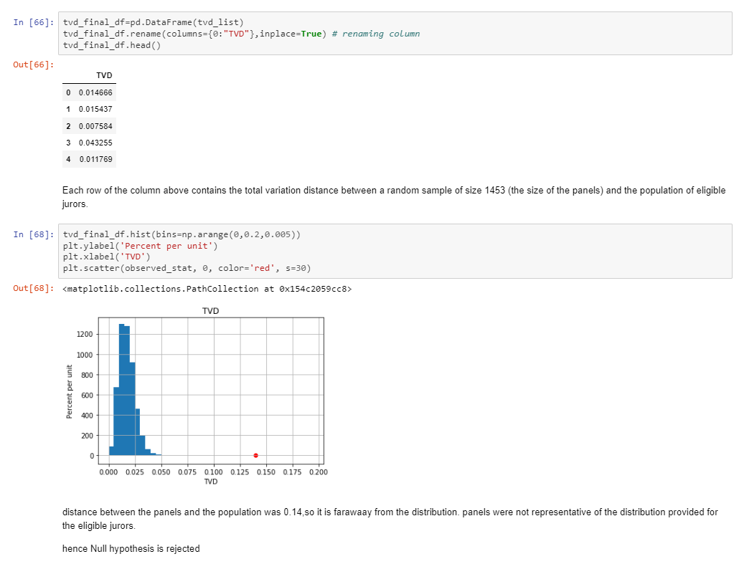

As we can see, the red dot is far away from the distribution. This shows that the panels were not representative of the distribution.

Thus, we Reject the Null Hypothesis