Employee Attendance Tracking System - Technical Documentation
Name: Nandini Arumalla
College: Vignan’s Lara Institute of Technology and Science
Phone No: 7013360967

1. Introduction
The Employee Attendance Tracking System is a MERN stack-based web application designed to streamline attendance monitoring within an organization. The system provides role-based access for both employees and managers, offering features like real-time check-in/check-out, automated status calculation, dashboard analytics, and downloadable reports.

2. Project Objectives
- Automate daily attendance tracking
- Provide accurate status marking: Present, Late, Half-Day, Absent
- Offer dashboard insights for managers
- Ensure proper authentication and role-based security
- Maintain monthly & daily logs for audit purposes

3. System Architecture
The system follows a client-server architecture using Node.js/Express for backend APIs, MongoDB for data storage, and React.js for front-end presentation. JWT authentication ensures secure role-based operations.
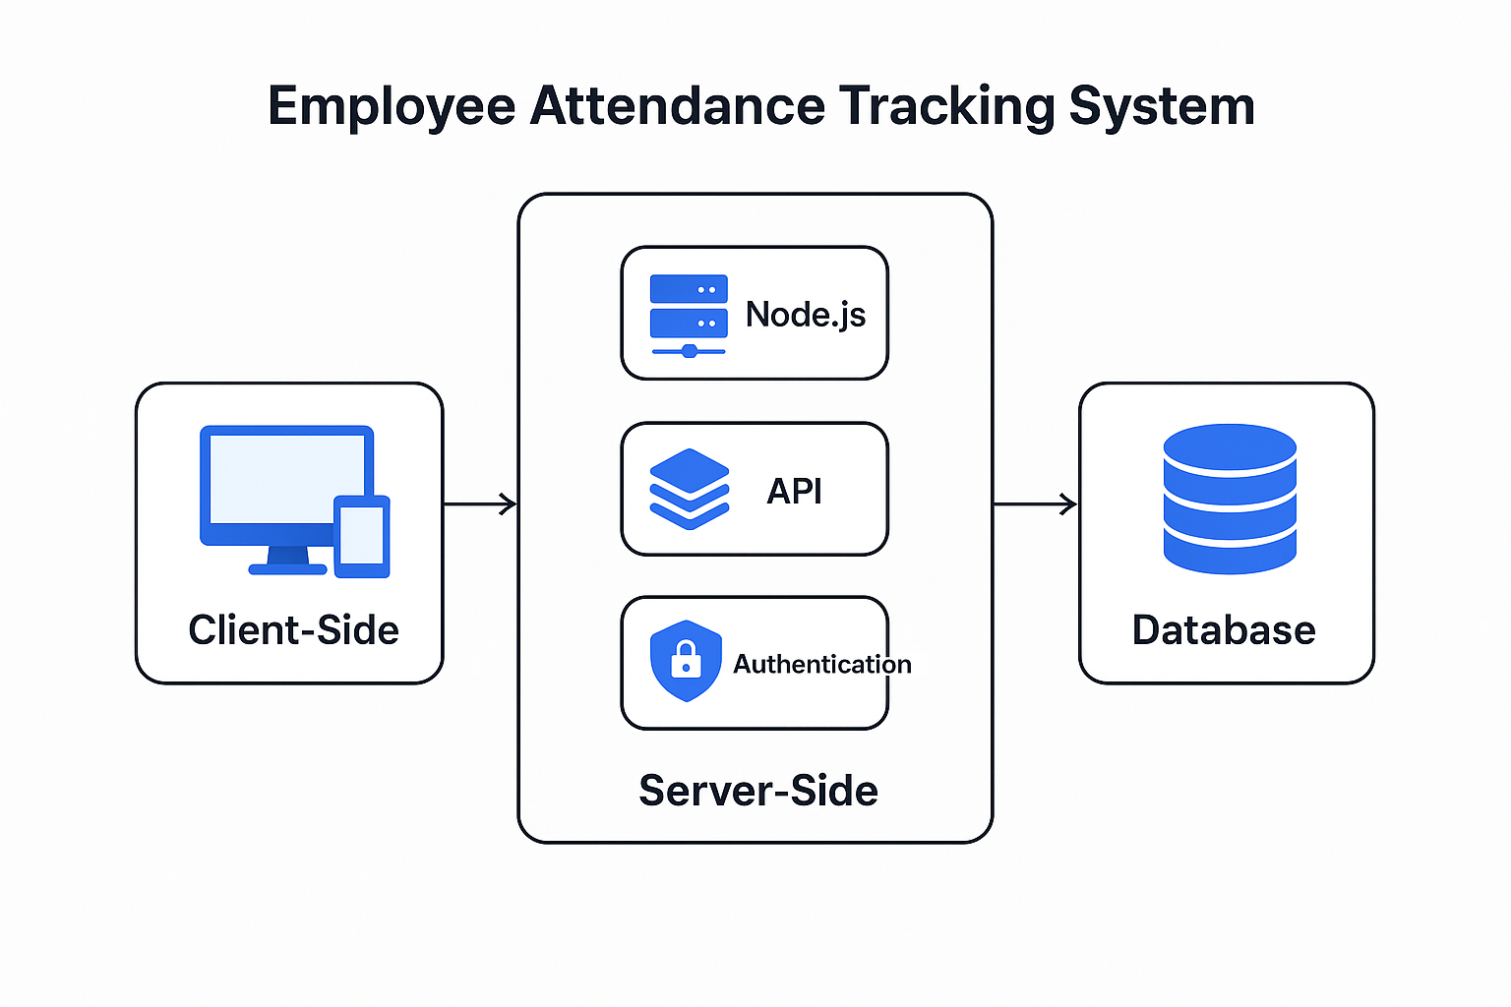

4. Key Features
1. Employee Login & Attendance Marking
- Check-in and check-out with automatic calculation of total hours.
- Status auto-updated based on check-in time.
- Profile viewing
- Track their attendance
2. Manager Dashboard
- View team attendance summary
- Weekly attendance trends
- Department-wise statistics
- Export attendance data as CSV
3. Admin/Manager Controls
- View all employees
- Monitor daily reports
- Generate overall summaries.

5. Technology Stack
Frontend:
- React.js
- Tailwind CSS
Backend:
- Node.js
- Express.js
Database:
- MongoDB
Authentication:
- JWT (JSON Web Token)

6. Workflow Description
1. Employee logs in → JWT token generated → Access to employee dashboard.
2. Employee checks in → System stores timestamp → Marks status based on rules.
3. Check-out triggers total hours calculation.
4. Manager dashboard aggregates today's and monthly records.
5. Manager exports attendance data for reporting.

7.Folder Structure:
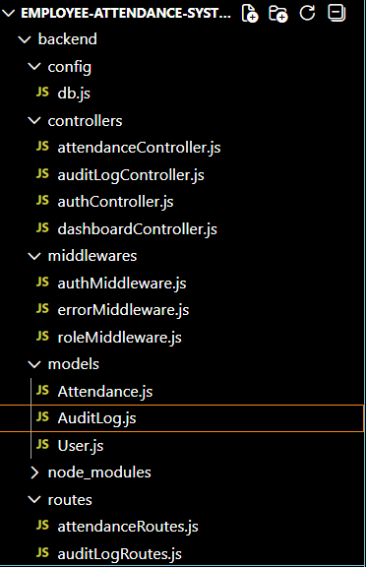

8. Attendance Status Logic
Present: Employee checks in before 9:00 AM.
Late: Check-in between 9:00 AM and 12:00 PM.
Half-Day: Check-out before 4 hours of working.
Absent: Did not check in for the day.

9. Database Schema Overview
1. User Model:
- name
- email
- password
- employeeId
- department
- role
2. Attendance Model:
- userId
- date
- checkInTime
- checkOutTime
- status
- total Hours

10. Backend API Endpoints:
Backend API Endpoints
Auth:
POST /api/auth/register
POST /api/auth/login
GET /api/auth/me
Attendance:
POST /api/attendance/check-in
POST /api/attendance/checkout
GET /api/attendance/today
GET /api/attendance/month
GET /api/attendance/export
Manager:
GET /api/manager/dashboard
GET /api/manager/all

Screenshots:
Register Page:
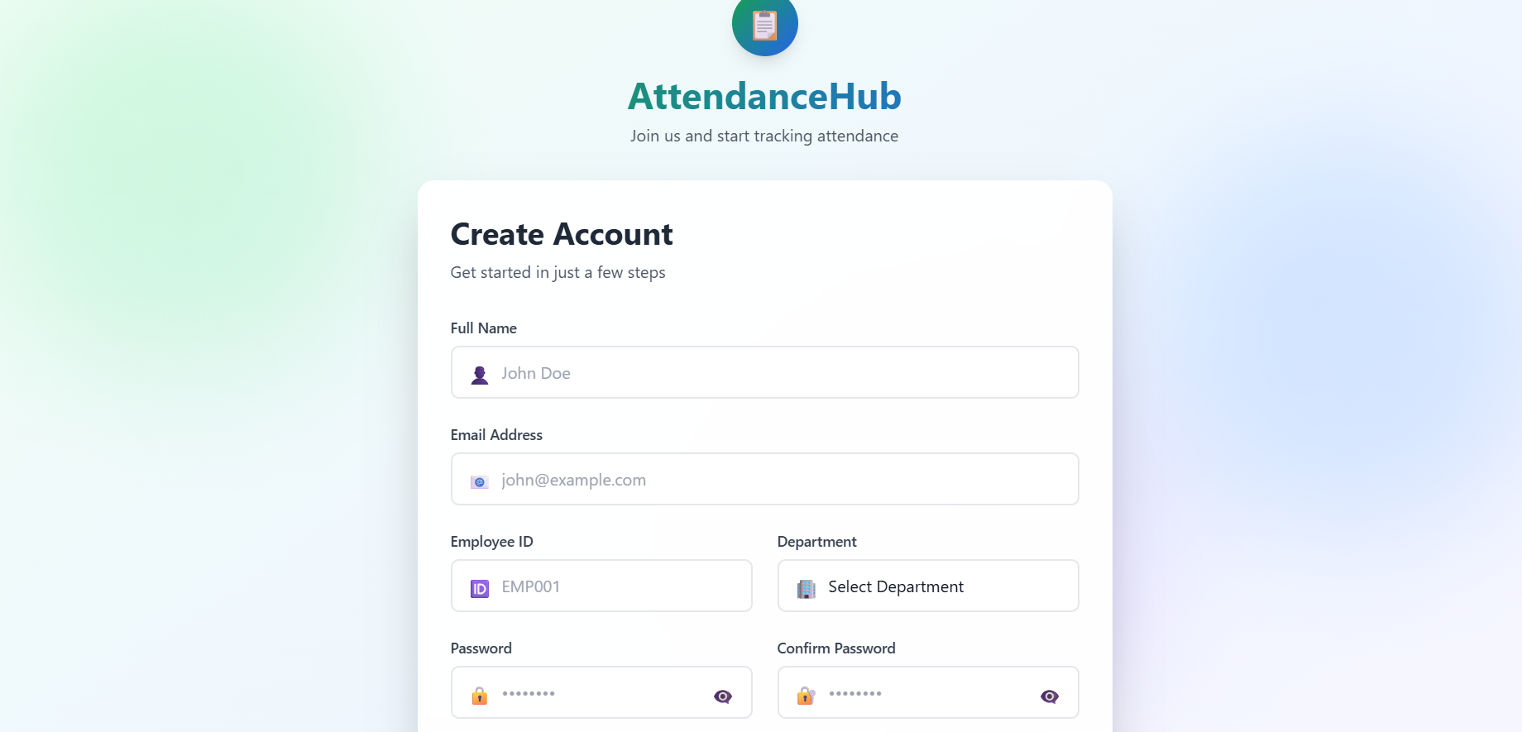
Employee Dashboard: 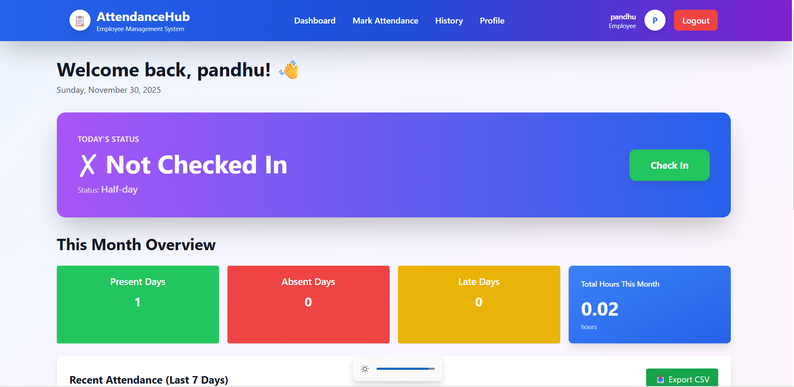
Employee History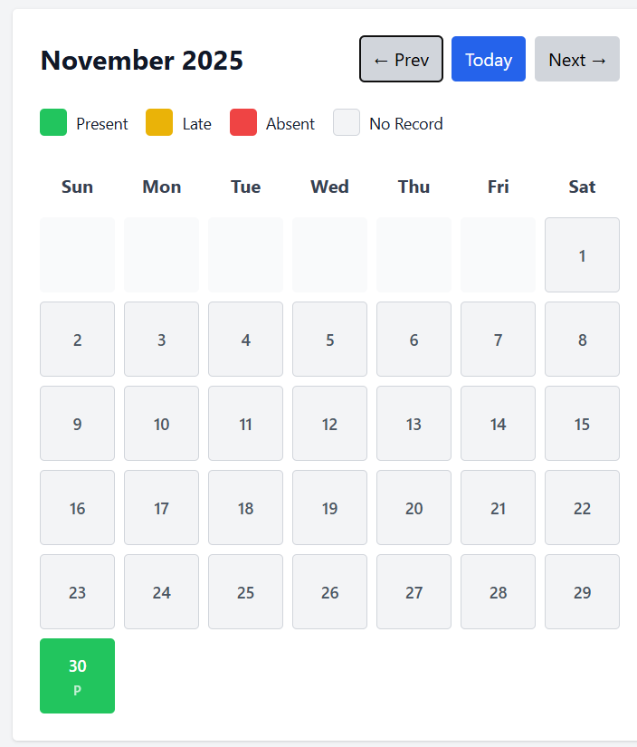
Profile:
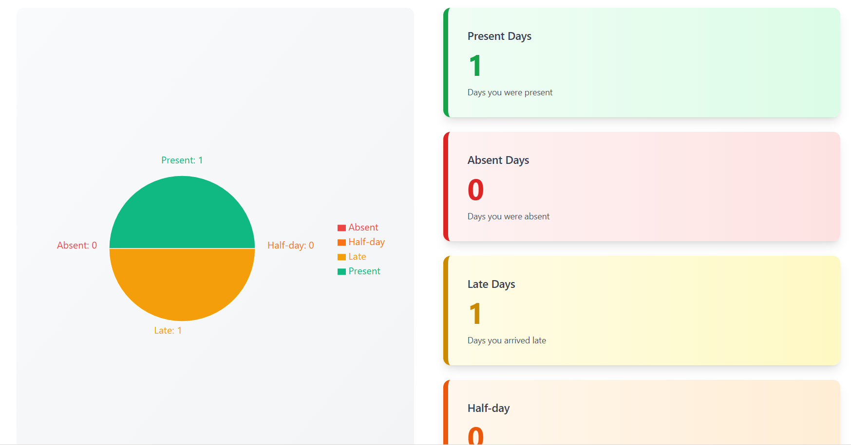

Manager Dashboard:
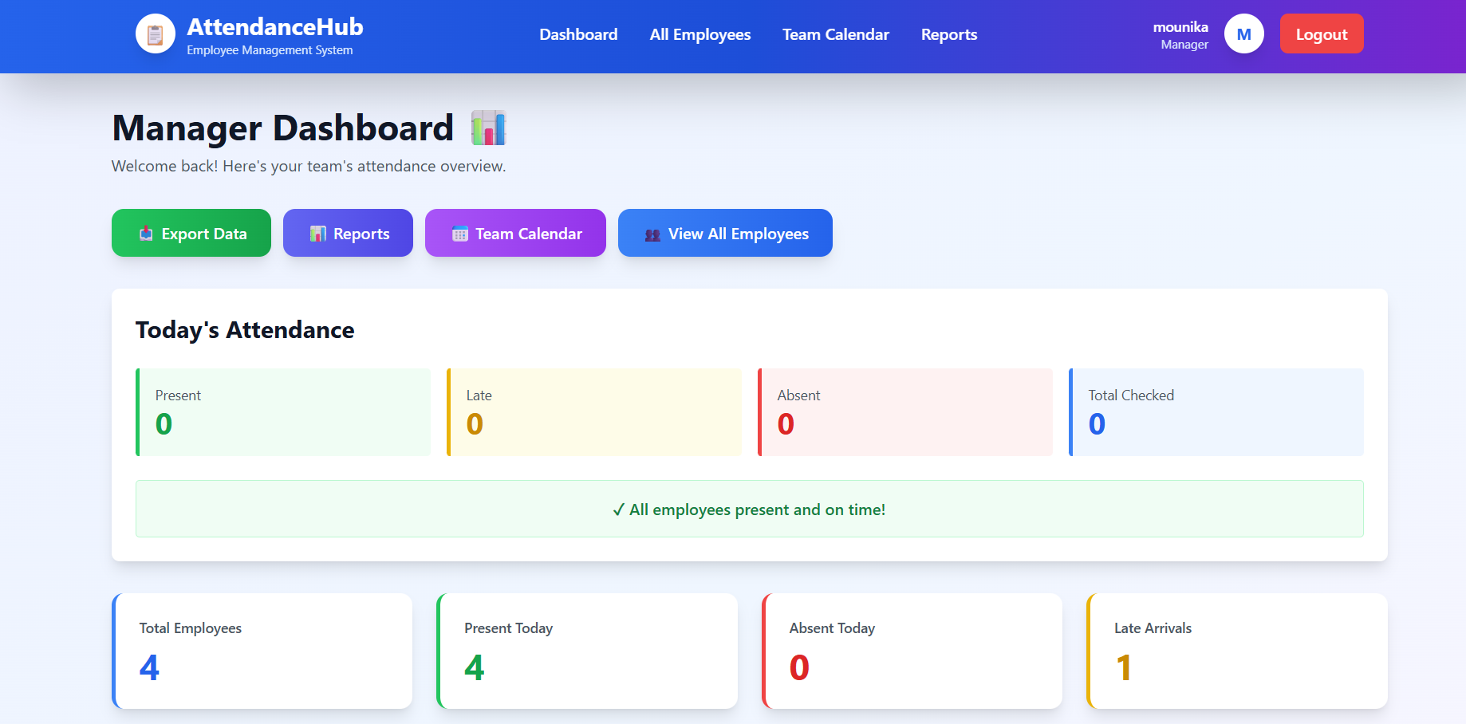
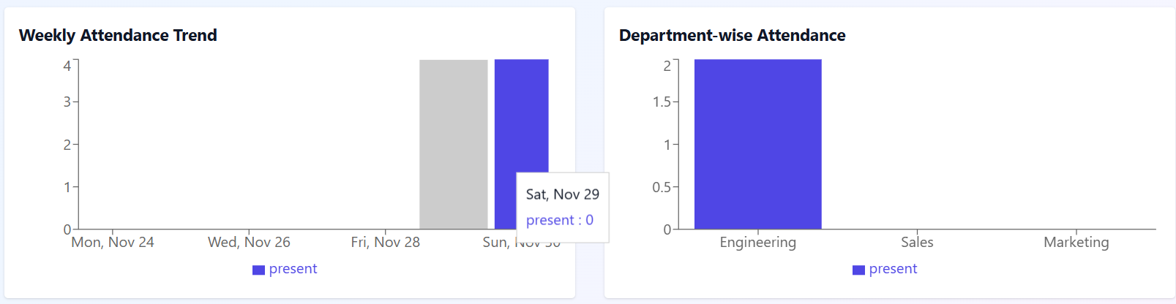
Report:
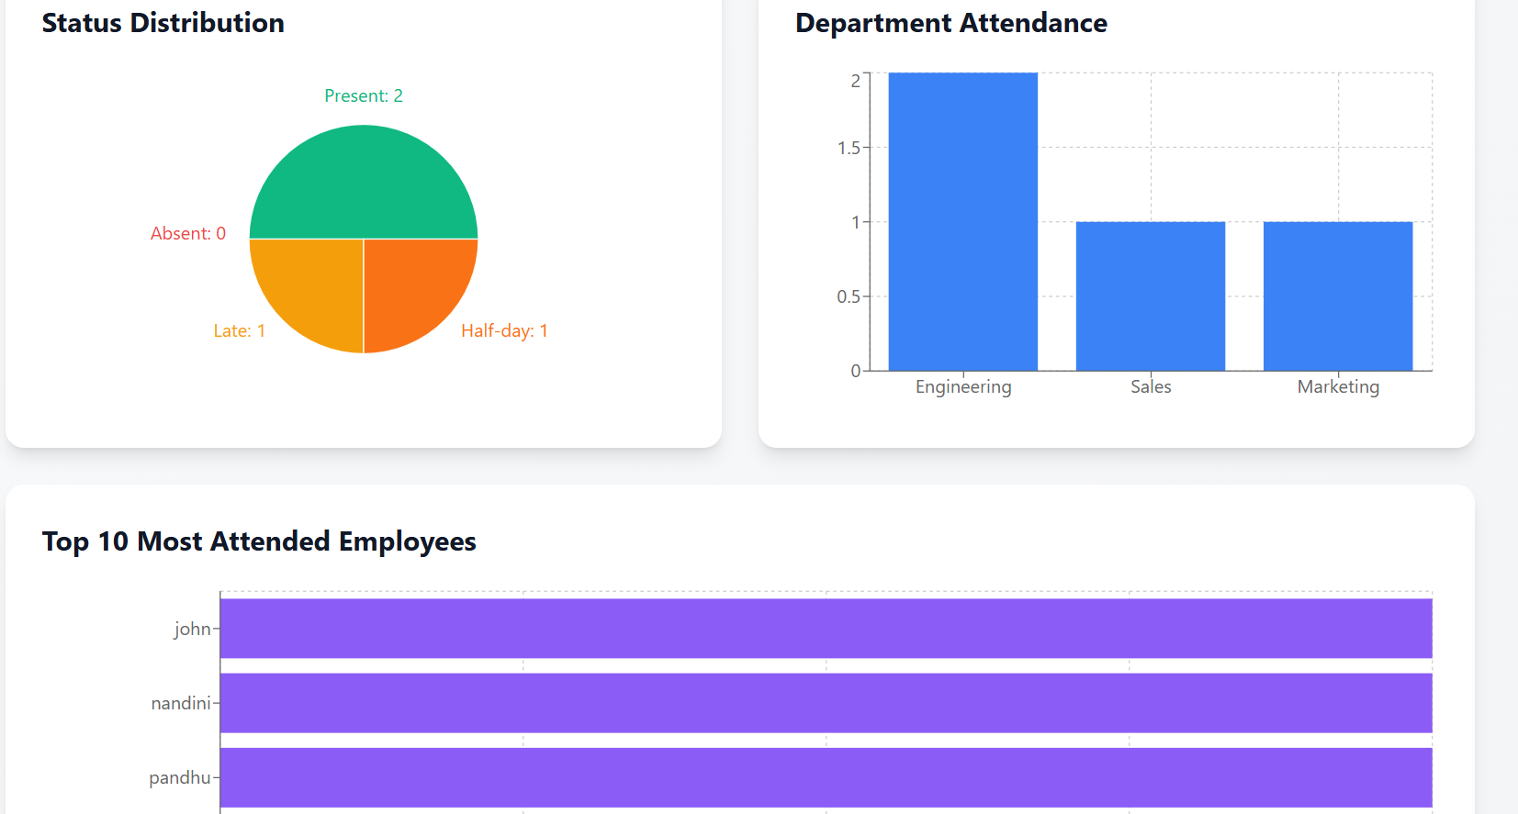

9. Conclusion
The Employee Attendance Tracking System provides an efficient and transparent way for organizations to track employee activity. With automated calculations, interactive dashboards, and secure authentication, this system improves productivity and simplifies attendance management.

