**HEALTH MONITORING SYSTEM FOR ELDERLY BED-RIDDEN PEOPLE**

**19Z604 - Embedded Systems Lab Report**

**Mukesh Balaji K (21Z323)**

**Nandikaa G (21Z325)**

**Samendhra G (21Z342)**

**Shreya Ramesh (21Z350)**

**Shreya Thiagarajan (21Z351)**

**BACHELOR OF ENGINEERING**

**Branch: COMPUTER SCIENCE AND ENGINEERING**

Of Anna University



## April 2024

**DEPARTMENT OF COMPUTER SCIENCE AND ENGINEERING**

**PSG COLLEGE OF TECHNOLOGY**

**(Autonomous Institution)**

**COIMBATORE – 641 004**

# **Table of contents**

|  |  |
| --- | --- |
| Problem Statement …………………… | ……………………………………….3 |
| Schematic Diagram ………………….. | ……………………………………….3 |
| Annotated C code …………………… | ……………………………………….4 |
| Output Screenshots ………………….. | ……………………………………….6 |

## 

## 

## **PROBLEM STATEMENT:**

In light of the demographic shift towards an aging population and the increasing need for continuous health monitoring among elderly individuals confined to bed due to critical conditions, a pressing challenge emerges in the healthcare sector. Current medical systems often lack the capacity to provide real-time, remote monitoring of vital signs, leading to delays in necessary interventions and heightening the vulnerability of bedridden patients to adverse outcomes. Additionally, the complexity and high costs associated with existing monitoring solutions hinder their widespread adoption and scalability, exacerbating the issue.

Therefore, there is an urgent call for the development of an accessible, user-friendly, and comprehensive health monitoring framework tailored specifically for elderly bedridden individuals. This framework must be capable of seamlessly tracking a range of vital parameters, including temperature, humidity, motion, and heartbeat, while enabling remote access for caregivers and medical professionals to intervene promptly when necessary. By incorporating alert mechanisms, this envisioned system aims to usher in a new era of proactive healthcare management, centered on early anomaly detection and swift intervention, thereby improving patient outcomes and easing the burden on healthcare resources.

**SCHEMATIC DIAGRAM:**

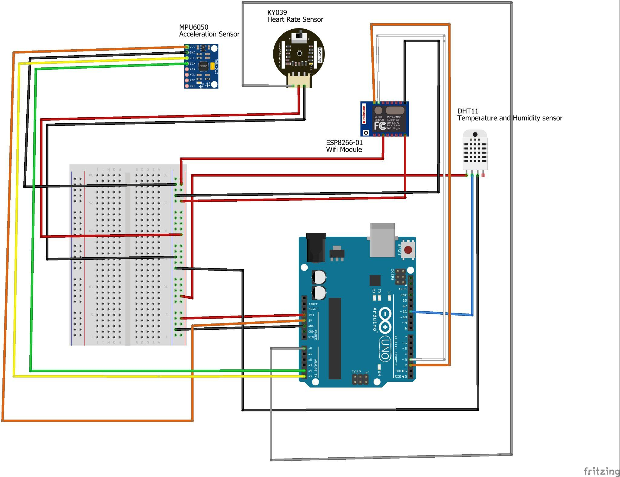

*Fig 1: Schematic diagram of Elderly people monitoring system project*

**Components used in this project:**

* Communication
  + ESP8266-01 Wi-Fi module
* Sensors
  + DHT11 Temperature and Humidity sensor – for monitoring temperature
  + MPU6050 Acceleration and Gyro sensor – for motion detection; sudden movements or fall
  + KY039 Heartbeat sensor – for monitoring heartbeat of the patient in care

These components are connected to the Arduino Uno board as specified in *Fig 1.* The sensors take the values from the environment and display them in the serial monitor for debug purposes. The data sensed by the sensor is sent to the ThingSpeak server (using the API Write key) which acts as the cloud from where using the API Read key the data is read and displayed in the web interface.

**Note:**

* Due to the unavailability of the exact components in the Fritzing software, the RHT sensor has been used instead of the DHT, ESP8266 (16 pin model) instead of the 8 pin model, and another Heartbeat sensor has been used in the schematic diagram.
* Any update in realtime data takes a minimum of 16k msec to be shown in the ThingSpeak server.

**C CODE:**

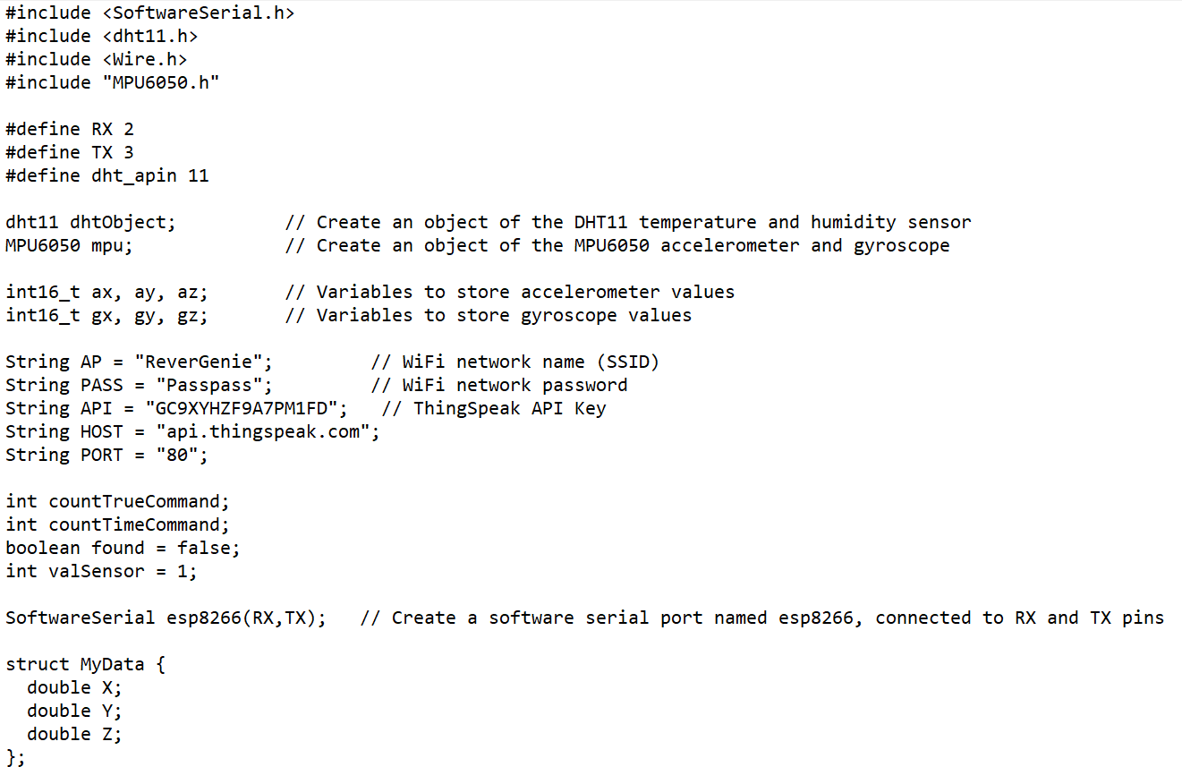

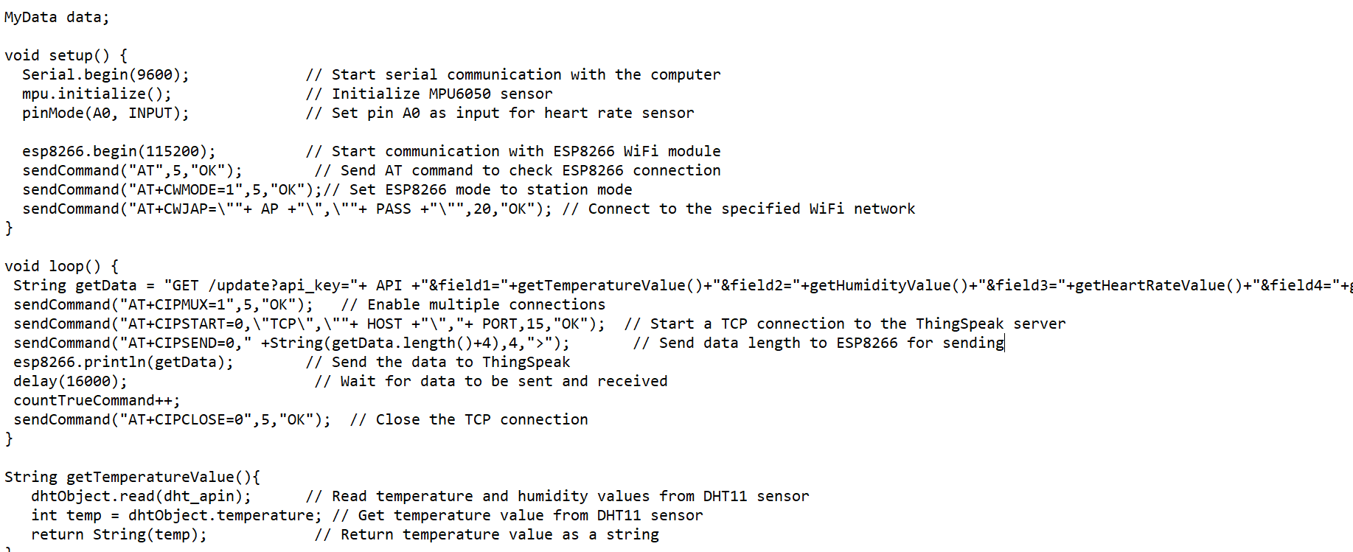

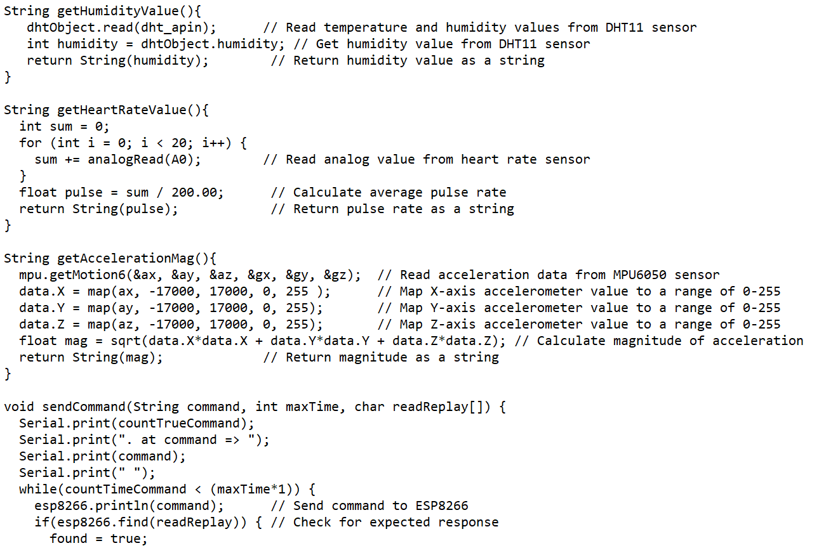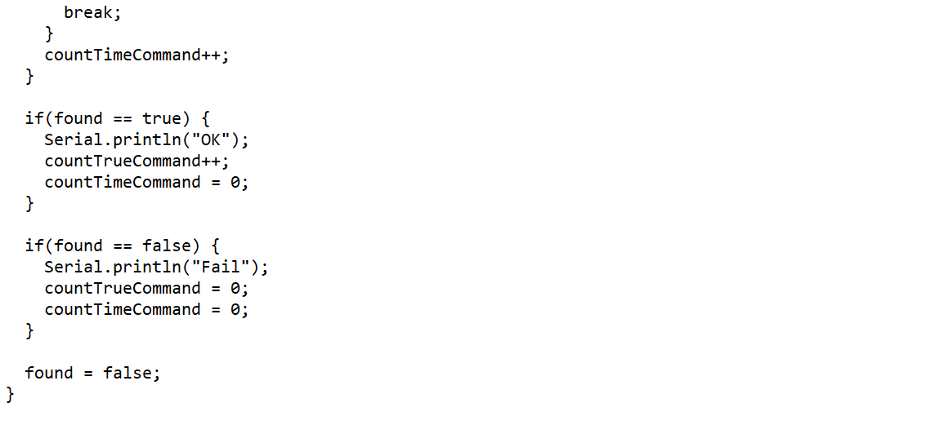

**PROJECT OUTPUT:**

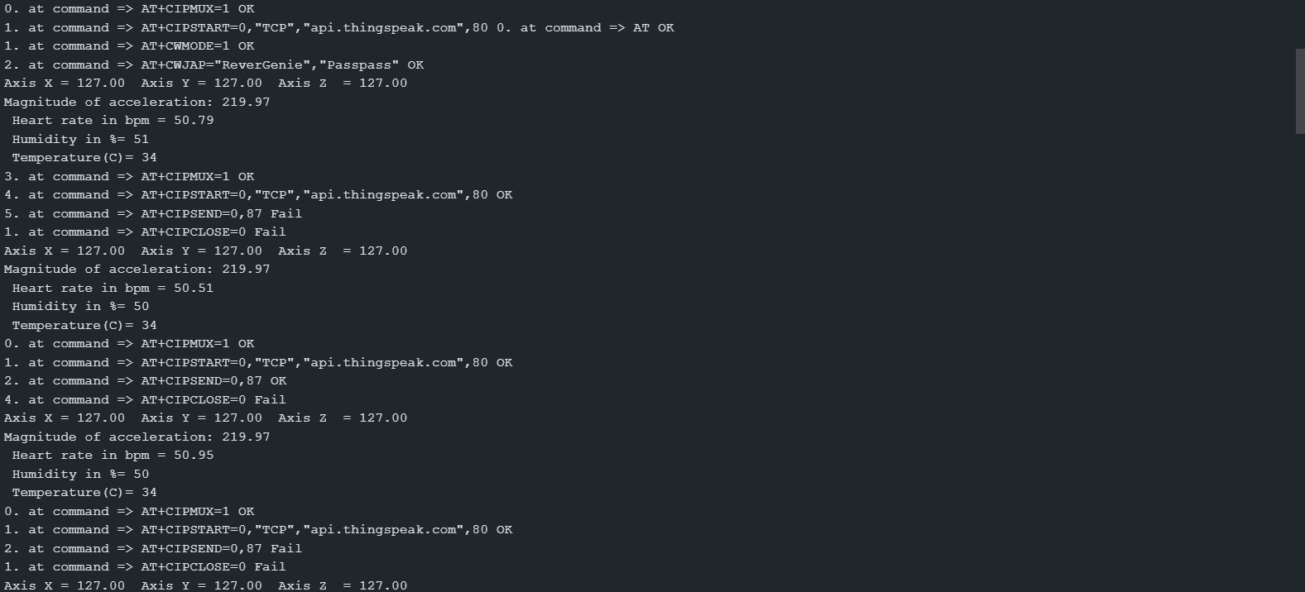

*Fig 2. Serial monitor output for debug purpose*

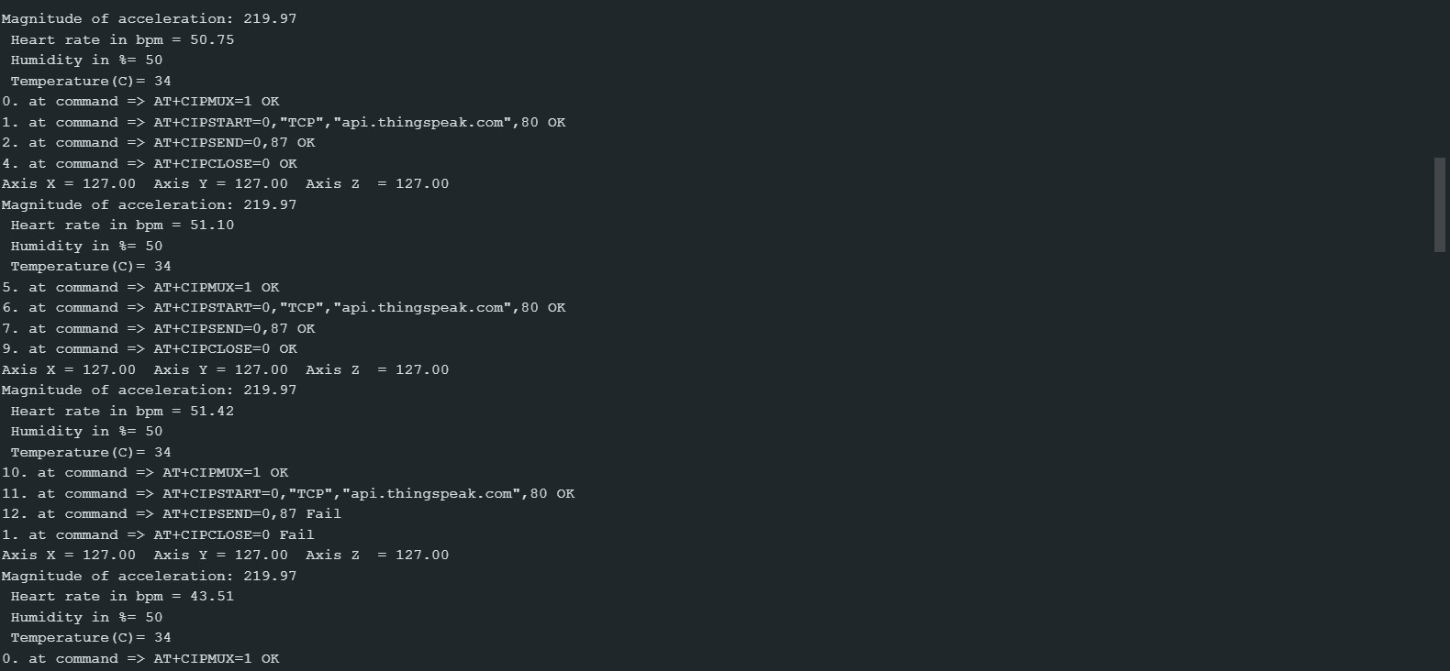

*Fig 3. Serial monitor output for debug purpose*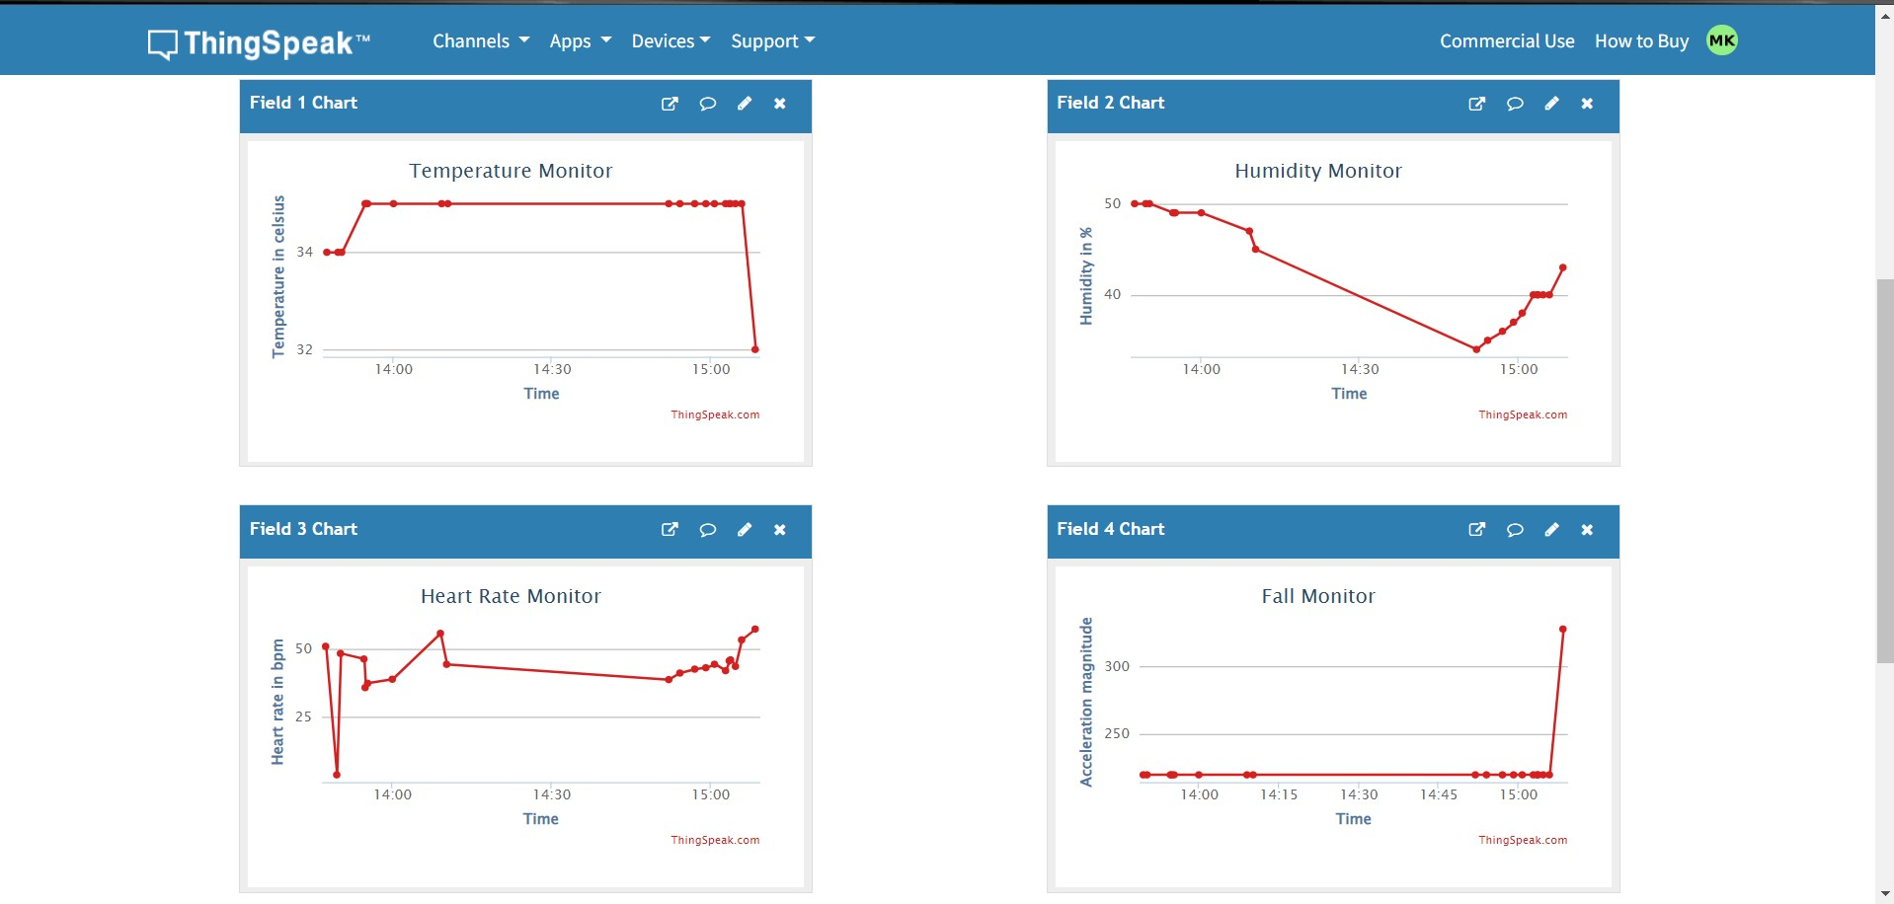

*Fig 4. ThingSpeak cloud*

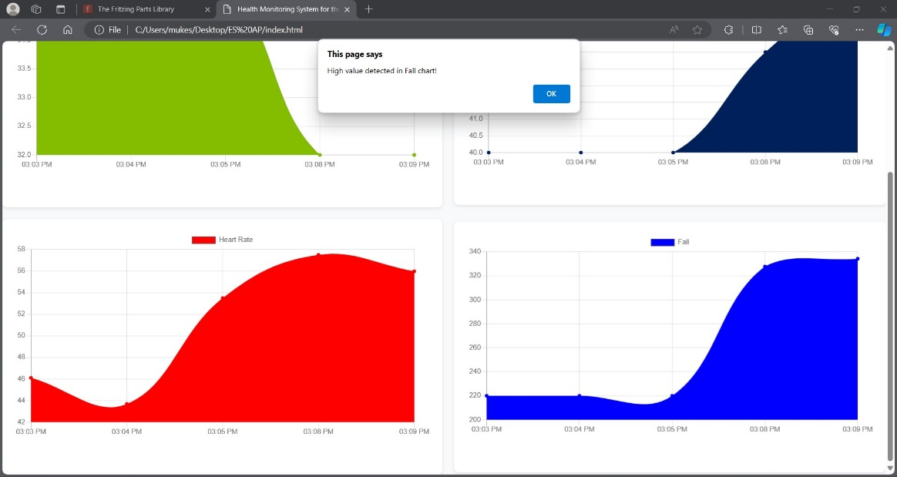

*Fig 5. High acceleration alert on web interface*

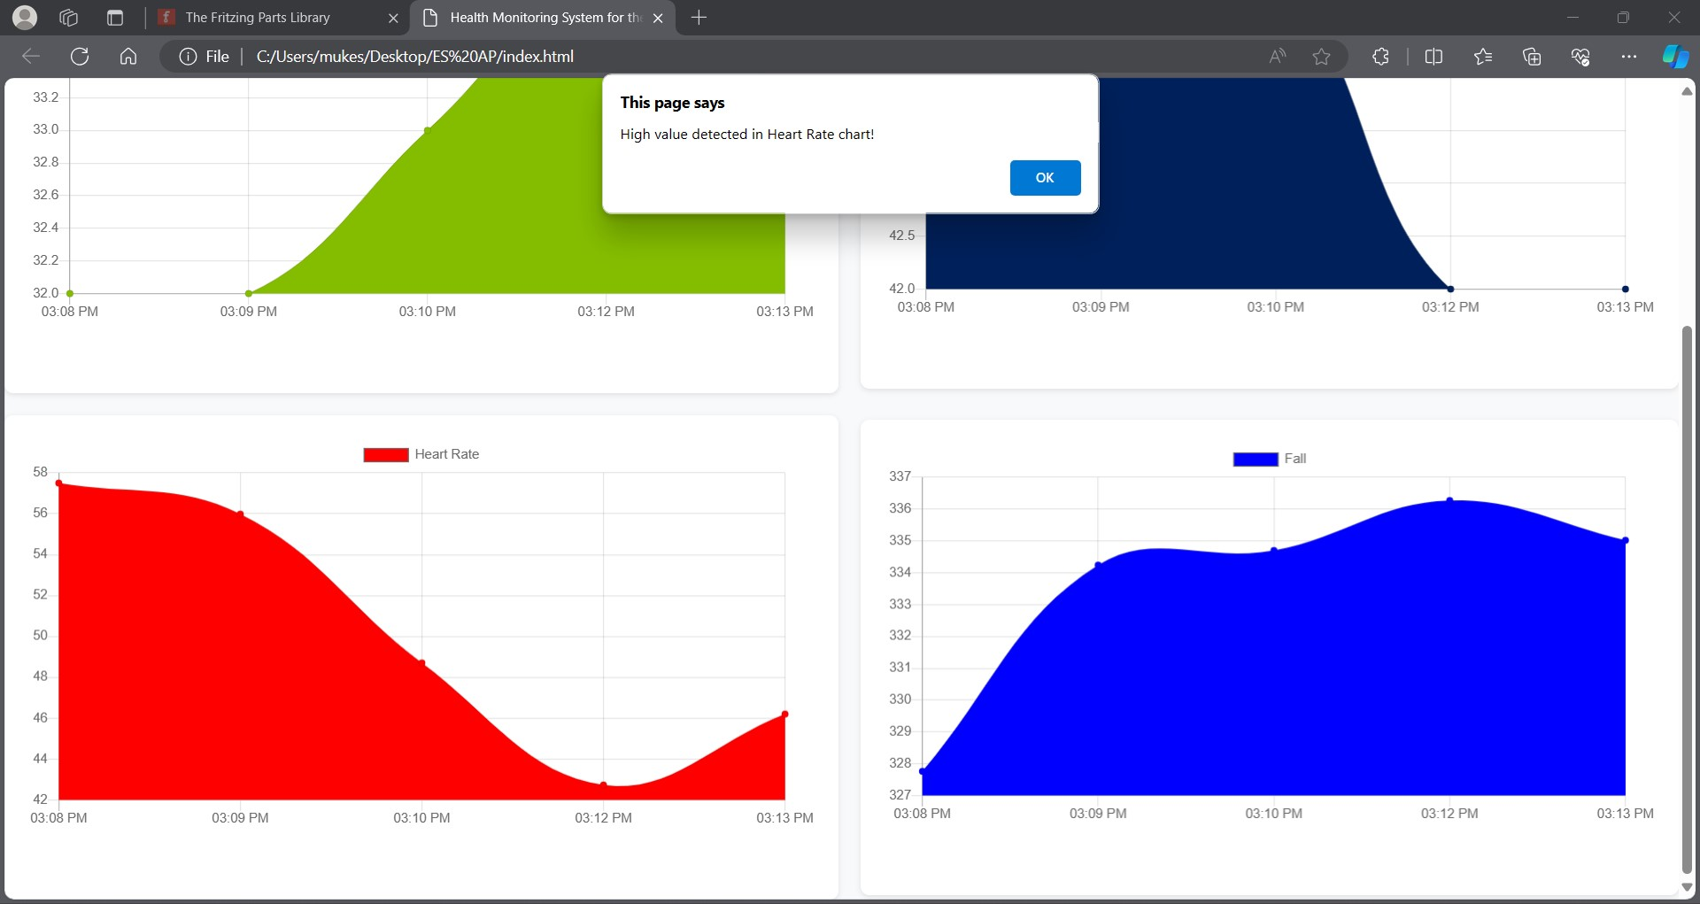

*Fig 6. High heart rate alert on web interface*