Black Box Testing

**Library Management System**

# Level 01 - Control Testing:

**Available Controls:**

|  |  |  |
| --- | --- | --- |
| **Control Name** | **Valid Value 1** | **Valid Value 2** |
| Password textbox | Any string / number / special characters, hidden with asterisk. | Combination of these. |
| Username textbox | Any string/ special characters/ numbers. | Combination of these. |
| ISBN Textbox | Number | - |
| Year textbox | Number (4) | - |
| Roll Number textbox | Alphanumeric (any ) | - |
| ID textbox | Numbers (6 digits) | - |
| Login Button | Username | Password |
| Admin button | Admin username | Admin password |

**Test Cases (Run down):**

|  |  |  |  |  |  |
| --- | --- | --- | --- | --- | --- |
| **S. No** | **Test case Name** | **Input** | **Output** | **Valid /Invalid** | **Notes** |
|  |  |  | **Student Login Window** |  |  |
| **1** | Student Login | Correct Username, Password | Switch to Student Window | Valid | **-** |
|  |  | Incorrect Username, Password |  | Invalid | **-** |
|  |  | Empty |  | Invalid | **-** |
|  |  |  | **Admin Login Window** |  |  |
| **2** | Admin Login | Admin Username, Password | Switch to Admin Window | Valid | **-** |
|  |  | Incorrect Username, Password |  | Invalid | Error in Message, must be “Invalid credentials for admin login” |
|  |  | Empty |  | Invalid | **-** |
|  |  |  | **Student Registration Window** |  |  |
| **3** | Registration | Name, Roll no, Password, Re-enter Password | Registration Complete. | Valid | - |
|  |  | Empty field. |  | Invalid | X field empty, where X is Name, Roll No, Password, Re-enter Password depending upon what’s empty. |
|  |  | Password & Re-enter Password are not same. |  | Invalid | - |
|  |  |  | **Admin Options Window**  **(What can he do as an admin)** |  |  |
| **4** | New Book Entry | Correct Author, Title, Year, ISBN |  | Valid | This entry is received as an output in the textbox with entry number 1 & without the details of each field. |
|  |  | Incorrect Author, Title, Year, ISBN |  | Invalid | This entry is received as an output in the textbox. The entry number is not shown. |
| **5** | Delete Entry | Author, Title, Year, ISBN | Deletes Entry | Valid |  |
| **6** | Requested Books | Author, Title, ISBN | Nothing happens. | Valid | There’s no popup upon clicking this control, which is an error. |
| **7** | Issue Books | Correct ISBN |  | Valid | This returns in text box as an output upon clicking this control which is again an error. |
| **8** | Delete Entry | Author, Title, Year, ISBN | Nothing happens | Valid | There’s no popup upon clicking this control or option to update, which is an error. |
| **9** | Search | Author, Title, Year, ISBN |  | Valid | This returns in text box as an output upon clicking this control which is again an error. |
| **10** | Clear fields | On-click |  | Valid | - |
|  |  |  | **Student Options Window**  **(What can he do as a student)** |  |  |
| **11** | View all | On-click |  | Valid | This returns in text box as an output upon clicking this control which is again an error as the details aren’t available. |
| **12** | Search | Author, Title, Year, ISBN |  | Valid | This returns in text box as an output upon clicking this control which is again an error as the details aren’t available. |
| **13** | Issue | Author, Title, Year, ISBN | Nothing happens | Valid | There’s no popup upon clicking this control or option to update, which is an error. |
| **14** | Request | Author, Title, Year, ISBN |  | Valid | This returns in text box as an output upon clicking this control which is again an error. |
| **15** | Clear fields | On-click |  | Valid | - |

**Test Cases - Detailed View (Samples):**

* **Admin Page View**

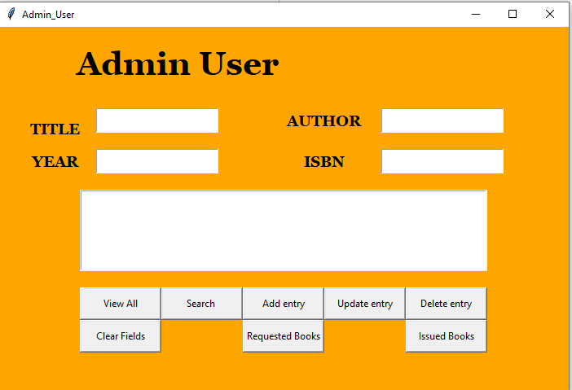

**If wrong ISBN = abcd is inserted:**

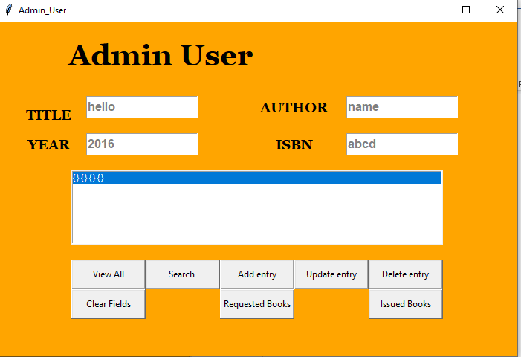

**Output:**

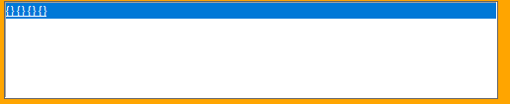

* **Login Page View**

**Upon inserting the correct credentials as input**

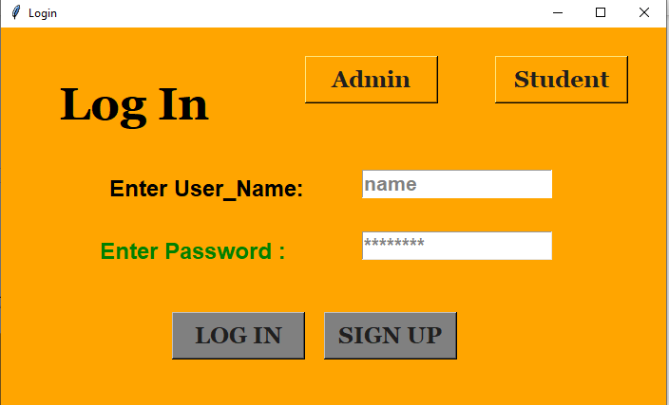

**Output: The following student page opens.**

* **Student Page**

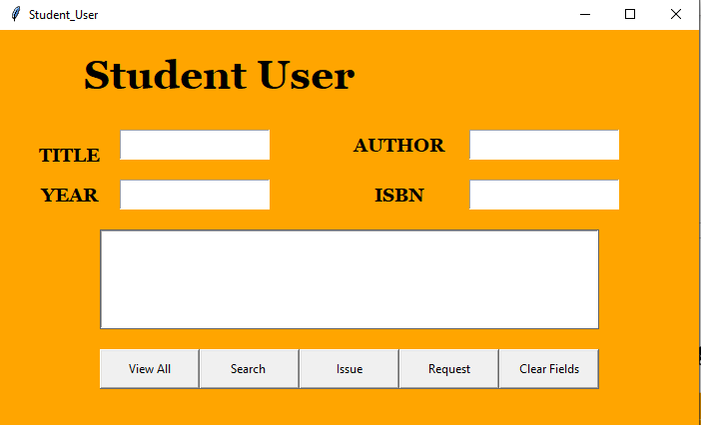

* **Registration Page**

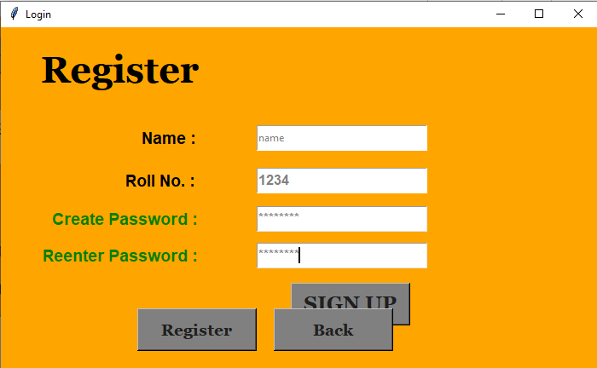

**If invalid name type = () is inserted as an input:**

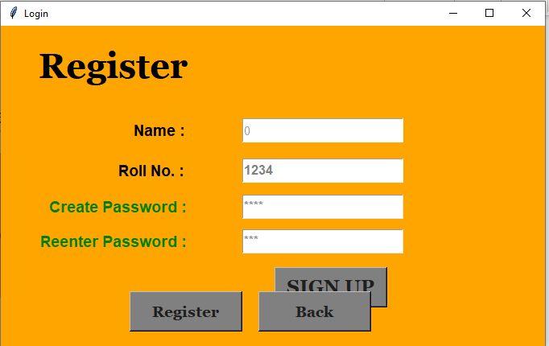

**Output: There’s no popup. However, this is obtained In terminal which suggests that no pop-up is an error.**



# Level 02 - Interface Testing:

**Application:**



➢      Start Application by Double Clicking on its ICON. The Loading message should show the application name,   
version number, and a bigger pictorial representation of the icon (a 'splash' screen).

Answer: No needs to be run by the python compiler independently

➢      ~~No Login is necessary~~

Answer: Login is necessary to use the application for registration.

➢      The main window of the application should have the same caption as the caption of the icon in ~~Program Manager~~ Windows Explorer

Answer: Yes the python icon shows normally across all windows

➢      Closing the application should result in an "Are you Sure" message box

Answer: Not implemented in the current revision of the software

➢      Attempt to start application Twice   
This should not be allowed - you should be returned to main Window

Answer: Partly functional as the application will load only once but certain elements of the software i.e. admin page will open as many times as the user wants

➢      Try to start the application twice as it is loading.

Answer: Loads only once if attempted the previous session will close and the newer session will resume

 ➢      On each window, if the application is busy, then the hour glass should be displayed. If there is no hour glass   
(e.g. alpha access enquiries) then some enquiry in progress message should be displayed.

Answer: The application is pretty light but even in a worse case the hour glass is displayed when loading database elements

➢      All screens should have a Help button, F1 should work doing the same.

Answer: Help functionality is not integrated in the current version of the software



**1.2. For Each Window in the Application**

➢      If Window has a Minimise Button, click it. 

Answer: Yes the application has a minimization option

➢      Window Should return to an icon on the bottom of the screen   
This icon should correspond to the Original Icon under ~~Program Manager~~ ,Windows Explorer.

Answer: No explorer icons exists in the application

➢      Double Click the Icon to return the Window to its original size.

Answer: Yes this feature is enabled

➢      The window caption for every application should have the name of the application and the window name -   
especially the error messages. These should be checked for spelling, English and clarity , especially on the top   
of the screen. Check does the title of the window makes sense.

Answer: Yes all parameters are matched with some exceptions to invalid cases mentioned above

➢      If  the screen has an Control menu, then use all ungreyed options. (see below)

Answer: The application does not have a control menu.

➢      Check all text on window for Spelling/Tense and Grammar .Use TAB to move focus around the Window. Use SHIFT+TAB to move focus backwards. ssTab order should be left to right, and Up to Down within a group box on the screen. All controls   
should get focus - indicated by dotted box, or cursor. Tabbing to an entry field with text in it should highlight   
the entire text in the field.

Answer: Tabbing entity works but grammatical errors checks are not included in the current software version

➢      The text in the Micro Help line should change - Check for spelling, clarity and non-updateable etc.

Answer: No micro help function is enabled in the system

➢      If a field is disabled (greyed) then it should not get focus. It should not be possible to select them with either   
the mouse or by using TAB. Try this for every greyed control.

Answer: Yes this feature is valid and tested under the registration menu.

➢      Never updateable fields should be displayed with black text on a grey background with a black label.

Answer: Not available under current revision.

➢      All text should be left-justified, followed by a colon tight to it.

Answer: Included in the software and verified.

➢      In a field that may or may not be updateable, the label text and contents changes from black to grey depending   
on the current status.

Answer: Yes it transitions from grey to white.

➢      List boxes are always white background with black text whether they are disabled or not. All others are grey.

Answer: List text boxes are not integrated into the software

➢      In general, do not use goto screens, use gosub, i.e. if a button causes another screen to be displayed, the   
screen should not hide the first screen, with the exception of tab in 2.0

Answer: each session is displayed on a separate screen displaying both the current and past sessions

➢      When returning return to the first screen cleanly i.e. no other screens/applications should appear.

Answer: Yes this functionality is validated in the software

➢      In general, double-clicking is not essential. In general, everything can be done using both the mouse and   
the keyboard.

Answer: Everything is commanded to be operated on a single click with keyboard gestures available to operate.



➢      All tab buttons should have a distinct letter.

Answer: There are no tab buttons included in the software.