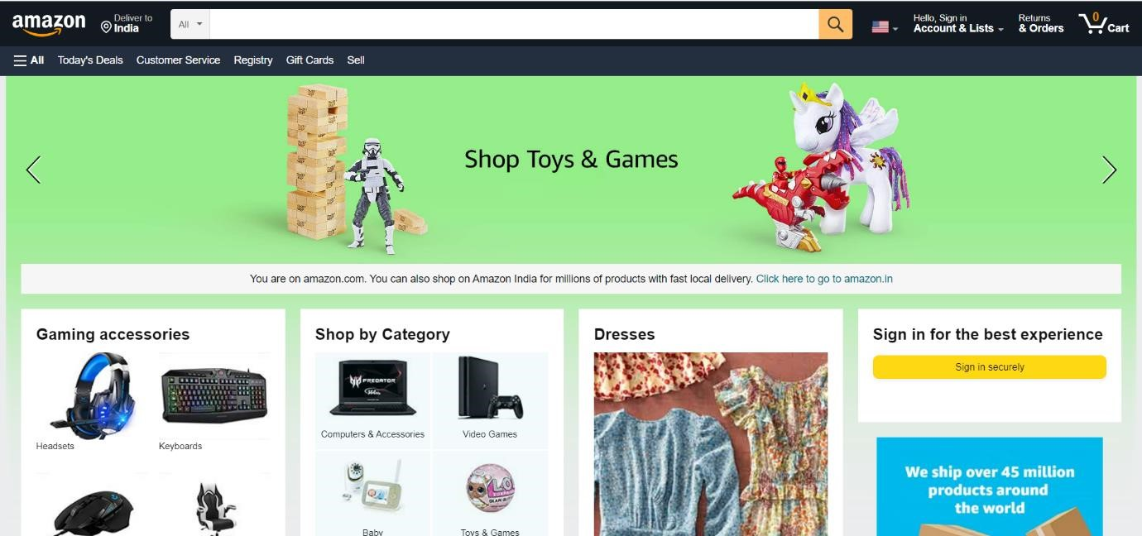



Nandikunta Sara Deepika

Edureka Presents

# Overview

**Amazon.com, Inc.** is an American multinational technology company which focuses on ecommerce, cloud computing, digital streaming, and artificial intelligence. It has been referred to as "one of the most influential economic and cultural forces in the world, and is one of the world's most valuable brands. It is one of the Big Five American information technology companies, alongside Alphabet, Apple, Meta, and Microsoft.

The domain *amazon.com* attracted at least 615 million visitors annually by 2008; by the beginning of 2016, over 130 million customers were visiting the U.S. website each month[.]](https://en.wikipedia.org/wiki/Amazon_(company)#cite_note-107) The company has invested heavily in a massive amount of server capacity for its website, especially to handle the excessive traffic during the [Christmas holiday season.](https://en.wikipedia.org/wiki/Christmas_holiday_season) According to [Alexa Internet](https://en.wikipedia.org/wiki/Alexa_Internet) rankings, *amazon.com* is the third most popular website in the United States and the 11th most popular website worldwide**.**

# Goals

1. Login Page
2. Address Page
3. Returns & Orders
4. Cart Page
5. Main Page

# History

Amazon was founded in July 1994 by [Jeff Bezos,](https://en.wikipedia.org/wiki/Jeff_Bezos) who chose the [Seattle](https://en.wikipedia.org/wiki/Seattle) area for its abundance of technical talent, as [Microsoft](https://en.wikipedia.org/wiki/Microsoft) was in the area.

Amazon went [public](https://en.wikipedia.org/wiki/Public_company) in May 1997. It began selling music and videos in 1998, and began international operations by acquiring online sellers of books in the United Kingdom and Germany. The following year, it began selling video games, consumer electronics, home improvement items, software, games, and toys.

In 2002, it launched [Amazon Web Services](https://en.wikipedia.org/wiki/Amazon_Web_Services) (AWS), which provided data on website popularity, Internet traffic patterns, and other statistics for marketers and developers. In 2006, it grew its AWS portfolio when [Elastic Compute Cloud](https://en.wikipedia.org/wiki/Amazon_Elastic_Compute_Cloud) (EC2), which rented computer processing power, provided [Simple Storage Service](https://en.wikipedia.org/wiki/Simple_Storage_Service) (S3), and rented data storage via the

Internet, also became available. That year, Amazon also started *Fulfillment by*

*Amazon* which allowed individuals and small companies to sell items through the company's Internet site. In 2012, Amazon bought [Kiva Systems](https://en.wikipedia.org/wiki/Amazon_Robotics) to automate its inventory management business. It purchased the [Whole Foods Market](https://en.wikipedia.org/wiki/Whole_Foods_Market) supermarket chain in 2017.

On February 2, 2021, Amazon announced that Jeff Bezos would step down as CEO to become executive chair of Amazon's board in Q3 of 2021. Andy Jassy, previously CEO of AWS, became Amazon's CEO.

Technologies used in Amazon

Front-End:

* HTML
* CSS
* Bootstrap
* React Dynamic:
* Javascript

Dynamic:

* Javascript
* Ci/cd with AWS
* Login and Logout (oauth and jwt)

Database

* Mongodb
* Json Data

Code Compilers

* Visual Studio Code
* Git Bash
* Git Hub
* Node js.

Github json link: