**40 questions on the database of music recommendation system using emotion detector.**

1. How many songs are stored in the "Happy" table?

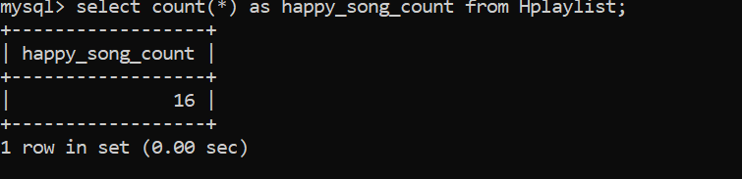

1. How many playlists are there in English in Happy table?

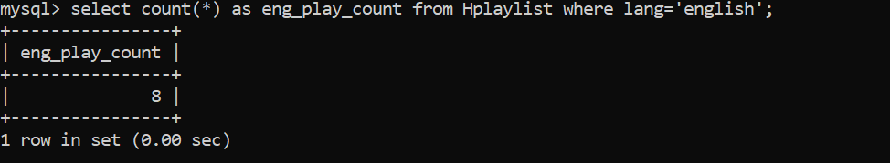

1. How many playlists are there in Hindi in Happy table?

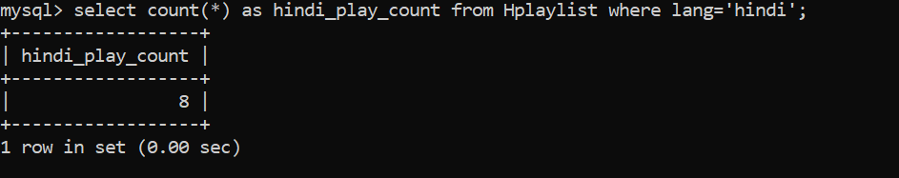

1. Finding the playlist with the longest URL in Aplaylist?

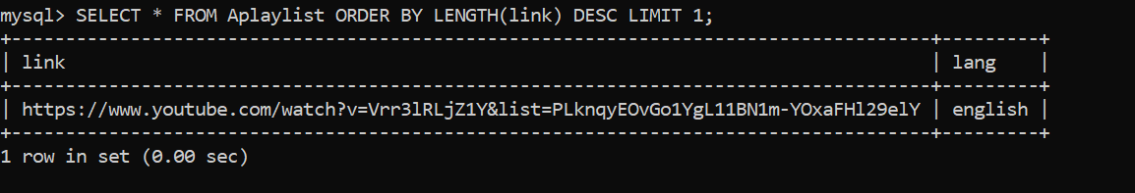

1. Counting the number of playlists in each language in Splaylist?

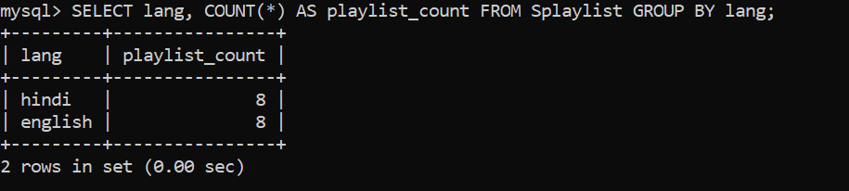

1. Finding the playlist with the shortest URL from Eplaylist?

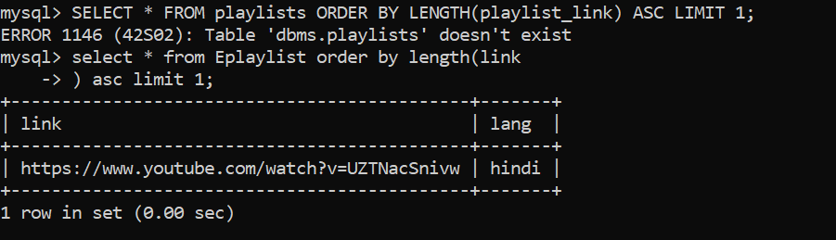

1. Finding the playlist with the longest URL from Eplaylist?

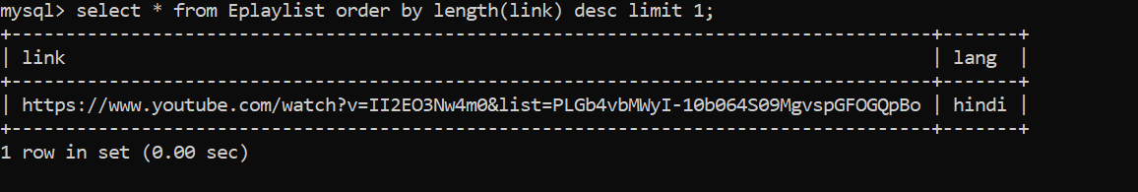

1. How many playlists are there in English Splaylist?

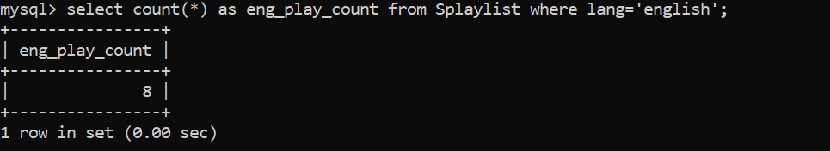

1. How many playlists are there in hindi Splaylist?

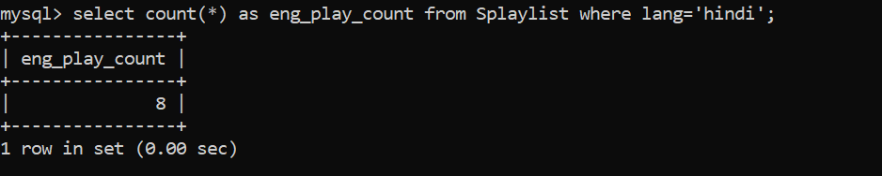

1. How many playlists have URLs that include the term "playlist" or "mix" in Hplaylist?

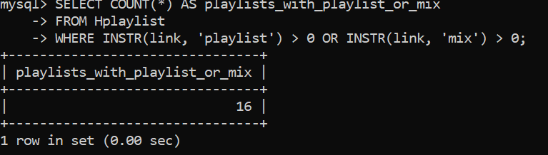

1. How many playlists have URLs that include the term "playlist" or "mix" in Splaylist?

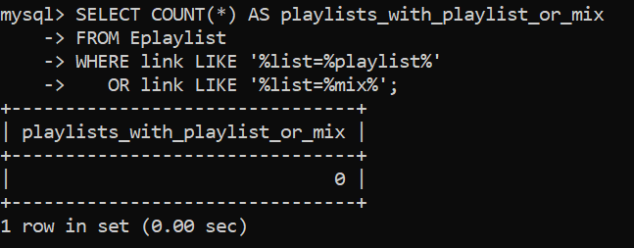

1. How many playlists have URLs that start with [https://](NULL) from Eplaylist?

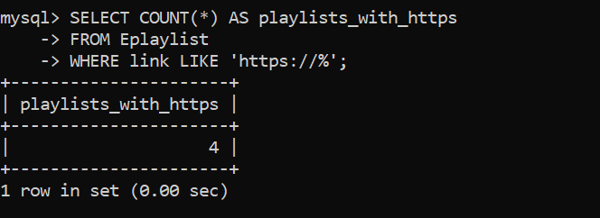

1. How many playlists have URLs that start with [https://](NULL) from Hplaylist?

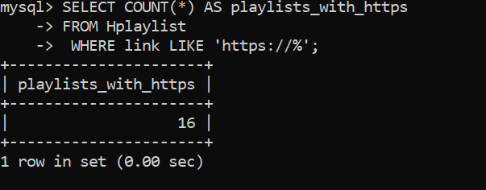

1. What is the average length of playlist links in Eplaylist?

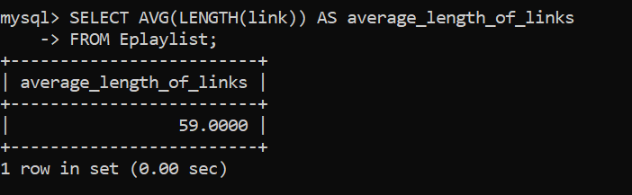

1. What is the average length of playlist links in Aplaylist?

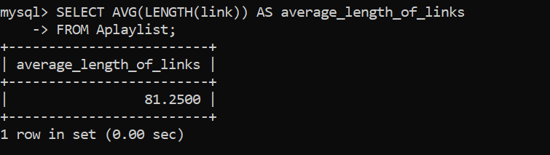

1. Which playlist has the URL with the highest ratio of vowels to consonants in Aplaylist?

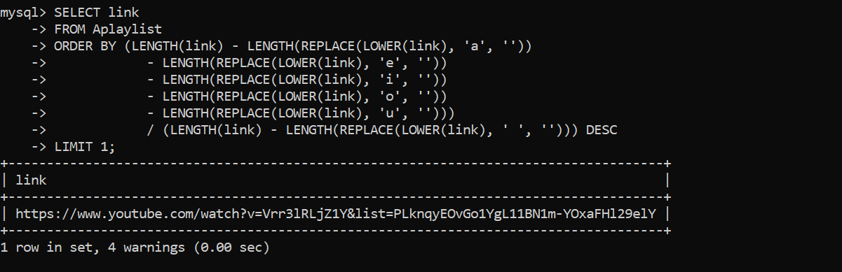

1. Which playlist has the URL with the highest ratio of vowels to consonants in Hplaylist?

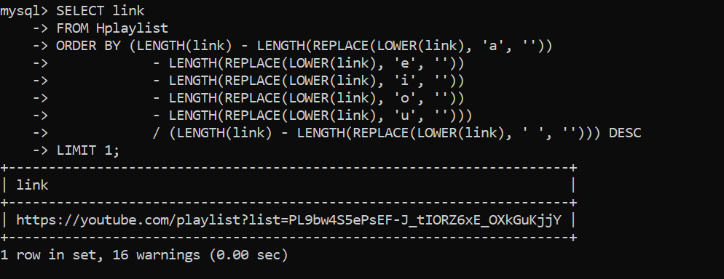

1. How many playlists have URLs that include the term "playlist" followed by a question mark in Hplaylist?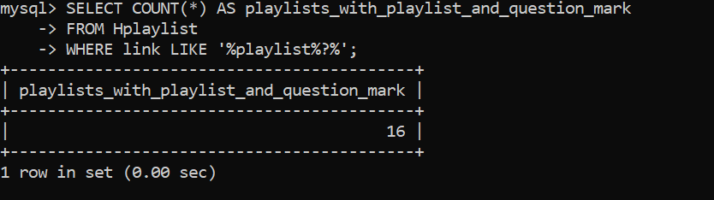
2. Which playlist has the URL with the lowest ratio of vowels to consonants in Splaylist?

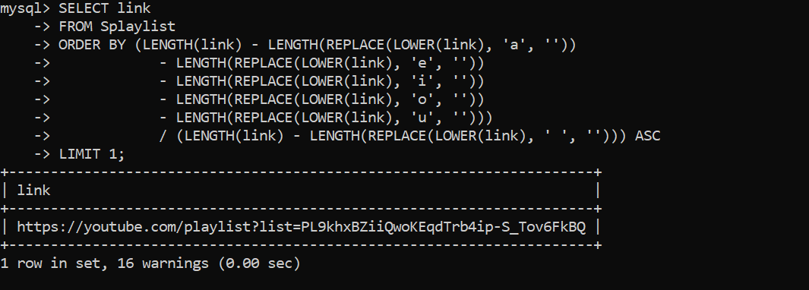

1. Which playlist has the URL with the lowest ratio of vowels to consonants in Aplaylist?

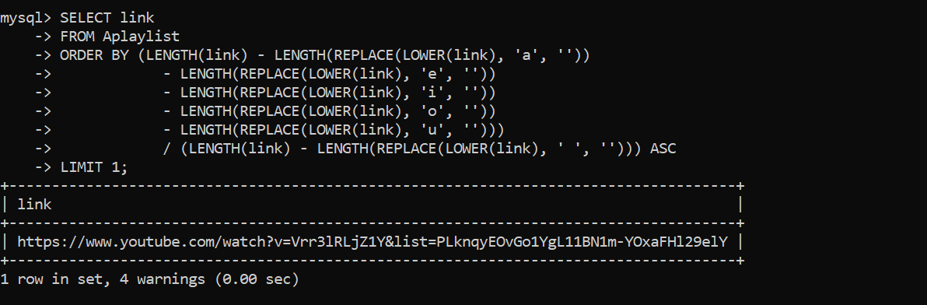

1. How many playlists contain the word "watch" in their URL in Aplaylist?

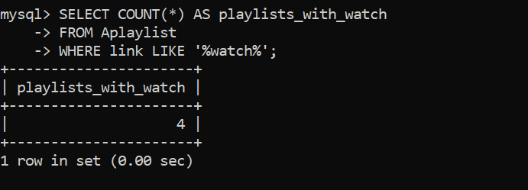

1. How many playlists contain the word "watch" in their URL in Eplaylist?

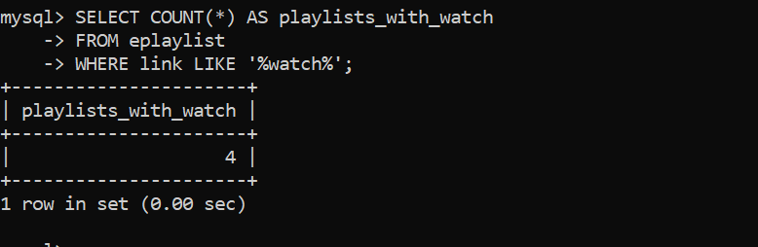

1. How many playlists have URLs that include the domain "youtube.com" in Eplaylist?

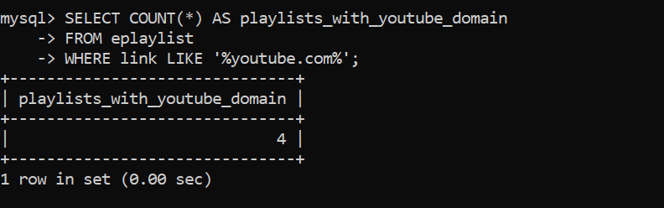

1. How many playlists have URLs that include the domain "youtube.com" in Splaylist?

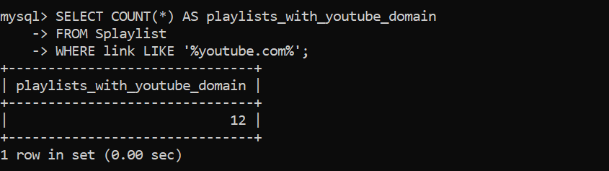

1. How many playlists have URLs containing numbers in Splaylist? 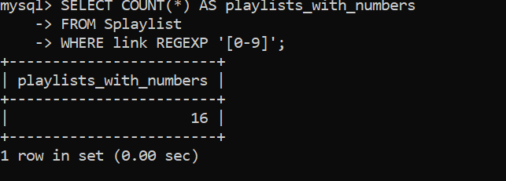
2. How many playlists have URLs containing numbers Aplaylist?

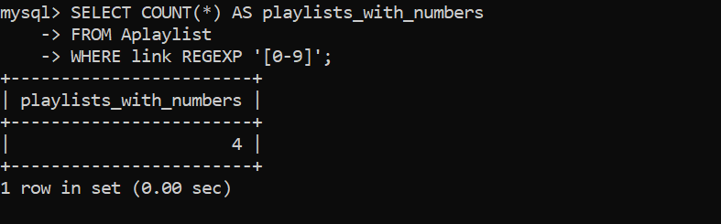

1. Which playlist has the URL containing the most special characters in Aplaylist?

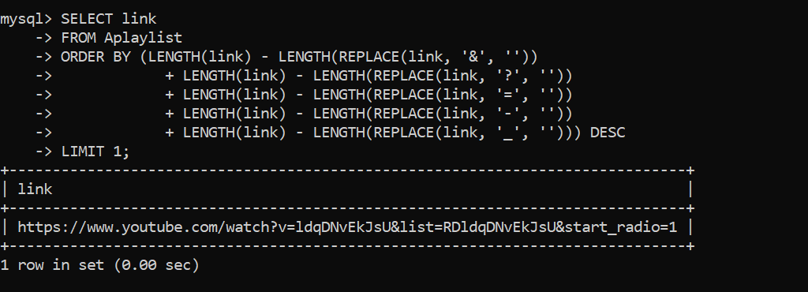

1. Which playlist has the URL containing the most special characters in Hplaylist?

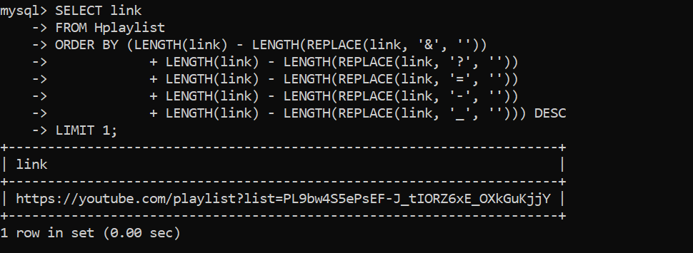

1. Which playlist has the URL containing the most special characters in Splaylist?

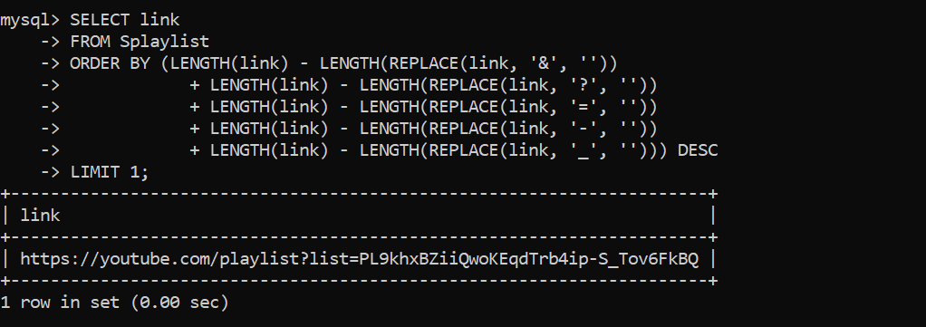

1. Which playlist has the URL containing the most special characters in Eplaylist?

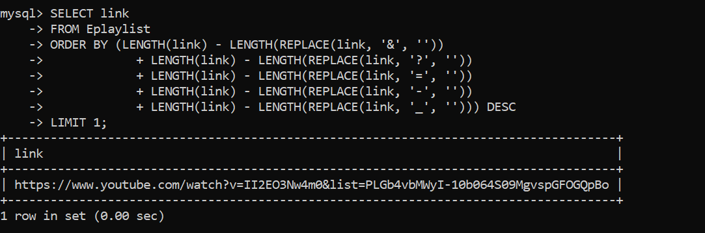

1. How many playlists have URLs that end with ".com" in Eplaylist?

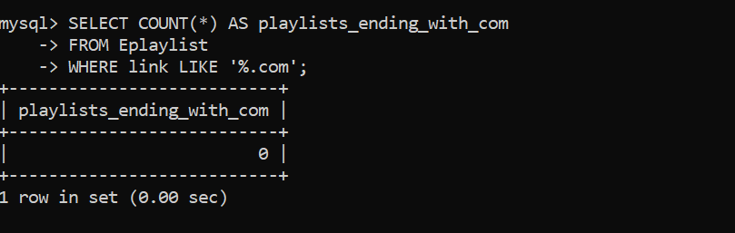

1. What is the distribution of playlists across different languages in Hplaylist?

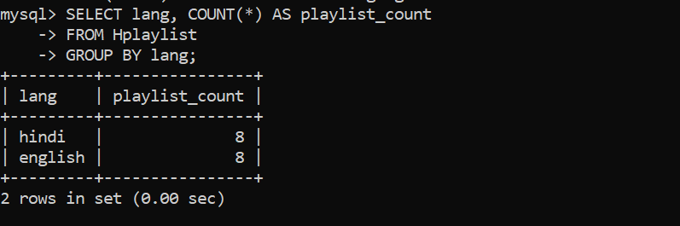

1. What is the distribution of playlists across different languages in Aplaylist?

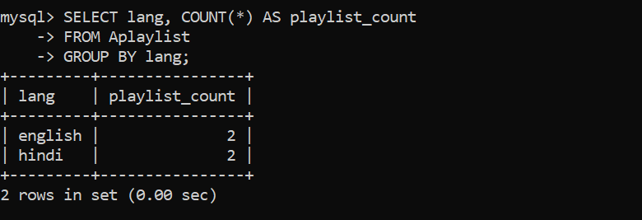

1. How many playlists have URLs that contain punctuation marks in Aplaylist?

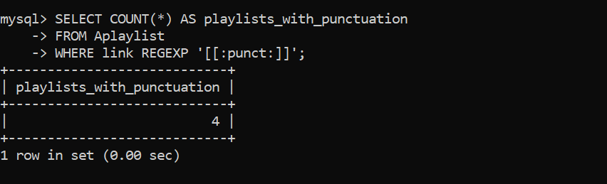

1. How many playlists have URLs that contain punctuation marks in Splaylist?

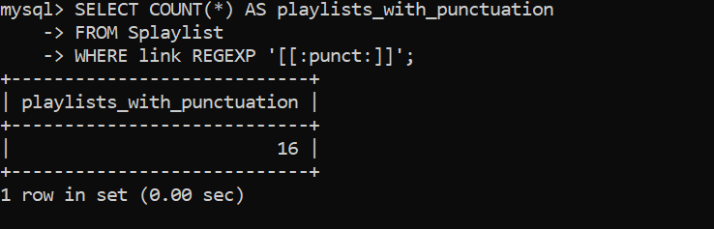

1. How many playlists have URLs that include the term "official" in Splaylist?

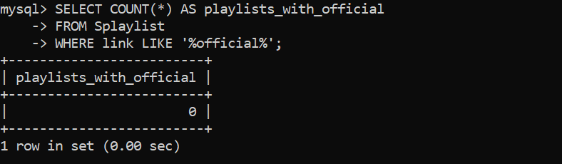

1. How many playlists are there with non-English characters in their URLs in Splaylist?

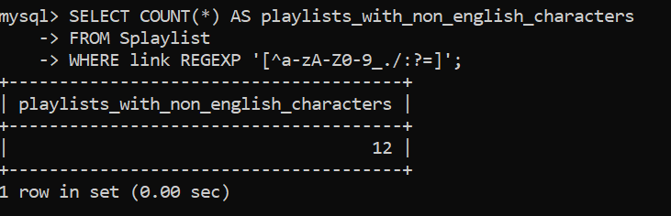

1. How many playlists are there with non-English characters in their URLs in Hplaylist?

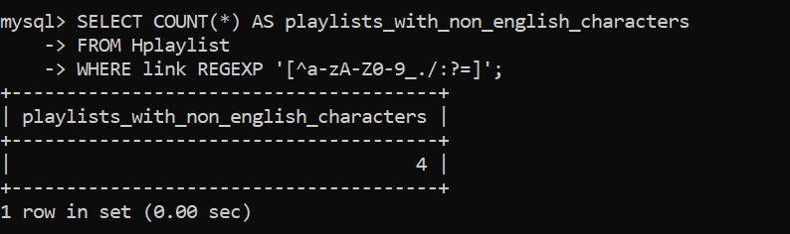

1. How many playlists are there with non-English characters in their URLs in Aplaylist?

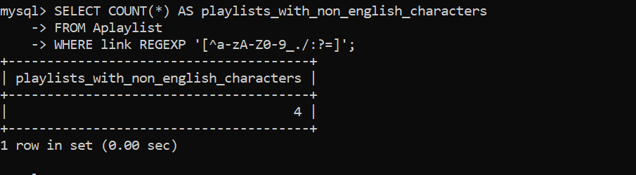

1. How many playlists are there with non-English characters in their URLs in Eplaylist?

