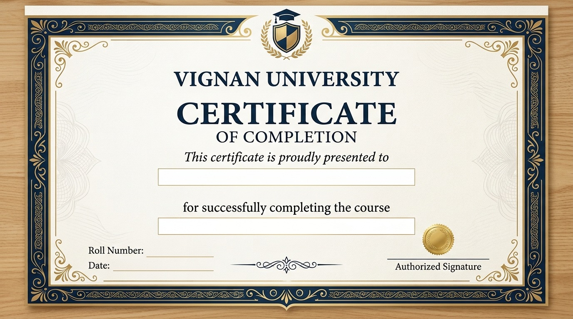
15-09-2026
Python
Vanakuri Likhitha
218x1a42c6

