**23CSE111**

**OBJECT ORIENTED PROGRAMMING**

**LAB REPORT**



**Department of Computer Science Engineering**

**Amrita School of Computing**

**Amrita Vishwa Vidyapeetham, Amaravati Campus**

**Name: K. NANDINI**

**Verified By Roll No: AV.SC.U4CSE24205**

**WEEK-1**

**Program-1**

**DOWNLOADING AND INSTALLATION OF JAVA**

## AIM: To download and install Java(JDK 21)

**PROCEDURE:**

This is the process for installation of JDK on windows.

Follow the steps below to install Java on Windows:

* Download JDK(Java Development Kit)
* Run the Installer
* Configure Environment Variables
* Update the path variable
* Verify Installation in Command Prompt

Here's a detailed explanation of each of the steps.

### Step 1: Download JDK

1. Go to the official oracle website in the google search to download the JDK.
2. Locate the downloaded jdk-21_windows-x64_bin.exe file.
3. Double-click to launch the installer.
4. Click Next on the setup wizard.
5. Choose the installation path (default is C:\Program Files\Java\jdk-21).
6. Click Next, then click Install.
7. Wait for the installation to complete.
8. Click Close once the installation is finished
9. Choose **x64 MSI Installer** on the windows tab and click on download link.

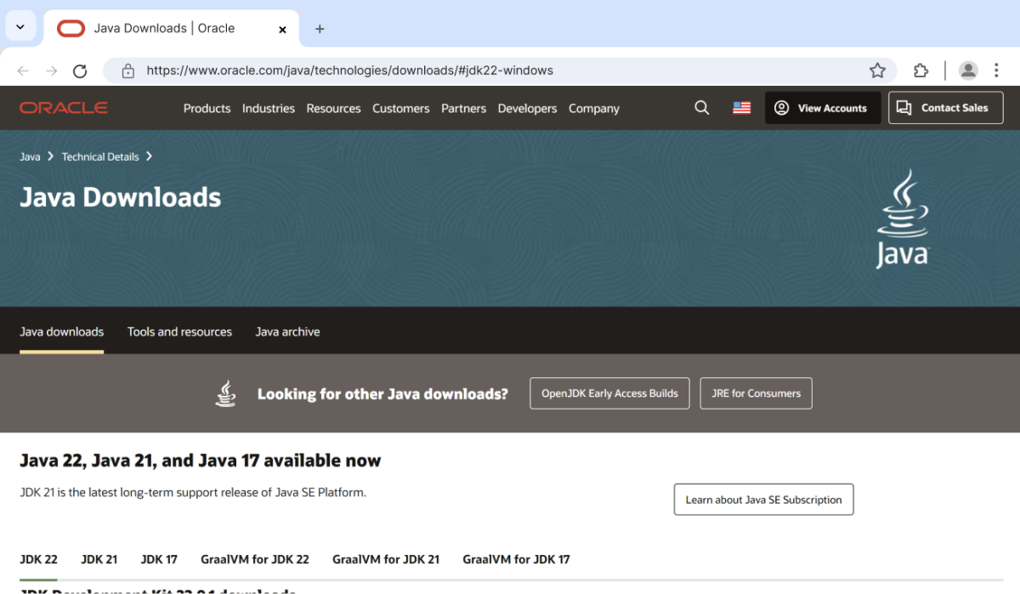

Step 2: Run the Installer

Now, go to your **downloads** folder and run the installer you just downloaded.

The screen below will be seen.

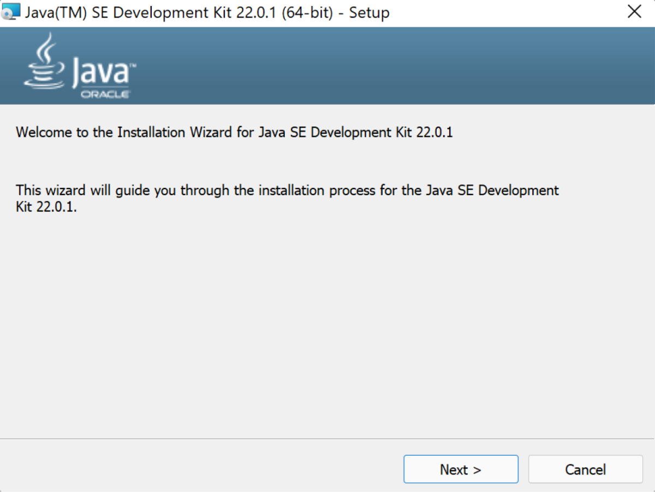

Simply click **Next** to proceed.Next you will be prompted a another screen simply click next on that also.

Step 3: Configure Environment Variables

After installation, you will need to tell your system where to find Java. This is done by setting environment variables.

These are the ways to follow:

1. Go to file manager on your laptop or pc

2) Go to “Windows C” Drive in File manager

3) Choose Program Files, select Java, then JDK 22, then select Bin.

4) Select and copy the path at the address bar

**Locate JDK Path**: Navigate through your file explorer to reach the JDK installation directory. Normally, it is located at

C:\Program Files\Java\jdk-22\bin

Copy this path

**Access Environment Variables**: Search **environment variable** on the terminal. In system properties, click on environment variables. You will be prompted to the screen below.

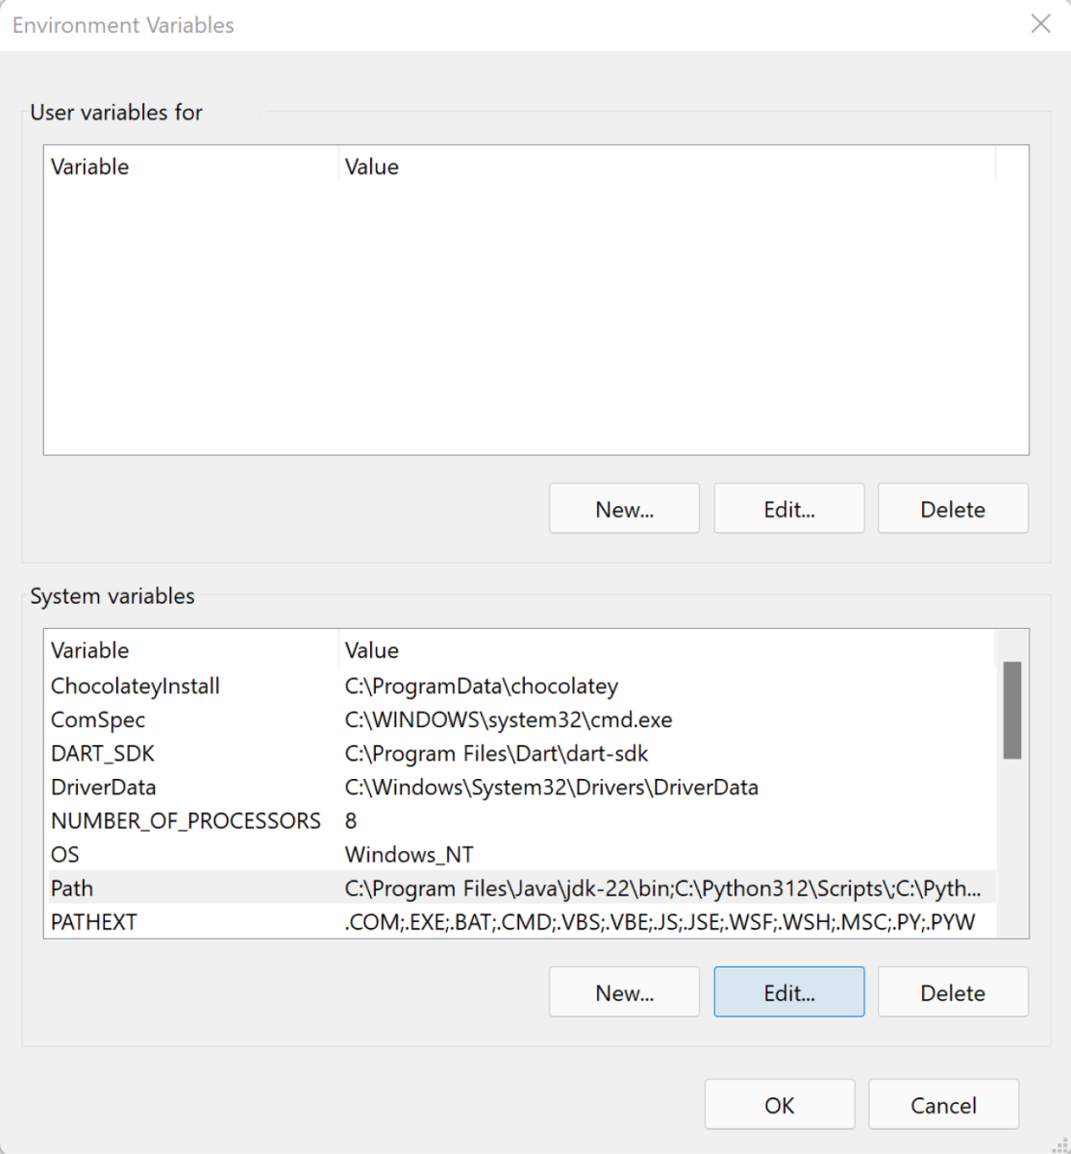

**Step 4: Update the Path Variable:**

Find the **Path** variable in the System variables section and click on **Edit**.

Then, click **New** and paste your JDK bin path (i.e. C:\Program Files\Java\jdk-22\bin).

Finally, click **Ok** to close each window.

### Step 5: Verify your Installation

After the installation, you can verify whether Java is installed by using the following command in the command prompt.

java --version

.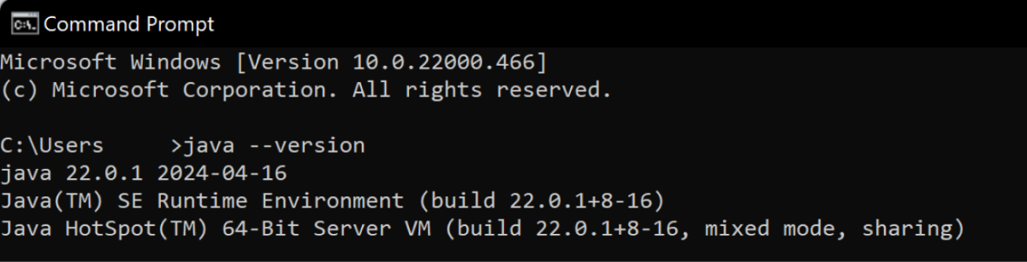

If Java is installed successfully, it will print the version information; otherwise, it will produce an error message indicating that the command is not recognized.

**PROGRAM-2:**

**AIM:** Write a Java program to print the message “Hello World”.

**Code**: 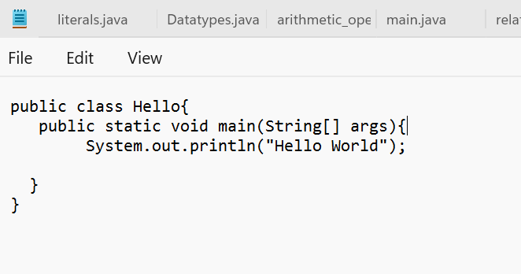

**OUTPUT:**

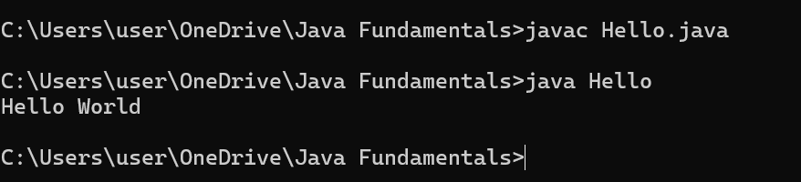

**ERROR TABLE**

|  |  |
| --- | --- |
| ERRORS | RECTIFICATION |
| S in string is written in lowercase letter | The error is rectified by writing s in uppercase letter |

**PROGRAM-3:**

**AIM:** Write a Java Program that prints Name, Roll No, Section of a student.

**CODE:**

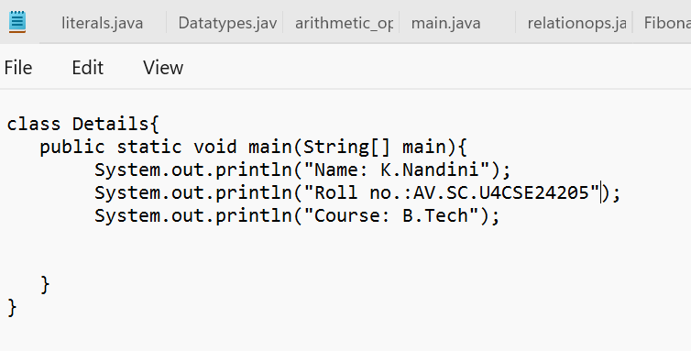

**OUTPUT:**

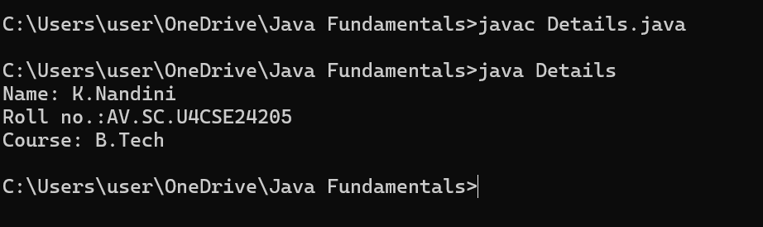

**ERROR TABLE:**

|  |  |
| --- | --- |
| ERROR | RECTIFICATION |
| In the statement at the end ; is not mentioned | Rectified by keeping ; at the end of the ststement |

WEEK – 2:

PROGRAM-1:

AIM: Write a java program to find the simple interest where all the inputs are taken from the user.

CODE:

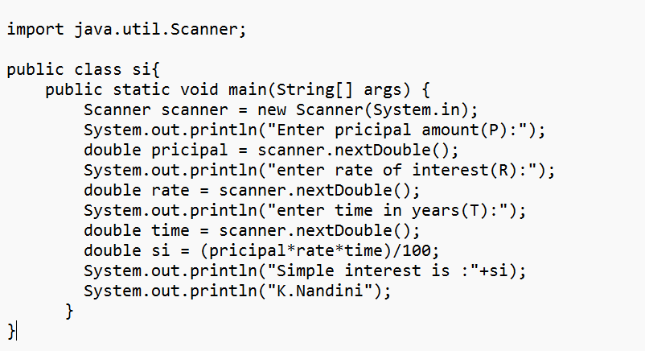

OUTPUT:

POSITIVE CASE:

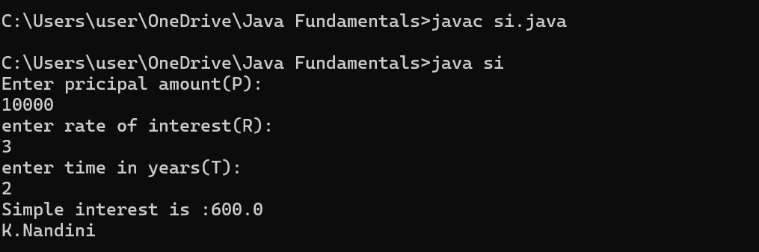

NEGATIVE CASE:

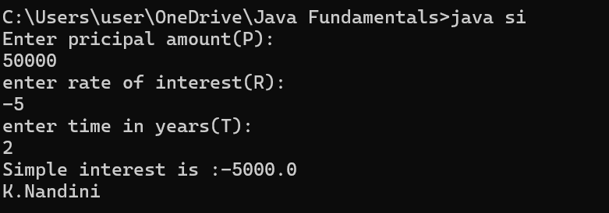

PROGRAM-2:

AIM: Write a java program to find the Fibonacci sequence of a given number

CODE:

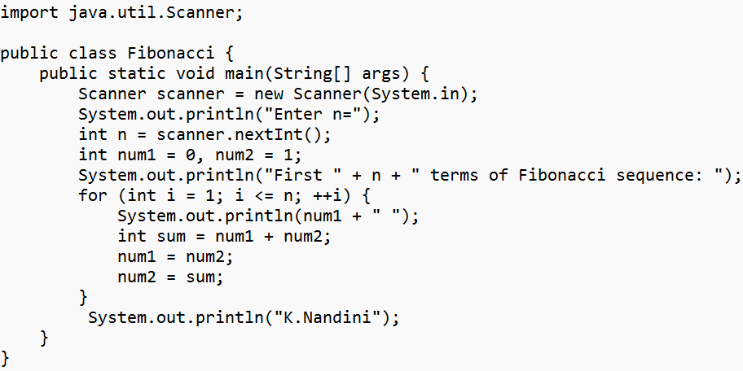

OUTPUT:

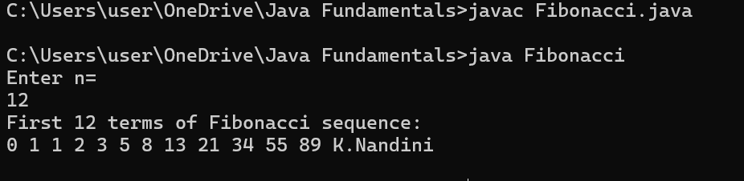

NEGATIVE CASE:

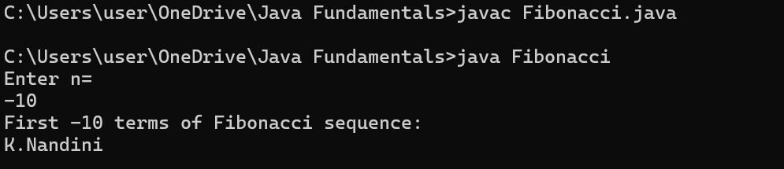

**Program-3:**

AIM: Write a java program to find the area of rectangle and triangle.

CODE:

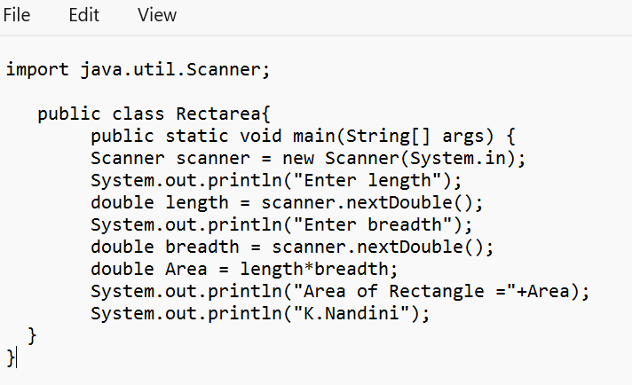

OUTPUT:

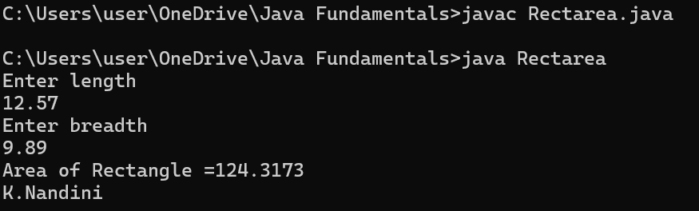

CODE:  
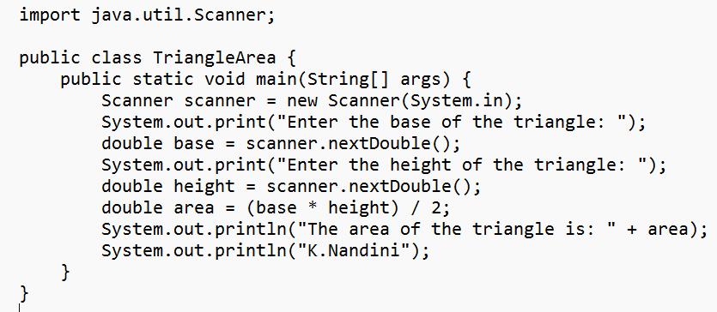

OUTPUT:  
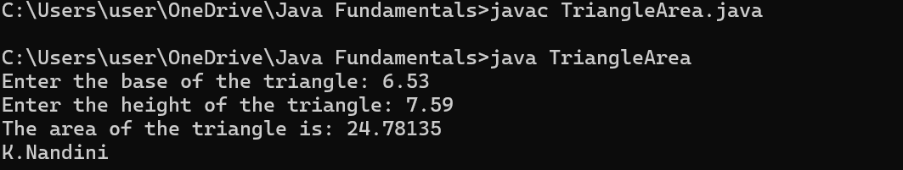

PROGRAM-4:  
AIM: Write a java code to convert the temperature from Celsius to Fahrenheit and from Fahrenheit to Celsius.

CODE:

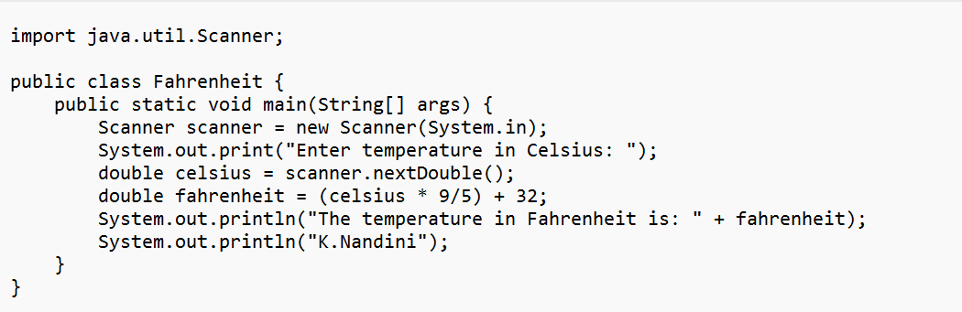

OUTPUT:

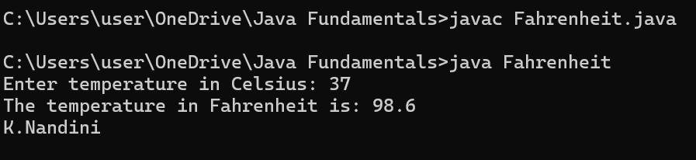

CODE:  
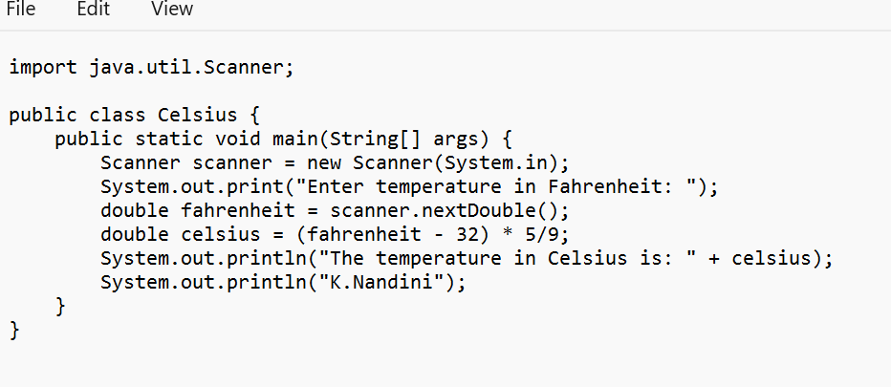

OUTPUT:

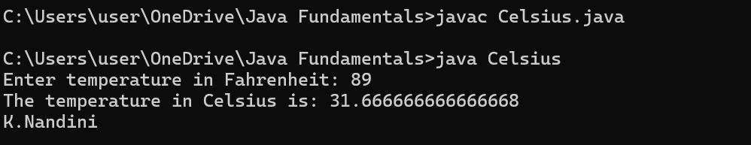

PROGRAM-5

AIM: Write a java code to find factorial of a number by taking input.

CODE:

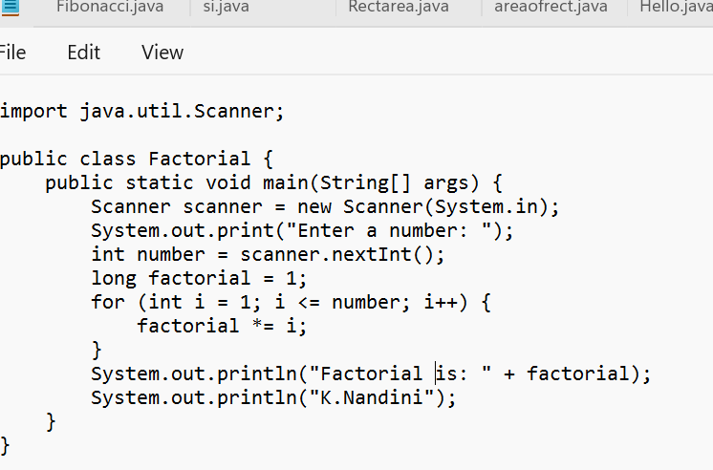

OUTPUT:

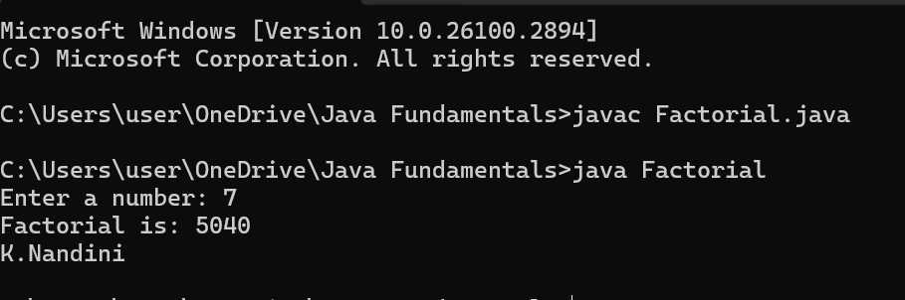

**WEEK-3**

**Program-1**

**AIM :** To create java program with following instructions

1. Create a class with name Car.
2. Create four attributes named Car_color, Car_brand, fuel_type, mileage.
3. Create three methods named start(), stop(), service().
4. Create three methods named Car1, Car2, Car3.

**CODE**:

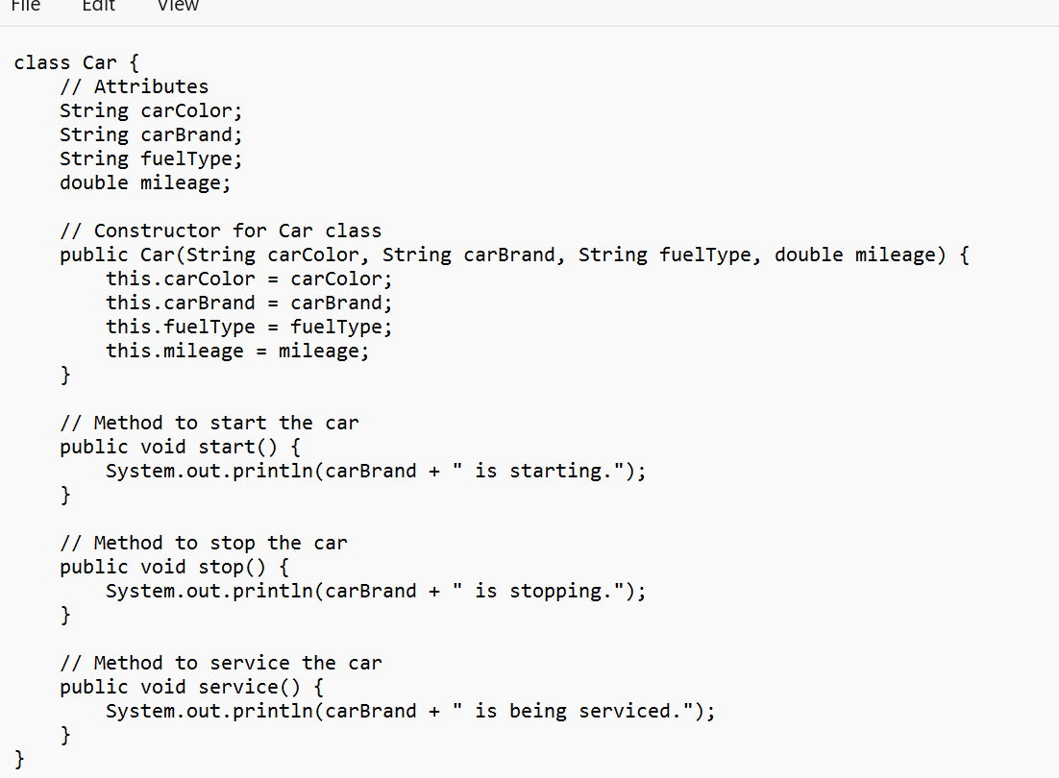

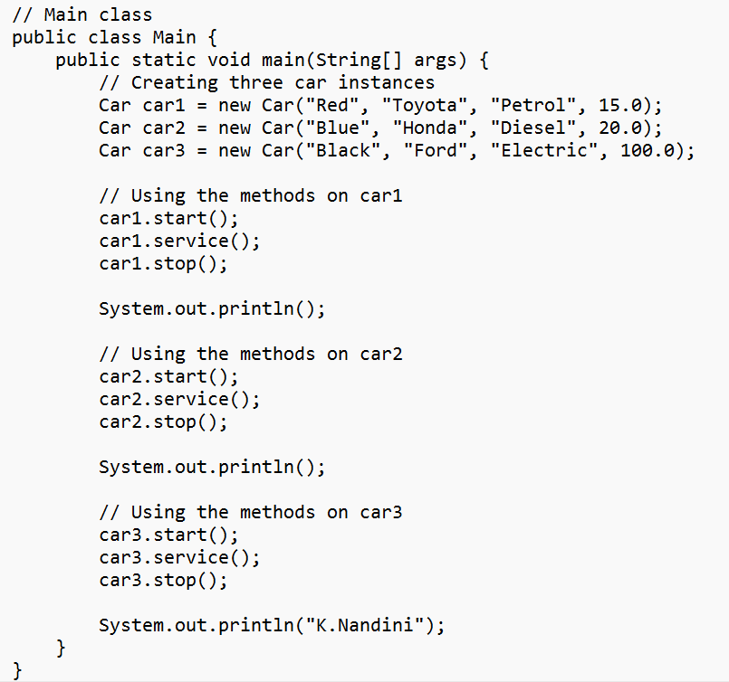

**OUTPUT**:

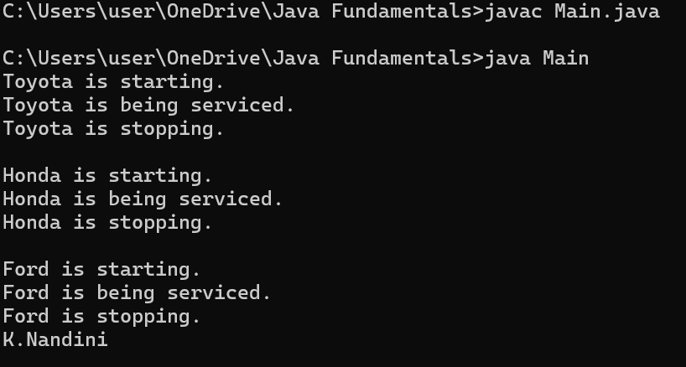

**CLASS DIAGRAM**:

|  |
| --- |
| Car |
| + Car_color: String  + Car_brand: String  - fuel_type: String  - mileage: double |
| + start(): void  + stop(): void  - service(): void  + Car1(): void  + Car2(): void  + Car3(): void |

**Program-2**

**Aim**: To create a class bank account with method deposit() and withdrawal().

**CLASS DIAGRAM:**

|  |
| --- |
| BankAccount |
| - balance: double |
| + BankAccount(initialBalance: double)  + deposit(amount: double): void  + withdrawal(amount: double): void  + getBalance(): double |

**CODE**:

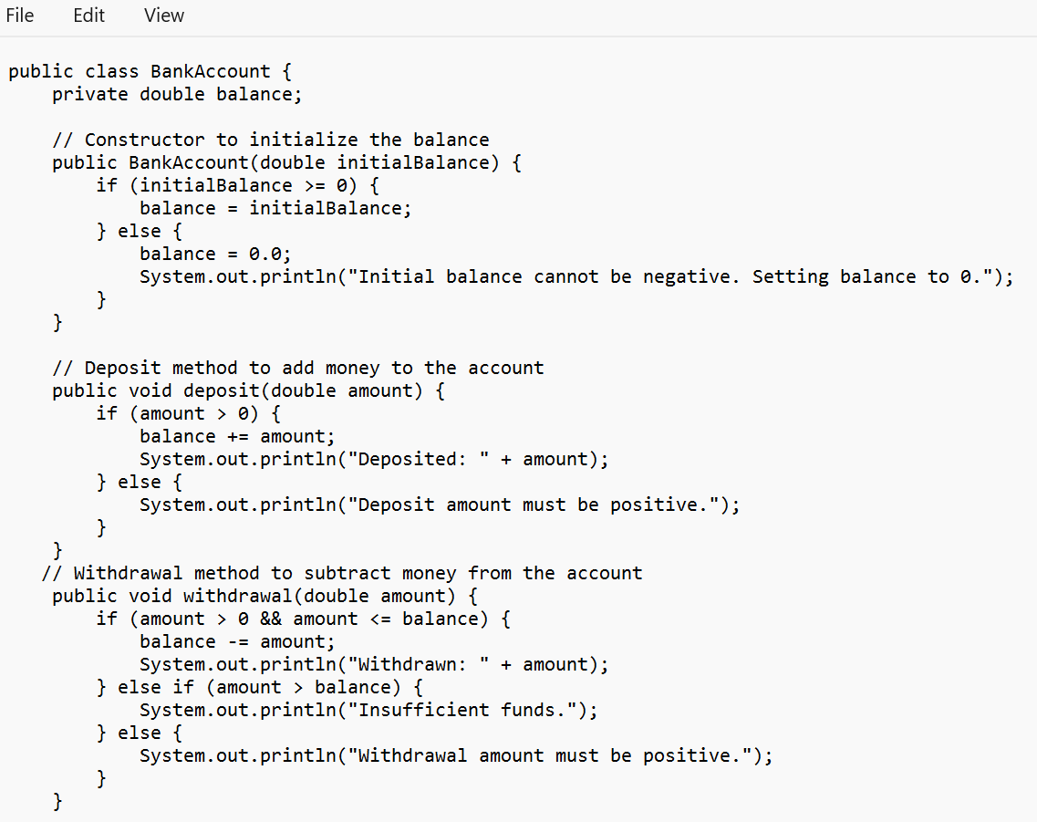

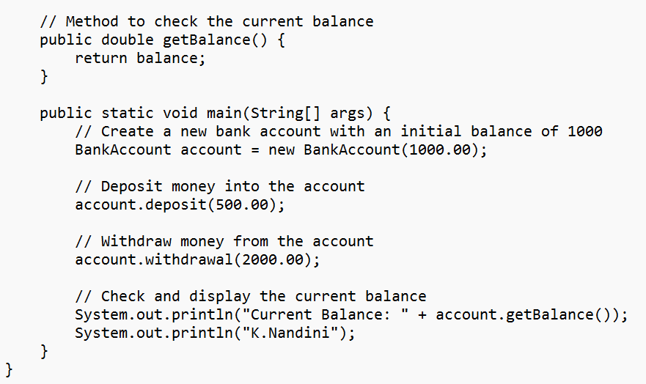

**OUTPUT:**

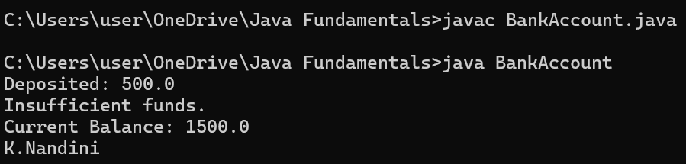

**WEEK-4**

**PROGRAM-1**

**Aim:** Write a java program with class named book. The class should contain various attributes such as title, author, year of publication. It should also contain a constructor with parameters which initializes title, author and year of publication. Create a method which displays the details of the book. Display the details of two books.

**CODE:**

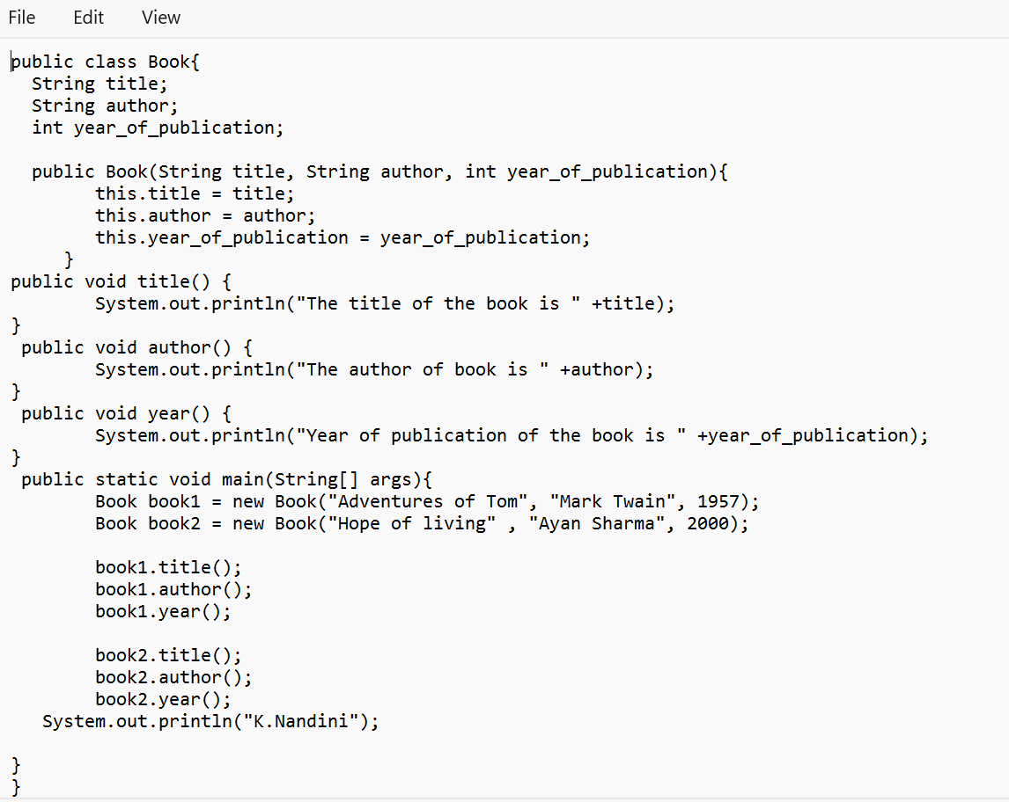

**OUTPUT**

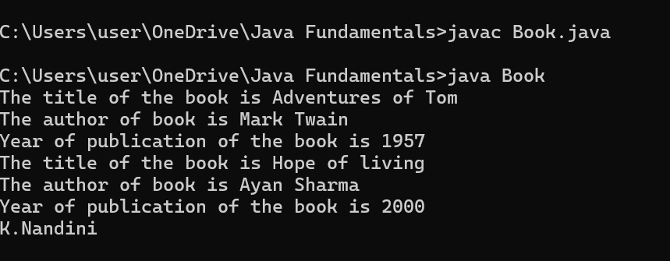

**PROGRAM-2**

**AIM:** Create a java program with class named “MyClass” with a static variable count of int type initialized to zero and a constant variable ‘pi’ of type double initialized to 3.14 as attributes of that class. Now define a constructor for “MyClass” that increments the count variable each time an object of “MyClass” is created. Finally print the final values of count and pi variables. Create three variables.

**CODE:**

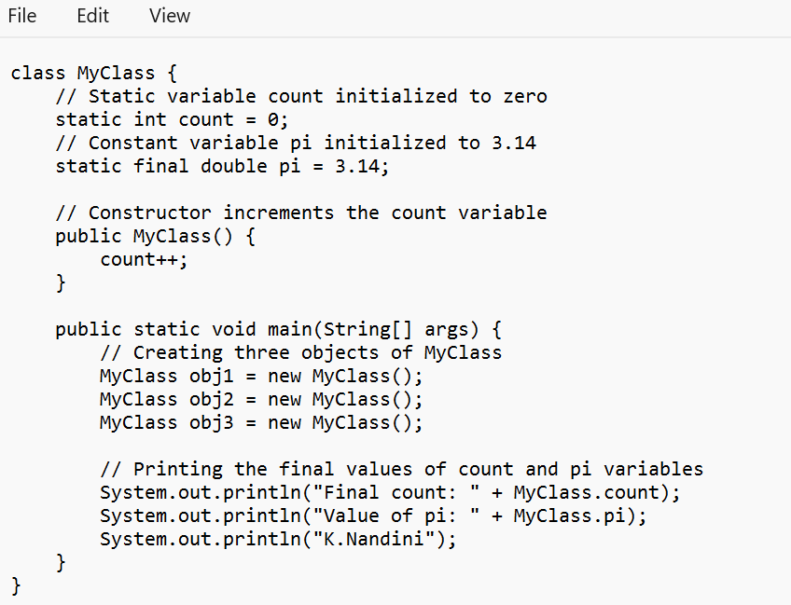

**OUTPUT:**

