FastAPI Microservices with Docker & NGINX
Step1: Create an EC2 Instance and Connect to EC2 Using PuTTY / SSH
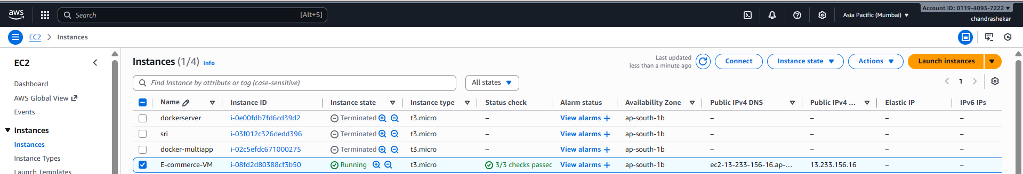

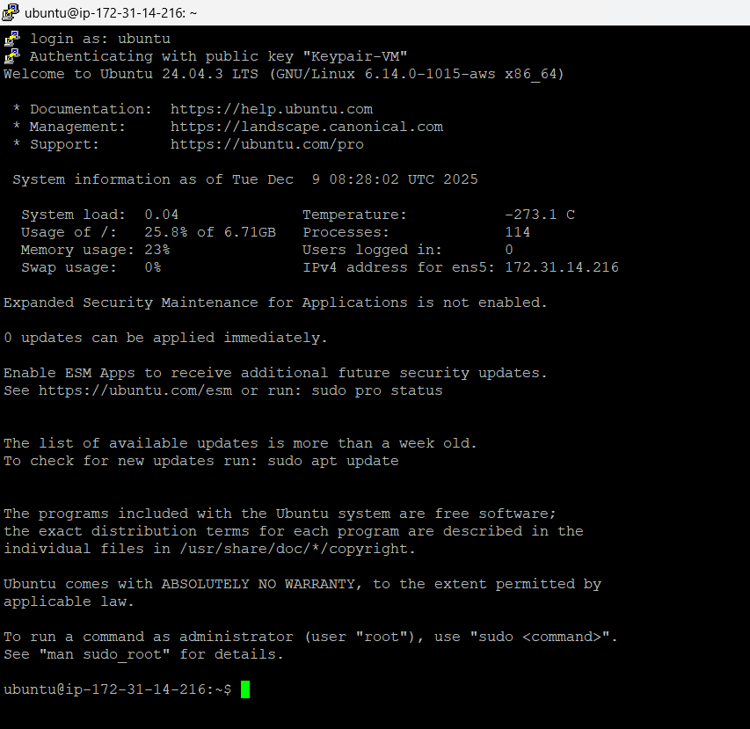
Step2: Update your Ubuntu EC2 server
Inside your EC2 terminal:
sudo apt update -y
sudo apt upgrade -y
Step3: Install Docker
sudo apt install docker.io -y
sudo systemctl enable docker
sudo systemctl start docker
Check Docker version:
docker –version
Step4: Install Docker Compose
sudo mkdir -p /usr/local/lib/docker/cli-plugins
sudo curl -SL https://github.com/docker/compose/releases/download/v2.29.2/docker-compose-linux-x86_64 \
-o /usr/local/lib/docker/cli-plugins/docker-compose
sudo chmod +x /usr/local/lib/docker/cli-plugins/docker-compose

docker compose version
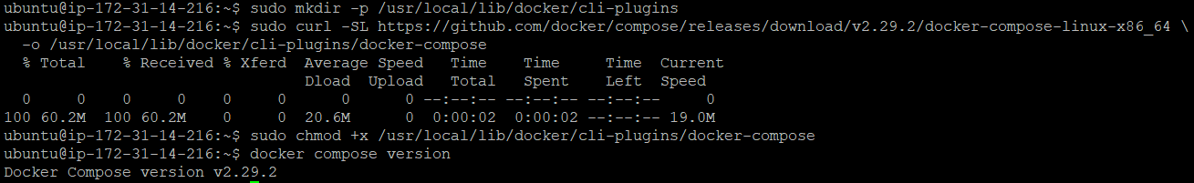
Step5: Create a folder for your Microservices Project
mkdir fastapi-microservices-docker
cd fastapi-microservices-docker
Step6: Create folder structure
mkdir user-service product-service order-service nginx
Now we have:
fastapi-microservices-docker/

1. user-service
2. product-service order-service
3.nginx

Step7: Start adding files
Create user-service
- Create requirements.txt
cat <<EOF > user-service/requirements.txt
fastapi
uvicorn
pydantic[email]
email-validator
EOF

- Create main.py
cat <<EOF > user-service/main.py
from fastapi import FastAPI
app = FastAPI(title="User Service")
@app.get("/users")
def get_users():
return {"message": "Users list returned successfully"}
EOF
- Create Dockerfile
cat <<EOF > user-service/Dockerfile
FROM python:3.11-slim
WORKDIR /app
COPY requirements.txt .
RUN pip install --no-cache-dir -r requirements.txt
COPY . .
CMD ["uvicorn", "main:app", "--host", "0.0.0.0", "--port", "8001"]
EOF

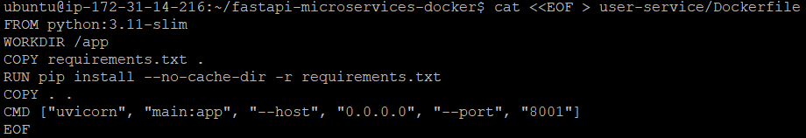
Repeat for product-service
requirements.txt
echo -e "fastapi==0.115.0\nuvicorn==0.30.0" > product-service/requirements.txt
main.py
cat <<EOF > product-service/main.py
from fastapi import FastAPI

app = FastAPI(title="Product Service")

@app.get("/products")
def get_products():
return [{"id": 1, "name": "Laptop"}, {"id": 2, "name": "Phone"}]
EOF
Dockerfile
cat <<EOF > product-service/Dockerfile
FROM python:3.11-slim
WORKDIR /app
COPY requirements.txt .
RUN pip install --no-cache-dir -r requirements.txt
COPY . .
CMD ["uvicorn", "main:app", "--host", "0.0.0.0", "--port", "8002"]
EOF

Repeat for order-service
requirements.txt
echo -e "fastapi==0.115.0\nuvicorn==0.30.0" > order-service/requirements.txt
main.py
cat <<EOF > order-service/main.py
from fastapi import FastAPI
app = FastAPI(title="Order Service")
@app.get("/orders")
def get_orders():
return [{"order_id": 101, "user_id": 1, "amount": 500}]
EOF
Dockerfile
cat <<EOF > order-service/Dockerfile
FROM python:3.11-slim
WORKDIR /app
COPY requirements.txt .
RUN pip install --no-cache-dir -r requirements.txt
COPY . .
CMD ["uvicorn", "main:app", "--host", "0.0.0.0", "--port", "8003"]
EOF
Step8: Create NGINX API Gateway
Create nginx/default.conf:
server {
listen 80;
location /users/ {
proxy_pass http://user-service:8001/;
}
location /products/ {
proxy_pass http://product-service:8002/;
}
location /orders/ {
proxy_pass http://order-service:8003/;
}
}
Step9: Create docker-compose.yml
cat <<EOF > docker-compose.yml
version: "3.9"
services:
user-service:
build: ./user-service
expose:
- "8001"
product-service:
build: ./product-service
expose:
- "8002"
order-service:
build: ./order-service
expose:
- "8003"
api-gateway:
image: nginx:latest
ports:
- "80:80"
volumes:
- ./nginx/default.conf:/etc/nginx/conf.d/default.conf
depends_on:
- user-service
- product-service
- order-service
EOF
Step10: Add your user to docker group
sudo usermod -aG docker $USER
exit and connect to server again
Step11: Run Microservices
docker compose up -d –build
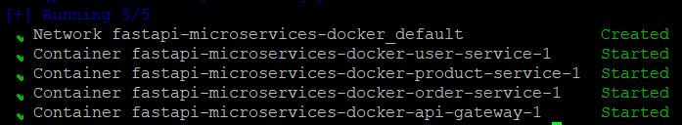
Check running containers:
docker compose ps

Step 12: Test Your Microservices
From browser:
http://<EC2-IP>/users
http://<EC2-IP>/products
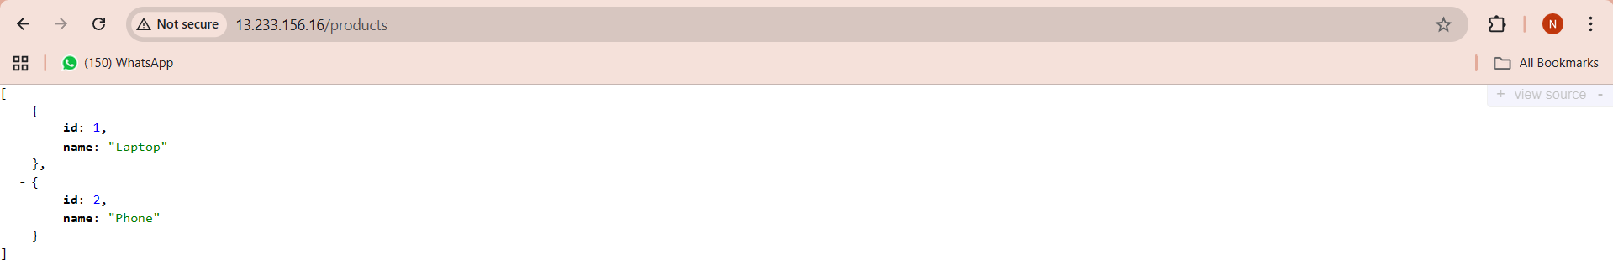

http://<EC2-IP>/orders
