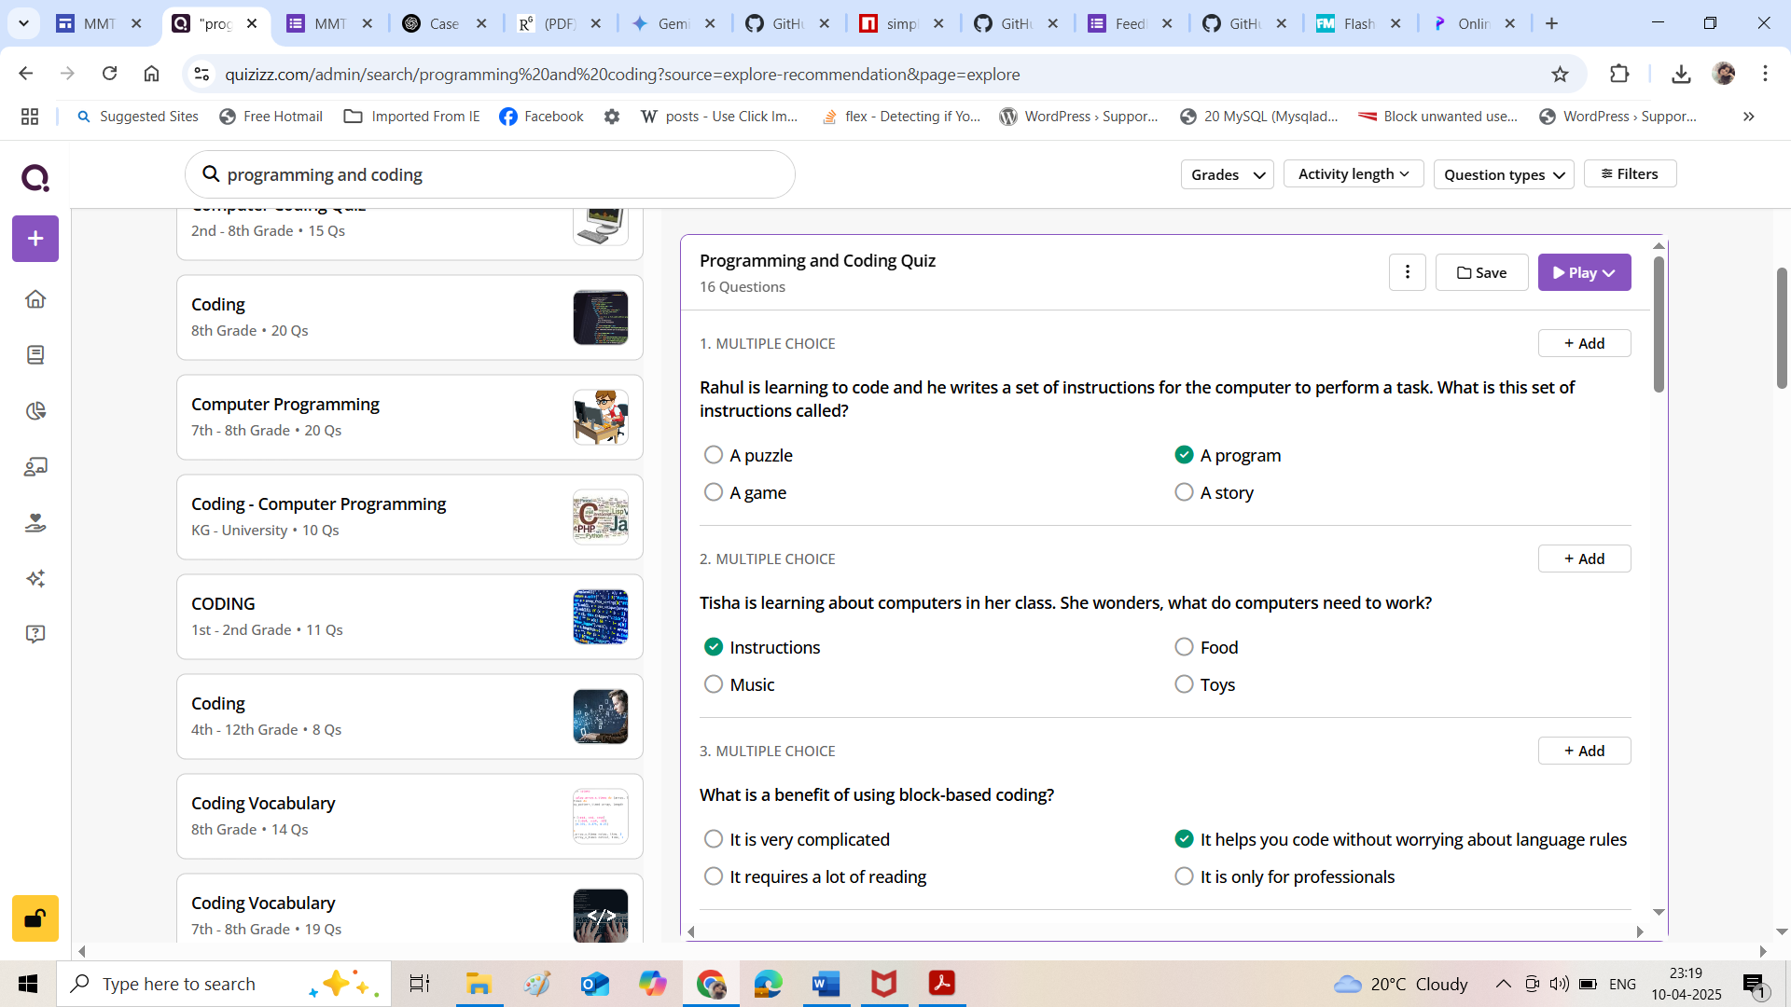

Quiz link <https://quizizz.com/join?gc=20968740>

Qr code **2096 8740**

