Task 1 – CSV File: Student Marks Record Problem Statement
Develop a Python program to collect the details of 10 students and store them in a CSV file named student_marks.csv.
The file should contain:
- Register Number
- Student Name
- Department
- Python Marks
- Data Science Marks

OUTPUT:
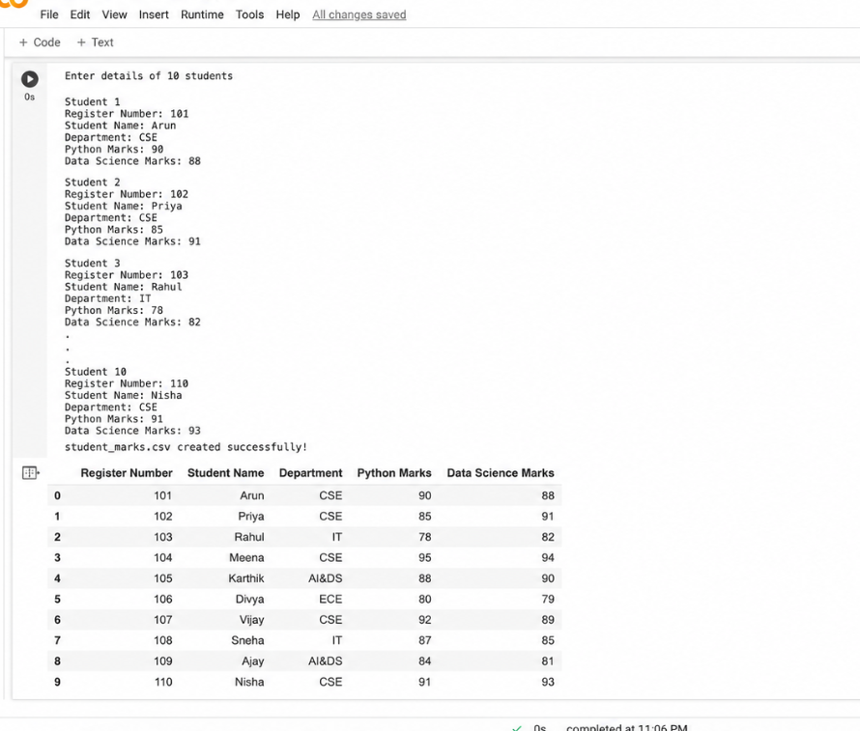

Task 2 – CSV File: Employee Database Problem Statement
Develop a Python program to collect employee information and store it in a CSV file named employees.csv.
The file should contain:
- Employee ID
- Employee Name
- Department
- Designation
- Salary
Store details of at least 5 employees.
OUTPUT:
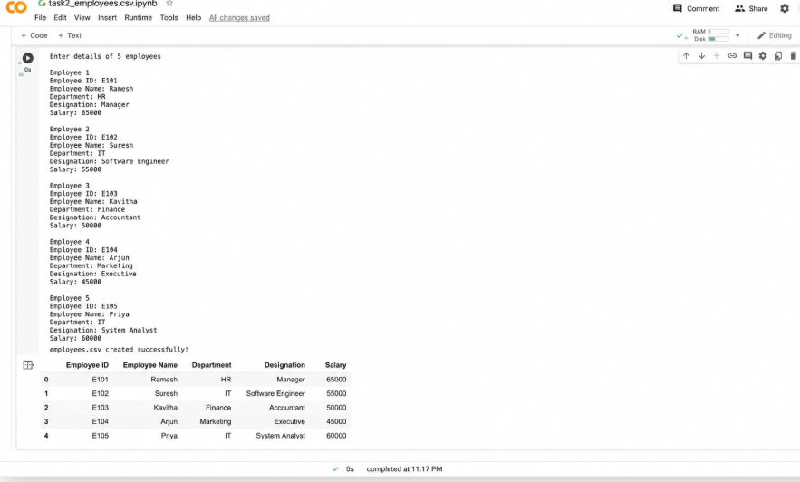

Task 3 – JSON File: Faculty Information System Problem Statement
Create a Python program to collect faculty details and store them in a JSON file named faculty.json.
Each faculty record should contain:
- Faculty ID
- Faculty Name
- Department

- Designation
- Experience (Years)
Store details of at least 5 faculty members.
OUTPUT:
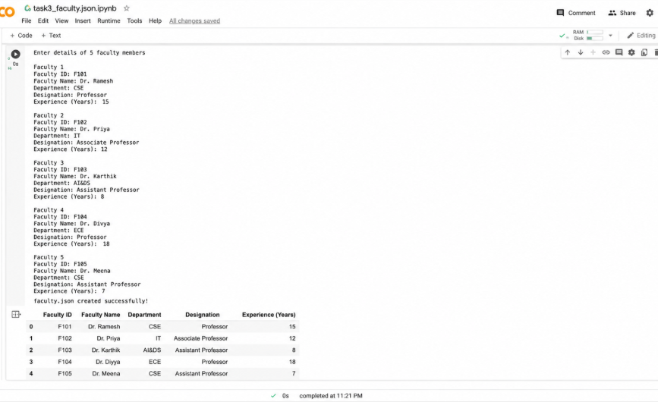

Task 4 – JSON File: Product Inventory Management Problem Statement
Develop a Python program to collect product information and store it in a JSON file named products.json.
Each product should contain:
- Product ID
- Product Name
- Category
- Price
- Quantity Available
Store details of at least 10 products.

OUTPUT:
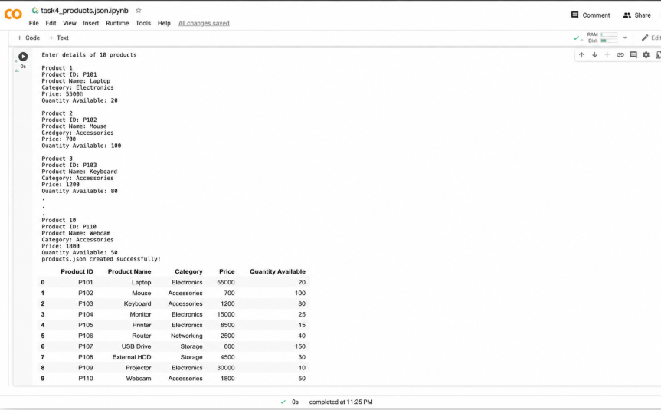

Task 5 – XML File: Course Information Database Problem Statement
Create a Python program to collect course details and store them in an XML file named courses.xml.
Each course should contain:
- Course Code
- Course Name
- Credits
- Department
- Faculty Name
Store details of at least 5 courses.

OUTPUT:
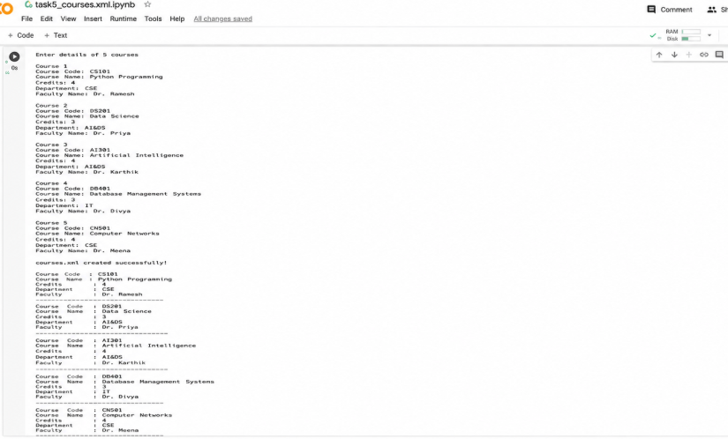

Task 6 – XML File: Hospital Patient Management System Problem Statement
Develop a Python program to collect patient information and store it in an XML file named patients.xml.
Each patient record should contain:
- Patient ID
- Patient Name
- Age
- Disease
- Doctor Assigned
Store details of at least 10 patients.

OUTPUT:
