**Project Report On**

Game Zone Management System

**Submitted By**

Shah Nandini Niravkumar

**(Seat No. 5115155)**

**Submitted for**

Project Work

BCA Semester - V (2023-24)

**Submitted To**



**S.G.M. English Medium College of Commerce and Management (SEMCOM)**

**CVM University**

# **The Charutar Vidya Mandal University**

# **S.G.M. English Medium College of Commerce and Management**

**(SEMCOM)**

**Vallabh Vidyanagar**

### CERTIFICATE

**Date: 30-10-2023**

This is to certify that **Shah Nandini Niravkumar** of BCA – SEM - V **(Seat No. 5115155)** has worked on project entitled **Game Zone Management System** from **19/06/2023 to 03/10/2023**. This **(**101150508) is an in-house project course of four credits.

She was regular in her work and developed the project including analysis and design. She has completed the project satisfactorily.

#### **Principal Project Guide**

* **ACKNOWLEDGEMENT:**

The satisfaction that accompanies that the successful completion of any task would be incomplete without the mention of people whose cooperation made it possible, whose constant guidance and encouragement crown all efforts with success.

I am grateful to my project guide Dr. Mehul Patel for the guidance, inspiration and constructive suggestions that helped me in the preparation of this In-House Project. I am also thankful to other staff members of college who constantly support and guide me for the project work. Specially Ms. Palak Patel, Mr. Premal Soni, Mr. Abhishek Dave, Mr. Dhruv Patel.

I am also thankful to my lab technician staff members and colleagues who have helped me in successful completion of the project.

I hereby declare that this project work titled **“Game Zone Management System”** is my original work and no part or it has been submitted for any other degree purpose or published in any other from till date.

**INDEX**

|  |  |  |
| --- | --- | --- |
| **Sr.**  **No.** | **Description of Topic** | **Page No.** |
| **1** | Title Page of Project | 1 |
| **2** | College Certificate | 2 |
| **3** | Acknowledgement | 3 |
| **4** | Index | 4 |
| **5** | Project Profile | 5 |
| **6** | An Existing System | 7 |
| **7** | Hardware and Software | 8 |
| **8** | Data Flow Diagram | 9 |
| **9** | Database Layout | 12 |
| **10** | Screens | 17 |
| **11** | Limitation | 23 |
| **12** | Conclusion | 24 |
| **13** | Bibliography | 25 |

* **Project Profile:**
* Introduction:
* Game Zone Management System, in which system will provide facilities of gaming equipment and operational team.
* From Storing-Preserving data in well manner to making updates in this data, also helps shopkeeper or manager to take decisions from past data easily and more efficiently.
* System will make game zone’s tasks easier like from registering new customer and saving data of his/her interested game to taking decisions from past data.
* This system will store games data in different packages form, which then can be updated or deleted or inserting new games in any package.
* According to package selection after successfully registering customer data system will provide final amount data with all necessary details.
* System can update or delete any customer data stored in database.
* System’s goal is to make things easy and in well manner from existing paper-based system.
* System will save manual efforts, it will save lot more time than existing system, also manager now can focus more on game zone’s development rather putting more efforts on operational task.
* Proposed System removes many drawbacks of existing system like preserving of data, make use of past data for any management activity , difficulties in accessing or getting old data, putting extra manual efforts on storing of data.
* Proposed System is easy, simple and efficient for doing any operational tasks like providing bills.
* System will provide data storage facility also easily accessible and easily reusable of data can be possible.
* Admin can easily take decisions from system with less efforts.
* It will digitalise process which is somehow more difficult and more time consuming in past paper-based system.
* Requires only a group of people which can work on computer, which have little knowledge of system.
* **Existing System:**
* This is an offline system – paper-based system. In which there is so much difficulties like,
  + - Manual on paper entries for every process
    - Storing of that data for future purpose
    - For Making Decisions from past data
    - Difficulty in Managing because admin had to take care of each detail, data
* In Existing System, there is a heavy work load on shop manager or shopkeeper, they have to take care of each data which is on paper also they have to take decision keeping all the data in their mind.
* It might be possible that the management might face problems while doing all the tasks with their own.
* It is more costly too because shop has to acquire good management team – group of people also for storing of data it requires more stationary which made more expenses for shop.
* It takes too much time for each process like bill entries, inventory management.
* Also, preserving of all these data which is in paper form, it is also a headache task.
* Existing system is dependent on manual works, employee or person has to write and has to memorised all data all the time.
* There must be redundancy in human work. It wastes time, also extra human power consumed, also there is increase of paper wastage.
* Manager has to go through with each record in order to make decisions for future of the game zone, it is very time consuming, boring and headache task in order to do so first manager must assembles all the past data according to duration then using its own methods and mind, he then can take decision which is not appropriate approach.
* In against, proposed system is easy to use and implement, task of accessing data and taking decisions also becomes easier and automatic with more efficiency.
* Existing system is slow, it has many drawbacks and it has less efficiency.
* **Hardware and Software:**
* **Hardware:**
* **Hardware**: User requires windows operating system either 32bit or 64bit, it can be any window 10 User’s System must fulfil this hardware requirements for best experience.
* 8 GB RAM
* 256 SSD
* **Software**:
* Front-end tools/languages:
* Microsoft Visual Basic 2010 Express
* For Designing, Validation of Data, Database connection
* Back-end tools/languages: Database that this application use is in-built services-based database which is provided by Visual Basic 2010 Express itself.
* MySQL 2010
* A Structured Query Language for CRUD(Create, Retrieve, Update, Delete) operations from Database
* **Data Flow Diagram:**
* Process Hierarchy

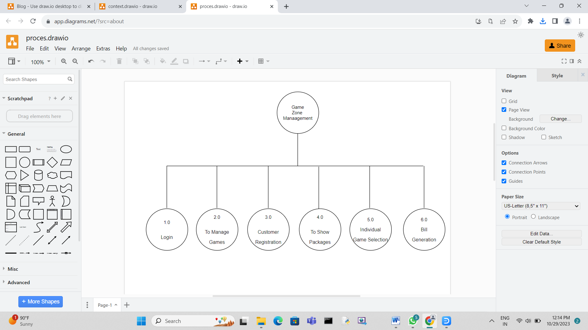

* Context Level DFD

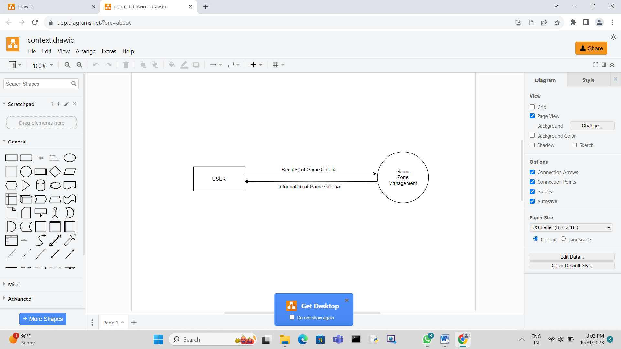

* **Zero Level DFD**

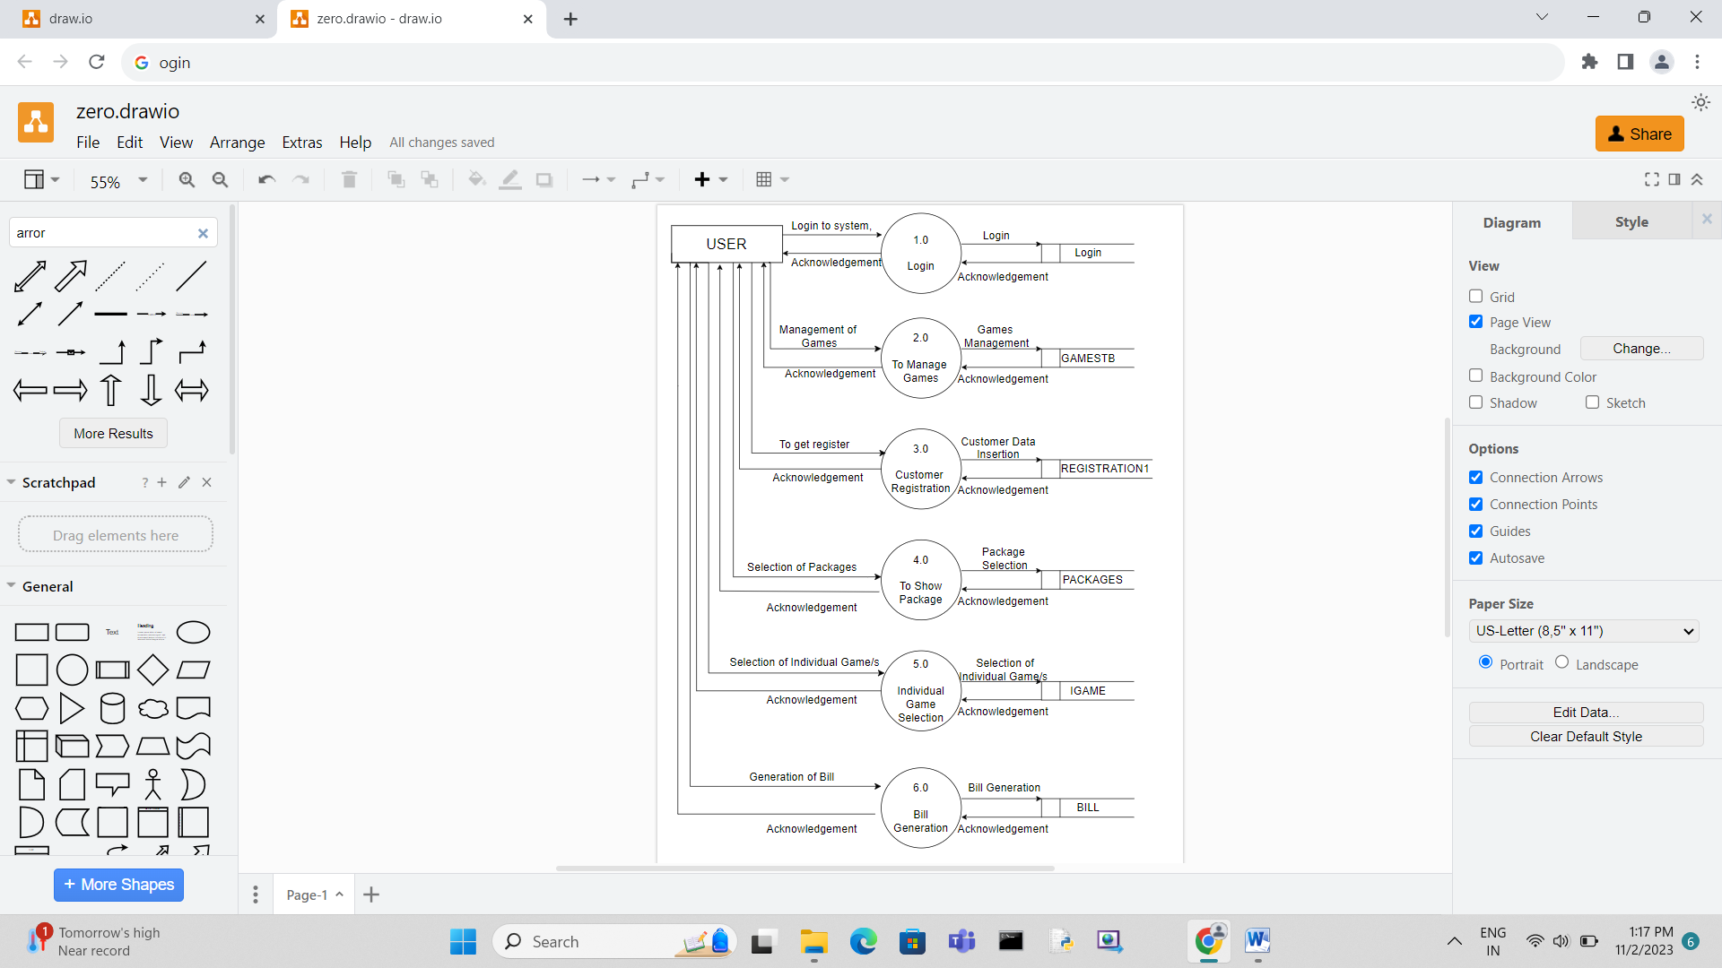

* **Database Layout:**
* packageTB:

|  |  |
| --- | --- |
| **Column Name** | **Data Type & Size** |
| Games | varchar(20) |
| Package | varchar(10) |

* gamesTB:

|  |  |  |
| --- | --- | --- |
| **Column Name** | **Data Type & Size** | **Constraints** |
| g_id | int(4) | Primary Key |
| g_name | varchar(30) |  |
| g_price | int(10) |  |

* registration1:

|  |  |  |
| --- | --- | --- |
| **Column Name** | **Data Type & Size** | **Constraints** |
| id | int(4) | Primary Key |
| name | varchar(15) |  |
| mno | nvarchar(10) |  |
| email | nvarchar(25) |  |
| gender | varchar(10) |  |
| bdate | nvarchar(30) |  |

* billTB:

|  |  |  |  |
| --- | --- | --- | --- |
| **Column Name** | **Data Type & Size** | **Allow Null** | **Constraints** |
| bill_no | int(3) |  | Primary Key |
| bill_date | date |  |  |
| cust_id | int(4) |  | reference to registration1 |
| pack_name | nvarchar(20) |  |  |
| games | nvarchar(MAX) |  |  |
| total | int(6) |  |  |

* igame:

|  |  |  |
| --- | --- | --- |
| **Column Name** | **Data Type & Size** | **Constraints** |
| g_id | int(4) | Primary Key |
| g_name | varchar(30) |  |
| g_price | int(10) |  |

* **Database with its Records:**
* Games Database:

|  |  |  |
| --- | --- | --- |
| **g_id** | **g_name** | **g_price** |
| 1 | 4 Lane Bowling Alley | 800 |
| 2 | Cricket | 400 |
| 3 | Air Hockey | 300 |
| 4 | Scary House | 400 |
| 5 | Virtual Golf | 300 |
| 6 | Bumper Car | 500 |
| 7 | Shooting Range | 600 |
| 8 | Mirror Maze | 300 |

* Registration Database:

|  |  |  |  |  |  |
| --- | --- | --- | --- | --- | --- |
| **id** | **name** | **mno** | **email** | **gender** | **bdate** |
| 1 | Nandini | 9856741256 | nn@gmail.com | Female | 04-06-2003 |
| 2 | Shreena | 8759865741 | sp@gmail.com | Female | 07-02-2003 |
| 3 | Krina | 9874123654 | kk@gmail.com | Female | 10-12-2004 |
| 4 | Pulin | 8756321458 | pns@gmail.com | Male | 16-08-2007 |

* Package Database:

|  |  |
| --- | --- |
| **Games** | **Package** |
| 4 Lane Bowling Alley | Diamond |
| Cricket | Diamond |
| Air Hockey | Diamond |
| Shooting Range | Diamond |
| Virtual Golf | Diamond |
| Bumper Car | Diamond |
| Mirror Maze | Diamond |
| 4 Lane Bowling Alley | Gold |
| Shooting Range | Gold |
| Virtual Golf | Gold |
| Bumper Car | Gold |
| Mirror Maze | Gold |
| Cricket | Silver |
| Air Hockey | Silver |
| Bumper Car | Silver |

* igame Database:

|  |  |  |
| --- | --- | --- |
| **g_id** | **g_name** | **g_price** |
| 1 | 4 Lane Bowling Alley | 800 |
| 2 | Cricket | 400 |
| 3 | Air Hockey | 300 |
| 4 | Scary House | 400 |
| 5 | Virtual Golf | 300 |
| 6 | Bumper Car | 500 |
| 7 | Shooting Range | 600 |
| 8 | Mirror Maze | 300 |

* billTB Database

|  |  |  |  |  |  |
| --- | --- | --- | --- | --- | --- |
| **bill_no** | **bill_date** | **cust_id** | **pack_name** | **games** | **total** |
| 1 | 10/15/2023 | 1 | Diamond | 4 Lane Bowling Alley, Cricket, Air Hockey, Shooting Range, Virtual Golf, Bumper Car, Mirror Maze | 3000 |
| 2 | 10/15/2023 | 1 | Gold | 4 Lane Bowling Alley, Shooting Range, Virtual Golf, Bumper Car, Mirror Maze | 2000 |
| 3 | 10/16/2023 | 1 | NULL | Shooting Range, Bumper Car | 1100 |
| 4 | 10/16/2023 | 1 | Silver | Air Hockey, Bumper Car, Mirror Maze | 1000 |

* **Screens**
* Login Page:

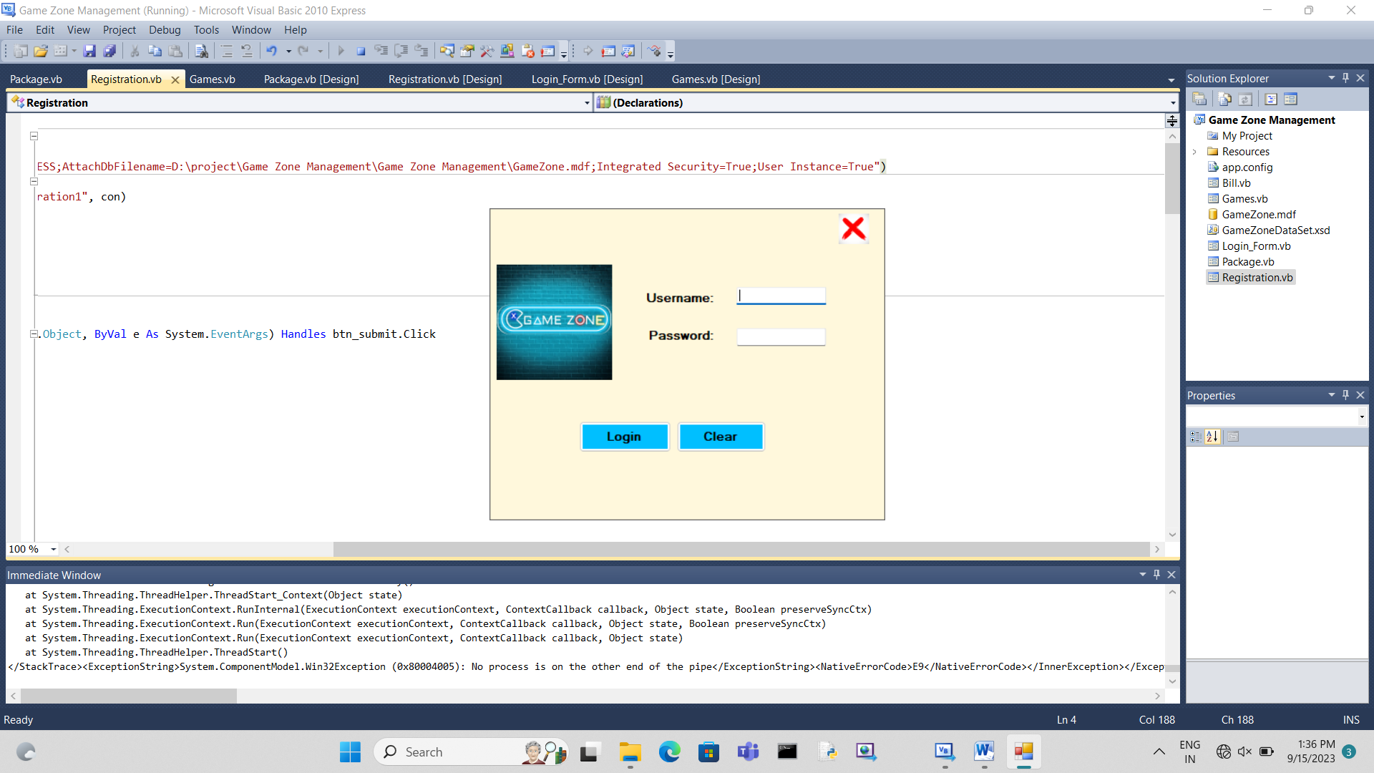

* Login Page: Login Form is used to login to system so only person who knows the Id and password can login to system which provides security to system.
* Game Management Page:

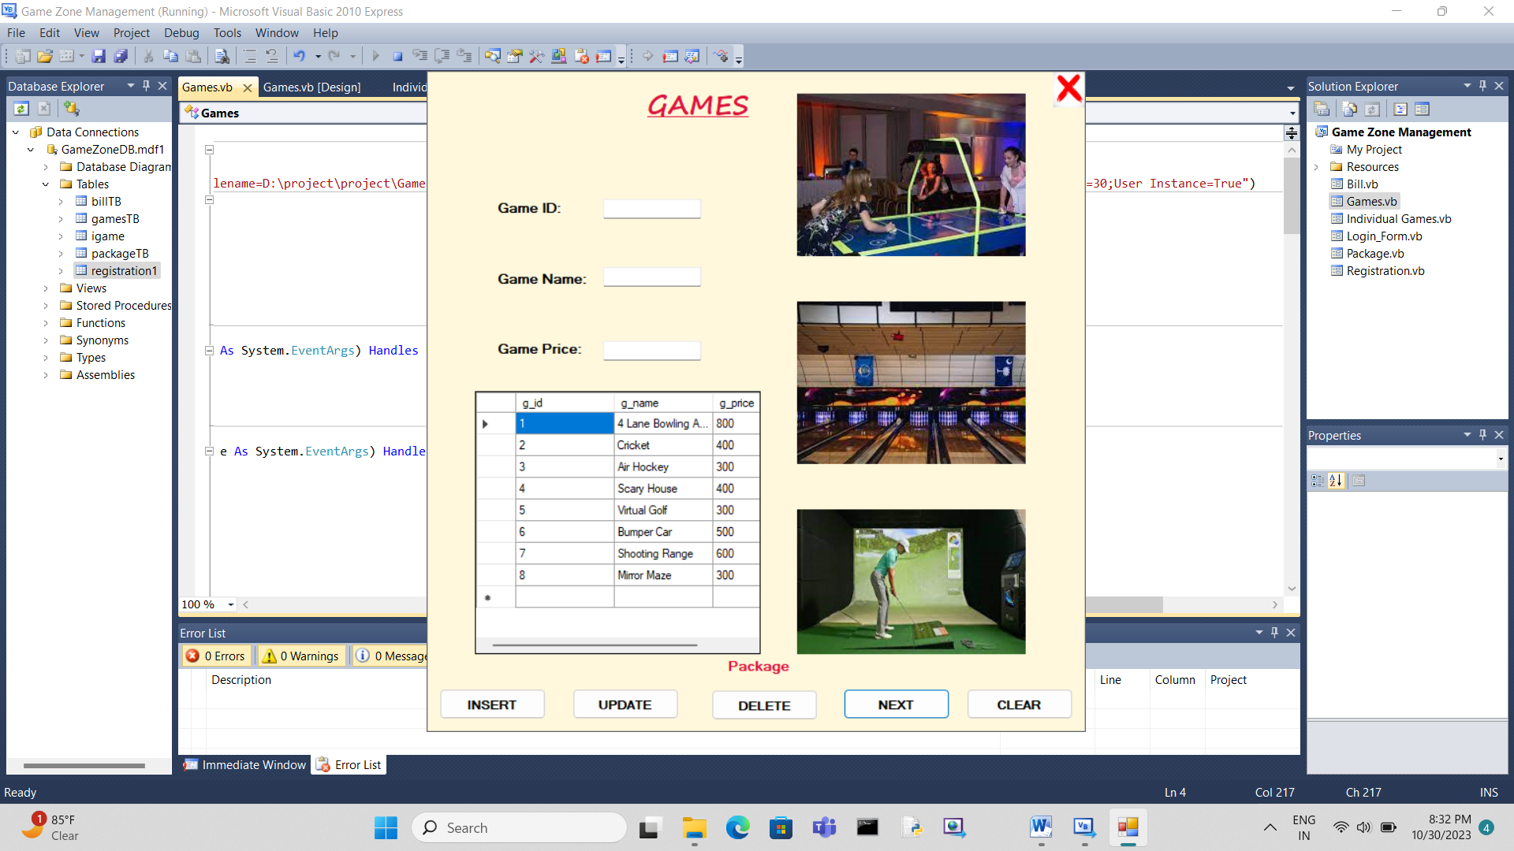

* Game Management Page: Game page is used to manage games, it is used to insert new games, update games and also delete the game.
* Registration Page:

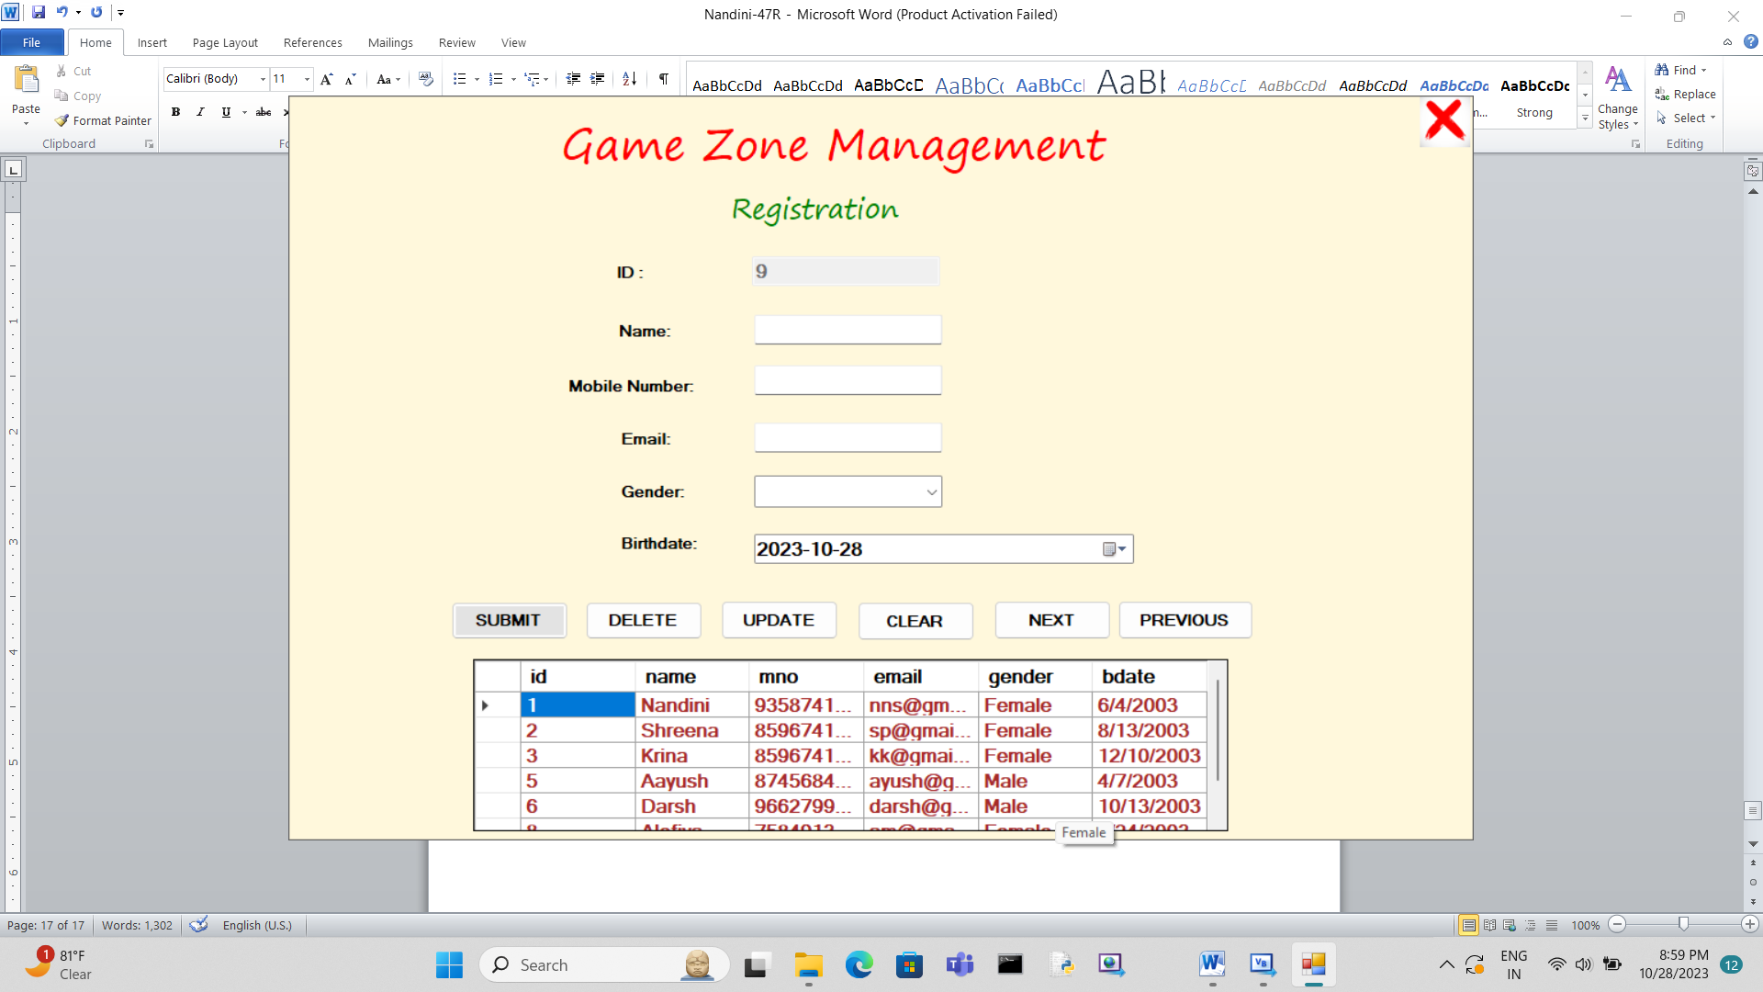

* Registration Page: It is used for customer registration, when new customer enters in shop and wants to make transactions he/she first needs to register then he/she gets benefits of proposed system.
* Package Page:

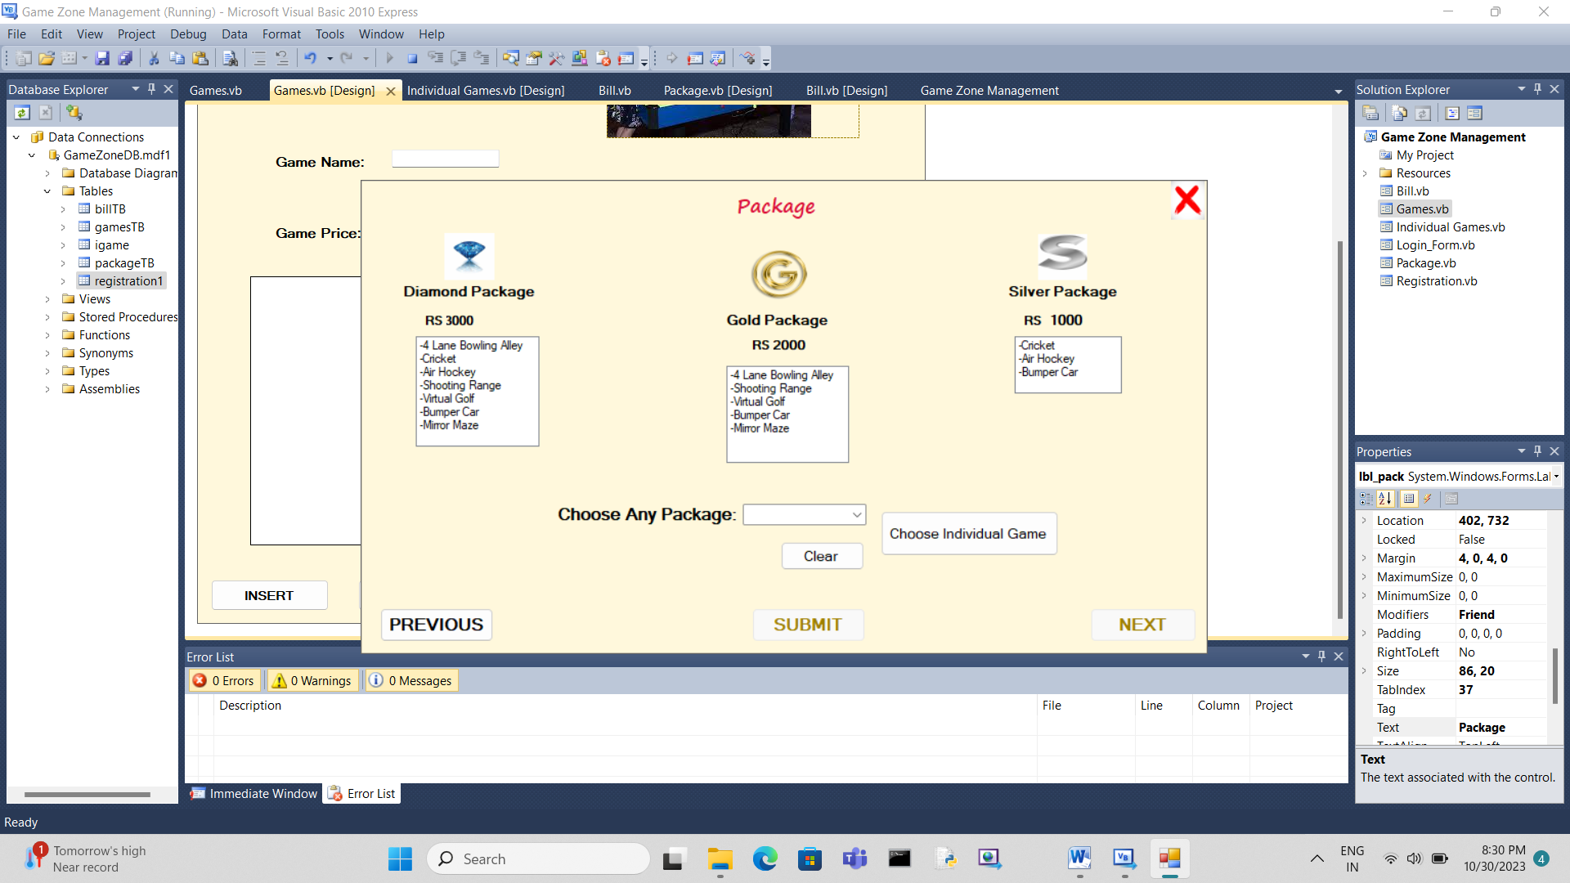

Package Page:

* Shop provides two different facilities to customer either he/she wants to choose package and only play those games which are available in the package.
* In this the customer choose package from the three packages which is Diamond Package, Gold Package and Silver Package and according package selection games- which are listed in it will be pass to bill and customer gets benefit of those games.
* Individual Game Selection:

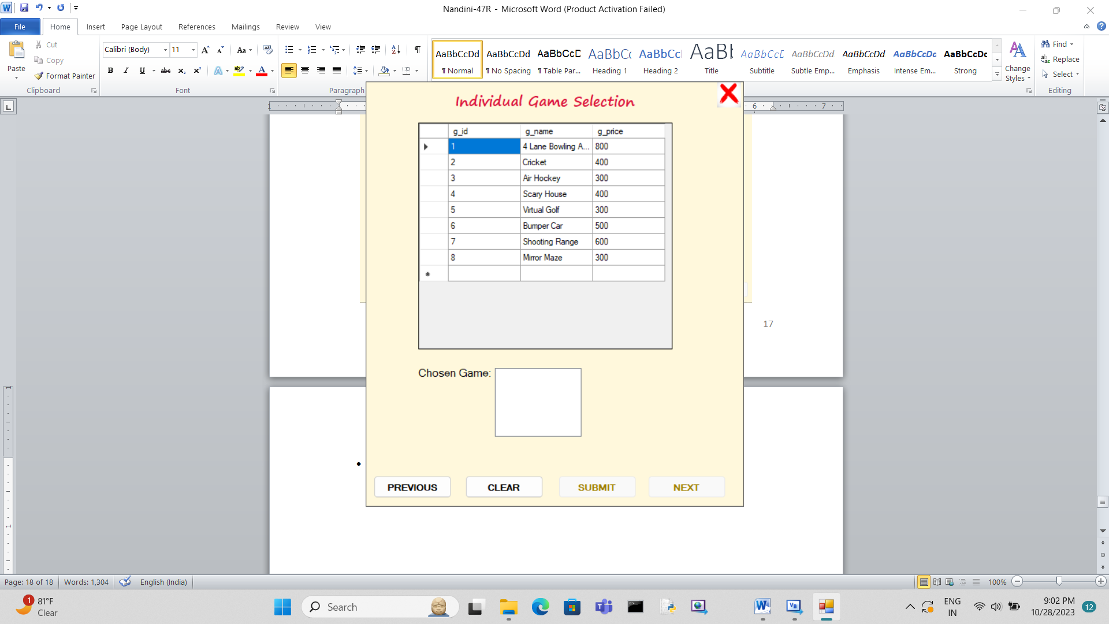

Individual Selection Page:

* Other facility which shop provides to customer is to choose individual games and customer gets benefit to those selected games, in this the customer gets to choose the game/s whichever he/she wants to play and these chosen game list will be pass to bill.
* Bill:

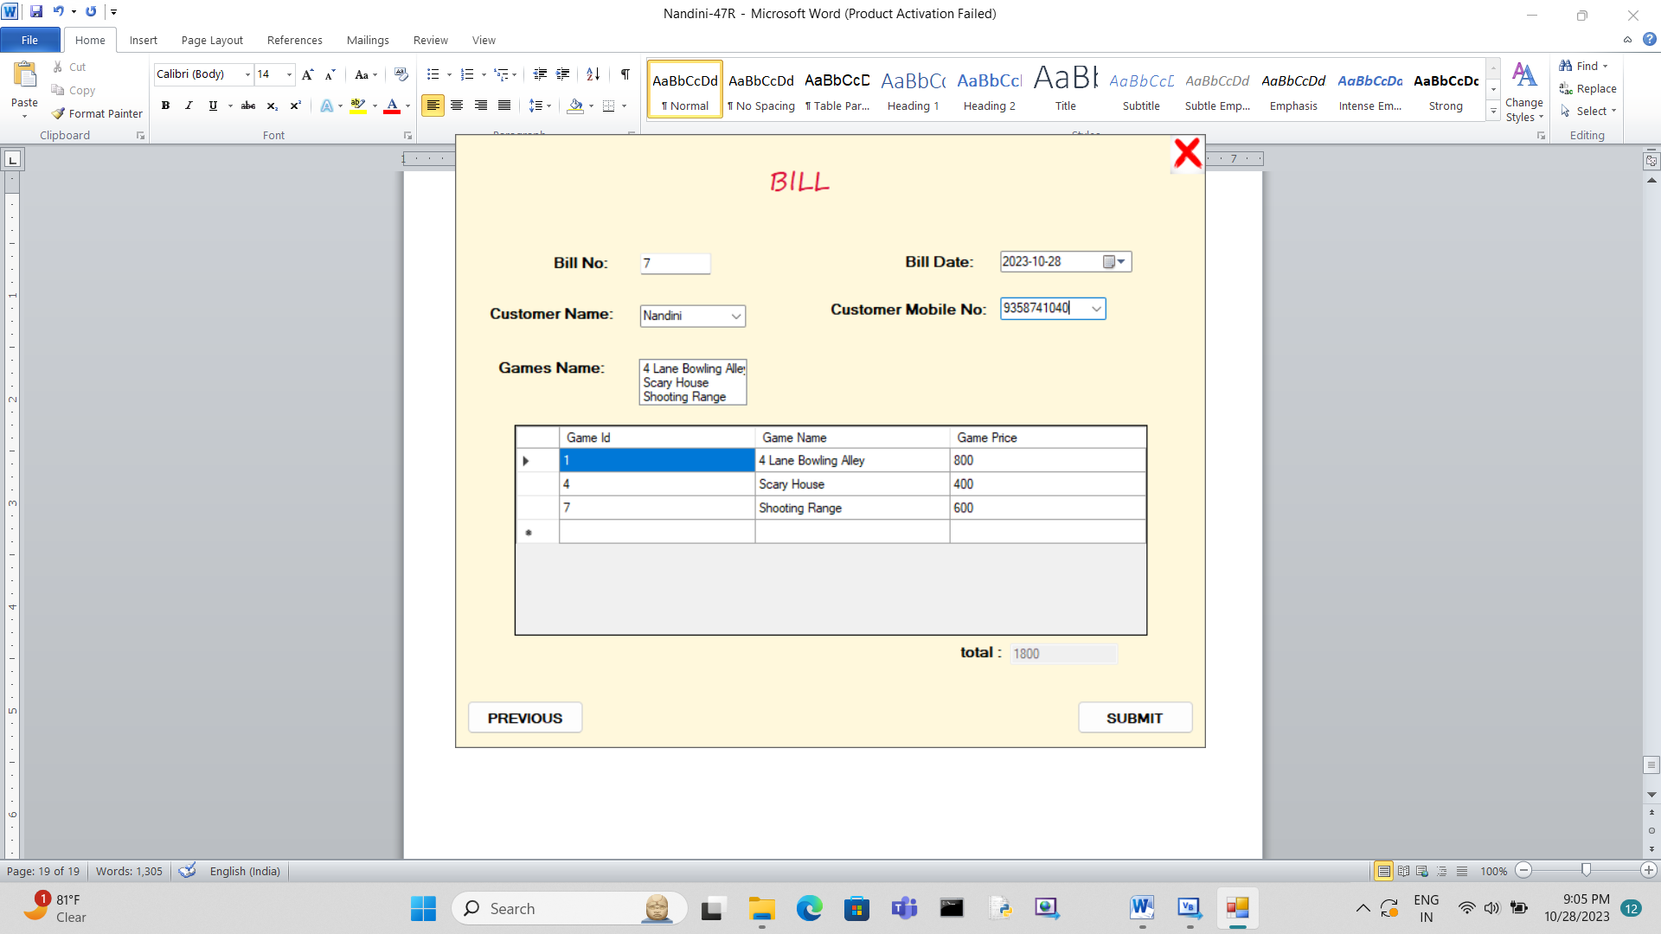

* Bill Page: Selected Package or individual games will be displayed in this page with total amount, Customer name and phone number will be taken as input for bill both jointly become a unique field for customer identification and on click of submit bill will be saved in database.

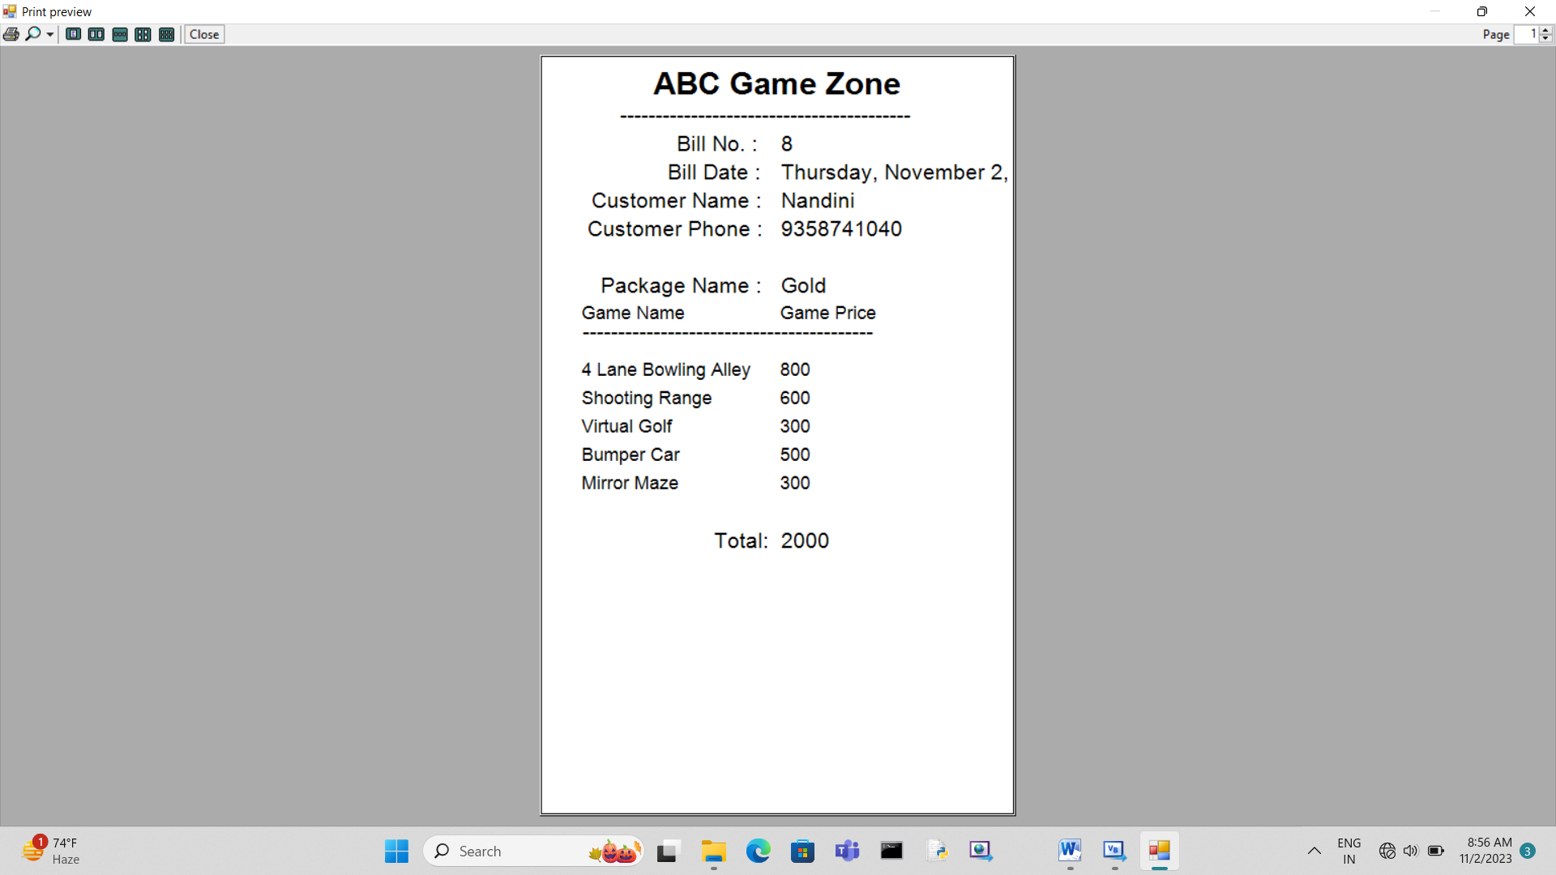

* After generating bill if the customer want the bill the system can give him/her a print of bill.
* **Limitations** :
* Proposed System is developed using visual basic (VB) language. So, there are number of limitations that the language itself has tool on which this system is created it is Visual Basic 2010 express edition so there can be done many changes of fixing done in newer editions.
* Limited cross-platform compatibility: VB is primarily designed for Windows, so it may not be the best choice if you need to develop applications for other platforms.
* Limited community support: The community of developers using VB has decreased over time, which means there are fewer resources available for troubleshooting and learning.
* Limited modern features: VB has not kept up with modern programming languages in terms of features and capabilities, which can make it less appealing to newer developers.
* Limited scalability: VB may not be the best choice for large-scale applications, as it can be difficult to maintain and scale as the application grows.
* Limited career opportunities: While there are still some job opportunities for VB developers, the demand for this language has decreased over time, which means that career prospects may be limited compared to other programming languages.
* **Conclusion :**

Proposed System automates manual works from existing paper based system, provides facility of data storage, data insertion and data consistency for billing, inventory management and vendor-customer management.

* During development of the project, there are many valuable learning’s that I gained:
* Planning is crucial: Proper planning, including defining clear project goals and requirements, can save time and prevent costly revisions later.
* Testing is essential: Comprehensive testing helps identify and fix bugs early, preventing them from becoming more significant issues later in the project.
* Flexibility is important: Be prepared to adapt to changing requirements or unexpected challenges during the project.
* Documentation matters: Maintain thorough documentation of your code and project details to ease future maintenance and collaboration.
* Time management matters: Effective time management can help keep the project on track and within the set timeline.
* Quality over quantity: Focus on producing high-quality code and features rather than rushing to add more features.
* Continuous learning: The technology landscape is always evolving, so embrace continuous learning to stay updated and improve your skills.
* **Bibliography :**
* <https://chat.openai.com/>
* <https://learn.microsoft.com/en-us/dotnet/visual-basic/>
* [How to Make a Shopping Receipt - Vb.net Billing and Get Print of the Receipt (YouTube Video)](https://youtu.be/a2ZezCJL_wI?si=GIH6q1_8NjW0Ex39)
* [Different Designs For Vb.net Application Tutorials- YouTube](https://www.youtube.com/results?search_query=Different+Designs+For+Vb.net+Application+Tutorials)
* System Analysis And Design By S.Parthasarthy Edition 6
* Software Engineering By Rogermoore
* Visual Basic Black Book By Rayao
* Programming Microsoft Visual Basic.NET: Francesco Balena
* Learning Visual Basic.Net
* Beginner’s Guide to Visual Basic .NET Programming