AI-Powered Citizen Grievance Analytics
& Resolution Intelligence System
Project Report
AICTE | IBM SkillsBuild — Data Analytics with AI Internship 2026

Organized by BharatCares | 17 August – 30 September 2026
Trainer: Mr. Kartik Hooda

Focus Area: Data Analytics with AI — Foundation to Implementation

Table of Contents
1. Problem Statement
2. Objectives
3. Dataset & Source
4. Data Cleaning & Preparation
5. Exploratory Data Analysis
6. Department / State-wise Analysis
7. Received vs Disposed vs Pending Analysis
8. Resolution / Pendency Insights
9. AI / ML Analysis
10. Key Findings
11. Conclusion
12. Future Scope
13. References & Limitations

1. Problem Statement
Citizens across India submit lakhs of grievances every year through the Centralised Public Grievance Redress and Monitoring System (CPGRAMS) — the Government of India's single online platform for lodging and tracking complaints against any Central Ministry, Department, State, or Union Territory. While CPGRAMS captures large volumes of receipt, disposal, and pendency data, this information is rarely converted into actionable, data-driven insight for citizens, researchers, or administrators. There is a clear need for a data-analytics system that can objectively measure how efficiently different government bodies resolve citizen grievances, identify where backlogs are concentrated, and apply AI/ML techniques to group and model performance so that limited administrative attention can be targeted where it is needed most.

2. Objectives
- Collect and clean an authentic, publicly available Government of India grievance-redressal dataset.
- Perform Exploratory Data Analysis (EDA) on grievances received vs. disposed vs. pending.
- Compare performance across Central Ministries/Departments and States/Union Territories.
- Derive pendency and resolution-delay insights, including how long grievances stay unresolved.
- Apply relevant AI/ML techniques (clustering and regression) on the available numeric fields.
- Summarise findings into clear, decision-useful insights, and recommend future extensions.

3. Dataset & Source
Field | Detail
Dataset | Department/State-wise Receipts, Disposal & Pendency of Public Grievances (CPGRAMS)
Publisher | Department of Administrative Reforms and Public Grievances (DARPG), Govt. of India
Platform | Open Government Data (OGD) Platform India — data.gov.in
Coverage period | 01 January 2016 to 01 November 2019 (cumulative, as on 01.11.2019)
Granularity | One row per Central Ministry/Department and per State/UT — 124 rows total
Original catalog page | data.gov.in/catalog/monthly-department-wise-public-grievance-receipts-and-disposals
File used | Dept_stat_receipt_disposal_010112019.csv
CPGRAMS portal | pgportal.gov.in

Note on provenance: data.gov.in blocks automated/bot downloads, so the exact, unmodified CSV was retrieved from a verified public GitHub mirror (github.com/kalyandutta209/cpgrams-statistical-analysis), whose README documents the file as the 'Original government dataset' sourced from DARPG/data.gov.in. The same file can also be requested directly from data.gov.in through a browser for independent verification.
Important, honest limitations of this dataset:
- This is a single cumulative snapshot (as on 01.11.2019), not a month-by-month or year-by-year time series. This project does not claim to show a multi-year volume trend line — that would require a different, time-indexed CPGRAMS dataset not available in clean tabular form in this environment.
- The dataset contains only aggregate counts — no individual grievance text/descriptions. No sentiment analysis or NLP topic modelling has been performed or fabricated. AI/ML in this project instead means clustering and regression on the genuine numeric fields available.
- Every number in this report is computed directly from the CSV file above; no statistic has been invented.

4. Data Cleaning & Preparation
The following cleaning and preparation steps were applied (see the accompanying Jupyter Notebook, Section 5, for the executable code):
- Renamed long, verbose column headers to short, code-friendly names.
- Stripped stray whitespace and a trailing comma found in one entity name.
- Checked for missing values (none found) and duplicate rows (none found) across all 124 rows.
- Classified every row as 'Central Ministry/Department' (88 rows) or 'State/Union Territory' (36 rows) using an explicit, verifiable list of Indian State/UT names, since this label does not exist in the raw file.
- Engineered three KPIs needed for the analysis: Disposal Rate %, Pendency Rate %, and Chronic Pendency % (share of currently-pending cases that have been pending for more than one year).

5. Exploratory Data Analysis
Central Ministries/Departments vs. States/UTs show a stark difference in performance on this dataset:
Metric (mean) | Central Ministries/Depts | States/UTs
Disposal Rate % | 96.89% | 45.24%
Pendency Rate % | 3.11% | 54.76%
Chronic Pendency % | 5.20% | 52.84%
Avg. Total Receipts | 33,083.89 | 51,894.58
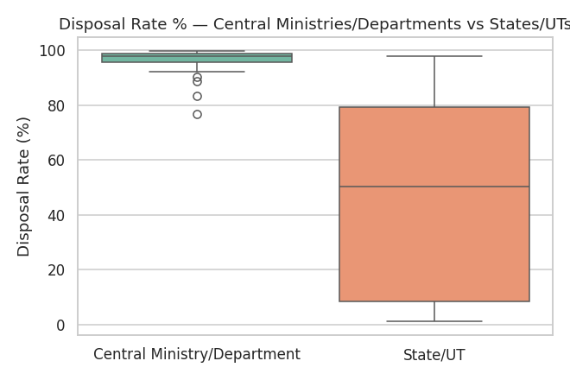
Fig 1: Disposal Rate % — Central Ministries/Departments vs. States/UTs
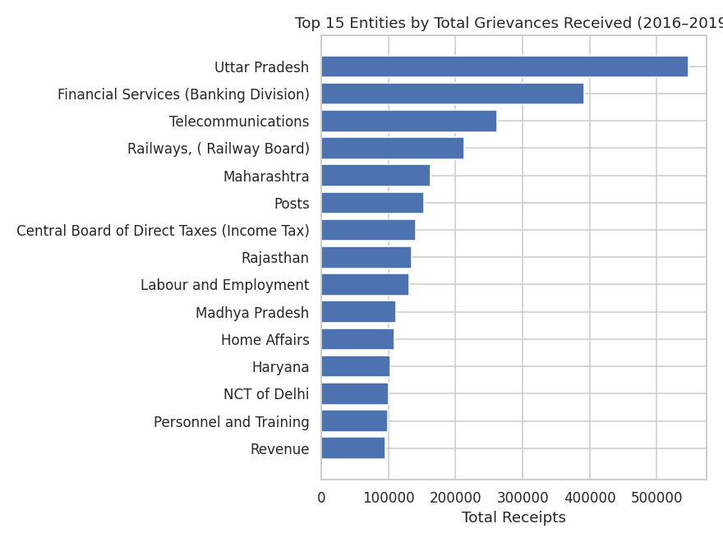
Fig 2: Top 15 entities by total grievances received (2016–2019)
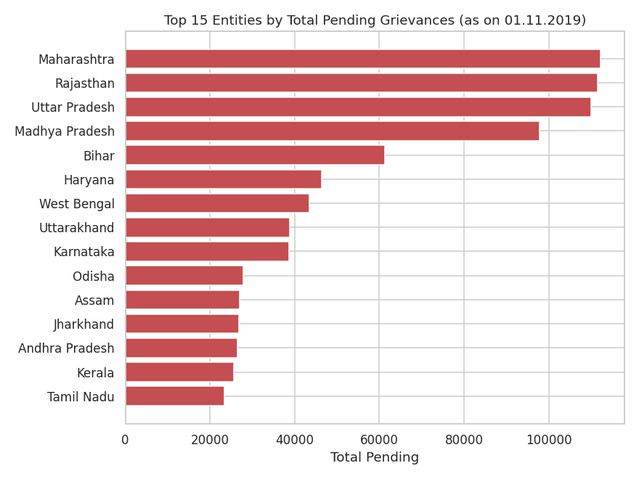
Fig 3: Top 15 entities by total pending grievances (as on 01.11.2019)

6. Department / State-wise Analysis
Among Central Ministries/Departments, NITI Aayog and Parliamentary Affairs recorded the best disposal rates (99.84% each), while Legal Affairs (76.63%) and Legislative Department (83.52%) trailed the group — still far above most States.
Among States/UTs, the smaller Union Territories (Daman & Diu 97.70%, Lakshadweep 97.06%) performed best, while several large states — Himachal Pradesh (1.24%), Andhra Pradesh (2.11%), Jammu & Kashmir (2.12%), Manipur (2.28%), and West Bengal (2.33%) — recorded disposal rates under 3%, meaning almost everything they received in this period remained open.
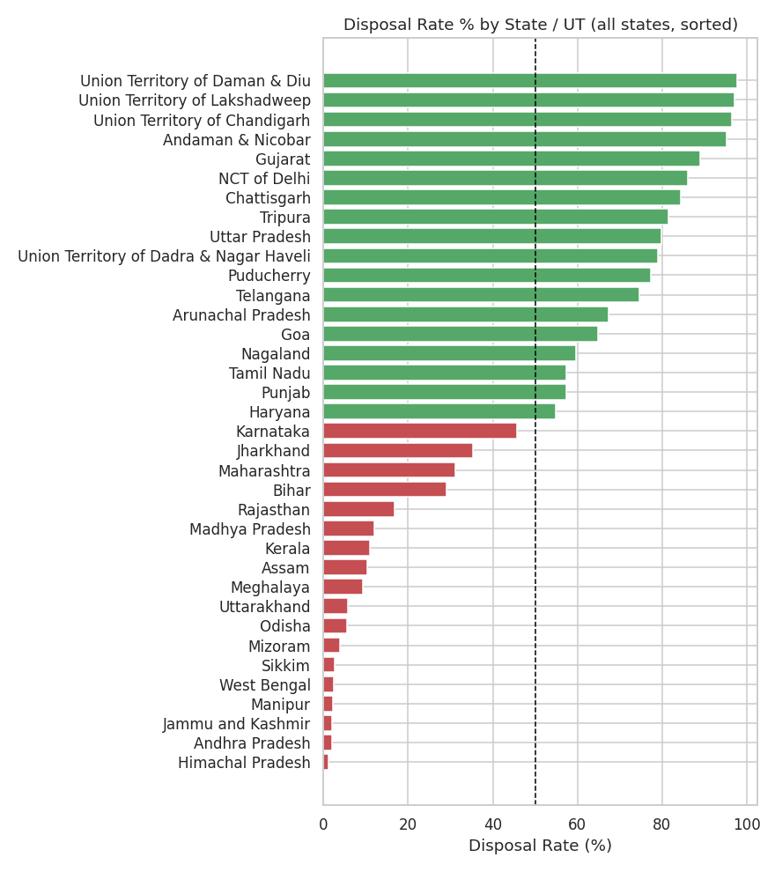
Fig 4: Disposal Rate % by State/UT, sorted (dashed line = 50%)

7. Received vs Disposed vs Pending Analysis
National Totals (2016 – 01.11.2019)
Total Grievances Received | 47,79,587
Total Disposed | 37,98,755 (79.5%)
Total Still Pending (as on 01.11.2019) | 9,80,832 (20.5%)
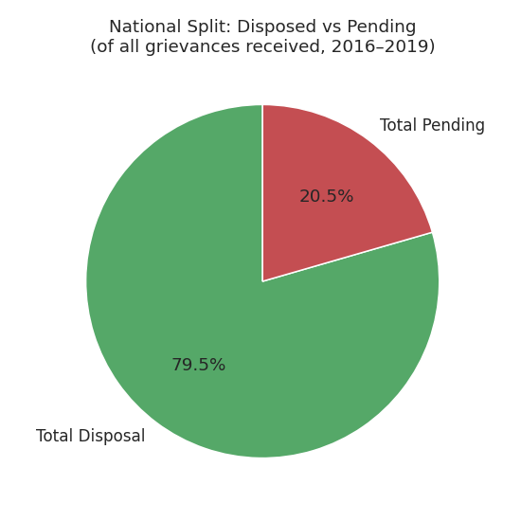
Fig 5: National split — Disposed vs Pending

8. Resolution / Pendency Insights
Breaking down the 9,80,832 pending grievances by how long they have been open reveals that pendency is not merely recent backlog — a large majority is chronic:
Pending Age Bucket | Count
Less than 2 months | 1,62,927
2 to 6 months | 1,18,237
6 to 12 months | 1,00,096
More than 1 year | 5,99,572 (61.13% of all pending cases)
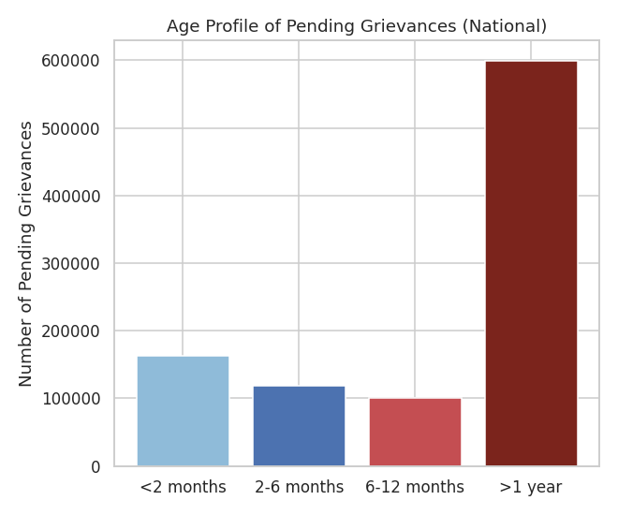
Fig 6: Age profile of pending grievances (national)
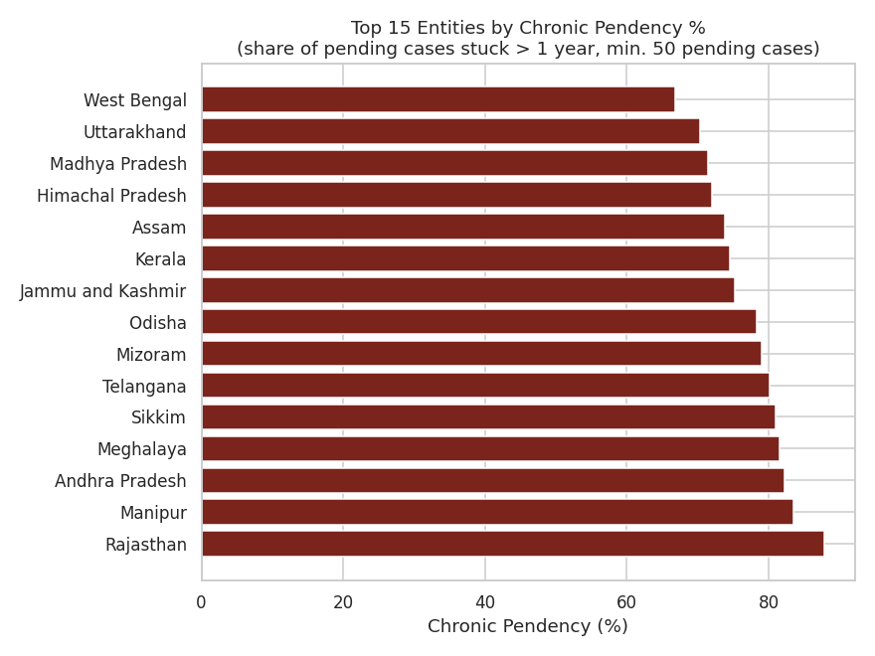
Fig 7: Top 15 entities by chronic pendency % (min. 50 pending cases)
This chronic-pendency ranking is only visible once the pending-duration buckets are used — 'total pending' alone would not distinguish an entity with a large but recent backlog from one whose cases have genuinely stalled for years.

9. AI / ML Analysis
The dataset has no free-text grievance descriptions, so no NLP or sentiment analysis is applied (doing so would require inventing text data, which this project explicitly avoids). Instead, two genuine, appropriate ML techniques were applied to the numeric fields:

9.1 K-Means Clustering (Unsupervised ML)
Features used: Disposal Rate %, Pendency Rate %, Chronic Pendency % (standardised). The number of clusters (k) was chosen objectively using the silhouette score, tested for k = 2 to 5:
k | Silhouette Score
2 | 0.807 ← selected
3 | 0.802
4 | 0.780
5 | 0.685
The algorithm — using only the numeric KPIs, with no access to the Central/State label — independently converged on a 2-way split:
Cluster | Entities
Cluster 0 — 'Healthy' | 100
Cluster 1 — 'High-Backlog' | 24
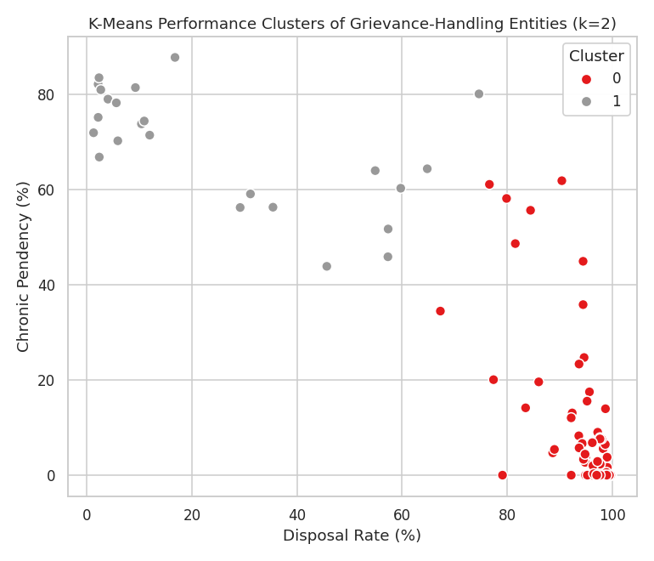
Fig 8: K-Means performance clusters (k=2)
This unsupervised result closely mirrors — but is not identical to — the manual Central-vs-State split in Sections 5–6, providing an independent, data-driven confirmation of the same finding.

9.2 Linear Regression — Receipts vs Disposal
Statistic | Value
Slope (disposal per grievance received) | 0.8429
Intercept | -1854.84
R-squared (R²) | 0.9200
Pearson Correlation (r) | 0.9592
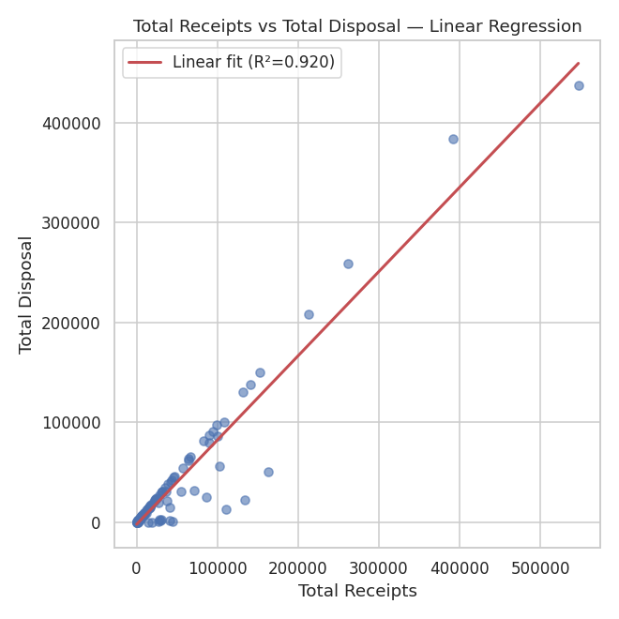
Fig 9: Total Receipts vs Total Disposal — linear fit
A strong positive correlation (r = 0.96, R² = 0.92) shows that larger entities dispose of grievances roughly in proportion to how many they receive — i.e. volume alone does not explain poor disposal performance. Points that fall well below the regression line are entities disposing of far fewer grievances than their receipt volume would predict, and these visibly match several of the low-disposal-rate States identified earlier.

10. Key Findings
- Central Ministries/Departments averaged a 96.89% disposal rate vs. just 45.24% for States/UTs over the same period — a very large institutional performance gap.
- 61.13% of all nationally pending grievances (as on 01.11.2019) had already been pending for more than one year — pendency is substantially chronic, not just recent inflow.
- A small number of large States (e.g. Maharashtra, Madhya Pradesh, Rajasthan, Uttar Pradesh) account for a disproportionate share of national pending cases (Fig 3).
- K-Means clustering independently confirmed a 2-group performance split (100 'healthy' vs. 24 'high-backlog' entities) using only numeric KPIs, without being told which rows were States.
- Receipts and disposal are strongly correlated (r = 0.96, R² = 0.92) — meaning disposal efficiency (rate), not raw volume, is what separates good and poor performers.

11. Conclusion
This project builds an end-to-end, honest data-analytics pipeline on a genuine Government of India CPGRAMS grievance-redressal dataset — from raw-CSV cleaning through EDA, department/state comparison, pendency-age analysis, and two appropriate ML techniques (clustering and regression) — without fabricating any data, statistic, or NLP capability the dataset does not support. The resulting insights are directly reproducible from the source file cited in Section 3 and the accompanying Jupyter Notebook.

12. Future Scope
This project has been deliberately structured (clean → EDA → KPIs → ML) so it can be extended without a rewrite:
- Interactive dashboard: port the KPIs and charts into a Power BI report or a Streamlit app with entity/state filters and live drill-down.
- NLP / sentiment layer: if a grievance-text-level CPGRAMS export becomes available (e.g. via an RTI request or an official data-sharing arrangement), add complaint-category classification and sentiment analysis on top of the existing entity_type/KPI structure.
- Time-series trend analysis: incorporate the monthly DARPG CPGRAMS performance reports (darpg.gov.in) to convert this single snapshot into a true month-on-month trend model, enabling forecasting of pendency.
- Predictive resolution-time model: once case-level, date-stamped data is available, train a model to predict expected resolution time or delay-risk for a new grievance at filing time.
- Automated alerting: flag entities whose chronic-pendency % crosses a threshold, for proactive administrative review.

13. References
- Open Government Data (OGD) Platform India — data.gov.in/catalog/monthly-department-wise-public-grievance-receipts-and-disposals
- Open Government Data (OGD) Platform India — data.gov.in/catalog/public-grievance-details-cpgrams-along-feedback-details
- CPGRAMS Official Portal — pgportal.gov.in
- Department of Administrative Reforms & Public Grievances (DARPG) — darpg.gov.in
- Dataset mirror used for retrieval — github.com/kalyandutta209/cpgrams-statistical-analysis

